Whatever

# Title1

## Title2

* we
* can
* make
* bullet lists

1. or
2. numbered
3. lists
   * another bullet list

**some basic** *formatting*

above is a line

a2 bsubscript

log2 fold change

$\sum_{i=1}^{n}{x^{i+1}}\text{log}(10)\text{sin}(π)χ^{2}$

|  |  |  |
| --- | --- | --- |
| something | something | else |
| asdf asdf | asdfasdfasdf | asdfasdf |
| next row | 2 +1 | $2^{e}$ |

Citing myself is a bad thing (Weiner et al. 2018).

# this will be computer code  
a <- 1  
  
plot(1:10)

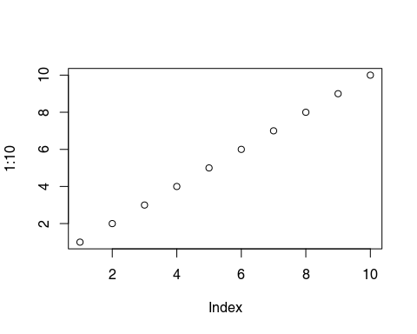

Weiner, January, Jeroen Maertzdorf, Jayne S Sutherland, Fergal J Duffy, Ethan Thompson, Sara Suliman, Gayle McEwen, et al. 2018. “Metabolite Changes in Blood Predict the Onset of Tuberculosis.” *Nature Communications* 9 (1): 1–12.