Appointment System Assignment

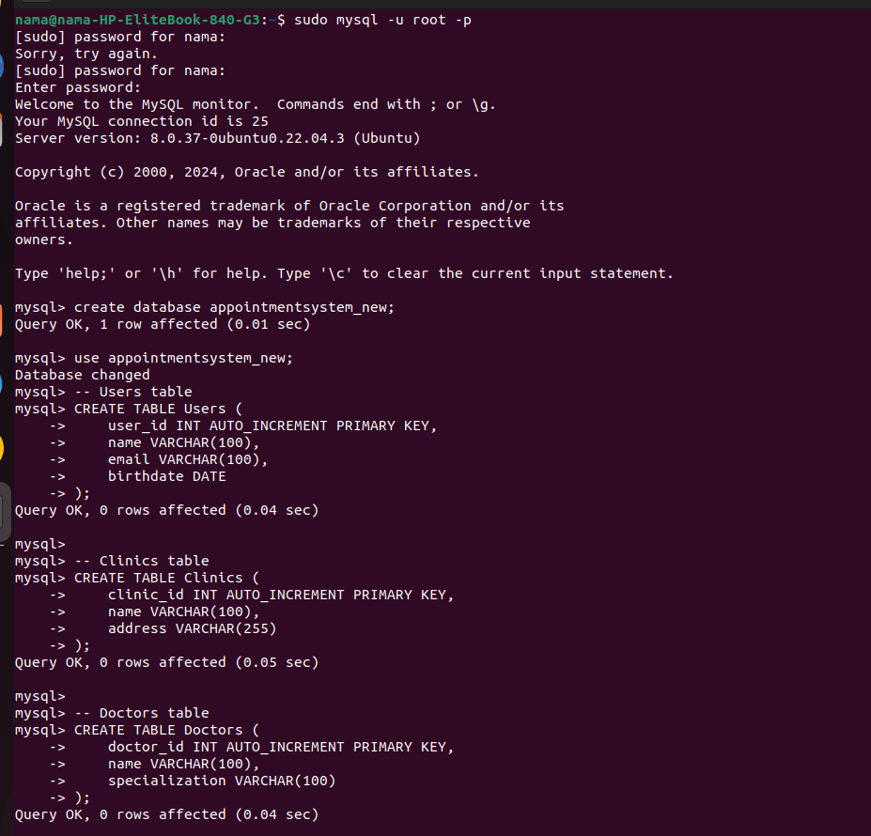

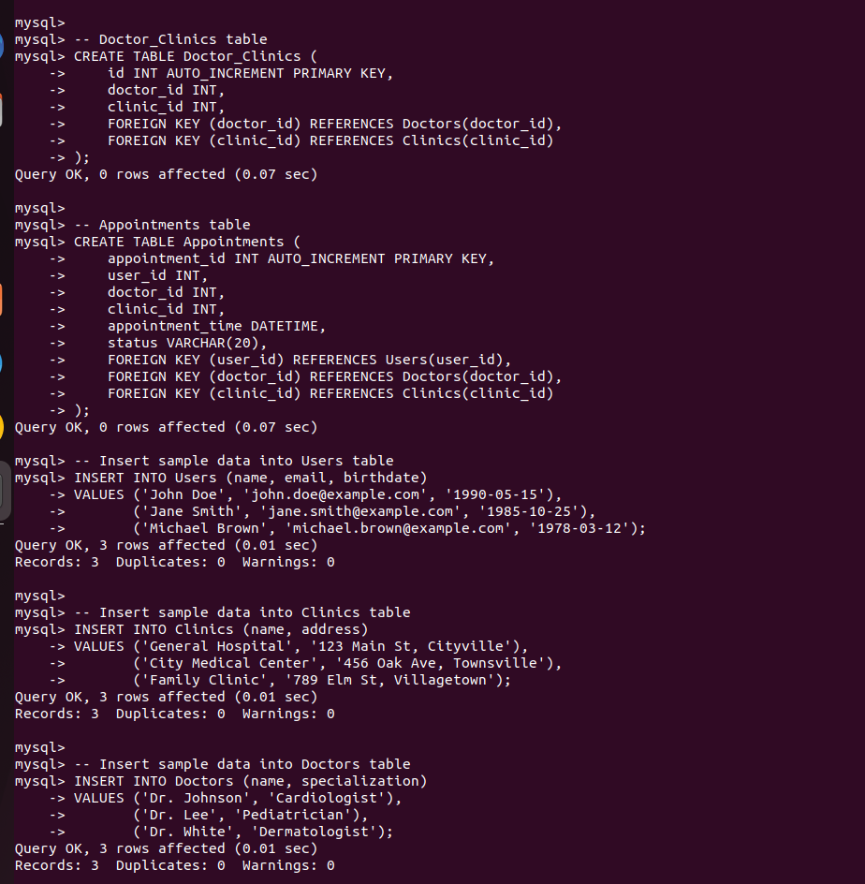
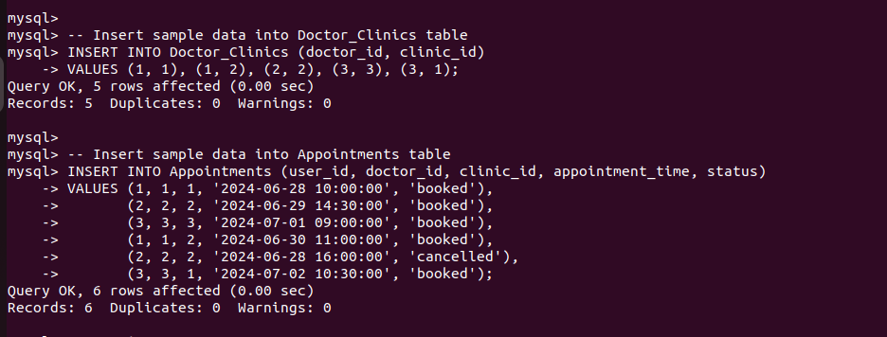

1. All appointments booked in last 7 days for a doctor
Query:
SELECT *
FROM Appointments
WHERE doctor_id = 1
AND appointment_time >= NOW() - INTERVAL 7 DAY
AND status = 'booked';

OUTPUT:
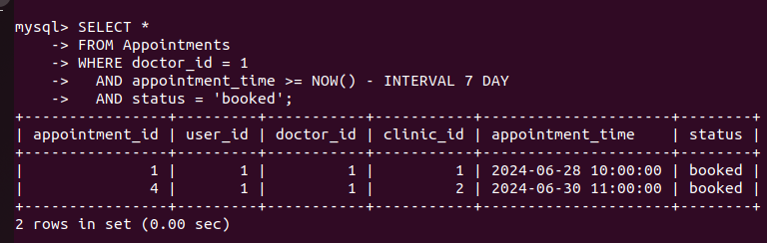
Explanation:
This SQL query retrieves all appointment records from the Appointments table where the doctor_id is 1, the appointment_time is within the last 7 days from the current date and time, and the status is 'booked'. Essentially, it gathers all recently booked appointments for a specific doctor over the past week, providing a focused view of the doctor's recent scheduling activity.

2.All appointments booked in last 2 days n scheduled within next 5 hours for a doctor.
Query:

SELECT *
FROM Appointments
WHERE doctor_id = 2
AND appointment_time BETWEEN NOW() - INTERVAL 2 DAY AND NOW()+ INTERVAL 5 HOUR
AND status = 'booked';
OUTPUT:
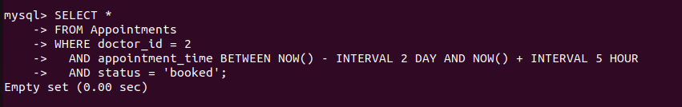
Explanation:
This SQL query retrieves all appointment records from the Appointments table where the doctor_id is 2, the appointment_time falls within the last 2 days up to the next 5 hours from the current date and time, and the status is 'booked'. In essence, it focuses on gathering all the appointments that have been booked for a specific doctor (with ID 2) within a very recent and near-future time window, specifically capturing appointments made over the past 48 hours and extending to those scheduled within the upcoming 5 hours. This can be useful for monitoring a doctor's recent and imminent appointments, ensuring they are aware of their immediate schedule.
3.Users who have at least one appointment and have their birthday coming in the next 5 days:
Query:
SELECT DISTINCT u.*
FROM Users u
JOIN Appointments a ON u.user_id = a.user_id
WHERE DATE_FORMAT(u.birthdate, '%m-%d') BETWEEN DATE_FORMAT(NOW(), '%m-%d')
AND DATE_FORMAT(NOW() + INTERVAL 5 DAY, '%m-%d');

OUTPUT:

Explanation:
The query identifies users who have appointments and whose birthdays are within the next 5 days. It joins the Users and Appointments tables to find users with appointments and uses the DATE_FORMAT function to compare only the month and day parts of the birthdate against the current date and the date 5 days ahead. The DISTINCT keyword ensures each user is listed only once, regardless of the number of appointments.

4.Appointments for a particular patient in the last 7 days:
Query:
SELECT *
FROM Appointments
WHERE user_id = 1
AND appointment_time >= NOW() - INTERVAL 7 DAY;
Output:
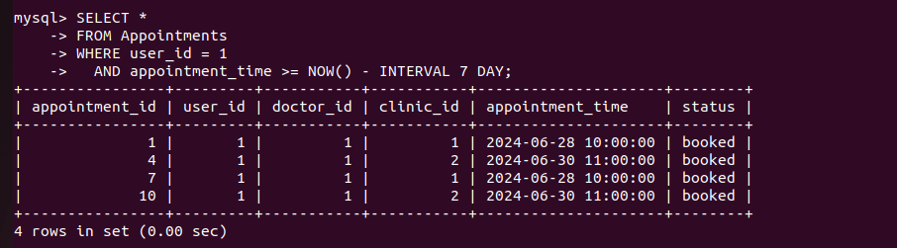
Explanation:
This SQL query retrieves all appointment records from the Appointments table for a specific user whose user_id is 1. It filters the results to include only those appointments where the appointment_time is within the last 7 days from the current date and time. Essentially, it gathers all the recent appointments made by the user with user_id 1 in the past week, providing a focused view of this user's recent appointment activity.

5.Appointment cancellation percentage for a doctor by clinic:
Query:
SELECT c.clinic_id, c.name,
(SUM(CASE WHEN a.status = 'cancelled' THEN 1 ELSE 0 END) / COUNT(*)) * 100 AS cancellation_percentage
FROM Appointments a
JOIN Clinics c ON a.clinic_id = c.clinic_id
WHERE a.doctor_id = 1
GROUP BY c.clinic_id, c.name;
OUTPUT:
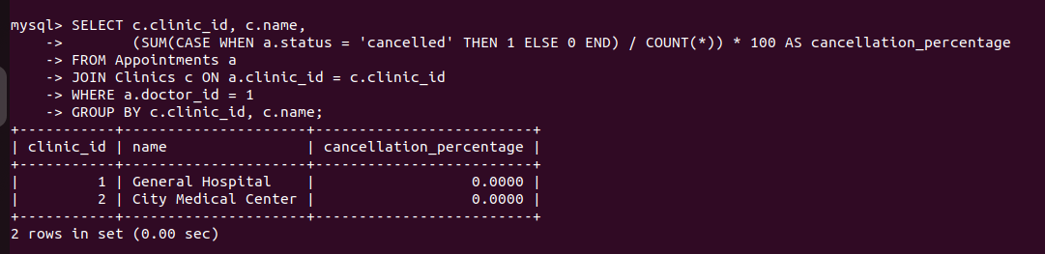
Explanation:
This SQL query calculates the cancellation percentage of appointments for a specific doctor at each clinic. It retrieves the clinic_id and name from the Clinics table, and joins it with the Appointments table on clinic_id. The cancellation percentage is computed as the ratio of cancelled appointments (status = 'cancelled') to the total number of appointments, multiplied by 100. The results are grouped by each clinic, providing a summary of cancellation rates for the specified doctor across different clinics.

ER DIAGRAM:
