[Date]

NETWORK VULNERABILITY ASSESSMENT

[Document subtitle]

Team id : LTVIP2023TMID07061

Team leader : pentakota saijahnavi

Team member: kinthali prabhuratnakumar

Team member: torati vinaykumar

Team member: yecherla seetaramaraju

Team member: cherukuri saivarma

PROJECT

Network vulnerability assessment

* Information gathering

1. Email footprinting analysis

Email is one of the most popular, widely used professional ways to communication which is used by every organization.

Email footprint analysis is a technique used to collect information about an individual or organization by analyzing their email communications. This can include analyzing the email headers, email addresses, and email content to gather information such as the sender IP address, email service providers, and communication patterns. This technique can be useful in threat intelligence, social engineering, and other cyber investigations.

Tracing an email using header can reveal the following information:

* Destination address
* Sender’s IP address
* Sender’s mail server
* Time & date information
* Authentication system information of sender’s mail server

**STEP BY STEP PROCESS**

Step 1 :

* Open your mail id where you can spam folder’s and open it .
* In spam folder where you can find many spam mails .
* Open any spam mail which you want perform the email footprint analysis.

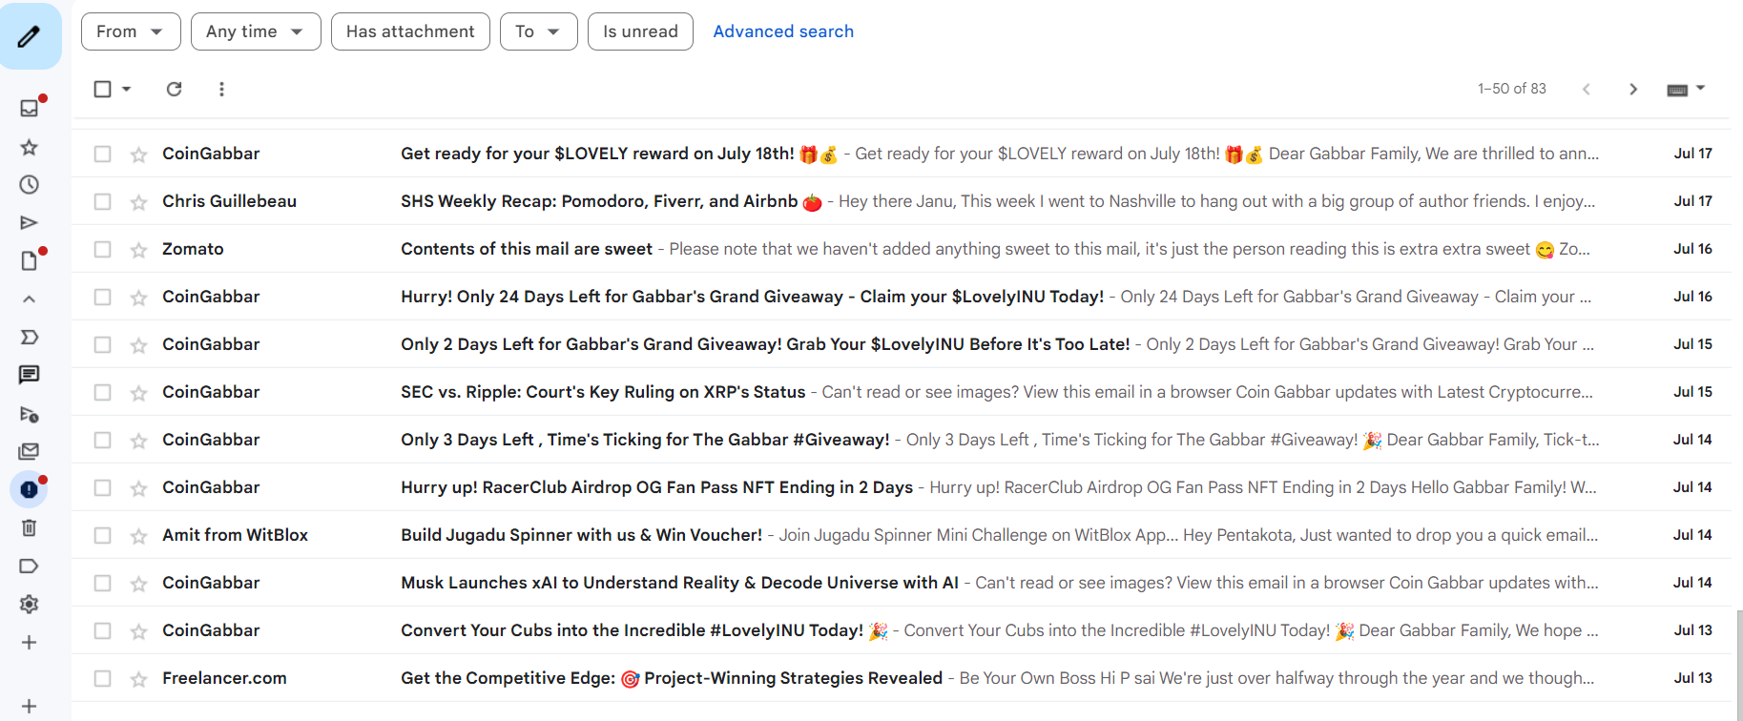

Step 2 :

* Now i will open freelancer spam mail to perform email footprint analysis .

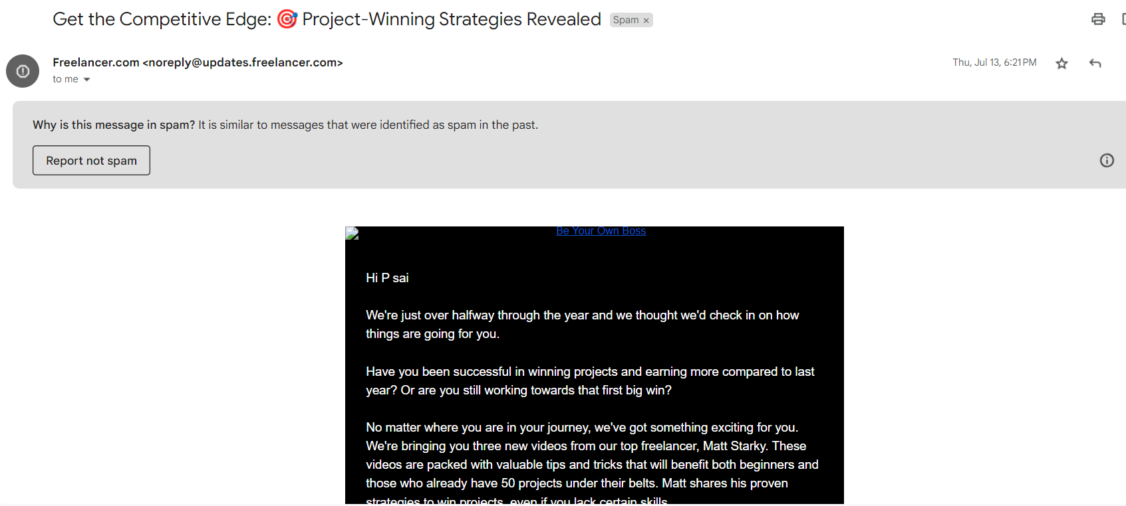



* As we see here the basic details of the freelancer.com.

Step 3:

* In spam mail you’ll find show original.

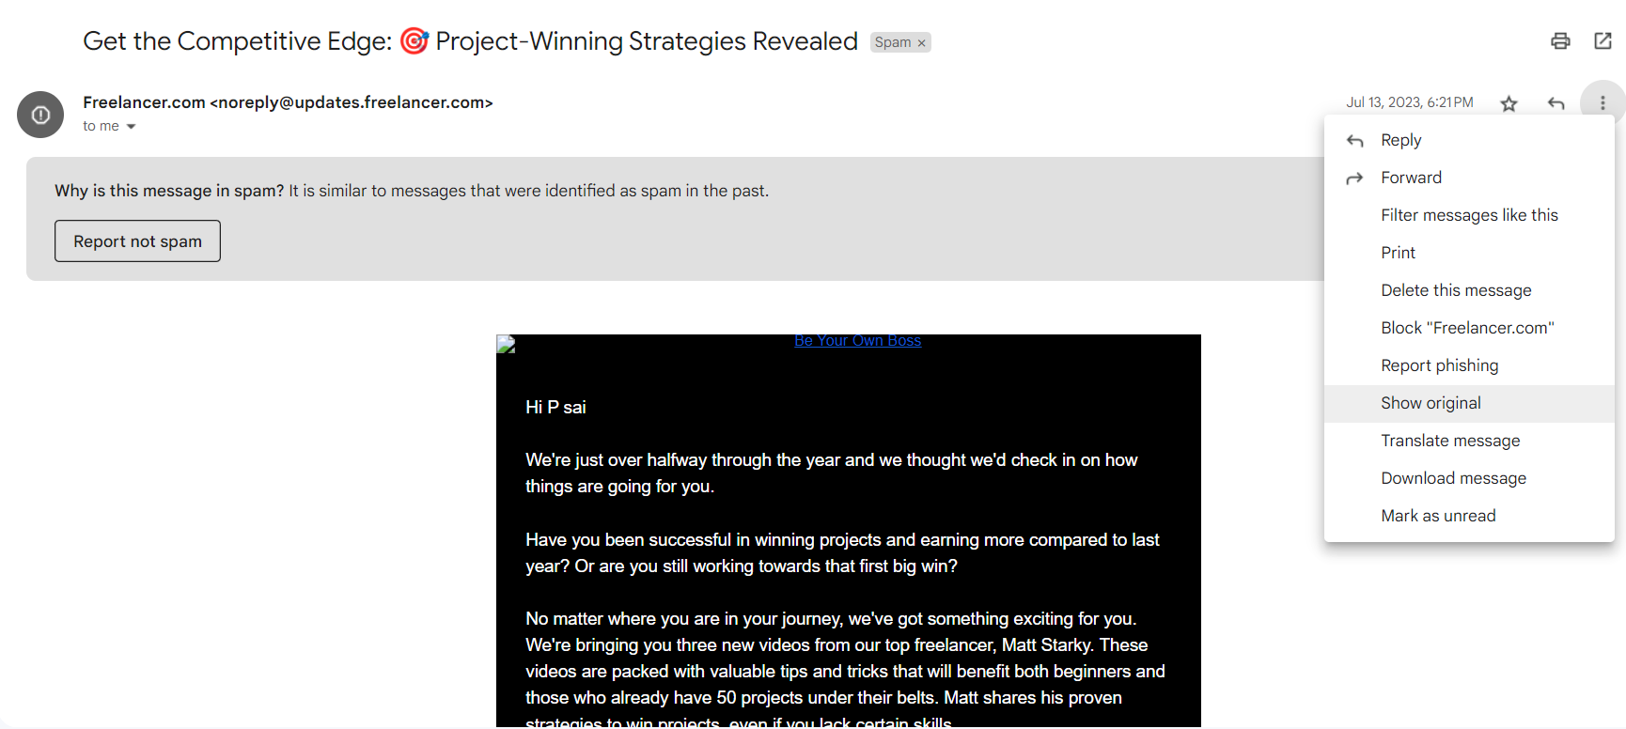



* Now click on the show original therefore you’ll redirect to new tab

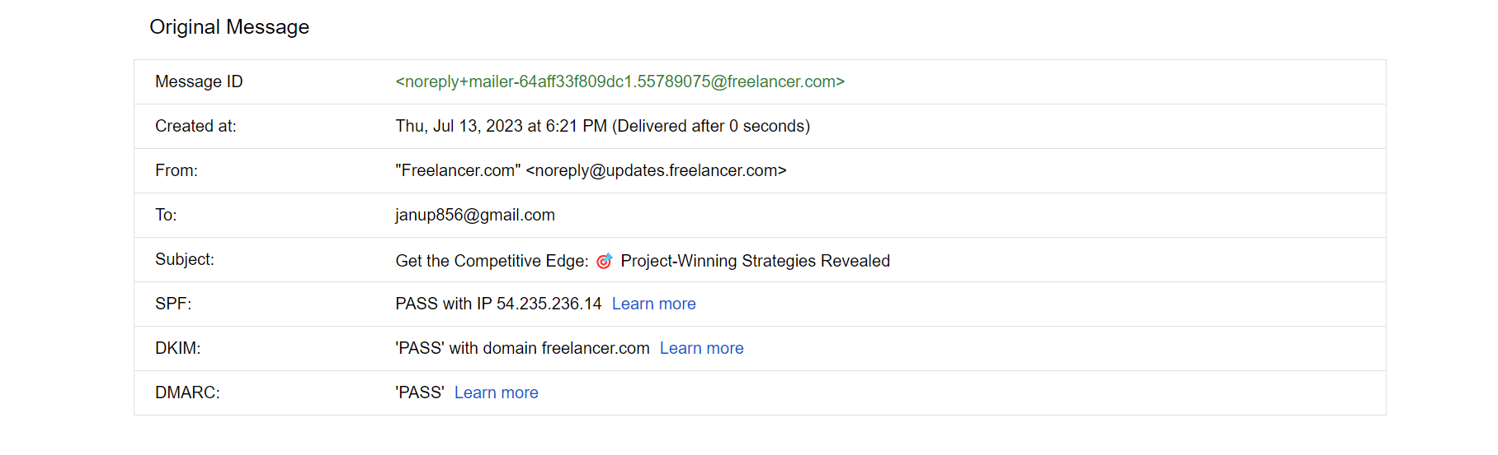



* You’ll find some code type below the original message in that you have to find “receive form”
* After finding receive form you’ll find IP address over there copy it.
* Open another new tab and search for whois IP lookup and open the first result of your search paste the IP address over there.



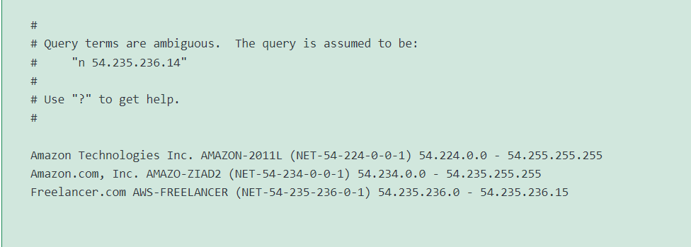

* In above you’ll find the ip address range from 54.234.0.0 to 54.235.255.255
* And also the mail is form amazon.com .

By this you’ll find the information by email footprint analysis.