**Title**:

Magnesium ions regulate mesenchymal stem cells population and osteogenic differentiation: a fuzzy agent-based modeling approach

**Authors:**

Jalil Nourisa, Berit Zeller-Plumhoff, Vladimir Ivannikov, Heike Helmholz, Berengere.Luthringer, Regine Willumeit-Römer

Helmholtz Zentrum Geesthacht, Institute of Metallic Biomaterials, Max-Planck-Straße 1, 21502 Geesthacht, Germany.

**Abstract**

Mesenchymal stem cells (MSCs) are proliferative and multipotent cells that play a key role in the bone regeneration process. Empirical data have repeatedly shown the bioregulatory importance of magnesium (Mg) ions in MSC growth and osteogenesis. In this study, we propose an agent-based model to predict the spatiotemporal dynamics of the MSC population and osteogenic differentiation in response to Mg2+ ions. A fuzzy-logic controller was designed to govern the decision-making process of cells by predicting four cellular processes of proliferation, differentiation, mortality, and migration in response to several important bioregulatory factors such as Mg2+ ions, pH, BMP2, and TGF-β1. The model was calibrated using the empirical data obtained from three sets of cell culture experiments. The model successfully reproduced the empirical observations regarding live cell count, viability, DNA content, and the differentiation-related markers of alkaline phosphate (ALP) and osteocalcin (OC). The simulation results, in agreement with the empirical data, showed that Mg2+ ions within 3-6mM concentration have the highest stimulation effect on cell population growth. The model also correctly reproduced the stimulatory effect of Mg2+ ions on ALP and its inhibitory effect on OC as the early and late differentiation markers, respectively. Besides, the numerical simulation shed light on the fundamental differences in the characteristics of the cells cultured in different experiments in terms of the proliferative capacity as well as sensitivity to Mg2+ ions. The proposed model can be adopted in the study of the osteogenesis around Mg-based implants where released ions due to degradation interact with local cells and regulate bone regeneration.

# Introduction

Mesenchymal stem cells (MSCs) are the key players in bone fracture healing [1]. MSCs migrate to the fracture site, increase cell population through a fast proliferation process, and differentiate into multiple cell types involved in bone tissue regeneration, in particular osteoblasts [2]. The self-replication process occurs through a cascade of cell cycle events including the two major processes of DNA synthesis and actual division of the parent cell into two daughter cells [2]. Proliferating MSCs withdraw from the normal cell cycle under certain circumstances and commit to the osteoblast lineage [3], [4]. The specialization of MSCs toward osteoblasts involves a complex intracellular interaction as well as extracellular signaling and is shown to occur continuously with recognizable intermediate cells such as osteoprogenitors and pre-osteoblasts [5]. During osteogenic differentiation, MSCs experience a decline in proliferative capacity and gain osteoblastic properties [6]. The onset of MSC differentiation to osteoblasts, the progression along this lineage, and the duration of the process are controlled by external signals [7]–[9].

Magnesium (Mg)-based biomaterials are biodegradable which makes them an attractive choice in the orthopedic application and medical-technical industry [10]. Mg implants degrade at the implantation site which results in an alteration in the microenvironment of the local tissue. Mg2+ ions released during degradation are demonstrated by several *in vivo* and *in vitro* studies to regulate gene and protein expressions associated with cell growth and osteogenesis [10]–[12]. The release of Mg2+ ions in high concentrations are also associated with the alteration of the microenvironment pH [12] causing alkaline condition and consequently interfering with a broad range of physiological processes such as cell metabolism, cell adhesion, and proliferation [13]–[15]. So far, the empirical approach has been the only means to study the bioregulatory effect of Mg-based materials. Experimentalstudies are expensive, time-consuming, cover a limited range of parameters, and more importantly, can pose animal-welfare issues. However, numerical models once validated are powerful tools that require significantly lower cost and time with no associated ethical issues.

Agent-based modeling (“agent-based model” and “agent-based modeling” are both abbreviated as ABM) is widely used in simulating complex systems with special attention to the behavioral properties of individual entities called agents [16][17]. By explicitly simulating cells as agents, ABM inherently provides a multiscale investigation of a system, as a direct observation can be made on individual cells while the cumulative results are captured at the population level. Several studies already demonstrated the capabilities of ABMs in incorporating several physiological scales [18]–[20]. A common challenge in ABM is the abstraction of cellular behavior which requires an algorithm to correctly govern the decision-making process [21], [22]. Among the available techniques, fuzzy logic-based (FLB) simulations have shown great potential in resolving technical barriers between experimental and simulation experts [23]. In this approach, knowledge about a system can be formulated in the form of IF-THEN statements, in which IF and THEN are conditions and results, respectively. This plain language can potentially ease the involvement of people with domain knowledge in the rapid development of computer models. Since FLB models can define a system without precise mechanistic information, it is possible to leverage qualitative knowledge in numerical modeling which would be otherwise difficult or impossible using other simulation approaches that require real-valued variables [23]. Due to these advantages, the FLB approach has already been repeatedly employed in the numerical investigation of bone regeneration [24]–[26].

In this study, we propose a fuzzy agent-based model to predict the spatiotemporal dynamics of mesenchymal stem cell population and osteogenic differentiation in response to Mg2+ ions. To this end, the available information in the literature regarding the bioregulatory effect of Mg2+ ions in tandem with pH and several other determinant factors is curated and tailored as fuzzy logic rules. The data obtained from three sets of published cell-culture experiments are used to estimate the model’s parameters by employing approximate Bayesian calculation.

# Materials & methods

The computer model developed in the present study consists of three parts; an agent-based model, a cell model, and a growth factor model. The agent-based model initializes the simulation, iteratively executes the two other models, and updates the simulation world (Figure 1-A). The cell model receives the environmental cue and predicts cellular reactions (see Figure 1-B). The growth factor model calculates the production and distribution of the growth factors within the simulation domain. During the formulation of the models, the unknown values are defined as free parameters and estimated during the calibration process. The model developed in this study can be found on [].

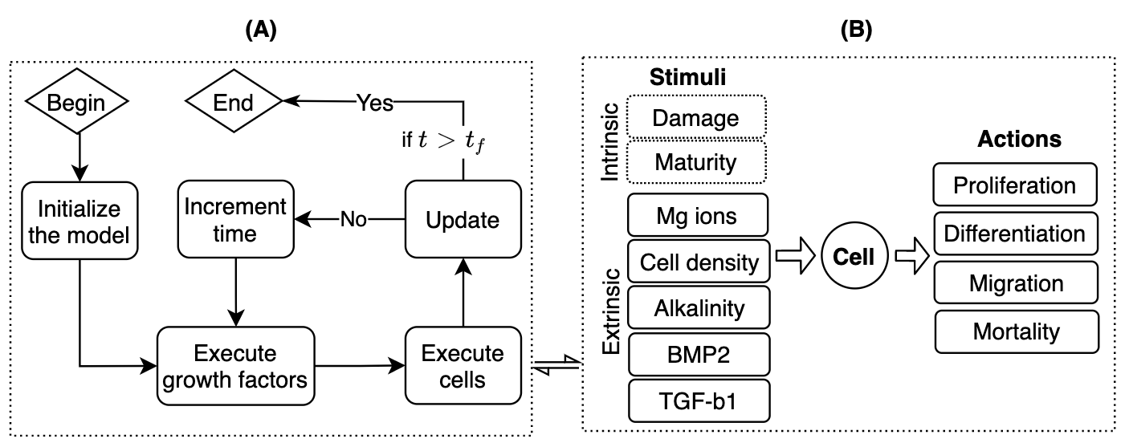

Figure : (A) the workflow of the agent-based simulation. Once the model is initialized, the cell and the growth factors models are executed iteratively, and the simulation world is updated according to their results. (B) the cell model governs the decision-making process of the cell by predicting cell actions for a given set of inputs. : the final time step of the simulation.

## Agent-based model

Osteoblastic differentiation of MSCs is shown to generate more than four cell layers in cell culture experiments [27]. Therefore, a three-dimensional (3D) space with 8 layers in the z-direction is created as the simulation domain [27]. A cube-shaped patch with a length of L is used for the discretization of the domain. L is calculated by taking into account the initial confluence (), initial cell count ), and culture surface area (A) of each experiment set,

|  |  |
| --- | --- |
|  | () |

At the beginning of the simulation, cells are randomly assigned to the patches. To account for the crowding effect, the occupancy of a patch is limited to only one cell at a time [28]. However, non-agent objects such as proteins are permitted to share a patch. Agents are designed to interact with each other and with the patches in their Moore neighborhood, i.e. the 27 immediately adjacent positions. To save computational power, we only simulate 1 of the culture area. To partly account for this simplification, periodic boundary conditions are applied to the external surfaces of the domain [29]–[31]. Each iteration in our simulation represents one hour [30], [32]. The computer model is configured according to the given experiments in terms of the initial cell count, the surface area of the culture plates, and the initial concentrations of Mg and growth factors. For culture experiments longer than 3 days, the content of the growth factors and pH value is reset to the initial values every 2.5 days accounting for the process of medium change [27]. CppyABM [33] is used for the ABM.

## Cell model

We define five inputs of Mg2+ ions, alkalinity, TGF-b1, BMP2, and cell density as the bioregulatory cues of the cellular behavior. In addition, two intrinsic factors of maturity and damage are simulated to influence cellular functions (see Figure 1-B). The cell model predicts four cellular behavior of proliferation, differentiation, mortality, and migration. The cell model consists of two parts; a Mamdani-type fuzzy-logic controller to compute the intensity of the cellular actions as a cumulative result of the stimulatory signal, and a set of equations to convert the fuzzy controller’s outputs to the agent-based model. The fuzzy controller operates in three steps of fuzzification, fuzzy inference, and defuzzification as shown in Figure 2-A [34]. FuzzyLite Library [35] is used for the design of the fuzzy logic controller.

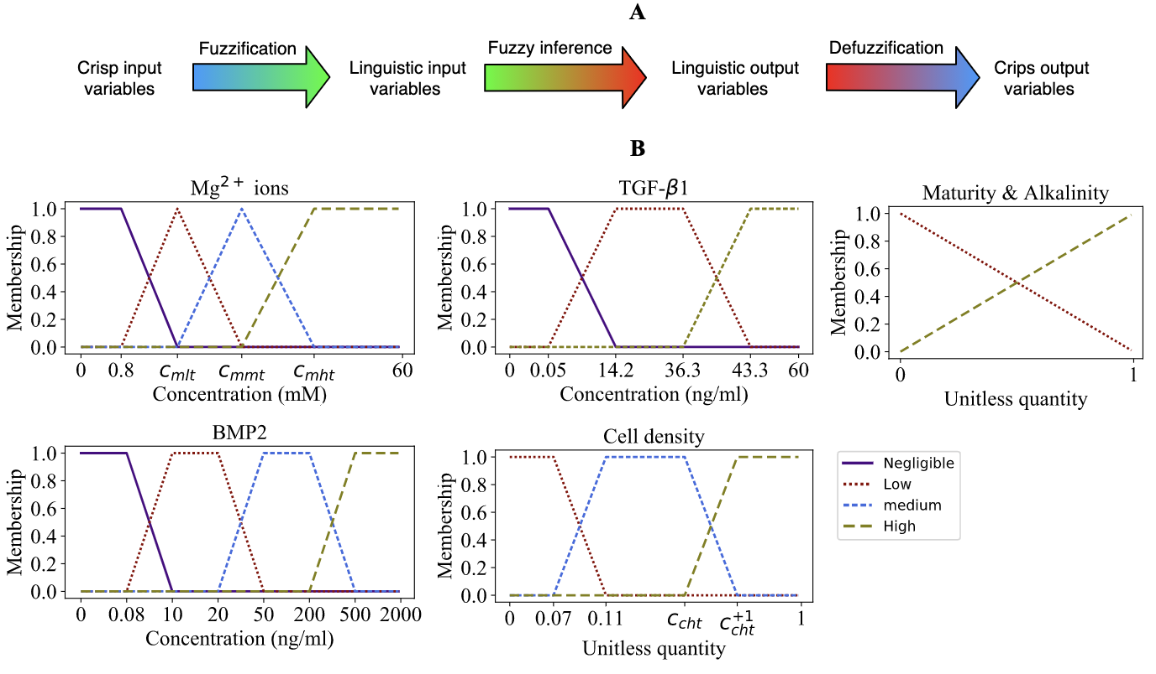

Figure : (A) the main three steps of the fuzzy-logic controller to receive cellular inputs and calculate the outputs. (B) Membership functions for the cellular input variables. The parameters, which are visible on the x-axes, are the free parameters defined during the fuzzification process.

### Fuzzification

The process of fuzzification converts the crisp values of the cellular inputs to the linguistic variables. In this section, each cellular input is defined according to the available knowledge and fuzzified.

**Mg2+****ions** are shown to regulate cellular responses depending on the applied concentration, exposure duration, and the state of cell differentiation [4], [12], [36], [37]. Mg2+ ions within the concentration range of 2-10 mM enhance cell metabolism and upregulate proliferation and early differentiation rate [4], [36], [38]–[40]. However, Mg2+ ions above 1.8 mM have shown an inhibitory effect on late differentiation rate and matrix mineralization [39] [41]. Also, Mg2+ ions at concentrations ranging from 20 to 40 mM is reported toxic and can reduce cell viability [39], [42], [43]. Four membership levels of ***negligible*, *low*, *medium*, and *high* are assigned to fuzzify the factor** Mg2+ **ions shown** in Figure 2-B. **The concentration of** 0.8 mM that is used in cell culture medium (minimal essential Medium-MEM) is assumed to mark the beginning of the *low* membership [12], [40]. **Three free parameters of , , and are defined to represent the peak occurrence of the *low*, *medium*, and *high* memberships, respectively. These parameters are estimated within 2-10, 10-20, and 20-40 mM, respectively.**

**Alkalinity** is defined as the sudden change of the ambient pH with respect to the intracellular pH. Mg2+ ions are reported to alter microenvironmental pH in a concentration-dependent fashion (see Figure S1-A in the supplements). MSCs are shown to recover from alkalinity caused by the Mg2+ ions concentration of 25 mM in the span of three weeks [12]. To account for this observation, we assume a constant pH adjustment (internal to ambient) rate of 0.002 per hour. Alkalinity can significantly affect cellular reaction depending on the severity and exposure time [14]. Several minutes of exposure to severe alkalinity is reported to cause cell contraction and detachment from the culture surface [15]. Severe alkalinity can compromise human MSC renewal capability and growth and thereby downregulate proliferation rate [13]. High alkalinity also reduces cell viability in culture experiments [13]. However, a mild alkaline environment with a pH as high as 8.5 has shown no significant negative effect on osteoblast differentiation [13]. We assume a linear effect of alkalinity on the cellular behavior and assign two levels of *low* and *high* to fuzzify this factor as shown in Figure 2-B.

**TGF-β1** is an important regulatory factor in every stage of bone regeneration [17][44][45]. Within the physiological concentration of 14.2-36.3 ng/mL, TGF-β1 is shown to stimulate the proliferation process, promote early osteoblast differentiation, and inhibit the later phase of differentiation [44][45]. Within the physiological range, TGF-β1 is also shown to block the natural process of apoptosis [46]. Three linguistic terms of *negligible*, *low*, and *high* are used to fuzzify TGF-β1 as a signaling factor as depicted in Figure 2-B. The concentration of 0.05 ng/ml is assumed to mark the beginning of the low membership [47] [48]. The *high* level is assigned to the range of 43.3 to 60 ng/ml [49]**.**

**BMP2** is the most potent BMP heterodimers in the stimulation of osteoblast differentiation [45][50][51]. BMP2 is shown to affect cell proliferation in a concentration-dependent fashion; while BMP2 at the concentration of 10-20 ng/ml promotes cell proliferation [52] [53], it has shown no effect and a negative effect respectively within the concentration ranges of 50-200 ng/ml and 500-2000 ng/ml, respectively [54][55]. BMP2 at the concentration of 10-20 ng/ml has also shown a stimulatory impact on osteogenic differentiation [52][53]. BMP2 at the concentration of 500-2000 ng/ml stimulates cell apoptosis and thereby decreases cell viability [54]. We assign four levels of ***negligible*, *low*, *medium*, and *high* for BMP2 as shown in** Figure 2-B**. We assume 0.08 ng/ml to mark the start of the *low* membership. This concentration represents the minimum value reported in *in vitro* experiments** [56]–[58].

**Cell density** is calculated as the normalized number of cells in one patch neighborhood. Cell density is another important factor that is known to affect various cellular reactions such as migration, proliferation, differentiation, and mortality [59]. High cell density results in a phenomenon termed contact inhibition that halts cell growth and initiates the differentiation process [60], [61]. Contact inhibition also affects cell migration as cells intend to move toward an area with less crowdedness to receive better nutrition and oxygen [62]. A high degree of crowdedness is also reported to be detrimental for cell nuclei health and can increase cell mortality [63]. Cells are also shown to be less proliferative and show lower viability in low cell density [64], [65]. Since there is no quantitative information available to mark the boundaries of the membership functions, we assume a minimum of two neighbors for cells to survive solitude, similar to [66]. Accordingly, the cell density of 0.07 is assumed to mark the beginning of the *medium* membership. A free parameter of marks the start of *high* membership that is assigned within the range of 0.7-1. For the case of ccht < 1, the *high* membership reaches 1 by the presence of one more neighbor cell which is denoted as .

**Maturity** is defined to represent the degree of maturation of MSCs along the line of osteoblast lineage (see Figure S1-C in the supplements). The free parameter of , estimated within 0.5-1, is defined to mark the early differentiation phase. Maturity increases by cell commitment to the differentiation process at each time step of the simulation. During this process, cells lose their characteristics as MSCs and obtain osteoblastic characteristics. More specifically, in the current model, the proliferative capacity of cells declines, and differentiation-related markers experience an increase. Two linguistic levels of *low* and *high* are defined for maturity as shown in Figure 2-B.

**Damage** simulates the permanent effect of high alkalinity. While cells generally show an ability to recover from an alkaline environment, long exposure to a high pH can result in permanent damage and failure in recovery [14]. Empirical observations suggest that the severity of an alkaline environment together with the exposure time can determine the degree of cell damage [14]; at a pH above 8.5, an exposure for more than 10 to 15 minutes suffices to cause cell detachment from the culture plate, while it takes 45 minutes for a pH value of 8.2 to produce a similar effect [14]. Since the simulation step is 1 hour in this study, we assume that the exposure to a threshold pH () for one simulation step can cause permanent damage. is defined as a free parameter within 8.5 to 9.5 [14]. During fuzzification, the *damage* is defined as a crisp quantity holding a value of either 0 or 1.

### Fuzzy inference and defuzzification

Once the cellular inputs are converted into linguistic variables, the set of rules given in Table 1 is used to determine the intensity of actions that cells produce. The five linguistic terms of *very low*, *low*, *medium*, *high*, and *very high* are defined to describe proliferation, differentiation, and mortality, while two levels of *low* and *high* were assigned for the migration function. Since a set of inputs can trigger multiple fuzzy rules in different intensities, the weighted fuzzy mean technique is used to combine the outputs of fuzzy sets as a single crisp output [34].

Table : Fuzzy logic rules describing the cellular reactions in response to stimulatory signals. To be concise, the combination of different inputs that results in the same output is coded in certain colors; blue: any choice of three or more from the given inputs, red: any choice of two or more from the given inputs; green: any choice of one or more from the given inputs. The symbol (-) indicates any of the linguistic levels defined for that variable. If the rule applies for all except a certain level, it is described as ~ followed by the linguistic level, e.g. ‘~L’ stands for all levels except *low*. N (*negligible*), L (*low*), M (*medium*), H (*high*).

|  |  |  |  |  |  |  |  |  |
| --- | --- | --- | --- | --- | --- | --- | --- | --- |
| Process | Intensity | Intrinsic signals | | Extrinsic signals | | | | |
| Damage | Maturity | Alkalinity | Cell density | Mg2+ ions | TGF-β1 | BMP2 |
| Proliferation | *very low* | H | - | H | H | - | - | - |
| *low* | L | H | L | ~H | ~L | ~L | ~L |
| *medium* | L | L | L | ~H | ~L | ~L | ~L |
| *high* | L | L | L | ~H | L | L | L |
| *very high* | L | L | L | ~H | L | L | L |
| Early differentiation | *very low* | H | - | - | - | - | - | - |
| *low* | L | - | - | H | L | L | L |
| *medium* | L | - | - | H | L | L | L |
| *high* | L | - | - | H | L | L | L |
| *very high* | L | - | - | H | L | L | L |
| Late differentiation | *very low* | H | - | - | - | - | - | - |
| *low* | L | - | - | L | ~L | ~L | L |
| *medium* | L | - | - | L | ~L | ~L | L |
| *high* | L | - | - | H | ~L | ~L | L |
| *very high* | L | - | - | H | ~L | ~L | L |
| Mortality | *very low* | L | - | L | ~H | ~H | ~N | ~H |
| *low* | L | - | L | H | H | N | H |
| *medium* | L | - | L | H | H | N | H |
| *high* | L | - | L | H | H | N | H |
| *very high* | H | - | H | - | - | - | - |
| Migration | *low* | H | - | - | ~H | - | - | - |
| *high* | ~H | - | - | H | - | - | - |

### Cellular processing

The controller’s outputs for proliferation, differentiation, mortality, and migration are , , , and , respectively, all outputted in the standardized format of within 0-1. We use these values to determine the mitosis chance (), the differentiation rate (), the mortality chance (), and the migration chance (), respectively, at each time step of the simulation,

|  |  |
| --- | --- |
|  | () |
|  | () |
|  | () |
|  | () |

where , , and are the base values of each action. is set to 0.0014/hour considering that the full differentiation process takes one month [27]. and are defined as free parameters; is set to the range of 0.021-0.083 /hour which corresponds to the mitosis time of 24-72 hours [67]; is set to 0.0001-0.001 /hour which is estimated by considering 50-100% for viability [68] [38]. In Eq.(2)-(4), , , and serve to scale up the fuzzy outputs as they are originally given within 0-1. , , and are set as free parameters estimated within the range of 1-20. In Eq.(4), two factors of the mitotic damage () and culture damage () contribute to cell mortality in addition to those included in the fuzzy output. It is shown that shortly after proliferation, one of the daughter cells is prone to undergo apoptosis mainly due to asymmetric distribution of pro- and anti-apoptotic proteins during the final stage of cell division [69]. We account for this observation by assigning ( if mitosis occurs, and otherwise) to one of the daughter cells after the cell cycle. Also, passaging cell lines is known to stress cells due to the chemical detachment and mechanical forces []. takes into this damage and is only applied once at the beginning of the simulation. The two free parameters of and are defined to take into account their weights in the accumulated mortality chance and are estimated within 0-10 and 0-100, respectively. In Eq.(2), is a logistic-based bias function to shift the probability distribution toward the end of the cycle and is defined,

|  |  |
| --- | --- |
|  | () |

where is the normalized embedded clock within each cell (see Figure S1-B in the supplements). The clock resets after the cell cycle. The normalization is done by taking into account .

Migration in the present model occurs due to contact inhibition [70]. The chance of migration () at each time step that is calculated in Eq.(5) was checked against a random number ranging 0 and 1 to determine whether relocation occurs.The choice of destination can be arbitrary as long as an adjacent grid is vacant. The motile cell can move one patch at a time step. If all neighboring grids are occupied, no relocation will take place.

## Growth factor model

BMP2 and TGF-β1 are simulated as diffusible proteins whose concentrations are assumed to undergo spatial and temporal variations due to diffusion, production, and degradation,

|  |  |
| --- | --- |
|  | () |

Where b, t are the abbreviations for BMP2 and *TGF-β1,* respectively, Di is the diffusion coefficient, pi is the production rate, cc is the local cell density, and is the degradation rate. The diffusion of the growth factors is modeled as a standard diffusion function where the is set to 0.36 mm2 h-1 for BMP2 [71] and is estimated as 0.094 mm2 h-1 for TGF-β1 considering the molecular weight of 25 kDa [72]. pi defined as,

|  |  |
| --- | --- |
|  | () |

increases with an increase in the average maturity of the cells (). This assumes that osteoblasts are more productive than MSCs []. Eq. (8) takes into account the saturation effect where Hi is set to 100 ng/ml for both TGF-β1 and BMP2 similar to [73]. ri0 as the base production rate is defined as free parameters of rb0 and rt0 respectively for BMP2 and TGF-β1. rb0 is estimated within 0.0005-0.005 ng/ml/h to keep BMP2 density in the range of 0.08-0.5 ng/ml according to in-vitro measurements [56], [74]. Rt0 is estimated within 0.001-0.1 ng/ml/h to keep TGF-β1 concentration in the physiological range of 14.2-36.3 ng/mL [44].

In Eq. (8), the growth factors degrade with the rate,

|  |  |
| --- | --- |
|  | () |

where is the half-life rate calculated as [75], in which is the half-life of the soluble and is set to 10.08 hours and 10 mins for BMP2 and TGF-β1, respectively [75] [73]. The described partial differential equation is solved at each time step of the simulation by receiving the initial density of the growth factors within the patches of the agent-based model. A step of 0.05 hours is used for time marching. FiPy [76] is used for the implementation of the growth factor model.

## Empirical data

The data obtained from three sets of cell culture experiments summarized in Table 2 are used to evaluate the current computer model. Study 1 examines the effect of five different Mg2+ ions concentrations on cell population by measuring two parameters of live cell count and viability [77]. Study 2 focuses on the osteogenic differentiation process by measuring the expression of a wide range of genes and proteins as biomarkers for differentiation at three time points of 7, 14, and 21 days as a response to two different concentrations of Mg2+ ions [40]. Study 3 reports live cell count at three time points of 3, 6, and 9 days for four different Mg2+ ions concentrations [78], [79]. The combined data provided 33 experimental measurements and 72 data points. All experiments were conducted with human umbilical cord perivascular (HUCPV) cells. In principle, the HUCPV cells of a continuous culture (passage three to five) were grown in α Minimal Essential Medium (MEM) with 15% stem cell Fetal Bovine Serum (scFBS) under cell culture conditions at 37°C, 5% CO2 and humidified atmosphere. The medium was changed every two to three days.

Table : The summary of the specifications of the cell culture experiments.

|  |  |  |  |  |  |  |  |
| --- | --- | --- | --- | --- | --- | --- | --- |
| Study | Mg2+ ions (mM) | Cultured cells  (103) | Initial confluence (%) | Culture surface (cm2) | Measurement time points (day) | Measurements | Ref. |
| 1 | 0.80,  3.04,  6.08,  12.16,  60.80 | 10 | 20 | 3.65 | 1, 2, 3 | live cell count, viability | [77] |
| 2 | 0.80  5.60 | 50 | 85 | 9.60 | 7, 14, 21 | DNA, alkaline phosphate, osteocalcin, BMP2, TGF-β1 | [40] |
| 3 | 0.80,  3.60,  7.20,  14.40 | 5 | 15 | 1.90 | 3, 6, 9 | live cell count | [78], [79] |

The scheme shown in Figure 3 is used to compare the simulation results to the empirical data. The viability reports the percentage of live cell count to the total cell count and is used to evaluate the mortality simulated in the current model. DNA content linearly correlates with the live cell count by taking into account the cell weight () which is defined as a free parameter in the range of 0.01-1 ng [80]. ALP and OC are reported as the normalized values against DNA content [40]. Therefore, these parameters linearly correlate with the maturity which is a normalized indicator of differentiation in our simulations. ALP is generally considered as an early differentiation marker. Thus, we assume that ALP increases with maturity (M) until the early differentiation threshold () and then stays constant afterward,

|  |  |
| --- | --- |
|  | () |

where is the correction coefficient set as a free parameter. For the case of OC, the linear relationship is continuous in the whole range of with a coefficient of . and are both estimated within 0.5-1. The quantities of TGF-β1 and BMP2 are reported as the normalized values against the housekeeping genes across all experiments [40]. Therefore, we normalize the simulated quantities of TGF-β1 and BMP2 with respect to the live cell count and assume a linear relationship between these quantities and the empirically measured counterparts with the coefficients and , respectively. These coefficients are estimated within 0.001-0.1.

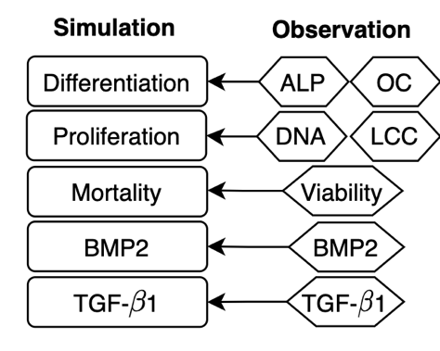

Figure : The summary statistic comparing the simulation outputs with the empirical measurements given in Table 2. ALP: alkaline phosphate; OC: osteocalcin; LCC: live cell count.

## Calibration process

The current model contains 20 free parameters (see Table S1 in the supplements). The empirical data to determine the values of these parameters are limited as they are either difficult to measure or represent a combination of several processes. Instead, we use a range of possible values based on empirical observations or estimations and then use the calibration process using the summary statistics to estimate their values. The approximate Bayesian calculation (ABC) is employed for parameter inference [81] (see section S1 in the supplement). However, due to the curse of dimensionality, sampling in a 20-dimensional space requires a very large number of runs, i.e. in the order of several million, which is impractical considering the size of the current model. To overcome this, we employ an iterative calibration process depicted in Figure 4 that follows three main steps of (1) determining the five most important parameters using the sensitivity analysis (see section S2 in the supplement), (2) estimating the values of the chosen parameters using ABC, and (3) updating the model with the inferred values and repeating step 1 and 2. We use fractional factorial design and analysis of variance for the sensitivity analysis (see also section S1 in the supplement). The iterative calibration process ends once no new parameter is inferred at the previous iteration. The calibration process was conducted separately on each dataset, encoded as C1, C2, and C3, as well as on the combined data of all experiments, encoded as C1-3.

Each simulation result is a vector of summary statistics () that needs to be evaluated against the corresponding empirical data (). The following goodness of fit (R2) is used to evaluate the simulations results with reference to the observation,

|  |  |
| --- | --- |
|  | () |

which prevents one measurement factor to dominate another by having factor in the denominator. We execute the model 5000 times and choose the top 100 model runs that produce the best fit. This method is known as the rejection algorithm which is the most fundamental ABC method in sampling from the posterior distribution (Beaumont, 2018). The obtained posterior distributions were used for the value inference. Levene’s test was used to examine whether the marginal posteriors are significantly narrower than priors [81].

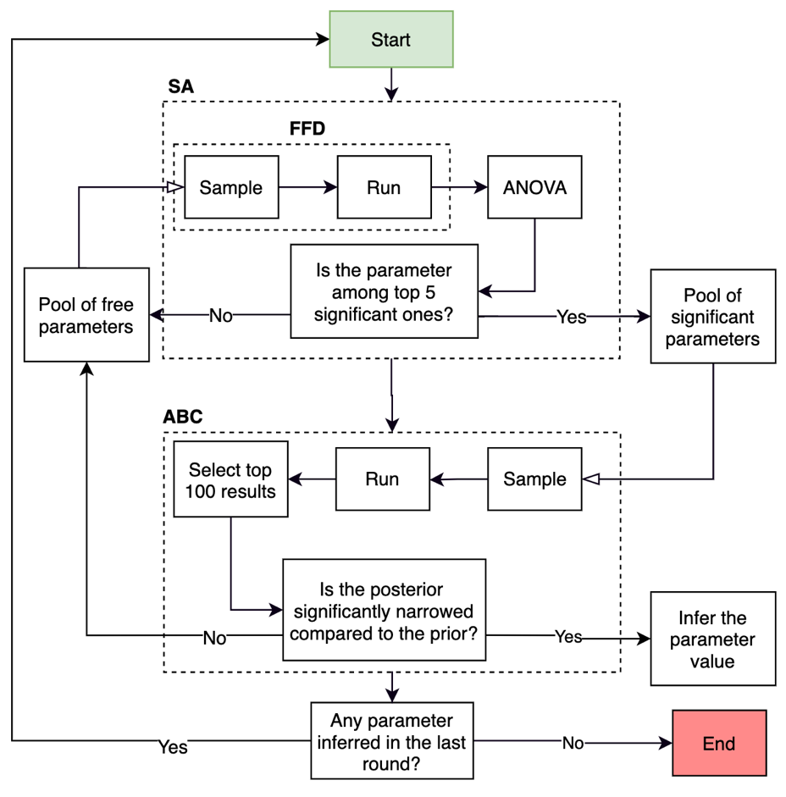

Figure : The iterative calibration process used for the parameter estimation in this study. At each iteration, the top five significant parameters are determined by the sensitivity analysis that consists of the fractional factorial design (FFD) and the analysis of variance (ANOVA). The significant parameters are sent to ABC for the parameter inference. At each iteration, the model is executed 5000 times with the parameter sets sampled from the pool of significant parameters. The posteriors are generated using the top 100 results. If the posterior is significantly narrower than the prior, the median of the posterior is accepted as the estimated value. If not, the parameter is added to the pool of the free parameters for the next round of calibration.

# Results

## Calibration process

The results of the iterative calibration process are given in Figure 5. It took 5, 8, 5, and 8 iterations for C1, C2, C3, and C1-3, respectively, to complete the calibration process. The parameters that appeared in the early iterations had a higher impact on the model’s predictions. However, the order of their appearance varied from one study to another (see Figure 5). The proliferation-related parameters (base proliferation chance) and (the weight of the fuzzy output on the proliferation chance) had the highest impact for C1 and C3. For C2, the top two impactful parameters were the (cellular weight) and (the weight of the fuzzy output on the differentiation rate). For C1-3, the top two significant parameters were and , similar to C1 and C3, and the second two important parameters were and , similar to C2.

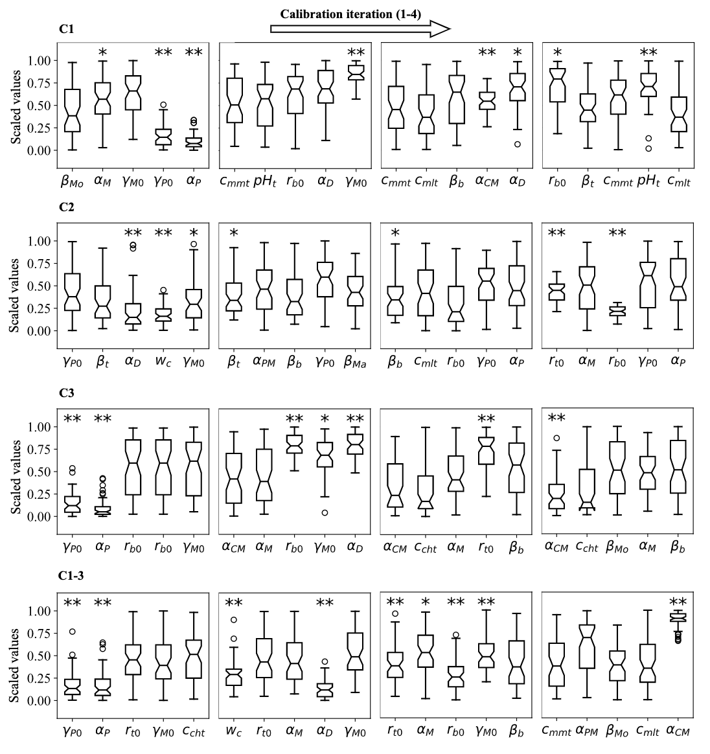

Figure : Posterior distributions of the parameter values estimated during different calibration scenarios of C1, C2, C3, and C1-3. The values are scaled by dividing by the range of the priors. The results of the consecutive runs are listed from left to right. Only the results of the first four iterations are shown here due to space limitation. The complete set of results are given in Figure S2 in the supplements. The significance in narrowing is marked by * for and ** for . Boxes show 1st and 3rd quartiles. Whiskers mark the limits of 1.5 × interquartile range. Hedges indicate medians.

The iterative calibration process resulted in the estimation of 8 out of 20 free parameters for C1, 15 for C2, 7 for C3, and 15 for C1-3. The estimated values obtained from different calibration scenarios are given in a scaled format in Figure 6. The real values are presented in Table S2 in the supplement. No values were inferred for the parameters of and , and several parameters were only inferred in certain calibration scenarios (Figure 6). There was a large variation among the estimated values of certain parameters during different calibration scenarios. Among them were and , connected to proliferation process, and , associated with mortality, and , related to differentiation process (see Eq. (2)-(5)).

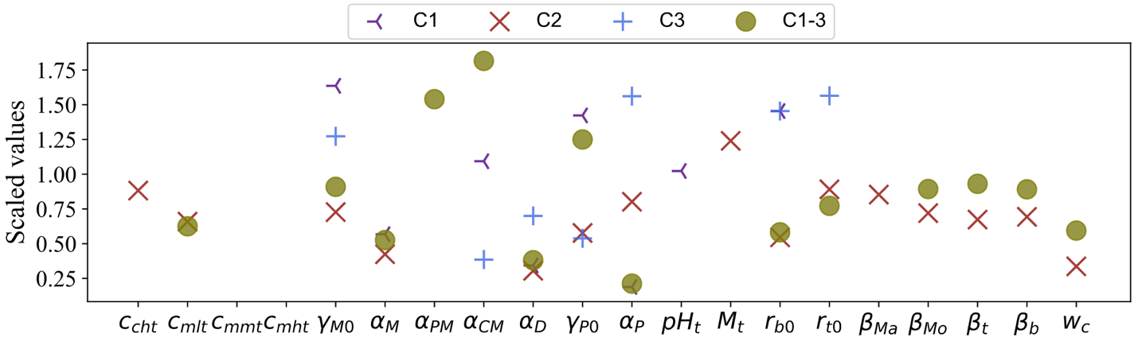

Figure : The comparative representation of the values estimated for the free parameters during different calibration scenarios. The values were scaled by dividing by the mean of the priors.

## The goodness of fit ()

The evolution of the in terms of the mean and standard deviation obtained from the 100 best results during the iterative calibration process are plotted in Figure 7. The standard deviation indicates the extent of the variations in the mean caused by the uncalibrated parameters. The mean and standard deviation respectively increased and decreased 4% and 5% for C1, 6% and 46% for study 2, 7% and 29% for C3, and 9% and 31% for C1-3 during the iteration process. The improvements made in the first five iterations account for 83% and 93% of the total improvements on the mean and standard deviation, respectively, during C2 and 89% and 96%, respectively, during C1-3.

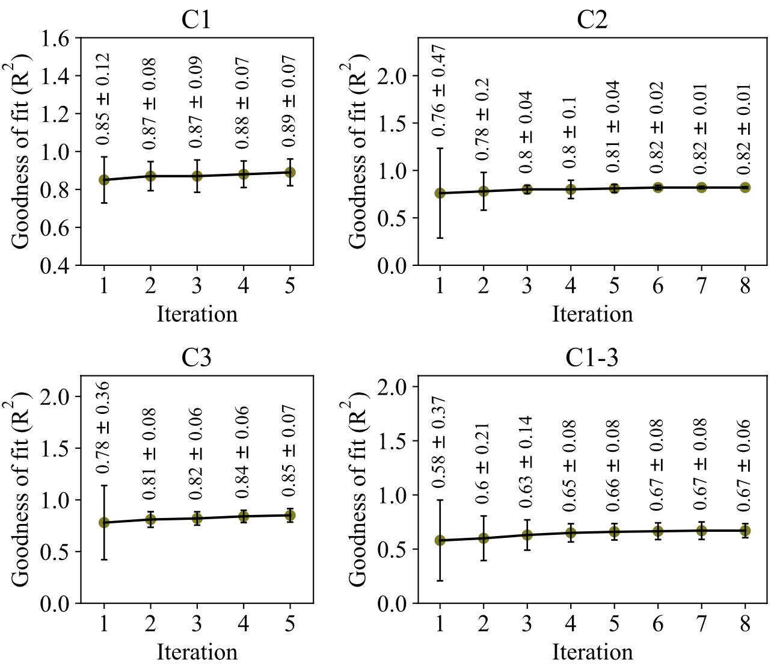

Figure : The evolution of the mean and standard deviation of the goodness of fit obtained from the 100 best results during different calibration scenarios.

## The model’s predictions

The agent-based model parametrized with the values accepted by ABC were compared against the empirical data as demonstrated in Figure 8-11. The fits of the model to the data of each study given in Table 2 are given in separate sections in the following.

### Study 1

The fits of the model to the data of study 1 are given in Figure 8. The model calibrated by C1-3 produced the of 0.87 and 0.72 for the live cell count and viability, respectively. Overall, Mg2+ ions at the concentration of 3 mM resulted in the highest cell population followed by 6 mM, 0.8 mM (control), 12 mM, and 60 mM, which was correctly explained by the model. For the case of viability, the model closely reproduced the culture data given for Mg2+ ions concentration of 60 mM but overestimated the rest. Once calibrated against C1, the model’s predictions for the viability were considerably improved, i.e. increased from 0.72 to 0.91. The model was able to closely match the culture data for all Mg2+ ions. The simulation outcomes showed little change in the case of the live cell count comparing C1 to C1-3.

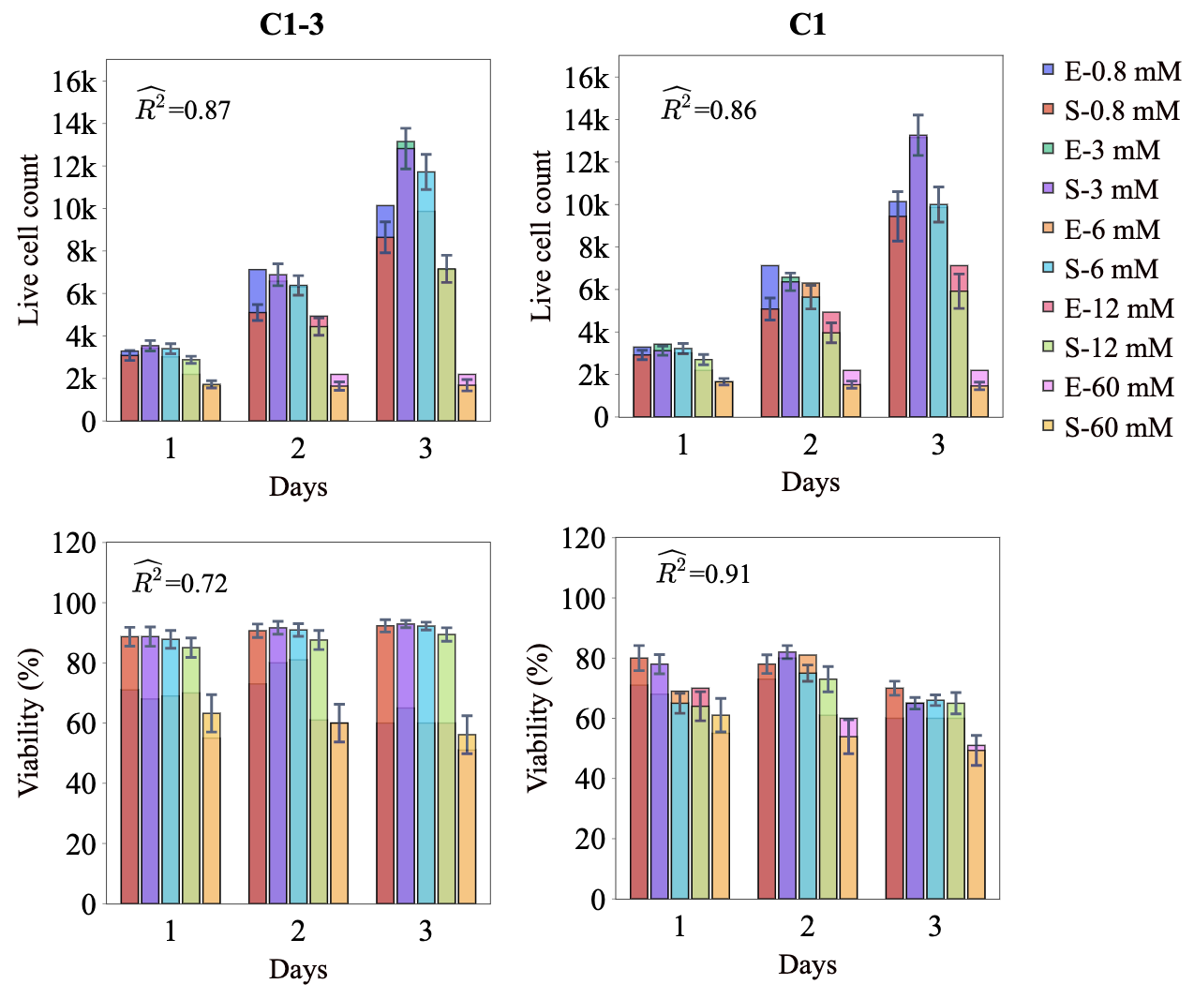

Figure : Fits of the model calibrated by C1-3 and C1 to the empirical data of study 1. Bars indicate the average of the best 100 simulations (S-) and the corresponding empirical data (E-) for increasing Mg2+ ion concentrations. The error bars belong to the simulation results and indicate the standard deviation of the 100 best fits. is the average calculated for each measurement item.

### Study 2

The fits of the model to the data of study 2 are given in Figure 9 and Figure 10. The model calibrated by C1-3 resulted in an average of 0.72 for DNA content (see Figure 9). The model was able to capture the decreasing trend of the DNA content in the course of experiments from day 7 to 21. The model was also in agreement with the culture data in terms of predicting higher DNA contents for the Mg2+ ions concentration of 5 mM compared to the control. However, there was an overall overestimation in the predictions made on the day 7 and 14 for both causes. Once calibrated by C2, the improved from 0.72 to 0.91, and the model’s predictions closely matched the culture data in terms of trends and exact values (see Figure 9).

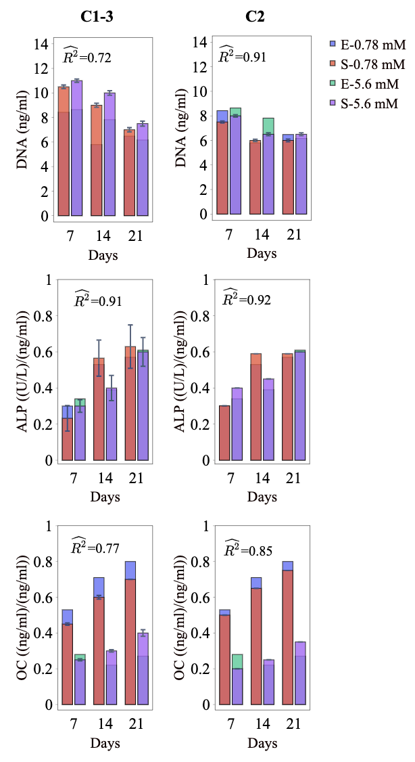

Figure : Fits of the model calibrated by C1-3 and C2 to the empirical data of study 2. Bars indicate the average of the best 100 simulations (S-) and the corresponding empirical data (E-) for different Mg concentrations. The error bars belong to the simulation results and indicate the standard deviation of the 100 best fits. is the average calculated for each measurement item.

For the case of ALP and OC, the model calibrated by C1-3 resulted in average of 0.91, and 0.77, respectively (see Figure 9). The culture experiments reported higher ALP for the Mg2+ ions concentration of 5 mM on day 7 and lower on day 14 compared to the control, which was correctly captured by the model. The OC content was reported lower for the Mg2+ ions concentration of 5 mM compared to the control in all three time points, which was also captured by the model (see Figure 9). However, the model predicted an increase in OC content from day 7 to 21 which was not in close agreement with the data. Also, the model underestimated the OC content reported for the control in all three measurement points. Once calibrated by C2, the predictions of the model for the OC content were closer to the experimental data with 8% improvements in the (see Figure 9).

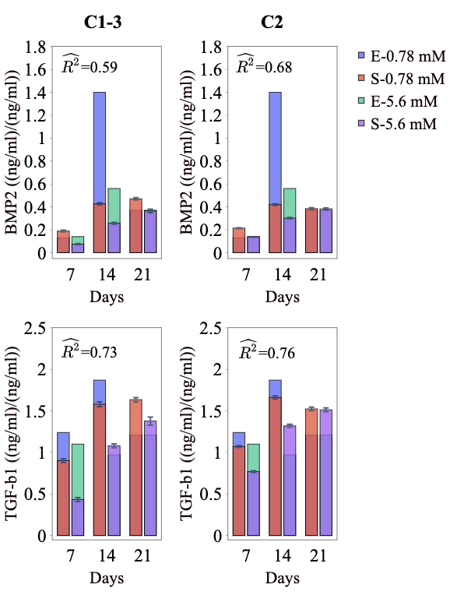

Figure : Fits of the model calibrated by C1-3 and C2 to the empirical data of study 2. Bars indicate the average of the best 100 simulations (S-) and the corresponding empirical data (E-) for different Mg concentrations. The error bars belong to the simulation results and indicate the standard deviation of the 100 best fits. is the average calculated for each measurement item.

The model calibrated by C1-3 produced the average of 0.73 and 0.59 for the growth factors of TGF-β1 and BMP2, respectively (see Figure 10). For both TGF-β1 and BMP2, the cell culture data reported lower values for the condition of 5 mM Mg compared to the control in all three time points, which was also captured by the model. However, the non-linearity shown in the data, in particular the sharp jump on day 14 of BMP2, was not seen in the model. Once calibrated by C2, the obtained average increased from 0.73 to 0.76 for TGF-β1 and from 0.59 to 0.68 for BMP2. However, the model was still not in a close match with the culture data.

### Study 3

The fits of the model to the data of study 3 are given in Figure 11. The model calibrated by C1-3 correctly reproduced the trend observed in the cell culture; the live cell count experienced a continuous increase from day 3 to day 9 for all Mg2+ concentrations; and the highest live cell count resulted infor 3 mM and the lowest was obtained for 14 mM. The model disagreed with the data in two aspects; firstly, there was a general overestimation in the predictions of the model especially for the case of the Mg2+ concentration of 14 mM; and secondly, the culture data reported large variations across different Mg concentrations, in particular on day 6 and 9, while the model’s predictions for different Mg2+ ions were close to one another. Once calibrated by C3, there was a substantial increase in the , i.e. from 0.48 to 0.85 (see Figure 11). The results of the predictions were in a close agreement with the culture data both in terms of trend and the exact values.

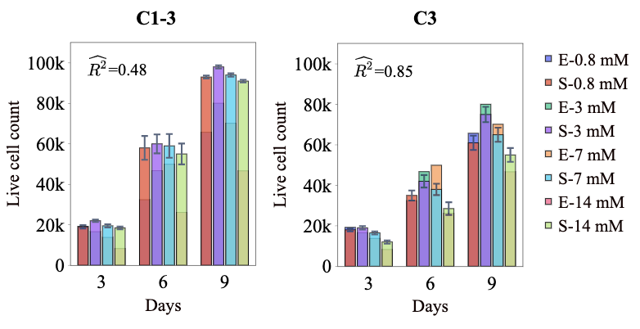

Figure : Fits of the model calibrated by C1-3 and C3 to the empirical data of study 3. Bars indicate the average of the best 100 simulations (S-) and the corresponding empirical data (E-) for different Mg concentrations. The error bars belong to the simulation results and indicate the standard deviation of the 100 best fits. is the average calculated for each measurement item.

# Discussion

The fuzzy agent-based model developed in the present study was initially calibrated using the entire data given in Table 2. The model was capable of successfully reproducing several empirical observations, more notably, the live cell count reported in study 1 and the differentiation-related markers of ALP and OC. The results of the simulation, consistent with the experiments, showed that Mg2+ ions within the range 3-6 mM results in the largest cell hMSC population (see Figure 8 and Figure 11). Also, the model correctly reproduced the culture data in showing that while Mg2+ ions stimulates early differentiation, it inhibits the differentiation in the later phase (see Figure 9).

However, there was an overall discrepancy between the model’s predictions and the data for the case of viability, the DNA content, the live cell count reported in study 3, and the growth factors (see section ‎3.3). To investigate whether such disagreement originated from the inherent inability of the model in capturing the complexity of the experiments or from a possible discrepancy among the given empirical data, we conducted the second round of calibration in which the model was tuned against the culture data given for each model separately (C1, C2, and C3). The results showed a significant improvement in the model’s accuracy in explaining the population-related data of DNA content, live cell count, and viability data (see section ‎3.3). To better understand the underlying differences between the models calibrated by different sets of data, their estimated parameter values were plotted against one another (see Figure 6). The observed variation in the estimated values primarily originates from the exploration of ABC in finding the global minimum based on the target measurements. However, there were meaningful patterns associated with certain parameters. It was shown that the base proliferation rate () was estimated similarly between C1 and C1-3, whereas C2 and C3 produced a notably smaller value. A similar pattern was also verified between the predictions of the models in terms of the live cell count and DNA content; the results of the live cell count predicted for study 1 were similar between C1 and C1-3 (see Figure 8), while the results of the DNA content predicted for the study 2 and live-cell count predicted for the study 3 were overall higher for C1-3 compared to C2 and C3 (see Figure 9 and Figure 11). This suggests that the cells experimented in studies 2 and 3 were less proliferative compared to study 1. Considering that all experiments used similar a cell type (HUCPV) within the passage number 3 and 5, such discrepancy might step from the differences in the cell donors [].

A similar conclusion can be drawn by evaluating the variations between the estimated values for (see Figure 6). This parameter controls the rate of differentiation from MSC to osteoblast (see Eq. (3)). In study 2 that reports the differentiation markers of DNA and OC, was primarily tuned to maximize the model’s prediction with respect to these markers. However, for studies 1 and 3, which lack differentiation-related measurements, serves as another mechanism to regulate the proliferation of cells; a higher value of encourages a fast conversion of MSCs to osteoblasts and therefore reduces the proliferation capacity of cells as osteoblasts are assumed less proliferative than MSCs. It can be seen that was estimated lower in C1 compared to C2 (see Figure 6), indicating that the model calibrated with the data of study 1 tends to hinder cell differentiation in order to produce a higher population. This is in agreement with the previous conclusion indicating a higher proliferation rate of cells cultured in study 1 compared to study 2.

Another proliferation-associated parameter whose value showed a high variation across different calibration schemes was (see Figure 6). This parameter simulates the model’s sensitivity to the stimuli related to the proliferation process including Mg2+ ions (see Eq. (2)). Both C2 and C3 estimated a higher value for compared to C1-3 and C1 (see Figure 6). Simultaneously, the model calibrated by C2 and C3 produced a higher contrast across different Mg concentrations in terms of live cell count and DNA contents (see section ‎3.3). Hence, it can be understood that the cells cultured in study 1 were fundamentally more sensitive to Mg2+ ions compared to the study 1 and 2.

Studies 2 and 3 lacked the quantitative measurements of cell viability (see Table 2). Instead, a minimum threshold of 50% is used according to similar experiments [4], [37], [41], [68], in order to prevent the calibration process from producing an overall high fitness value at the cost of an unrealistic cellular mortality rate. To satisfy this condition, C1-3 failed to closely reproduce the viability values given in study 1 (see Figure 8). This implies that no parameter set could simultaneously satisfy the minimum viability assumed for studies 2 and 3 and the measured value in study 1. The predictions of C1-3 for mortality were higher than given data (see Figure 8), implying a higher mortality rate of cells experimented in study 1 compared to studies 2 and 3. According to this observation, either the cells cultured in the different studies had fundamental differences in their mortality rate or Eq. (4) was inadequate in incorporating all essential factors that affect cell mortality. Considering that the duration of study 1 was three days, a higher mortality rate in the early days of culture compared to the later days can justify the observed differences. According to Eq. (4), the factor of the culture damage (δC) contributes to early cellular mortality. However, assigning a large weighting factor for this process (αC) contributes to a sudden diminishing of live cells and subsequently leaving the remaining cells in solitude. Cells in isolation experience a high mortality rate (see section ‎2.2.1) which leads to further shrinkage in the cell population. Therefore, there might be another factor that gradually contributes to cellular mortality in the early days of cell culture which is not included in our simulations.

The experimental cell culture data shows that the content of the growth factors increases from day 7 to 14 and decreases from day 14 to 21. Given the fact that the reported contents for the growth factors were normalized against DNA, the given jump on day 14 can indicate that cells were more productive within the first period of the experiment. On the other hand, the cells were not fully differentiated before day 21, according to the results of the differentiation markers (see Figure 9). This implies that the cells produced a higher amount of growth factors within their early differentiation phase compared to the later stage. In our formulations, we assumed a maturity-dependent production rate for cells as shown in Eq. (8). The results of our simulations produced a continuous growth in the predicted contents for BMP2 and TGF-β1 throughout the experiment (see Figure 10) as the maturity increases during the experiment. Consequently, the simulation results were not in close agreement with the data. Further investigations are required to elucidate the relationship between the cellular activity regarding growth factors production and the degree of osteogenic differentiation.

An iterative process was used to calibrate the model’s free parameters (see Figure 4). In the proposed scheme, the iterative calibration process continued until no significant narrowing occurred. Overall, the performance of the model in terms of the mean and standard deviation of was considerably improved in the course of the iteration (see Figure 7). The standard deviation, which indicates the uncertainty in the predictions of the model, dropped to a negligible value at the end of the iterative process (see Figure 7). The remaining variations can stem from the stochastic nature of the agent-based modeling. The results also showed that the first few iterations can account for a large portion of the total improvements; for C1 and C2, the first five iterations accounted for over 90 percent of the total improvements (see section ‎3.2). Therefore, the calibration scheme proposed in this study can be further improved in the future by adding the alteration in the mean and standard deviation of as another factor to control the iteration number.

In this study, the fractional factorial design combined with the analysis of variance was used for the sensitivity analysis, similar to [83][84]. We used the resolution of V for the design of the experiment which is capable of extracting the main effects non-confounded with higher degree interactions [83][85]. Resolutions higher than V are known to be unnecessary as in practice high-order interactions rarely occur [83][85]. The importance of parameters with respect to one another was determined using the analysis of variance. Although this approach correctly evaluates the relative importance of the parameters, the results can heavily depend on the initial ranges defined for the priors. In addition, the results of the sensitivity analysis can also be influenced by the given calibration data; the parameters that are more closely involved with measurement items are identified as more important. For instance, in our simulations, the sensitivity analysis was conducted on study 3 (C3) which contains only live cell count, two proliferation-related parameters of and were identified as the top important parameters. Once the model was evaluated against study 1 (C1), containing the viability data in addition to the live cell count, the mortality-related parameters of and were also detected among the influential parameters (see Figure 5). By the assessment of the model against the data of study 2 (C2), which provides a broader range of measurements, the parameters involved in more diverse processes such as differentiation () and growth factor production ( and ) were turned out to be important. Therefore, the results of the sensitivity analysis can only be interpreted considering the given priors as well as the summary statistics.

The present study has several limitations. In the implemented cell model, each simulated cellular reaction was dependent on several intrinsic and extrinsic factors. The available knowledge in the literature regarding the bioregulatory effect of individual cellular input was collected and tailored as fuzzy inputs. However, there was not sufficient knowledge to define the logic of interaction among the stimulatory factors [86]. Therefore, the principle of superimposition was used to combine the effects for different cellular inputs (see Table 2), similar to the previous studies [18], [87], [88]. Such an assumption violates the structural validity of a computer model [88] but is inevitable considering the shortage of information regarding the biological systems. Therefore, future experiments should be defined to elucidate the logic of interaction between the regulatory factors in deriving a particular cellular reaction. Also, the predictive power of the proposed model was not evaluated due to insufficient empirical data. Although ﻿a wealth of studies has measured the MSC population and osteogenic differentiation in response to Mg2+ ions, the data of the published studies is either not available or lacks critical information to set up the simulation. Therefore, at this stage, we could only gather three sets of experiments with full accessibility to the data. In the future, the model will be further calibrated and tested against newly arrived data to gain the predictive capability. The data used for the calibration of the current model including the setup information and empirical observations are available online [] to facilitate open-access research.

# Conclusion

The fuzzy agent-based computer model presented in this study was (partly?) able to reproduce the empirical observations reported for the MSC population and osteogenic differentiation. The model closely captured the nonlinearities in the regulatory effect of Mg2+ ions on multiple cellular processes such as cell proliferation, differentiation, and mortality. The model also showed fundamental differences between the cells cultured in different experiments in terms of proliferation capacity and sensitivity to environmental variables such as Mg2+ ions. Besides, the iterative calibration approach proposed in this study was shown advantageous in improving the performance of the model and is thereby recommended over the single-round calibration method commonly used in the literature. In summary, this study shows the significance of numerical modeling in understanding and objectively explaining the experiments by special attention to the mechanisms underlying cellular processes.

# Acknowledgment

The computational work was facilitated by the Maxwell computational resources operated at Deutsches Elektronen-Synchrotron (DESY), Hamburg, Germany.

# References

[1] I. Trejo and H. V Kojouharov, “Understanding the Fundamental Molecular Mechanism of Osteogenic Differentiation from Mesenchymal Stem Cells,” vol. 14, no. 2, pp. 687–698, 2019.

[2] R. E. Holland, James F and Pollock, *Holland-Frei cancer medicine 8*. PMPH-USA, 2010.

[3] T. Ogasawara, “Cell cycle control factors and skeletal development,” *Jpn. Dent. Sci. Rev.*, vol. 49, no. 2, pp. 79–87, 2013, doi: 10.1016/j.jdsr.2013.03.001.

[4] D.-H. Leem, Yea-Hyun and Lee, Kang-Sik and Kim, Jung-Hwa and Seok, Hyun-Kwang and Chang, Jae-Suk and Lee, “Magnesium ions facilitate integrin alpha 2-and alpha 3-mediated proliferation and enhance alkaline phosphatase expression and activity in hBMSCs,” *J. Tissue Eng. Regen. Med.*, vol. 10, pp. 527–536, 2016, doi: 10.1002/term.

[5] J. B. Lian *et al.*, “Networks and hubs for the transcriptional control of osteoblastogenesis.,” *Rev. Endocr. Metab. Disord.*, vol. 7, no. 1–2, pp. 1–16, Jun. 2006, doi: 10.1007/s11154-006-9001-5.

[6] J. E. Aubin, “Mesenchymal Stem Cells and Osteoblast Differentiation AND CONTROL OF OSTEOBLAST,” *In Vivo (Brooklyn).*, pp. 85–107, 2008.

[7] L. Xian *et al.*, “Matrix IGF-1 maintains bone mass by activation of mTOR in mesenchymal stem cells,” *Nat. Med.*, vol. 18, no. 7, p. 1095, 2012.

[8] R. K. Jaiswal, N. Jaiswal, S. P. Bruder, G. Mbalaviele, D. R. Marshak, and M. F. Pittenger, “Adult human mesenchymal stem cell differentiation to the osteogenic or adipogenic lineage is regulated by mitogen-activated protein kinase,” *J. Biol. Chem.*, vol. 275, no. 13, pp. 9645–9652, 2000.

[9] M.-C. Qi, J. Hu, S.-J. Zou, H.-Q. Chen, H.-X. Zhou, and L.-C. Han, “Mechanical strain induces osteogenic differentiation: Cbfa1 and Ets-1 expression in stretched rat mesenchymal stem cells,” *Int. J. Oral Maxillofac. Surg.*, vol. 37, no. 5, pp. 453–458, 2008.

[10] R. Willumeit-Römer, “The Interface Between Degradable Mg and Tissue,” *Jom*, vol. 71, no. 4, pp. 1447–1455, 2019, doi: 10.1007/s11837-019-03368-0.

[11] L. Hou *et al.*, “In vitro and in vivo studies on biodegradable magnesium alloy,” 2014, doi: 10.1016/j.pnsc.2014.09.002.

[12] L. Wu, F. Feyerabend, A. F. Schilling, R. Willumeit-Romer, and B. J. Luthringer, “Effects of extracellular magnesium extract on the proliferation and differentiation of human osteoblasts and osteoclasts in coculture,” *Acta Biomater.*, vol. 27, no. 294--304, 2015.

[13] R. Fliefel, C. Popov, M. Tröltzsch, J. Kühnisch, M. Ehrenfeld, and S. Otto, “Mesenchymal stem cell proliferation and mineralization but not osteogenic differentiation are strongly affected by extracellular pH.,” *J. Craniomaxillofac. Surg.*, vol. 44, no. 6, pp. 715–724, Jun. 2016, doi: 10.1016/j.jcms.2016.03.003.

[14] A. M. S. Simão, M. Bolean, M. F. Hoylaerts, J. L. Millán, and P. Ciancaglini, “Effects of pH on the Production of Phosphate and Pyrophosphate by Matrix Vesicles’ Biomimetics,” *Calcif. Tissue Int.*, vol. 93, no. 3, pp. 222–232, 2013, doi: 10.1007/s00223-013-9745-3.

[15] A. C. Taylor, “Responses of cells to pH changes in the medium,” *J. Cell Biol.*, vol. 15, no. 2, pp. 201–209, 1962.

[16] J. S. Yu and N. Bagheri, “Multi-class and multi-scale models of complex biological phenomena,” *Curr. Opin. Biotechnol.*, vol. 39, pp. 167–173, 2016, doi: 10.1016/j.copbio.2016.04.002.

[17] E. Borgiani, G. N. Duda, and S. Checa, “Multiscale modeling of bone healing: Toward a systems biology approach,” *Frontiers in Physiology*, vol. 8, no. MAY. 2017, doi: 10.3389/fphys.2017.00287.

[18] C. Kuhn and S. Checa, “Computational modeling to quantify the contributions of VEGFR1, VEGFR2, and lateral inhibition in sprouting angiogenesis,” *Front. Physiol.*, vol. 10, no. MAR, pp. 1–14, 2019, doi: 10.3389/fphys.2019.00288.

[19] B. Lambert, A. L. MacLean, A. G. Fletcher, A. N. Combes, M. H. Little, and H. M. Byrne, “Bayesian inference of agent-based models: a tool for studying kidney branching morphogenesis,” *J. Math. Biol.*, vol. 76, no. 7, pp. 1673–1697, 2018, doi: 10.1007/s00285-018-1208-z.

[20] N. Nickaeen, J. Ghaisari, M. Heiner, S. Moein, and Y. Gheisari, “Agent-based modeling and bifurcation analysis reveal mechanisms of macrophage polarization and phenotype pattern distribution,” *Sci. Rep.*, vol. 9, no. 1, pp. 1–14, 2019, doi: 10.1038/s41598-019-48865-z.

[21] D. L. DeAngelis and S. G. Diaz, “Decision-making in agent-based modeling: A current review and future prospectus,” *Front. Ecol. Evol.*, vol. 6, p. 237, 2019.

[22] M. Soheilypour and M. R. K. Mofrad, “Agent-Based Modeling in Molecular Systems Biology,” *BioEssays*, vol. 40, no. 7, pp. 1–8, 2018, doi: 10.1002/bies.201800020.

[23] S. Spolaor *et al.*, “Towards human cell simulation,” in *Lecture Notes in Computer Science (including subseries Lecture Notes in Artificial Intelligence and Lecture Notes in Bioinformatics)*, vol. 11400, Springer Verlag, 2019, pp. 221–249.

[24] T. Ren and H. L. Dailey, “Mechanoregulation modeling of bone healing in realistic fracture geometries,” *Biomech. Model. Mechanobiol.*, no. 0123456789, 2020, doi: 10.1007/s10237-020-01340-5.

[25] F. Liu, M. Heiner, and M. Yang, “Fuzzy stochastic petri nets for modeling biological systems with uncertain kinetic parameters,” *PLoS One*, vol. 11, no. 2, pp. 1–19, 2016, doi: 10.1371/journal.pone.0149674.

[26] M. Wang and N. Yang, “Computational simulation of the influence of mechanical stability on growth factors activities during bone fracture healing,” *IEEE Access*, vol. 7, pp. 9827–9835, 2019, doi: 10.1109/ACCESS.2019.2892125.

[27] H. Hanna, L. M. Mir, and F. M. Andre, “In vitro osteoblastic differentiation of mesenchymal stem cells generates cell layers with distinct properties,” *Stem Cell Res. Ther.*, vol. 9, no. 1, p. 203, 2018.

[28] M. J. Simpson, K. A. Landman, and B. D. Hughes, “Cell invasion with proliferation mechanisms motivated by time-lapse data,” *Phys. A Stat. Mech. its Appl.*, vol. 389, no. 18, pp. 3779–3790, 2010.

[29] G. Jäger, “Replacing Rules by Neural Networks A Framework for Agent-Based Modelling,” 2019, doi: 10.3390/bdcc3040051.

[30] A. P. Browning, S. W. McCue, R. N. Binny, M. J. Plank, E. T. Shah, and M. J. Simpson, “Inferring parameters for a lattice-free model of cell migration and proliferation using experimental data,” *J. Theor. Biol.*, vol. 437, pp. 251–260, 2018, doi: 10.1016/j.jtbi.2017.10.032.

[31] A. J. Kabla, “Collective cell migration: Leadership, invasion and segregation,” *J. R. Soc. Interface*, vol. 9, no. 77, pp. 3268–3278, 2012, doi: 10.1098/rsif.2012.0448.

[32] K. A. Norton and A. S. Popel, “Effects of endothelial cell proliferation and migration rates in a computational model of sprouting angiogenesis,” *Sci. Rep.*, vol. 6, Nov. 2016, doi: 10.1038/srep36992.

[33] J. Nourisa, “janursa/CppyABM v1.0.18.” Zenodo, Feb. 2021, doi: 10.5281/zenodo.4541247.

[34] I. Iancu, “A Mamdani type fuzzy logic controller,” *Fuzzy Log. Control. Concepts, Theor. Appl.*, pp. 325–350, 2012.

[35] J. Rada-Vilela, “The FuzzyLite Libraries for Fuzzy Logic Control,” 2018. https://fuzzylite.com/.

[36] S. Yoshizawa, A. Brown, A. Barchowsky, and C. Sfeir, “Magnesium ion stimulation of bone marrow stromal cells enhances osteogenic activity, simulating the effect of magnesium alloy degradation,” *Acta Biomater.*, vol. 10, no. 6, pp. 2834–2842, 2014, doi: 10.1016/j.actbio.2014.02.002.

[37] F. Cecchinato *et al.*, “Influence of magnesium alloy degradation on undifferentiated human cells,” *PLoS One*, vol. 10, no. 11, pp. 1–18, 2015, doi: 10.1371/journal.pone.0142117.

[38] D. Maradze, D. Musson, Y. Zheng, J. Cornish, M. Lewis, and Y. Liu, “High Magnesium Corrosion Rate has an Effect on Osteoclast and Mesenchymal Stem Cell Role during Bone Remodelling,” *Sci. Rep.*, vol. 8, no. 1, pp. 1–15, 2018, doi: 10.1038/s41598-018-28476-w.

[39] X. Zhang *et al.*, “Ion channel functional protein kinase TRPM7 regulates Mg ions to promote the osteoinduction of human osteoblast via PI3K pathway: In vitro simulation of the bone-repairing effect of Mg-based alloy implant,” *Acta Biomater.*, vol. 63, no. 6, pp. 369–382, 2017, doi: 10.1016/j.actbio.2017.08.051.

[40] B. J. C. Luthringer and R. Willumeit-Römer, “Effects of magnesium degradation products on mesenchymal stem cell fate and osteoblastogenesis,” *Gene*, vol. 575, no. 1, pp. 9–20, 2016, doi: 10.1016/j.gene.2015.08.028.

[41] T. Qi *et al.*, “Insights into the Role of Magnesium Ions in Affecting Osteogenic Differentiation of Mesenchymal Stem Cells,” *Biol. Trace Elem. Res.*, 2020, doi: 10.1007/s12011-020-02183-y.

[42] A. Burmester, R. Willumeit-Römer, and F. Feyerabend, “Behavior of bone cells in contact with magnesium implant material,” *J. Biomed. Mater. Res. - Part B Appl. Biomater.*, vol. 105, no. 1, pp. 165–179, 2015, doi: 10.1002/jbm.b.33542.

[43] J. Wang *et al.*, “Recommendation for modifying current cytotoxicity testing standards for biodegradable magnesium-based materials,” *Acta Biomater.*, vol. 21, pp. 237–249, 2015.

[44] K. Janssens, P. ten Dijke, S. Janssens, and W. Van Hul, “Transforming growth factor-beta1 to the bone.,” *Endocr. Rev.*, vol. 26, no. 6, pp. 743–774, Oct. 2005, doi: 10.1210/er.2004-0001.

[45] I. Grafe *et al.*, “TGF-β family signaling in mesenchymal differentiation,” *Cold Spring Harb. Perspect. Biol.*, vol. 10, no. 5, 2018.

[46] M. A. Karsdal *et al.*, “Matrix Metalloproteinase-dependent Activation of Latent Transforming Growth Factor- ␤ Controls the Conversion of Osteoblasts into Osteocytes by Blocking Osteoblast Apoptosis *,” vol. 277, no. 46, pp. 44061–44067, 2002, doi: 10.1074/jbc.M207205200.

[47] T. L. Chen and R. L. Bates, “Recombinant Human Transforming Growth Factor Modulates Bone Remodeling in a Mineralizing Bone Organ Culture,” vol. 8, no. 4, 1993.

[48] E. C. Breen, R. A. Ignotz, L. McCabe, J. L. Stein, G. S. Stein, and J. B. Lian, “TGF$β$ alters growth and differentiation related gene expression in proliferating osteoblasts in vitro, preventing development of the mature bone phenotype,” *J. Cell. Physiol.*, vol. 160, no. 2, pp. 323–335, 1994.

[49] K. Sarahrudi *et al.*, “Elevated transforming growth factor-beta 1 (TGF-β1) levels in human fracture healing,” *Injury*, vol. 42, no. 8, pp. 833–837, 2011, doi: 10.1016/j.injury.2011.03.055.

[50] K. Schmidt-Bleek, R. Marcucio, and G. Duda, “Future treatment strategies for delayed bone healing: an osteoimmunologic approach,” *J. Am. Acad. Orthop. Surg.*, vol. 24, no. 10, p. e134, 2016.

[51] M. El-Safadi *et al.*, “Convergence of TGF$β$ and BMP signaling in regulating human bone marrow stromal cell differentiation,” *Sci. Rep.*, vol. 9, no. 1, pp. 1–13, 2019.

[52] M. Knippenberg, M. N. Helder, B. Z. Doulabi, P. Wuisman, and J. Klein-Nulend, “Osteogenesis versus chondrogenesis by BMP-2 and BMP-7 in adipose stem cells,” *Biochem. Biophys. Res. Commun.*, vol. 342, no. 3, pp. 902–908, 2006.

[53] H. Lysdahl, A. Baatrup, C. B. Foldager, and C. Bünger, “Preconditioning human mesenchymal stem cells with a low concentration of BMP2 stimulates proliferation and osteogenic differentiation in vitro,” *Biores. Open Access*, vol. 3, no. 6, pp. 278–285, 2014, doi: 10.1089/biores.2014.0044.

[54] H. K. W. Kim, I. Oxendine, and N. Kamiya, “High-concentration of BMP2 reduces cell proliferation and increases apoptosis via DKK1 and SOST in human primary periosteal cells.,” *Bone*, vol. 54, no. 1, pp. 141–150, May 2013, doi: 10.1016/j.bone.2013.01.031.

[55] A. Yamaguchi *et al.*, “Recombinant human bone morphogenetic protein-2 stimulates osteoblastic maturation and inhibits myogenic differentiation in vitro.,” *J. Cell Biol.*, vol. 113, no. 3, pp. 681–687, May 1991, doi: 10.1083/jcb.113.3.681.

[56] Y. Wang *et al.*, “Comparative study of serum levels of BMP-2 and heterotopic ossification in traumatic brain injury and fractures patients,” *Zhongguo Gu Shang*, vol. 24, no. 5, pp. 399–403, May 2011.

[57] Y. Park *et al.*, “The bone morphogenesis protein-2 (BMP-2) is associated with progression to metastatic disease in gastric cancer,” *Cancer Res. Treat. Off. J. Korean Cancer Assoc.*, vol. 40, no. 3, p. 127, 2008.

[58] F. O. Ribeiro, M. J. Gómez-Benito, J. Folgado, P. R. Fernandes, and J. M. García-Aznar, “In silico mechano-chemical model of bone healing for the regeneration of critical defects: The effect of BMP-2,” *PLoS One*, vol. 10, no. 6, 2015, doi: 10.1371/journal.pone.0127722.

[59] P. Garg, M. M. Mazur, A. C. Buck, M. E. Wandtke, J. Liu, and N. A. Ebraheim, “Prospective review of mesenchymal stem cells differentiation into osteoblasts,” *Orthop. Surg.*, vol. 9, no. 1, pp. 13–19, 2017.

[60] M. Pavel *et al.*, “Contact inhibition controls cell survival and proliferation via YAP/TAZ-autophagy axis,” *Nat. Commun.*, vol. 9, no. 1, pp. 1–18, 2018.

[61] M. G. P. Stoker and H. Rubin, “Density dependent inhibition of cell growth in culture,” *Nature*, vol. 215, no. 5097, pp. 171–172, 1967.

[62] C. C. Liang, A. Y. Park, and J. L. Guan, “In vitro scratch assay: A convenient and inexpensive method for analysis of cell migration in vitro,” *Nat. Protoc.*, vol. 2, no. 2, pp. 329–333, 2007, doi: 10.1038/nprot.2007.30.

[63] L. Qiao and G. C. Farrell, “The effects of cell density, attachment substratum and dexamethasone on spontaneous apoptosis of rat hepatocytes in primary culture,” *Vitr. Cell. Dev. Biol. - Anim.*, vol. 35, no. 7, pp. 417–424, 1999, doi: 10.1007/s11626-999-0117-2.

[64] W. Yuan-kun, T. Yuan-kun, Y. Jiashing, and N. Chen, “The Influence of Cell Culture Density on the Cytotoxicity of Adipose-Derived Stem Cells Induced by L-Ascorbic Acid-2- Phosphate,” pp. 1–11, 2020, doi: 10.1038/s41598-019-56875-0.

[65] J. Wu, Y. Fan, and E. S. Tzanakakis, “Proliferation , Prolonged G 1 Phase , and Enhanced,” vol. 24, no. 7, pp. 892–903, 2015, doi: 10.1089/scd.2014.0384.

[66] W. Deveaux, K. Hayashi, and K. Selvarajoo, “Defining rules for cancer cell proliferation in TRAIL stimulation,” *npj Syst. Biol. Appl.*, vol. 5, no. 1, Dec. 2019, doi: 10.1038/s41540-019-0084-5.

[67] D. Baksh, R. Yao, and R. S. Tuan, “Comparison of proliferative and multilineage differentiation potential of human mesenchymal stem cells derived from umbilical cord and bone marrow,” *Stem Cells*, vol. 25, no. 6, pp. 1384–1392, 2007.

[68] C. Yang, G. Yuan, J. Zhang, Z. Tang, X. Zhang, and K. Dai, “Effects of magnesium alloys extracts on adult human bone marrow-derived stromal cell viability and osteogenic differentiation,” *Biomed. Mater.*, vol. 5, no. 4, 2010, doi: 10.1088/1748-6041/5/4/045005.

[69] E. Bieberich, S. MacKinnon, J. Silva, S. Noggle, and B. G. Condie, “Regulation of cell death in mitotic neural progenitor cells by asymmetric distribution of prostate apoptosis response 4 (PAR-4) and simultaneous elevation of endogenous ceramide,” *J. Cell Biol.*, vol. 162, no. 3, pp. 469–479, 2003.

[70] V. Miskolci, L. C. Klemm, and A. Huttenlocher, “Cell Migration Guided by Cell-Cell Contacts in Innate Immunity,” *Trends Cell Biol.*, vol. 31, no. 2, pp. 86–94, Feb. 2021, doi: 10.1016/j.tcb.2020.11.002.

[71] A. Badugu, C. Kraemer, P. Germann, D. Menshykau, and D. Iber, “Digit patterning during limb development as a result of the BMP-receptor interaction,” *Sci. Rep.*, vol. 2, p. 991, 2012.

[72] J. Massagué, “The transforming growth factor-beta family.,” *Annu. Rev. Cell Biol.*, vol. 6, pp. 597–641, 1990, doi: 10.1146/annurev.cb.06.110190.003121.

[73] A. Bailón-Plaza and M. C. H. Van Der Meulen, “A mathematical framework to study the effects of growth factor influences on fracture healing,” *J. Theor. Biol.*, vol. 212, no. 2, pp. 191–209, 2001, doi: 10.1006/jtbi.2001.2372.

[74] C.-J. Wang, K. D. Yang, J.-Y. Ko, C.-C. Huang, H.-Y. Huang, and F.-S. Wang, “The effects of shockwave on bone healing and systemic concentrations of nitric oxide (NO), TGF-beta1, VEGF and BMP-2 in long bone non-unions.,” *Nitric oxide Biol. Chem.*, vol. 20, no. 4, pp. 298–303, Jun. 2009, doi: 10.1016/j.niox.2009.02.006.

[75] D. S. Bramono *et al.*, “Bone marrow-derived heparan sulfate potentiates the osteogenic activity of bone morphogenetic protein-2 (BMP-2),” *Bone*, vol. 50, no. 4, pp. 954–964, 2012.

[76] J. E. Guyer, D. Wheeler, and J. A. Warren, “FiPy: Partial Differential Equations with Python,” *Comput. Sci. Eng.*, vol. 11, no. 3, pp. 6–15, 2009, doi: 10.1109/MCSE.2009.52.

[77] A. H. Martinez-Sanchez, “Cell reactions to the degradation of Mg-based materials: chondrogenic differentiation,” 2017.

[78] L. Xu, R. Willumeit-römer, and B. J. C. Luthringer-feyerabend, “Effect of magnesium-degradation products and hypoxia on the angiogenesis of human umbilical vein endothelial cells,” vol. 98, pp. 269–283, 2019, doi: 10.1016/j.actbio.2019.02.018.

[79] L. Xu, R. Willumeit-römer, and B. Luthringer-feyerabend, “Hypoxia influences the effects of magnesium degradation products on the interactions between endothelial and mesenchymal stem cells,” vol. 101, pp. 624–636, 2020, doi: 10.1016/j.actbio.2019.10.018.

[80] et al Lodish H, Berk A, Zipursky SL, “Molecular Cell Biology. 4th edition,” in *The Molecules of Life*, New York: W. H. Freeman, 2000.

[81] E. van der Vaart, M. A. Beaumont, A. S. A. Johnston, and R. M. Sibly, “Calibration and evaluation of individual-based models using Approximate Bayesian Computation,” *Ecol. Modell.*, vol. 312, pp. 182–190, Sep. 2015, doi: 10.1016/j.ecolmodel.2015.05.020.

[82] R. N. Gutenkunst, J. J. Waterfall, F. P. Casey, K. S. Brown, C. R. Myers, and J. P. Sethna, “Universally Sloppy Parameter Sensitivities in Systems Biology Models,” vol. 3, no. 10, 2007, doi: 10.1371/journal.pcbi.0030189.

[83] F. D. Van Voorhees and A. T. Bahill, “Sensitivity analysis by design of experiments,” pp. 58–65, 2002, doi: 10.1109/ecbs.1995.521841.

[84] H. Isaksson, C. C. van Donkelaar, R. Huiskes, J. Yao, and K. Ito, “Determining the most important cellular characteristics for fracture healing using design of experiments methods,” *J. Theor. Biol.*, vol. 255, no. 1, pp. 26–39, 2008, doi: 10.1016/j.jtbi.2008.07.037.

[85] R. F. Gunst and R. L. Mason, “Fractional factorial design,” *Wiley Interdiscip. Rev. Comput. Stat.*, vol. 1, no. 2, pp. 234–244, 2009.

[86] W. T. Gibson *et al.*, “Control of the mitotic cleavage plane by local epithelial topology.,” *Cell*, vol. 144, no. 3, pp. 427–438, Feb. 2011, doi: 10.1016/j.cell.2010.12.035.

[87] L. Geris, A. Gerisch, J. Vander Sloten, R. Weiner, and H. Van Oosterwyck, “Angiogenesis in bone fracture healing: A bioregulatory model,” *J. Theor. Biol.*, vol. 251, no. 1, pp. 137–158, 2008, doi: 10.1016/j.jtbi.2007.11.008.

[88] C. Zhao, A. C. Mirando, R. J. Sové, T. X. Medeiros, B. H. Annex, and A. S. Popel, “A mechanistic integrative computational model of macrophage polarization: Implications in human pathophysiology,” *PLoS Comput. Biol.*, vol. 15, no. 11, pp. 1–28, 2019, doi: 10.1371/journal.pcbi.1007468.