Tic-tac-toe game based on Queued Message Handler Template

Tasks / Parallel loops
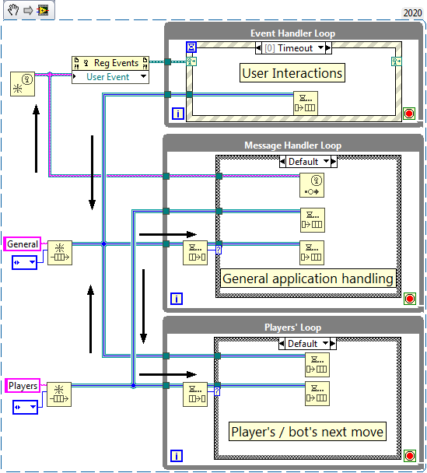Scheme of comunnications between loops
All three loops run in parallel and each of them is paused until Event Structure or Dequeue Element nodes detect data addressed to them.
1. Event Handler Loop – has Event Structure that listens for user interactions (buttons pushed) and events generated by Message Handler Loop and enqueues messages for Message Handler Loop only.
2. Message Handler Loop – receives messages and handles them accordingly. When a new game is started, message is enqueued to Players’ Loop to generate appropriate response.
3. Players’ Loop – starts a game with settings sent by Message Handler Loop. Handles consequent players’ moves: listens for next move by human player or generates bot’s move according to a selected setting.

