Grid-Aware Spatio-Temporal Load Shaping for Geo-Distributed Data Centers via Deep Reinforcement Learning:
A Cell-Aggregate Study on Google ClusterData 2019
Janusz Gal
Master's Thesis Draft — generated working paper; numbers correspond to the multi-seed default-off campaign (5 seeds/config); the demand-charge extension is explicitly labeled single-seed.
Abstract — Hyperscale data centers are now grid-scale electrical loads whose consumption coincides with regional net-demand peaks (the “duck curve”). We study whether a reinforcement-learning agent can route workload across geographically distributed data centers — spatially (where) and temporally (when, for deferrable batch work) — to minimize electricity cost while reducing the fleet's contribution to grid stress. Following the aggregate load-shaping paradigm of Google's production Carbon-Intelligent Computing System rather than job-level scheduling, we model four Borg cells from the Google ClusterData 2019 trace as proxy data centers: measured per-tier demand curves (service vs. no-SLO batch, extracted from instance-level usage by priority tier), per-cell power models calibrated on the companion PowerData2019 measurements (R² = 0.75–0.80 per cell vs. 0.43 pooled), regional net-demand series (EIA-930 for US regions; documented approximations outside the US), and documented synthetic regional price series (see provenance note, Sec. IV-D). Across five training seeds per configuration, a continuous-action PPO policy controlling routing fractions, batch drain rates, and batch placement beats the grid-unaware status quo by 2.7–12.9%, a foresighted lookahead heuristic by 5.0–14.8%, and the best discrete DQN variant by 2.5–9.9% (winning 19 of 20 seed-paired comparisons), and sits within 1.3–5.7% of a clairvoyant convex-QP lower bound — with zero deadline violations and 100% of service demand served. A three-stage generalization study shows transfer succeeds along an observed net-demand-year shift (real EIA-930 for US regions; updated approximations for non-US regions) but fails along an unobserved one (held-out cells), until domain randomization restores it; and the spatial advantage survives inter-site movement costs up to ~0.35–0.53× the energy cost of serving a unit. We additionally contribute three experimentally validated modeling lessons — deadline penalties must scale with the energy value of deferred work; capacity-blocked work must queue, not expire; and synthetic workload generators must conserve the demand-presentation process (requests ≠ usage) — each of which, while uncorrected, inverted the experimental ranking.
Index Terms — data centers, demand response, reinforcement learning, workload scheduling, duck curve, Google cluster trace, load shaping.

I. INTRODUCTION
Data centers consumed roughly 415 TWh of electricity in 2024, and the IEA projects consumption to more than double to ~950 TWh — about 3% of global electricity demand — by 2030 [28]; the geographic concentration of hyperscale campuses turns individual operators into grid-scale loads. Simultaneously, solar-heavy grids exhibit the duck curve: midday renewable generation depresses net demand, followed by a steep evening ramp during which prices spike and grid stress peaks. A data-center fleet that concentrates its draw during these ramps contributes directly to system peaks; a fleet that shifts flexible work across locations and hours can instead smooth them. Google's production Carbon-Intelligent Computing System (CICS) demonstrates temporal shifting at hyperscale [3]; geographic load-balancing work establishes the spatial lever [23]–[25]. Open RL environments for sustainable data-center scheduling now exist — SustainDC for within-DC multi-agent control [26] and SustainCluster for geo-distributed per-task dispatch [27] — but none provides measured per-tier (flexible vs. inflexible) demand decomposition of a hyperscale trace, power models calibrated on companion power measurements, or a grid net-demand (duck-curve) objective; those are the gaps this thesis fills.
This thesis asks: can a model-free reinforcement-learning agent, observing only per-site demand, prices, and grid net demand, learn a joint spatial-temporal load-shaping policy that beats both the grid-unaware status quo and foresighted scheduling heuristics? We answer affirmatively, on an environment combining measured traces with explicitly identified modeled market inputs, and we document — unusually, as a first-class contribution — the modeling errors we made on the way, each of which inverted the experimental ranking until found and fixed.
Contributions. (C1) A reproducible Gymnasium environment for multi-data-center grid-aware load shaping at cell-aggregate granularity, grounded in Google ClusterData 2019 [1], PowerData2019 [2], EIA-930 US net demand, documented non-US net-demand approximations, and synthetic regional prices. (C2) Ground-truth measured per-tier demand decomposition (SLO service vs. no-SLO batch) of four trace cells, with the finding that resource requests overestimate the deferrable usage share by 3–5×. (C3) A continuous-action PPO formulation (routing + drain + batch placement) that, across five seeds per configuration, wins every evaluated configuration against heuristic, DQN, and status-quo baselines with zero deadline violations, and lands within 1.3–5.7% of a clairvoyant QP lower bound. (C4) Identification of marginal-power (slope) arbitrage as an emergent routing strategy enabled by per-cell power calibration. (C5) A three-stage generalization result establishing that transfer tracks observability, with domain randomization closing the unobserved axis. (C6) Three transferable modeling lessons for deferral-with-deadlines simulators, each validated by ranking inversion.
II. RELATED WORK AND METHODOLOGICAL LINEAGE
This work deliberately assembles its methodology from prior art; this section states precisely what is taken from where.
A. The trace and its semantics
ClusterData 2019, documented by Tirmazi et al. [1], covers eight Borg cells for May 2019 (~96k machines). We adopt three of its definitions wholesale: the cell as the natural management unit (§2 of [1]); priority tiers, from which we define deferrable work as the union of the two no-SLO tiers — free (priority ≤ 99) and best-effort batch (100–115, per the normative trace documentation [22]; Tirmazi et al. [1] describe the range as 110–115) — production work (120–359) is explicitly protected by eviction of lower tiers and is never deferred; and Normalized Compute Units. The companion PowerData2019 trace provides measured per-PDU power utilization [2], used here for calibration. Tirmazi's heavy-tail observation (top 1% of jobs consume >99% of resources) informs our distribution fits; notably we find the tail does not survive aggregation (Sec. VII).
B. Workload-generation lineage
Our synthetic batch generator descends directly from Da Costa, Grange & De Courchelle [5], instantiated as the scipy-based Listing 1 of Grange et al. [4], in the Feitelson workload-modeling tradition [21]. Those works use the 2011 Google trace; we retain the generator family but re-fit every distribution to ClusterData2019. We reproduce Listing 1 verbatim (scripts/grange_generator.py recovers their published lognormal s = 1.634, scale = 447), then extend it: distributions are re-fit to the 2019 trace under the no-SLO definition, selected by minimum Kolmogorov–Smirnov distance (the p-value saturates at n ≈ 10⁵), with discrete negative-binomial task counts. Grange's SLA-flexibility knob becomes our deadline model, Eq. (7). Critically, in the final environment the generator is demoted to sensitivity analysis: measured per-tier curves are the primary input, after we found single-timestep job pulses inflated batch burstiness by two orders of magnitude (Sec. VII).
C. Geographic load balancing for electricity cost
Spatial electricity-price arbitrage across internet-scale systems predates the renewable-aware literature: Qureshi et al. quantified the savings from routing request load toward cheap electricity markets [23]; Rao et al. formalized cost minimization for distributed data centers across multiple electricity markets [24]; and Liu, Lin, Wierman, Low and Andrew gave the optimization treatment of geographical load balancing with renewable supply, characterizing when 'follow the renewables' routing is optimal [25]. Our spatial lever is a direct descendant of this lineage — with two displacements: the objective targets grid net demand (the duck-curve quantity) rather than price alone, and the routed quantity is measured aggregate tier demand rather than request traffic.
D. Single-DC renewable-aware scheduling
The deferral-with-deadlines pattern originates in single-DC work: GreenSlot [10] delays jobs toward predicted cheap/green slots; Grange et al. [4] add due-date constraints and an infrastructure-agnostic objective signal; Xu et al. [7] split workloads into brownout-able interactive and deferrable batch; Haghshenas et al. [8] schedule heterogeneous workloads against rate structures; Liu et al. [9] forecast-then-plan. We benchmark against this lineage at the level of objectives and effects — cost, peak contribution, deferral value — not mechanism: our Trough-Slot baseline retargets GreenSlot's slot valuation from solar supply to grid net demand, and our service/batch split operationalizes Xu's taxonomy via measured tiers.
E. Aggregate load shaping at hyperscale
Radovanović et al. [3] describe CICS, which shapes aggregate cluster load via day-ahead Virtual Capacity Curves and operates independently from real-time job-level scheduling, using cluster demand forecasts rather than a job-level workload model. Our environment is a CICS-shaped formulation made reproducible: aggregate flexible/inflexible demand curves per cluster, power models trained separately per cluster, and both spatial and temporal shifting — retargeted from carbon to grid demand smoothing, on public data.
F. Reinforcement learning and open environments
RL for DC energy management is surveyed in [15]; DeepEE [16] jointly schedules jobs and cooling with DRL (cooling is excluded from our scope). At finer granularity, CFWS [6] applies DQN with a flattened-index action encoding to VM/PM migration. We do not benchmark or reimplement CFWS; we borrow only its compact index-decoding idea for a 48-action aggregate DQN sensitivity, alongside a 759-action routing grid, against continuous-action PPO [18] (DQN [19]; implementations via Stable-Baselines3 [20]). Energy-model form follows the linear idle+slope server model surveyed in [14] and canonicalized by Fan et al. [17]; the demand-response framing follows [13]; broader green-DC context in [11], geo-distributed scheduling in [12].
Open benchmark environments for this problem class have recently emerged. SustainDC [26] provides multi-agent Gymnasium environments for control *within* a data center (workload shifting, cooling, battery). SustainCluster [27] is a complementary geo-distributed environment: a centralized scheduler dispatches or defers *individual tasks* of the Alibaba 2020 GPU trace across 20+ global locations every 15 minutes, optimizing energy cost, carbon, SLA, and per-GB transmission overheads. Our environment is complementary on three axes: granularity (CICS-style measured aggregate per-tier curves rather than per-task dispatch), data grounding (Google ClusterData 2019 with PowerData2019-calibrated per-cell power, rather than Alibaba GPU jobs with carbon-intensity feeds), and objective (grid net-demand peak contribution rather than carbon). We deliberately do not run our experiments inside SustainCluster: answering our question there would require replacing both its objective (carbon → grid net demand) and its action model (per-task dispatch → aggregate tier control, the granularity Sec. II-E argues for), while abandoning the Google-trace data contributions — at which point the environment would no longer be SustainCluster. The two environments are complementary benchmarks; SustainCluster's transmission-cost model is the natural template for the movement-cost sensitivity analysis of Sec. VIII, and cross-validation of our policies inside it is listed as future work.
III. SYSTEM MODEL
N = 4 data centers, indexed by i, j ∈ {1,…,N} (i is the site under consideration; j is a running index used in fleet-wide sums), operate over T = 8,917 five-minute steps, indexed by t, τ ∈ {1,…,T} (t is the current step; τ is a running index over earlier steps), with Δ = 300 s and Δh = 1/12 h. Site i has measured aggregate demand curve wᵢ,ₜ ∈ [0,1] (fraction of cell capacity), decomposed by measured priority tier into non-deferrable service demand vᵢ,ₜ and deferrable batch arrivals aᵢ,ₜ with wᵢ,ₜ = vᵢ,ₜ + aᵢ,ₜ exactly. The total service demand pooled across the fleet at step t is Dₜ = Σᵢ vᵢ,ₜ — the quantity the routing fractions redistribute. Site inputs further include electricity price πᵢ,ₜ ($/kWh), normalized grid net demand dᵢ,ₜ ∈ [0,1] (0 = grid slack; 1 = grid peak, the duck-curve neck), and capacity κᵢ from fleet machine data.
A. Power and cost
Each site has a per-cell calibrated linear power model — the standard idle+slope server model [14], [17] (Sec. IV-C):
Pᵢ(u) = Pᵢⁱᵈˡᵉ + sᵢ · u (1)
gᵢ,ₜ = Pᵢ(uᵢ,ₜ) · R, R = 100 MW (2)
where uᵢ,ₜ is served CPU, Pᵢⁱᵈˡᵉ is cell i's idle power (its draw at zero CPU, as a fraction of theoretical peak), sᵢ is its marginal power slope (the extra power per unit of CPU — the per-cell quantity the agent arbitrages, Sec. VI-B), R is rated power per site, and g is the grid draw (sites are pure grid loads; no on-site generation). Energy cost and the quadratic, net-demand-weighted peak-contribution penalty are
Eₜ = Σᵢ πᵢ,ₜ · gᵢ,ₜ · 1000 · Δh (3)
Φₜ = α · Σᵢ gᵢ,ₜ² · dᵢ,ₜ, α = 0.015 (4)
The quadratic form penalizes concentration; the d-weighting makes draw near the duck-curve neck expensive and slack-hour draw nearly free [13]. Φ is a grid-stress SHADOW PRICE, not a tariff: α is calibrated to a target share of total cost (Sec. V-A), not derived from a rate schedule, and Φ differs from a commercial demand charge in all three respects that matter — it is summed over every interval rather than taken as a maximum, it is quadratic rather than linear in kW, and it is weighted by grid net demand, which no tariff observes.
Because that distinction is easy to lose, the operator's actual tariff term is modeled separately. Commercial and industrial customers are billed on the single highest demand interval of each billing period, per meter. Such charges can be a substantial C&I bill component, but the share is tariff- and customer-specific; our reference sensitivity assumes no universal percentage. The billed quantity is the sum of per-SITE maxima, not the fleet coincident peak:
Ψ = c · Σᵢ maxₜ gᵢ,ₜ · 1000, c in $/kW per billing period (5)
A maximum over the period is not a per-step cost, so Ψ is charged in the telescoping form below, where Dᵢ,ₜ = maxₜ′≤ₜ gᵢ,ₜ′ is the running billed peak. Each step pays exactly the amount by which it raises the running maximum, and the sum over a period is exactly Ψ:
ψᵢ,ₜ = c · max(0, gᵢ,ₜ − Dᵢ,ₜ₋₁) · 1000, Σₜ ψᵢ,ₜ = c · maxₜ gᵢ,ₜ · 1000 (6)
The complete 8,917-step episode is one study billing cycle by default, so c is applied exactly once and the in-reward quantity matches the post-hoc metric. A shorter configured period is a different tariff with its own $/kW-period rate, not a monthly proxy. The telescoping identity is exact under the RL objective only when gamma = 1; the training entry points therefore select gamma = 1 whenever the term is enabled and reject a lower discount. The observation then includes Dᵢ,ₜ₋₁ for every site plus billing-period progress and the active-rate fraction, and a new period is reset before its first observation. Together these make the tariff state Markov and prevent actions from seeing a stale prior-period peak. Ψ is reported for every policy in Sec. VI-G but is DISABLED in the reward (c = 0) for all results in this paper, so the trained policies and their objective are unchanged.
The $15/kW reference is a sensitivity analysis rather than a reconstruction of four utility bills. It is a mid-range US commercial/industrial reference within the broad tariff range catalogued by the NREL demand-charge survey [29]; it uses that one US rate across all geographies solely for comparison, treats each five-minute trace sample as a demand interval, aligns the cycle to the episode, and omits site-specific time-of-use demand tiers, ratchets, contract demand, and power-factor clauses.
B. Deferrable batch dynamics
Each origin site maintains a batch pool with per-entry deadlines. Queue timing must be explicit: Q⁻ᵢ,ₜ is work carried into step t before the current arrival and deadline boundary; Q⁺ᵢ,ₜ is the work eligible for release after arrival aᵢ,ₜ is added and expired work Xᵢ,ₜ is removed. The per-cell deadline horizon follows fitted mean duration μᵢ and flexibility factor φ = 1 (after [4]). An arrival at t is eligible during steps t,…,t+Hᵢ−1 and expires at the start of t+Hᵢ if unfinished:
Hᵢ = ⌈ μᵢ (1 + φ) / Δ ⌉ (7)
Q⁺ᵢ,ₜ = Q⁻ᵢ,ₜ + aᵢ,ₜ − Xᵢ,ₜ; rᵢ,ₜ = δᵢ,ₜQ⁺ᵢ,ₜ; Q⁻ᵢ,ₜ₊₁ = Q⁺ᵢ,ₜ − qᵢ,ₜ (8)
Here rᵢ,ₜ is origin i's requested release and qᵢ,ₜ is the amount of that origin's work actually completed anywhere in the fleet. This two-phase notation resolves an indexing ambiguity in earlier drafts: if Q were instead defined as the post-arrival pool, its next-step recurrence would indeed use aᵢ,ₜ₊₁. With Q⁻ defined before the arrival, aᵢ,ₜ in Eq. (8) is correct. A release is only an intent to run; capacity-blocked work remains in Q with its original deadline. Only completed q leaves the pool and only work at its deadline boundary becomes X.
C. Action, serving, and reward
The agent outputs a ∈ [−3,3]³ᴺ, decoded as service routing fractions f = softmax(a₁:ₙ), drain rates δ = sigmoid(aₙ₊₁:₂ₙ), and batch placement h = softmax(a₂ₙ₊₁:₃ₙ) — batch work, having no latency SLO, may execute anywhere. Indices now distinguish origin i from execution site j. Service has first claim on destination capacity; batch runs in the remainder:
σⱼ,ₜ=min(fⱼ,ₜDₜ+Bⱼ,ₜ₋₁,κⱼ); yⱼ,ₜ=min(hⱼ,ₜΣᵢrᵢ,ₜ,κⱼ−σⱼ,ₜ); ρₜ=Σⱼyⱼ,ₜ/Σᵢrᵢ,ₜ; qᵢ,ₜ=ρₜrᵢ,ₜ; uⱼ,ₜ=σⱼ,ₜ+yⱼ,ₜ (9)
In Eq. (9), σ is service executed at destination j, y is batch executed there, and q is completed work removed from origin i's queue. The global serve ratio ρ allocates any capacity shortfall proportionally across origin release requests (ρ = 0 when no work is requested), so Σᵢqᵢ,ₜ = Σⱼyⱼ,ₜ. Within each origin, completed work is removed earliest-deadline-first. This origin/destination distinction is required once batch placement is spatial; earlier notation incorrectly used one Sᵢ,ₜ for both roles. The ±3 action bound (not the SB3 default ±1) matters: SB3 clips actions to the action box before the decode, so ±1 would cap every routing share to [4.3%, 71%] and every drain rate to [27%, 73%], making full concentration and multi-hour holding impossible by construction; ±3 restores parity with the discrete baselines (shares to ~98.5%). The reward is the negative per-step cost:
rₜ = −[ Eₜ + Φₜ + Σᵢ(ψᵢ,ₜ + λ_bBᵢ,ₜ) + χₜ ] (10)
With the tariff disabled, backlog weight λ_b = 25 and expiry weight λ_x = 250 preserve the historical objective. Enabling a demand charge also enables an economic guard: both weights are raised above a conservative bound on the largest one-step energy + grid-penalty + demand-charge saving obtainable by dropping one normalized CPU unit (with a 5% margin). This prevents the tariff from making unserved work economically optimal. Default-off χₜ=λ_xΣᵢXᵢ,ₜ. Demand-enabled runs use the exact dense potential χₜ=λ_xΣᵢ(aᵢ,ₜ−qᵢ,ₜ); with γ=1, Σₜχₜ=λ_x(expired+terminal-pool work). This credits completion immediately while preserving the finite-horizon objective. Raw dollar costs remain in logs and reports, while the RL reward is multiplied by 10⁻⁴ for numerical conditioning. Capacity is a hard serving constraint in Eq. (9), so no capacity-violation term belongs in the mathematical objective (the implementation retains a zero-valued diagnostic guard). The zero-expiry audit is an observed result, not a hard constraint. The demand-smoothing metric reported alongside cost is fleet load factor LF = mean(g)/max(g).
D. Worked three-step example
A one-site slice makes the units concrete. Let κ=1, R=100 MW, P(u)=0.50+0.40u, α=0.015, c=$15/kW-cycle, and assume no backlog or expiry. The values below use Eq. (8)–(10); a multi-site step performs the same arithmetic after f and h divide service and batch across destinations.
ILLUSTRATIVE THREE-STEP EQUATION WALKTHROUGH
Quantity | t=0 | t=1 | t=2
D; Q⁻; a | 0.50; 0.10; 0.20 | 0.40; 0.15; 0.10 | 0.70; 0.15; 0
δ; Q⁺; q=y | 0.50; 0.30; 0.15 | 0.40; 0.25; 0.10 | 1.00; 0.15; 0.15
u=σ+y | 0.65 | 0.50 | 0.85
g=(.50+.40u)100 | 76 MW | 70 MW | 84 MW
π; d | $0.06; 0.80 | $0.04; 0.50 | $0.08; 0.90
Energy E | $380.00 | $233.33 | $560.00
Grid penalty Φ | $69.31 | $36.75 | $95.26
Demand increment ψ | $1.140M | $0 | $0.120M
Next Q⁻ | 0.15 | 0.15 | 0

For example, at t=2 the queue closes as Q⁻₃=0.15+0−0−0.15=0. Grid draw rises from the prior 76 MW record to 84 MW, so the demand charge adds 15×(84−76)×1000=$120,000. Energy and grid penalty still accrue every step, whereas ψ is zero whenever the running peak does not increase.
E. Problem formulation
Putting the terms together, the agent solves a constrained cost-minimization over the full episode. With the per-step controls fₜ (service-routing fractions), δₜ (drain rates), and hₜ (batch placement) of Sec. III-C:
minimize J = Σₜ [ Eₜ + Φₜ + Σᵢ(ψᵢ,ₜ + λ_bBᵢ,ₜ) + χₜ ] (11)
subject to, for all i,j,t: the power model (1)–(2); the serving and origin-completion rules (9) with uⱼ,ₜ≤κⱼ; routing and placement simplexes Σⱼfⱼ,ₜ=Σⱼhⱼ,ₜ=1 with f,h≥0 and δ∈[0,1]; service conservation Bⱼ,ₜ=Bⱼ,ₜ₋₁+fⱼ,ₜDₜ−σⱼ,ₜ; and the two-phase batch conservation (8). At each deadline boundary, every due arrival is either represented in cumulative origin completion q or charged once as expiry X. Thus deadlines are soft penalties in the environment, not hard constraints; the reported policies happen to achieve X=0. In words: route service and schedule batch to minimize energy, grid contribution, the actual demand tariff, backlog, and expiry cost while respecting capacity.
Eq. (11) is an offline, full-information statement; the deployed controller is causal (it cannot observe future prices or demand). We therefore solve it with model-free RL. PPO maximizes 𝔼[Σₜγᵗrₜ]; when γ<1 this is not identical to undiscounted J, so older default-off results are evaluated on J but were trained with γ=0.99. Demand-charge-enabled runs set γ=1, aligning training and evaluation. The clairvoyant convex QP uses the same backlog and soft-expiry accounting, with fluid actions and perfect foresight; these relaxations make its optimum a lower bound on the evaluated J (Sec. VI-F).
The formulation follows CICS's aggregate flexible/inflexible load-shaping problem [3], retargeted from carbon to grid net-demand and electricity cost, with the cost-minimization-over-distributed-DCs structure of geographic load balancing [23]–[25], a linear idle+slope power model [14], [17], a peak-contribution term in the peak-shaving and demand-response tradition [9], [13] — though Φ is a per-interval quadratic shadow price, not a demand charge in the tariff sense; the tariff term Ψ is modeled separately (Eq. 5) and reported in Sec. VI-G — and aggregate batch-with-deadline dynamics [4], [9].
IV. DATA AND CALIBRATION
A. Cells as proxy data centers
Cells a–d serve as four proxy DCs. Cell locations in the trace are anonymized; the geographic assignment is a modeling choice (US scenario: a CAISO-exposed Western DC + MISO/Southern/Duke territories; Global scenario: US-West/US-Central/NL/Singapore). Tirmazi documents considerable inter-cell workload variation but no geography. The normalized curve provides the demand shape; R = 100 MW sets hyperscale magnitude (a real cell is ~3–5 MW, invisible to a regional grid). Sensitivity to R is future work.
B. Measured per-tier demand
The service/batch split is measured, not modeled: instance_usage is joined to collection priority and aggregated per 5-minute bucket into service (SLO tiers) and batch (no-SLO tiers, priority ≤ 115) curves with v + a = w to machine precision (Fig. 2). Measured deferrable usage shares are 16.6% (a), 15.7% (b), 22.3% (c), 26.4% (d) — consistent with the ~20%-of-capacity best-effort average reported for the trace [1]. Request-weighted proxies (job counts × requested CPU) suggest 63–85%, an overestimate of 3–5×, consistent with Borg's over-allocation of best-effort tiers. Requests measure intent; usage measures schedulable reality.
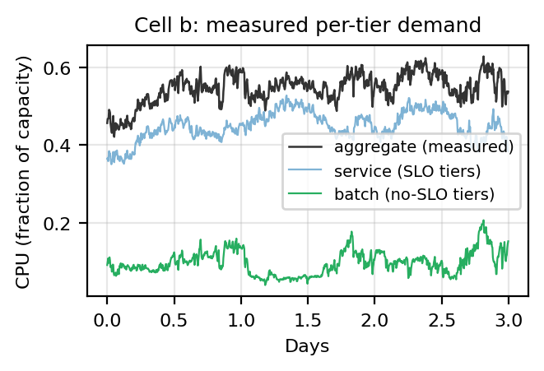
Fig. 2. Measured per-tier decomposition of cell b (3 of 31 days): service + batch equals the measured aggregate at every step.
C. Per-cell power calibration
We adopt the standard linear idle+slope server model (Eq. 1) — the form used throughout the data-center power literature [14], [17] — and fix its two constants per cell from data rather than from a single textbook value. Joining hourly PowerData2019 measured power (whose ‘power utilization’ is defined exactly as our normalization: actual power over theoretical peak [2]) with aggregate CPU over 2,980 (cell, hour) samples, least-squares gives the per-cell idle and slope of Table II. The calibration is literature-consistent: the fitted idle draw is 0.40–0.61 of each cell's peak, consistent with the substantial idle fractions reported in server-power measurements and surveys [14], [17], so the constants are credible without appeal to goodness-of-fit. We keep PER-CELL constants (not one pooled value) because the cells span a meaningful proportionality range — cell d (idle 0.38, slope 0.57) is far more energy-proportional than cell a (0.53, 0.34) — and that BETWEEN-cell spread is precisely the routing signal the agent exploits (slope arbitrage, Sec. VI-B); a single literature constant would erase it. This mirrors CICS's choice of per-cluster power models [3]. (R² is reported in Table II as a diagnostic only — 0.43 pooled vs 0.75–0.80 per cell, confirming the pooled residual is between-cell heterogeneity rather than noise — but it is not the model's justification. Using one calibrated model gives a controlled comparison, but errors in marginal slopes could still change routing rankings; the held-out-cell and domain-randomization tests probe that sensitivity.)
TABLE II. POWER MODEL CALIBRATION (POWERDATA2019)
Cell | idle | slope | R²
a | 0.528 | 0.340 | 0.79
b | 0.548 | 0.376 | 0.75
c | 0.440 | 0.526 | 0.76
d | 0.382 | 0.570 | 0.80
pooled | 0.479 | 0.444 | 0.43

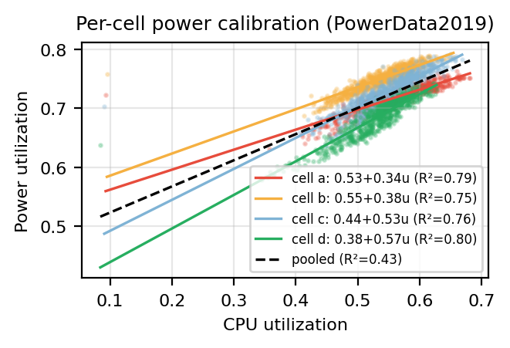
Fig. 3. Per-cell power calibration: four distinct idle/slope lines; the pooled fit (dashed) blurs them into R² = 0.43.
D. Market-data provenance (prices and net demand)
We state the price and net-demand provenance precisely, since it bounds the claims. NET DEMAND is real: hourly EIA-930 series (demand minus utility-scale wind+solar) for the assigned US balancing authorities, normalized to [0,1] by each region's window peak; the Global scenario's EU/Singapore net demand is synthesized where EIA-930 does not apply. PRICES, by contrast, are DOCUMENTED SYNTHETIC: a calibrated diurnal model anchored to plausible May-2019 regional wholesale averages, NOT real locational marginal prices. Real hourly LMP is not uniformly obtainable for this footprint — two US scenario regions (Southern Co./GA, Duke/SC) are vertically integrated utilities with no public wholesale market, and the EIA API exposes no hourly price route — so a fully-real price series is not currently available. This is a known limitation we intend to resolve (real CAISO/MISO LMP plus documented proxies for the non-ISO territories) in future work. Two points bound its interpretation. Every policy sees the same series, which makes the experiment controlled, but bias does NOT algebraically cancel because policies respond differently; rankings may change under real prices. The modeled price DYNAMICS the agent exploits (diurnal spread, cross-region differences) are structurally realistic even if the absolute levels are modeled. The generalization study (Sec. VI-H) additionally shifts US net demand to EIA-930 May-2024 data while updating documented non-US approximations.
V. EXPERIMENTAL SETUP
A. Agents and baselines
PPO (Stable-Baselines3, MLP 128×128, lr 3e-4, 500k steps) acts in the continuous 3N-dimensional space. Its observation includes per-DC dynamic state (demand, price, net demand, pool/backlog) AND static site context (per-DC idle power, slope, capacity, deferrable fraction) — the latter added so that per-site heterogeneity is exploitable as a function of observed parameters rather than memorized by slot (Sec. VI-H). Two DQN variants share hyperparameters (MLP 256×256, replay 100k, target update 1k): a 759-action routing grid, and a 48-action compact flattened index inspired by CFWS's encoding philosophy, decoding to (source DC, destination DC, drain level) [6]. It is not a CFWS reproduction. Nine heuristics span the policy space, including Round Robin, price-chasing and slack-grid concentrators, defer-to-trough rules, a GreenSlot-style Trough-Slot Lookahead foresighted heuristic with privileged 3-hour net-demand foresight [10], and the no-optimization Status Quo (serve locally, immediately) — the counterfactual of a CICS-style layer switched off.
B. Configurations and protocol
{US, Global} × {spatial-only, batch = spatial + temporal}. Each (algorithm, configuration) is trained with FIVE seeds; we report mean ± std and paired PPO-vs-best-DQN statistics (sign test, Wilcoxon, bootstrap CI). All policies are then evaluated deterministically on the identical full-trace episode.
C. Validation invariant
By construction service + batch = measured demand, so a serve-everything-now policy must reproduce the spatial-only run exactly. This holds to the dollar: Status Quo scores $9,847,536 in both US modes with zero expiry — the batch machinery is demand-neutral, and any batch-mode difference between policies is scheduling, not artifact. This invariant caught two of the three modeling errors of Sec. VII.
VI. RESULTS
TABLE I. EPISODE COST (M$), 5-SEED MEAN. ΔSQ = PPO SAVINGS VS STATUS QUO; QP = CLAIRVOYANT OPTIMUM; gap = PPO ABOVE QP.
Config | SQ | Trough | DQN | PPO (±sd) | ΔSQ | QP | gap
US spatial | 9.85 | 11.23 | 9.81 | 9.57±.03 | 2.8% | 9.46 | 1.6%
US batch | 9.85 | 10.09 | 9.89 | 9.59±.08 | 2.7% | 9.44 | 1.3%
Glob spatial | 14.06 | 14.32 | 13.35 | 12.62±.25 | 10.3% | 11.95 | 5.7%
Glob batch | 14.06 | 13.76 | 13.46 | 12.25±.14 | 12.9% | 11.89 | 3.1%

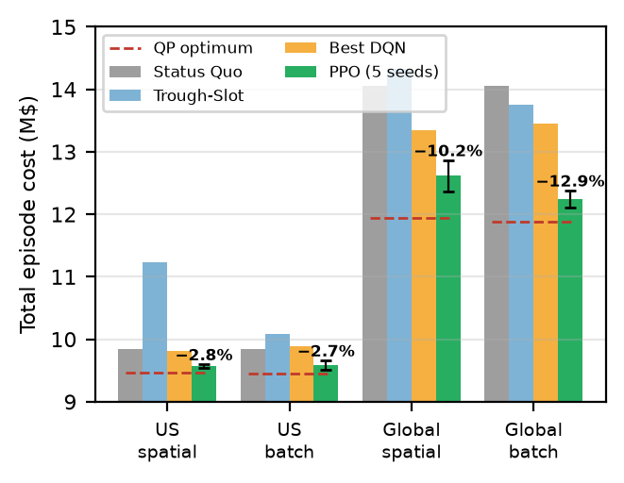
Fig. 1. Five-seed mean episode cost (PPO error bars = ±1 sd); red dashed line is the clairvoyant QP lower bound. PPO savings vs. status quo annotated.
A. Headline
Across five seeds per configuration, PPO is the best policy — learned or heuristic — in all four: 2.7–12.9% below the grid-unaware status quo, 5.0–14.8% below the foresighted Trough-Slot heuristic, and 2.5–9.9% below the best DQN variant. PPO beats the best DQN in 19 of 20 seed-paired comparisons (sign/Wilcoxon p = 0.031 in three of four configs; the exception is Global spatial-only, 4/5, p = 0.19). Crucially, PPO lands within 1.3–5.7% of a clairvoyant convex-QP lower bound (Sec. VI-F) — so little headroom remains to ANY policy, causal or not. Savings scale with exploitable structure: modest under US-only diversity, large under global price/timezone spread. PPO also serves 100% of service demand with zero deadline violations (Sec. VI-E) and the flattest, lowest fleet draw (Fig. 4).
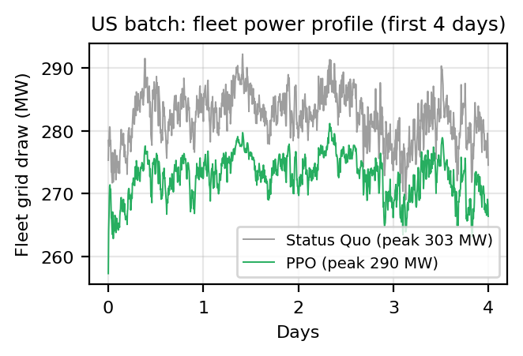
Fig. 4. Fleet power profile, US batch (first 4 days): PPO serves the same work at lower, flatter draw.
B. Emergent slope arbitrage
Per-cell power calibration converts the low-diversity US scenario from “nothing to learn” (under pooled power, all DCs are energetically identical and near-uniform routing is optimal) into a real optimization: idle power is sunk, so each marginal unit of CPU is cheapest where the slope is lowest. PPO inverts the load distribution relative to the do-nothing policies — toward low-slope cells a/b, away from high-slope c/d — worth +2.8% over the status quo with no spatial price diversity at all. No baseline encodes this strategy. In the Global scenario, slope arbitrage compounds with price arbitrage: PPO routes aggressively away from high-priced Singapore toward cheap, low-slope US capacity.
C. The foresighted heuristic loses everywhere
Trough-Slot Lookahead holds privileged 3-hour future net-demand information yet loses every configuration by 5.0–14.8% vs. PPO — and in the US it is the single most expensive policy, worse even than the do-nothing status quo. Two structural flaws cost it: its slack-grid routing rule CONCENTRATES load, raising the fleet peak that the quadratic penalty punishes (LF ≈ 0.86 vs. PPO's ≈ 0.96), and it is blind to per-cell power (it optimizes against net demand only, while PPO additionally arbitrages each cell's slope). Foresight does not compensate for optimizing the wrong surface.
D. The temporal lever, honestly sized
At the measured deferrable fractions (16–26% of usage), batch deferral adds +2.7 points over the spatial-only result in the Global scenario (+10.3% → +12.9% vs. status quo) but is essentially neutral in the US (+2.8% → +2.7%), where there is little price or timezone diversity for temporal shifting to exploit. The temporal lever is real but secondary to spatial routing, and it is scenario-dependent. (Earlier drafts' inflated +6% estimates were artifacts L1–L3, Sec. VII.)
E. Deadline and backlog audit
Because every policy is scored on the shaped objective (Eq. 10), we audit that PPO's savings are genuine scheduling, not penalty-dodging. Across all ten PPO batch-mode seeds: service served / demand = 1.0000, terminal backlog = 0, terminal batch pool ≤ 0.95 units (≤0.025% of arrivals), ZERO expired batch, peak transient backlog ≤ 3.9 units, and backlog penalty ≤1%. Default-off evaluation retains that finite-horizon convention for model compatibility and reports the tail explicitly. Demand-enabled runs observe full-episode progress and charge terminal pool like expiry, closing the economically material tariff loophole. The historical tail is <$238 (<0.003% of cost), so rankings do not change, but 'all batch completed' was too strong.
F. Optimality gap
The environment is convex in the serving decisions (linear power and energy cost, convex-quadratic peak penalty, linear queue/backlog dynamics), so a clairvoyant planner with full-episode foresight and fluid allocation solves a quadratic program whose optimum LOWER-BOUNDS any policy. We assemble it directly for the Clarabel solver with the simulator's service backlog, cumulative soft-expiry accounting, and optional demand-charge epigraph. The manual sparse assembly matches CVXPY below 10⁻⁸ relative and solves the four default-off configs in 2–15 s. PPO's gap is 1.6% (US spatial), 1.3% (US batch), 5.7% (Global spatial), and 3.1% (Global batch). The bound is generous — it has perfect foresight and no causality or action-parameterization constraints — so the true gap to the best ACHIEVABLE causal policy is smaller still. A useful by-product: the QP's spatial-only and batch optima differ by only ~0.2–0.5%, confirming the intrinsic value of temporal flexibility at these deferrable fractions is small (Sec. VI-D).
G. The demand charge: post-hoc audit and trained extension
Φ is a grid-stress shadow price, not the operator's tariff (Sec. III-A). Because a demand charge is the single largest line item that our objective omits, we quantify it for every policy from the grid-draw traces, at a reference c = $15/kW for the complete 8,917-step study billing cycle, WITHOUT putting it in the reward — so the policies compared are exactly those of Sec. VI-A. Billing is per meter, so the billed quantity is Σᵢ maxₜ gᵢ,ₜ, not the fleet coincident peak.
The charge is large: $4.69M per study cycle under the status quo, equal to 39% of that scenario's $12.06M energy charge, 28% of the combined energy-plus-demand bill, and 2.3× the Φ term already in the objective. PPO reduces it to $4.32M (−8.0%, Global spatial+temporal) and $4.35M (−7.3%, US spatial+temporal) as a SIDE EFFECT of routing for energy price, with the term absent from its reward. These are reference-rate sensitivity results, not bill reconstructions.
Two findings temper the obvious next step of adding it to the reward. First, the headroom is small, because most of the charge is not shapeable: sites never power off, so Σᵢ Pᵢⁱᵈˡᵉ·R = 189.8 MW = $2.85M is irreducible — 66% of the best charge any policy could achieve. Solving for the peak-minimizing feasible allocation (the clairvoyant LP collapses to a greedy lowest-sᵢ·R fill, since only the busiest step binds) gives a floor of 267.1 MW = $4.01M, so the entire prize is $0.69M and PPO already captures about half of it incidentally. What remains — roughly $0.31M, 2.5% of J — sits inside our seed-to-seed spread and would not survive as a headline result. Second, a demand charge would PENALIZE part of PPO's current strategy: concentrating load on the cheap, efficient sites raises their site peaks (Global batch: US-West +9%, US-Central +15%) even as EU and Asia fall, so a retrained policy would trade energy saving for peak relief rather than adding to it.
The genuinely interesting consequence is for the temporal lever. Energy arbitrage pays only if timing is right CONTINUOUSLY for a month; clipping a demand charge pays if timing is right at the binding interval. Under the default-off objective the corrected QP values temporal flexibility at only 0.19% (US) to 0.52% (Global). Adding the guarded $15/kW US-reference tariff raises the spatial-to-batch QP improvement to about 1.0–1.1% and lowers its optimal billed peak by about 9.6 MW in both scenarios, with numerical-zero expiry. The corrected environment uses the full episode as one billing cycle, resets period state before the next action, exposes the running peak and cycle context, and requires γ = 1 when the term is enabled so the incremental reward remains exactly the final billed maximum. Tariff-aware backlog/expiry floors prevent dropping work, reward scaling conditions RL, and dense arrival-minus-completion shaping preserves unfinished-work cost.
DEMAND-AWARE SINGLE-SEED RESULTS (M$, PEAK IN MW)
Config | QP | SQ | Best feasible | PPO | PPO peak
US spatial | 13.820 | 14.542 | RR 14.388 | 14.396 | 304.1
US spatial+temp | 13.676 | 14.545 | Drain 14.391 | 14.561 | 312.1
Global spatial | 16.290 | 18.756 | PPO 18.283 | 18.283 | 304.3
Global spatial+temp | 16.139 | 18.759 | Drain 18.641 | 18.798 | 311.3

These seed-42 runs are a negative but informative result. Demand-aware PPO reduces cost 1.0% vs. status quo in US spatial and 2.5% in Global spatial, but Round Robin narrowly wins US spatial. Adding the temporal head does not capture the QP's ~1% temporal opportunity: Drain Immediately is best in both batch scenarios, while PPO is 0.1–0.2% above status quo and 6.5–16.5% above the clairvoyant bound. Both DQN encodings are less reliable; incomplete-work penalties dominate several batch runs. Thus the tariff matters and the QP shows shapeable value, but 500k-step single-seed PPO/DQN does not establish a successful temporal demand-charge optimizer. These results are reported separately from the five-seed default-off headline.
H. Generalization: transfer tracks observability
We test the frozen policies (no retraining) on two distribution shifts (Fig. 6). On an UNOBSERVED shift — held-out cells e–h, with workload, tier mix, and per-cell power the policy never saw — context-aware PPO fails where its edge is purely spatial (US spatial −19%, Global spatial −27% vs. the held-out status quo): the policy had learned per-site routing keyed to static parameters that, although now in the observation, never VARIED during training and so carried no gradient signal. Training-time domain randomization (permuting compute bundles across market slots and resampling power parameters within the measured 8-cell range) fixes this, restoring positive transfer in three of four configs (+4.0–5.2%); Global spatial-only, whose price-concentration strategy has no deferral pool to absorb mistakes on unseen capacity, stays brittle — and its batch counterpart, which does, transfers at +5.2%. On an OBSERVED shift — US net demand swapped to real EIA-930 May-2024 while non-US sites use matching-year documented approximations, with prices fixed — the SAME frozen policies transfer near-perfectly (+3.1–13.2%, within ~0.5 point of their on-training result). Generalization succeeds along the axis the policy can observe and fails along the one it cannot; this both answers the calendar-memorization concern for the demand signal and prescribes the fix (observe + randomize static context).
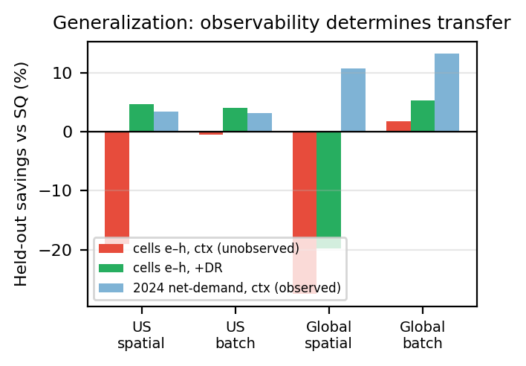
Fig. 6. Held-out transfer. Red: unobserved cell shift breaks context-only policies. Green: domain randomization restores it. Blue: the observed net-demand-year shift transfers without any special treatment.
I. Robustness to movement cost
The spatial lever assumes free inter-site movement; we test how much survives a per-unit cost on work routed away from its home cell (the SustainCluster transmission-cost idea [27]). Charging existing policies post-hoc — a conservative bound, since a movement-aware policy would route less and recover more — the Global advantage is robust: it survives until movement costs reach $219/unit (Global spatial) and $331/unit (Global batch), i.e. 0.35× and 0.53× the energy cost of serving a unit, still returning +7.9% and +11.0% at a substantial $50/unit (Fig. 7). The US margin is thinner (break-even ~0.14× unit energy), honestly reflecting its smaller spatial diversity. The 10–13% Global savings are thus not an artifact of free fungibility.
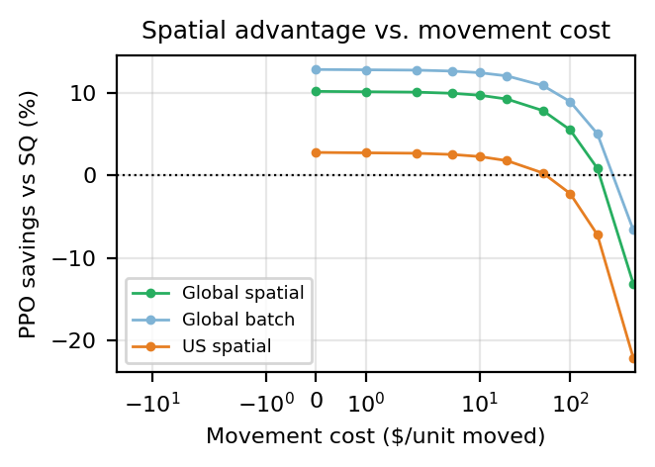
Fig. 7. PPO savings vs. per-unit inter-site movement cost (symlog x). Global routing keeps paying well past realistic egress prices.
VII. LESSONS LEARNED AND THREATS TO VALIDITY
Three modeling errors each inverted the experimental ranking while present; we report them as first-class results because any deferral-with-deadlines simulator can reproduce them.
L1 — Deadline penalties must scale with the value of deferred work. A fixed expiry weight λ_x = 2 made expiring a unit ~75× cheaper than serving it (~$150 of energy); the cost-optimal policy was to discard batch, and aggressive-expiry heuristics beat PPO. Because the penalty is linear in expiry, any rollout can be re-ranked analytically as cost(λ_x) = (cost − λ₀·x) + λ_x·x (exact for a fixed rollout; retrained agents change behavior with λ_x); the ranking inverts at λ_x ≈ 183. We set λ_x = 250, safely above both the ~$150 serving cost and that inversion point.
L2 — Capacity-blocked work must queue, not expire. Re-queueing blocked batch with a one-step deadline manufactured a policy-independent expiry floor (~5,059 units, identical across scenarios — the tell), contradicting Borg's queued batch semantics [1]. Preserving original deadlines collapsed Status Quo expiry by 85% immediately and to zero in the final environment, and eliminated a spurious “concentrators win by dumping” effect.
L3 — Synthetic generators must conserve the demand-presentation process. Injecting each sampled job's whole demand at its arrival timestep produced batch curves with peak/mean ≈ 195 vs. ≈ 1.24 in the measured trace: jobs present rate over duration, and concurrency smooths the aggregate. Corollary (L3b): requests ≠ usage — request-weighted tier shares overestimated the deferrable fraction 3–5×. A one-line shape check (generated vs. source peak/mean) catches both.
Threats to validity. (i) PRICES are documented synthetic, not real LMP (Sec. IV-D) — the most significant limitation; relative comparisons share the same series, but absolute price levels are modeled. US net demand uses EIA-930 while non-US series include documented approximations; replacing both with validated market data is primary future work. (ii) Cell locations are anonymized; the geographic assignment is a modeling choice justified by documented inter-cell heterogeneity [1]. (iii) The 100 MW magnitude bridges cell scale to grid relevance; results should be swept over R, and a 300 MW fleet would plausibly move LMPs (the price-taker assumption). (iv) The measured tier curves make episodes deterministic; Sec. VI-H addresses the resulting memorization concern directly and shows transfer along observed axes. (v) May is the deepest duck-curve month in CAISO; seasonal generalization is untested. (vi) Cooling and PUE are excluded by scope; a multiplicative PUE would scale, not reorder, results. (vii) The linear power model is calibrated on u ≈ 0.1–0.7 and omits memory/IO effects (+0.03 R² at most); a policy pushing utilization outside that range extrapolates. (viii) Five seeds and one hyperparameter set per algorithm; DQN's higher seed variance (std up to ±$0.9M vs. PPO's ≤$0.25M) is itself reported as a stability finding.
VIII. FURTHER TOPICS OF CONSIDERATION
(1) REAL PRICES: replace the synthetic price series with real CAISO/MISO LMP (and documented proxies for the non-ISO territories) — the highest-priority item, since it is the main provenance limitation (Sec. IV-D). (2) Sensitivity sweeps: deferrable fraction (via the retained generator), rated power R, flexibility factor φ, peak weight α; and seasonal generalization beyond May. (3) Carbon objective: swap or add marginal carbon-intensity signals to compare against CICS's objective directly [3]. (4) Forecast features: day-ahead price and net-demand forecasts as observations, quantifying the residual value of explicit foresight. (5) Constrained RL: enforce zero deadline violations as a hard constraint (e.g., Lagrangian PPO) rather than a penalty. (6) Hybrid granularity: a job-level inner scheduler below the aggregate outer policy, bridging to the CFWS setting [6]. (7) Storage and demand response: batteries and market participation extend the action space naturally [13]. (8) DQN stabilization: distributional/double variants and action-space curricula to separate encoding effects from optimizer fragility. (9) Multi-objective Pareto analysis of cost vs. peak contribution vs. completion latency. (10) Transfer to other public traces — e.g., the Alibaba 2020 GPU trace already packaged by SustainCluster [27] — to test trace dependence of the slope-arbitrage finding, and cross-validation of our policies inside the SustainCluster environment. (11) Demand-charge optimization: multi-seed training, peak-aware curricula or constrained control, and policy designs that close the 6.5–16.5% PPO gap to the demand-aware QP in batch mode.
IX. CONCLUSION
On an environment assembled from measured workload and power traces, EIA-930 US net demand, documented non-US net-demand approximations, and synthetic prices — a continuous-action PPO agent learns grid-aware spatio-temporal load shaping that, across five seeds per configuration, beats the grid-unaware status quo by 2.7–12.9%, a foresighted heuristic by 5.0–14.8%, and discrete DQN variants by 2.5–9.9% (19 of 20 seed comparisons) in every configuration, landing within 1.3–5.7% of a clairvoyant QP bound with zero deadline violations and a flatter, lower fleet profile. The savings come from continuously exploitable structure — price spreads and per-cell marginal-power (slope) arbitrage — and they transfer to unseen market conditions along the axes the policy observes, with domain randomization extending transfer to unseen workloads. Equally important, the path to these numbers required finding and fixing several modeling errors that each inverted the ranking, and an honest accounting of what is measured (demand, power, net demand) versus modeled (prices); we offer the corrected environment, the validation invariant, the QP bound, and the lessons themselves as contributions to reproducible research in sustainable computing. A separate single-seed US-reference demand-charge campaign shows spatial PPO can help, especially globally, but learned temporal policies do not beat immediate drain despite QP headroom; this negative result defines the next algorithmic problem rather than extending the headline claim.
REFERENCES
[1] M. Tirmazi, A. Barker, N. Deng, M. E. Haque, Z. G. Qin, S. Hand, M. Harchol-Balter, and J. Wilkes, “Borg: the Next Generation,” in Proc. EuroSys, 2020.
[2] V. Sakalkar, V. Kontorinis, D. Landhuis, S. Li, D. De Ronde, T. Blooming, A. Ramesh, J. Kennedy, C. Malone, J. Clidaras, and P. Ranganathan, “Data Center Power Oversubscription with a Medium Voltage Power Plane and Priority-Aware Capping,” in Proc. ASPLOS, 2020; companion dataset documentation: https://github.com/google/cluster-data/blob/master/PowerData2019.md.
[3] A. Radovanović, R. Koningstein, I. Schneider, B. Chen, A. Duarte, B. Roy, D. Xiao, M. Haridasan, P. Hung, N. Care, S. Talukdar, E. Mullen, K. Smith, M. Cottman, and W. Cirne, “Carbon-Aware Computing for Datacenters,” IEEE Trans. Power Systems, vol. 38, no. 2, pp. 1270–1280, Mar. 2023, doi: 10.1109/TPWRS.2022.3173250 (arXiv:2106.11750).
[4] L. Grange, G. Da Costa, and P. Stolf, “Green IT scheduling for data center powered with renewable energy,” Future Generation Computer Systems, vol. 86, pp. 99–120, 2018.
[5] G. Da Costa, L. Grange, and I. De Courchelle, “Modeling and generating large-scale Google-like workload,” in Proc. Int. Green and Sustainable Computing Conf. (IGSC), 2016.
[6] D. Zhao, J.-t. Zhou, and K. Li, “CFWS: DRL-Based Framework for Energy Cost and Carbon Footprint Optimization in Cloud Data Centers,” IEEE Trans. Sustainable Computing, vol. 10, no. 1, pp. 95–107, Jan./Feb. 2025, doi: 10.1109/TSUSC.2024.3391791.
[7] M. Xu, A. N. Toosi, and R. Buyya, “A Self-Adaptive Approach for Managing Applications and Harnessing Renewable Energy for Sustainable Cloud Computing,” IEEE Trans. Sustainable Computing, 2020.
[8] K. Haghshenas, A. Taheri, M. Goudarzi, and S. Mohammadi, “Infrastructure-Aware Heterogeneous-Workloads Scheduling for Data Center Energy Cost Minimization,” IEEE Trans. Cloud Computing, 2022.
[9] Z. Liu, Y. Chen, C. Bash, A. Wierman, D. Gmach, Z. Wang, M. Marwah, and C. Hyser, “Renewable and Cooling Aware Workload Management for Sustainable Data Centers,” in Proc. ACM SIGMETRICS, 2012.
[10] Í. Goiri, K. Le, M. E. Haque, R. Beauchea, T. D. Nguyen, J. Guitart, J. Torres, and R. Bianchini, “GreenSlot: Scheduling Energy Consumption in Green Datacenters,” in Proc. SC, 2011.
[11] W. Lin et al., “A systematic review of green-aware management techniques for sustainable data center,” Sustainable Computing: Informatics and Systems, 2024.
[12] Y. Wu et al., “Task Scheduling in Geo-Distributed Computing: A Survey,” arXiv:2501.15504, 2025.
[13] T. L. Vasques, P. Moura, and A. de Almeida, “A review on energy efficiency and demand response with focus on small and medium data centers,” Energy Efficiency, vol. 12, 2019.
[14] M. Dayarathna, Y. Wen, and R. Fan, “Data Center Energy Consumption Modeling: A Survey,” IEEE Communications Surveys & Tutorials, vol. 18, no. 1, 2016.
[15] H. Kahil, S. Sharma, P. Välisuo, and M. Elmusrati, “Reinforcement learning for data center energy efficiency optimization: A systematic literature review and research roadmap,” Applied Energy, 2024.
[16] Y. Ran, H. Hu, X. Zhou, and Y. Wen, “DeepEE: Joint Optimization of Job Scheduling and Cooling Control for Data Center Energy Efficiency Using Deep Reinforcement Learning,” in Proc. IEEE ICDCS, 2019.
[17] X. Fan, W.-D. Weber, and L. A. Barroso, “Power provisioning for a warehouse-sized computer,” in Proc. ISCA, 2007.
[18] J. Schulman, F. Wolski, P. Dhariwal, A. Radford, and O. Klimov, “Proximal Policy Optimization Algorithms,” arXiv:1707.06347, 2017.
[19] V. Mnih et al., “Human-level control through deep reinforcement learning,” Nature, vol. 518, 2015.
[20] A. Raffin, A. Hill, A. Gleave, A. Kanervisto, M. Ernestus, and N. Dormann, “Stable-Baselines3: Reliable Reinforcement Learning Implementations,” JMLR, vol. 22, 2021.
[21] D. G. Feitelson, Workload Modeling for Computer Systems Performance Evaluation. Cambridge University Press, 2015.
[22] J. Wilkes, “Google cluster-usage traces v3,” Google Inc., technical documentation distributed with ClusterData2019, rev. 2020-08.
[23] A. Qureshi, R. Weber, H. Balakrishnan, J. Guttag, and B. Maggs, “Cutting the Electric Bill for Internet-Scale Systems,” in Proc. ACM SIGCOMM, 2009.
[24] L. Rao, X. Liu, L. Xie, and W. Liu, “Minimizing Electricity Cost: Optimization of Distributed Internet Data Centers in a Multi-Electricity-Market Environment,” in Proc. IEEE INFOCOM, 2010.
[25] Z. Liu, M. Lin, A. Wierman, S. H. Low, and L. L. H. Andrew, “Greening Geographical Load Balancing,” in Proc. ACM SIGMETRICS, pp. 233–244, 2011, doi: 10.1145/1993744.1993767.
[26] A. Naug, A. Guillen, R. Luna, V. Gundecha, D. Rengarajan, S. Ghorbanpour, S. Mousavi, A. Ramesh Babu, D. Markovikj, L. D. Kashyap, and S. Sarkar, “SustainDC: Benchmarking for Sustainable Data Center Control,” in Advances in Neural Information Processing Systems (NeurIPS), 2024.
[27] Hewlett Packard Enterprise, “SustainCluster: A high-fidelity, open-source Gymnasium environment for benchmarking multi-objective, sustainable workload scheduling across geo-distributed data centers,” GitHub repository, MIT License, https://github.com/HewlettPackard/sustain-cluster (accessed Aug. 2026).
[28] International Energy Agency, “Energy and AI,” IEA, Paris, Jan. 2025. [Online]. Available: https://www.iea.org/reports/energy-and-ai.
[29] J. McLaren et al., “Identifying Potential Markets for Behind-the-Meter Battery Energy Storage: A Survey of U.S. Demand Charge Rates,” NREL/TP-6A20-64980, National Renewable Energy Laboratory, 2015.

