Grid-Aware Spatio-Temporal Load Shaping for Geo-Distributed Data Centers via Deep Reinforcement Learning:
A Cell-Aggregate Study on Google ClusterData 2019
Janusz Gal
Master's Thesis Draft — energy-model v2 design gate. The real May-2025 CAISO source and corrected QP gate are current. Prior learned-policy results are archived separately as energy-model v1 evidence and are not final v2 claims.
Abstract — Hyperscale data centers are now grid-scale electrical loads whose consumption coincides with regional net-demand peaks (the “duck curve”). We study whether a reinforcement-learning agent can route workload across geographically distributed data centers — spatially (where) and temporally (when, for deferrable batch work) — to minimize electricity cost while reducing the fleet's contribution to grid stress. The active experiment combines Google ClusterData 2019 workload shapes and PowerData2019-calibrated power models with one co-timestamped, real May-2025 CAISO archetype: native five-minute net demand and solar plus NP15 day-ahead LMP. Price and net demand are shifted together by local wall time across four US slots and four global slots, preserving negative prices and signed net demand over a complete 8,928-step (744-hour) experiment. Measured workload shapes map to equal 100 MW/unit-capacity proxies, and current batch arrivals are observed before same-step release. Routing is unrestricted and therefore represents an optimistic upper bound, not a deployment claim. The corrected clairvoyant-QP gate finds 8.0–17.4% joint headroom, of which only 0.6–2.3% is incremental temporal value. An a–d-only coefficient sweep supports α=0.015 for the convex positive-grid-stress term; a standardized demand charge remains secondary. No v2 PPO training has begun.
Index Terms — data centers, demand response, reinforcement learning, workload scheduling, duck curve, Google cluster trace, load shaping.

I. INTRODUCTION
Data centers consumed roughly 415 TWh of electricity in 2024, and the IEA projects consumption to more than double to ~950 TWh — about 3% of global electricity demand — by 2030 [28]; the geographic concentration of hyperscale campuses turns individual operators into grid-scale loads. Simultaneously, solar-heavy grids exhibit the duck curve: midday renewable generation depresses net demand, followed by a steep evening ramp during which prices spike and grid stress peaks. A data-center fleet that concentrates its draw during these ramps contributes directly to system peaks; a fleet that shifts flexible work across locations and hours can instead smooth them. Google's production Carbon-Intelligent Computing System (CICS) demonstrates temporal shifting at hyperscale [3]; geographic load-balancing work establishes the spatial lever [23]–[25]. Open RL environments for sustainable data-center scheduling now exist — SustainDC for within-DC multi-agent control [26] and SustainCluster for geo-distributed per-task dispatch [27] — but none provides measured per-tier (flexible vs. inflexible) demand decomposition of a hyperscale trace, power models calibrated on companion power measurements, or a grid net-demand (duck-curve) objective; those are the gaps this thesis fills.
This thesis asks: can a model-free reinforcement-learning agent, observing only per-site demand, prices, and grid net demand, learn a joint spatial-temporal load-shaping policy that beats the grid-unaware status quo? This revision deliberately does not answer that question with a learned v2 policy yet. It first freezes and audits the real energy surface on which the answer will depend, then uses a clairvoyant QP to verify that measurable headroom exists before spending another training campaign.
Contributions. (C1) A reproducible Gymnasium environment for multi-data-center grid-aware load shaping at cell-aggregate granularity, grounded in Google ClusterData 2019 [1] and PowerData2019 [2]. (C2) Ground-truth measured per-tier demand decomposition (SLO service vs. no-SLO batch) of four trace cells, with the finding that resource requests overestimate the deferrable usage share by 3–5×. (C3) A real, reproducible May-2025 CAISO duck-curve/price archetype whose paired signals are shifted by IANA local wall time across US and global slots. (C4) A no-training QP gate that sizes the opportunity before policy selection and shows that spatial diversity dominates temporal flexibility. (C5) A preserved audit trail of the retired mixed/synthetic model and the simulator corrections that prevented invalid results from being promoted.
II. RELATED WORK AND METHODOLOGICAL LINEAGE
The current thesis combines four established ideas rather than claiming a new scheduling paradigm: measured aggregate workload shaping, geographic load balancing, deadline-constrained deferral, and model-free control. This section identifies only the lineage that remains active in energy-model v2.
A. Aggregate workload shaping and trace semantics
ClusterData 2019 [1] defines a Borg cell as one management unit and reports five-minute, normalized resource usage across eight heterogeneous cells. We use those measured cell aggregates directly. Collection priority separates the no-SLO free/best-effort tiers (priority ≤115 [22]) from SLO-bearing service; no synthetic arrival stream is used in the primary experiment. PowerData2019 [2] supplies the companion per-cell power calibration.
Google's CICS [3] is the main production precedent for this granularity. It shapes aggregate flexible and inflexible cluster demand independently of the real-time job scheduler, using cluster-specific forecasts and power models. Our temporal abstraction follows that aggregate view, while the objective changes from carbon to electricity cost and grid net demand. CICS is a precedent, not a reproduced system, and it does not supply our spatial head.
B. Geographic load balancing for electricity cost
Spatial electricity-price arbitrage across internet-scale systems predates the renewable-aware literature: Qureshi et al. quantified the savings from routing request load toward cheap electricity markets [23]; Rao et al. formalized cost minimization for distributed data centers across multiple electricity markets [24]; and Liu, Lin, Wierman, Low and Andrew gave the optimization treatment of geographical load balancing with renewable supply, characterizing when 'follow the renewables' routing is optimal [25]. Our spatial lever is a direct descendant of this lineage — with two displacements: the objective targets grid net demand (the duck-curve quantity) rather than price alone, and the routed quantity is measured aggregate tier demand rather than request traffic.
C. Deadline-constrained deferral
GreenSlot [10] and related single-DC work establish the basic temporal idea: delay flexible work toward predicted cheap or renewable-rich intervals. Grange et al. [4] add due-date constraints; Xu et al. [7] distinguish interactive from deferrable work; Haghshenas et al. [8] and Liu et al. [9] combine heterogeneous load with prices or forecasts. We borrow the pool-and-deadline abstraction, not their job-level placement mechanisms. In our aggregate model, measured no-SLO demand enters a queue and the controller selects its release rate and execution site.
D. Reinforcement learning and open environments
Model-free RL is established for data-center control [15], with DeepEE [16] as one example of joint scheduling and infrastructure control. We use PPO [18] because the current action is continuous: routing fractions, release rates, and batch-placement fractions. The paper does not claim a new RL algorithm; its contribution is the measured workload/energy formulation and the controlled evaluation around it.
SustainDC [26] addresses multi-agent control within a data center, while SustainCluster [27] dispatches individual Alibaba GPU tasks across many locations with carbon, cost, SLA, and transmission objectives. They are complementary rather than drop-in baselines: this thesis controls divisible aggregate Google-cell demand and explicitly targets CAISO net-demand shape. Reproducing the same question in either benchmark would require changing its workload granularity or objective.
E. Current positioning
The active contribution is a controlled geo-distributed workload-shaping experiment that combines measured aggregate service/batch curves, per-cell power models, and one real May-2025 CAISO net-demand/price archetype shifted across US and global local-time slots. A clairvoyant QP sizes spatial and temporal headroom before PPO is trained. This is not a real multi-market replay, a CICS reproduction, or a VM/job scheduler, and no archived v1 learned-policy result is promoted as v2 evidence.
III. SYSTEM MODEL
N = 4 data centers, indexed by i, j ∈ {1,…,N} (i is the site under consideration; j is a running index used in fleet-wide sums), operate over T = 8,928 five-minute steps, indexed by t, τ ∈ {1,…,T} (t is the current step; τ is a running index over earlier steps), with Δ = 300 s and Δh = 1/12 h. Site i has measured aggregate demand curve wᵢ,ₜ ∈ [0,1] (fraction of cell capacity), decomposed by measured priority tier into non-deferrable service demand vᵢ,ₜ and deferrable batch arrivals aᵢ,ₜ with wᵢ,ₜ = vᵢ,ₜ + aᵢ,ₜ exactly. The total service demand pooled across the fleet at step t is Dₜ = Σᵢ vᵢ,ₜ — the quantity the routing fractions redistribute. Site inputs further include electricity price πᵢ,ₜ ($/kWh), signed grid net demand dᵢ,ₜ ∈ [−1,1] (negative = renewable oversupply, positive = residual grid load), and normalized proxy capacity κᵢ = 1.
A. Equal-capacity proxy, power, and cost
Each wᵢ,ₜ is already measured CPU usage divided by its SOURCE cell's CPU capacity. We use that real curve as a utilization shape and map it onto an equal 100 MW proxy DC. Therefore every destination has κᵢ = 1: w = 0.70 means 70% of that proxy's capacity. Raw machine totals remain provenance metadata and support calibration; they do not shrink destination capacity again. This avoids mixing own-cell utilization units with capacity expressed relative to the largest source fleet.
Each site has a per-cell calibrated linear power model — the standard idle+slope server model [14], [17] (Sec. IV-C):
Pᵢ(u) = Pᵢⁱᵈˡᵉ + sᵢ · u (1)
gᵢ,ₜ = Pᵢ(uᵢ,ₜ) · R, R = 100 MW (2)
where uᵢ,ₜ∈[0,1] is served utilization of the equal 100 MW proxy, Pᵢⁱᵈˡᵉ is cell i's idle power (its draw at zero CPU, as a fraction of theoretical peak), sᵢ is its marginal power slope (the extra power per unit of CPU and an observable routing context), R is rated power per site, and g is the grid draw (sites are pure grid loads; no on-site generation). Energy cost and the quadratic, net-demand-weighted peak-contribution penalty are
Eₜ = Σᵢ πᵢ,ₜ · gᵢ,ₜ · 1000 · Δh (3)
Φₜ = α · Σᵢ gᵢ,ₜ² · max(dᵢ,ₜ,0) (4)
The quadratic form penalizes concentration; the d-weighting makes draw near the duck-curve neck expensive. Signed d remains observable, while max(d,0) keeps the QP convex. At negative net demand Φ is zero; the real low or negative LMP provides the economic reward for moving work into the duck-curve belly. Φ is a grid-stress SHADOW PRICE, not a tariff: α must be selected by a documented v2 component/sensitivity study, not inherited from v1 or derived from a rate schedule, and Φ differs from a commercial demand charge in all three respects that matter — it is summed over every interval rather than taken as a maximum, it is quadratic rather than linear in kW, and it is weighted by grid net demand, which no tariff observes.
All slots use the same CAISO archetype and signed MW denominator, so d is comparable by construction inside this controlled experiment. This is not a claim that real California, Amsterdam, and Singapore systems have equal physical scarcity.
Ramp-rate treatment — evaluated, not optimized.
The duck curve combines a deep midday trough with a steep upward evening ramp. The primary objective addresses trough economics and HIGH net-demand EXPOSURE, but contains no derivative dₜ−dₜ₋H; it does not directly optimize ramp rate. Price is an incomplete proxy: its correlation is 0.895 with net-demand level but only 0.206 with the one-hour ramp and 0.429 with the three-hour ramp.
This omission is deliberate for the first v2 campaign. Concentrating work during negative-demand, very-low-price intervals is acceptable within proxy capacity, and Φ is zero there. Evaluation reports per-region maximum and 95th-percentile upward ramps for H=1 hour and H=3 hours, comparing max(0,Nₜ−Nₜ₋H) with max(0,(Nₜ+gₜ)−(Nₜ₋H+gₜ₋H)). Regions are not summed into a fictitious global grid. A ramp-aware reward is future work and will be introduced only if the first v2 policies worsen these physical KPIs. Status Quo changes the maximum one-hour regional ramp by only −0.4 to +1.7 MW across scenarios against an 11,465 MW raw CAISO maximum; trained-policy effects remain unknown.
Because that distinction is easy to lose, the operator's actual tariff term is modeled separately. Commercial and industrial customers are billed on the single highest demand interval of each billing period, per meter. Such charges can be a substantial C&I bill component, but the share is tariff- and customer-specific; our reference sensitivity assumes no universal percentage. The billed quantity is the sum of per-SITE maxima, not the fleet coincident peak:
Ψ = c · Σᵢ maxₜ gᵢ,ₜ · 1000, c in $/kW per billing period (5)
A maximum over the period is not a per-step cost, so Ψ is charged in the telescoping form below, where Dᵢ,ₜ = maxₜ′≤ₜ gᵢ,ₜ′ is the running billed peak. Each step pays exactly the amount by which it raises the running maximum, and the sum over a period is exactly Ψ:
ψᵢ,ₜ = c · max(0, gᵢ,ₜ − Dᵢ,ₜ₋₁) · 1000, Σₜ ψᵢ,ₜ = c · maxₜ gᵢ,ₜ · 1000 (6)
The complete 8,928-step episode is one study billing cycle by default, so c is applied exactly once and the in-reward quantity matches the post-hoc metric. A shorter configured period is a different tariff with its own $/kW-period rate, not a monthly proxy. The telescoping identity is exact under the RL objective only when gamma = 1; the training entry points therefore select gamma = 1 whenever the term is enabled and reject a lower discount. The observation then includes Dᵢ,ₜ₋₁ for every site plus billing-period progress and the active-rate fraction, and a new period is reset before its first observation. Together these make the tariff state Markov and prevent actions from seeing a stale prior-period peak. The v2 primary protocol fixes c=0 in the reward and reports the standardized $15/kW-cycle charge as a secondary sensitivity for every policy. Demand-aware training is a separate extension.
The $15/kW reference is a sensitivity analysis rather than a reconstruction of four utility bills. It is a mid-range US commercial/industrial reference within the broad tariff range catalogued by the NREL demand-charge survey [29]; it uses that one US rate across all geographies solely for comparison, treats each five-minute trace sample as a demand interval, aligns the cycle to the episode, and omits site-specific time-of-use demand tiers, ratchets, contract demand, and power-factor clauses.
The reference charge is about $4.694M for Status Quo, large enough to dominate the controlled objective, and it is not a real Dutch or Singapore tariff. These are the reasons it is not primary.
B. Deferrable batch dynamics
Each origin site maintains a batch pool with per-entry deadlines. Queue timing must be explicit: Q⁻ᵢ,ₜ is work carried into step t before the current arrival and deadline boundary; Q⁺ᵢ,ₜ is the work eligible for release after arrival aᵢ,ₜ is added and expired work Xᵢ,ₜ is removed. The per-cell deadline horizon follows fitted mean duration μᵢ and flexibility factor φ = 1 (after [4]). An arrival at t is eligible during steps t,…,t+Hᵢ−1 and expires at the start of t+Hᵢ if unfinished:
Because the current action may release part of aᵢ,ₜ in the same step, aᵢ,ₜ is included explicitly in the pre-action observation alongside Q⁻, service demand, urgency, price, net demand, and site context. The decision process therefore observes every state variable that determines its same-step transition.
The trace contains no job deadlines. Hᵢ is therefore an experimental control semantic, not a recovered SLO: μᵢ is fitted from observed duration and φ sets counterfactual slack. The primary model freezes φ=1 (H=2μ); robustness uses φ∈{0,2}, corresponding to H∈{μ,3μ}.
Hᵢ = ⌈ μᵢ (1 + φ) / Δ ⌉ (7)
Q⁺ᵢ,ₜ = Q⁻ᵢ,ₜ + aᵢ,ₜ − Xᵢ,ₜ; rᵢ,ₜ = δᵢ,ₜQ⁺ᵢ,ₜ; Q⁻ᵢ,ₜ₊₁ = Q⁺ᵢ,ₜ − qᵢ,ₜ (8)
Here rᵢ,ₜ is origin i's requested release and qᵢ,ₜ is the amount of that origin's work actually completed anywhere in the fleet. This two-phase notation resolves an indexing ambiguity in earlier drafts: if Q were instead defined as the post-arrival pool, its next-step recurrence would indeed use aᵢ,ₜ₊₁. With Q⁻ defined before the arrival, aᵢ,ₜ in Eq. (8) is correct. A release is only an intent to run; capacity-blocked work remains in Q with its original deadline. Only completed q leaves the pool and only work at its deadline boundary becomes X.
C. Action, serving, and reward
The agent outputs a ∈ [−3,3]³ᴺ, decoded as service routing fractions f = softmax(a₁:ₙ), drain rates δ = sigmoid(aₙ₊₁:₂ₙ), and batch placement h = softmax(a₂ₙ₊₁:₃ₙ) — batch work, having no latency SLO, may execute anywhere. Indices now distinguish origin i from execution site j. Service has first claim on each unit-capacity proxy; batch runs in the remainder:
The primary controlled experiment assumes both service and batch are freely routable among all four slots, including intercontinental Global routing. Latency, data residency, and movement cost are not modeled. This is an explicit optimistic assumption, not an operational deployment claim.
σⱼ,ₜ=min(fⱼ,ₜDₜ+Bⱼ,ₜ₋₁,κⱼ); yⱼ,ₜ=min(hⱼ,ₜΣᵢrᵢ,ₜ,κⱼ−σⱼ,ₜ); ρₜ=Σⱼyⱼ,ₜ/Σᵢrᵢ,ₜ; qᵢ,ₜ=ρₜrᵢ,ₜ; uⱼ,ₜ=σⱼ,ₜ+yⱼ,ₜ (9)
In Eq. (9), σ is service executed at destination j, y is batch executed there, and q is completed work removed from origin i's queue. The global serve ratio ρ allocates any capacity shortfall proportionally across origin release requests (ρ = 0 when no work is requested), so Σᵢqᵢ,ₜ = Σⱼyⱼ,ₜ. Within each origin, completed work is removed earliest-deadline-first. This origin/destination distinction is required once batch placement is spatial; earlier notation incorrectly used one Sᵢ,ₜ for both roles. The ±3 action bound (not the SB3 default ±1) matters: SB3 clips actions to the action box before the decode, so ±1 would cap every routing share to [4.3%, 71%] and every drain rate to [27%, 73%], making full concentration and multi-hour holding impossible by construction; ±3 restores parity with the discrete baselines (shares to ~98.5%). The reward is the negative per-step cost:
rₜ = −[ Eₜ + Φₜ + Σᵢ(ψᵢ,ₜ + λ_bBᵢ,ₜ) + χₜ ] (10)
With the tariff disabled, backlog weight λ_b = 25 and expiry weight λ_x = 250 preserve the historical objective. Enabling a demand charge also enables an economic guard: both weights are raised above a conservative bound on the largest one-step energy + grid-penalty + demand-charge saving obtainable by dropping one normalized CPU unit (with a 5% margin). This prevents the tariff from making unserved work economically optimal. Default-off χₜ=λ_xΣᵢXᵢ,ₜ. Demand-enabled runs use the exact dense potential χₜ=λ_xΣᵢ(aᵢ,ₜ−qᵢ,ₜ); with γ=1, Σₜχₜ=λ_x(expired+terminal-pool work). This credits completion immediately while preserving the finite-horizon objective. Raw dollar costs remain in logs and reports, while the RL reward is multiplied by 10⁻⁴ for numerical conditioning. Capacity is a hard serving constraint in Eq. (9), so no capacity-violation term belongs in the mathematical objective (the implementation retains a zero-valued diagnostic guard). The zero-expiry audit is an observed result, not a hard constraint. The demand-smoothing metric reported alongside cost is fleet load factor LF = mean(g)/max(g); independent physical ramp KPIs are reported separately and are not reward terms.
D. Worked three-step example
A one-site slice makes the units concrete. Let κ=1, R=100 MW, P(u)=0.50+0.40u, α=0.015, c=$15/kW-cycle, and assume no backlog or expiry. The values below use Eq. (8)–(10); a multi-site step performs the same arithmetic after f and h divide service and batch across destinations.
ILLUSTRATIVE THREE-STEP EQUATION WALKTHROUGH
Quantity | t=0 | t=1 | t=2
D; Q⁻; a | 0.50; 0.10; 0.20 | 0.40; 0.15; 0.10 | 0.70; 0.15; 0
δ; Q⁺; q=y | 0.50; 0.30; 0.15 | 0.40; 0.25; 0.10 | 1.00; 0.15; 0.15
u=σ+y | 0.65 | 0.50 | 0.85
g=(.50+.40u)100 | 76 MW | 70 MW | 84 MW
π; d | $0.06; 0.80 | $0.04; 0.50 | $0.08; 0.90
Energy E | $380.00 | $233.33 | $560.00
Grid penalty Φ | $69.31 | $36.75 | $95.26
Demand increment ψ | $1.140M | $0 | $0.120M
Next Q⁻ | 0.15 | 0.15 | 0

For example, at t=2 the queue closes as Q⁻₃=0.15+0−0−0.15=0. Grid draw rises from the prior 76 MW record to 84 MW, so the demand charge adds 15×(84−76)×1000=$120,000. Energy and grid penalty still accrue every step, whereas ψ is zero whenever the running peak does not increase.
E. Problem formulation
Putting the terms together, the agent solves a constrained cost-minimization over the full episode. With the per-step controls fₜ (service-routing fractions), δₜ (drain rates), and hₜ (batch placement) of Sec. III-C:
minimize J = Σₜ [ Eₜ + Φₜ + Σᵢ(ψᵢ,ₜ + λ_bBᵢ,ₜ) + χₜ ] (11)
J contains no direct ramp-rate penalty. Any ramp improvement is therefore an independently measured outcome rather than a consequence built into the training objective.
subject to, for all i,j,t: the power model (1)–(2); the serving and origin-completion rules (9) with uⱼ,ₜ≤κⱼ; routing and placement simplexes Σⱼfⱼ,ₜ=Σⱼhⱼ,ₜ=1 with f,h≥0 and δ∈[0,1]; service conservation Bⱼ,ₜ=Bⱼ,ₜ₋₁+fⱼ,ₜDₜ−σⱼ,ₜ; and the two-phase batch conservation (8). At each deadline boundary, every due arrival is either represented in cumulative origin completion q or charged once as expiry X. Thus deadlines are soft penalties in the environment, not hard constraints; the reported policies happen to achieve X=0. In words: route service and schedule batch to minimize energy, grid contribution, the actual demand tariff, backlog, and expiry cost while respecting capacity.
Eq. (11) is an offline, full-information statement; the deployed controller is causal (it cannot observe future prices or demand). We therefore solve it with model-free RL. PPO maximizes 𝔼[Σₜγᵗrₜ]; when γ<1 this is not identical to undiscounted J, so older default-off results are evaluated on J but were trained with γ=0.99. Demand-charge-enabled runs set γ=1, aligning training and evaluation. The clairvoyant convex QP uses the same backlog and soft-expiry accounting, with fluid actions and perfect foresight; these relaxations make its optimum a lower bound on the evaluated J (Sec. IV-D).
The formulation follows CICS's aggregate flexible/inflexible load-shaping problem [3], retargeted from carbon to grid net-demand and electricity cost, with the cost-minimization-over-distributed-DCs structure of geographic load balancing [23]–[25], a linear idle+slope power model [14], [17], a peak-contribution term in the peak-shaving and demand-response tradition [9], [13] — though Φ is a per-interval quadratic shadow price, not a demand charge in the tariff sense; the tariff term Ψ is modeled and reported separately (Eq. 5) — and aggregate batch-with-deadline dynamics [4], [9].
IV. DATA AND CALIBRATION
A. Cells as proxy data centers
Cells a–d serve as four proxy DCs. Cell locations in the trace are anonymized; assigning them to market slots is a modeling choice. Energy-model v2 uses Pacific/Mountain/Central/Eastern slots for the US experiment and Pacific/Central/Amsterdam/Singapore slots for the Global experiment, all driven by the same shifted CAISO archetype. Tirmazi documents considerable inter-cell workload variation but no geography. The normalized curve provides the own-cell utilization shape; κ = 1 maps every shape to an equal proxy destination; and R = 100 MW sets hyperscale magnitude (a real cell is ~3–5 MW, invisible to a regional grid). Raw machine totals are metadata, not a second capacity normalization. Sensitivity to R is future work.
B. Measured per-tier demand
The primary demand path starts in instance_usage, not the job table and not a generator. For each cell, we join collection priority, keep top-level instances with at least a five-minute usage record, group average CPU usage into 300-second buckets, and divide by measured cell CPU capacity. Priority ≤115 is no-SLO batch; all higher priorities are service. We then define w = normalized total usage, a = normalized batch usage, and v = w − a. Consequently v + a = w at every interval to machine precision (Fig. 2).
Each cell produces 8,929 ordinal workload rows. The v2 energy calendar has 8,928 rows, so the loader removes the one extra workload boundary row and uses a complete 744-hour control episode. The source's discarded absolute timestamp is not reconstructed: workload timestep zero is explicitly anchored to May 1, 2025 00:00 PDT as a cross-year counterfactual.
The source curves already equal measured usage divided by each cell's own CPU capacity. Because the modeled sites are equal 100 MW proxies, the loader sets destination capacity to 1.0 for every cell. Thus a source value of 0.70 remains 70% utilization after mapping; machine-count differences do not double-normalize it.
MEASURED NO-SLO SHARE OF AGGREGATE CPU USAGE
Cell | Batch share | Cell | Batch share
a | 16.6% | e | 23.5%
b | 15.7% | f | 8.4%
c | 22.3% | g | 37.7%
d | 26.4% | h | 29.1%

At runtime, v(t) is the must-serve input and a(t) is the measured arrival placed into its origin queue. The four-site PPO action routes pooled service, chooses each origin's release fraction, and places released batch across destinations. Service consumes capacity first; only completed batch is removed earliest-deadline-first, while capacity-blocked work keeps its original deadline. The full-month batch_fraction reported to the policy is context only; it never replaces the measured time-varying a(t) curve.
The fitted job-distribution JSON supplies mean duration for the experimental deadline (and a memory ratio when memory modeling is enabled), but the BatchArrivalGenerator is not constructed when tier_curves is present. It therefore has no role in primary v2 training or scoring. Its only remaining purpose is optional counterfactual sensitivity to batch volume or arrival shape; it does not validate the measured trace.
The frozen v2 evaluation will be symmetric and out of fold: train on a–d and score deterministic policies on e–h, then train on e–h and score on a–d, with ten seeds per fold/configuration. Training-only randomization may permute compute bundles and interpolate measured power parameters using only the training fold. Scoring uses the untouched held-out curves, the same v2 energy slots, Status Quo/Round Robin/Drain Immediately baselines, and the clairvoyant QP diagnostic. Reports include objective components, service completion, batch completion, expiry, and terminal backlog/pool so savings cannot be obtained by dropping work.
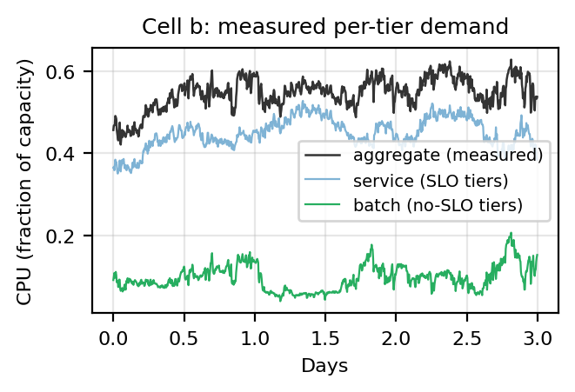
Fig. 2. Measured per-tier decomposition of cell b (3 of 31 days): service + batch equals the measured aggregate at every step.
C. Per-cell power calibration
We adopt the standard linear idle+slope server model (Eq. 1) — the form used throughout the data-center power literature [14], [17] — and fix its two constants per cell from data rather than from a single textbook value. Joining hourly PowerData2019 measured power (whose ‘power utilization’ is defined exactly as our normalization: actual power over theoretical peak [2]) with aggregate CPU over 2,980 (cell, hour) samples, least-squares gives the per-cell idle and slope of Table II. The calibration is literature-consistent: the fitted idle draw is 0.40–0.61 of each cell's peak, consistent with the substantial idle fractions reported in server-power measurements and surveys [14], [17], so the constants are credible without appeal to goodness-of-fit. We keep PER-CELL constants (not one pooled value) because the cells span a meaningful proportionality range — cell d (idle 0.38, slope 0.57) is far more energy-proportional than cell a (0.53, 0.34) — and that BETWEEN-cell spread is a routing signal available to the agent. Preferring lower marginal slope when idle power is sunk is a direct consequence of this model, not a novel RL mechanism; a single literature constant would erase it. This mirrors CICS's choice of per-cluster power models [3]. (R² is reported in Table II as a diagnostic only — 0.43 pooled vs 0.75–0.80 per cell, confirming the pooled residual is between-cell heterogeneity rather than noise — but it is not the model's justification. Using one calibrated model gives a controlled comparison, but errors in marginal slopes could still change routing rankings; the held-out-cell and domain-randomization tests probe that sensitivity.)
TABLE II. POWER MODEL CALIBRATION (POWERDATA2019)
Cell | idle | slope | R²
a | 0.528 | 0.340 | 0.79
b | 0.548 | 0.376 | 0.75
c | 0.440 | 0.526 | 0.76
d | 0.382 | 0.570 | 0.80
pooled | 0.479 | 0.444 | 0.43

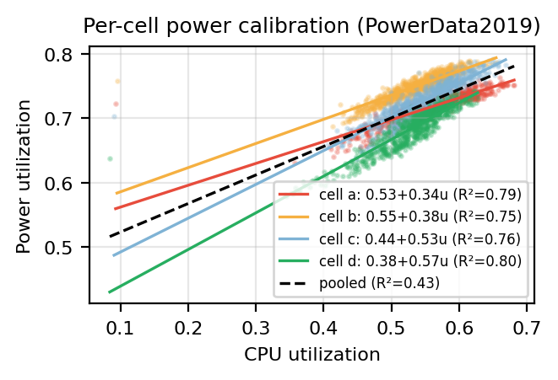
Fig. 3. Per-cell power calibration: four distinct idle/slope lines; the pooled fit (dashed) blurs them into R² = 0.43.

D. Energy Model v2 Review Gate — May 2025
No PPO retraining has been launched. This section validates the energy system and theoretical headroom first.
Experimental energy model
The primary model is one co-timestamped, real CAISO archetype: CAISO Today's Outlook native five-minute net demand; CAISO OASIS NP15 hourly day-ahead total LMP expanded stepwise to five minutes; negative prices preserved; one Pacific civil-time calendar with IANA/DST conversion; price and net demand shifted together across market slots; and no regional price re-averaging.
US slots are Pacific, Mountain, Central, and Eastern. Global slots are Pacific, Central, Amsterdam, and Singapore. Google's May-2019 workload shapes are anchored to the May-2025 energy calendar as an explicit cross-year counterfactual.
Finite-window boundary handling
The time-zone transformation is continuous rather than circular. Every slot contains exactly 8,928 five-minute intervals (744 hours), but shifted slots can use adjacent real CAISO hours at the month boundary instead of wrapping May 31 back to May 1. Singapore is 15 hours ahead of Pacific time, so its reference window replaces CAISO's first 15 hours of May (mean $21.54/MWh) with the first 15 hours of June (mean $29.16/MWh). Its monthly mean is therefore $26.09/MWh instead of Pacific's $25.93/MWh: a $0.154/MWh (0.59%) boundary effect, not extra simulated time or a Singapore price premium.
The continuous shift is retained because a circular within-May shift would create an artificial May 31-to-May 1 discontinuity. Baselines, QP, and future learned policies are compared on the same slot data within each scenario; regional monthly means are not forced to match.
Reference diagnostics
ENERGY MODEL V2 REFERENCE DIAGNOSTICS (PRICE IN USD/MWh)
Slot | Mean | Std | r(price, net) | Price peak UTC | Net peak UTC
US Pacific | $25.93 | $16.48 | 0.895 | 03:00 | 03:00
US Mountain | $25.93 | $16.48 | 0.895 | 02:00 | 02:00
US Central | $25.94 | $16.48 | 0.895 | 01:00 | 01:00
US Eastern | $25.94 | $16.48 | 0.895 | 00:00 | 00:00
Global Pacific | $25.93 | $16.48 | 0.895 | 03:00 | 03:00
Global Central | $25.94 | $16.48 | 0.895 | 01:00 | 01:00
Global Amsterdam | $25.94 | $16.47 | 0.894 | 18:00 | 18:00
Global Singapore | $26.09 | $16.39 | 0.892 | 12:00 | 12:00

Reference CAISO facts: mean DAM price is about $25.93/MWh; negative-price intervals are retained; the average local price and net-demand trough is approximately 12:00 PDT; the average local price and net-demand peak is approximately 20:00 PDT; and price/net-demand correlation is approximately 0.895.
Negative-net-demand intervals average $2.86/MWh versus $29.88/MWh otherwise. The deepest 5% of net-demand intervals average $0.11/MWh and have negative prices 56% of the time. Real energy cost therefore already strongly favors execution in the duck-curve belly.
QP headroom gate
NO-TRAINING CLAIRVOYANT-QP HEADROOM (UNRESTRICTED-ROUTING UPPER BOUND)
Scenario | Status quo | Spatial QP | Joint QP | Spatial | Joint | Temporal
US a–d | $6.568M | $6.092M | $6.045M | 7.24% | 7.95% | 0.77%
US e–h | $6.219M | $5.768M | $5.637M | 7.26% | 9.36% | 2.27%
Global a–d | $6.598M | $5.559M | $5.525M | 15.75% | 16.26% | 0.60%
Global e–h | $6.276M | $5.246M | $5.185M | 16.42% | 17.38% | 1.16%

Objective coefficient and demand-charge treatment
The frozen primary coefficient is α=0.015. Calibrated only on a–d, the Status Quo grid-stress component is 18.2% of real energy cost in US and 18.3% in Global: material but not dominant. Headroom conclusions remain stable for α∈{0,0.005,0.015,0.03}.
The standardized $15/kW-cycle demand charge is excluded from the primary reward and reported as a secondary sensitivity. It is about $4.694M for Status Quo—large enough to dominate—and is not a real Dutch or Singapore tariff. Demand-aware training remains a separate extension.
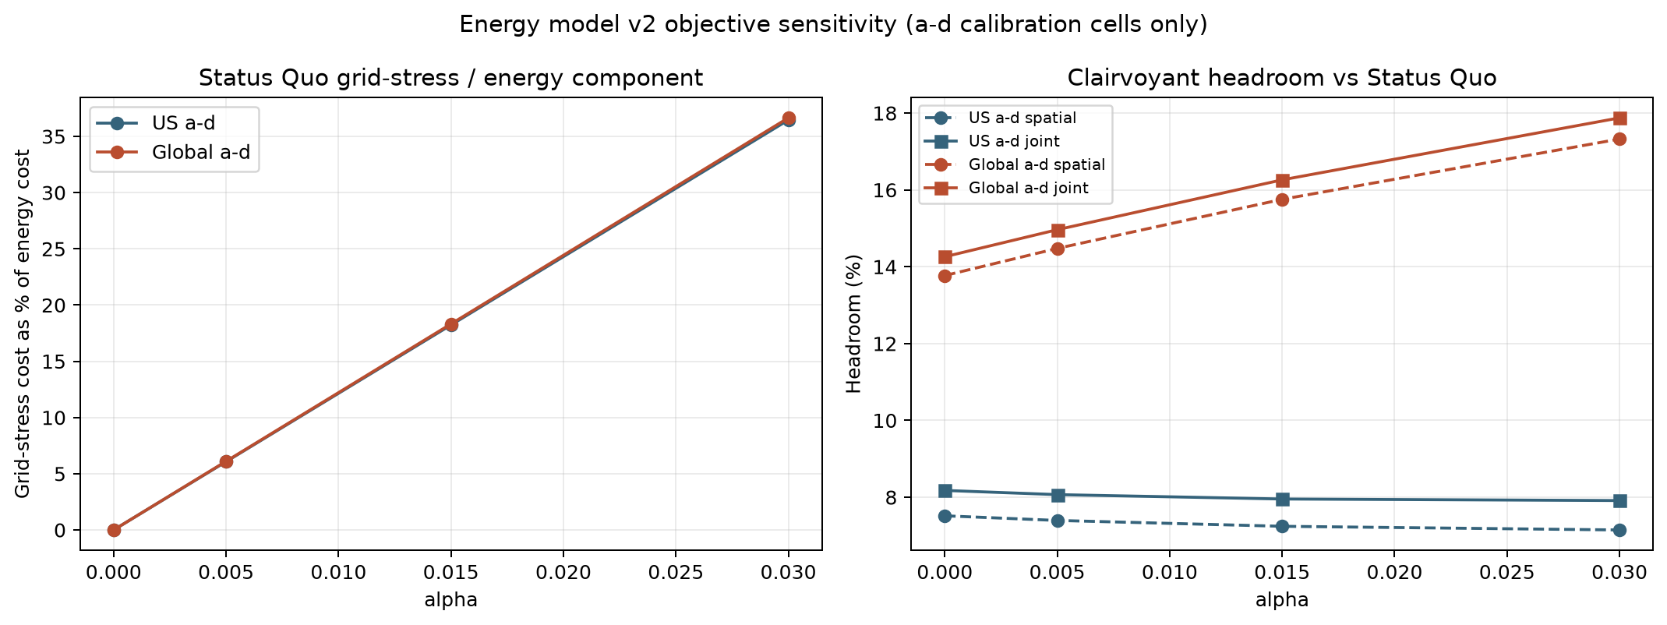
Objective sensitivity on a–d calibration cells only: component share and clairvoyant headroom across α.
Structural attribution and rated-power sensitivity
V2 uses one CAISO price level shifted in local time, so the v1 unequal-mean synthetic-price criticism no longer applies. The a–d-only ablations below diagnose interacting sources of spatial headroom; they are not an additive causal decomposition.
SPATIAL-QP STRUCTURAL ABLATIONS (A–D CALIBRATION CELLS)
Condition | US | Global
Primary | 7.24% | 15.75%
Energy only | 7.52% | 13.77%
Pooled power | 4.14% | 14.64%
Synchronous market | 5.67% | 5.67%
Shifted market only | 4.36% | 12.58%
Power heterogeneity only | 6.33% | 6.33%
Fully equal control | 0.05% | 0.05%

Shifted market phase is the dominant Global lever; calibrated per-cell power heterogeneity materially increases US headroom. The latter makes the optimization non-degenerate but is a direct linear-model consequence, not a novel RL discovery. With fixed α, R=50–200 MW yields 7.18–7.34% US and 14.81–17.35% Global headroom.
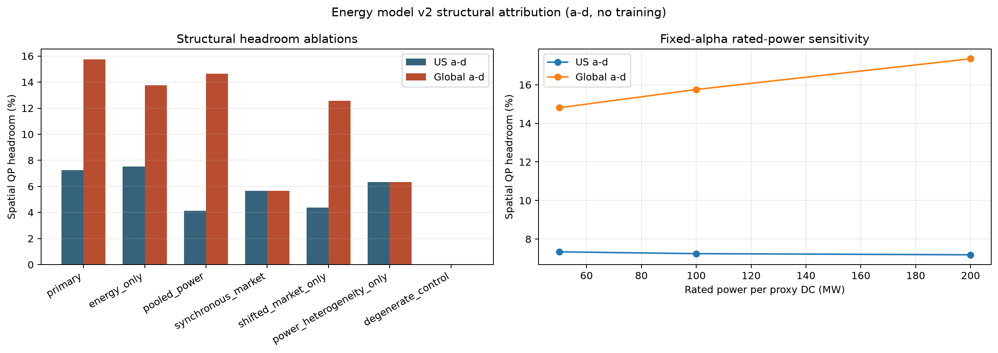
No-training structural and rated-power sensitivity on a–d calibration cells. Mechanisms interact; bars are not additive attributions.
Experimental deadline sensitivity
ClusterData 2019 supplies no deadlines. The primary φ=1 gives H=2μ. Clairvoyant robustness at φ=0 (H=μ) yields 0.3–1.2% incremental temporal headroom; primary φ=1 yields 0.6–2.3%; loose φ=2 (H=3μ) yields 0.8–3.2%. Temporal value remains secondary across the sweep.
Figures
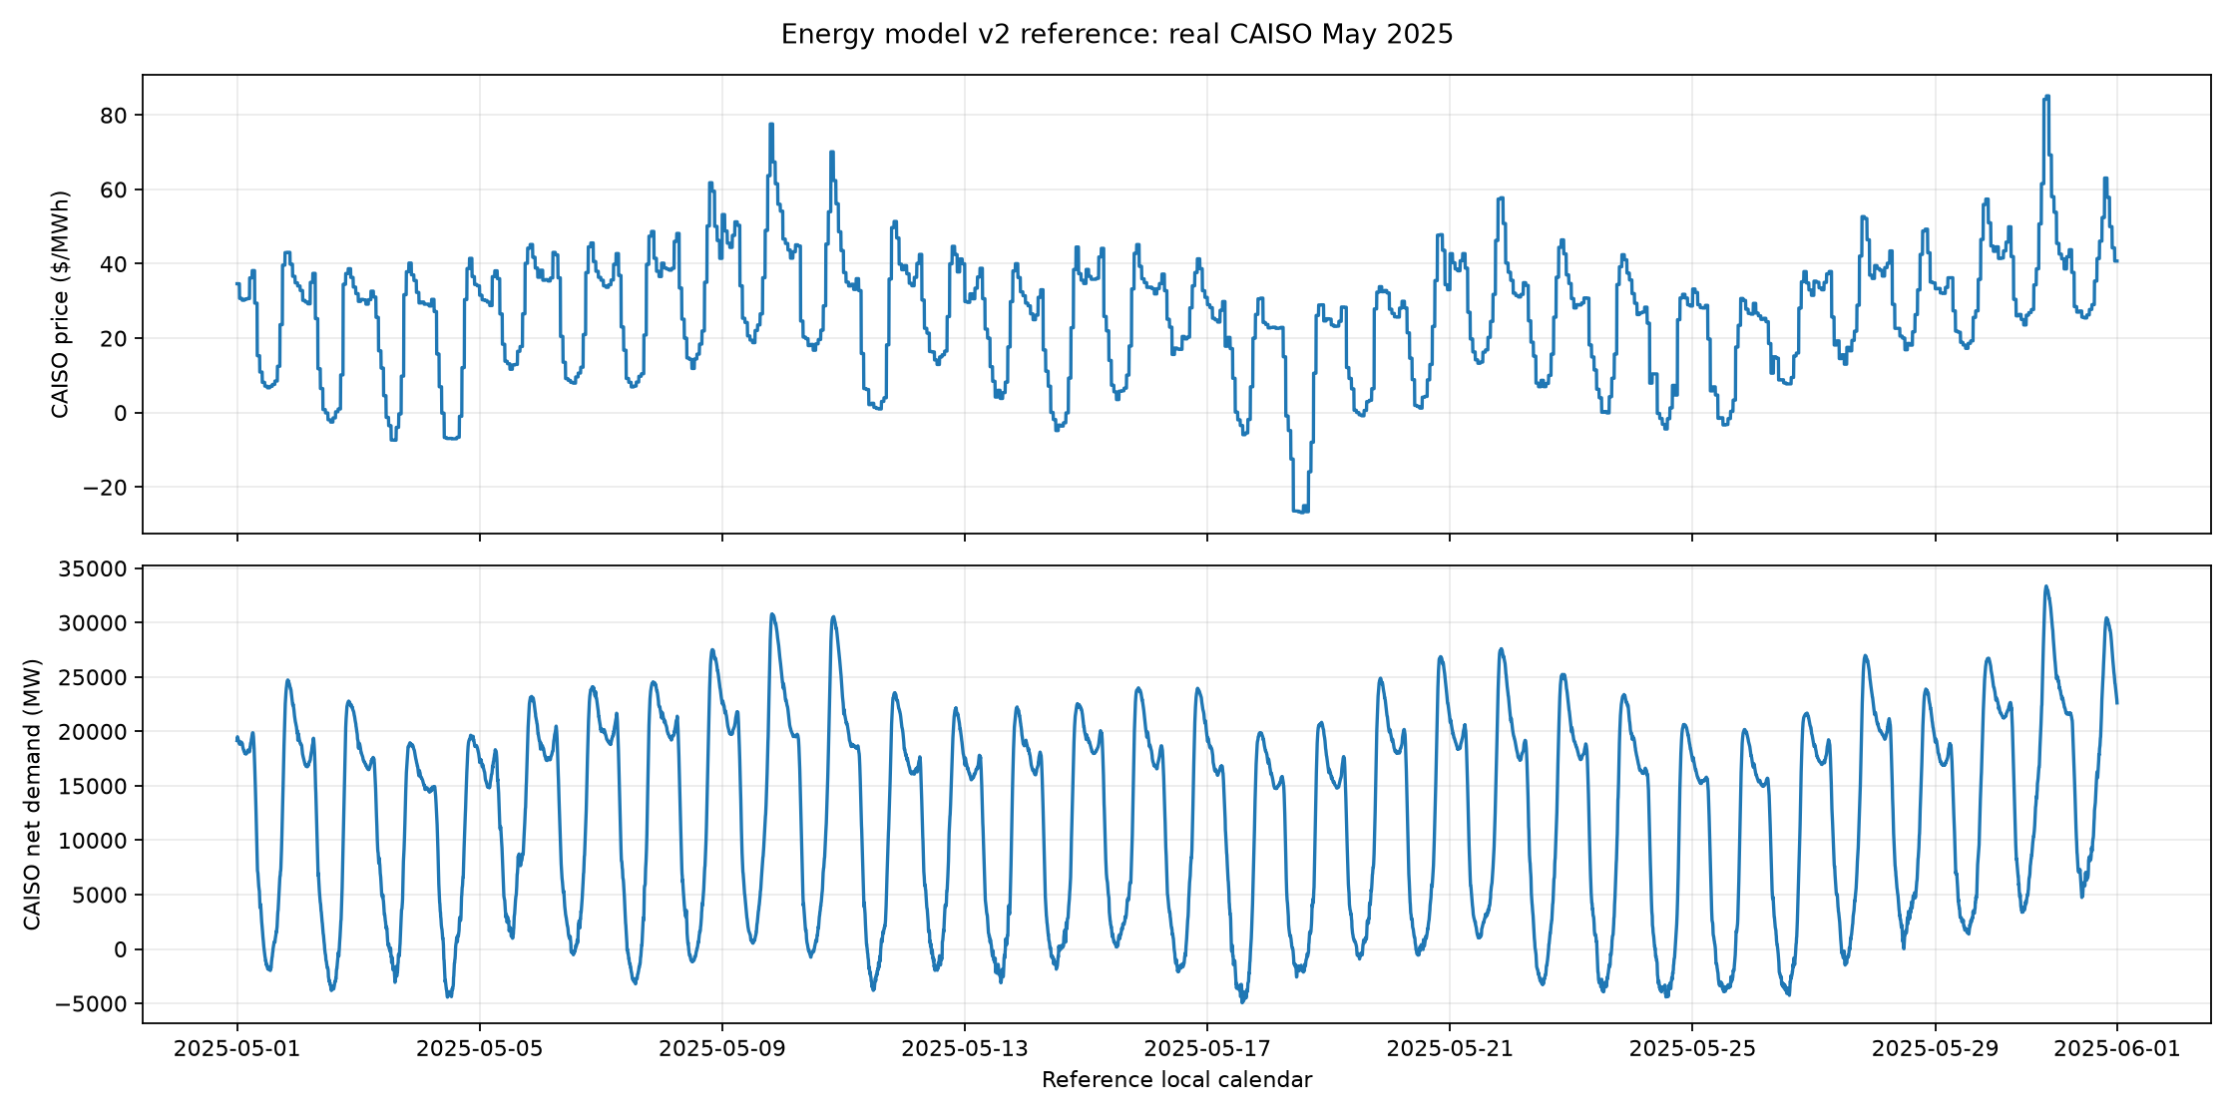
Energy model v2 reference month: real May-2025 CAISO day-ahead price, net demand, and solar.
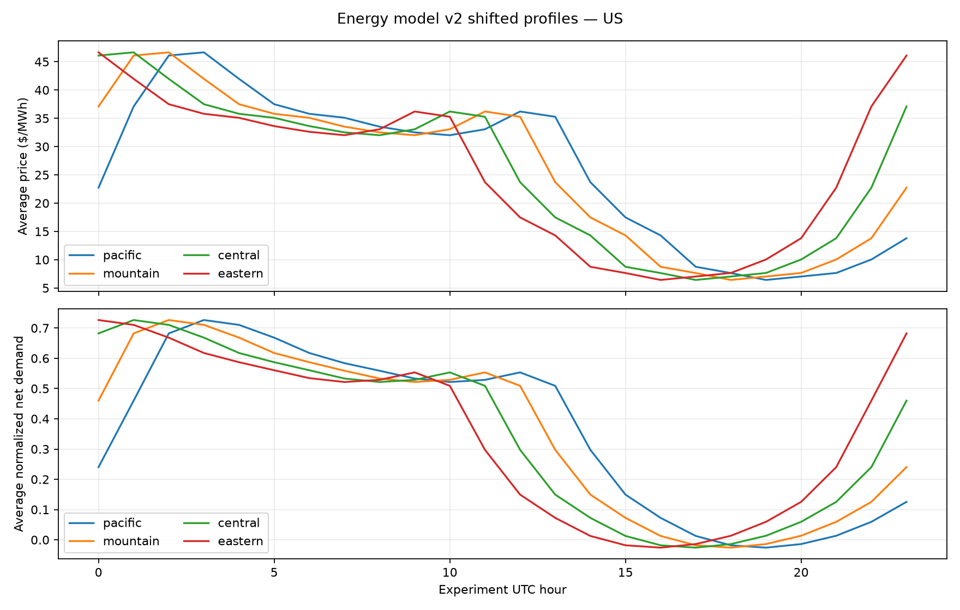
Energy model v2 average daily profiles shifted across Pacific, Mountain, Central, and Eastern slots.
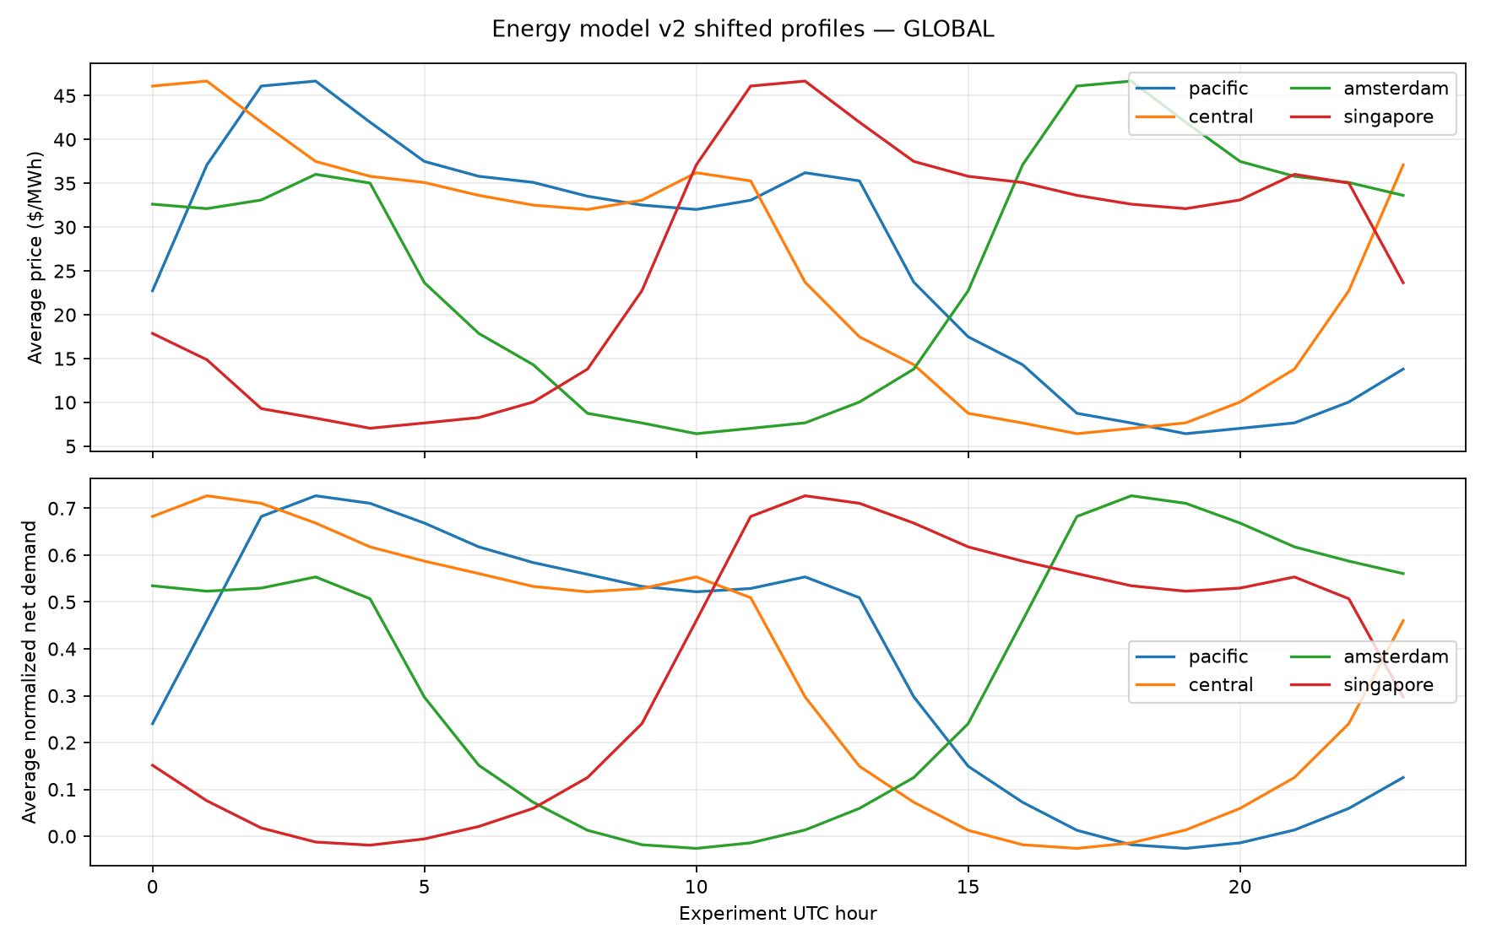
Energy model v2 average daily profiles shifted across Pacific, Central, Amsterdam, and Singapore slots.
Review interpretation
The corrected signed-demand/equal-capacity model creates 8.0–17.4% optimistic unrestricted-routing joint headroom depending on scenario. Spatial diversity remains dominant. Incremental temporal headroom is positive but modest at 0.6–2.3%.
Explicit limitations and future work
The primary experiment is a controlled CAISO archetype, not a real multi-market replay. Regional price levels are intentionally not re-averaged. Time-zone shifts use adjacent real boundary hours rather than a circular within-May wrap, so shifted monthly means can differ slightly. Five-minute RTM price is future robustness work. Historical 2019/2024 duck-curve comparison and extrapolation are future work, not additional training scenarios. Workload shapes are from May 2019 while the energy calendar is May 2025; this is an explicit counterfactual. OOF holds out workload cells, not the shared energy month. Routing is unrestricted across all slots; latency, residency, and movement are future work. MPC is future work; the QP is a clairvoyant diagnostic only.
Gate status
The α=0.015 primary objective and secondary demand-charge treatment are frozen with a 501,760-step, 10-seed, two-fold runner. No PPO training has begun; the committed checkpoint must pass the runner's clean-tree preflight before launch.

V. FURTHER TOPICS OF CONSIDERATION
(1) Market robustness: compare the primary NP15 DAM archetype with CAISO five-minute RTM and, later, a documented real multi-market replay with regional price levels and demand shapes. (2) Historical comparison: quantify how the 2025 duck curve deepened from 2019/2024 and test extrapolated future curves. (3) Sensitivity sweeps: deferrable fraction, rated power R, flexibility factor φ, peak weight α, and workload seasonality. (4) Bound global routing with latency, residency, and movement-cost constraints. (5) Add marginal carbon intensity to compare directly with CICS [3]. (6) Add a causal receding-horizon MPC comparator with day-ahead price and net-demand forecasts. (7) Explore constrained RL for completion guarantees. (8) Add a job-level inner scheduler below the aggregate controller. (9) Extend the action space to storage and demand response. (10) Transfer to other public workload traces. (11) Test peak-aware policy designs against the demand-charge QP. (12) Add a ramp-aware objective only if the first v2 policies worsen the reported one-hour/three-hour physical ramp KPIs.
VI. CONCLUSION
The active thesis experiment now begins with a reproducible real energy model rather than a mixture of synthetic regional inputs. One May-2025 CAISO net-demand/solar series and one NP15 day-ahead price series are shifted together across four US and four global local-time slots. The 8,928-step calendar preserves negative prices, aligns the average trough near noon and the average peak near 20:00 PDT, and yields price/net-demand correlation of approximately 0.895. Continuous boundary handling keeps real chronology: Singapore's slightly higher monthly mean comes from substituting 15 real June boundary hours, not extra duration or a regional premium. Equal 100 MW unit-capacity proxies and observed current batch arrivals now pass the preflight. The corrected QP gate shows 8.0–17.4% joint headroom but only 0.6–2.3% incremental temporal value. α=0.015 makes grid stress about 18% of energy cost; the standardized demand charge remains secondary. The mixed/synthetic v1 campaigns remain archived; no learned-policy claim will be promoted until the frozen v2 out-of-fold campaign is trained and evaluated.
REFERENCES
[1] M. Tirmazi, A. Barker, N. Deng, M. E. Haque, Z. G. Qin, S. Hand, M. Harchol-Balter, and J. Wilkes, “Borg: the Next Generation,” in Proc. EuroSys, 2020.
[2] V. Sakalkar, V. Kontorinis, D. Landhuis, S. Li, D. De Ronde, T. Blooming, A. Ramesh, J. Kennedy, C. Malone, J. Clidaras, and P. Ranganathan, “Data Center Power Oversubscription with a Medium Voltage Power Plane and Priority-Aware Capping,” in Proc. ASPLOS, 2020; companion dataset documentation: https://github.com/google/cluster-data/blob/master/PowerData2019.md.
[3] A. Radovanović, R. Koningstein, I. Schneider, B. Chen, A. Duarte, B. Roy, D. Xiao, M. Haridasan, P. Hung, N. Care, S. Talukdar, E. Mullen, K. Smith, M. Cottman, and W. Cirne, “Carbon-Aware Computing for Datacenters,” IEEE Trans. Power Systems, vol. 38, no. 2, pp. 1270–1280, Mar. 2023, doi: 10.1109/TPWRS.2022.3173250 (arXiv:2106.11750).
[4] L. Grange, G. Da Costa, and P. Stolf, “Green IT scheduling for data center powered with renewable energy,” Future Generation Computer Systems, vol. 86, pp. 99–120, 2018.
[5] G. Da Costa, L. Grange, and I. De Courchelle, “Modeling and generating large-scale Google-like workload,” in Proc. Int. Green and Sustainable Computing Conf. (IGSC), 2016.
[6] D. Zhao, J.-t. Zhou, and K. Li, “CFWS: DRL-Based Framework for Energy Cost and Carbon Footprint Optimization in Cloud Data Centers,” IEEE Trans. Sustainable Computing, vol. 10, no. 1, pp. 95–107, Jan./Feb. 2025, doi: 10.1109/TSUSC.2024.3391791.
[7] M. Xu, A. N. Toosi, and R. Buyya, “A Self-Adaptive Approach for Managing Applications and Harnessing Renewable Energy for Sustainable Cloud Computing,” IEEE Trans. Sustainable Computing, 2020.
[8] K. Haghshenas, A. Taheri, M. Goudarzi, and S. Mohammadi, “Infrastructure-Aware Heterogeneous-Workloads Scheduling for Data Center Energy Cost Minimization,” IEEE Trans. Cloud Computing, 2022.
[9] Z. Liu, Y. Chen, C. Bash, A. Wierman, D. Gmach, Z. Wang, M. Marwah, and C. Hyser, “Renewable and Cooling Aware Workload Management for Sustainable Data Centers,” in Proc. ACM SIGMETRICS, 2012.
[10] Í. Goiri, K. Le, M. E. Haque, R. Beauchea, T. D. Nguyen, J. Guitart, J. Torres, and R. Bianchini, “GreenSlot: Scheduling Energy Consumption in Green Datacenters,” in Proc. SC, 2011.
[11] W. Lin et al., “A systematic review of green-aware management techniques for sustainable data center,” Sustainable Computing: Informatics and Systems, 2024.
[12] Y. Wu et al., “Task Scheduling in Geo-Distributed Computing: A Survey,” arXiv:2501.15504, 2025.
[13] T. L. Vasques, P. Moura, and A. de Almeida, “A review on energy efficiency and demand response with focus on small and medium data centers,” Energy Efficiency, vol. 12, 2019.
[14] M. Dayarathna, Y. Wen, and R. Fan, “Data Center Energy Consumption Modeling: A Survey,” IEEE Communications Surveys & Tutorials, vol. 18, no. 1, 2016.
[15] H. Kahil, S. Sharma, P. Välisuo, and M. Elmusrati, “Reinforcement learning for data center energy efficiency optimization: A systematic literature review and research roadmap,” Applied Energy, 2024.
[16] Y. Ran, H. Hu, X. Zhou, and Y. Wen, “DeepEE: Joint Optimization of Job Scheduling and Cooling Control for Data Center Energy Efficiency Using Deep Reinforcement Learning,” in Proc. IEEE ICDCS, 2019.
[17] X. Fan, W.-D. Weber, and L. A. Barroso, “Power provisioning for a warehouse-sized computer,” in Proc. ISCA, 2007.
[18] J. Schulman, F. Wolski, P. Dhariwal, A. Radford, and O. Klimov, “Proximal Policy Optimization Algorithms,” arXiv:1707.06347, 2017.
[19] V. Mnih et al., “Human-level control through deep reinforcement learning,” Nature, vol. 518, 2015.
[20] A. Raffin, A. Hill, A. Gleave, A. Kanervisto, M. Ernestus, and N. Dormann, “Stable-Baselines3: Reliable Reinforcement Learning Implementations,” JMLR, vol. 22, 2021.
[21] D. G. Feitelson, Workload Modeling for Computer Systems Performance Evaluation. Cambridge University Press, 2015.
[22] J. Wilkes, “Google cluster-usage traces v3,” Google Inc., technical documentation distributed with ClusterData2019, rev. 2020-08.
[23] A. Qureshi, R. Weber, H. Balakrishnan, J. Guttag, and B. Maggs, “Cutting the Electric Bill for Internet-Scale Systems,” in Proc. ACM SIGCOMM, 2009.
[24] L. Rao, X. Liu, L. Xie, and W. Liu, “Minimizing Electricity Cost: Optimization of Distributed Internet Data Centers in a Multi-Electricity-Market Environment,” in Proc. IEEE INFOCOM, 2010.
[25] Z. Liu, M. Lin, A. Wierman, S. H. Low, and L. L. H. Andrew, “Greening Geographical Load Balancing,” in Proc. ACM SIGMETRICS, pp. 233–244, 2011, doi: 10.1145/1993744.1993767.
[26] A. Naug, A. Guillen, R. Luna, V. Gundecha, D. Rengarajan, S. Ghorbanpour, S. Mousavi, A. Ramesh Babu, D. Markovikj, L. D. Kashyap, and S. Sarkar, “SustainDC: Benchmarking for Sustainable Data Center Control,” in Advances in Neural Information Processing Systems (NeurIPS), 2024.
[27] Hewlett Packard Enterprise, “SustainCluster: A high-fidelity, open-source Gymnasium environment for benchmarking multi-objective, sustainable workload scheduling across geo-distributed data centers,” GitHub repository, MIT License, https://github.com/HewlettPackard/sustain-cluster (accessed Aug. 2026).
[28] International Energy Agency, “Energy and AI,” IEA, Paris, Jan. 2025. [Online]. Available: https://www.iea.org/reports/energy-and-ai.
[29] J. McLaren et al., “Identifying Potential Markets for Behind-the-Meter Battery Energy Storage: A Survey of U.S. Demand Charge Rates,” NREL/TP-6A20-64980, National Renewable Energy Laboratory, 2015.

