Grid-Aware Spatio-Temporal Load Shaping for Geo-Distributed Data Centers via Deep Reinforcement Learning:
A Cell-Aggregate Study on Google ClusterData 2019
Janusz Gal
Master's Thesis Draft — frozen energy-model v2 campaign: 80 PPO models, two symmetric held-out workload folds, and 10 optimizer seeds/configuration. The broad joint-shaping headline criterion failed; v1 remains historical. A post-hoc exploratory v3 recovery study (Sec. VII) partially repairs a v2 state-observability defect and re-screens PPO under a stricter safety-first gate; it still fails, reinforcing rather than reversing the frozen v2 conclusion. A completed v4 hard-safety study (Sec. VIII) then adds a non-MPC one-step feasibility projector — 36 newly trained models plus an archived-policy replay — that gives every evaluated seed exact completion with zero infeasibility certificates, while honestly separating the deterministic safety guarantee from the learned, projector-mediated economics.
Abstract — Hyperscale data centers are now grid-scale electrical loads whose consumption coincides with regional net-demand peaks (the “duck curve”). We study whether a reinforcement-learning agent can route workload across geographically distributed data centers — spatially (where) and temporally (when, for deferrable batch work) — to minimize electricity cost while reducing the fleet's contribution to grid stress. The active experiment combines Google ClusterData 2019 workload shapes and PowerData2019-calibrated power models with one co-timestamped, real May-2025 CAISO archetype: native five-minute net demand and solar plus NP15 day-ahead LMP. Price and net demand are shifted together by local wall time across four US slots and four global slots, preserving negative prices and signed net demand over a complete 8,928-step (744-hour) experiment. Measured workload shapes map to equal 100 MW/unit-capacity proxies, and current batch arrivals are observed before same-step release. Routing is unrestricted and therefore represents an optimistic upper bound, not a deployment claim. The corrected clairvoyant-QP gate finds 8.0–17.4% joint headroom, of which only 0.6–2.3% is incremental temporal value. We then train 80 PPO models under a frozen two-fold a–d/e–h protocol with 10 seeds/configuration and no test-fold selection. Global spatial PPO is the only robust learned success, saving 0.90% and 1.19% on the two held-out folds; both optimizer-bootstrap CIs and wider t-interval sensitivities remain positive. US spatial savings are not established (−0.29% and +0.07%). Joint batch control fails the frozen headline: only 9/40 batch seeds meet the 99.99% completion floor, and joint PPO does not reliably improve over separately trained spatial PPO. Spatial PPO lowers the secondary demand-charge reference, whereas joint PPO raises it and worsens rare maximum three-hour ramps. Thus the evidence supports a small optimistic Global spatial effect, not reliable joint spatio-temporal optimization. A post-hoc exploratory v3 study adds episode progress and deadline buckets and re-screens PPO across a GAE/KL/learning-rate/idle-subtraction/potential/normalization sweep and a three-point budget curve (151,552–1,003,520 steps) under a stricter safety-first gate requiring all ten seeds feasible and a positive optimizer-bootstrap interval. It still fails: the safety-first-selected US configuration is 1/10 feasible with a CI crossing zero, and the Global configuration is 1/10 feasible despite a positive CI, so unconstrained PPO remains unsuitable as a trustworthy joint controller under this model. A completed v4 hard-safety study (Sec. VIII) then replaces the shaped, sigmoid-capped drain decoder with a non-MPC one-step Euclidean feasibility projector — cumulative exact earliest-deadline-first admission, exact transport conservation, and exact 0–100% drain endpoints under a frozen, train-only-derived capacity bound with a proven no-leakage property — and trains 36 new PPO+projector models (plus a no-retraining replay of the archived v3 weights). Every evaluated seed, across replay, the staged a–d gate, and descriptive e–h transfer, reaches exact completion with zero expiry and zero infeasibility certificates. US remains economically indistinguishable from Status Quo (−0.246% a–d, −0.149% e–h) while the projector rarely intervenes (≤0.6% of steps); Global is unambiguously positive (+3.262% a–d, +3.611% e–h, every seed and CI positive) but the projector materially alters roughly one step in five (18.8–20.2%), so that gain is attributed to the composed PPO+projector system rather than to unconstrained PPO alone.
Index Terms — data centers, demand response, reinforcement learning, workload scheduling, duck curve, Google cluster trace, load shaping.

I. INTRODUCTION
Data centers consumed roughly 415 TWh of electricity in 2024, and the IEA projects consumption to more than double to ~950 TWh — about 3% of global electricity demand — by 2030 [28]; the geographic concentration of hyperscale campuses turns individual operators into grid-scale loads. Simultaneously, solar-heavy grids exhibit the duck curve: midday renewable generation depresses net demand, followed by a steep evening ramp during which prices spike and grid stress peaks. A data-center fleet that concentrates its draw during these ramps contributes directly to system peaks; a fleet that shifts flexible work across locations and hours can instead smooth them. Google's production Carbon-Intelligent Computing System (CICS) demonstrates temporal shifting at hyperscale [3]; geographic load-balancing work establishes the spatial lever [23]–[25]. Open RL environments for sustainable data-center scheduling now exist — SustainDC for within-DC multi-agent control [26] and SustainCluster for geo-distributed per-task dispatch [27] — but none provides measured per-tier (flexible vs. inflexible) demand decomposition of a hyperscale trace, power models calibrated on companion power measurements, or a grid net-demand (duck-curve) objective; those are the gaps this thesis fills.
This thesis asks: can a model-free reinforcement-learning agent, observing only per-site demand, prices, and grid net demand, learn a joint spatial-temporal load-shaping policy that beats the grid-unaware status quo? The frozen evidence gives a qualified answer: Global spatial routing transfers with a small positive effect, US spatial savings are not established, and joint batch control is unstable and fails the completion criterion. The energy/system construction succeeds as a reproducible test bed; the broad learned joint-optimization claim does not.
Contributions. (C1) A reproducible Gymnasium environment for multi-data-center grid-aware load shaping at cell-aggregate granularity, grounded in Google ClusterData 2019 [1] and PowerData2019 [2]. (C2) Ground-truth measured per-tier demand decomposition (SLO service vs. no-SLO batch) of four trace cells, with the finding that resource requests overestimate the deferrable usage share by 3–5×. (C3) A real, reproducible May-2025 CAISO duck-curve/price archetype whose paired signals are shifted by IANA local wall time across US and global slots. (C4) A no-training QP gate that sizes the opportunity before policy selection and shows that spatial diversity dominates temporal flexibility. (C5) A provenance-locked 80-model held-out campaign showing a robust but small Global spatial effect and a negative result for reliable joint batch control. (C6) A preserved audit trail of the retired mixed/synthetic model and the simulator corrections that prevented invalid results from being promoted. (C7) A post-hoc exploratory v3 state-repair and budget-scaling study (Sec. VII) showing the v2 joint failure survives an augmented state representation and a 2× larger training budget, so it is not merely an observability artifact. (C8) A completed v4 hard-safety study (Sec. VIII): a non-MPC one-step feasibility projector with a frozen, train-only, no-leakage capacity envelope, exact transport and exact drain endpoints, a ten-test smoke suite, and a staged replay/short/medium/full/e–h gate protocol across 36 newly trained models that achieves zero completion failures fleet-wide while making explicit that Global's positive economic result — unlike US's null one — is jointly attributable to the PPO+projector system rather than to the learned policy alone.
II. RELATED WORK AND METHODOLOGICAL LINEAGE
The current thesis combines four established ideas rather than claiming a new scheduling paradigm: measured aggregate workload shaping, geographic load balancing, deadline-constrained deferral, and model-free control. This section identifies only the lineage that remains active in energy-model v2.
A. Aggregate workload shaping and trace semantics
ClusterData 2019 [1] defines a Borg cell as one management unit and reports five-minute, normalized resource usage across eight heterogeneous cells. We use those measured cell aggregates directly. Collection priority separates the no-SLO free/best-effort tiers (priority ≤115 [22]) from SLO-bearing service; no synthetic arrival stream is used in the primary experiment. PowerData2019 [2] supplies the companion per-cell power calibration.
Google's CICS [3] is the main production precedent for this granularity. It shapes aggregate flexible and inflexible cluster demand independently of the real-time job scheduler, using cluster-specific forecasts and power models. Our temporal abstraction follows that aggregate view, while the objective changes from carbon to electricity cost and grid net demand. CICS is a precedent, not a reproduced system, and it does not supply our spatial head.
B. Geographic load balancing for electricity cost
Spatial electricity-price arbitrage across internet-scale systems predates the renewable-aware literature: Qureshi et al. quantified the savings from routing request load toward cheap electricity markets [23]; Rao et al. formalized cost minimization for distributed data centers across multiple electricity markets [24]; and Liu, Lin, Wierman, Low and Andrew gave the optimization treatment of geographical load balancing with renewable supply, characterizing when 'follow the renewables' routing is optimal [25]. Our spatial lever is a direct descendant of this lineage — with two displacements: the objective targets grid net demand (the duck-curve quantity) rather than price alone, and the routed quantity is measured aggregate tier demand rather than request traffic.
C. Deadline-constrained deferral
GreenSlot [10] and related single-DC work establish the basic temporal idea: delay flexible work toward predicted cheap or renewable-rich intervals. Grange et al. [4] add due-date constraints; Xu et al. [7] distinguish interactive from deferrable work; Haghshenas et al. [8] and Liu et al. [9] combine heterogeneous load with prices or forecasts. We borrow the pool-and-deadline abstraction, not their job-level placement mechanisms. In our aggregate model, measured no-SLO demand enters a queue and the controller selects its release rate and execution site.
D. Reinforcement learning and open environments
Model-free RL is established for data-center control [15], with DeepEE [16] as one example of joint scheduling and infrastructure control. We use PPO [18] because the current action is continuous: routing fractions, release rates, and batch-placement fractions. The paper does not claim a new RL algorithm; its contribution is the measured workload/energy formulation and the controlled evaluation around it.
SustainDC [26] addresses multi-agent control within a data center, while SustainCluster [27] dispatches individual Alibaba GPU tasks across many locations with carbon, cost, SLA, and transmission objectives. They are complementary rather than drop-in baselines: this thesis controls divisible aggregate Google-cell demand and explicitly targets CAISO net-demand shape. Reproducing the same question in either benchmark would require changing its workload granularity or objective.
E. Current positioning
The active contribution is a controlled geo-distributed workload-shaping experiment that combines measured aggregate service/batch curves, per-cell power models, and one real May-2025 CAISO net-demand/price archetype shifted across US and global local-time slots. A clairvoyant QP sizes spatial and temporal headroom before PPO is trained. This is not a real multi-market replay, a CICS reproduction, or a VM/job scheduler, and no archived v1 learned-policy result is promoted as v2 evidence.
III. SYSTEM MODEL
N = 4 data centers, indexed by i, j ∈ {1,…,N} (i is the site under consideration; j is a running index used in fleet-wide sums), operate over T = 8,928 five-minute steps, indexed by t, τ ∈ {1,…,T} (t is the current step; τ is a running index over earlier steps), with Δ = 300 s and Δh = 1/12 h. Site i has measured aggregate demand curve wᵢ,ₜ ∈ [0,1] (fraction of cell capacity), decomposed by measured priority tier into non-deferrable service demand vᵢ,ₜ and deferrable batch arrivals aᵢ,ₜ with wᵢ,ₜ = vᵢ,ₜ + aᵢ,ₜ exactly. The total service demand pooled across the fleet at step t is Dₜ = Σᵢ vᵢ,ₜ — the quantity the routing fractions redistribute. Site inputs further include electricity price πᵢ,ₜ ($/kWh), signed grid net demand dᵢ,ₜ ∈ [−1,1] (negative = renewable oversupply, positive = residual grid load), and normalized proxy capacity κᵢ = 1.
A. Equal-capacity proxy, power, and cost
Each wᵢ,ₜ is already measured CPU usage divided by its SOURCE cell's CPU capacity. We use that real curve as a utilization shape and map it onto an equal 100 MW proxy DC. Therefore every destination has κᵢ = 1: w = 0.70 means 70% of that proxy's capacity. Raw machine totals remain provenance metadata and support calibration; they do not shrink destination capacity again. This avoids mixing own-cell utilization units with capacity expressed relative to the largest source fleet.
Each site has a per-cell calibrated linear power model — the standard idle+slope server model [14], [17] (Sec. IV-C):
Pᵢ(u) = Pᵢⁱᵈˡᵉ + sᵢ · u (1)
gᵢ,ₜ = Pᵢ(uᵢ,ₜ) · R, R = 100 MW (2)
where uᵢ,ₜ∈[0,1] is served utilization of the equal 100 MW proxy, Pᵢⁱᵈˡᵉ is cell i's idle power (its draw at zero CPU, as a fraction of theoretical peak), sᵢ is its marginal power slope (the extra power per unit of CPU and an observable routing context), R is rated power per site, and g is the grid draw (sites are pure grid loads; no on-site generation). Energy cost and the quadratic, net-demand-weighted peak-contribution penalty are
Eₜ = Σᵢ πᵢ,ₜ · gᵢ,ₜ · 1000 · Δh (3)
Φₜ = α · Σᵢ gᵢ,ₜ² · max(dᵢ,ₜ,0) (4)
The quadratic form penalizes concentration; the d-weighting makes draw near the duck-curve neck expensive. Signed d remains observable, while max(d,0) keeps the QP convex. At negative net demand Φ is zero; the real low or negative LMP provides the economic reward for moving work into the duck-curve belly. Φ is a grid-stress SHADOW PRICE, not a tariff: α must be selected by a documented v2 component/sensitivity study, not inherited from v1 or derived from a rate schedule, and Φ differs from a commercial demand charge in all three respects that matter — it is summed over every interval rather than taken as a maximum, it is quadratic rather than linear in kW, and it is weighted by grid net demand, which no tariff observes.
All slots use the same CAISO archetype and signed MW denominator, so d is comparable by construction inside this controlled experiment. This is not a claim that real California, Amsterdam, and Singapore systems have equal physical scarcity.
Ramp-rate treatment — evaluated, not optimized.
The duck curve combines a deep midday trough with a steep upward evening ramp. The primary objective addresses trough economics and HIGH net-demand EXPOSURE, but contains no derivative dₜ−dₜ₋H; it does not directly optimize ramp rate. Price is an incomplete proxy: its correlation is 0.895 with net-demand level but only 0.206 with the one-hour ramp and 0.429 with the three-hour ramp.
This omission is deliberate for the first v2 campaign. Concentrating work during negative-demand, very-low-price intervals is acceptable within proxy capacity, and Φ is zero there. Evaluation reports per-region maximum and 95th-percentile upward ramps for H=1 hour and H=3 hours, comparing max(0,Nₜ−Nₜ₋H) with max(0,(Nₜ+gₜ)−(Nₜ₋H+gₜ₋H)). Regions are not summed into a fictitious global grid. A ramp-aware reward is future work and will be introduced only if the first v2 policies worsen these physical KPIs. Status Quo changes the maximum one-hour regional ramp by only −0.4 to +1.7 MW across scenarios against an 11,465 MW raw CAISO maximum; trained-policy effects remain unknown.
Because that distinction is easy to lose, the operator's actual tariff term is modeled separately. Commercial and industrial customers are billed on the single highest demand interval of each billing period, per meter. Such charges can be a substantial C&I bill component, but the share is tariff- and customer-specific; our reference sensitivity assumes no universal percentage. The billed quantity is the sum of per-SITE maxima, not the fleet coincident peak:
Ψ = c · Σᵢ maxₜ gᵢ,ₜ · 1000, c in $/kW per billing period (5)
A maximum over the period is not a per-step cost, so Ψ is charged in the telescoping form below, where Dᵢ,ₜ = maxₜ′≤ₜ gᵢ,ₜ′ is the running billed peak. Each step pays exactly the amount by which it raises the running maximum, and the sum over a period is exactly Ψ:
ψᵢ,ₜ = c · max(0, gᵢ,ₜ − Dᵢ,ₜ₋₁) · 1000, Σₜ ψᵢ,ₜ = c · maxₜ gᵢ,ₜ · 1000 (6)
The complete 8,928-step episode is one study billing cycle by default, so c is applied exactly once and the in-reward quantity matches the post-hoc metric. A shorter configured period is a different tariff with its own $/kW-period rate, not a monthly proxy. The telescoping identity is exact under the RL objective only when gamma = 1; the training entry points therefore select gamma = 1 whenever the term is enabled and reject a lower discount. The observation then includes Dᵢ,ₜ₋₁ for every site plus billing-period progress and the active-rate fraction, and a new period is reset before its first observation. Together these make the tariff state Markov and prevent actions from seeing a stale prior-period peak. The v2 primary protocol fixes c=0 in the reward and reports the standardized $15/kW-cycle charge as a secondary sensitivity for every policy. Demand-aware training is a separate extension.
The $15/kW reference is a sensitivity analysis rather than a reconstruction of four utility bills. It is a mid-range US commercial/industrial reference within the broad tariff range catalogued by the NREL demand-charge survey [29]; it uses that one US rate across all geographies solely for comparison, treats each five-minute trace sample as a demand interval, aligns the cycle to the episode, and omits site-specific time-of-use demand tiers, ratchets, contract demand, and power-factor clauses.
The reference charge is about $4.694M for Status Quo, large enough to dominate the controlled objective, and it is not a real Dutch or Singapore tariff. These are the reasons it is not primary.
B. Deferrable batch dynamics
Each origin site maintains a batch pool with per-entry deadlines. Queue timing must be explicit: Q⁻ᵢ,ₜ is work carried into step t before the current arrival and deadline boundary; Q⁺ᵢ,ₜ is the work eligible for release after arrival aᵢ,ₜ is added and expired work Xᵢ,ₜ is removed. The per-cell deadline horizon follows fitted mean duration μᵢ and flexibility factor φ = 1 (after [4]). An arrival at t is eligible during steps t,…,t+Hᵢ−1 and expires at the start of t+Hᵢ if unfinished:
Because the current action may release part of aᵢ,ₜ in the same step, aᵢ,ₜ is included explicitly in the pre-action observation alongside Q⁻, service demand, urgency, price, net demand, and site context. The decision process therefore observes every state variable that determines its same-step transition.
The trace contains no job deadlines. Hᵢ is therefore an experimental control semantic, not a recovered SLO: μᵢ is fitted from observed duration and φ sets counterfactual slack. The primary model freezes φ=1 (H=2μ); robustness uses φ∈{0,2}, corresponding to H∈{μ,3μ}.
Hᵢ = ⌈ μᵢ (1 + φ) / Δ ⌉ (7)
Q⁺ᵢ,ₜ = Q⁻ᵢ,ₜ + aᵢ,ₜ − Xᵢ,ₜ; rᵢ,ₜ = δᵢ,ₜQ⁺ᵢ,ₜ; Q⁻ᵢ,ₜ₊₁ = Q⁺ᵢ,ₜ − qᵢ,ₜ (8)
Here rᵢ,ₜ is origin i's requested release and qᵢ,ₜ is the amount of that origin's work actually completed anywhere in the fleet. This two-phase notation resolves an indexing ambiguity in earlier drafts: if Q were instead defined as the post-arrival pool, its next-step recurrence would indeed use aᵢ,ₜ₊₁. With Q⁻ defined before the arrival, aᵢ,ₜ in Eq. (8) is correct. A release is only an intent to run; capacity-blocked work remains in Q with its original deadline. Only completed q leaves the pool and only work at its deadline boundary becomes X.
C. Action, serving, and reward
The agent outputs a ∈ [−3,3]³ᴺ, decoded as service routing fractions f = softmax(a₁:ₙ), drain rates δ = sigmoid(aₙ₊₁:₂ₙ), and batch placement h = softmax(a₂ₙ₊₁:₃ₙ) — batch work, having no latency SLO, may execute anywhere. Indices now distinguish origin i from execution site j. Service has first claim on each unit-capacity proxy; batch runs in the remainder:
The primary controlled experiment assumes both service and batch are freely routable among all four slots, including intercontinental Global routing. Latency, data residency, and movement cost are not modeled. This is an explicit optimistic assumption, not an operational deployment claim.
σⱼ,ₜ=min(fⱼ,ₜDₜ+Bⱼ,ₜ₋₁,κⱼ); yⱼ,ₜ=min(hⱼ,ₜΣᵢrᵢ,ₜ,κⱼ−σⱼ,ₜ); ρₜ=Σⱼyⱼ,ₜ/Σᵢrᵢ,ₜ; qᵢ,ₜ=ρₜrᵢ,ₜ; uⱼ,ₜ=σⱼ,ₜ+yⱼ,ₜ (9)
In Eq. (9), σ is service executed at destination j, y is batch executed there, and q is completed work removed from origin i's queue. The global serve ratio ρ allocates any capacity shortfall proportionally across origin release requests (ρ = 0 when no work is requested), so Σᵢqᵢ,ₜ = Σⱼyⱼ,ₜ. Within each origin, completed work is removed earliest-deadline-first. This origin/destination distinction is required once batch placement is spatial; earlier notation incorrectly used one Sᵢ,ₜ for both roles. The ±3 action bound (not the SB3 default ±1) matters: SB3 clips actions to the action box before the decode, so ±1 would cap every routing share to [4.3%, 71%] and every drain rate to [27%, 73%], making full concentration and multi-hour holding impossible by construction; ±3 restores parity with the discrete baselines (shares to ~98.5%). The reward is the negative per-step cost:
rₜ = −[ Eₜ + Φₜ + Σᵢ(ψᵢ,ₜ + λ_bBᵢ,ₜ) + χₜ ] (10)
With the tariff disabled, backlog weight λ_b = 25 and expiry weight λ_x = 250 preserve the historical objective. Enabling a demand charge also enables an economic guard: both weights are raised above a conservative bound on the largest one-step energy + grid-penalty + demand-charge saving obtainable by dropping one normalized CPU unit (with a 5% margin). This prevents the tariff from making unserved work economically optimal. Default-off χₜ=λ_xΣᵢXᵢ,ₜ. Demand-enabled runs use the exact dense potential χₜ=λ_xΣᵢ(aᵢ,ₜ−qᵢ,ₜ); with γ=1, Σₜχₜ=λ_x(expired+terminal-pool work). This credits completion immediately while preserving the finite-horizon objective. Raw dollar costs remain in logs and reports, while the RL reward is multiplied by 10⁻⁴ for numerical conditioning. Capacity is a hard serving constraint in Eq. (9), so no capacity-violation term belongs in the mathematical objective (the implementation retains a zero-valued diagnostic guard). The zero-expiry audit is an observed result, not a hard constraint. The demand-smoothing metric reported alongside cost is fleet load factor LF = mean(g)/max(g); independent physical ramp KPIs are reported separately and are not reward terms.
D. Worked three-step example
A one-site slice makes the units concrete. Let κ=1, R=100 MW, P(u)=0.50+0.40u, α=0.015, c=$15/kW-cycle, and assume no backlog or expiry. The values below use Eq. (8)–(10); a multi-site step performs the same arithmetic after f and h divide service and batch across destinations.
ILLUSTRATIVE THREE-STEP EQUATION WALKTHROUGH
Quantity | t=0 | t=1 | t=2
D; Q⁻; a | 0.50; 0.10; 0.20 | 0.40; 0.15; 0.10 | 0.70; 0.15; 0
δ; Q⁺; q=y | 0.50; 0.30; 0.15 | 0.40; 0.25; 0.10 | 1.00; 0.15; 0.15
u=σ+y | 0.65 | 0.50 | 0.85
g=(.50+.40u)100 | 76 MW | 70 MW | 84 MW
π; d | $0.06; 0.80 | $0.04; 0.50 | $0.08; 0.90
Energy E | $380.00 | $233.33 | $560.00
Grid penalty Φ | $69.31 | $36.75 | $95.26
Demand increment ψ | $1.140M | $0 | $0.120M
Next Q⁻ | 0.15 | 0.15 | 0

For example, at t=2 the queue closes as Q⁻₃=0.15+0−0−0.15=0. Grid draw rises from the prior 76 MW record to 84 MW, so the demand charge adds 15×(84−76)×1000=$120,000. Energy and grid penalty still accrue every step, whereas ψ is zero whenever the running peak does not increase.
E. Problem formulation
Putting the terms together, the agent solves a constrained cost-minimization over the full episode. With the per-step controls fₜ (service-routing fractions), δₜ (drain rates), and hₜ (batch placement) of Sec. III-C:
minimize J = Σₜ [ Eₜ + Φₜ + Σᵢ(ψᵢ,ₜ + λ_bBᵢ,ₜ) + χₜ ] (11)
J contains no direct ramp-rate penalty. Any ramp improvement is therefore an independently measured outcome rather than a consequence built into the training objective.
subject to, for all i,j,t: the power model (1)–(2); the serving and origin-completion rules (9) with uⱼ,ₜ≤κⱼ; routing and placement simplexes Σⱼfⱼ,ₜ=Σⱼhⱼ,ₜ=1 with f,h≥0 and δ∈[0,1]; service conservation Bⱼ,ₜ=Bⱼ,ₜ₋₁+fⱼ,ₜDₜ−σⱼ,ₜ; and the two-phase batch conservation (8). At each deadline boundary, every due arrival is either represented in cumulative origin completion q or charged once as expiry X. Thus deadlines are soft penalties in the environment, not hard constraints; the reported policies happen to achieve X=0. In words: route service and schedule batch to minimize energy, grid contribution, the actual demand tariff, backlog, and expiry cost while respecting capacity.
Eq. (11) is an offline, full-information statement; the deployed controller is causal (it cannot observe future prices or demand). We therefore solve it with model-free RL. PPO maximizes 𝔼[Σₜγᵗrₜ]; when γ<1 this is not identical to undiscounted J, so older default-off results are evaluated on J but were trained with γ=0.99. Demand-charge-enabled runs set γ=1, aligning training and evaluation. The clairvoyant convex QP uses the same backlog and soft-expiry accounting, with fluid actions and perfect foresight; these relaxations make its optimum a lower bound on the evaluated J (Sec. IV-D).
The formulation follows CICS's aggregate flexible/inflexible load-shaping problem [3], retargeted from carbon to grid net-demand and electricity cost, with the cost-minimization-over-distributed-DCs structure of geographic load balancing [23]–[25], a linear idle+slope power model [14], [17], a peak-contribution term in the peak-shaving and demand-response tradition [9], [13] — though Φ is a per-interval quadratic shadow price, not a demand charge in the tariff sense; the tariff term Ψ is modeled and reported separately (Eq. 5) — and aggregate batch-with-deadline dynamics [4], [9].
IV. DATA AND CALIBRATION
A. Cells as proxy data centers
Cells a–d serve as four proxy DCs. Cell locations in the trace are anonymized; assigning them to market slots is a modeling choice. Energy-model v2 uses Pacific/Mountain/Central/Eastern slots for the US experiment and Pacific/Central/Amsterdam/Singapore slots for the Global experiment, all driven by the same shifted CAISO archetype. Tirmazi documents considerable inter-cell workload variation but no geography. The normalized curve provides the own-cell utilization shape; κ = 1 maps every shape to an equal proxy destination; and R = 100 MW sets hyperscale magnitude (a real cell is ~3–5 MW, invisible to a regional grid). Raw machine totals are metadata, not a second capacity normalization. Sensitivity to R is future work.
B. Measured per-tier demand
The primary demand path starts in instance_usage, not the job table and not a generator. For each cell, we join collection priority, keep top-level instances with at least a five-minute usage record, group average CPU usage into 300-second buckets, and divide by measured cell CPU capacity. Priority ≤115 is no-SLO batch; all higher priorities are service. We then define w = normalized total usage, a = normalized batch usage, and v = w − a. Consequently v + a = w at every interval to machine precision (Fig. 1).
Each cell produces 8,929 ordinal workload rows. The v2 energy calendar has 8,928 rows, so the loader removes the one extra workload boundary row and uses a complete 744-hour control episode. The source's discarded absolute timestamp is not reconstructed: workload timestep zero is explicitly anchored to May 1, 2025 00:00 PDT as a cross-year counterfactual.
The source curves already equal measured usage divided by each cell's own CPU capacity. Because the modeled sites are equal 100 MW proxies, the loader sets destination capacity to 1.0 for every cell. Thus a source value of 0.70 remains 70% utilization after mapping; machine-count differences do not double-normalize it.
MEASURED NO-SLO SHARE OF AGGREGATE CPU USAGE
Cell | Batch share | Cell | Batch share
a | 16.6% | e | 23.5%
b | 15.7% | f | 8.4%
c | 22.3% | g | 37.7%
d | 26.4% | h | 29.1%

At runtime, v(t) is the must-serve input and a(t) is the measured arrival placed into its origin queue. The four-site PPO action routes pooled service, chooses each origin's release fraction, and places released batch across destinations. Service consumes capacity first; only completed batch is removed earliest-deadline-first, while capacity-blocked work keeps its original deadline. The full-month batch_fraction reported to the policy is context only; it never replaces the measured time-varying a(t) curve.
The fitted job-distribution JSON supplies mean duration for the experimental deadline (and a memory ratio when memory modeling is enabled), but the BatchArrivalGenerator is not constructed when tier_curves is present. It therefore has no role in primary v2 training or scoring. Its only remaining purpose is optional counterfactual sensitivity to batch volume or arrival shape; it does not validate the measured trace.
The frozen v2 evaluation will be symmetric and out of fold: train on a–d and score deterministic policies on e–h, then train on e–h and score on a–d, with ten seeds per fold/configuration. Training-only randomization may permute compute bundles and interpolate measured power parameters using only the training fold. Scoring uses the untouched held-out curves, the same v2 energy slots, Status Quo/Round Robin/Drain Immediately baselines, and the clairvoyant QP diagnostic. Reports include objective components, service completion, batch completion, expiry, and terminal backlog/pool so savings cannot be obtained by dropping work.
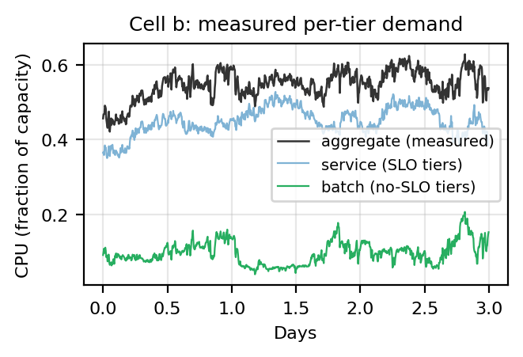
Fig. 1. Measured per-tier decomposition of cell b (3 of 31 days): service + batch equals the measured aggregate at every step.
C. Per-cell power calibration
We adopt the standard linear idle+slope server model (Eq. 1) — the form used throughout the data-center power literature [14], [17] — and fix its two constants per cell from data rather than from a single textbook value. Joining hourly PowerData2019 measured power (whose ‘power utilization’ is defined exactly as our normalization: actual power over theoretical peak [2]) with aggregate CPU over 2,980 (cell, hour) samples, least-squares gives the per-cell idle and slope of Table II. The calibration is literature-consistent: the fitted idle draw is 0.40–0.61 of each cell's peak, consistent with the substantial idle fractions reported in server-power measurements and surveys [14], [17], so the constants are credible without appeal to goodness-of-fit. We keep PER-CELL constants (not one pooled value) because the cells span a meaningful proportionality range — cell d (idle 0.38, slope 0.57) is far more energy-proportional than cell a (0.53, 0.34) — and that BETWEEN-cell spread is a routing signal available to the agent. Preferring lower marginal slope when idle power is sunk is a direct consequence of this model, not a novel RL mechanism; a single literature constant would erase it. This mirrors CICS's choice of per-cluster power models [3]. (R² is reported in Table II as a diagnostic only — 0.43 pooled vs 0.75–0.80 per cell, confirming the pooled residual is between-cell heterogeneity rather than noise — but it is not the model's justification. Using one calibrated model gives a controlled comparison, but errors in marginal slopes could still change routing rankings; the held-out-cell and domain-randomization tests probe that sensitivity.)
TABLE II. POWER MODEL CALIBRATION (POWERDATA2019)
Cell | idle | slope | R²
a | 0.528 | 0.340 | 0.79
b | 0.548 | 0.376 | 0.75
c | 0.440 | 0.526 | 0.76
d | 0.382 | 0.570 | 0.80
pooled | 0.479 | 0.444 | 0.43

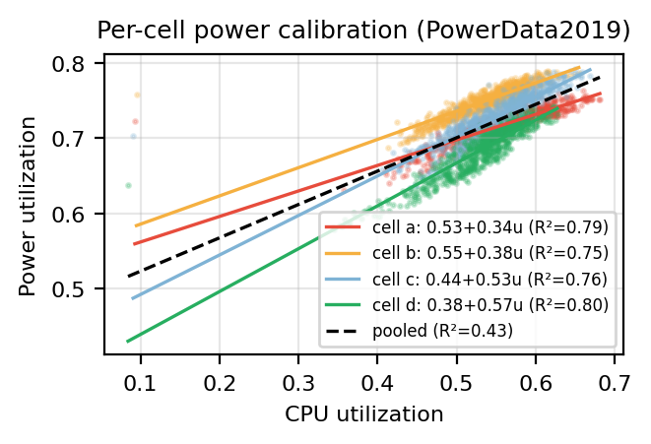
Fig. 2. Per-cell power calibration: four distinct idle/slope lines; the pooled fit (dashed) blurs them into R² = 0.43.

D. Energy Model v2 Review Gate — May 2025
No PPO retraining has been launched. This section validates the energy system and theoretical headroom first.
Experimental energy model
The primary model is one co-timestamped, real CAISO archetype: CAISO Today's Outlook native five-minute net demand; CAISO OASIS NP15 hourly day-ahead total LMP expanded stepwise to five minutes; negative prices preserved; one Pacific civil-time calendar with IANA/DST conversion; price and net demand shifted together across market slots; and no regional price re-averaging.
US slots are Pacific, Mountain, Central, and Eastern. Global slots are Pacific, Central, Amsterdam, and Singapore. Google's May-2019 workload shapes are anchored to the May-2025 energy calendar as an explicit cross-year counterfactual.
Finite-window boundary handling
The time-zone transformation is continuous rather than circular. Every slot contains exactly 8,928 five-minute intervals (744 hours), but shifted slots can use adjacent real CAISO hours at the month boundary instead of wrapping May 31 back to May 1. Singapore is 15 hours ahead of Pacific time, so its reference window replaces CAISO's first 15 hours of May (mean $21.54/MWh) with the first 15 hours of June (mean $29.16/MWh). Its monthly mean is therefore $26.09/MWh instead of Pacific's $25.93/MWh: a $0.154/MWh (0.59%) boundary effect, not extra simulated time or a Singapore price premium.
The continuous shift is retained because a circular within-May shift would create an artificial May 31-to-May 1 discontinuity. Baselines, QP, and future learned policies are compared on the same slot data within each scenario; regional monthly means are not forced to match.
Reference diagnostics
ENERGY MODEL V2 REFERENCE DIAGNOSTICS (PRICE IN USD/MWh)
Slot | Mean | Std | r(price, net) | Price peak UTC | Net peak UTC
US Pacific | $25.93 | $16.48 | 0.895 | 03:00 | 03:00
US Mountain | $25.93 | $16.48 | 0.895 | 02:00 | 02:00
US Central | $25.94 | $16.48 | 0.895 | 01:00 | 01:00
US Eastern | $25.94 | $16.48 | 0.895 | 00:00 | 00:00
Global Pacific | $25.93 | $16.48 | 0.895 | 03:00 | 03:00
Global Central | $25.94 | $16.48 | 0.895 | 01:00 | 01:00
Global Amsterdam | $25.94 | $16.47 | 0.894 | 18:00 | 18:00
Global Singapore | $26.09 | $16.39 | 0.892 | 12:00 | 12:00

Reference CAISO facts: mean DAM price is about $25.93/MWh; negative-price intervals are retained; the average local price and net-demand trough is approximately 12:00 PDT; the average local price and net-demand peak is approximately 20:00 PDT; and price/net-demand correlation is approximately 0.895.
Negative-net-demand intervals average $2.86/MWh versus $29.88/MWh otherwise. The deepest 5% of net-demand intervals average $0.11/MWh and have negative prices 56% of the time. Real energy cost therefore already strongly favors execution in the duck-curve belly.
QP headroom gate
NO-TRAINING CLAIRVOYANT-QP HEADROOM (UNRESTRICTED-ROUTING UPPER BOUND)
Scenario | Status quo | Spatial QP | Joint QP | Spatial | Joint | Temporal
US a–d | $6.568M | $6.092M | $6.045M | 7.24% | 7.95% | 0.77%
US e–h | $6.219M | $5.768M | $5.637M | 7.26% | 9.36% | 2.27%
Global a–d | $6.598M | $5.559M | $5.525M | 15.75% | 16.26% | 0.60%
Global e–h | $6.276M | $5.246M | $5.185M | 16.42% | 17.38% | 1.16%

Objective coefficient and demand-charge treatment
The frozen primary coefficient is α=0.015. Calibrated only on a–d, the Status Quo grid-stress component is 18.2% of real energy cost in US and 18.3% in Global: material but not dominant. Headroom conclusions remain stable for α∈{0,0.005,0.015,0.03}.
The standardized $15/kW-cycle demand charge is excluded from the primary reward and reported as a secondary sensitivity. It is about $4.694M for Status Quo—large enough to dominate—and is not a real Dutch or Singapore tariff. Demand-aware training remains a separate extension.
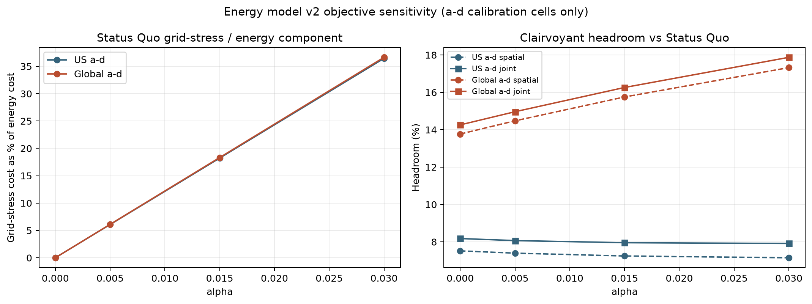
Fig. 3. Objective sensitivity on a–d calibration cells only: component share and clairvoyant headroom across α.
Structural attribution and rated-power sensitivity
V2 uses one CAISO price level shifted in local time, so the v1 unequal-mean synthetic-price criticism no longer applies. The a–d-only ablations below diagnose interacting sources of spatial headroom; they are not an additive causal decomposition.
SPATIAL-QP STRUCTURAL ABLATIONS (A–D CALIBRATION CELLS)
Condition | US | Global
Primary | 7.24% | 15.75%
Energy only | 7.52% | 13.77%
Pooled power | 4.14% | 14.64%
Synchronous market | 5.67% | 5.67%
Shifted market only | 4.36% | 12.58%
Power heterogeneity only | 6.33% | 6.33%
Fully equal control | 0.05% | 0.05%

Shifted market phase is the dominant Global lever; calibrated per-cell power heterogeneity materially increases US headroom. The latter makes the optimization non-degenerate but is a direct linear-model consequence, not a novel RL discovery. With fixed α, R=50–200 MW yields 7.18–7.34% US and 14.81–17.35% Global headroom.
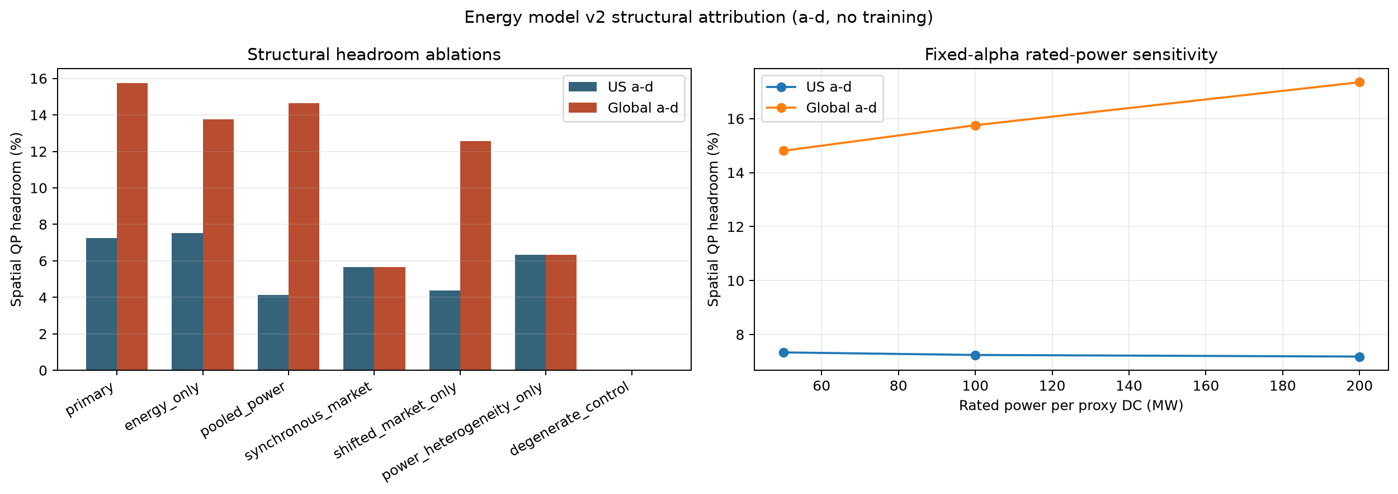
Fig. 4. No-training structural and rated-power sensitivity on a–d calibration cells. Mechanisms interact; bars are not additive attributions.
Experimental deadline sensitivity
ClusterData 2019 supplies no deadlines. The primary φ=1 gives H=2μ. Clairvoyant robustness at φ=0 (H=μ) yields 0.3–1.2% incremental temporal headroom; primary φ=1 yields 0.6–2.3%; loose φ=2 (H=3μ) yields 0.8–3.2%. Temporal value remains secondary across the sweep.
Figures
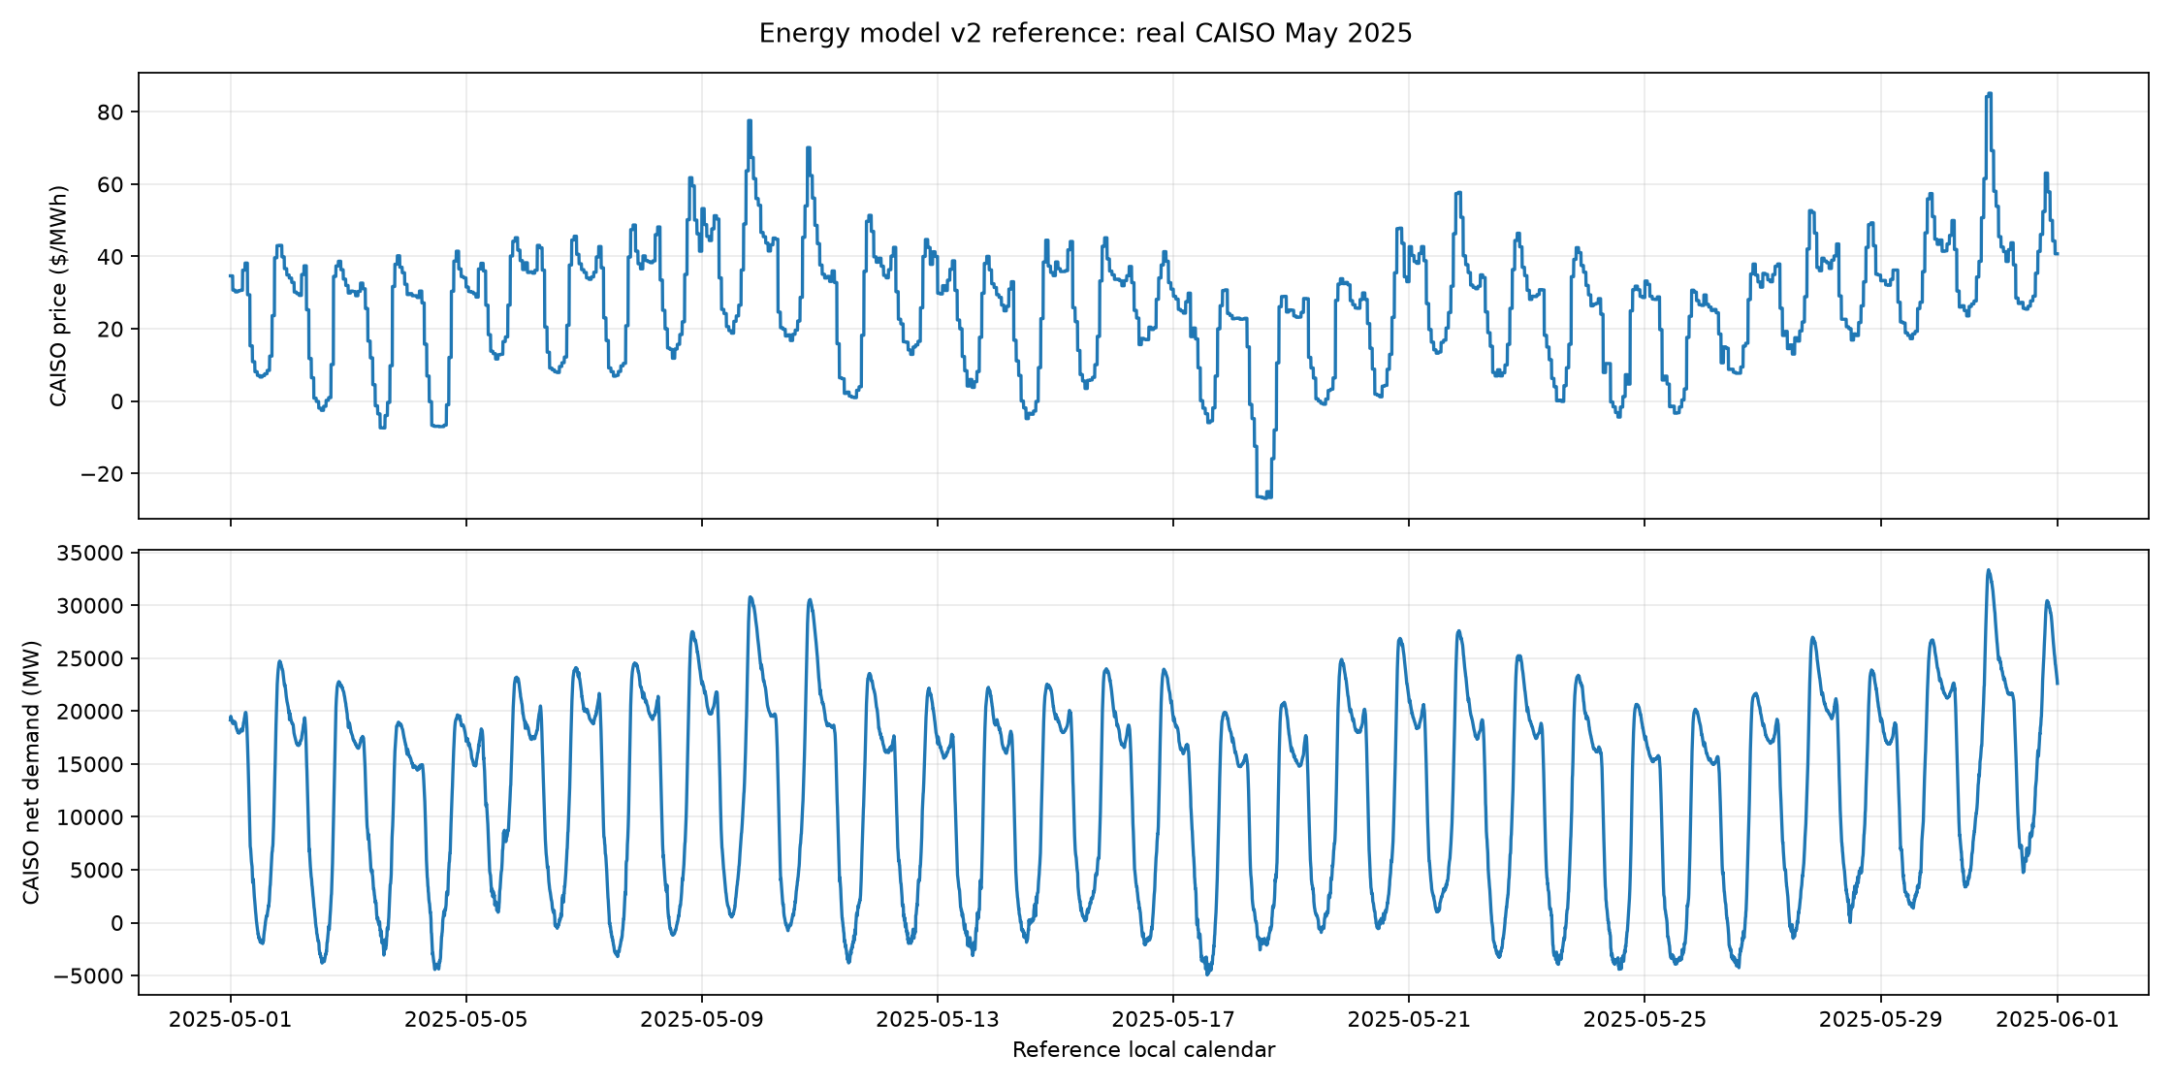
Fig. 5. Energy model v2 reference month: real May-2025 CAISO day-ahead price, net demand, and solar.
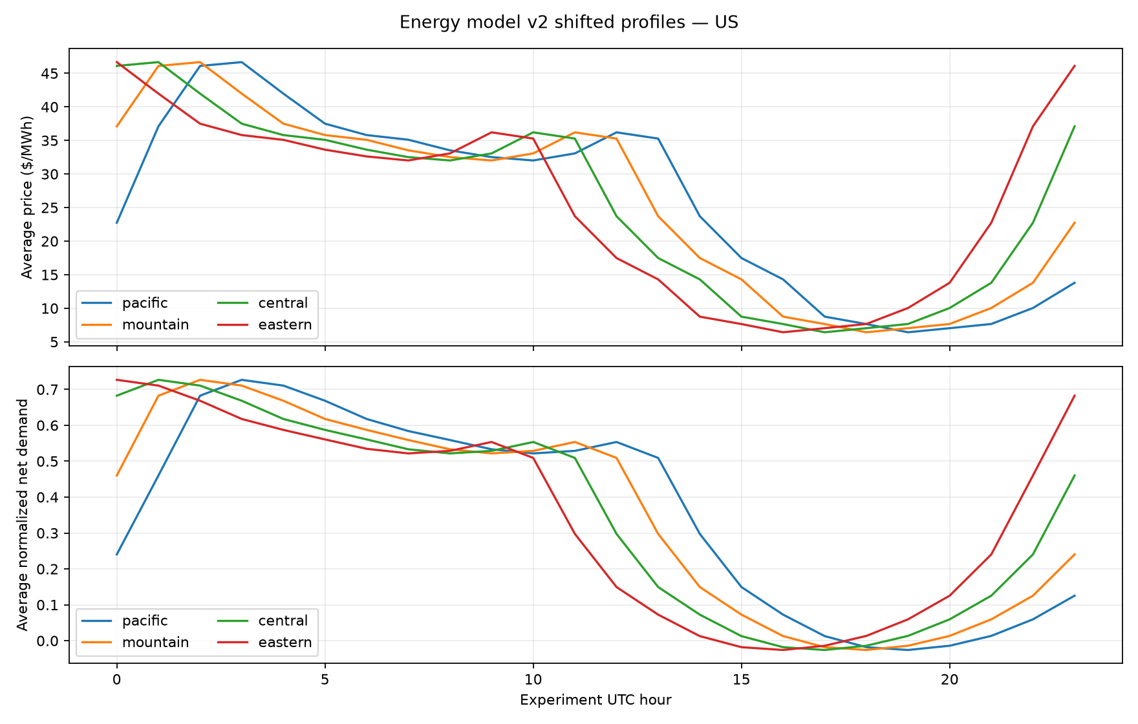
Fig. 6. Energy model v2 average daily profiles shifted across Pacific, Mountain, Central, and Eastern slots.
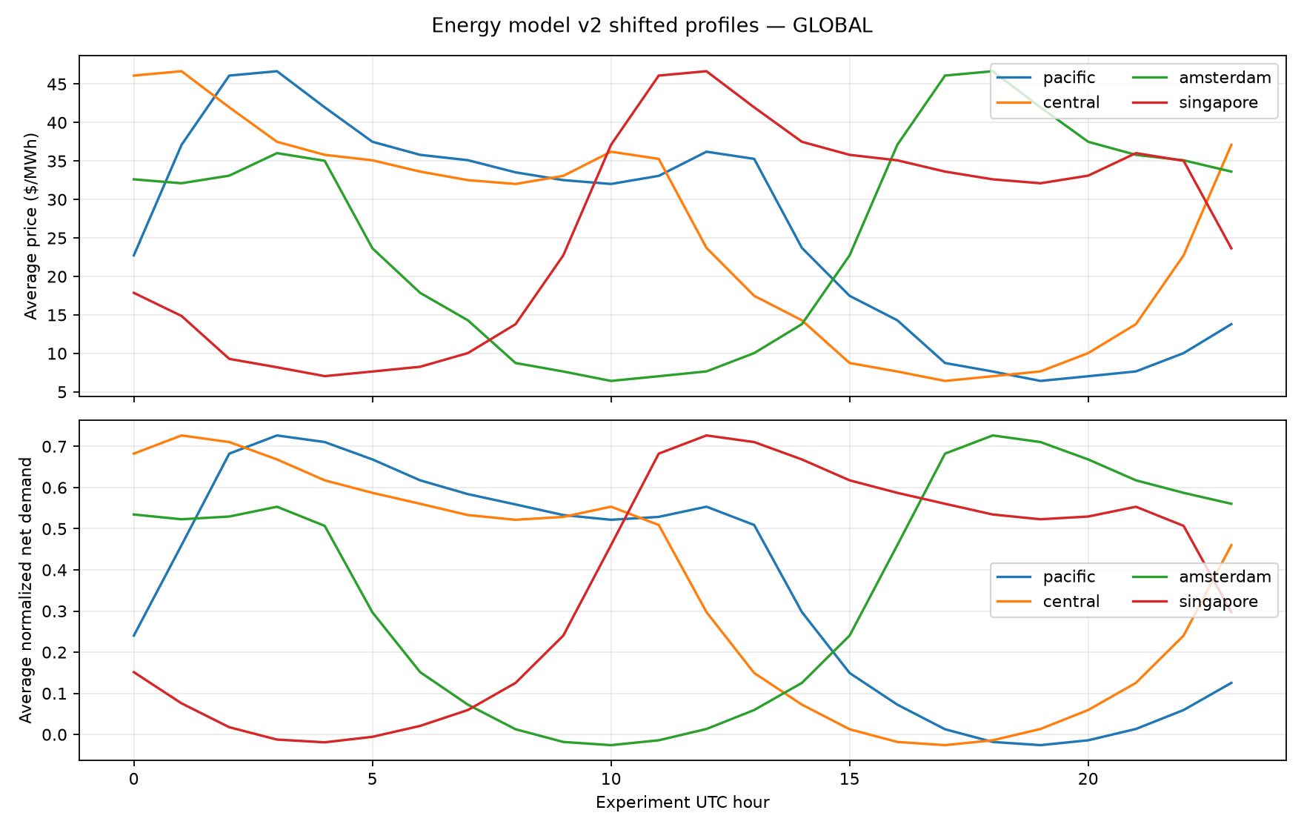
Fig. 7. Energy model v2 average daily profiles shifted across Pacific, Central, Amsterdam, and Singapore slots.
Review interpretation
The corrected signed-demand/equal-capacity model creates 8.0–17.4% optimistic unrestricted-routing joint headroom depending on scenario. Spatial diversity remains dominant. Incremental temporal headroom is positive but modest at 0.6–2.3%.
Explicit limitations and future work
The primary experiment is a controlled CAISO archetype, not a real multi-market replay. Regional price levels are intentionally not re-averaged. Time-zone shifts use adjacent real boundary hours rather than a circular within-May wrap, so shifted monthly means can differ slightly. Five-minute RTM price is future robustness work. Historical 2019/2024 duck-curve comparison and extrapolation are future work, not additional training scenarios. Workload shapes are from May 2019 while the energy calendar is May 2025; this is an explicit counterfactual. OOF holds out workload cells, not the shared energy month. Routing is unrestricted across all slots; latency, residency, and movement are future work. MPC is future work; the QP is a clairvoyant diagnostic only.
Gate status
The energy gate was consumed by the completed 80-model frozen OOF campaign. The joint-shaping headline criterion failed; only Global spatial PPO produced positive held-out optimizer CIs in both folds.

V. END-TO-END FROZEN V2 EXPERIMENTAL PROTOCOL
Figure 5 materializes the complete research chain for a reader unfamiliar with PPO training. Every arrow corresponds to a persisted, hashed source, transformation, scenario, model, or result artifact; no v2 result is selected on the held-out fold.
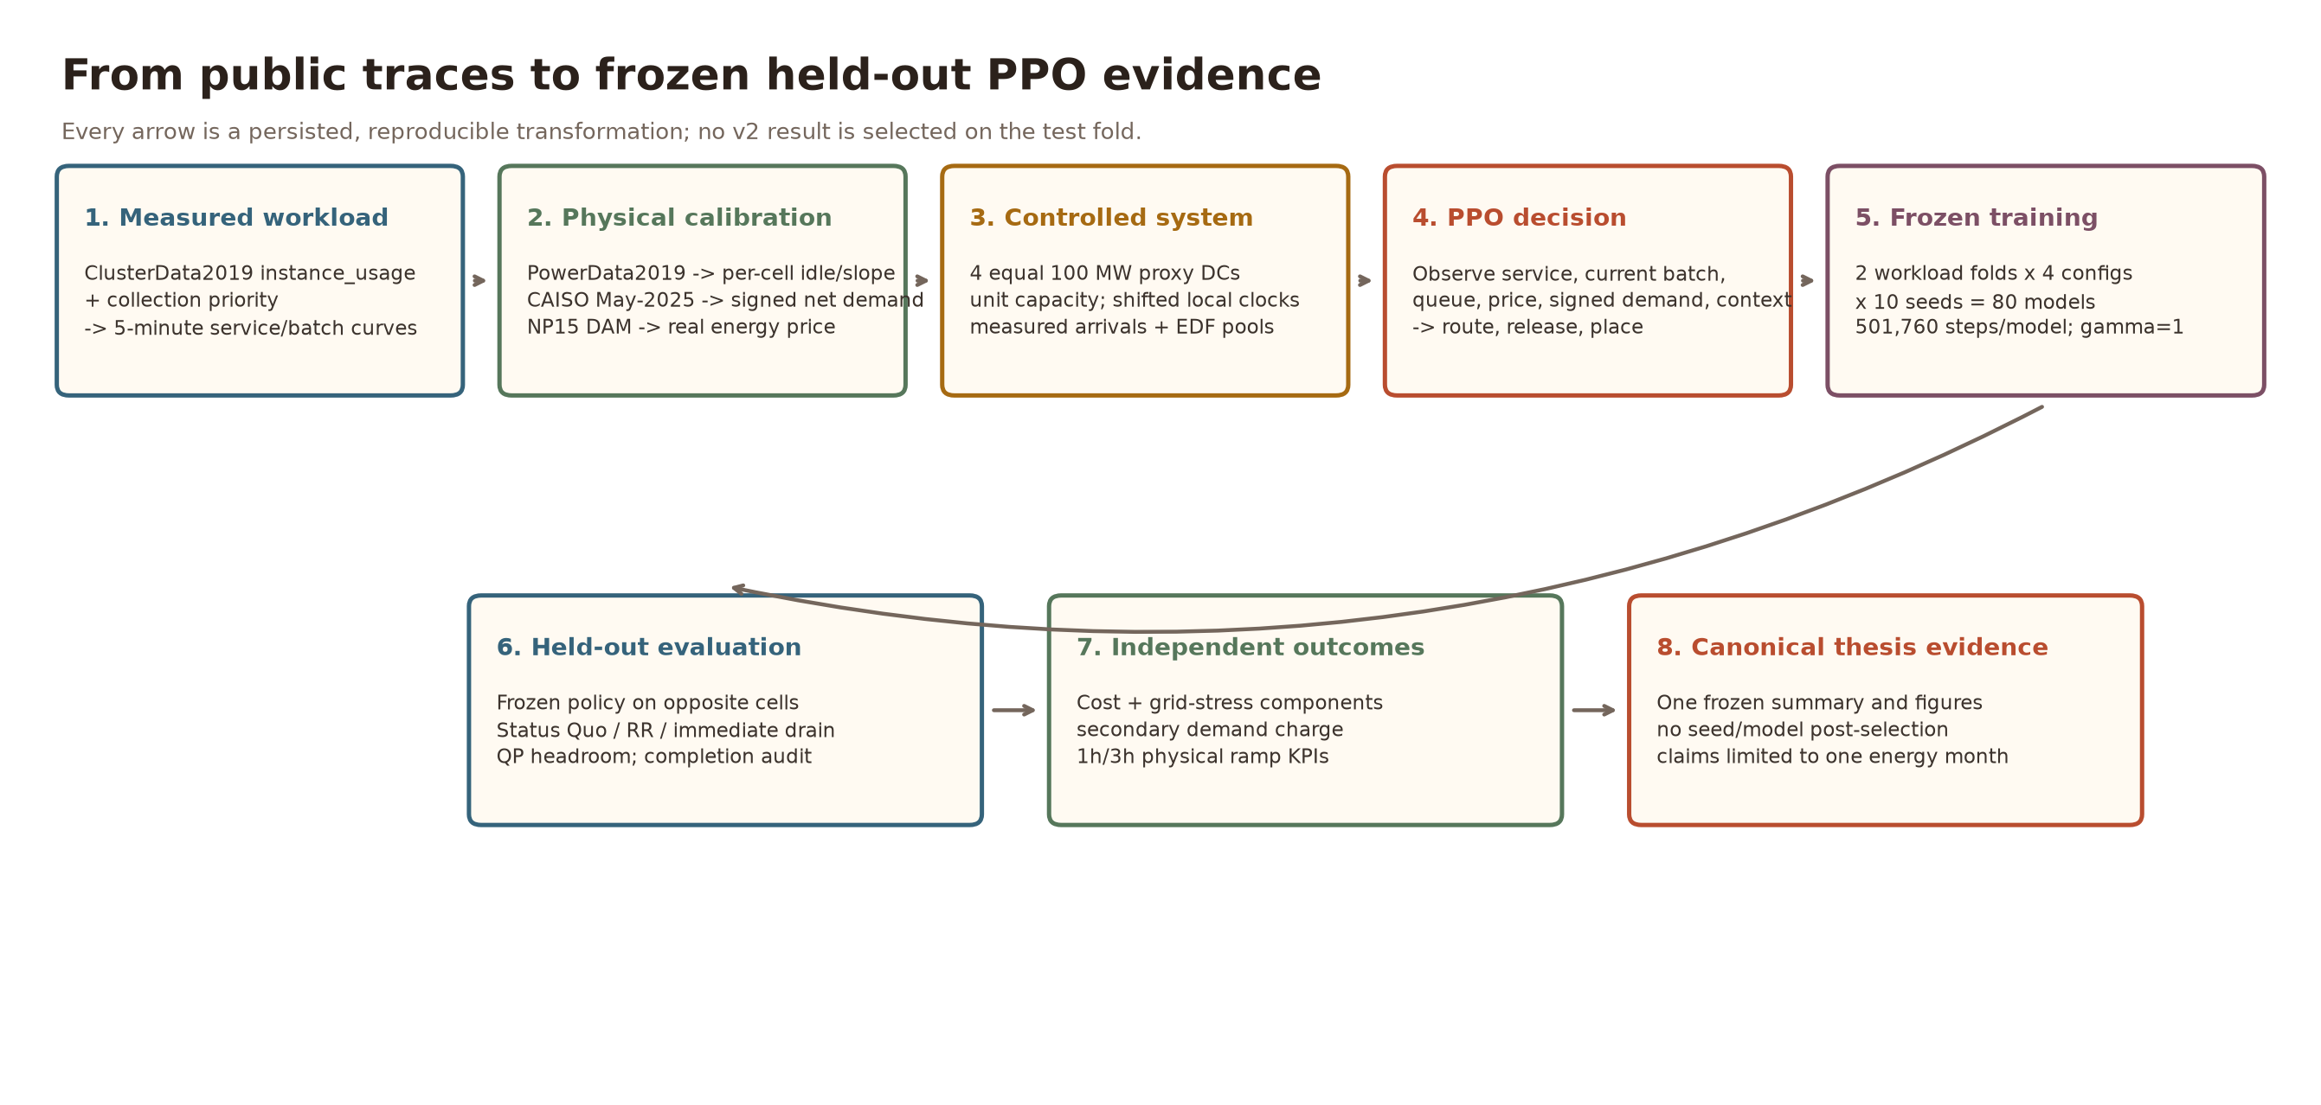
Fig. 8. End-to-end v2 pipeline: public workload/power/market traces are transformed into an equal-proxy Gymnasium system, frozen PPO training, opposite-cell evaluation, and canonical thesis evidence.
A. Workload materialization
ClusterData2019 instance_usage is joined to collection priority and aggregated into five-minute curves. Priority ≤115 supplies measured no-SLO batch; the remainder supplies service, with service+batch=aggregate exactly. Each own-cell-normalized shape maps to a unit-capacity 100 MW proxy. The synthetic generator is bypassed; fitted mean duration only parameterizes the experimental deadline.
B. Physical and market materialization
PowerData2019 supplies per-cell idle/slope models. CAISO Today's Outlook supplies May-2025 five-minute signed net demand/solar, and OASIS NP15 supplies real hourly DAM price. The price/demand pair is shifted together across US and Global local clocks, retaining one controlled price level. Routing is unrestricted and therefore represents an optimistic upper bound.
C. State, action, and objective
At each step PPO observes measured service, the current measured batch arrival, carried EDF pool/urgency, backlog, real price, signed net demand, solar, current load, and site context. It outputs service-routing fractions, batch-release rates, and batch-placement fractions. Service receives first capacity; only completed batch leaves its origin queue. The primary objective is real energy + α=0.015 positive-grid-stress cost + service/completion safeguards. Demand charge and 1h/3h ramp rate are independent outcomes.
D. Frozen training protocol
TABLE III. FROZEN ENERGY-MODEL V2 PPO PROTOCOL
Element | Frozen value
Algorithm | PPO; MLP [128,128]; lr=3e-4
Rollout / minibatch | 2,048 / 64
Budget | 501,760 steps = 245 rollouts/model
Discount | γ=1
Seeds | 101–110
Fold A | train a–d; test frozen policy on e–h
Fold B | train e–h; test frozen policy on a–d
Configs | US/Global × spatial-only/joint batch
Total | 2 × 4 × 10 = 80 models
Selection | none; no validation/test-fold tuning

The runner enforces a clean committed tree; hashes source, data, package versions, protocol, models, and logs; publishes each model atomically; and requires all 80 completion records before evaluation.
E. Held-out evaluation and statistics
Every policy executes one deterministic complete held-out month. References are Status Quo, Round Robin, Drain Immediately (joint mode), and the clairvoyant QP diagnostic. The frozen 95% interval is a 20,000-resample percentile bootstrap over n=10 optimizer seeds. This interval describes optimizer variability, not workload- or market-population uncertainty; a Student-t sensitivity is also reported.
VI. FROZEN ENERGY-MODEL V2 HELD-OUT RESULTS
Frozen verdict — JOINT-SHAPING HEADLINE NOT SUPPORTED.
TABLE IV. HELD-OUT PPO SAVINGS VS STATUS QUO (10 SEEDS/FOLD)
Fold | Config | Savings [95% CI] | + seeds | Feasible | QP head | PPO gap
a–d→e–h | US spatial | −0.29% [−0.76,+0.15] | 4/10 | 10/10 | 7.26% | 8.13%
a–d→e–h | US joint | −4.30% [−12.45,+0.20] | 4/10 | 3/10 | 9.36% | 15.07%
a–d→e–h | Global spatial | +0.90% [+0.34,+1.42] | 8/10 | 10/10 | 16.42% | 18.57%
a–d→e–h | Global joint | +0.17% [−1.00,+1.19] | 6/10 | 2/10 | 17.38% | 20.84%
e–h→a–d | US spatial | +0.07% [−0.27,+0.42] | 5/10 | 10/10 | 7.24% | 7.74%
e–h→a–d | US joint | +0.04% [−0.59,+0.71] | 4/10 | 2/10 | 7.95% | 8.60%
e–h→a–d | Global spatial | +1.19% [+0.81,+1.58] | 10/10 | 10/10 | 15.75% | 17.29%
e–h→a–d | Global joint | +1.38% [+0.82,+1.87] | 9/10 | 2/10 | 16.26% | 17.77%

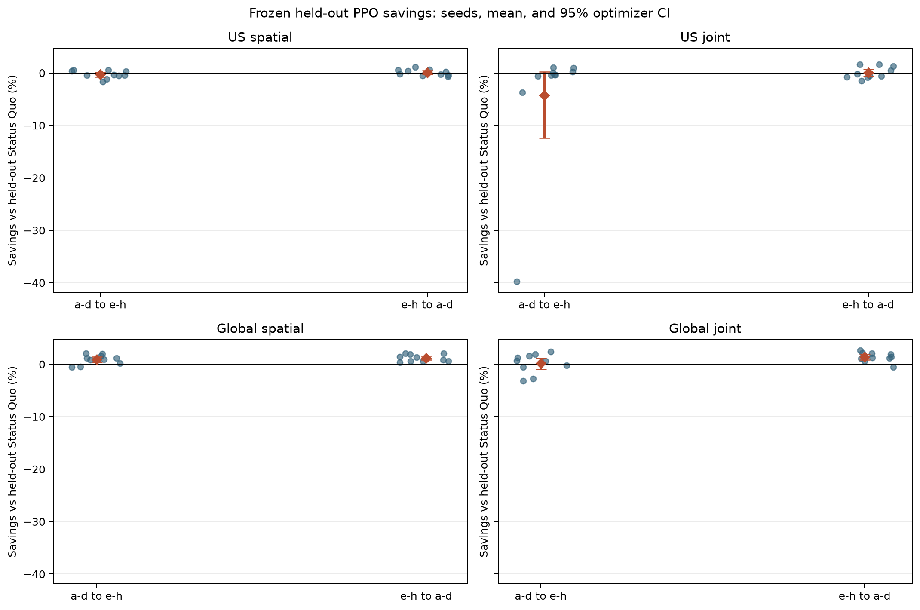
Fig. 9. Held-out seed savings, means, and frozen 95% optimizer-bootstrap intervals. Only Global spatial is positive in both folds.
A. The only robust learned success: Global spatial
Global spatial PPO saves 0.90% and 1.19% on the two held-out folds, with complete service and positive optimizer-bootstrap intervals. Wider n=10 Student-t intervals remain positive: [0.24,1.55]% and [0.71,1.66]%. The effect is real within this frozen optimizer-seed experiment but small and optimistic because routing is unrestricted. PPO captures only 5.47% and 7.55% of available QP savings.
B. US spatial savings are not established
US a–d→e–h averages −0.29% [−0.76,+0.15] and its PPO mean also loses to Round Robin. The reverse fold averages +0.07% [−0.27,+0.42]. Thus US spatial is consistent with a small loss in one direction and indistinguishable from zero in the other.
C. Joint batch control fails the frozen criterion
Joint PPO does not reliably improve over separately trained spatial PPO. It is worse in both US folds and Global a–d→e–h, and only 0.19% better in the remaining Global fold. This is not a clean estimate of pure temporal value because completion fails in 31/40 batch seeds. Only 9/40 seeds (2 configs × 2 folds × 10) meet the 99.99% floor; no joint configuration reaches 4/10 feasible seeds in a fold.
All 80 policies complete 100% of service. Global joint e–h→a–d seed 103 expires 0.889 normalized units. US joint a–d→e–h seed 101 leaves the largest terminal pool (7.690 units) and accumulates $2.289M of transient service-backlog cost, producing the −39.77% outlier. The QP proves temporal opportunity exists; PPO does not capture it reliably.
This negative joint result is itself conditional on an omitted state variable and a frozen budget, not a clean statement that PPO cannot learn joint control: the frozen reward charged joint policies a terminal-completion liability without letting them observe episode position whenever the (default-off) demand charge was disabled, so the same partial state carried two different marginal completion costs late in the episode. Sec. VII adds the missing episode position and deadline buckets, re-screens optimizer and reward-weight hyperparameters, and trains at up to 2× this budget under a stricter safety-first gate — and still fails to produce a trustworthy joint controller, so the frozen conclusion above stands.
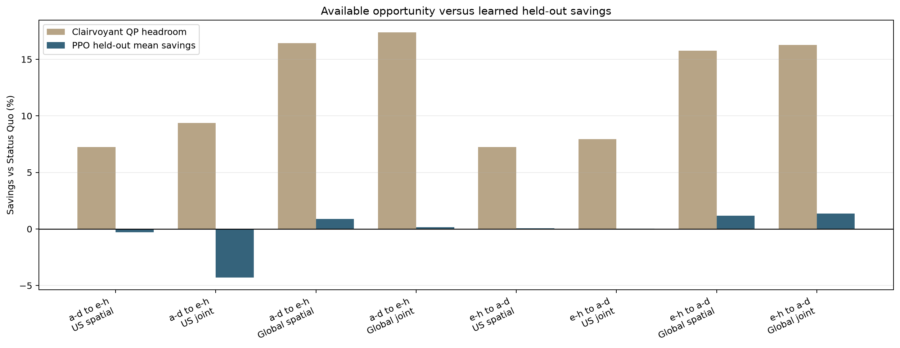
Fig. 10. Clairvoyant opportunity versus learned held-out savings. Large QP headroom does not translate into comparable PPO gains.
D. Secondary billing and physical-grid effects
Spatial PPO lowers the standardized secondary demand charge by 1.4–3.0% across folds. Joint PPO raises it by 5.3–8.1%, showing that unstable temporal control can reduce the primary objective while worsening a site peak tariff. Ramp rate is not optimized: joint PPO worsens the rare maximum three-hour ramp across all sites in every fold by +1.09 to +3.05 MW, although typical p95 three-hour ramps improve. Spatial ramp effects are small and mixed.
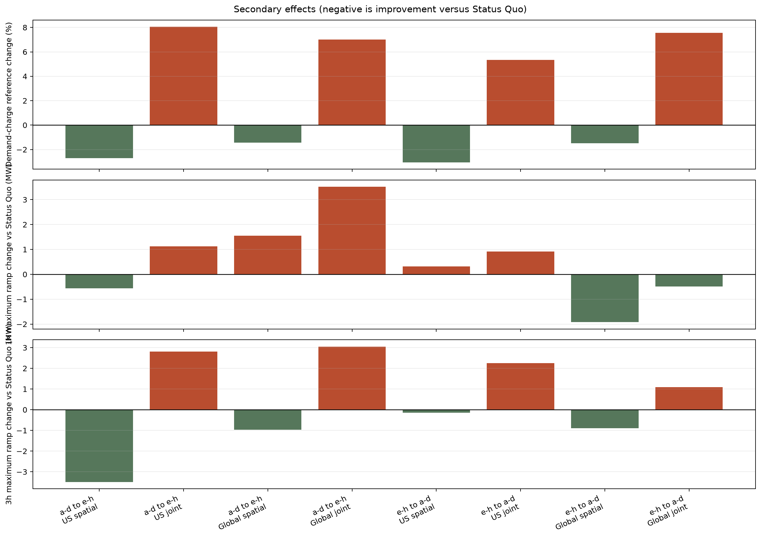
Fig. 11. Secondary demand-charge and physical ramp effects versus held-out Status Quo. Negative values indicate improvement.
E. Empirical conclusion and claim boundary
The frozen campaign supports a narrow conclusion: one real CAISO archetype contains substantial optimistic spatial opportunity, and PPO captures a small reproducible part only in the Global spatial setting. It does not establish US savings or reliable joint spatio-temporal optimization. Claims are limited to optimizer-seed variability, one Google workload month, one CAISO energy month, equal 100 MW proxies, unrestricted routing, and the constructed Φ metric. This negative headline result is scientifically useful: it identifies batch-safe constrained control and stronger spatial policy optimization as the next algorithmic problems.
VII. EXPLORATORY V3 STATE-REPAIR AND JOINT PPO RECOVERY STUDY
Status — POST-HOC, EXPLORATORY, NON-HEADLINE. This section reports a protocol-frozen but non-selection-gated follow-up (env/protocols/v3_reward_sweep.yaml, parent protocol energy-model-v2-2025) that partially repairs a diagnosed state-observability defect in the frozen v2 joint controller and re-screens PPO under a stricter, pre-registered safety-first gate. It explicitly excludes model-predictive control and spatial-only retraining, and it does not overturn the frozen Sec. VI evidence, which remains the thesis's primary held-out result.
A. Motivating defect and reframing of the v2 joint claim
Diagnosis of the Sec. VI-C failures found that the frozen v2 joint reward charged terminal batch-completion liability (backlog and expiry weight) without exposing episode position to the policy whenever the primary demand-charge rate was zero — the default-off configuration used for every frozen headline number. Two states that differ only in how much episode remains therefore looked identical to the policy while carrying different true marginal costs of leaving work unfinished near the horizon. The v2 joint negative result is consequently conditional on this partially observable state representation and on one frozen 501,760-step training budget — not clean evidence that PPO cannot learn joint control in this environment. This section tests that conditional claim directly by fixing the state and enlarging the budget, while leaving every other frozen v2 modeling choice (equal 100 MW proxies, unrestricted routing, Φ objective, the same US/Global scenarios) untouched.
B. V3 state additions, action, and objective changes
Two observation additions address the hidden episode horizon and coarse deadline context, gated behind opt-in flags so frozen v2 models are unaffected: pre-action episode progress and remaining-horizon fractions t/(T−1) and (T−1−t)/(T−1) (observe_episode_progress), and a per-site histogram of batch-pool mass across deadline buckets edged at {1,3,6,12,24} steps plus the current arrival's own bucket (deadline_bucket_edges) — six bins per site instead of one pooled backlog scalar. Both are computed pre-action; Sec. VII-G documents a remaining deadline-boundary observation defect found after the run. The action space, decode (softmax/sigmoid, ±3 logit bound), and per-step objective (Eq. 10) are unchanged; only joint temporal+spatial control is retrained (spatial-only retraining and MPC are protocol-excluded, Sec. VII intro). Evaluation always scores the full-dollar objective at fixed guard weights — service-backlog and batch-completion weight 1000/1000, matched to the ≈$626/normalized-unit economic floor computed from the largest one-step saving obtainable by dropping served work — so the metric used to rank policies never changes across the sweep. Only the TRAINING-only reward weights (service-backlog, batch-completion, and an optional urgency potential) vary between candidates; this separates a genuine hyperparameter/incentive sweep from a moving scoreboard.
C. Staged protocol: rollout-aligned budgets, seeds, and safety-first selection
TABLE V. STAGED V3 PROTOCOL (a–d DEVELOPMENT CELLS)
Stage | Budget (rollouts) | Seeds | Sweep axis | Promotes
Round 1 | 151,552 (74) | 201–203 (3) | GAE λ∈{.95,.99,1.0}; KL target∈{none,.02}; LR sched∈{fixed,linear}; reward mode∈{full,idle-subtracted}; obs. normalization∈{off,on} — 6 candidates R0–R5 | 1 candidate/region
Round 2 | 301,056 (147) | 201–205 (5) | Training-only reward weights on the Round-1 winner: service-backlog/batch-completion/urgency-potential — 4 variants P0–P3 | 1 variant/region
Full development | 501,760 (245) | 201–210 (10) | Winning combo only — reproduces the frozen v2 budget under the augmented state | gate check
Budget scaling | 151,552 / 501,760 / 1,003,520 (74/245/490) | compare 201–205 (5); replicate 201–210 (10) | Winning combo only — diagnoses whether 501,760 steps was compute-limited | 1 budget/region

Safety-first selection is lexicographic and identical in structure at every stage, but step (1) is evaluated against the seed count run AT THAT STAGE, not a fixed count of 10: (1) all seeds in the current stage safe — 3 seeds in Round 1, 5 seeds in Round 2 and in the budget-scaling comparison sweep, 10 seeds in full development and in the final budget-scaling replication — (2) most safe seeds, (3) lowest worst-seed total cost, (4) lowest mean total cost, (5, budget stage only) lower training budget as a final tie-break. A seed is SAFE only if it clears every one of: service-completion floor ≥0.999999999, batch-completion floor ≥0.9999, expired-work tolerance ≤1e-9, terminal-pool fraction tolerance ≤1e-4, and maximum transient service backlog ≤0.25 normalized units. The pre-registered final gate additionally requires ALL 10 seeds safe and a positive 95% optimizer-bootstrap CI vs. Status Quo; failing either reports the recovery as unsuccessful without activating any controller.
TABLE VI. ROUND-1 OPTIMIZER/STATE SCREEN, 3 SEEDS/CANDIDATE (★=PROMOTED; ALL CANDIDATES 0/3 SAFE)
Region | Cand. | GAE λ | KL | LR | Reward mode | Norm. | Mean sav. | Worst sav.
US | R0 | 0.95 | — | fixed | full | off | −0.101% | −0.787%
US | R1 | 0.99 | — | fixed | full | off | −0.239% | −0.770%
US | R2 | 1.00 | — | fixed | full | off | −0.131% | −0.889%
US | R3 ★ | 0.99 | 0.02 | linear | full | off | +0.171% | −0.072%
US | R4 | 0.99 | 0.02 | linear | idle-sub. | off | −0.367% | −1.697%
US | R5 | 0.99 | 0.02 | linear | idle-sub. | on | +0.047% | −0.638%
Global | R0 ★ | 0.95 | — | fixed | full | off | +1.893% | +0.755%
Global | R1 | 0.99 | — | fixed | full | off | +0.950% | −0.130%
Global | R2 | 1.00 | — | fixed | full | off | −1.185% | −2.869%
Global | R3 | 0.99 | 0.02 | linear | full | off | +0.998% | +0.322%
Global | R4 | 0.99 | 0.02 | linear | idle-sub. | off | +0.903% | +0.537%
Global | R5 | 0.99 | 0.02 | linear | idle-sub. | on | −0.035% | −0.599%

No Round-1 candidate is safe on any seed — the state augmentation alone does not restore completion feasibility. R3 (GAE λ=0.99, KL target 0.02, linear LR decay, full reward mode) is promoted for US on mean/worst savings; R0 (GAE λ=0.95, fixed LR, no KL target) is promoted for Global on the same criteria. Both promotions are ties broken by economics only, since no candidate clears the safety floor.
TABLE VII. ROUND-2 REWARD-WEIGHT SCREEN ON THE ROUND-1 WINNER, 5 SEEDS/VARIANT (★=PROMOTED; ALL VARIANTS 0/5 SAFE)
Region | Variant | Backlog wt. | Completion wt. | Potential wt. | Mean sav. | Worst sav.
US | P0 | 1000 | 1000 | 0 | +0.191% | −1.952%
US | P1 ★ | 700 | 1000 | 0 | +0.547% | +0.303%
US | P2 | 700 | 2000 | 0 | +0.401% | −0.473%
US | P3 | 700 | 1500 | 250 | +0.452% | −0.614%
Global | P0 | 1000 | 1000 | 0 | +1.654% | −1.070%
Global | P1 | 700 | 1000 | 0 | +1.586% | −0.525%
Global | P2 | 700 | 2000 | 0 | +2.014% | +0.182%
Global | P3 ★ | 700 | 1500 | 250 | +1.167% | +0.306%

Combo R3_P1 (US) and R0_P3 (Global) carry forward to full development and budget scaling. P3's urgency-potential term has the best worst-seed savings for Global among safety-tied variants (all 0/5 safe) but is not categorically safer; P1 wins US on worst-seed cost despite reducing the backlog weight below the P0 baseline, illustrating that within this sweep reward-weight choice trades off mean economics against tail cost rather than buying completion safety outright.
D. Three-point matched-config budget curve
TABLE VIII. MATCHED-CONFIG BUDGET CURVE, 5 SEEDS (201–205) PER POINT
Region | Combo | Budget | Mean sav. | Worst sav. | Safe seeds | Notes
US | R3_P1 | 151,552 | +0.205% | −0.513% | 1/5 | —
US | R3_P1 | 501,760 | +0.350% | −0.676% | 0/5 | backlog>0
US | R3_P1 | 1,003,520 | −0.241% | −1.014% | 0/5 | 16.7 units expired; 2.16% action saturation
Global | R0_P3 | 151,552 | +0.889% | −1.020% | 0/5 | —
Global | R0_P3 | 501,760 | +1.231% | +0.138% | 0/5 | backlog 1.23 units
Global | R0_P3 | 1,003,520 | +1.764% | +0.996% | 0/5 | —

More compute helps Global economics monotonically (+0.889% → +1.231% → +1.764% as budget rises from 151,552 to 1,003,520 steps) but not safety: 0/5 seeds are safe at every Global budget on this matched-seed comparison. US shows the opposite compute pathology: mean savings rise from +0.205% to +0.350% and then reverse to −0.241% at 1,003,520 steps, where the policy also begins expiring batch work (16.7 normalized units) and saturating actions (2.16% of steps) — degradation, not diminishing returns. Extra optimizer budget therefore helps Global's economics without helping its safety, and actively hurts US at the largest budget tested; there is no budget in this sweep at which unconstrained joint PPO becomes a safe controller.
E. Final safety-first-selected configuration and gate result (a–d)
TABLE IX. FINAL SAFETY-FIRST GATE, 10 SEEDS (201–210), a–d DEVELOPMENT CELLS
Region | Combo | Budget | Safe seeds | Mean sav. | Worst sav. | Optimizer 95% CI (USD) | All-seed +
US | R3_P1 | 151,552 | 1/10 | +0.051% | −1.057% | [−22,193.78, +28,226.55] | No
Global | R0_P3 | 1,003,520 | 1/10 | +2.032% | +0.996% | [+103,383.64, +167,438.74] | Yes

The lexicographic rule selects 151,552 steps for US (uniquely 1/5 safe among the three matched budgets) and 1,003,520 steps for Global (all three budgets tied at 0/5 safe on the comparison seeds, broken by lowest worst-seed and mean cost). Re-validated at 10 seeds, US R3_P1 is 1/10 safe with mean savings +0.051% and an optimizer-bootstrap CI that crosses zero ([−$22,193.78, +$28,226.55]) — economically indistinguishable from Status Quo. Global R0_P3 is also only 1/10 safe despite +2.032% mean savings and a CI strictly above zero ([+$103,383.64, +$167,438.74], all 10 seeds individually positive): the pre-registered gate requires ALL seeds safe, so Global fails on completion even though it would pass on economics alone. Both regions therefore fail the final gate (protocol failure_outcome: report the recovery as unsuccessful; do not activate a spatial-only, temporal-only, or MPC controller).
F. Descriptive e–h transfer — not confirmatory, not a headline
Cells e–h were already exposed during the frozen v2 campaign (Sec. V-E), so evaluating the two safety-first-selected v3 combos there — US R3_P1 trained at its selected budget of 151,552 steps and Global R0_P3 trained at its selected budget of 1,003,520 steps (Sec. VII-E) — is a one-time descriptive check, not fresh confirmatory data and not headline-eligible (final_eh_transfer.json: headline_eligible=false). It is reported for completeness only.
TABLE X. DESCRIPTIVE e–h TRANSFER OF THE a–d-SELECTED-BUDGET MODELS, 10 SEEDS (NON-CONFIRMATORY)
Region | Combo | Training budget | Safe seeds | Mean savings | Worst savings
US | R3_P1 | 151,552 | 7/10 | −0.155% | −0.760%
Global | R0_P3 | 1,003,520 | 5/10 | +2.826% | +1.106%

Transfer is not consistently better than the a–d gate: US mean savings turn negative on e–h even though more seeds individually clear the safety floor (7/10 vs. 1/10), and Global remains only half-safe. This inconsistency is additional descriptive evidence against treating either combo as a settled joint controller, but because e–h is not fresh data it cannot itself confirm or refute the a–d gate result.
G. Documented limitations and claim boundary
V2 reward-scale confound (not resolved by v3). The frozen v2 protocol trained spatial-only policies at reward_scale=1.0 and completion-guarded joint (batch) policies at reward_scale=1e-4, with an identical learning rate (3e-4) across both configurations (env/protocols/v2_2025.yaml). The two controller classes were therefore optimized against training signals of very different numerical magnitude even though both are scored on the same dollar objective at evaluation time, so v2's spatial-vs-joint comparison mixes a genuine policy-class difference with an unmatched training scale. V3 does not resolve this confound: it trains joint (temporal+spatial) policies only, at one fixed reward_scale throughout Rounds 1–2 and budget scaling (Sec. VII-B), and never introduces or repeats a spatial-only run at a matched scale for comparison. This section therefore cannot and does not settle the historical v2 spatial-vs-joint cross-control comparison; it only asks whether joint PPO, evaluated on its own terms, can pass a stricter safety-first bar.
Equal-capacity limitation (unchanged from v2). Every site remains an equal 100 MW proxy. This isolates workload, market-phase, and calibrated power-model effects, but it also removes real fleet-size heterogeneity and may understate or overstate US spatial opportunity; it is an explicit controlled-system limitation carried into v3 unchanged, not a v3-specific artifact.
Negative-net-demand objective caveat (unchanged from v2). Φ is zero whenever net demand is negative (Eq. 4), so nothing in the reward discourages concentrating joint routing and drain during those intervals; the v3 policies' behavior there is only observed and audited (Sec. VI-D ramp KPIs), never separately regularized, and this caveat applies to every v3 result in this section exactly as it applies to v2.
Deterministic negative-net-demand probe (a–d, ten deterministic seed policies per region). To audit rather than merely flag the preceding caveat, we reconstructed the a–d evaluation environment and reran all ten selected-policy seeds per region with domain randomization disabled — US R3_P1 at 151,552 steps and Global R0_P3 at 1,003,520 steps — contrasting steps with at least one site at negative net demand against all other steps (Table XI).
TABLE XI. DETERMINISTIC NEGATIVE-NET-DEMAND PROBE, ALL-10-SEED SELECTED a–d POLICIES
Region | Neg.-step share | Drain, ≥1 neg. | Drain, else | Clear., ≥1 neg. | Clear., else | Route share, neg. (policy) | Route share, neg. (uniform) | Neg. steps, drain>90%
US | 23.89% | 50.91% | 51.32% | 50.82% | 50.79% | 61.11% | 61.18% | 0.0%
Global | 48.25% | 52.00% | 52.12% | 50.15% | 50.21% | 33.26% | 30.05% | 0.0%

The uniform benchmark is the mean fraction of destinations that are themselves at negative net demand on the same any-negative steps, i.e. the routed share a destination-blind policy would achieve by construction. US policy route share to negative-demand destinations (61.11%) is essentially indistinguishable from — if anything, marginally below — that uniform benchmark (61.18%): US routing shows no systematic preference for or against negative-demand destinations. Global policy route share (33.26%) exceeds its uniform benchmark (30.05%) by 3.21 percentage points, a modest but real tilt toward negative-demand destinations. Neither region shows increased drainage on those steps: mean drain is, if anything, slightly LOWER on negative-demand steps than otherwise in both regions (US 50.91% vs. 51.32%; Global 52.00% vs. 52.12%), realized pool clearance is effectively unchanged between the two conditions in both regions (US 50.82% vs. 50.79%; Global 50.15% vs. 50.21%), and the share of negative-demand steps with mean drain above 90% is 0.0% for both US and Global — neither policy blasts through capacity. This is a deterministic, descriptive audit of ten deterministic seed policies per region on the fixed evaluation trace, not a causal or confirmatory claim about why either policy routes as it does, and it does not alter the Sec. VII-E gate result.
Demand-charge shorter-period guard and telescoping regression tests (unchanged from v2, exercised by v3's own smoke tests). A demand-charge period shorter than the episode raises a hard error unless allow_multiple_demand_charge_periods=True is passed explicitly, preventing an accidental per-sub-period tariff from silently multiplying the reference charge. scripts/smoke_test_demand_charge.py numerically asserts two already-published identities to machine precision: (i) incremental per-step demand charges sum to c×max_t g_t over each complete billing period, and (ii) summed arrivals minus completions equals expired work plus the terminal batch pool — an accounting identity, not a reward potential. scripts/smoke_test_ppo_v3.py separately and independently regression-tests that the new v3 urgency-potential shaping term telescopes under γ=1 to a policy-independent constant fixed only by the initial batch-pool state, so potential-based shaping cannot alter the undiscounted return regardless of which actions are taken; both suites pass for every configuration used in this section.
Remaining deadline-boundary observation defect. At step t, the pre-action observation can include carried pool entries with deadline_step ≤ t even though the transition expires those entries before service. Selected US training had expiry in 0/10 seeds (0.000 units total), while selected Global training had expiry in 9/10 seeds (127.597 units across all randomized episodes). Every selected a–d and descriptive e–h evaluation seed had zero expiry, so the reported evaluation failures are terminal-pool failures rather than direct boundary-expiry artifacts; nevertheless, v3 is not a fully repaired state formulation. The next protocol must compute actionable pool size, urgency, and deadline buckets only from entries with deadline_step > t, optionally expose unavoidable due-now mass separately, and retrain before any positive state-repair claim. Frozen v3 semantics and results remain unchanged.
Hard vs. soft constraints and the sigmoid reachability ceiling. Every safety property enforced here — service completion, batch completion, zero expiry, bounded backlog — remains a SOFT, reward-shaped penalty; none is a hard constraint on the action, which is why 31/40 v2 seeds and, now, 9/10 or more v3 seeds per region can violate it despite heavy shaping. Only the batch DRAIN head is sigmoid-decoded; service routing and batch spatial placement are softmax-decoded shares that already sum to exactly 1 and carry no endpoint-reachability problem. For the drain head, the ±3 action-logit bound caps the reachable rate at sigmoid(3)=95.257% (and floors it at sigmoid(−3)=4.743%, Sec. III-C): a policy can request draining a site's entire batch pool in one step only up to 95.257% of it, never exactly 100%, regardless of training. Raising the bound narrows but never closes this gap — sigmoid(10)=99.995% already exceeds the 99.99% batch-completion floor used for the safety gate — yet the sigmoid's open range (0,1) means no finite logit bound reaches EXACT full drain. Because exact 0–100% reachability, not merely a value above 99.99%, is what a completion guarantee requires, merely widening the sigmoid bound is insufficient on its own: the next step (Sec. VIII) is not a larger action bound or an MPC comparator (both remain excluded by this protocol) but a non-MPC joint feasibility/action-projection layer — a hard decoder or a post-hoc override on the drain head with true 0/1 endpoints — that maps any learned action onto the nearest feasible one with exact reachable endpoints.
Everything else about the v2 protocol continues to apply unchanged: ramp rate and the standardized demand charge remain independent, audited KPIs rather than reward terms (Sec. III-A); unrestricted cross-site routing remains an explicit optimistic assumption, not a deployment claim (Sec. III-C); and this section makes no MPC claim of any kind — MPC is structurally excluded from the v3 protocol, exactly as in v2.
H. Conclusion of the recovery study
Repairing the diagnosed state-observability defect, re-screening six optimizer/state variants and four reward-weight variants per region, and training at up to 2× the frozen v2 budget does not produce a safety-first-gate-passing joint controller: the best US configuration remains economically indistinguishable from Status Quo (CI crossing zero) and the best Global configuration, despite a real positive economic effect, fails on completion safety with only 1/10 seeds safe. More compute measurably helps Global's economics and measurably hurts US's at the largest budget tested, but no amount tried buys joint safety. The evidence therefore reframes, but does not reverse, Sec. VI's negative joint finding: unconstrained PPO remains unsuitable as a trustworthy joint spatio-temporal controller under this model, whether or not it can observe episode position, and the appropriate next step is safety-constrained action projection (Sec. VIII), not a larger sweep of the same unconstrained policy class.
VIII. COMPLETED V4 HARD-SAFETY STUDY: A NON-MPC ONE-STEP FEASIBILITY PROJECTOR
Status — COMPLETED, PROTOCOL-FROZEN (env/protocols/v4_safety.yaml, parent protocol ppo-reward-sweep-v3, parent commit a989465). This section answers the Sec. VII-G/-H call for a hard, non-MPC joint feasibility/action-projection layer by replacing the sigmoid-decoded, penalty-shaped drain head with a deterministic one-step Euclidean projector that gives every evaluated episode exact service/batch completion and zero expiry under the frozen causal envelope; infeasible states fail closed with certificates rather than degrading silently. These properties come from construction, not reward learning. It reuses the frozen v3 selected configurations unchanged (US R3_P1, Global R0_P3, Sec. VII-C/-E) and trains 36 new models across a staged short/medium/full protocol, plus replays the archived (frozen) v3 policy weights through the projector without any retraining as a separate diagnostic. It explicitly excludes model-predictive control, spatial-only training, and temporal-only training (identical exclusions to v2/v3), and cells e–h remain descriptive-only because they were already exposed by v2/v3 (fresh_confirmatory_data_available: false).
A. From soft shaping to hard projection
Sec. VII-G showed every prior safety property — service completion, batch completion, zero expiry, bounded backlog — was a SOFT, reward-shaped penalty that even heavy shaping left 9/10 or more v3 seeds per region capable of violating, and that the sigmoid drain head's ±3-logit bound caps reachable drain at sigmoid(3)=95.257% with no finite bound reaching exact full drain. V4 does not retrain that decoder or widen its bound; it inserts a projector between the policy's raw decoded action and the environment transition, so every applied action is the nearest feasible point to what PPO requested, with EXACT 0–100% reachable endpoints and hard, checkable completion guarantees that hold on every step, not merely in expectation across seeds.
B. Ten hard-constraint requirements
The projector and its surrounding protocol enforce ten requirements, each with its own fail-closed certificate or measured invariant (Table XII). None of the ten is a reward term; all ten are algebraic properties of the one-step projection or of the frozen protocol around it, verified by the smoke suite (Sec. VIII-H) and by every evaluation record.
TABLE XII. THE TEN V4 HARD-CONSTRAINT REQUIREMENTS
# | Requirement | Enforcement / certificate
1 | Advertise only actionable pool work with deadline_step > t | actionable_* pool features; due-now carryover fails closed
2 | Cumulative deadline feasibility, including episode end, under a frozen train-only 2.25/1.00/4.00 envelope | nested EDF prefixes; 0.75 guaranteed carried-work capacity
3 | Zero service backlog from a clean state whenever current service is physically schedulable | service-first capped simplex; local pre-backlog certificate
4 | Every origin drain equals destination placement and execution | exact_transport row/column sums; no proportional serve_ratio
5 | Applied drain can reach exact 0% or 100% | post-decode physical-amount projection; endpoint counters
6 | Fail closed on envelope, capacity, deadline, grid, or ramp infeasibility | structured SafetyInfeasibleError certificate
7 | Use the nearest safe action to preserve PPO preferences | Euclidean capped-simplex/box projection; L2 distance logged
8 | Train with the projector active and persist all safety telemetry | intervention, distance, binding horizon, slack, endpoints, certificates
9 | Keep negative-demand flushing optional and after mandatory work | replay-only ablation; disabled in primary training
10 | Implement optional grid/ramp caps but disable them primary | max_grid_mw/max_upward_ramp_mw tested; protocol values null

C. Non-MPC one-step projector: architecture and math
Let N=4 sites and let the policy's raw 3N-dimensional action decode, exactly as in Sec. III-C, into a service-share preference s_pref = softmax(a[0:N]), a per-origin drain preference d_raw = sigmoid(a[N:2N]), and a destination-share preference b_pref = softmax(a[2N:3N]). Desired (unconstrained) targets are s̃ = s_pref·S_t (S_t = total service demand, an environment quantity, not a policy choice) and g̃_i = d_raw_i·Q_i,t (Q_i,t = origin i's pool total). The projector then applies four closed-form Euclidean projections, once per step, using only the CURRENT step's state:
s_t = argmin_s ‖s−s̃‖² s.t. Σs_i=S_t, 0≤s_i≤c_i,t (11)
solved by bisection on a shared water-filling shift (capped-simplex projection, project_capped_simplex), giving residual site capacity r_t = c_t − s_t for batch.
m = cumulative-EDF floor: ∀ deadline δ, D_δ ≤ (δ−t−1)·ĝ + protected_δ (12)
where D_δ is pool mass due by δ (aggregated per origin) and ĝ=0.75 is the frozen guaranteed future per-step drain capacity (requirement 2). Any positive deficit at a given δ is admitted NOW as the minimal-ℓ²-distance reallocation of the policy's own drain preference among only the origins carrying that deadline's mass — never an arbitrary or origin-blind top-up — yielding a per-origin mandatory floor m with Σm_i equal to the unavoidable batch that must move this step.
g_t = argmin_g ‖g−g̃‖² s.t. Σg_i=g*, m_i≤g_i≤Q_i,t (13)
where g* is itself the total-batch amount clipped into [Σm, min(ΣQ,Σr_t)] (never below the EDF floor, never above residual capacity or remaining pool) — a box-constrained projection with a permitted sum interval (project_box_sum_range), built from the same capped-simplex primitive after subtracting the floor.
b_t = argmin_b ‖b−b_pref·g_t‖² s.t. Σb_j=g_t, 0≤b_j≤r_t,j (14)
gives the destination allocation, and a deterministic greedy northwest-corner-style match (exact_transport) builds a bipartite flow F∈ℝ^{N×N}_{≥0} with ΣⱼF_ij=g_{t,i} and ΣᵢF_ij=b_{t,j} exactly (≤1e-8, requirement 4) — an EXACT transport, not an approximate one. Steps 11–14 are a single deterministic, closed-form map from (raw PPO action, current state) to a feasible action, evaluated once per step with no lookahead, no rollout, and no model of future dynamics beyond the frozen scalar ĝ. That is precisely why this is NOT model-predictive control: MPC re-solves a multi-step optimization over a receding horizon using a forward dynamics model; the v4 projector performs one non-anticipative projection per step using only the current state and a pre-registered constant, and MPC remains structurally excluded from this protocol exactly as in v2/v3.
D. Train-only envelopes and no future-trace leakage
The three envelope constants (service 2.25, batch arrival 1.00, future fleet capacity 4.00) are rounded upward from the maximum total service (2.130388) and batch arrival (0.831723) observed ONLY across development cells a–d (envelope_id ad-rounded-envelope-v1, envelope_scope a-d-development-only) and are frozen into the protocol snapshot before any replay or training job runs (Table VII protocol.json, Sec. VIII-G preflight). They never use a realized future step's value: the preflight envelope_scan re-derives and hard-asserts these maxima against the live a–d scenarios before every campaign, and a dedicated smoke test (test_no_future_trace_leakage) reconstructs an identical current state with a different future trace and asserts the projection is bit-identical — the projector is a pure function of the current step, never of anything downstream of it.
E. Clean-state guarantee and the local-backlog caveat
The zero-service-backlog guarantee is a CLEAN-STATE guarantee: it holds from a reset with no pre-existing local backlog, and the environment fails closed — raising a preexisting_local_service_backlog certificate, not silently absorbing the work — if any site carries nonzero local backlog when a step is attempted (test_preexisting_backlog_fails_closed). This is a documented scope boundary, not a claim that backlog can never physically arise: it says the hard guarantee applies once the controller is engaged from a clean state, and any accumulated local backlog must be surfaced as an explicit certificate rather than pooled into the projector's accounting.
F. Exact flows, endpoints, and optional extensions
Every applied transport is an EXACT flow (requirement 4) and every drain decision reaches an EXACT 0% or 100% endpoint when the cumulative-EDF floor or the residual-capacity ceiling binds (requirement 5), closing the sigmoid-reachability gap of Sec. VII-G. Two extensions are wired into the SafetyConfig but are OPTIONAL and off by default in every trained v4 model: a negative-net-demand flush (negative_demand_flush) that widens the minimum drain floor toward destinations currently at negative net demand, and per-site power/ramp caps (max_grid_mw, max_upward_ramp_mw) that would further clip the residual-capacity feasible set. Neither is used in the primary training or evaluation mode (primary_negative_demand_flush: false, primary_power_caps/primary_ramp_caps: null); the flush is exercised only as a replay-time ablation on the already-frozen v3 policy weights (Sec. VIII-I), never during any of the 36 newly trained v4 models, and the power/ramp caps are exercised only by the smoke suite (test_optional_grid_and_ramp_caps).
G. Staged protocol, gates, and thirty-six trained models
TABLE XIII. STAGED V4 PROTOCOL (36 NEWLY TRAINED MODELS: 6+10+20)
Phase | What it does | Jobs / models
preflight | Validates config, hashes sources/data, re-derives and asserts the a–d envelope bound, runs all smoke tests | 0
replay | Replays the FROZEN archived v3 policy weights (10 seeds/region, R3_P1 US / R0_P3 Global) through the v4 projector at eval time only, in both safety_only and safety_plus_negative_demand_flush modes — no retraining | 0 (20 archived models reused × 2 modes)
short | Trains fresh PPO+projector models at the short budget (151,552 steps), 3 seeds/region | 6
medium | Gated on the short promotion gate; trains at 301,056 steps, 5 seeds/region | 10
full | Gated on the medium gate; trains at each region's selected final budget (US 151,552 / Global 1,003,520), 10 seeds/region | 20
final | Gated on the full gate; re-evaluates the 20 full-stage models on cells e–h (descriptive transfer, no retraining) | 0

Each of short/medium/full enforces the SAME promotion gate (Table XIV) on ALL seeds run at that stage before the next stage may start (ensure_gate_passed): service completion exactly 1 (within 1e-9), batch completion exactly 1 (within 1e-9), zero total expired, terminal batch pool and terminal service backlog ≤1e-8, zero safety-infeasibility certificates, and maximum transport-conservation error ≤1e-8 — the same seven checks spanning requirements 2–6 above, now asserted per seed rather than only in aggregate. A region's stage only passes if EVERY seed clears every check; because these are hard, constructed guarantees rather than shaped penalties, every one of the 36 trained-and-evaluated short/medium/full seed×region combinations passes on the first attempt.
H. Ten-test smoke suite
scripts/smoke_test_safety_v4.py numerically exercises exactly the ten requirements of Table XII before any training job is allowed to start (preflight, Table XIII): projection primitives conserve sum/box bounds; deadline semantics and actionable-state truncation are exact; a deliberately wrong policy origin is overridden to the mandatory EDF origin with exact 0/100% endpoints; service-capacity and pre-action-deadline-miss certificates fail closed; pre-existing local backlog fails closed; reconstructing an identical current state with a different future trace gives a bit-identical projection (no leakage); the negative-demand flush is confirmed optional (behavior differs only when explicitly enabled); 250 randomized adversarial projections all satisfy every conservation, bound, and cumulative-slack invariant on ≥200/250 feasible draws; optional power/ramp caps are respected and reject an infeasible cap below unavoidable idle draw; and a full-episode all-hold (-3 logit) policy still reaches exact completion with zero expiry and sub-1e-8 transport error on both US and Global scenarios. All ten pass for every configuration used in this section.
I. Replay of the archived v3 policies under the v4 projector
Before training anything new, the FROZEN v3-selected policy weights (US R3_P1, Global R0_P3, Sec. VII-C/-E) are replayed — unmodified, no additional training — through the v4 projector on the same 10 selected v3 seeds (201–210), in both the primary safety_only mode and the negative-demand-flush ablation mode, purely as a diagnostic of what the projector alone contributes to an already-trained policy.
TABLE XV. REPLAY OF ARCHIVED (FROZEN) v3 POLICIES UNDER THE V4 PROJECTOR, 10 SEEDS (201–210), a–d CELLS (DIAGNOSTIC, NOT A GATE)
Region | Mode | Mean sav. | Worst sav. | Optimizer 95% CI (USD) | Mean interv. rate
US | safety_only | +0.057% | −1.049% | [−21,771.99, +28,697.55] | 0.011%
US | +flush (ablation) | +0.002% | −1.067% | [−25,141.42, +25,021.96] | 23.902%
Global | safety_only | +2.041% | +1.016% | [+103,992.80, +167,976.56] | 0.473%
Global | +flush (ablation) | +1.257% | +0.146% | [+50,314.19, +111,332.53] | 48.516%

Every replayed seed in both modes reaches exact service/batch completion with zero expiry and zero infeasibility certificates — the ten requirements hold even for a policy that never saw the projector during training, because they are constructed, not learned. Turning on the optional negative-demand-flush ablation lowers absolute mean cost (US $6.564M→$6.552M; Global $6.464M→$6.302M), but the flush-enabled Status Quo also benefits, so PPO's relative savings against its mode-matched baseline fall (US +0.057%→+0.002%; Global +2.041%→+1.257%). Intervention rises from 0.011%→23.902% (US) and 0.473%→48.516% (Global), making flush a dominant economic heuristic rather than a minimal safety shield. It is retained only as a diagnostic and never used for a primary number.
J. Staged and final a–d results for the 36 freshly trained models
TABLE XVI. STAGED a–d PROMOTION GATE, ALL SEEDS SAFE AT EVERY STAGE
Stage | Region | Seeds | Safe | Mean sav. | Worst sav. | Interv. rate
Short | US | 3 | 3/3 | −0.024% | −1.182% | 0.011%
Short | Global | 3 | 3/3 | +2.209% | +1.234% | 5.376%
Medium | US | 5 | 5/5 | −0.105% | −0.477% | 2.052%
Medium | Global | 5 | 5/5 | +1.557% | −1.408% | 1.270%
Full | US | 10 | 10/10 | −0.246% | −1.413% | 0.021%
Full | Global | 10 | 10/10 | +3.262% | +0.857% | 18.786%

All 36 short/medium/full seed×region combinations are safe (Sec. VIII-G): service and batch completion are exactly 1, expiry is exactly 0, and zero infeasibility certificates are raised, on every single seed — not merely on a lexicographically selected subset as in Sec. VII. At the final full-budget a–d evaluation (10 seeds, 301–310), US is economically indistinguishable from Status Quo (mean −0.246%, optimizer-bootstrap 95% CI [−$44,444.54, +$11,040.73], crossing zero) at a mean safety-intervention rate of only 0.021% of steps — the projector is a rare backstop that almost never overrides US's own preferences. Global is unambiguously positive: mean +3.262% with EVERY one of the 10 seed-level improvements positive and a 95% CI strictly above zero ([+$160,775.24, +$267,540.82]) — diagnostically also above the archived-v3-replay comparator ([+$18,047.17, +$142,269.02], Sec. VIII-I) — but at a mean intervention rate of 18.786%, i.e., roughly one step in five has its action materially altered by the projector (Sec. VIII-L).
K. Descriptive e–h transfer (non-confirmatory)
Cells e–h were already exposed during the frozen v2/v3 campaigns (Sec. V-E, Sec. VII-F), so evaluating the same 20 full-stage v4 models there — no retraining — is a one-time descriptive check, not fresh confirmatory data and not headline-eligible (final_results.json: headline_eligible= false), exactly as for v3's Table X.
TABLE XVII. DESCRIPTIVE e–h TRANSFER OF THE 20 a–d FULL-STAGE MODELS, 10 SEEDS (NON-CONFIRMATORY)
Region | Seeds | Safe | Mean sav. | Worst sav. | Interv. rate
US | 10 | 10/10 | −0.149% | −1.763% | 0.580%
Global | 10 | 10/10 | +3.611% | +0.510% | 20.170%

All 20 evaluated seeds remain safe on e–h — service/batch completion exactly 1, zero expiry, zero infeasibility certificates on every seed in both regions — because the ten requirements of Table XII are properties of the projector and the frozen envelope, not of the scenario being evaluated, so they transfer unconditionally. The economic numbers (US −0.149%, Global +3.611%) move only modestly from their a–d full-stage counterparts (−0.246%, +3.262%) and Global's intervention rate rises slightly (18.786%→20.170%); because e–h is not fresh data, this is reported for completeness only and cannot itself confirm or extend the a–d result.
L. Interpretation: the Global result belongs to PPO+projector jointly
Safety is deterministic; economics is learned — and how much of the economics is attributable to the learned policy alone depends on how often the projector must overrule it. US's mean intervention rate is 0.021% (full a–d) / 0.580% (e–h) — on the order of 1 in 5,000 to 1 in 170 steps — so the US result is, to a close approximation, still a statement about the frozen PPO R3_P1 policy's own preferences, with the projector acting as a rare backstop. Global's mean intervention rate is 18.786% (full a–d) / 20.170% (e–h) — roughly one step in five — so a material fraction of Global's applied actions are NOT what the PPO network proposed; they are the projector's nearest-feasible correction to it. The reported Global economic gain (+3.262% / +3.611%, both CIs or all ten seeds strictly positive) is therefore a property of the COMPOSED system — the trained PPO R0_P3 network together with the one-step projector — and cannot be attributed to either part alone: it is not evidence that unconstrained PPO would itself achieve these savings (Sec. VI/VII showed it does not, safely), nor is it evidence that the projector alone, driving a policy-agnostic desired action, would recover this gain (the projector has no preference of its own; requirement 5's minimal-ℓ²-distance reallocation and every other projection step start from the policy's OWN preference and move it the minimum necessary distance). What IS attributable to the projector alone, on any policy whatsoever, is the safety guarantee itself: Table XV shows the same ten requirements hold identically on the untouched archived v3 weights that never saw a projector during training, and Sec. VIII-H's randomized/adversarial and all-hold-policy smoke tests show they hold for policy-agnostic and even pathological actions. No part of this section makes an MPC claim of any kind; MPC remains structurally excluded from the v4 protocol exactly as from v2/v3.
M. Conclusion of the hard-safety study
A non-MPC, one-step Euclidean feasibility projector — cumulative exact EDF admission, exact transport conservation, exact 0–100% drain endpoints, and a frozen a–d-only future-capacity bound with a proven no-leakage property — replaces the Sec. VII-G sigmoid-reachability gap with a hard, constructed guarantee that holds on every one of the 36 newly trained short/medium/full seed×region combinations, on all 20 descriptively transferred e–h seeds, and on the untouched archived v3 policy weights under replay: zero completion failures, zero expiry, and zero infeasibility certificates throughout. This finally answers Sec. VII-H's call for safety-constrained action projection rather than a larger sweep of the same unconstrained policy class. Economically, US remains statistically indistinguishable from Status Quo while rarely invoking the projector (0.021%–0.580% of steps); Global is unambiguously positive (+3.262% a–d, +3.611% e–h, every seed and CI positive) but with the projector materially co-authoring roughly one step in five (18.786%–20.170%), so that gain is correctly attributed to the composed PPO+projector system, not to PPO in isolation. The defensible new contribution is therefore a hard safety guarantee obtained without retraining away the underlying joint-control difficulty, plus honest attribution of which economic results are — and are not — evidence about the learned policy on its own.

IX. FURTHER TOPICS OF CONSIDERATION
(1) Sec. VIII delivers batch-safe constrained control — a non-MPC one-step feasibility projector with exact 0–100% drain reachability and zero completion failures across all 36 newly trained and 20 replayed models — so that specific prior priority is now closed; the open question it leaves behind is reducing Global's 18.786–20.170% mean safety-intervention rate, i.e., training the policy itself to need the projector's correction less often rather than only guaranteeing safety when it does intervene. (2) Collect FRESH e–h (or a genuinely new region/month) confirmatory data for the projected controller, since the current e–h numbers (Sec. VIII-K) remain descriptive only because those cells were already exposed by v2/v3. (3) Improve spatial policy optimization, especially for Global where unconstrained PPO captures only 5.47–7.55% of QP savings, and diagnose the asymmetric US transfer. (4) Add ramp-aware training or constraints because joint PPO worsens rare maximum three-hour ramps, while preserving the observed p95 improvement; the v4 projector's optional max_upward_ramp_mw cap (Sec. VIII-F, Table XII item 10) is validated by smoke test but not yet exercised in a trained model. (5) Add the secondary demand charge to a true multi-objective/Pareto study because joint PPO raises the reference bill 5.3–8.1%. (6) Bound Global routing with latency, residency, network capacity, and movement costs. (7) Add a causal receding-horizon MPC comparator — excluded from the v2, v3, AND v4 protocols to date and not claimed anywhere in this thesis. (8) Test CAISO five-minute RTM, other energy months/years, and other workload traces. (9) Add carbon intensity, storage, and demand-response participation only after the core control problem is stable.
X. CONCLUSION
This thesis builds a reproducible chain from measured Google service/batch usage and PowerData2019 calibration to one real May-2025 CAISO energy archetype, equal 100 MW proxy DCs, a joint PPO controller, and a frozen two-fold held-out evaluation. The system exposes substantial clairvoyant spatial headroom (7.2–16.4%) and modest incremental temporal headroom (0.6–2.3%). Learned performance is much narrower. Global spatial PPO saves 0.90% and 1.19% on the two held-out folds with positive optimizer CIs and complete service, but captures only 5.47–7.55% of QP savings. US spatial does not establish savings. Joint batch PPO fails the frozen headline: only 9/40 seeds meet the completion floor, gains are fold-dependent, and rare maximum ramps and the secondary demand-charge reference worsen. A post-hoc exploratory v3 study (Sec. VII) adds the missing episode/deadline context, but a post-run boundary audit shows the state repair remains incomplete; it re-screens optimizer and reward-weight hyperparameters and trains at up to 2× the frozen budget under a stricter pre-registered safety-first gate; it still fails — the recovered US configuration is economically indistinguishable from Status Quo and the recovered Global configuration is only 1/10-seed safe despite a real positive economic effect — so the joint failure is not an artifact of the omitted state or of training budget. A completed v4 hard-safety study (Sec. VIII) then replaces the shaped, sigmoid-capped drain decoder with a non-MPC one-step feasibility projector — cumulative exact EDF admission, exact transport conservation, exact 0–100% drain endpoints, and a frozen, no-leakage a–d-only capacity bound — and trains 36 new PPO+projector models plus replays the archived v3 weights under it: every one of the 36 newly trained, 20 replayed, and 20 descriptively transferred e–h seeds reaches exact service/batch completion with zero expiry and zero infeasibility certificates. US remains economically indistinguishable from Status Quo (−0.246% a–d, −0.149% e–h, CIs crossing zero) while rarely invoking the projector (0.021–0.580% of steps); Global is unambiguously positive (+3.262% a–d, +3.611% e–h, every seed and CI positive) but with the projector materially co-authoring roughly one step in five (18.786–20.170%), so that gain is honestly attributed to the composed PPO+projector system rather than to unconstrained PPO, which Sec. VI/VII already showed cannot achieve it safely on its own. The defensible contribution is therefore the real, audited experimental system; the modest optimistic Global spatial result; the negative evidence, twice obtained under two different state representations and training budgets, that unconstrained PPO does not solve reliable joint spatio-temporal shaping; and a hard, constructed safety guarantee — obtained without an MPC comparator and without retraining away the underlying difficulty — that finally closes the reachability and completion gaps documented in Sec. VII while making explicit which of its economic gains are, and are not, evidence about the learned policy in isolation. The next step is not a stronger claim but fresh confirmatory transfer data and a policy that needs the projector's correction less often.
REFERENCES
[1] M. Tirmazi, A. Barker, N. Deng, M. E. Haque, Z. G. Qin, S. Hand, M. Harchol-Balter, and J. Wilkes, “Borg: the Next Generation,” in Proc. EuroSys, 2020.
[2] V. Sakalkar, V. Kontorinis, D. Landhuis, S. Li, D. De Ronde, T. Blooming, A. Ramesh, J. Kennedy, C. Malone, J. Clidaras, and P. Ranganathan, “Data Center Power Oversubscription with a Medium Voltage Power Plane and Priority-Aware Capping,” in Proc. ASPLOS, 2020; companion dataset documentation: https://github.com/google/cluster-data/blob/master/PowerData2019.md.
[3] A. Radovanović, R. Koningstein, I. Schneider, B. Chen, A. Duarte, B. Roy, D. Xiao, M. Haridasan, P. Hung, N. Care, S. Talukdar, E. Mullen, K. Smith, M. Cottman, and W. Cirne, “Carbon-Aware Computing for Datacenters,” IEEE Trans. Power Systems, vol. 38, no. 2, pp. 1270–1280, Mar. 2023, doi: 10.1109/TPWRS.2022.3173250 (arXiv:2106.11750).
[4] L. Grange, G. Da Costa, and P. Stolf, “Green IT scheduling for data center powered with renewable energy,” Future Generation Computer Systems, vol. 86, pp. 99–120, 2018.
[5] G. Da Costa, L. Grange, and I. De Courchelle, “Modeling and generating large-scale Google-like workload,” in Proc. Int. Green and Sustainable Computing Conf. (IGSC), 2016.
[6] D. Zhao, J.-t. Zhou, and K. Li, “CFWS: DRL-Based Framework for Energy Cost and Carbon Footprint Optimization in Cloud Data Centers,” IEEE Trans. Sustainable Computing, vol. 10, no. 1, pp. 95–107, Jan./Feb. 2025, doi: 10.1109/TSUSC.2024.3391791.
[7] M. Xu, A. N. Toosi, and R. Buyya, “A Self-Adaptive Approach for Managing Applications and Harnessing Renewable Energy for Sustainable Cloud Computing,” IEEE Trans. Sustainable Computing, 2020.
[8] K. Haghshenas, A. Taheri, M. Goudarzi, and S. Mohammadi, “Infrastructure-Aware Heterogeneous-Workloads Scheduling for Data Center Energy Cost Minimization,” IEEE Trans. Cloud Computing, 2022.
[9] Z. Liu, Y. Chen, C. Bash, A. Wierman, D. Gmach, Z. Wang, M. Marwah, and C. Hyser, “Renewable and Cooling Aware Workload Management for Sustainable Data Centers,” in Proc. ACM SIGMETRICS, 2012.
[10] Í. Goiri, K. Le, M. E. Haque, R. Beauchea, T. D. Nguyen, J. Guitart, J. Torres, and R. Bianchini, “GreenSlot: Scheduling Energy Consumption in Green Datacenters,” in Proc. SC, 2011.
[11] W. Lin et al., “A systematic review of green-aware management techniques for sustainable data center,” Sustainable Computing: Informatics and Systems, 2024.
[12] Y. Wu et al., “Task Scheduling in Geo-Distributed Computing: A Survey,” arXiv:2501.15504, 2025.
[13] T. L. Vasques, P. Moura, and A. de Almeida, “A review on energy efficiency and demand response with focus on small and medium data centers,” Energy Efficiency, vol. 12, 2019.
[14] M. Dayarathna, Y. Wen, and R. Fan, “Data Center Energy Consumption Modeling: A Survey,” IEEE Communications Surveys & Tutorials, vol. 18, no. 1, 2016.
[15] H. Kahil, S. Sharma, P. Välisuo, and M. Elmusrati, “Reinforcement learning for data center energy efficiency optimization: A systematic literature review and research roadmap,” Applied Energy, 2024.
[16] Y. Ran, H. Hu, X. Zhou, and Y. Wen, “DeepEE: Joint Optimization of Job Scheduling and Cooling Control for Data Center Energy Efficiency Using Deep Reinforcement Learning,” in Proc. IEEE ICDCS, 2019.
[17] X. Fan, W.-D. Weber, and L. A. Barroso, “Power provisioning for a warehouse-sized computer,” in Proc. ISCA, 2007.
[18] J. Schulman, F. Wolski, P. Dhariwal, A. Radford, and O. Klimov, “Proximal Policy Optimization Algorithms,” arXiv:1707.06347, 2017.
[19] V. Mnih et al., “Human-level control through deep reinforcement learning,” Nature, vol. 518, 2015.
[20] A. Raffin, A. Hill, A. Gleave, A. Kanervisto, M. Ernestus, and N. Dormann, “Stable-Baselines3: Reliable Reinforcement Learning Implementations,” JMLR, vol. 22, 2021.
[21] D. G. Feitelson, Workload Modeling for Computer Systems Performance Evaluation. Cambridge University Press, 2015.
[22] J. Wilkes, “Google cluster-usage traces v3,” Google Inc., technical documentation distributed with ClusterData2019, rev. 2020-08.
[23] A. Qureshi, R. Weber, H. Balakrishnan, J. Guttag, and B. Maggs, “Cutting the Electric Bill for Internet-Scale Systems,” in Proc. ACM SIGCOMM, 2009.
[24] L. Rao, X. Liu, L. Xie, and W. Liu, “Minimizing Electricity Cost: Optimization of Distributed Internet Data Centers in a Multi-Electricity-Market Environment,” in Proc. IEEE INFOCOM, 2010.
[25] Z. Liu, M. Lin, A. Wierman, S. H. Low, and L. L. H. Andrew, “Greening Geographical Load Balancing,” in Proc. ACM SIGMETRICS, pp. 233–244, 2011, doi: 10.1145/1993744.1993767.
[26] A. Naug, A. Guillen, R. Luna, V. Gundecha, D. Rengarajan, S. Ghorbanpour, S. Mousavi, A. Ramesh Babu, D. Markovikj, L. D. Kashyap, and S. Sarkar, “SustainDC: Benchmarking for Sustainable Data Center Control,” in Advances in Neural Information Processing Systems (NeurIPS), 2024.
[27] Hewlett Packard Enterprise, “SustainCluster: A high-fidelity, open-source Gymnasium environment for benchmarking multi-objective, sustainable workload scheduling across geo-distributed data centers,” GitHub repository, MIT License, https://github.com/HewlettPackard/sustain-cluster (accessed Aug. 2026).
[28] International Energy Agency, “Energy and AI,” IEA, Paris, Jan. 2025. [Online]. Available: https://www.iea.org/reports/energy-and-ai.
[29] J. McLaren et al., “Identifying Potential Markets for Behind-the-Meter Battery Energy Storage: A Survey of U.S. Demand Charge Rates,” NREL/TP-6A20-64980, National Renewable Energy Laboratory, 2015.

