Tourism Experience Analytics
Project Documentation Report

1. Project Overview
This project builds an end-to-end analytics pipeline for a tourism platform, combining transactional visit data with user and attraction metadata to power three capabilities: predicting how a user will rate an attraction (regression), predicting how a user is likely to travel (classification of visit mode), and recommending attractions a user is likely to enjoy (collaborative filtering with a content-based fallback). The pipeline was deployed as an interactive Streamlit application.

2. Data Pipeline
Ten relational tables were merged into a single master dataset: Transaction, User, City, Country, Region, Continent, Visit Mode, Attraction Type, and Attraction (Item) tables, including an expanded attraction catalog (1,698 attractions vs. the original 30-row file).

2.1 Cleaning steps
- Removed placeholder rows ('-' values) from geography and mode lookup tables
- Filtered ratings to the valid 1-5 range and months to 1-12
- Deduplicated all lookup and fact tables on their primary keys
- Filled missing User CityId with a sentinel value rather than dropping rows
- Joined geography (City → Country → Region → Continent) onto each user

2.2 Result
52,930 transactions were retained after cleaning, covering 33,530 unique users and (in the transaction log) 30 distinct attractions actively visited, joined against the fuller 1,698-attraction catalog for content-based recommendations.

3. Exploratory Data Analysis
Key findings from the EDA:
- Average rating overall is 4.16/5 — ratings skew positive, with most falling in the 4-5 range
- 'Couples' is the most common visit mode (41% of transactions), followed by Family and Friends
- Nature & Wildlife Areas is the most-visited attraction type; Water Parks earn the highest average rating among popular types
- The Americas account for the largest share of transactions by user continent
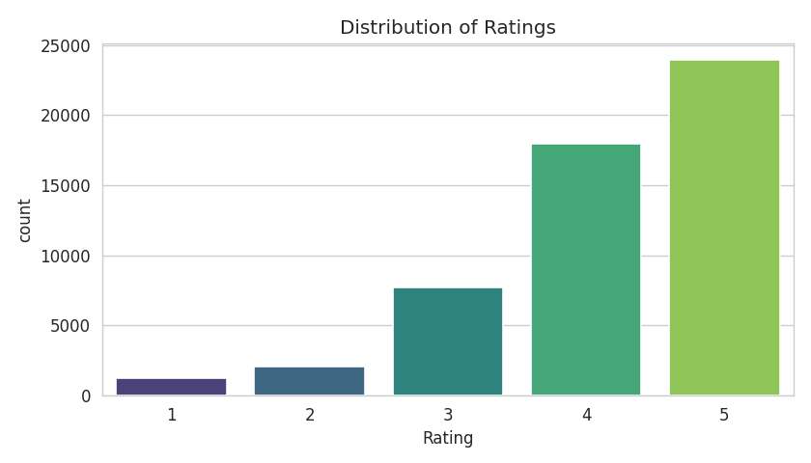
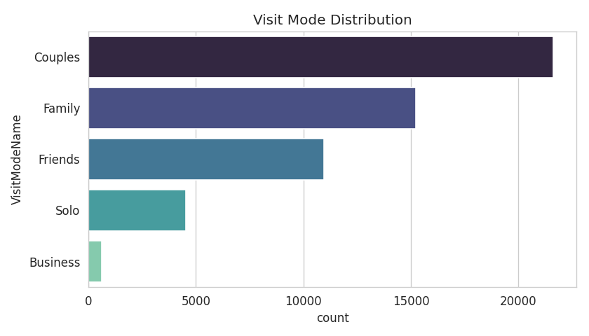
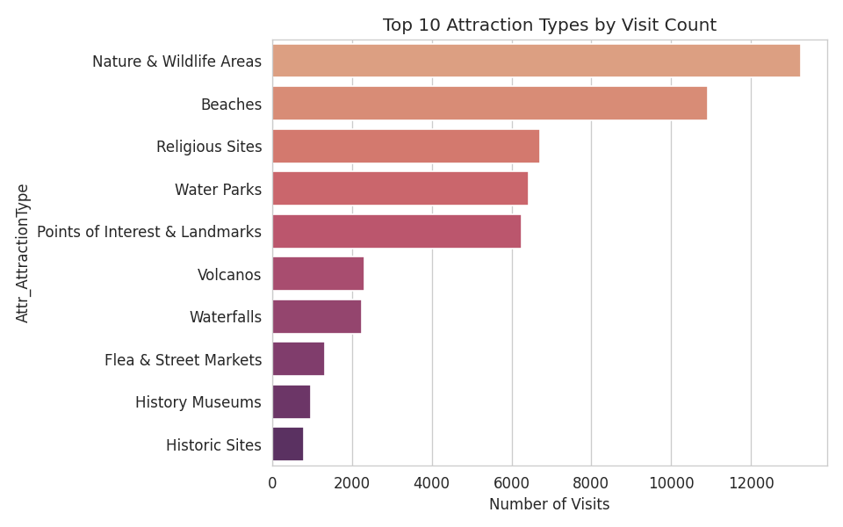
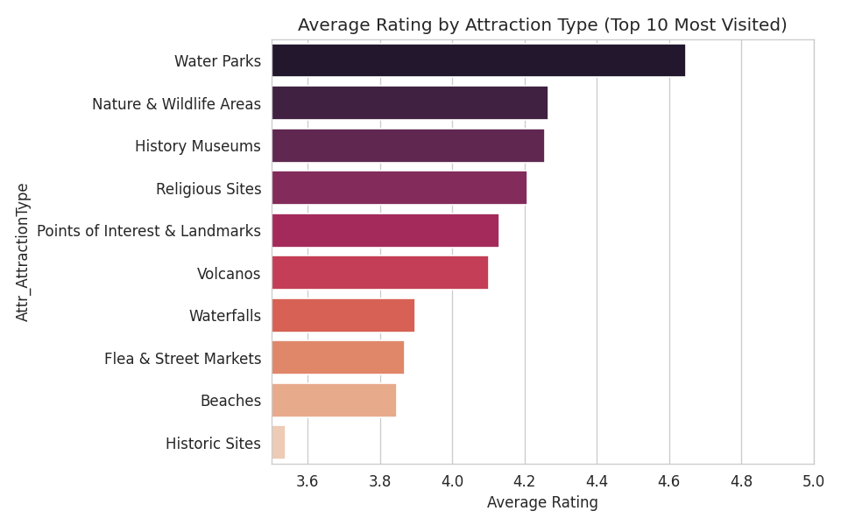
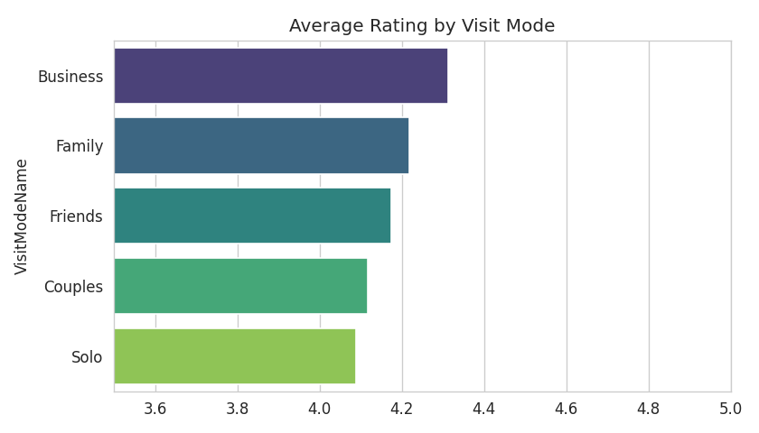
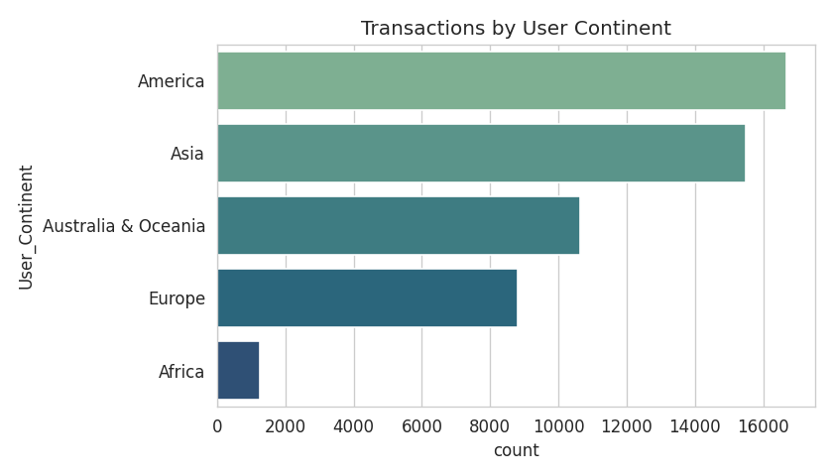
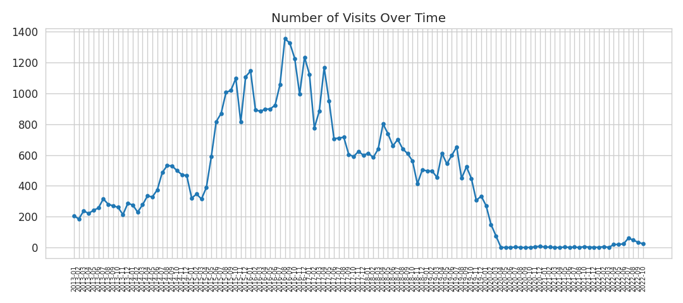
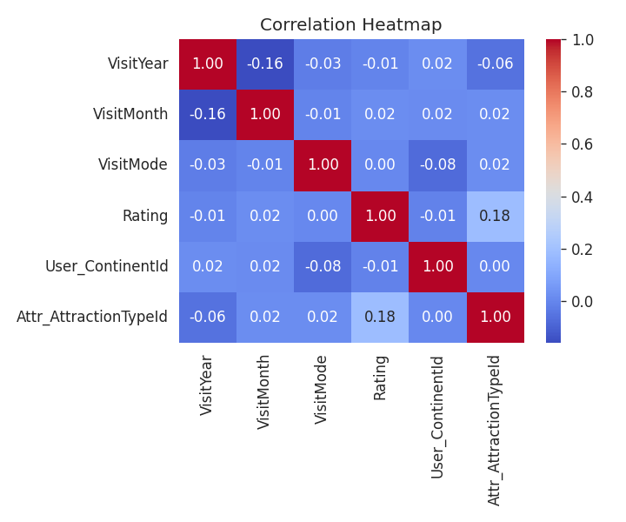

4. Modeling

4.1 Regression — Predicting Rating
A LightGBM regressor was trained on user geography, attraction type, visit timing, and user/attraction historical averages.
Metric | Value
R² | 0.746
MSE | 0.239
MAE | 0.259

4.2 Classification — Predicting Visit Mode
A LightGBM classifier was trained to predict one of five visit modes (Business, Couples, Family, Friends, Solo), benchmarked against a Random Forest baseline.
Metric | Value
LightGBM Accuracy | 0.508
LightGBM F1 (weighted) | 0.462
Random Forest Accuracy | 0.496
Random Forest F1 (weighted) | 0.483
Performance is strongest for the majority classes (Couples, Family); minority classes (Business, Solo) are harder to predict due to class imbalance — a known limitation to flag for stakeholders.

4.3 Recommendation System
A truncated-SVD collaborative filtering model was built on the user-item rating matrix (mean-centered per user). A content-based fallback recommends attractions of the same type a user previously rated highly, used for cold-start users with no rating history.
Metric | Value
RMSE (held-out ratings) | 1.058
Precision@5 | 0.048
The modest Precision@5 reflects the dataset's small attraction catalog (only 30 actively-visited attractions) relative to its user base, which limits differentiation between recommendations — a natural target for future improvement with more attraction inventory.

5. Deployment
All three models were wrapped in a multi-tab Streamlit application:
- Predict My Trip — enter geography, attraction type, and timing to get a predicted rating and visit mode
- Recommendations — select a user to see personalized, collaborative-filtering-based attraction suggestions
- Trends & Insights — an interactive Plotly dashboard of ratings, visit modes, attraction popularity, and continent-level traffic
- About — project and methodology summary
The app was smoke-tested and confirmed to launch and serve requests successfully.

6. Limitations & Next Steps
- Visit-mode classification accuracy (~51%) is moderate; richer behavioral features (trip duration, group size, prior mode history) could improve it
- The recommender is constrained by a small pool of actively-visited attractions; expanding real interaction data across the fuller 1,698-attraction catalog would improve personalization
- Regression performance benefits from attraction/user historical averages, which assumes some rating history exists — a pure cold-start rating predictor would need additional content features

