1.What is SDLC

* Software Development Life Cycle
* Stages:

1)Requirement Gathering

1)Functional Requirement->

2)Non Functional Requirement->

* Written Format
* Diagram Format->usecase Diagram

2)Analysis->What,How

3)Design->

* Web ->
* Graphic

4)Implementation:Coding[Backend Developer]

5)Testing[Tester]

6)Maintenance

1)Corrective Maintenance :

2)Adaptive Maintenance :Convert to the new Platform

3)Perfective Maintenance :

2.What is software testing?

* Software Testing is a process used to identify the correctness, completeness, and quality of developed computer software.
* testing is executing a system in order to identify any gaps, errors or missing requirements in contrary to the actual desire or requirements.

3.What is agile methodology?

* Agile Model is combination of iterative and incremental model
* Each iteration typically lasts from about one to three weeks.
* Agile Methods break the product into small incremental builds.
* At the end of the iteration a working product is displayed to the customer
* There is no deadline for project completion

4.What is SRS

* A software requirements specification (SRS) is a complete description of the behavior of the system to be developed.
* This standard describes possible structures, desirable contents, and

qualities of a software requirements specification.

5.What is oops

* Object Oriented Programming
* Identifying objects and assigning

responsibilities to these objects.

* An object is like a black box.
* The internal details are hidden.

 6.Write Basic Concepts of oops

1)Object : Any Entity which has own state and behaviour

ex:Pen,Paper,Chair etc..

2)Class : Collection of objects

ex: Human body

3)Abstraction : Hiding internal details and showing functionalities

ex: Login Page

4)Encapsulation : Wrapping up of data or binding of data

ex: Capsule

5)Inheritance : When one object acquire all the properties and behaviour of parent class

ex: Father - Son

6)Polymorphism : Many ways to perform anything

ex :1)Method Overloading

2)Method Overriding

7.What is object

* This is the basic unit of object oriented programming(OOP).
* That is both data and function that operate on data are bundled as a

unit called as object.

8.What is class

* abstraction of the object and abstracts the properties and behavior of that object.
* An object is a particular instance of a class which has actual existence and there can be many objects (or instances) for a class.

9.What is encapsulation

* Encapsulation is the practice of including in an object everything it needs hidden from other objects.
* The internal state is usually not accessible by other objects.
* Encapsulation in Java is the process of wrapping up of data

(properties) and behavior (methods) of an object into a single unit and the unit here is a Class (or interface).

10.What is inheritance

* Inheritance means that one class inherits the characteristics of another class. This is also called a “is a” relationship.
* In general, Java supports single-parent, multiple-children inheritance and multilevel inheritance (Grandparent-> Parent -> Child) for classes and interfaces.
* Java supports multiple inheritances (multiple parents, single child) only through interfaces.

11.What is polymorphism

* Polymorphism means “having many forms”.
* It allows different objects to respond to the same message in different ways, the response specific to the type of the object.
* The ability to change form is known as polymorphism.

12.Draw Usecase on Online book shopping.

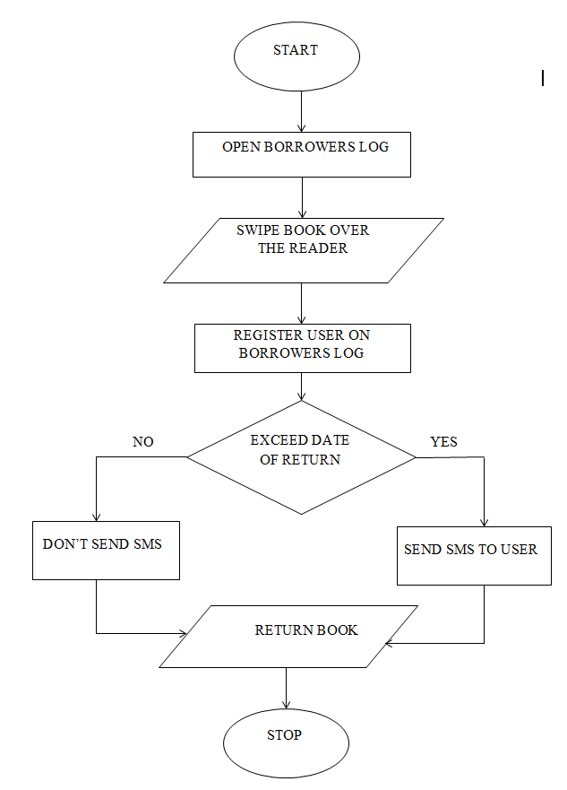

13. Draw Usecase on online bill payment system (paytm)

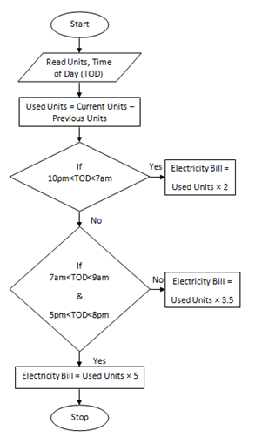

14.Write SDLC phases with basic introduction

* RequirementsCollection/Gathering
* Establish Customer Needs
* Analysis
* Model And Specify the requirements-“What”
* Design
* Model And Specify a Solution “Why”
* Implementation
* Construct a Solution In Software
* Testing
* Validate the solution against the requirements
* Maintenance
* Repair defects and adapt the solution to the new requirements

15.Explain Phases of the waterfall model

* Waterfall Model is Used for short term project
* We can use this model when requirements are fixed
* We can use this model when project requirements are not ambiguous
* We can use this Model if Project Requirement is very well documented, clear and fixed
* Technology is understood and is not dynamic.
* Product definition is stable.

16.Write phases of spiral model

* Author name: Bohem Stages

1)Planning

2)Risk Analysis

3)Engineering

4)Customer Evaluation

* Spiral Model is very widely used
* When costs there are a budget constraint and risk evaluation is important.
* For medium to high-risk projects
* Long Term Project
* Customer is not sure of their requirements
* New product line which should be released in phases to get enough customer feedback.

18.Explain working methodology of agile model and also write pros and cons.

* Agile Model is combination of iterative and incremental model
* Each iteration typically lasts from about one to three weeks.
* Agile Methods break the product into small incremental builds.
* At the end of the iteration a working product is displayed to the customer
* There is no deadline for project completion

Pros:

* Is a very realistic approach to software development
* Promotes teamwork and cross training.
* Functionality can be developed rapidly
* Suitable for fixed or changing requirements
* Little or no planning required
* Easy to manage
* Gives flexibility to developers

Cons:

* Not suitable for handling complex dependencies.
* Strict delivery management dictates
* Transfer of technology to new team members

19.Draw usecase on Online shopping product using COD.

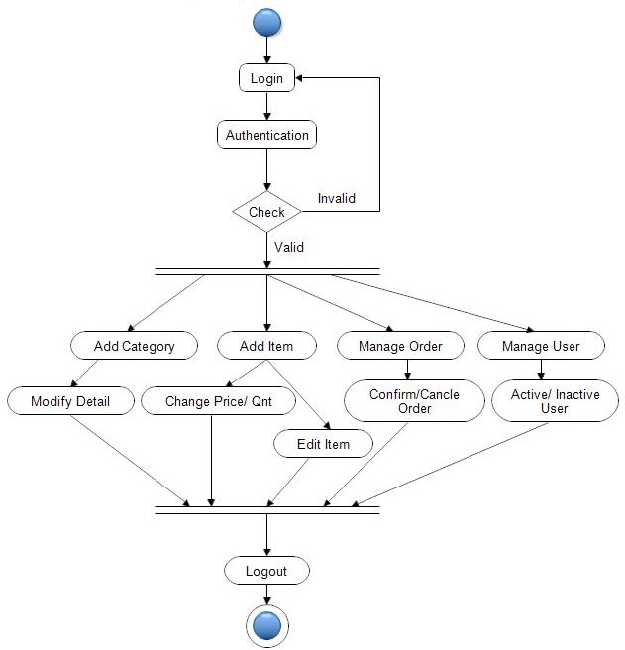

20.Draw usecase on Online shopping product using payment gateway.

