**Report**

I signed into AWS management console.

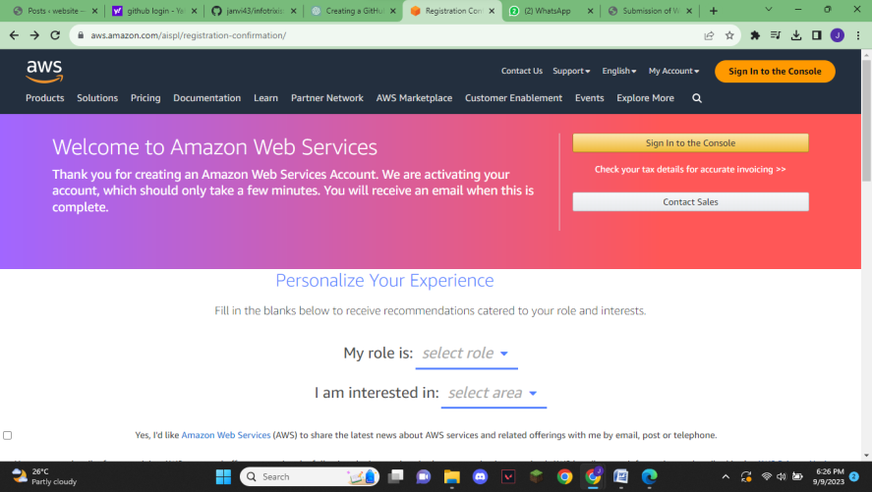

->Clicked on EC2(virtual server in the cloud).

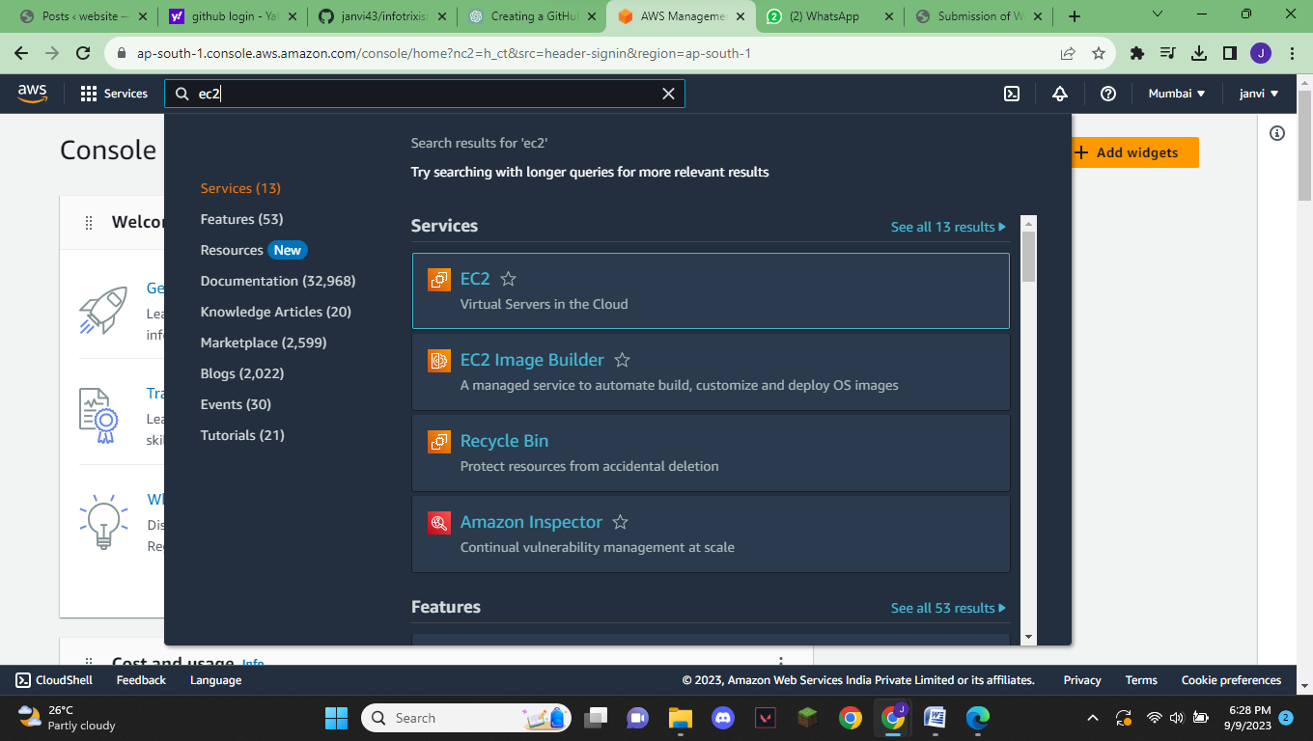

->Created a instance to Deploy Web application

->For I have used EC2 instance type: t2-micro, AMI: Amazon Linux

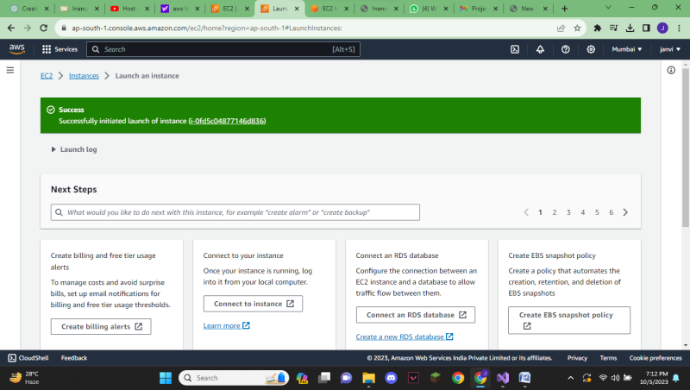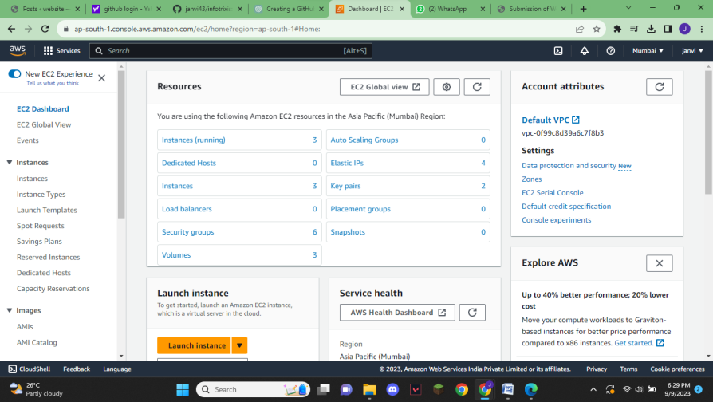

After then Connected EC2 instances via SSH.

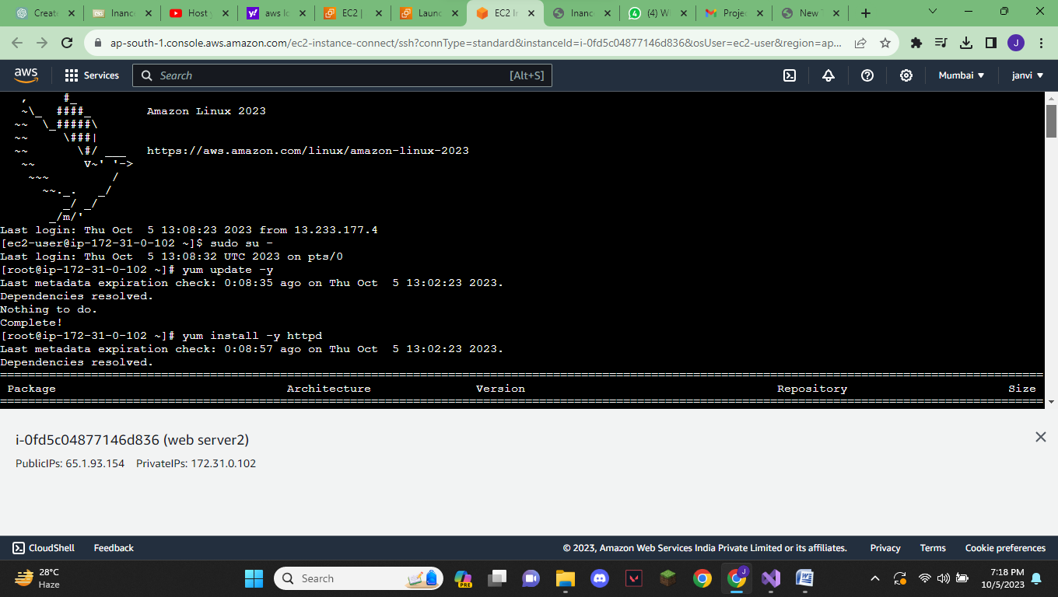

By using Amozon linux commands with the help of youtube I deployed the my INANCE web application on EC2 instance.( <http://65.1.93.154/about.html>) .You can see it with this link.

