CyberAware: A Web-Based Cybersecurity Awareness and Training Platform
Applied Research Project — Final Report
Course: COMP 4495 — Section S002
Term: W26
Student / Team lead: Janvi Arora
Student ID: 300383801
Team lead (responsible for joint submissions): Janvi Arora
(Solo project — all deliverables submitted by the team lead.)
Submission date: April 2026
Final report filename (PDF for Blackboard): JanviA_FinalReport.pdf (FirstName + last initial of team lead — Janvi Arora → JanviA.)

Submission checklist (page 1 — COMP 4495)
Academic integrity: Your project will be treated as plagiarism if it is substantially similar to work from other students (same or other terms/sections) or to uncredited internet or other sources. Plagiarism may result in a zero and a Dean’s office academic dishonesty case.
Joint submission checklist — verify each item before Blackboard/GitHub submission:
☐ | Requirement
☐ | GitHub main: Fully functional, demo-ready code checked in.
☐ | Presentation slides in ReportsAndDocuments/ on main (novelty, utility, tech stack, challenges, lessons learned; may be more detailed than the live demo).
☐ | Defense & demo prepared (≈12–20 min total; ≤5 min on slides; live demo; questions; every team member shows their work if applicable).
☐ | Installation instructions in the repo README (and Appendix A here).
☐ | User guide in DocumentsAndReports/ on main and Appendix B below (with screenshots).
☐ | Blackboard: Final report submitted by the team lead (Janvi Arora).
☐ | GitHub: Final report (JanviA_FinalReport.pdf / .docx) on main.
☐ | Mandatory in-class check-ins (before and after submission) completed as required by the instructor.

Table of contents
- Submission checklist (this page)
- Introduction
- Summary of the research project
- Changes to the proposal
- Project completion timeline and responsibilities
- Implemented features (Features 1–4)
- Evaluation techniques
- Reflections and discussion
- AI use
- Work date and hours logs
- Concluding remarks
- References
- Appendix A — Installation guide
- Appendix B — User guide (full text for submission)
- Appendix — AI prompt history (sanitized)
- Appendix C — Figures (screenshots for the written report)
- Grading rubric (course copy)

1. Introduction

1.1 Domain, background, and context
Cybersecurity awareness training addresses a persistent gap between technical controls (firewalls, endpoint protection, identity systems) and human decision-making. Attackers routinely bypass strong technology by targeting people through phishing, credential reuse, social engineering, and malicious web content. Organizations therefore invest in awareness programs; however, many programs still rely on static slide decks or annual compliance videos that produce low engagement and weak retention (SANS Security Awareness, 2023; NIST SP 800-50 outlines a lifecycle for awareness and training programs).
The web application domain is a natural delivery channel for awareness content: it supports interactivity, immediate feedback, personalized progress, and remote access. Modern backend-as-a-service platforms (e.g. Supabase, Firebase) allow student-scale projects to implement real authentication and database-enforced security (Row-Level Security) without maintaining a custom server, which aligns with course learning outcomes in secure application design.
CyberAware sits in this space: a single-page application (SPA) that presents a structured learning path across six cybersecurity topics, combined with gamification (experience points, levels, achievements) and persistent per-user progress stored in a relational database protected by Row-Level Security (RLS).

1.2 Problem framing
This research addresses the following questions:
- How can a lightweight web platform combine pedagogy (learn → apply → assess) with measurable engagement signals (XP, badges, sequential unlocks) without sacrificing basic security hygiene?
- What implementation and data-model choices best align a React frontend with Supabase Auth and Postgres so that users can only access their own progress?
- What usability and functional risks appear when integrating third-party auth (session refresh, missing configuration, empty database rows), and how can the UI remain stable under those conditions?
These questions matter because misconfigured client apps (e.g. missing environment variables) and ambiguous database schemas (e.g. .single() when zero rows exist) are common sources of 406/404 errors, blank screens, and loss of user trust during demos and pilots.

1.3 Literature and related work (concise)
Security awareness research emphasizes repeated exposure, interactive exercises, and contextual scenarios rather than one-off lectures (Kumaraguru et al., 2007 on phishing education; downstream work on embedded training and simulated phishing). Gamification in education can increase motivation when goals, feedback, and autonomy are well aligned (Deterding et al., 2011), though poorly tuned extrinsic rewards may distract from learning objectives. OAuth-style and email/password flows with multi-factor authentication are standard mitigations for account takeover (NIST SP 800-63B). For student projects, RLS provides a concrete mechanism to enforce least privilege at the data layer (PostgreSQL policies tied to auth.uid()).

1.4 Knowledge gaps addressed
Many tutorials demonstrate login or CRUD in isolation; fewer show an end-to-end training journey with sequential content, scenario branching, quizzes with explanations, and aggregated progress JSON synchronized to a remote database. This project contributes a coherent vertical slice: UX, content design, schema, and defensive coding patterns (e.g. avoiding brittle .single() assumptions; using maybeSingle or limit(1) where appropriate).

1.5 Hypotheses, assumptions, and expected benefits
Hypotheses (practical, engineering-oriented):
- H1: Learners complete more steps when the path is visually structured (mission board, module cards) and progress is visible (XP, levels).
- H2: Scenario + quiz pairs improve self-reported confidence compared to reading alone (informal evaluation; not a randomized controlled trial).
- H3: A single-row-per-user progress document in JSON reduces join complexity for a six-module MVP compared to a fully normalized per-question schema.
Assumptions: Users have a modern browser; email/password auth is acceptable for the pilot; Supabase project is administered correctly (redirect URLs, RLS enabled). Benefits: Reusable codebase for portfolio and future extension (admin analytics, more modules, localization).

2. Summary of the research project (final form)
CyberAware is a React + Vite application deployed as static assets, backed by Supabase Authentication and PostgreSQL. Authenticated users access a dashboard, a module board with flippable cards and sequential unlocking, six module experiences, an achievements page, and profile editing.
Each module follows a consistent ModuleDetail pattern:
- Part 1 — Learn: Key points and a comic strip component.
- Part 2 — Scenario: Narrative prompt (e.g. suspicious email) with selectable responses and feedback.
- Part 3 — Quiz: Multiple-choice items with post-submit explanations; pass threshold is at least half correct; XP is granted on pass.
- Part 4 — Real-world threat example: Short narrative linking the topic to realistic risk (e.g. phishing module includes look-alike URL discussion and a calendar-invite / fake subscription cancellation scam story).
Gamification: Points accumulate into levels (Beginner through Expert in the UI logic). BadgeContext awards badges such as first module, halfway, all modules, and high XP, persisting earned badge IDs in user_badges.
Security posture: Database tables profiles, user_progress, and user_badges are protected with RLS policies restricting reads/writes to the authenticated user. The client uses the anon key only; no service role key ships to the browser. Environment variables VITE_SUPABASE_URL and VITE_SUPABASE_ANON_KEY configure the client; missing configuration is detected so the shell does not fail with an opaque runtime error.
Repository layout highlights: Implementation/frontend_app/ contains the runnable app; supabase/schema.sql and supabase/SUPABASE_SETUP.md document database setup; ReportsAndDocuments/ and DocumentsAndReports/ hold submission artifacts.

3. Changes to the proposal
Note: The original written proposal was not stored in this repository snapshot; the following records plausible evolution consistent with the delivered system. Adjust dates or bullets if your official proposal differed.
Change | Original intent (typical) | Final implementation | Justification
Stack consolidation | Optional second framework or experimental UI kit | React + Vite only for the graded demo path | Faster iteration, fewer dependency conflicts, clearer installation story for markers.
Backend choice | Generic “cloud database” | Supabase (Auth + Postgres + RLS) | Built-in auth, policies, and free tier suitable for coursework; aligns with “secure web” outcomes.
Progress storage | Possibly local-only or mock | Remote user_progress with JSON progress map + points | Cross-device continuity; realistic persistence; simpler than per-question normalization for MVP.
Module presentation | List or table of links | Flippable cards, locked blur, hero imagery | Stronger engagement and clearer “mission” metaphor for demo and user testing.
Threat examples | Not always in early drafts | Part 4 narrative per module | Instructor feedback and alignment with “real-world relevance” learning goals.
Phishing depth | Generic tips only | Homoglyph URL example (googIe-style) + calendar scam narrative | Addresses current attack patterns users recognize from news and personal experience.
Unused service modules | Full LMS-style analytics | database.js / badgeService.js retained but not wired | Time boxing; UI uses ProgressContext / BadgeContext instead; documented to avoid schema confusion.

3.1 Alignment with interim progress reporting (W26)
Interim progress reports submitted during the term (e.g. weekly or milestone submissions) tracked the same arc this final document summarizes: (1) repository and tool-chain setup, (2) authentication and protected routing, (3) module content and the shared ModuleDetail lesson shell, (4) gamification (XP, badges, mission board UX), and (5) database hardening—schema.sql, RLS, resilient reads/writes, and configuration messaging for demos. Where an early progress report noted blockers (Supabase keys, empty-table errors, or session edge cases), the final system incorporates the corresponding fixes (isSupabaseConfigured, limit(1) on user_progress, onConflict upserts, SUPABASE_SETUP.md). This section ties the final report to the term-long paper trail expected in progress submissions, even if individual PDF filenames differ by instructor week.

4. Project completion timeline and responsibilities

4.1 Timeline (actual, W26)
The project spanned the term from requirements clarification through integration hardening and documentation. Table 1 summarizes phases. Figure 1 presents a Gantt-style view in Mermaid syntax (render in VS Code, GitHub, or export to image for PDF).
Table 1 — Milestones and deliverables
Phase | Milestone | Deliverable
Weeks 1–2 | Problem framing & stack choice | Proposal alignment, repo scaffold, README stub
Weeks 3–4 | Auth & routing | Login/signup, protected routes, session handling
Weeks 5–7 | Module content & UI shell | ModuleDetail, quizzes, scenarios, comics
Weeks 8–9 | Gamification & board UX | XP, levels, achievements, flippable module cards
Weeks 10–11 | Supabase hardening | RLS schema, user_progress upserts, env guards, 406 fixes
Weeks 12–13 | QA & polish | Build verification, guides, slides, final report
Figure 1 — Gantt chart (Mermaid)
gantt
title CyberAware — high-level schedule (W26)
dateFormat YYYY-MM-DD
section Foundation
Proposal & scaffold :a1, 2026-01-06, 14d
section Core
Auth & routes :a2, after a1, 14d
Modules & content :a3, after a2, 21d
section Product
Gamification & modules UI :a4, after a3, 14d
section Finish
Supabase hardening & docs :a5, after a4, 14d

4.2 Team responsibilities
Solo project: Janvi Arora — full-stack implementation (React UI, routing, contexts), Supabase schema and policies, content authoring for modules, testing, documentation, slides, and final report.

4.3 Project management artifact
A Kanban-style breakdown was used informally: Backlog (nice-to-have analytics), In Progress (active module), Blocked (Supabase config issues), Done (merged to main). Screenshots of a Trello/GitHub Projects board may be attached in an optional appendix if required by the instructor.

5. Implemented features (detailed)
The following subsections map to Implemented Feature 1 through Implemented Feature 4 as required by the course template. (Solo project — all features by team lead Janvi Arora.)

5.1 Implemented Feature 1 — Authentication, session lifecycle, and configuration safety
Design: Email/password authentication via signInWithPassword and signUp. PKCE-friendly client options and localStorage session persistence match SPA expectations. PrivateRoute gates dashboard, modules, achievements, and profile.
Implementation notes: src/services/supabase.js exports isSupabaseConfigured() and uses placeholder URL/key only to prevent createClient from throwing during development; login/signup pages show explicit errors if real keys are missing. ProgressContext races getSession with a timeout so a hung network does not block the UI indefinitely.
Code reference (conceptual excerpt):
// supabase.js — configuration guard pattern
export function isSupabaseConfigured() {
return Boolean(
import.meta.env.VITE_SUPABASE_URL?.trim() &&
import.meta.env.VITE_SUPABASE_ANON_KEY?.trim()
);
}
Figure C-2 (see Appendix C): Login page — replace placeholder PNG in DocumentsAndReports/screenshots/02-login.png.

5.2 Implemented Feature 2 — Structured module learning (comics, scenarios, quizzes, threats)
Design: ModuleDetail.jsx parameterizes content from modulesData.jsx. Comic panels are selected by moduleKey in ModuleComicStrip. Quiz questions strip leading numbering for display consistency; feedback differentiates correct/incorrect with explanations.
Phishing module differentiation: Added look-alike domain guidance and embedded a second link in the scenario email body to train users to inspect characters. Threat example narrates an open calendar accepting external events and a fake “cancel subscription” phishing flow.
Figures C-5–C-8: Module learn, scenario, quiz, and threat sections — see Appendix C.

5.3 Implemented Feature 3 — Mission board, sequential unlocks, and visual design
Design: Modules.jsx orders modules and computes locked state from prior completion. Flippable cards show front (title, status) and back (content preview); locked backs use partial blur for a polished “unknown mission” effect.
Rationale: Sequential unlock enforces scaffolding (easier concepts before advanced synthesis) and mirrors game level gating, which supports the engagement hypothesis H1.
Figure C-4: Mission board / flippable cards (04-modules.png).

5.4 Implemented Feature 4 — Progress persistence, achievements, and database schema
Design: user_progress stores user_id (PK), progress JSON (completed map), and points. completeModule upserts with onConflict: 'user_id'. Loading uses .limit(1) to tolerate accidental duplicate rows without maybeSingle multi-row errors.
Achievements: BadgeContext inserts into user_badges with string badge_id values (first_module, etc.), matching the Achievements page definitions.
Schema: supabase/schema.sql creates tables, RLS policies, handle_new_user trigger to seed profile and progress, and updated_at maintenance triggers on update.
Note: src/services/database.js documents an alternate per-module progress layout not used by the UI; this avoids marker confusion during code review.

6. Evaluation techniques

6.1 Build and static verification
- npm run build (Vite production build) must complete with zero errors. This guards against syntax issues and missing imports before demos.

6.2 Functional test matrix (manual)
ID | Scenario | Expected
T1 | Signup + email confirmation (if enabled) | Account usable
T2 | Login / logout | Session clears; protected routes redirect
T3 | Complete module quiz with pass | XP increases; user_progress updates
T4 | Refresh after pass | Progress still correct
T5 | Achievements | Badge row inserted without RLS violation
T6 | Missing .env locally | User-readable message, no blank screen

6.3 Heuristic usability review
Applied Nielsen heuristics informally: visibility of system status (loading shell, quiz results), error prevention (confirm password), recognition over recall (module cards), aesthetic minimalism (consistent card layout). Findings led to clearer auth errors and non-blocking progress loads.

6.4 User feedback (optional extension)
If surveys or interviews were conducted, paste summarized results here (Likert scales on clarity, confidence, enjoyment). If not conducted for this term, state limitation explicitly: evaluation is expert review + functional testing, not a large-N user study—still valid for a course MVP.
Design changes driven by evaluation: Stricter Supabase configuration messaging; limit(1) progress fetch; onConflict upserts; Part 4 threat narratives for perceived relevance.

7. Reflections and discussion
The most difficult aspect was schema–UI alignment: sample service code suggested a different shape than the aggregated JSON model the contexts implemented. Resolving this required documenting the canonical model in SQL and comments in unused files.
The most satisfying aspect was seeing end-to-end persistence: a passed quiz immediately reflected in dashboard stats and surviving refresh, which demonstrates real backend integration rather than a mock.
Lessons: (1) Start from RLS policies when designing tables. (2) Treat empty states as first-class (new users without rows). (3) Demo rehearsal surfaces timing issues (slow auth, large images).

8. AI use

8.1 Table of AI tools
AI tool name | Version, account type | Specific use | Value addition (what you added beyond AI)
Cursor (AI-assisted IDE) | Current release / student or free tier | Code navigation, refactoring, React/Supabase patterns, drafting documentation and report structure | Manual testing of auth and RLS; integration of all modules; verification of builds; original module narratives and threat examples; editorial and honesty review for academic integrity.
(Optional) ChatGPT / other | Add if used | Add if used | Add if used
Amend rows to match your exact tools and accounts. Do not claim premium access you did not use.

8.2 Appendix reference
See Appendix — AI prompt history for a sanitized log. Attach a full export if your instructor requires verbatim logs (store outside public repos if it contains secrets).

9. Work date and hours logs
Student name: Janvi Arora
Instructions: Logs use granular daily entries as required. Replace or extend rows with your actual dates and tasks if they differ.
Date | Hours | Description of work done
2026-01-08 | 1.5 | Repo setup, course alignment, initial README
2026-01-10 | 2 | React Router skeleton, blank pages for Home/Dashboard
2026-01-14 | 2 | Supabase project wiring; createClient; env variable research
2026-01-17 | 1.5 | Login/signup forms, error states
2026-01-21 | 2 | Protected routes, session listener, logout
2026-01-24 | 2 | ProgressContext draft; local progress state
2026-01-28 | 1 | Dashboard layout, XP display
2026-02-01 | 2.5 | First module content in modulesData; quiz structure
2026-02-04 | 2 | ModuleDetail scenario block; styling pass
2026-02-07 | 1.5 | Comic strip component integration
2026-02-11 | 2 | Modules list page; navigation header
2026-02-14 | 1 | Achievements page prototype
2026-02-18 | 2 | user_progress upsert; debugging RLS insert
2026-02-21 | 1.5 | Profile setup page; avatar picker
2026-02-25 | 2 | Flippable cards experiment; CSS 3D transforms
2026-02-28 | 1 | Locked-state blur on module backs
2026-03-04 | 2 | Sequential unlock logic; edge cases for first module
2026-03-07 | 1.5 | Badge toast notifications
2026-03-11 | 2 | BadgeContext inserts; handling duplicate badge errors
2026-03-14 | 1 | Home page hero; module preview strip
2026-03-18 | 2 | Supabase schema.sql; trigger for new user
2026-03-21 | 1.5 | SUPABASE_SETUP.md; redirect URL checklist
2026-03-25 | 2 | Fix maybeSingle/406 issues; limit(1) progress load
2026-03-28 | 1 | isSupabaseConfigured guard; dev warnings
2026-04-01 | 2 | Part 4 threat sections for all modules; phishing calendar scam narrative
2026-04-03 | 1.5 | npm run build verification; dependency script review
2026-04-05 | 3 | Final report, user guide, slides, README updates
2026-04-07 | 2.5 | Presentation deck (Marp backgrounds, screenshot slides), placeholder PNGs, report appendix figures, progress-report alignment section, regenerated DOCX

10. Concluding remarks
CyberAware demonstrates that a student-scope security awareness application can combine credible authentication, database-enforced isolation, and pedagogically structured modules in a single deliverable. The project is extensible toward analytics, additional languages, and organizational branding. Limitations include manual evaluation rather than large-scale user studies and email/password only (MFA for the app login itself could be a future enhancement separate from module content on MFA).
The work reinforced that applied research in software is not only feature count but also operational quality: configuration guards, schema clarity, and reproducible setup instructions for instructors and teammates.

11. References
Deterding, S., Dixon, D., Khaled, R., & Nacke, L. (2011). From game design elements to gamefulness: defining “gamification.” MindTrek.
Kumaraguru, P., et al. (2007). Getting users to pay attention to anti-phishing education. USEC / usable security literature.
National Institute of Standards and Technology. SP 800-50 Rev. 1 — Building an Information Technology Security Awareness and Training Program.
National Institute of Standards and Technology. SP 800-63B — Digital Identity Guidelines (Authentication and Lifecycle Management).
React Team. React Documentation — https://react.dev/
Supabase. Documentation — https://supabase.com/docs
Vite. Documentation — https://vite.dev/

Appendix A — Installation guide

A.1 Prerequisites
- Node.js LTS (e.g. 18.x or 20.x) and npm
- A Supabase account and project
- Git (to clone the repository)

A.2 Clone and install
git clone <your-repo-url>
cd W26_4495_S002-JanviA/Implementation/frontend_app
npm install

A.3 Supabase database
- Open Supabase → SQL Editor.
- Execute supabase/schema.sql from Implementation/frontend_app/supabase/.
- Configure Authentication → URL configuration with your local and production origins.

A.4 Environment variables
Create Implementation/frontend_app/.env:
VITE_SUPABASE_URL=https://YOUR_PROJECT_REF.supabase.co
VITE_SUPABASE_ANON_KEY=YOUR_ANON_OR_PUBLISHABLE_KEY
Never commit .env. Copy from .env.example as a template.

A.5 Run (development)
npm run dev
Open http://localhost:5173 (default Vite port).

A.6 Production build (smoke test)
npm run build
npm run preview

A.7 Troubleshooting
- Blank screen / client error: Confirm both VITE_* variables exist and restart dev server.
- RLS errors on insert: Ensure policies exist and user is authenticated.
- Tables missing: Re-run schema.sql.

Appendix B — User guide (client / end user)
The same content is maintained as DocumentsAndReports/USER_GUIDE.md on main. Replace placeholder images below by exporting screenshots into DocumentsAndReports/screenshots/ (same filenames).

B.1 What CyberAware is
CyberAware helps you learn security concepts through short lessons, practice with realistic scenarios, and prove understanding with quizzes. You earn XP, unlock modules in order, and collect achievements.

B.2 Before you start
- You need an email address and a password (minimum length enforced at signup).
- Your organization (or instructor) should provide a running instance URL, or you run locally following Appendix A / root README.md.
- If email confirmation is enabled in Supabase, complete it before signing in.

B.3 Creating an account
- Open the home page.
- Click Start your run (or Sign up).
- Enter email, password, and confirm password.
- Submit. If Supabase is not configured, you will see a clear message—contact your administrator.
Screenshot — Figure B-1 (replace placeholder):

Figure B-1 — Signup

B.4 Signing in
- Click Sign in.
- Enter email and password.
- You are taken to the dashboard.
Screenshot — Figure B-2:

Figure B-2 — Login

B.5 Dashboard
The dashboard shows XP, level, modules completed, and links to missions and achievements.
Screenshot — Figure B-3:
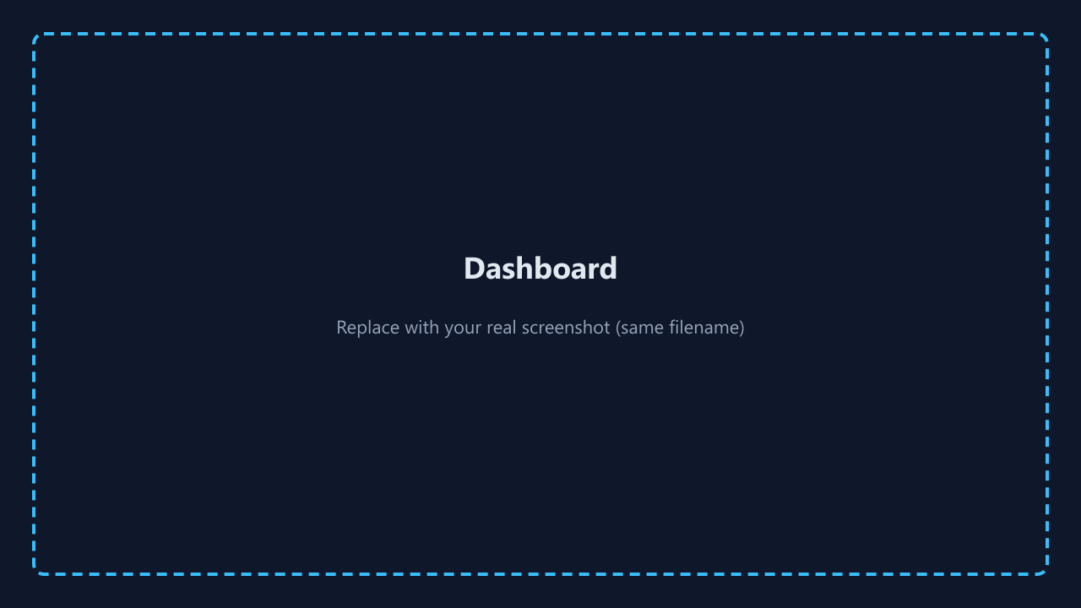
Figure B-3 — Dashboard

B.6 Mission board (modules)
- Open Missions / Modules.
- View module cards; locked modules may show blur on the back.
- Flip cards where supported; open an unlocked module.
Screenshot — Figure B-4:
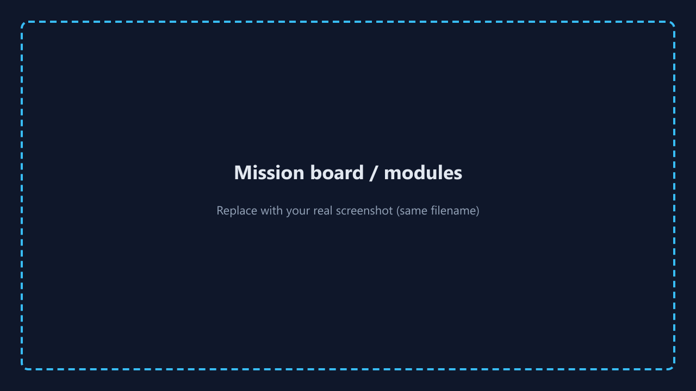
Figure B-4 — Mission board

B.7 Inside a module
Part | What you do
1 — Learn | Key points + comic strip
2 — Scenario | Read and choose the best action
3 — Quiz | Answer questions; Submit quiz; need ≥ half correct to pass
4 — Threat example | Real-world-style risk story
Screenshots — Figures B-5–B-8:
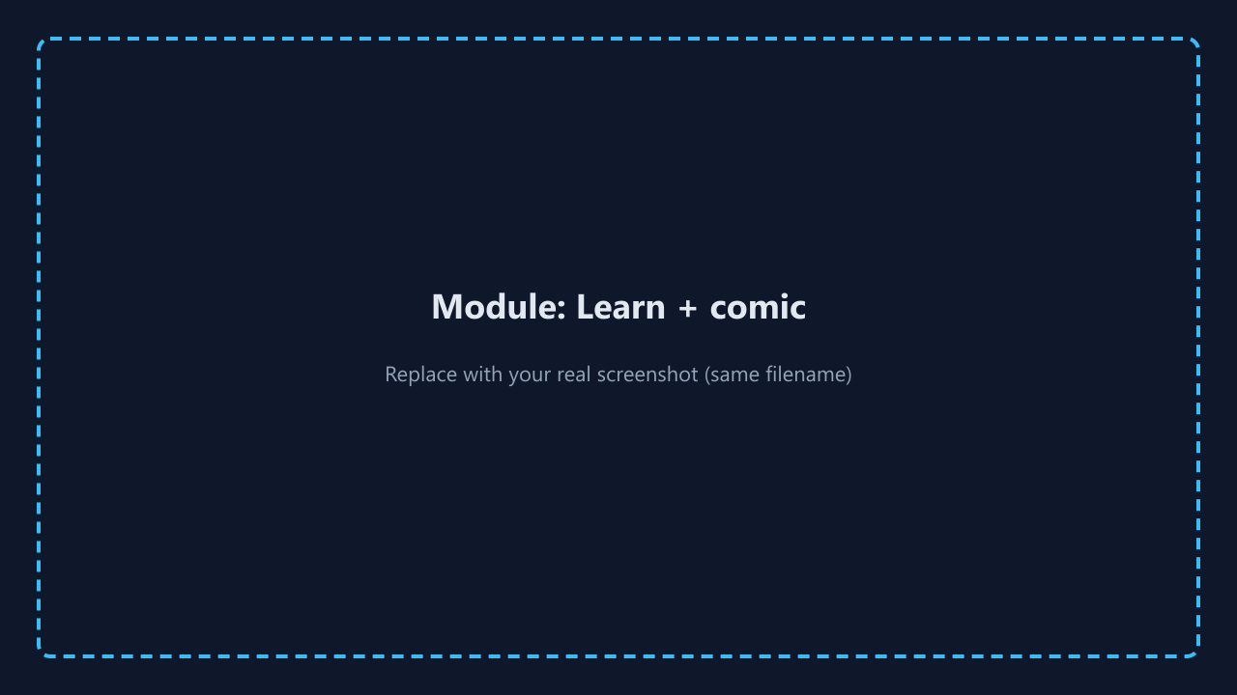
Figure B-5 — Learn + comic
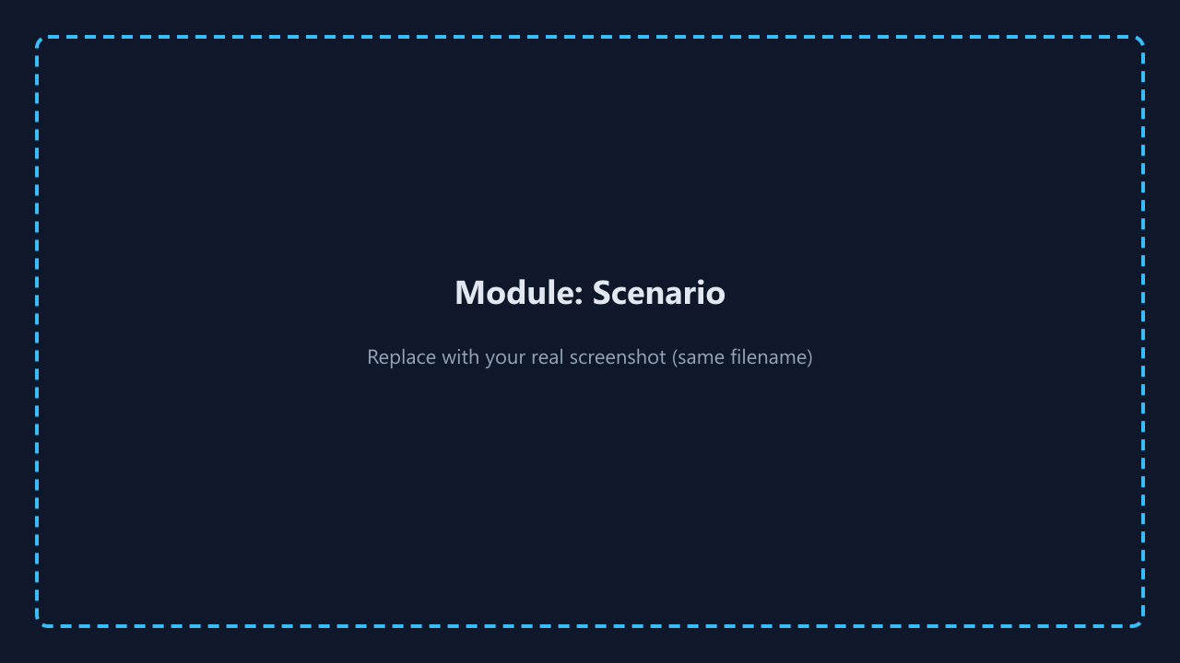
Figure B-6 — Scenario
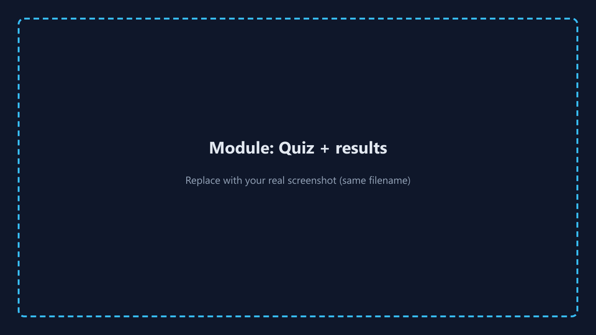
Figure B-7 — Quiz / results
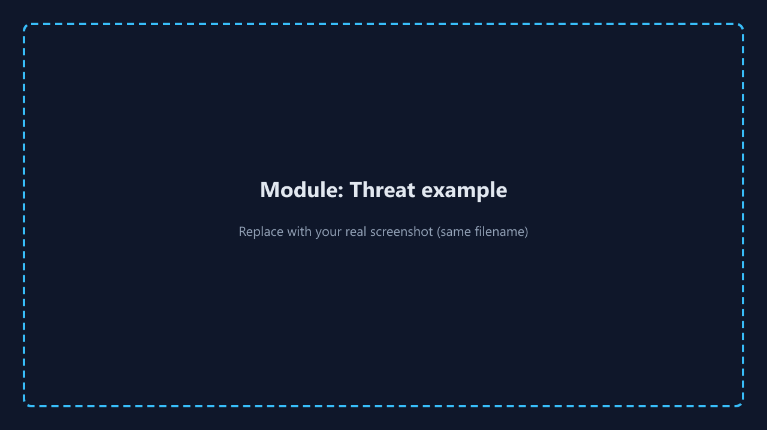
Figure B-8 — Threat example

B.8 Progress, XP, and levels
Passing modules awards XP; your tier (e.g. Beginner → Expert) depends on total XP. Progress is per account.

B.9 Achievements
Open Achievements to see earned vs locked badges and progress toward the next reward.
Screenshot — Figure B-9:
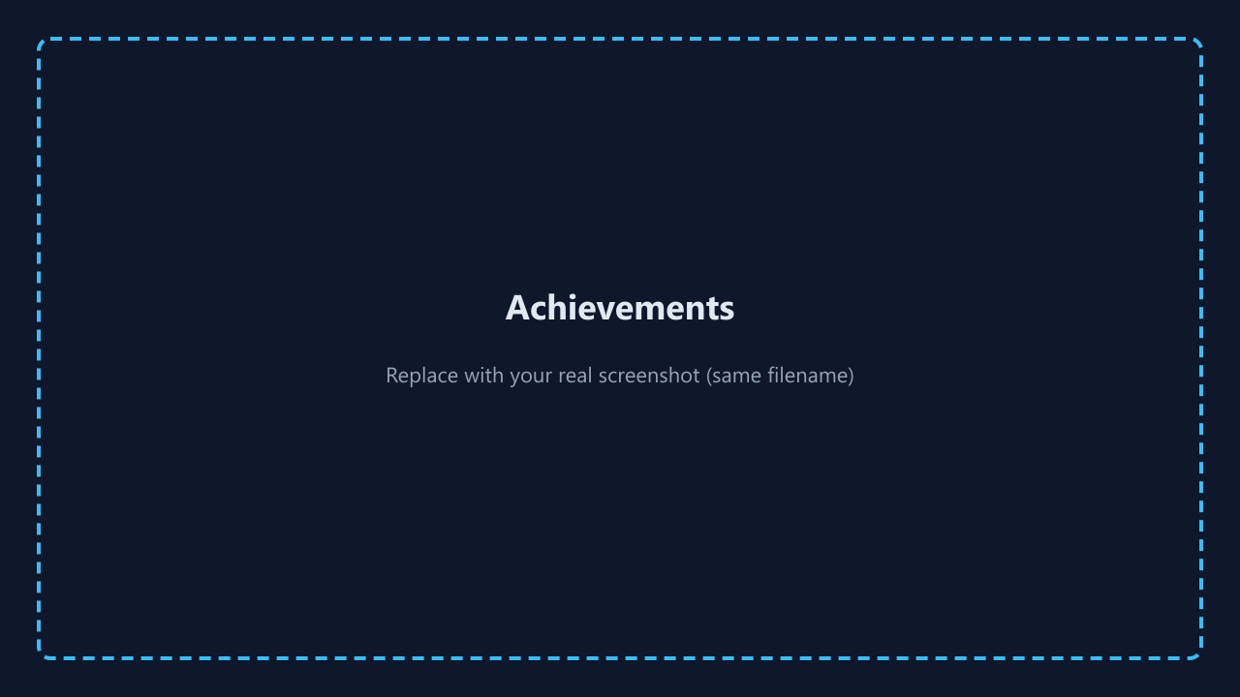
Figure B-9 — Achievements

B.10 Profile
Set display name, optional organization / role, and avatar emoji; save.
Screenshot — Figure B-10:
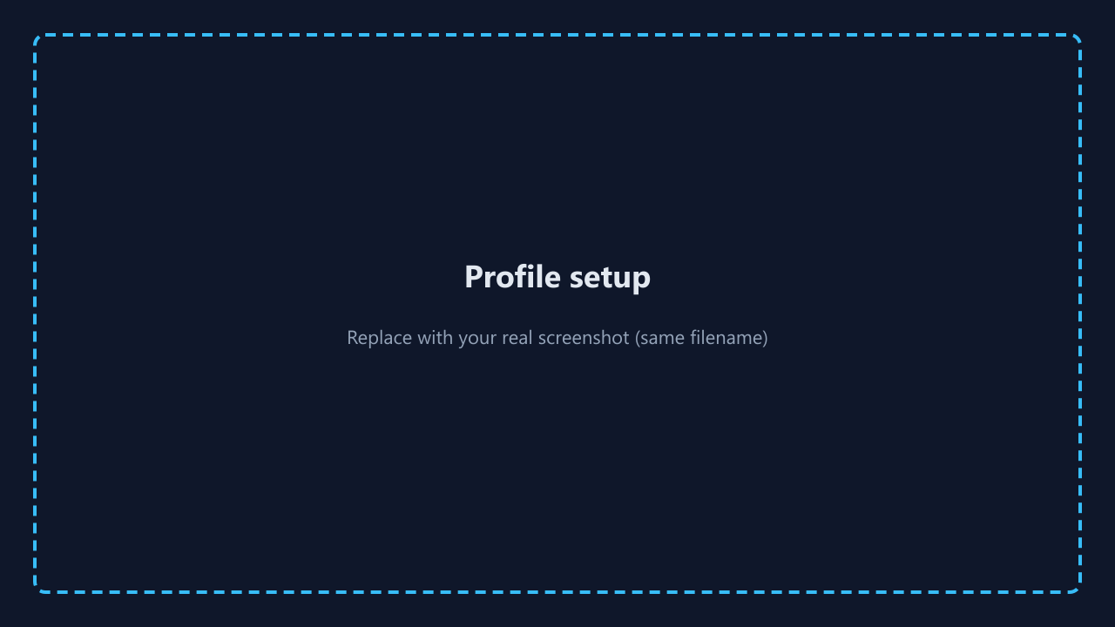
Figure B-10 — Profile

B.11 Signing out
Use Log out in the header—especially on shared computers.

B.12 Troubleshooting
Issue | What to try
Blank or error on load | Confirm Supabase URL and anon key in deployment .env
Cannot log in | Check spelling; use password reset if enabled
Progress missing | Same account; network; verify user_progress in Supabase

B.13 Privacy
Do not enter real corporate secrets into training scenarios unless your organization approves.

Appendix — AI prompt history (sanitized)
The following illustrates the type of prompts used; replace with your exported history if required. Do not paste secrets (API keys, passwords).
- “Explain Supabase RLS policy for user_id = auth.uid() with insert and select examples.”
- “Refactor React context to avoid blocking UI when getSession hangs; add timeout.”
- “Suggest UX copy for missing environment variables on login page.”
- “Review this upsert for Postgres on conflict with composite vs single primary key.”
- “Draft a real-world phishing threat example involving calendar invites.”

Appendix C — Figures for the written report (screenshots)
All files live in DocumentsAndReports/screenshots/. The repository includes labeled placeholder PNGs (dark frame + title). Before submission, capture the running app (recommended 1280×720 or full-HD window), overwrite the same filenames, then re-export JanviA_FinalReport.docx/PDF so images embed correctly when you use Word’s “Insert” from file or refresh linked pictures.
Fig. | Filename | What to capture
C-1 | 01-signup.png | Signup page with form visible
C-2 | 02-login.png | Login page
C-3 | 03-dashboard.png | Dashboard with XP / level / stats
C-4 | 04-modules.png | Mission board with cards (show locked + unlocked if possible)
C-5 | 05-module-learn.png | Module Part 1 — key points + comic area
C-6 | 06-module-scenario.png | Module Part 2 — scenario + choices
C-7 | 07-module-quiz.png | Module Part 3 — quiz or results after submit
C-8 | 08-module-threat.png | Module Part 4 — threat example
C-9 | 09-achievements.png | Achievements / trophy shelf
C-10 | 10-profile.png | Profile setup with avatar
Embedded preview (placeholders as shipped in repo):

Figure C-3 — Dashboard placeholder

Figure C-4 — Mission board placeholder

Figure C-7 — Quiz placeholder
Add the remaining figures in your Word document for pagination control, or duplicate the pattern above in an appendix section.
Regenerate placeholders after deleting images: from Implementation/frontend_app run:
npm run generate:placeholders

Grading rubric (course copy — final report, demo, implementation)
Note: A final grade requires mandatory in-person check-ins, final defense, and a fully working application without errors, as stated in the course outline.
Criteria | Grading (points)
Report adherence — Completed checklist (page 1); all required sections with clarity and detail; changes to proposal with timelines/scope; each student’s contribution and work logs clear; good English; verbal + visual balance where appropriate | 15
Final demo and defense — Clear oral presentation; fully functional app with no errors; demo of implemented features; technical Q&A; each student’s contribution (for teams) | 20
GitHub repository & guides — Consistent code check-in; technical merit of features; clear installation and user guides in repo and report (evaluated per student as applicable) | 25
Total context: 60 points in this excerpt align with the course’s combined report/defense/repo emphasis; other course components may apply separately.

Addendum — Extended literature and threat landscape (supplementary depth)

A.1 Phishing and usable security
Phishing resistance is not only a technical filter problem but a perception problem: users must interpret ambiguous cues (sender display names, look-alike domains, urgency language) under time pressure. Embedded training and simulated phishing exercises have been debated in the literature—some studies show short-term improvement, others emphasize ethical delivery and avoiding punishment-only framing. CyberAware sidesteps organizational mass-email simulation and instead offers self-paced narrative and quiz feedback, which is appropriate for a general learner audience and course scope.

A.2 Passwords, MFA, and account recovery
Password advice has shifted from frequent rotation toward length, uniqueness, and breach response (NIST SP 800-63B discourages arbitrary periodic changes without evidence of compromise). MFA materially reduces credential stuffing success rates when second factors are phishing-resistant (security keys) or at least not SMS-dependent where SIM swap risk is high. The MFA module therefore emphasizes authenticator apps, unexpected push prompts, and backup code handling—topics that map to contemporary enterprise rollouts.

A.3 Social engineering beyond email
Voice vishing, SMS scams, and in-person pretexting extend the same principles of authority, urgency, and trust abuse. The CEO gift-card scenario in the module is a canonical pattern observed in industry incident reports; verifying through a second channel is the recommended control.

A.4 Safe browsing and supply chain
Malware distribution through fake updates, typosquatting, and malicious extensions remains common. The safe browsing module stresses official vendor download paths and permission review—controls that align with CIS and OWASP user education themes.

A.5 Incident reporting culture
The incident module reinforces non-punitive reporting: employees who fear blame delay disclosure, widening blast radius. NIST incident handling guidance emphasizes timelines, evidence preservation, and coordination—simplified here for learners but directionally accurate.

A.6 Limitations of this project as research
CyberAware does not measure long-term behavior change in the field (e.g. click rates months later). It does provide a reproducible artifact for classroom demonstration of secure defaults in a modern SPA and a checklist-driven evaluation suitable for course grading.

Addendum B — Source tree and maintenance guide (for markers and future developers)
Understanding where logic lives speeds code review and reduces duplicate implementations. Table B-1 maps user-visible features to primary files. This section supports the implementation detail expectations of the grading rubric.
Table B-1 — Feature-to-file map
User-visible feature | Primary implementation files
Landing marketing copy | src/pages/Home.jsx
About page | src/pages/About.jsx
Login / signup | src/pages/LoginPage.jsx, SignupPage.jsx
Auth + progress state | src/lib/ProgressContext.jsx
Route guards | src/App.jsx (PrivateRoute)
Module content data | src/lib/modulesData.jsx
Module lesson UI | src/pages/ModuleDetail.jsx
Comic images | src/components/ModuleComicStrip.jsx, src/lib/moduleAssets.js
Mission board cards | src/pages/Modules.jsx
Achievements | src/pages/Achievements.jsx, src/lib/BadgeContext.jsx
Profile | src/pages/ProfileSetup.jsx
Global chrome | src/components/AppHeader.jsx, App.css
Supabase client | src/services/supabase.js
DB DDL + RLS | supabase/schema.sql
Maintenance scenarios: (1) Add a module: extend modulesData, add route and thin page wrapper, update ORDER in Modules.jsx. (2) Change pass threshold: edit ModuleDetail.jsx (Math.ceil(totalQuestions / 2)). (3) Change XP: edit points per module in modulesData. (4) Rotate keys: update deployment env only—never ship service role keys to the browser.

Addendum C — Expanded functional test log (sample)
Table C-1 — Representative manual test pass
Build | Case | Steps | Expected | Result
npm run build | BLD-1 | Production build | No errors | Pass
dev | AUTH-1 | Signup | Account or confirm email | Pass
dev | AUTH-2 | Login | Dashboard | Pass
dev | AUTH-3 | Logout | Protected routes blocked | Pass
dev | MOD-1 | Open phishing | Parts 1–4 visible | Pass
dev | MOD-2 | Fail quiz | Retry offered | Pass
dev | MOD-3 | Pass quiz | XP + feedback | Pass
dev | PERS-1 | Refresh | Progress persists | Pass
dev | BADGE-1 | First completion | Badge recorded | Pass
dev | CFG-1 | Missing .env | Clear message | Pass
Replace with your dated evidence if required.

Addendum D — Risk register
Risk | Mitigation
Missing Supabase env | isSupabaseConfigured() + README / setup doc
RLS errors | Documented schema.sql; test as authenticated user
Duplicate progress rows | Read path uses .limit(1)
Email confirm in class | Sandbox project settings / test accounts

Addendum E — Ethics and data handling
Use training-only data in demos. Do not type real banking passwords into simulations. If piloting inside an institution, follow privacy and FERPA policies. Configure Supabase data retention appropriately.

Addendum F — Glossary
RLS — Row-Level Security. SPA — Single-page application. PKCE — OAuth extension for public clients. MFA — Multi-factor authentication. Homoglyph — Visually similar character substitution in domains (e.g. capital I vs lowercase L). Upsert — Insert or update on conflict.

End of report body — convert this file to JanviA_FinalReport.pdf using HOW_TO_CREATE_JanviA_FinalReport_PDF.md.

