SOFTWARE TASK 2

Submitted By : JANVI AMBALIYA

Employee ID : 39172

Date : March 2, 2026

Topic : SHA256 The Final Result

Step 1: Random Seed Generation
This step generates a unique, 2-byte random number to act as a "salt" or "seed" for the subsequent calculations. It reads raw data from /dev/urandom, converts it into an unsigned decimal format using the od command, and strips any extra spaces. This ensures that every time the script runs, the final hash will be different even if the system hardware remains the same.
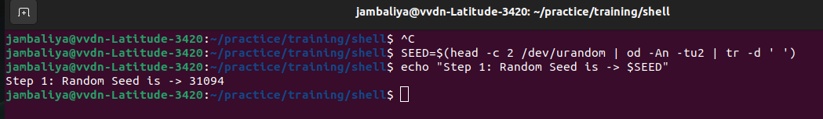

Step 2: File Descriptor Multiplied by Seed
In this stage, the script identifies the current count of open File Descriptors (FD) for the process. This count is then multiplied by the random seed generated in the first step to produce a large integer. This step introduces process-specific variability into the final data string.
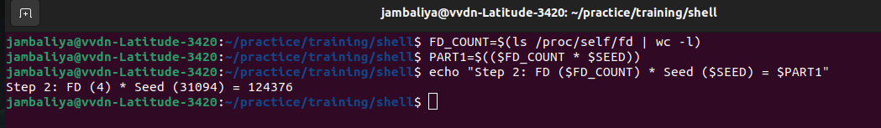

Step 3: MAC Address Extraction and Reversal
The script retrieves the hardware MAC address of the primary network interface from the system path /sys/class/net/. It then extracts the last three octets (the final six characters), removes the colon separators, and reverses the string. This adds a layer of hardware-based identification to the raw data.
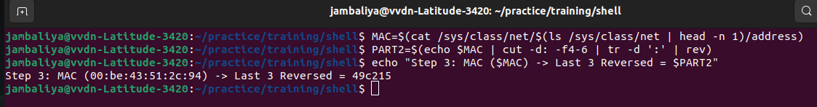

Step 4: SSH Directory Inode XOR Operation
This step retrieves the unique Inode number of the ~/.ssh directory using the stat command. A bitwise XOR operation is then performed between this Inode number and the initial random seed. This provides a unique file-system identifier that is masked by the seed for security.
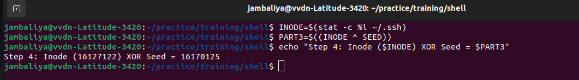

Step 5: Final Raw Concatenation
The three previously generated components—the FD product, the reversed MAC octets, and the XORed Inode—are joined together into a single "raw" string. This concatenation creates a unique, complex data string that represents the combined state of the hardware, file system, and random seed.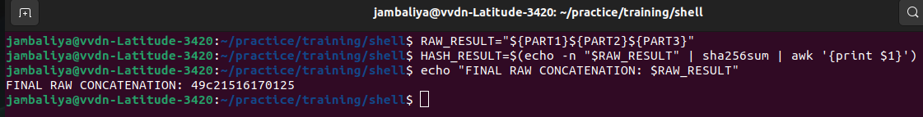

Step 6: SHA256 Hash Generation
In the final step, the concatenated raw string is piped into the sha256sum utility. This cryptographic algorithm processes the input and produces a 64-character hexadecimal hash. This result serves as a secure, fixed-length digital fingerprint of the entire multi-step process.
