Compilation Stage

- Preprocessing Stage

- Replaces #define macros
- Expands #include header files

- Removes comments
- Handles conditional compilation (#ifdef, #ifndef)
Input: file.c
Output: file.i
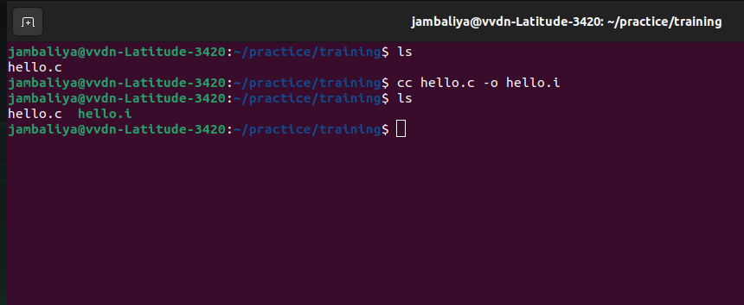
- Translator Stage

- Converts preprocessed C code into assembly code
- Checks syntax errors
- Performs optimization (if enabled)
Input: file.i
Output: file.s
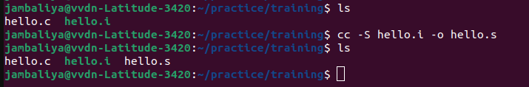
- Assembly Stage
- Converts assembly code into machine code
- Generates object file
Input: file.s
Output: file.o
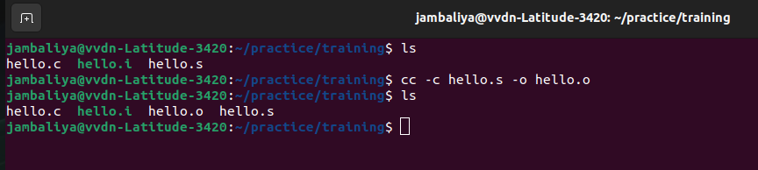

- Linking Stage

- Links object file with:
  - Standard libraries (like stdio.h)
  - Other object files
- Resolves function references
- Produces final executable file
Input: file.o
Output: output (executable)
