Static Linking

- Static linking means all required library code is copied into the final executable file at compile time.
- The executable becomes self-contained.

How it Works
- Object file (.o) is created.
- Required library functions (like printf) are copied from static library (.a).
- Everything is combined into one executable.

Characteristics
- Larger executable size
- No need for external libraries at runtime
- Faster execution (no runtime linking)
- More memory usage
- If library updates, program must be recompiled

Dynamic Linking

- Dynamic linking means libraries are not copied into the executable.
Instead, they are linked at runtime.
- The program uses shared libraries (.so).

How it Works
- Executable contains only reference to library.
- At runtime, OS loads required shared library.
- Linking happens while program runs.

Characteristics
- Smaller executable size
- Saves memory (shared among programs)
- Library updates automatically apply
- Slightly slower at startup
- Needs required library installed on system

Static Linking vs Dynamic Linking
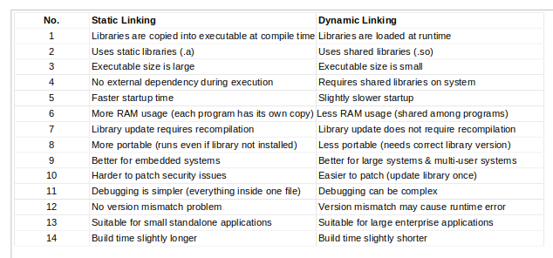
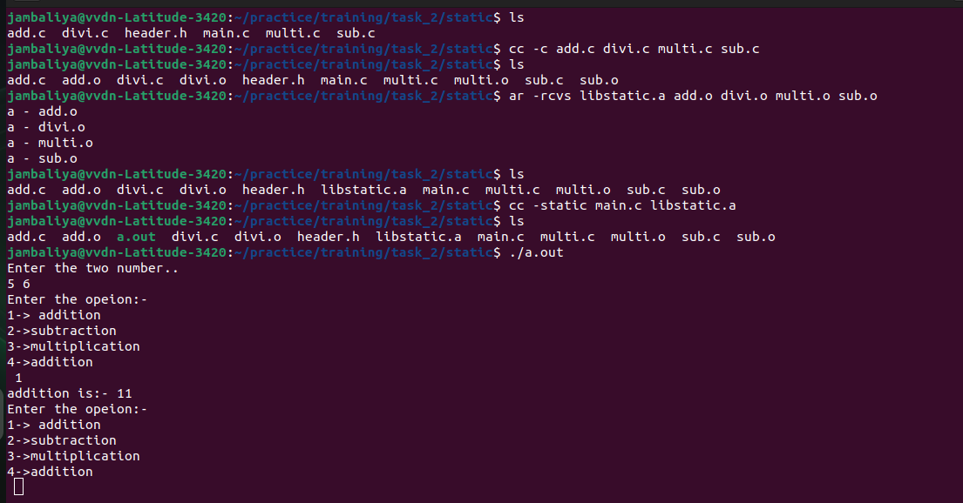

Static Linking

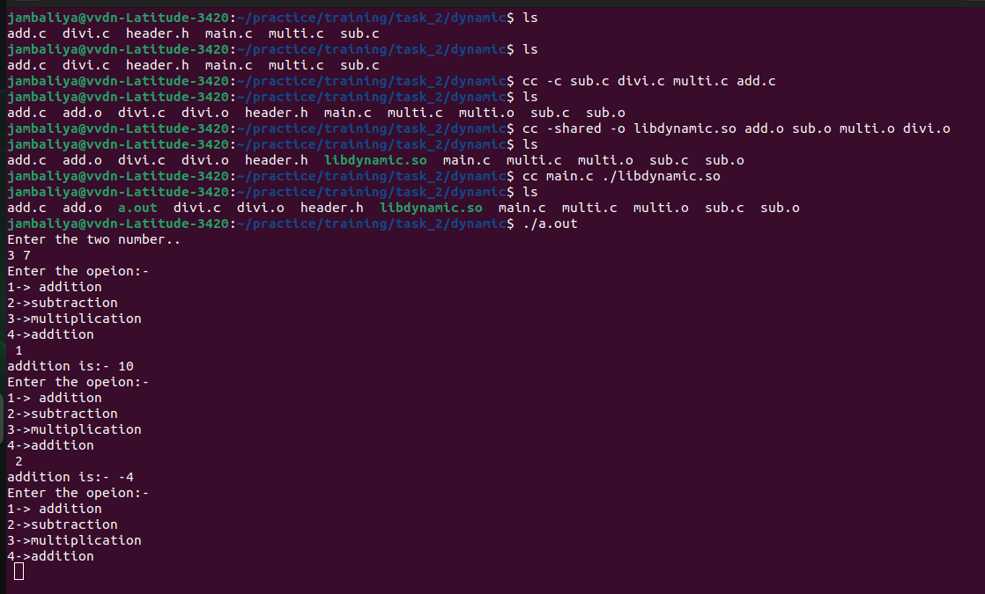
Dynamic Linking

