|  |
| --- |
| Project Report  On  Pharmacy Management System      Created By  **JANVI S. JADAV PGDCA-2**    Under The Guidance of  **PROF. HRASH JOSHI**  Submitted To  **GEETANAJALI COLLEGE OF COMPUTER SCIENCE & COMMERCE**        Affiliated To  **SAURASTRA UNIVERSITY**    For Academic Year  **2022-23** |
|  |

Acknowledgement

The project on **PHARMACY MANAGEMENT SYSTEM** is developed in **PHP** Language at GEETANJALI COLLEGE OF COMPUTER SCIENCE & COMMERCE.

I would like to acknowledge that my project has been completed and I am ensuring that, in this accomplishment, I would like to express my special gratitude to all my teachers and specially to **PROF. HARSH JOSHI** without their guidance and feedback it is not possible to complete this assignment.

**Index**

|  |  |
| --- | --- |
| PERTICULARS | PAGE NO |

* Introduction
  + Abstract 1
  + Purpose 1
* Project Profile 2
* SDLC process model 3
* Software Resources 5
* List of Modules 5
* Data Dictionary 6
* DFD
  + Context Diagram 8
  + Level 1 Diagram 10
* E-R Diagram 11
* Use Case Diagram12
* Testing – Test cases13
* Snapshots 17
* Limitations 26
* Future Enhancement 27
* Conclusion 28
* Webliography 29

# INTRODUCTION

## Abstract

The pharmacy management system is intended to increase accuracy, safety, and efficiency in the pharmacy. It is a computer-based system that stores important information and makes medical stores run better.

Admin can add new user.

## Purpose

* To reduce the headache of maintaining the record of medicine’ related documents.
* Pharmacists can use the Pharmacy Management System program to help them methodically manage their pharmacies.
* When a medicine’s name is input, the Pharmacy Management System can help by providing details about the medicine.
* Pharmacy management system project is a great system for storing data, maintaining and organizing the use and process of medication is the pharmacy.

# Project Profile

**Project Title:** Pharmacy Management System

**Development Software:** Visual Studio

**Front End Tool:** PHP

**Back End Tool:** SQL Server

**Academic Year:** 2022-23

**Developed By:** JANVI S. JADAV

**Submitted To:** GEETANJALI COLLEGE

# Process Model

The Process Model used in our projects "Pharmacy Management System" is waterfall model.

* **The Waterfall Model:**

The waterfall model is a sequential design process, used in software development processes, in which progress is seen as flowing steadily downwards (like a waterfall) through the phases of Conception, Initiation, Analysis, Design, Construction, Testing, Production/Implementation and Maintenance.

The waterfall development model originates in the manufacturing and construction industries: highly structured physical environments in which after-the-fact changes are prohibitively costly, if not impossible. Since no formal software development methodologies existed at the time, this hardware-oriented model was simply adapted for software development.

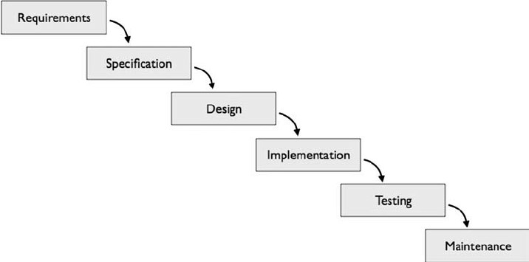

* **Reason the waterfall model in the software development cycle:**

→ Since we have well known, clean and fixed requirements therefore it best suits for our software development.

→ Our product definitions are stable.

→ Technology is clearly understood.

→ The project is short.

* **Advantages of the waterfall model:**

→ This model is simple and easy to understand and use. In, this model phases are processed and completed one at a time and phases do not overlap.

→ Waterfall model works well for smaller projects where sequence is very well understood.

# Software Resources

**Frontend Design Tool:** Microsoft Visual Studio 2010

**Backend Design Tool:** Microsoft SQL server

**Code-Behind Language:** PHP

➢ **Functionality:** o Login/Logout

O Add Cutomer o Manage cutomer

O New Invoice o Manage invoice

O Add medicine

o Manage medicine

o Manage medicine stock

o Add supplier

o Manage supplier

o Add purchase

o Manage purchase

o Sales report

o Purcahse report

o Create new User[admin]

## List Of Modules

* Login
* Pharmacy Module
* Cutomer Module
* Sales Module
* Supplier Module
* Purcahse Module

# Data Dictionary

**Admin Login**

|  |  |  |
| --- | --- | --- |
| **columns** | **Datatype** | **Constraints** |
| Email id | varchar (20) | Not null |
| Password | varchar (20) | Not null |

## Admin Details Table

|  |  |  |
| --- | --- | --- |
| **columns** | **Datatype** | **Constraints** |
| id | Int(2) | Not null |
| fname | Varchar(20) | Not null |
| lname | Varchar(20) | Not null |
| email | Varchar(20) | Not null |
| contact | Varchar(10) | Not null |
| password | Varchar(20) | Not null |
| role | Varchar(20) | Not null |
| avatar | Varchar(20) | Not null |

## Customer Table

|  |  |  |
| --- | --- | --- |
| **columns** | **Datatype** | **Constraints** |
| id | Int(2) | Not null |
| nname | Varchar(20) | Not null |
| Contact | Varchar(0) | Not null |
| address | Varchar(20) | Not null |

## Invoices Table

|  |  |  |
| --- | --- | --- |
| **columns** | **Datatype** | **Constraints** |
| id | int(2) | Not null |
| net_total | Varchar(20) | Not null |
| invoice_date | Varchar(20) | Not null |
| Customer_id | Varchar(20) | Not null |
| total_amount | Varchar(20) | Not null |
| total_discount | Varchar(20) | Not null |

## Medicine Table

|  |  |  |
| --- | --- | --- |
| **columns** | **Datatype** | **Constraints** |
| id | int(2) |  |
| name | Varchar(20) | Not null |
| packing | Varchar(200) | Not null |
| generic_name | Varchar(100) | Not null |
| supplier_name | Varchar(100) | Not null |

### Medicine stock Table

|  |  |  |
| --- | --- | --- |
| **columns** | **Datatype** | **Constraints** |
| id | int(2) | PK |
| name | Varchar(20) | Not null |
| batch_id | Varchar(20) | Not null |
| expiry_date | Varchar(20) | Not null |
| mrp | Varchar(50) | Not null |
| rate | Varchar(50) | Not null |

### Purchase Table

|  |  |  |
| --- | --- | --- |
| **columns** | **Datatype** | **Constraints** |
| supplier_name | Varchar(20) | Not null |
| invoice_no | Varchar(20) | Not null |
| vouchr_no | Varchar(20) | Not null |
| total_amount | Varchar(20) | Not null |
| payment_status | Varchar(50) | Not null |
| rate | Varchar(50) | Not null |

### Suppliers Table

|  |  |  |
| --- | --- | --- |
| **columns** | **Datatype** | **Constraints** |
| id | int(2) | AI |
| name | Varchar(20) | Not null |
| email | Varchar(20) | Not null |
| address | Varchar(20) | Not null |
| contact_no | Int(10) | Not null |
| id | int(2) | Not null |

# DFD [Data Flow Diagram]

## Data flow diagram symbol

|  |  |
| --- | --- |
| **Symbol** | **Description** |
|  | **Data Flow** – Data flow are pipelines through the packets of information flow. |
|  | **Process :** A Process or task performed by the system. |
|  | **Entity :** Entity are object of the system. A source or destination data of a system. |
|  | **Data Store :** A place where data to be stored. |

* 0 level DFD (Context Diagram):



Database



**Login**



**User**

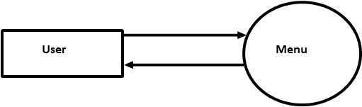

**medicine**

**purchases**



**User**

* Level 1 DFD :



ada



**Admin**



Login



medicin

n

e



invoice

Data



sales

Data



DataBase



DataBase



DataBase



DataBase

# ERD [Entity Relationship Diagram]



pharmacy



medicine

add

manage



medicine

purchase

sales



1



1

# Use Case Diagram

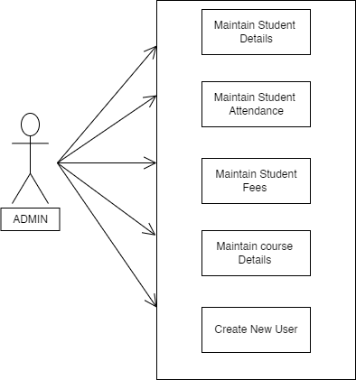

# Test Cases

The testing phase is an important part of the software developed. It is the process of finding errors and missing operations and a complete verification to determine whether the objectives are met and the user requirements are satisfied.

Login Screen:

|  |  |  |  |  |
| --- | --- | --- | --- | --- |
| **Serial No.** | Condition to be Check | Test Data | Expected Output | Remarks |
| 1 | If Fields are empty | Value of form fields. | Alert the user to enter the fields and then proceed. | SUCCESSFUL |
| 2 | If incorrect username or password | Value of Textbox of Username & password | Alert user that “Invalid  Username or password” And stay in same page. | SUCCESSFUL |

Student Add & Edit Screen:

|  |  |  |  |  |
| --- | --- | --- | --- | --- |
| **Serial No.** | Condition to be Check | Test Data | Expected Output | Remarks |
| 1 | If Fields are empty | Value of form fields. | Alert the user to enter the fields and then proceed. | SUCCESSFUL |
| 2 | If Email is not in proper format | Value of Textbox of email | Alert user that  “Email Must be in proper Format  ” And stay in same page. | SUCCESSFUL |
| 3 | If alphabets input in Phone no field | Value of Phone  No Text Field | Alert user that “Only digits are Allowed” | SUCCESSFUL |
| 4 | If Phone NO Value < 10 | Value of Phone  No Text Field | Alert user that  “Phone no length must  be 10 digits” | SUCCESSFUL |
| 5 | If user search for student, whose data is not available | Value of Filter  Text Field | Alert user that  “No Records  Found” | SUCCESSFUL |

Student Fees Page:

|  |  |  |  |  |
| --- | --- | --- | --- | --- |
| **Serial No.** | Condition to be Check | Test Data | Expected Output | Remarks |
| 1 | If Fields are empty | Value of form fields. | Alert the user to enter the fields and then proceed. | SUCCESSFUL |

Course Details Page:

|  |  |  |  |  |
| --- | --- | --- | --- | --- |
| **Serial No.** | Condition to be Check | Test Data | Expected Output | Remarks |
| 1 | If Any Field value is empty | Value of form text fields. | Alert the user to enter the field value | SUCCESSFUL |
| 2 | If Inputs Duplicate Values | Value Of All Fields | Alerts The user That  “Duplicate value Found” | SUCCESSFUL |

Create New User Page:

|  |  |  |  |  |
| --- | --- | --- | --- | --- |
| **Serial No.** | Condition to be Check | Test Data | Expected Output | Remarks |
| 1 | If Any Field value is empty | Value of form text fields. | Alert the user to enter the field value | SUCCESSFUL |
| 2 | If password & Conform password does not match | Value Of Password &  Conform  Password Fields | Alerts The user That  “Password  Characters  Does not  match” | SUCCESSFUL |

Create New User Page:

|  |  |  |  |  |
| --- | --- | --- | --- | --- |
| **Serial No.** | Condition to be Check | Test Data | Expected Output | Remarks |
| 1 | If Any Field value is empty | Value of form text fields. | Alert the user to enter the field value | SUCCESSFUL |
| 2 | If password & Conform password does not match | Value Of Password &  Conform  Password Fields | Alerts The user That  “Password  Characters  Does not  match” | SUCCESSFUL |

# Snapshots

* Loading Screen:



* Login Screen:

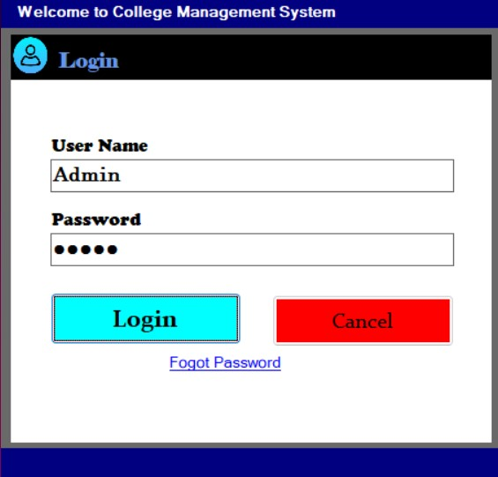

→ In this page user must give username & password.

→ If the password is correct, then he will be redirect to home page else he gets the prompt.

→ If the user forgot the password, then he will be able to change his password from this page.

Home Page:

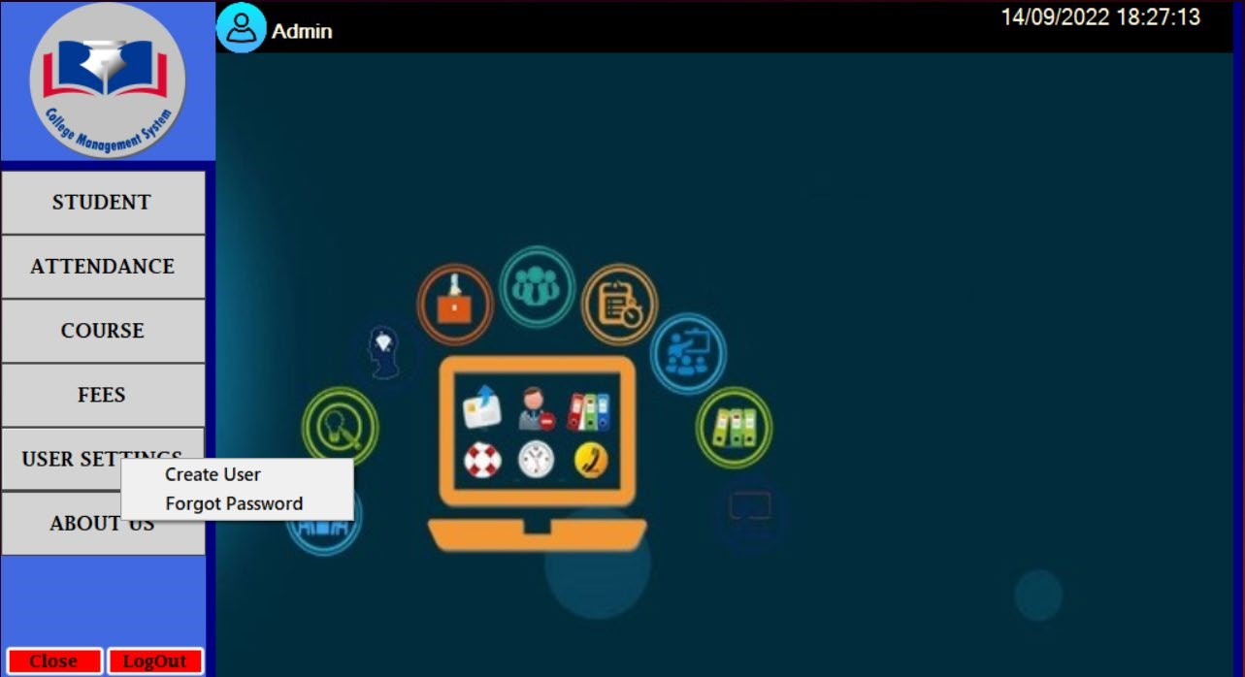

→ In this section of page user get all options & access functionality of it.

→ To close the software user can use either close button or can press ESC key from keyboard.

→ To Click on logo user will get back on This page.

* Student Add & Edit Page:

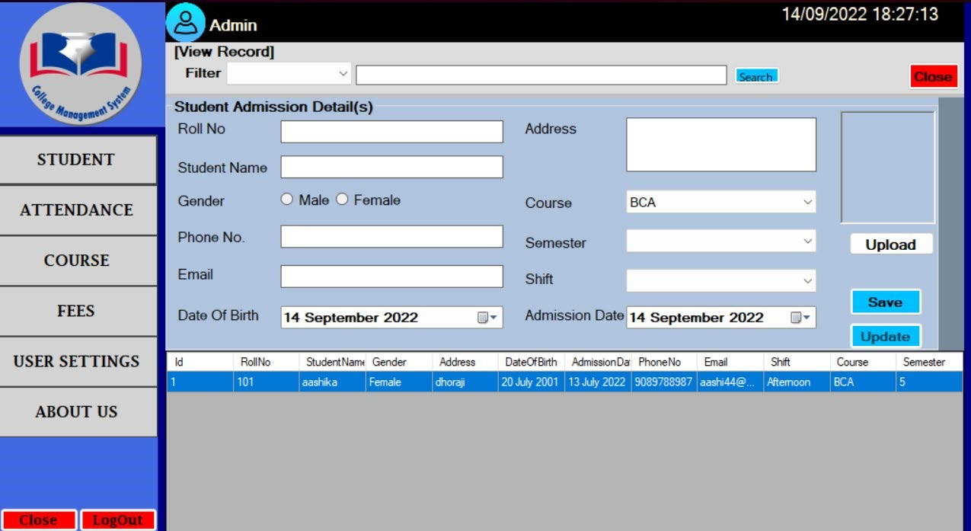

→ In this section user can add new student & edit the student information.

→ He also able to search student & also can show available all student details.

Student Attendance Page:

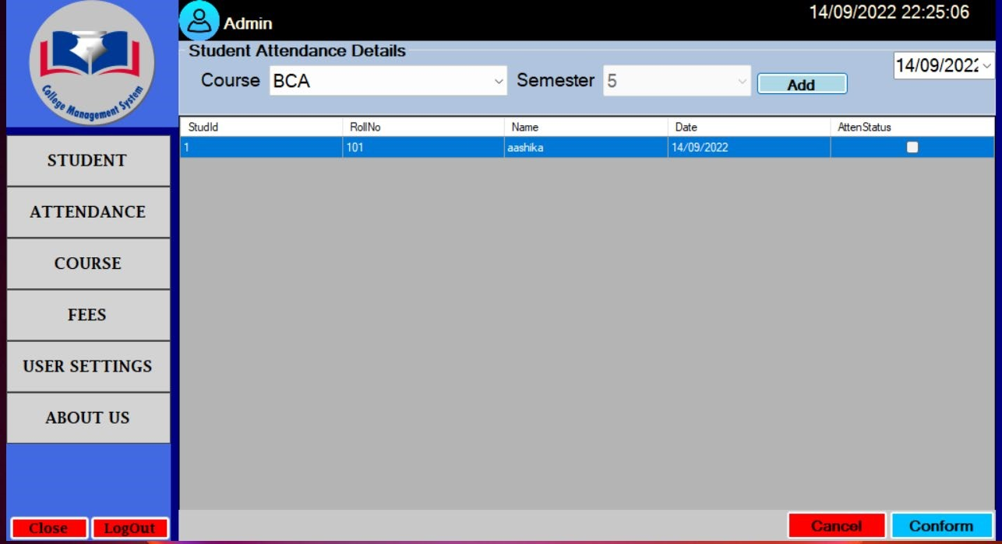

* In this page user can take attendance of students.
* Cancel button used for going back to home page.

➢ Course page:

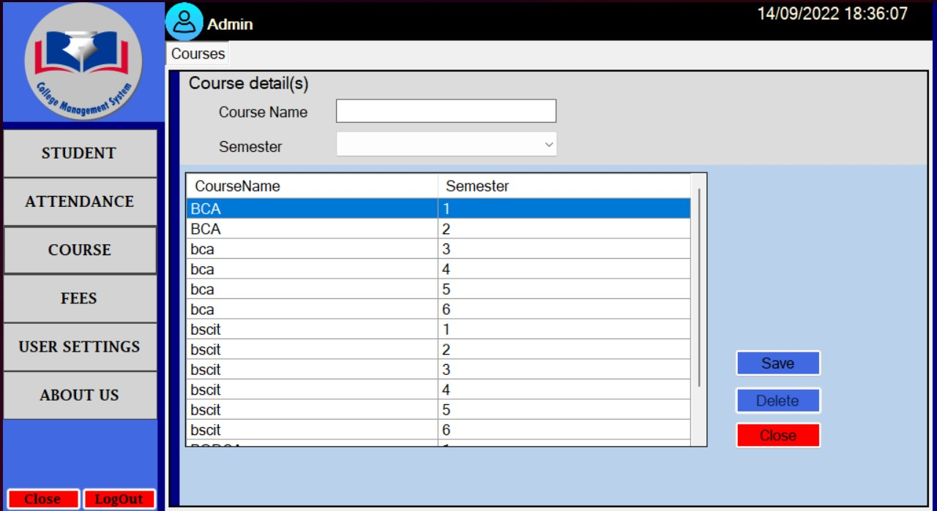

→ In the course details page user can add & modify the course details .→ Close button is used for go back to home page.

Fees Payment page:

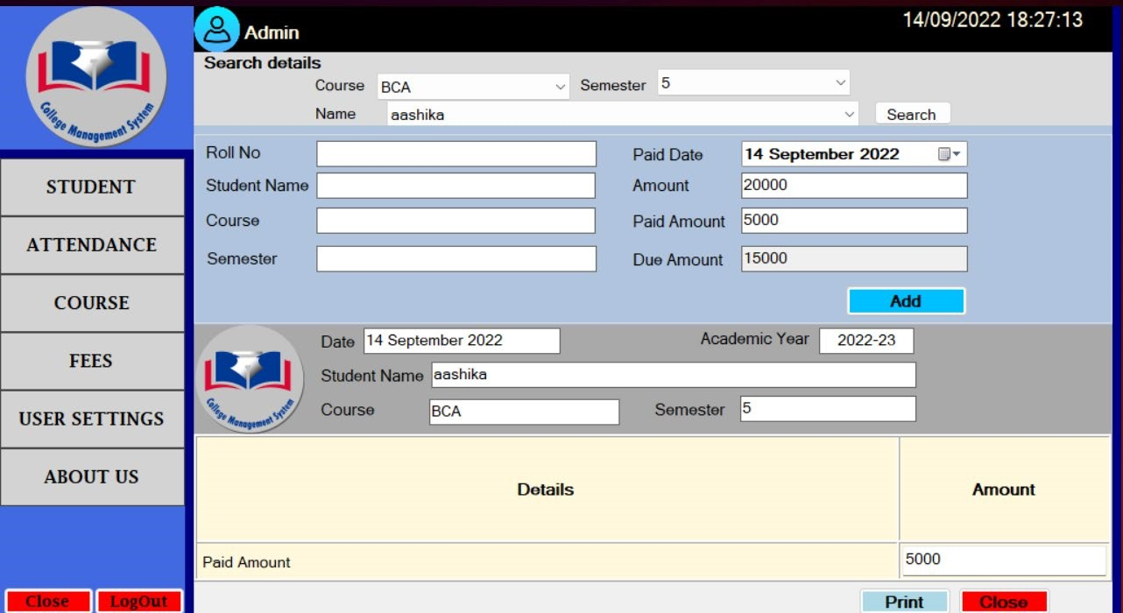

* In this page student fees data should be entered.
* After adding details the paid fees receipt will be generated and also can print that.

Create User Page:

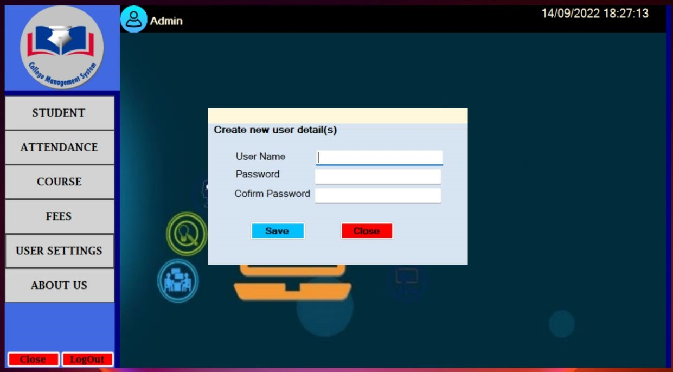

→ In the Create user page admin can add new user.

About Us Page:

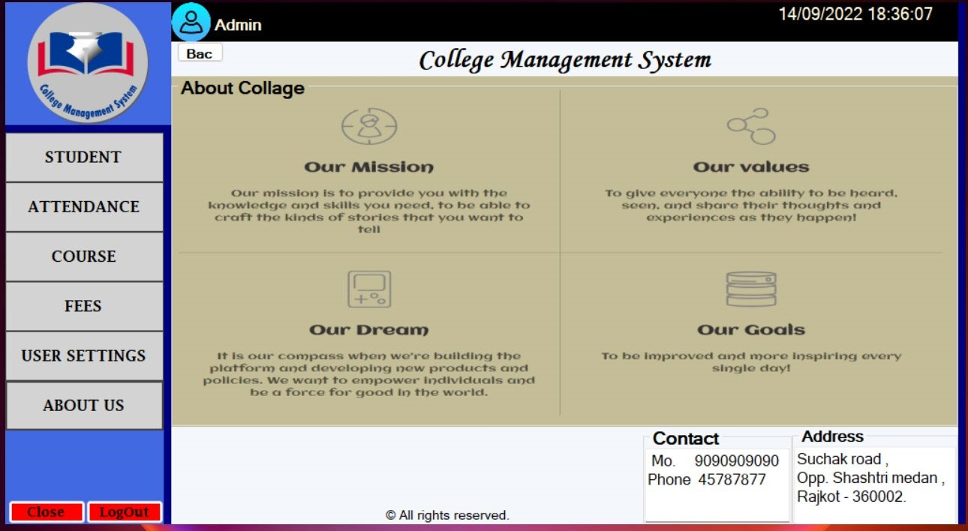

* In this page user can know about college like what are goals, what are missions etc.

Limitations:

Though we tried our best in developing this software but as limitation are major part of any software so are of our software. Some limitation of innovator to investors portal are as follows:

→ Limited functionality is available.

→ If database gets big amount of data, it gets much time to load.

→ Specific user roles are not provided in this software. That’s why this can only be used by admin.

## Future Enhancement

To conclude, Project data grid works like a component which can access all the databases and pick-ups different function by admin. Trying to remove the many limitations and add some more functionality in future.

* Account Module would be implemented with all features as per user requirements.
* In Login module Students will be added as user so they can use CMS.
* It would be more user-friendly software.
* We would give more advance software of CMS with more functionality.
* Will Implement the backup mechanism to take Backup of database.

# Conclusion

The project entitled as College Management System is the system that deals with the issues related to a particular institution.

* This project is successfully implemented with all the features mentioned in system requirements specification.
* The application provides appropriate information to users according to the chosen service.
* The project is designed keeping in view the day-to-day problems faced by a college.

Deployment of our application will certainly help the college to reduce unnecessary wastage of time in personally going to each department for some information.

Awareness and right information about any college is essential for both the development of student as well as faculty. So, this serves the right purpose in achieving the desired requirements of both the communities.

## Webliography

* <https://creately.com/>
* <https://stackoverflow.com/>
* <https://www.c-sharpcorner.com/>