**Department of Computer Engineering**

**Academic Term: First Term 2023-24**

**Class: T.E /Computer Sem – V / Software Engineering**

|  |  |  |  |  |  |  |
| --- | --- | --- | --- | --- | --- | --- |
| **Practical No:** | |  | **2** | | | |
| **Title:** | |  | **Implementing project using Scrum meothod on JIRA tool.** | | | |
| **Date of Performance:** | |  | **02-08-2023** | | | |
| **Roll No:** | |  | **9627** | | | |
| **Team Members:** | |  | **Janvi Naik ,Jenny Lopes, Anuf Shaikh** | | | |
| Sr.  No | Performance Indicator | Excellent | | Good | Below  Average | Total Score |
| 1 | On time Completion &  Submission (01) | 01 (On  Time ) | | NA | 00 (Not on  Time) |  |
| 2 | Theory  Understanding(02) | 02(Correct) | | NA | 01 (Tried) |  |
| 3 | Content Quality (03) | 03(All used) | | 02 (Partial) | 01 (rarely followed) |  |
| 4 | Post Lab Questions (04) | 04(done  well) | | 3 (Partially  Correct) | 2(submitted) |  |

**Signature of the Teacher:**

# Lab Experiment 02

Experiment Name: Implementing Project Using Scrum Method on JIRA Tool in Software Engineering.

1. Users in the project:

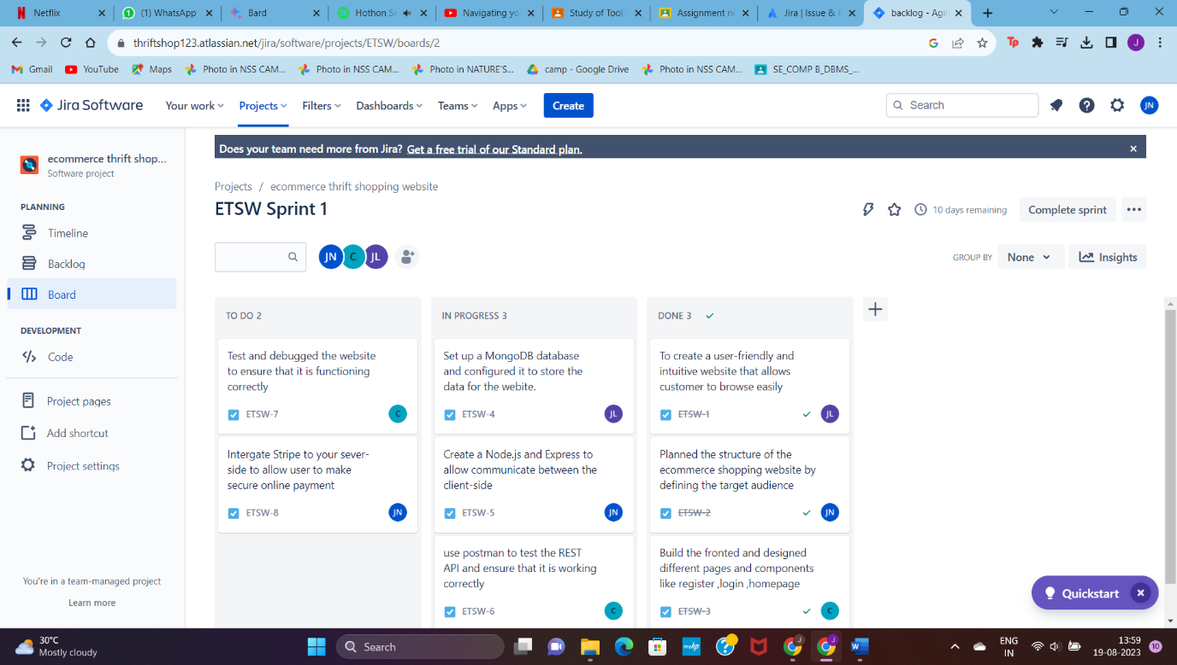

1. Issues:

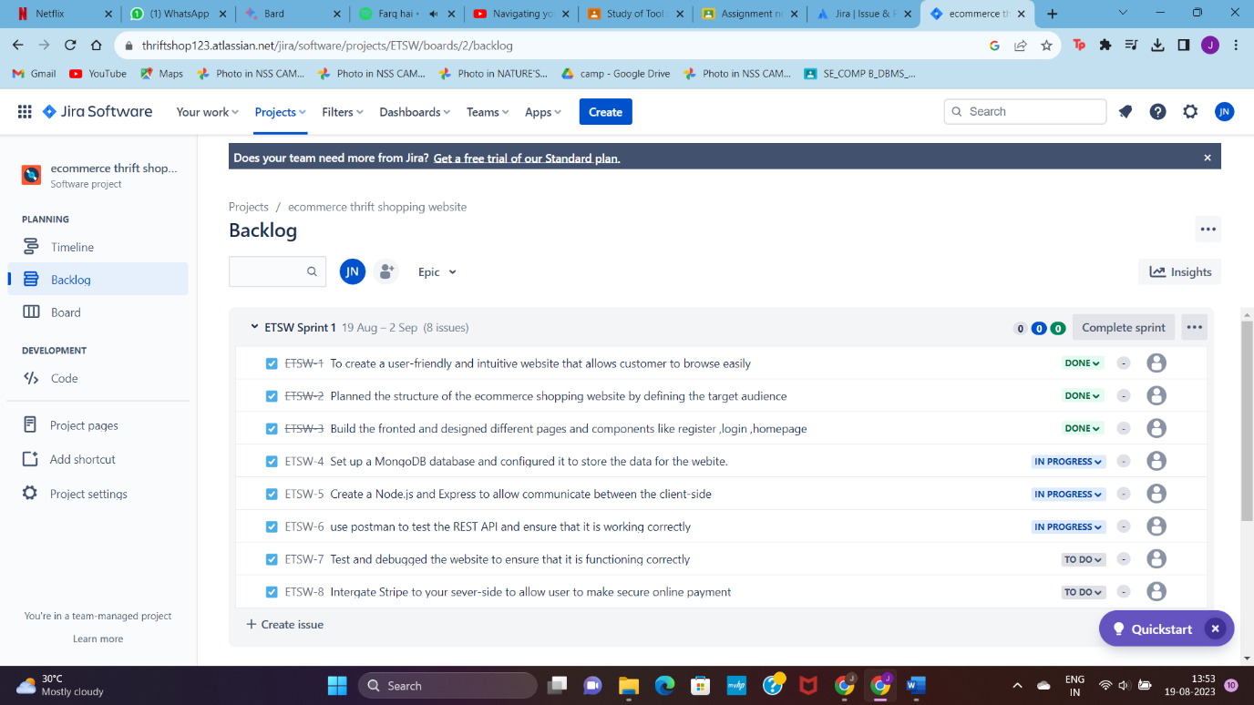

1. Backlog:

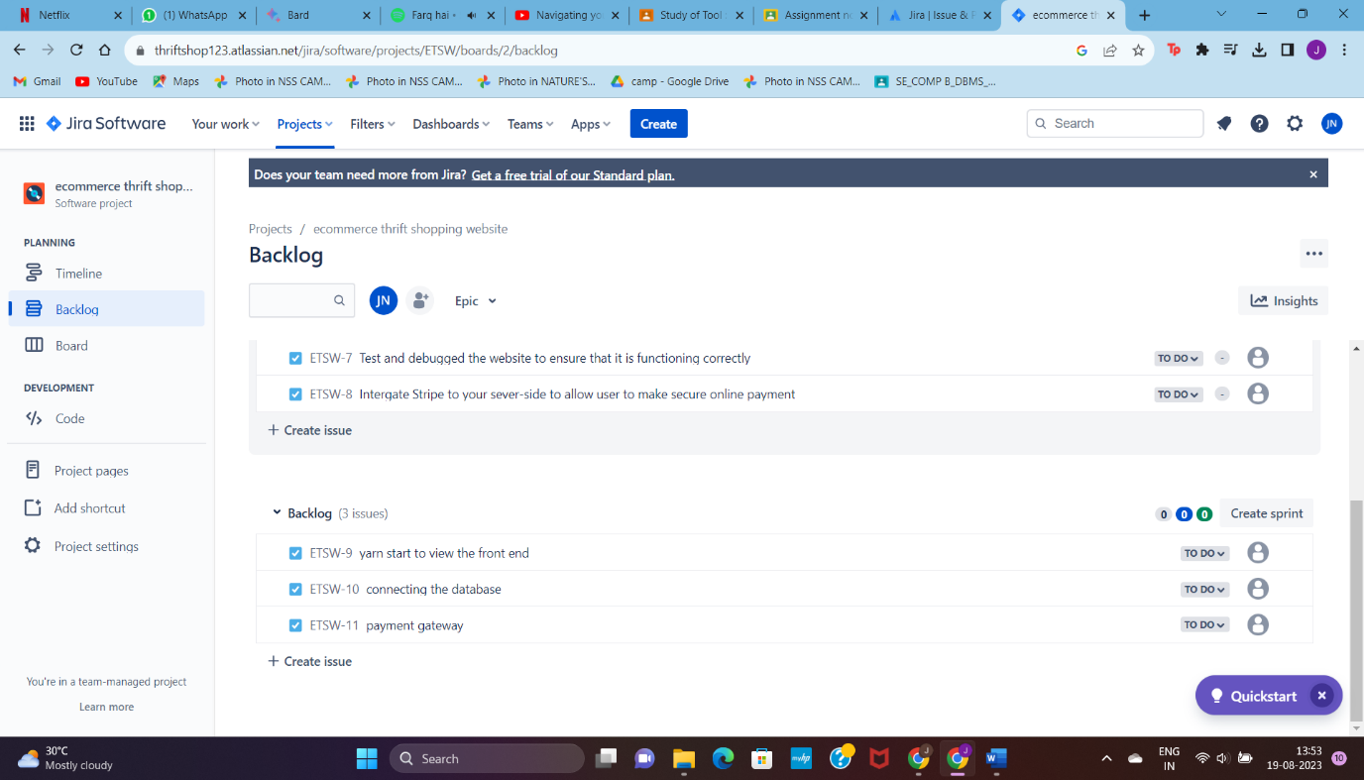

1. Epic:

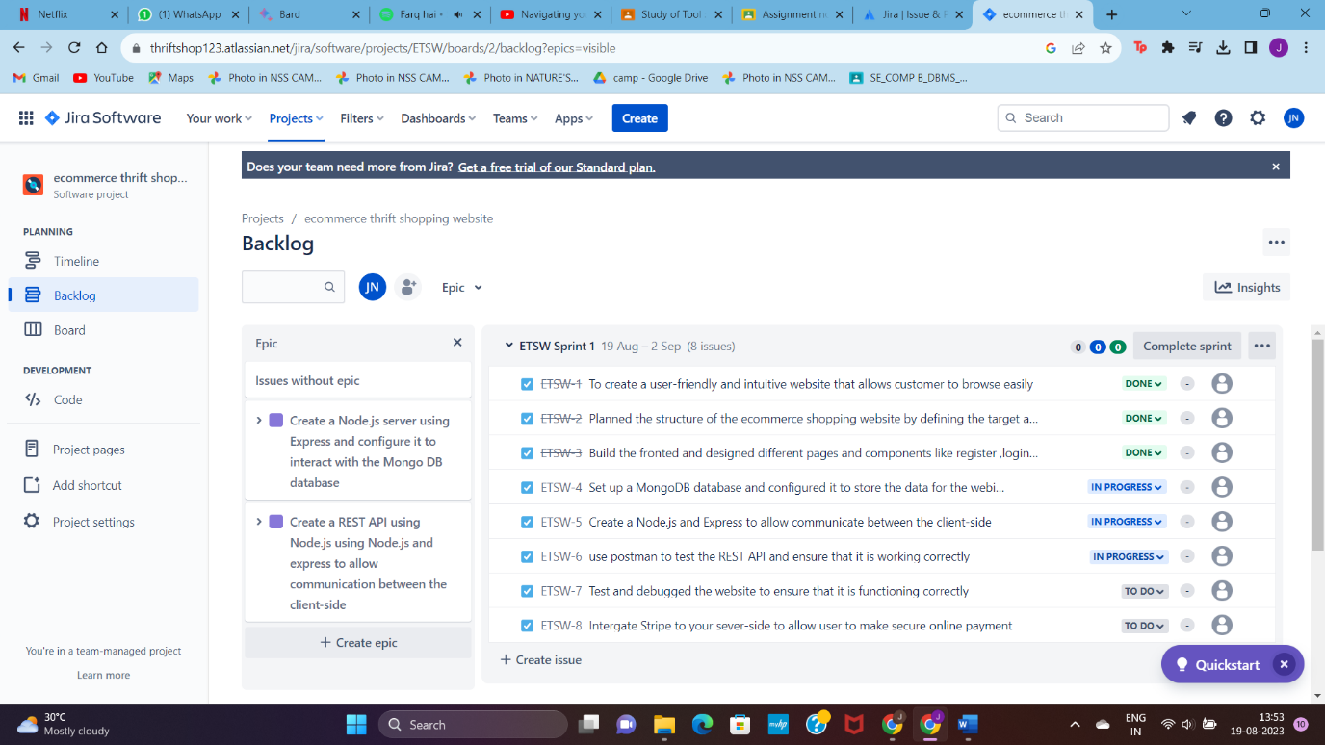

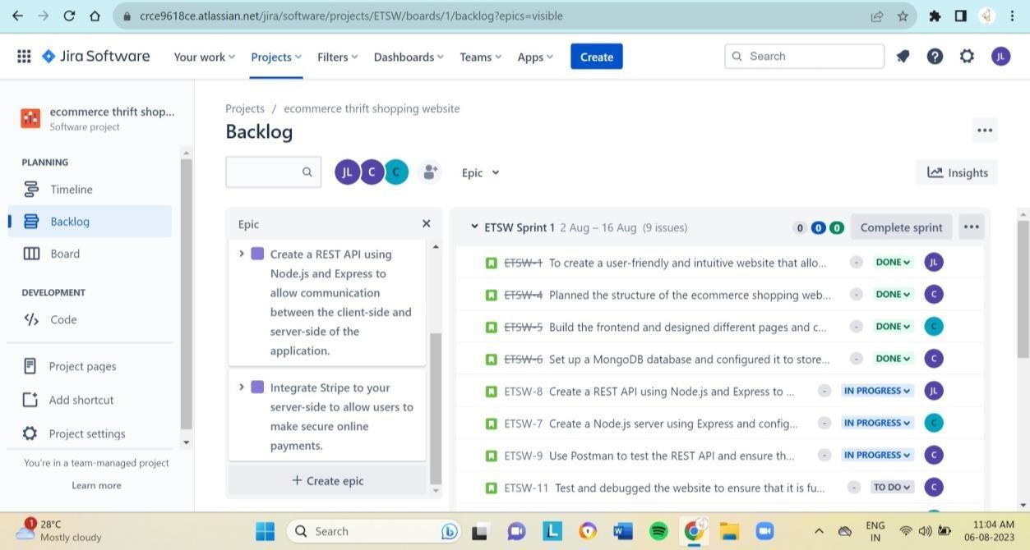

1. Board:

Assigned to user1:

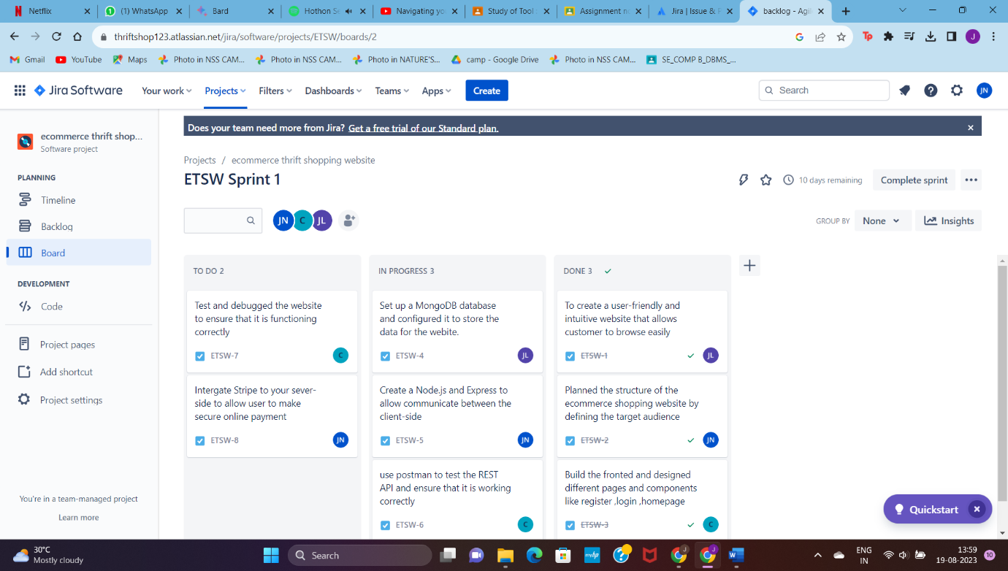

Assigned to user2:

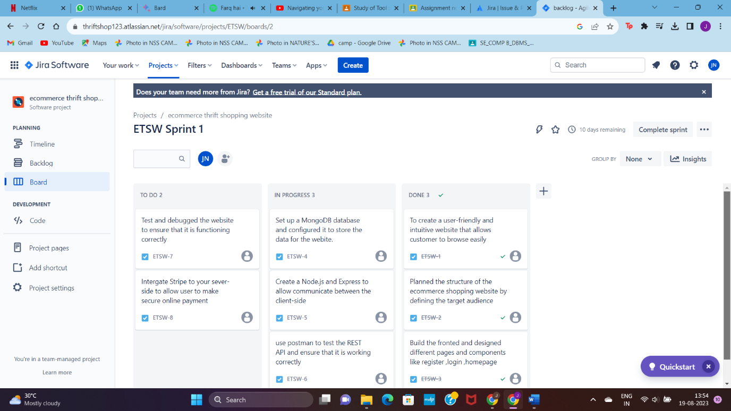

Assigned to user3:

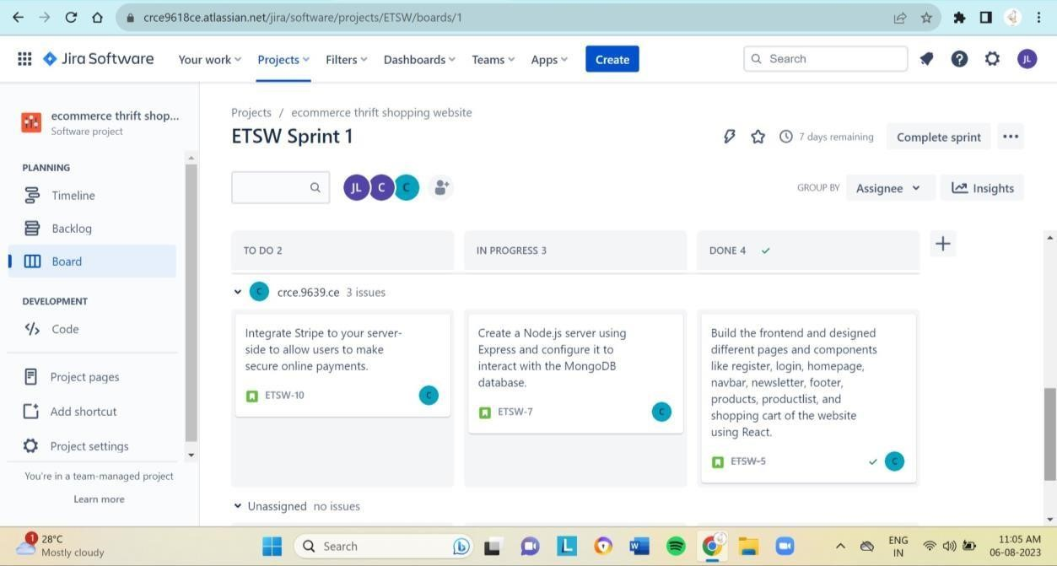

POSTLAB:

Q1)

Scrum has been widely adopted and utilized in the software development industry as an Agile framework. It offers an iterative and incremental approach to managing projects, focusing on flexibility and customer collaboration. To assess the effectiveness of the Scrum framework compared to traditional project management methodologies, let's consider some key aspects:

Flexibility and Adaptability: Scrum is highly flexible and allows teams to adapt to changing requirements and priorities. It empowers teams to adjust their course of action during the project's development, making it well-suited for dynamic environments where requirements can evolve rapidly. In contrast, traditional project management methodologies, like the

Waterfall model, are more rigid and less adaptable to changes once the project plan is set.

Incremental Delivery: Scrum emphasizes delivering software in small, incremental releases called "sprints," typically lasting 1-4 weeks. This allows stakeholders to see progress regularly and provides early opportunities for feedback and course correction. Traditional methodologies often involve delivering the entire project at the end, which can lead to longer development cycles without feedback until the final delivery.

Customer Collaboration: Scrum encourages continuous collaboration with customers and stakeholders throughout the project. This engagement helps ensure that the product being developed aligns with customer needs and expectations. Traditional methodologies may not emphasize customer collaboration as frequently, potentially leading to misalignment between the final product and customer requirements.

Team Empowerment: Scrum empowers development teams by allowing them to selforganize and make decisions on how to accomplish their goals. This autonomy fosters a sense of ownership and responsibility, leading to higher team morale and productivity. Traditional methodologies may be more hierarchical, with decisions made by managers or project leaders.

Risk Management: Scrum's iterative nature allows teams to identify and address risks early in the development process. By regularly reviewing progress, issues can be detected and resolved promptly. Traditional methodologies might not offer such early risk mitigation opportunities, leading to potential project delays or failure.

Communication and Transparency: Scrum emphasizes transparent communication among team members and stakeholders through various ceremonies like Daily Standups, Sprint Reviews, and Sprint Retrospectives. This enhances visibility into the project's progress and challenges. Traditional methodologies may not have such built-in communication structures, leading to potential information gaps.

Size and Complexity of Projects: Scrum is well-suited for smaller to medium-sized projects or projects with evolving requirements. For larger, more complex projects, traditional methodologies might offer better predictability and control.

Q2)

In the context of JIRA, "yarn start" typically refers to a task or user story in the backlog related to starting a development server for a project that uses the Yarn package manager. Analyzing this backlog item, we can identify potential bottlenecks or issues that might hinder the team's progress during the sprint:

Dependency on External Factors: Running "yarn start" may require specific dependencies or configurations, and if these are not well-documented or readily available, it could cause delays as developers try to figure out the necessary setup.

Integration or Environment Issues: The task might involve integrating various components or modules, and issues may arise if the development environment is not correctly configured or if there are conflicts between dependencies.

Build or Compilation Failures: Running "yarn start" could trigger a build process, and if there are errors or compilation failures in the codebase, it may delay the team's progress until the issues are resolved.

Performance or Resource Constraints: The "yarn start" command may consume significant system resources, and if the development machines are not powerful enough or if there are performance bottlenecks, it could slow down the development process.

Lack of Automated Testing: If the task involves changes that impact the application's functionality, the team should have automated tests in place to ensure that new code does not introduce regressions. A lack of sufficient test coverage might lead to time-consuming manual testing efforts and increase the risk of bugs slipping into the production code.

Lack of Documentation: If the task is not adequately documented, it might lead to misunderstandings or confusion among team members, causing them to spend additional time seeking clarification.

Inadequate Task Breakdown: The "yarn start" task might be too broad or vague, making it difficult for developers to estimate and plan their work effectively. Breaking down the task into smaller, more manageable subtasks can improve accuracy in estimation and progress tracking.

Competing Priorities: During the sprint, the team may encounter competing priorities or urgent issues that divert their attention away from completing the "yarn start" task as planned.

External Dependencies and Delays: The task might rely on external teams or third-party services, and any delays from these external sources could hinder the team's progress.

Q3)

The Scrum Master plays a critical role in handling conflicts within the development team and resolving impediments to maintain a smooth project flow in the Scrum framework. Their primary focus is on facilitating the Scrum process and supporting the team to achieve their goals. Here's how the Scrum Master fulfills these responsibilities:

Facilitating Communication and Collaboration: The Scrum Master ensures open and transparent communication within the team. They create an environment where team members feel comfortable expressing their concerns and ideas. By fostering collaboration, the Scrum Master helps prevent conflicts from escalating and encourages the team to work together effectively.

Conflict Resolution: When conflicts arise within the development team, the Scrum Master acts as a mediator and facilitator. They actively listen to all parties involved and help them understand each other's perspectives. By addressing conflicts early and constructively, the Scrum Master prevents them from becoming major roadblocks to progress.

Removing Impediments: The Scrum Master identifies and resolves impediments that hinder the team's progress. These impediments can be related to technical issues, organizational challenges, or process inefficiencies. The Scrum Master works closely with the team and stakeholders to eliminate or mitigate these impediments, ensuring a smooth project flow.

Coaching and Mentoring: The Scrum Master serves as a coach and mentor for the development team. They help team members enhance their skills, adopt Agile practices, and understand the Scrum framework. By providing guidance and support, the Scrum Master enables the team to self-organize and self-manage effectively.

Protecting the Team: The Scrum Master shields the development team from external interference and distractions. They ensure that the team can focus on their work during the sprint without undue pressure from stakeholders or external parties.

Facilitating Scrum Events: The Scrum Master facilitates various Scrum events, such as Daily Standups, Sprint Planning, Sprint Reviews, and Sprint Retrospectives. These events provide opportunities to address concerns, assess progress, and improve the team's performance.

Continuous Improvement: The Scrum Master encourages a culture of continuous improvement within the team. They help the team reflect on their performance and identify areas for enhancement. By promoting a learning mindset, the Scrum Master assists the team in delivering better results in each subsequent sprint.

Servant Leadership: The Scrum Master embodies the principle of servant leadership, focusing on the needs of the team above their own. They support the team's development and wellbeing, ensuring that the team has what it needs to succeed.