Department of Computer

Academic Term: First Term 2023

# Class: T.E /Computer Sem – V / Software Engineering

|  |  |
| --- | --- |
| **Practical No:** | **3** |
| **Title:** | **Implementing Project using the KANBAN method on the**  **JIRA Tool** |
| **Date of Performance:** | **09-08-23** |
| **Roll No:** | **9618** |
| **Team Members:** | **Janvi Naik ,Jenny Lopes, Anuf Shaikh** |

|  |  |  |  |  |  |
| --- | --- | --- | --- | --- | --- |
| **Sr.**  **No** | **Performance Indicator** | **Excellent** | **Good** | **Below Average** | **Total Score** |
| 1 | On time Completion &  Submission (01) | 01 (On  Time ) | NA | 00 (Not on  Time) |  |
| 2 | Theory Understanding(02) | 02(Correct  ) | NA | 01 (Tried) |  |
| 3 | Content Quality (03) | 03(All used) | 02 (Partial) | 01 (rarely followed) |  |
| 4 | Post Lab Questions (04) | 04(done well) | 3 (Partially  Correct) | 2(submitted) |  |

Signature of the Teacher:

# Lab Experiment 03

## Experiment Name: Implementing Project Using Kanban Method on JIRA Tool in Software Engineering

**Objective:** The objective of this lab experiment is to introduce students to the Kanban method and its implementation using the JIRA tool. Students will gain practical experience in managing a software project using Kanban principles and learn how to utilize JIRA as a project management tool to visualize workflow, manage work items, and improve team productivity.

**Introduction:** Kanban is an agile project management method that emphasizes visualizing work, limiting work in progress, and continuously improving the workflow. JIRA is a popular tool that supports Kanban practices, allowing teams to manage their tasks and activities effectively.

**Lab Experiment Overview:**

1. Introduction to Kanban: The lab session begins with an overview of the Kanban method, including the principles of visualizing work, managing flow, and making incremental improvements.
2. JIRA Tool Introduction: Students are introduced to the JIRA tool and its features for implementing Kanban. They learn to create boards, swimlanes, columns, and customize workflows.
3. Defining the Project: Students are assigned a sample software project and create a Kanban board in JIRA to visualize their workflow. They set up columns to represent different stages of their development process.
4. Creating Work Items: Students create work items (tasks, user stories, or issues) on the Kanban board, representing the work that needs to be done.
5. Managing Workflow: Students move work items through the columns on the Kanban board as they progress through their development process. They monitor work in progress limits to maintain an efficient workflow.
6. Continuous Improvement: Students conduct regular team meetings to discuss the workflow, identify bottlenecks, and make improvements to enhance their efficiency.
7. Completion and Review: At the end of the lab experiment, students review their project progress on the Kanban board. They discuss their experiences with implementing the Kanban method on JIRA and share insights on its effectiveness.
8. Conclusion and Reflection: Students reflect on their experience with Kanban and JIRA, discussing the benefits and challenges they encountered during the project. They also consider how Kanban principles can be applied to future software development projects.

**Learning Outcomes:** By the end of this lab experiment, students are expected to:

* Understand the Kanban method and its application in agile project management.
* Gain practical experience in using the JIRA tool to implement Kanban boards and workflows.
* Learn to visualize work, manage flow, and limit work in progress using Kanban principles.
* Develop team collaboration skills by continuously improving the workflow through regular team meetings.
* Appreciate the importance of visualizing and managing work items for better project management.

**Pre-Lab Preparations:** Before the lab session, students should familiarize themselves with the Kanban method and the basics of the JIRA tool. They should review Kanban principles, visualizing workflows, and the features of JIRA relevant to Kanban implementation.

**Materials and Resources:**

* Computers with internet access for accessing the JIRA tool
* Project brief and details for the sample software project
* Whiteboard or projector for explaining Kanban concepts

**Conclusion:** The lab experiment on implementing a project using the Kanban method on the JIRA tool provides students with practical insights into agile project management. By applying Kanban principles and utilizing JIRA's capabilities, students learn to visualize their work, manage flow efficiently, and continuously improve their development process. The hands-on experience with Kanban and JIRA fosters teamwork, collaboration, and adaptability, enabling students to effectively manage software projects with a focus on efficiency and quality. The lab experiment encourages students to adopt Kanban's lean principles, promoting a culture of continuous improvement and optimizing their workflow to deliver valuable software products.

## 1. Creating KANBAN Board and work items

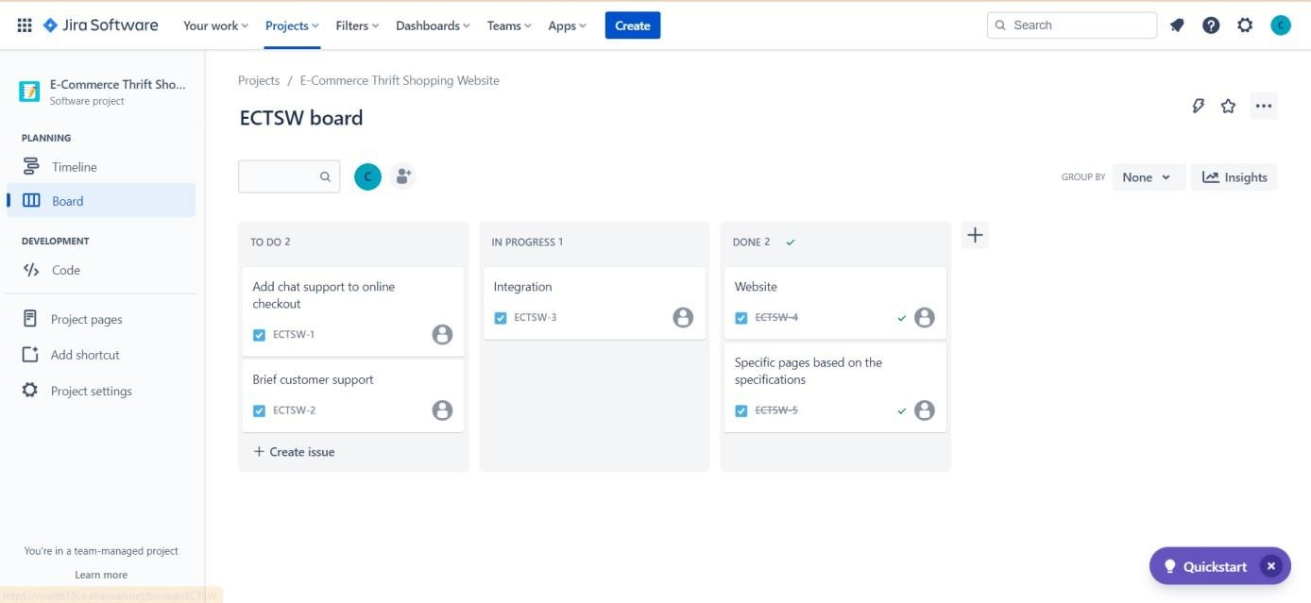

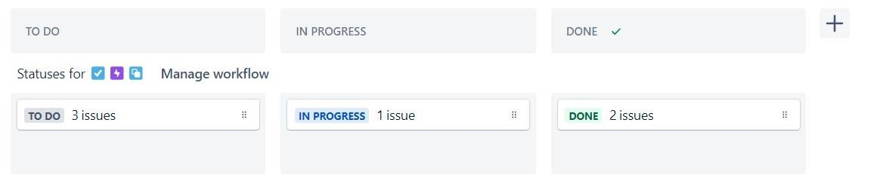

## 2. Inviting team members



## 3. Timeline – creating epic

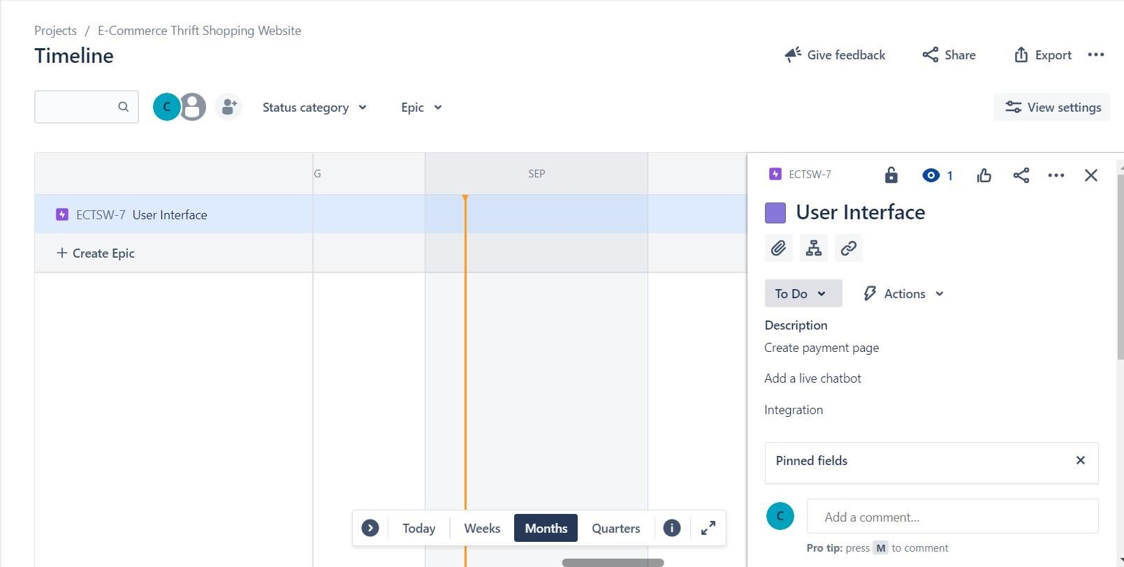

**Postlab**:

**a) Compare and contrast the Kanban and Scrum methodologies in terms of flexibility, adaptability, and workflow management in different project scenarios.**

1.Flexibility:

Kanban: Extremely adaptable, ideal for erratic work, and capable of doing so fast in response to shifting priorities.

Scrum: Less adaptable due to defined sprint lengths; modifications sometimes put off until the following sprint.

2.Adaptability:

Kanban: Designed for continuous adaptation, allowing real-time changes to priorities and processes.

Scrum: Adapts during sprints, however large changes are usually postponed until the end of the sprint.

3.Workflow administration:

Kanban: Limits work-in-progress (WIP) and emphasises flow while visualising work on a board.

Scrum: Uses predetermined sprint lengths and a sprint backlog to manage work.

4.Projects:

Projects with dynamic or regularly changing needs and varied work sizes are best served by kanban.

Scrum: Focusing on organised planning and delivery, it is ideal for projects with predictable requirements and set deadlines.

1. **Analyse a Kanban board in JIRA and propose improvements to optimize the**  **team's efficiency and productivity.**

* 1. Examine the Kanban board in place:

Make sure that the columns on the board appropriately depict the team's operations.

Check that the types of work items are properly categorised.

WIP limitations: Verify that each column's Work in Progress (WIP) limitations are established.

* 1. Enhance WIP Capacity:

WIP ceilings should be adjusted to avoid overworking or underusing team members.

* 1. Track and evaluate metrics:

To find bottlenecks and areas for improvement, monitor cycle time, lead time, and throughput.

* 1. Constant Development:

Review and modify the board and procedures frequently depending on data and team input.

* 1. Integration and Automation

Automate repetitive activities and integrate JIRA with other technologies to streamline work,

1. **Evaluate the impact of Work In Progress (WIP) limits on a Kanban board and how it affects the team's throughput and cycle time.**

**Impact of WIP restrictions in Kanban**

* 1. Throughput

Encourage concentration and equitable workload distribution.

Identifying Constraints: Assists in locating and resolving process bottlenecks.

2.Cycle Period:

Reduced interruptions and more focused work result in shorter cycle times.

Increases task completion predictability and release planning predictability.

3. Excellence

Better quality assurance and fewer defects are possible with improved quality. Fewer Interruptions: Reduces interruptions at work, improving consistency.Impact of WIP restrictions in Kanban