Name: Janvi Singh
Batch:B19
Sap ID:5900226680

Linear Search vs Binary Search

Linear Search 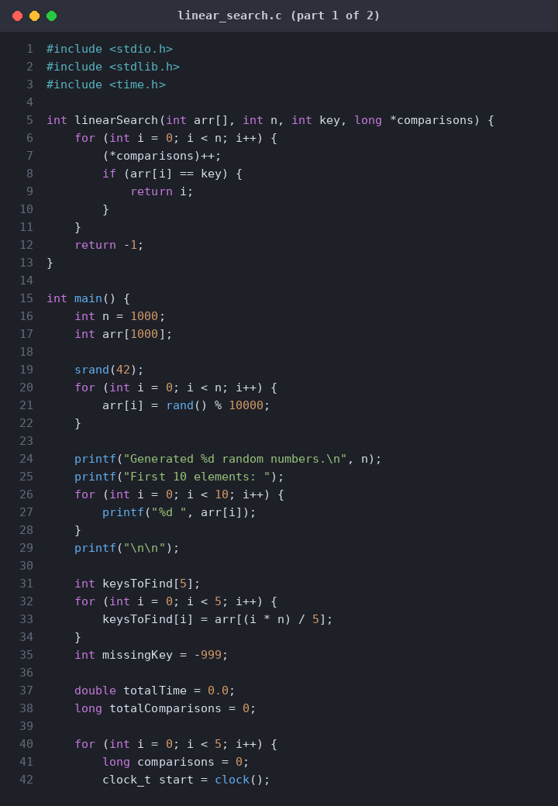

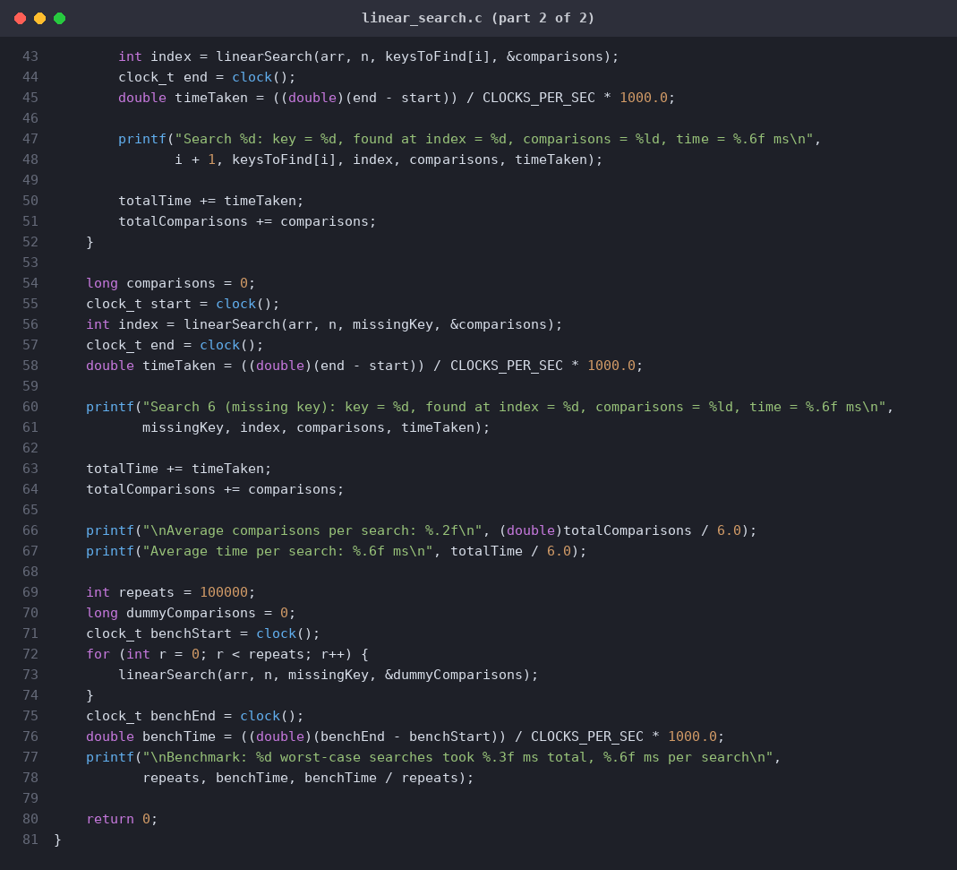

Linear Search
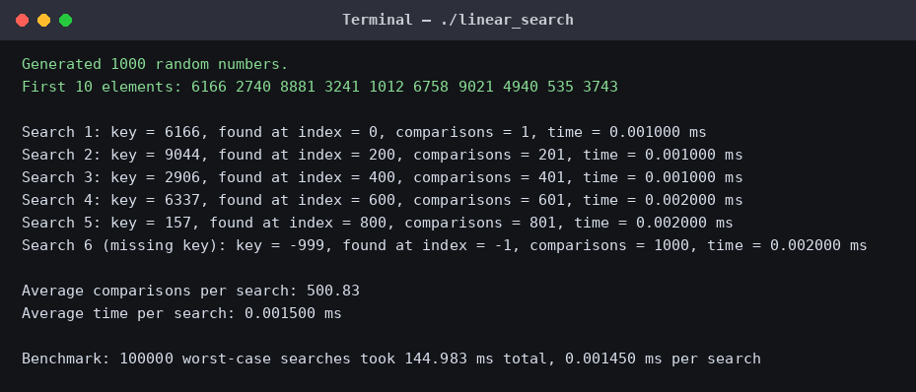

Binary Search 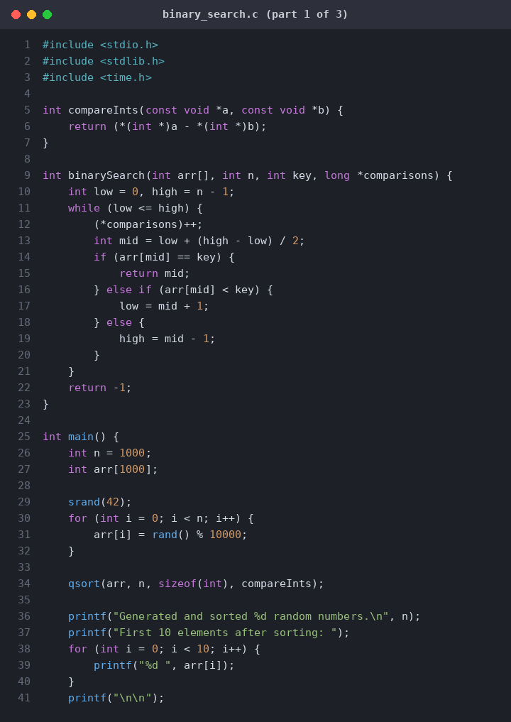

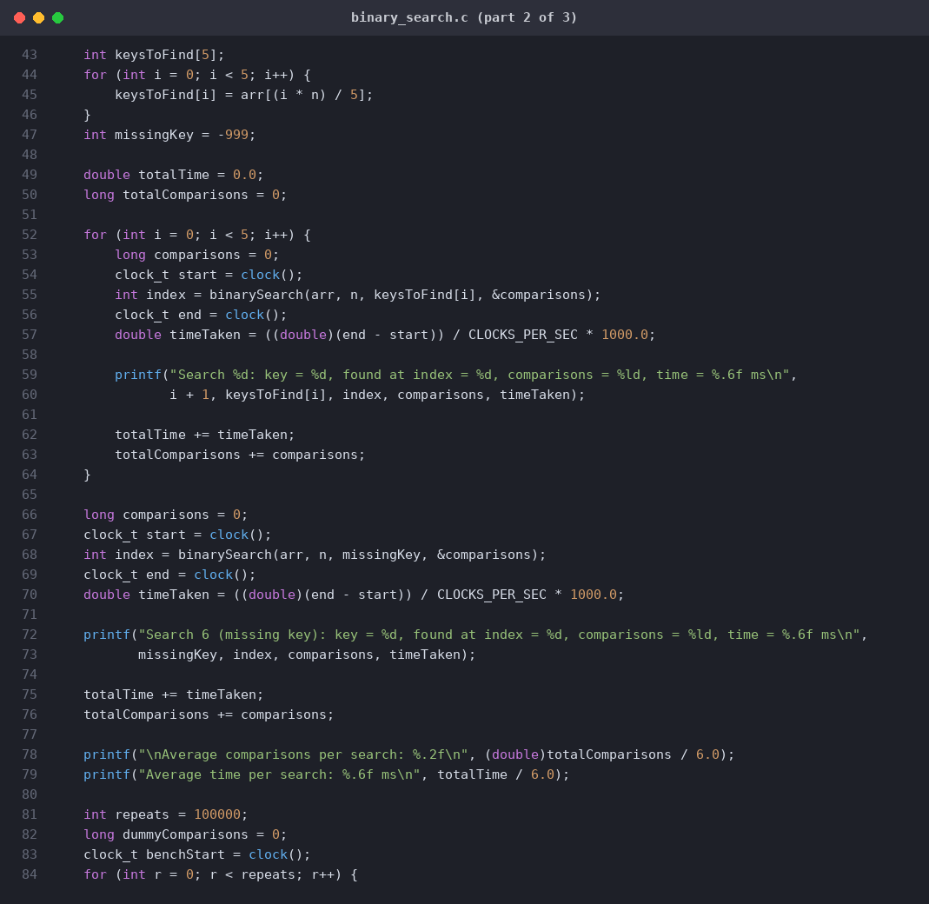
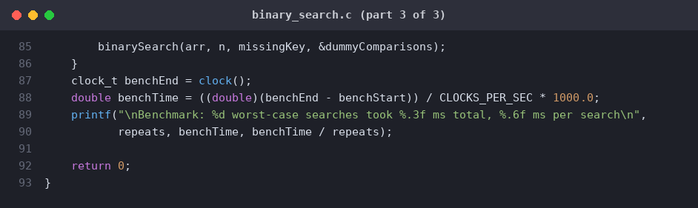

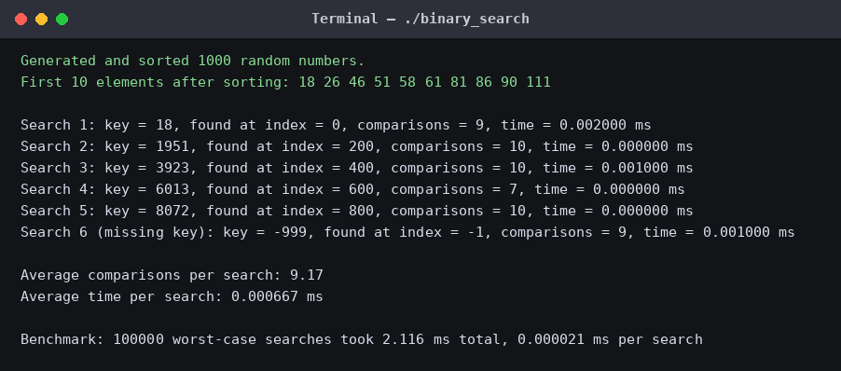
Graphical Comparison
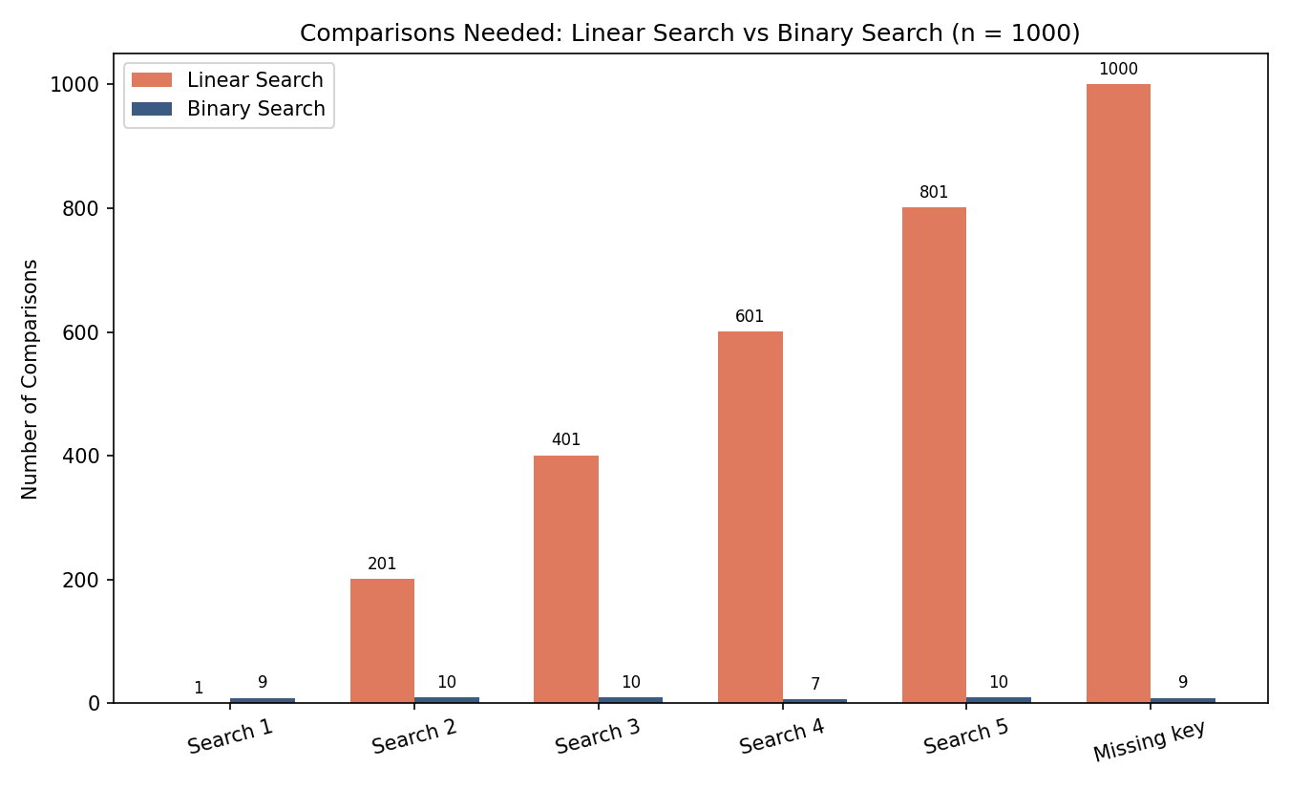
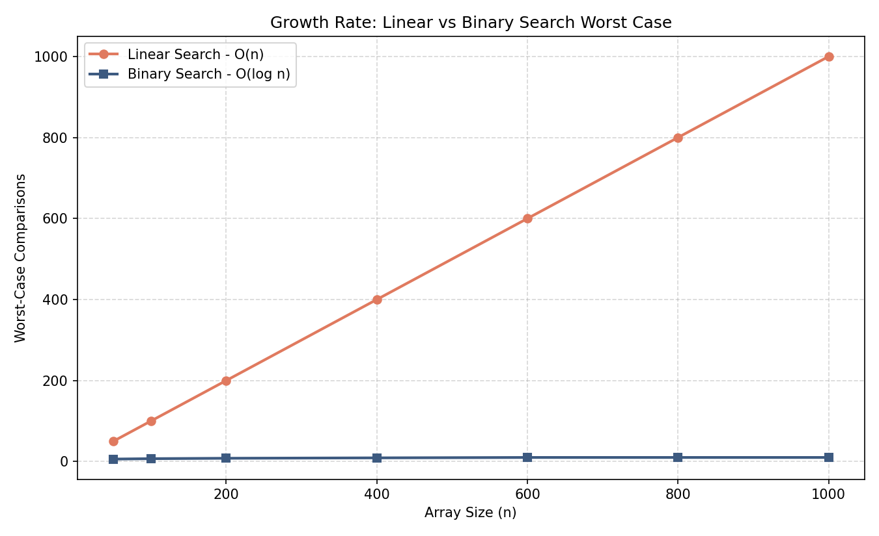
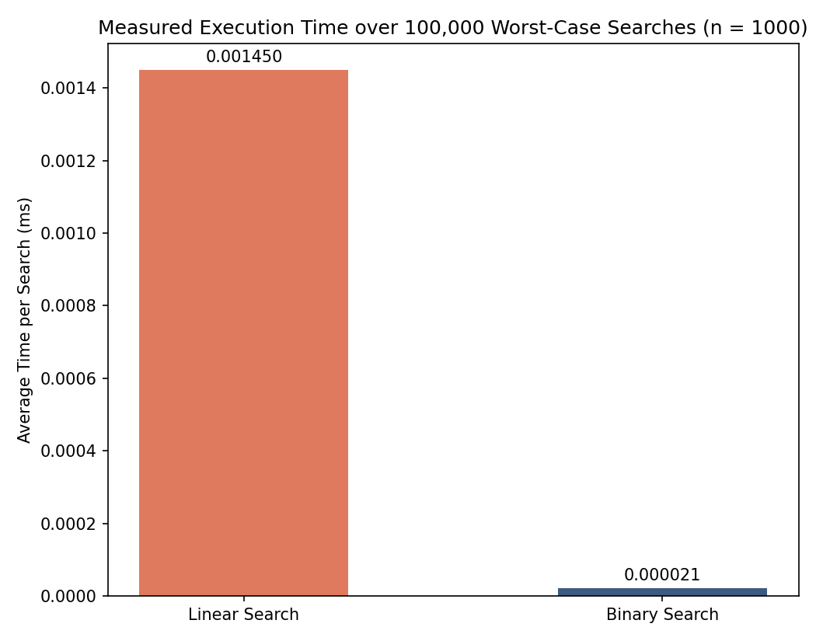

Understanding
Binary search is superior to linear search for large datasets because its $O\left(\log{n}\right)$ time complexity dramatically reduces lookups compared to linear search's $O\left(n\right)$ linear scan. However, binary search requires $O\left(n\log{n}\right)$ upfront time (and potentially additional space) to sort the data first, making linear search the more efficient, zero-overhead $O\left(1\right)$ choice for small lists or one-off searches.

