Assignment 1

Rens van Schouwenburg: 6626394  
&  
Jan Vrieler: 6569552

Pattern Recognition

A comparison of classification algorithms

Contents

1. Introduction 2

1.1 The dataset 2

2. Data exploration 2

3. Multinomial Logit 2

3.1 Density 3

3.2 Top-bottom ratio 4

3.3 Density and Top-bottom ratio 5

4. Pre-processing MNIST 2

5. Multinomial logit with LASSO 2

6. K-nearest neighbour 2

7. Support vector-machine 2

8. Conclusion 2

References 3

# 1. Introduction

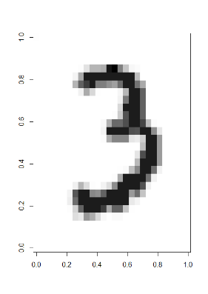This report will discuss different classification algorithms and their performance on the MNIST dataset. First the dataset itself will be discussed, then a multinomial logit model will be applied to the dataset using single features. Thereafter three different models will be applied to the dataset and their performances will be compared. The models consist of; a regularised multinomial logit model, a k-nearest neighbour model and a support vector machine. The steps taking in pre-processing the data for the algorithms and the parameters chosen will also be discussed.

## 1.1 The dataset

The MNIST dataset contains 42.000 different handwritten numbers on a 28x28 grid. Each pixel in this grid has a value between 0 and 255. This value will be referred to as ‘pixel value’ throughout the report. The higher the pixel value, the ‘darker’ it is in the picture. A pixel value of 0 refers to an empty or unused pixel, whereas a pixel value of 255 refers to a completely darkened pixel. In total, each handwritten number consists of 784 pixels. Before the data is analysed, the data will be explored to spot potentially superfluous pixels. Figure 1 presents an example of how the handwritten digits are represented in the dataset. As can be seen, some parts of the digit are darker than others, these shades correspond with the ‘pixel value’ described earlier.

# 2. Data exploration

Creating a summary of every feature shows that there are pixels with a maximum value of 0. This suggests that the pixel values are 0 for all 42.000 observations. These pixels cannot contribute to the classification of the observations, because they are the same for every observation. Some pixels have scores very close to 0. A low pixel score doesn’t inherently mean that a pixel is useless for the classification of the different numbers. It might be that a pixel with a lower score is only used by one of the 10 numbers. However, when the score becomes too low, it is more likely that the pixel has been coloured incidentally in a few observations. Therefore, it might be beneficial to also delete pixels with a total score that is close to 0. In this case, a threshold of 1000 is chosen for removing superfluous pixels. A score of 1000 over 42.000 observations is still low, but the threshold is kept low to prevent loss of key features for identifying numbers. There are 151 pixels with a total pixel value under 1000. Almost all of those pixels reside on the corners or outer edges of the image. This seems logical, as the numbers are generally written on the middle of the paper.

Table 1 shows the distribution of the classes in the dataset. It shows that the least abundant number is 5, and that the majority class is 1. The mean of the different numbers is 4,200. The majority class provides a baseline accuracy to compare to when evaluating new models. When the majority class is predicted (class 1) 11,15% of the predictions will be correct. Of course, this performance is far from stellar. To be useful, the accuracy of this model should be much higher.

Figure 1: handwritten number 3

# 3. Multinomial Logit

Table 1: count and percentage of classes

|  |  |  |
| --- | --- | --- |
| Class | Count | Percentage |
| 0 | 4132 | 9.83% |
| 1 | 4684 | 11.15% |
| 2 | 4177 | 9.95% |
| 3 | 4351 | 10.36% |
| 4 | 4072 | 9.70% |
| 5 | 3795 | 9.04% |
| 6 | 4137 | 9.85% |
| 7 | 4401 | 10.48% |
| 8 | 4063 | 9.67% |
| 9 | 4188 | 9.97% |

This chapter will discuss three multinomial logit models with different features. First, a feature called ‘density’ is created and discussed. Thereafter, its performance on classifying the handwritten digits will be discussed. The same procedure will be followed with a different feature called the top-bottom ratio. Finally, both features will be applied to the data, and the performance of the model will be discussed.

A multinomial logit model, also known as a multinomial logistic regression, is a classification method that can be applied to cases with multiple classes. It can be used to predict the class of an observation based on its variables. In case of this paper, which handwritten digits does the observation represent, based on the pixel values in it pixels. The model uses a linear combination of the features of an observation to predict its class. In this chapter, the model will be applied to the MNIST dataset with either one or two features. The entire MNIST dataset was used for training and testing in this chapter. Note that this deviates from the next chapter.

## 3.1 Density

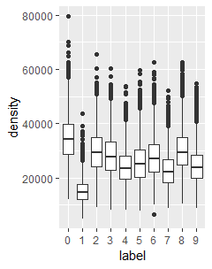The first tested model was ran on a feature called ‘density’. The density of an observation can roughly be translated to its ‘ink cost’. To obtain the density of each observation, the sum of all pixel values in one observation was calculated. This resulted in 42.000 different densities. Table 2 shows the average density for each of the classes along with the standard deviation. Figure 2 visualises the distribution of density per class.

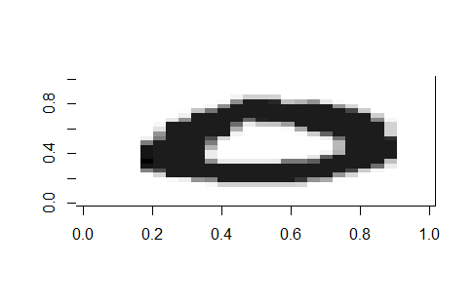

Figure 2: boxplot of density per class

Table 2 shows the mean densities for all 10 classes, and their standard deviations. It shows that some classes have a much different mean density than others. For instance, the digit 0, on average, uses double the ink that is used for the digit 1. In theory, these numbers should be easily distinguishable from each other based on their density. Reversely, the digits 9 and 4 are only an average pixel value if 300 apart from each other. This should make them more difficult to distinguish. In general, the means of the classes are relatively close to each other. Correct classification is made even more difficult by the fact that the standard deviations are relatively high. This shows that many observations deviate from the mean by several thousand points in pixel value.

Figure 3: digit no. 111

Table 2: mean and standard deviation of density per class

|  |  |  |
| --- | --- | --- |
| Class | Mean | Std. dev. |
| 0 | 34.632,41 | 8462,91 |
| 1 | 15.188,47 | 4409.93 |
| 2 | 29.871,10 | 7653,92 |
| 3 | 28.320,19 | 7574.98 |
| 4 | 24.232,72 | 6375,42 |
| 5 | 25.835,92 | 7527,60 |
| 6 | 27.734,92 | 7531,41 |
| 7 | 22.931.24 | 6169,04 |
| 8 | 30.184,15 | 7778,35 |
| 9 | 24.553,75 | 6466,00 |

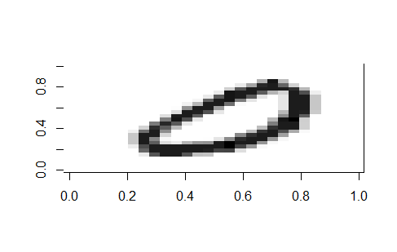Figure 2 visualises the problem described above. The ‘boxes’ represent 50% of all density values for a specific class. For almost all classes, except digit 1, there is another class at the same level. This will product difficulties in classifying the observations. Additionally, the ‘whiskers’ of the boxes represent the other 50% of the data, barring the outliers. The variability of the observations make it logical that the value of density fluctuates within class. Factors like the style of handwriting, the pen used, ink colour or how much force is applied to the paper while writing can all influence the density of an observation. Figure 3 and 4 show two different digits 0 from the dataset. This further illustrates the data shown in figure 2 and table 2.

Figure 4: digit no.18

Figure 5 shows a stacked bar chart with the outcome of the classification using only density as feature.

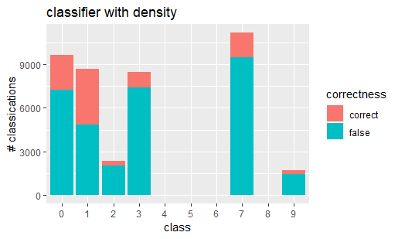

Figure 5: performance of density as a classifier

As can be seen from the figure, density does not perform well as a classifier. Four out of ten classes are not predicted at all, and those classes that are predicted are generally wrong. The predictions made based on table 2 and figure 2 seem to be correct. Digit 1 seems to be classified correctly the most often. The model was not able to discern the different classes with a mean around 24.000.

The accuracy of this model is 22,7%. Compared to the baseline performance of predicting the majority class, the performance has almost doubled. However, 22,7% is still far from reliable.

## 3.2 Top-bottom ratio

In search of more distinctive feature to classify the data, a new feature call the ‘top-bottom ratio’ was created. The pixels in the pictures of the handwritten digits are ordered from left to right. Which means that the top and bottom half can easily be separated from each other. To create the top-bottom ratio, the sums of the pixel values of the first 387 pixels and second 387 pixels were calculated. This created a dataset with the sum of pixel value in the top half and bottom half for each observation. To obtain the ratio, the sum of the bottom half pixel values was divided by the sum of the top half pixel values. The calculation is shown in equation 1.

$$\left(1\right) ratio= \frac{sum\left(observation\left[388:784\right]\right)}{sum(observation\left[1:387\right])}$$

This creates a ratio where a value of >1 means more pixel value on the bottoms half, and a value of <1 means more pixel value on the top half. It is assumed that on average the digits are written in the middle of the paper, dividing the digits into two equal halves. Of course this assumption is not always satisfied, but it is assumed that it holds in general.

Table 3 and figure 6 show the mean ratio for each class and its standard deviations.

|  |  |  |
| --- | --- | --- |
| Class | Mean | Std. dev. |
| 0 | 0,925 | 0,085 |
| 1 | 0,904 | 0,075 |
| 2 | 0,703 | 0,138 |
| 3 | 0,973 | 0,146 |
| 4 | 0,798 | 0,172 |
| 5 | 0,983 | 0,174 |
| 6 | 0,665 | 0,120 |
| 7 | 1,218 | 0,220 |
| 8 | 0,969 | 0,108 |
| 9 | 1,006 | 0,196 |

Table 3: mean and standard deviation per class

Table 3 shows the same problem takes place with the top-bottom ratio as with density. Though there is more difference between the classes, some are still very similar. It also seems that the assumption that on average, the numbers are written in the middle of the paper is violated. Symmetrical digits should be very close to a mean of 1. However, this is not the case.

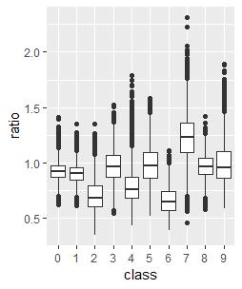

Figure 6: Boxplot of ratio

Figure 6 confirms that there is more diversity in ratio than there was in density between the numbers. There are still some very similar numbers however. Judging by their similarity in the boxplot, labels 3 and 5 should be very hard to distinguish for the model. Though the feature does show promise in distinguishing between the digits 2 and 7. This makes sense intuitively, because the biggest part of a 2 is on its bottom, whereas a 7 is more ‘top heavy’. Once again, the variability of the data hinders the ability of the model to correctly classify the data based on this feature. Handwriting plays a large part in the ratio of a digit. As well as where on the paper the digit has been written.

The results of a multinomial logit model with the top-bottom ratio as the only feature are shown in figure 7.

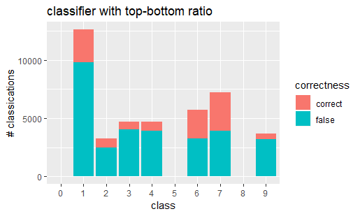

Figure 7: performance of top-bottom ratio as a classifier

Figure 7 shows an improvement in performance over density, but still does not use all classes for classification. There are still 3

classes that are never predicted by the model, and if classes are predicted, then the predictions are mostly incorrect. The accuracy

of this model is 27,0%, which still makes the performance very poor. As was predicted, number 5 could not be distinguished from other classes. Likewise, 0 and 8 were too ‘average’ to stand out between the other predictors.

## 3.3 Density and Top-bottom ratio

This paragraph will discuss a multinomial logit model with both density and top-bottom ratio as features. To assess the relation between top-bottom ratio and density, a scatterplot was created. Figure 9 shows the relation between density and top-bottom ratio for all ten classes. From the scatterplot it can already be seen that there isn’t a strong correlation between the two features. This makes sense intuitively, as the amount of ink used, and the ratio between two halves of a number do not necessarily have anything to do with each other when writing a number. Especially in the lower left corner, the classes do not seem to show a clear distinction from each other. The only exception being digit 7, which seems to use a lot of ink, and has a large top-bottom ratio. Digit 1 shows a centralised clump at the bottom of the figure, but due to it being surrounded by other classes, it is not likely to be predicted often. It is also expected that digit 5 still won’t be predicted, as both features didn’t classify any observation as digit 5 on their own.

Figure 8 shows the result of using both features as a classifier for the MNIST dataset.

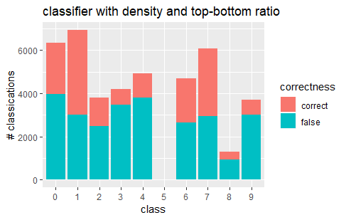

Figure 8: performance of ratio and density

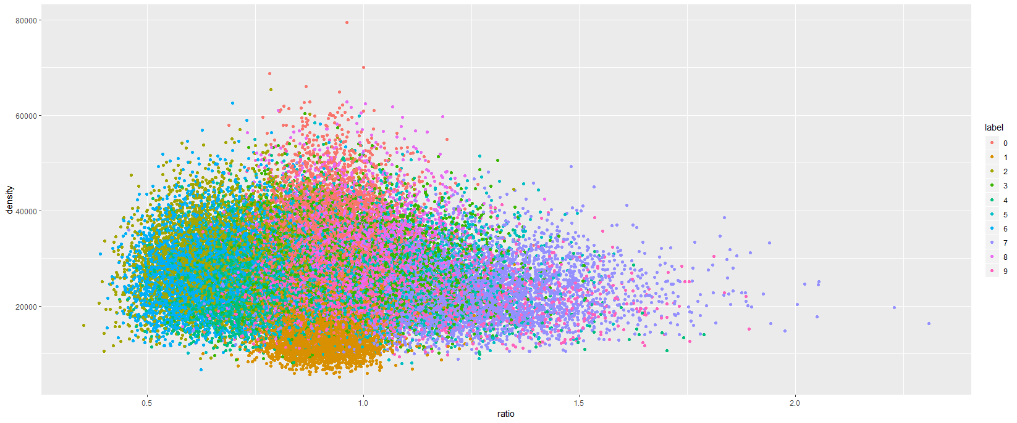As expected, the model still does not predict the digit 5. The combination of density and top-bottom ratio cannot distinguish 5 from any of the other classes. This also makes sense when looking at figures 2 and 6, where 5 is in the ‘middle of the pack’. Digit 1 is picked often, and classified correctly more than 50% of the time. This shows that the centrality of its positioning makes it more recognisable for the model, which makes it perform better on 1 than on the other numbers. The other example of this is 7. Its position in the scatterplot us more over to the right, making the outliers to the lower right of the chart more recognisable as a 7. Though there is still a lot of room for improvement.

Figure 9: scatterplot of density and ratio

However, the combined features have improved the performance of the model. The performance with the two features combined amounts to 37,3%. The performance still isn’t very good, but compared to the baseline, the accuracy of the model has risen by 26,15%.

Based on these results, it becomes clear that adding more features to the model would be beneficial to its performance. However, it could also be beneficial to apply features that are better able to individually distinguish between different classes.

# 4. Pre-processing MNIST

Next to multinomial logistic regression method we also trained and evaluated three other models that classified the MNIST images. These classification algorithms are compared to one another based on accuracy and classification error on which the best classifier is picked. The following models are used in this comparison:

1. a multinomial logistic regression with LASSO (least absolute shrinkage and selection operator),
2. k-nearest neighbour, and
3. supported vector machines. that are trained and evaluated on

We drew a random sample (sample size = 6.000) and used this as a training data set for all three classifiers in order to evaluate and compare their performances. The remaining 36.000 observations is used as a test dataset.

In contrast with the multinomial logit model, we used more variables to predict labels of the handwritten digits. This would result into higher complex models that implies on the one hand higher accuracies, but on the other hand it is computationally heavier. To counter this phenomenon, we pre-processed the MNIST dataset and applied feature selection. That is selecting the variables that have relative high correlations with the outcomes. This would result in removing redundant variables and creating new variables.

As you know each image in the MNIST dataset has the dimensions of 28x28 pixels that creates 784 features. However, training a classifier based on all these features is extremely time consuming. So we reduced the dimension to a 14x14 pixel image, that resulted in a 196 feature heavy dataset. This is a reduction of 75% that decreased the training time significantly.

Next to the dimension reduction, we subsequently removed features which had pixel values below 4.000. This threshold is arbitrarily defined and could be played with to influence time complexity of the models in future research. How this threshold affected the training duration is outside the scope of this research.

# 5. Multinomial logit with LASSO

# 6. K-nearest neighbour

# 7. Support vector-machine

# 8. Conclusion

# References

**Het huidige document heeft geen bronnen.**