Introduction incl. problem statement
(...)
All of the user data should be stored properly in a database, so that user of our product would be ensured to has their details saved safely. Details of an account should consist of login information and all progress that user has set and achieved.

Requirements
(...)
For the database part, user should be able to access their account details without a specific knowledge of how are they stored. To suit user’s requirements we should provide easy access to their account.
Possible queries that user might want to execute are:
-Creating an account and logging to it
-Deleting an account
-Setting and changing personal details, like: name, e-mail, age, profile picture etc.
-Creating new habits and deleting old ones
-Setting and completing goals

Architecture
There should be a separate package for a database. Other packages should be able to sent queries to the database package and get simple responses.

Early design of a database structure should look like this.
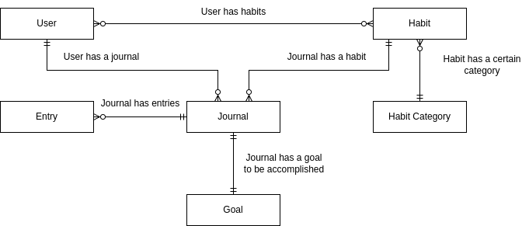
For the prototype purpose, data would be stored on the user’s localhost using their own Database Management System, which is considered as a hardware since data is saved on a hard drive. Our software would be able to work with this system properly.
Each of table in the database is supposed to have their own class and a service class in the application package, so that other packages could call them easily. For the purpose of deleting entries a ‘deleter’ service is required, so that references inside the database would not get lost at some point.
Design

Tables content description:
User
Table of all users. Possibility of extension and deletion is not excluded.
Distinguishable from usernames.
Name of a row | Is a primary key? | Type | Description
UserName | yes | Text, max. 64 characters. Letters, special characters and numbers. | The username given during registration process. Not changeable.
Name | no | Text, max. 64 characters. Only letters | The real name of the user
Surname | no | Text, max. 64 characters. Only letters. | The surname of the user
Age | no | Natural number | The age of the user
Email | no | Text, max 64 characters. Letter, special characters and numbers. | User’s e-mail adress given during registration process.
Password | no | Text, max 64 characters. Letters, special characters and numbers | User’s password given during registration process. Saved as a hash.

Jorunal
Table of all journals. Possibility of extension and deletion is not excluded.
Distinguishable from IDs. Used to store a multiple habits for a specific user.
Name of a row | Is a primary key? | Type | Description
Journal_ID | yes | Natural number | The unique id for a journal. Auto-incremented value
Current_Streak | no | Natural number | The current-streak counter for a given journal. Describes how many days in a row user accomplished their goal.
Start_Date | no | Date | Date that a journal was created on
End_Date | no | Date | Date that a journal was closed on
Activity_Type | no | Text, max 64 characters. Only letters | Describes a type of activity that journal is about.

Habit
Table of all habits. Possibility of extension and deletion is not excluded.
Distinguishable from IDs. Used for creating journal and describing what is its purpose.
Name of a row | Is a primary key? | Type | Description
Habit_ID | yes | Natural number | The unique id for a habit. Auto-incremented value
Name | no | Text, max. 64 characters. Only letters. | The name of the habit
Description | no | Text, max 1024 characters. Letters, special characters and numbers | The text that describes what a habit is about.

Habit category
Table of all habits categories. Possibility of extension and deletion is not excluded.
Distinguishable from names. Used to group habits.
Name of a row | Is a primary key? | Type | Description
Habit_Cat_Name | yes | Text, max 64 characters. Only letters | The unique name for a habit category.
Description | no | Text, max 1024 characters. Letters, special characters and numbers. | The text that describes what a category is about.

Goal
Table of all goals. Possibility of extension and deletion is not excluded.
Distinguishable from IDs. Used to set a specific goal to journal.
Name of a row | Is a primary key? | Type | Description
Goal_ID | yes | Natural number | The unique id for a goal. Auto-incremented value
Description | no | Text, max 1024 characters. Letters, special characters and numbers. | The text that describes what a category is about.
Value | no | Text, max 64 characters. Only letters | The text that specifies the unit value that is set for a specific goal. Like “km”, “amount”, “minutes”
Entry
Table of all entries. Possibility of extension and deletion is not excluded.
Distinguishable from IDs. Used for creating entries to an existing user’s journal.
Name of a row | Is a primary key? | Type | Description
Entry_ID | yes | Natural number | The unique id for an entry. Auto-incremented value
Date | no | Date | The date that the entry was created on.
Value | no | Text, max 64 characters. Letters and numbers. | The text that specifies what was an outcome of an entry.

Relations description

Name | Table no. 1 | Table no. 2 | Type of a relation | Description
User has habits | User | Habit | 0… n : 0…n | Relation assign users to habits. One user can have multiple habits, and one habit could have multiple users. There could be a user without a habit, and habit could be without a user.
Habit has a certain category | Habit | Habit_Category | 0…n : 1 | Habit always has a category. Habit_Category could have multiple habits. There could be a Habit_Category without a Habit assigned
User has a journal | User | Journal | 1 : 0…n | User could have multiple journals. Journal is always assigned for a certain user.
Journal has a habit | Journal | Habit | 0…n : 1 | Journal always has a habit. Habit could be assigned to multiple journals
Journal has an entry | Journal | Entry | 1 : 0…n | Entry always has a journal. Journal could have multiple entries.
Journal has a goal | Journal | Goal | 1 : 1 | Journal always has a goal and goal always has a journal.

