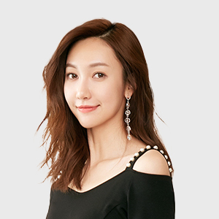
Professional Skills:
- Being familiar with accounting theory
- Mastering share option,futures and foreign currency hedge.
- Mastering risk management.
Personal skills:
- Intermediate German and Chinese languages
- Basic French language
- Self-taught guitar player/vocalist
SPECIAL SLILLS
2012.09-2016.06

Sun Yat-sen University
Accounting (Bachelor)
2012.09-2016.06

Sun Yat-sen University
Accounting (Bachelor)
2012.09-2016.06

Sun Yat-sen University
Accounting (Bachelor)
EXPERIENCE
BASIC INFORMATION

Birth date:
August 10, 1989

Mobile:
13500135000

E-mail:
1906222627@qq.com

Living place:
HuangCun,Tianhe District, Guangzhou, Guangdong
WORK EXPERIENCE

ICBC | Bank accounting and teller 2016.01-2016.06
- Responsible to foreign deposit and interest calculations, computerized accounting, printings of vouchers, bankbooks, deposit receipts and cash collecting and paying.
- Dealing with balance accounts and printing their bills, clearing and checking cash holdings, important blank vouchers and documents of value, storing after checking business chops, then seal the previous materials under the supervision of integrated tellers and transfer the data of accounts including vouchers to the integrated teller before the shift.

Bank of China | Customer service 2015.07-2015.09
- Providing custom service including 7*24 financial consultations, trading assistants, Q&As and customer cares through telephone and internet.
- In the cases of which clients’ problems could not be solved online, transfer the information to the back staff to settle, and track the settlements before communicating with the clients.
- Abiding the regulations and working closely with the operating administration and other co-workers.
CERTIFICATE

2012-2013
Accounting qualification certificate

2013-2014
Financial analyst certificate

2012-2014
Computer two level certificate

2015-2015
Driver's license
PROFILE

I’m familiar to related regulations and institutions, thus able to control the risk of bank operation.Consequently my positive attitude and strong ability of learning led to my outstanding academic achievement.
With a creative and dynamic mind, I’m keen on attending social practice and volunteer work with a quality of hardworking and rigor.
Last but not least, I’m always honest by sticking to my promise and always willing to communicate with others or to help them with a great sense of teamwork.
Lincaiwei
Objective: Bank Teller

