**What are the true effect sizes of winner and loser effects?: A meta-analysis comparing self- and random selection protocols**

**RATIONALE AND OBJECTIVES**

The experience and outcomes of prior aggressive contests between two same-sex conspecifics can have profound effects on an individual’s behaviour and success in subsequent contests. Many studies have reported that winners are more likely to win successive contests (winner effects), and losers are more likely to lose successive contests (loser effects). Quantifying the magnitude of these effects is of great interest to biologists because fighting success can influence an individual’s ability to acquire and hold resources, territories, and access to reproductive opportunities. However, many studies that quantify winner and loser effects commit selection bias by pairing two animals in a fight and assigning the winner to a "winner" treatment, and loser to a "loser" treatment, rather than testing individuals randomly assigned to initial winning and losing conditions. The widespread use of biased protocols may mean that our general estimation of the magnitude of winner and loser effects are over-estimated. As such, the goal of this meta-analysis is to answer the following questions:

1. What are the magnitudes of winner and loser effects? And can their sign be estimated confidently?

2. Is the magnitude of loser effects higher than that of winner effects (as previously suggested by Bakker et al. (1989)?

3. Is the magnitude of winner and loser effects lower in experiments using random assignment than in studies that commit selection bias?

4. What is the proportion of papers on winner and loser effects that use random assignment protocols instead of self selection? Has it increased over time?

**METHODS**

***Search strategy***

In July 2019, we had two independent observers enter our search term (fighting OR aggression AND "winner effects" OR "loser effects" OR "winner effect" OR "loser effect") into Google Scholar which yielded 2080 results. We included empirical studies that assessed the effect of prior contest wins or losses on subsequent contest outcomes. We excluded studies that were not peer-reviewed, did not explicitly quantify fighting outcome as a response variable (many studies only quantify aggression or physiological measures), or did not match individuals to naïve, unfamiliar competitors in the test phase. The observers also cross-referenced two other major reviews that focused on winner and loser effects (Hsu et al., 2006; Rutte et al., 2006). After stage one of our screen where we read the title and abstracts of the 2086 Google Scholar search results, 82 papers remained. We then read the full text of these 82 papers which resulted in 31 final studies.

In August 2023, we performed an updated search by entering the same search term into Google Scholar while excluding all papers that were published prior to 2019 to avoid screening the same papers from our first search. Using the same exclusion criteria as our initial search, we found 6 more studies that were eligible for our meta-analysis resulting in 37 total studies.

***Data extraction***

From each of the eligible studies, we extracted the following information:

**Primary information:**

1. Study protocol (selection bias or random selection)
2. Initial contest experience (win or loss)

3) Sample size

4) Fighting outcome of test contest

- Measured by # of wins and # of losses

5) Genus and species of the study animals

6) Year of study publication

**Secondary information:**

7) Sex of study animals

8) Duration of the initial contest experience treatment

9) Latency between the initial contest experience treatment and test phase

10) Number of initial contest experiences

11) Any additional manipulations made to animals prior to test  
  
All but one of the studies tested for both the winner effect and loser effect and many had additional manipulations. Therefore, extracting data for the 37 included studies resulted in a total of 168 comparisons.

***STATISTICAL ANALYZES***

We completed all our analyses using R 4.1.1 and used the *metafor* package to conduct a mixed-effect meta regression analysis. Our goal was to generate a single model that assessed the strength of both winner and loser effects while also examining whether the two protocols (random assignment vs. self selection) affected effect size estimates. We started by using the *escalc()* function to generate effect sizes and sampling variances for each comparison using the following code:  
  
all_data <- escalc(data = all_data, xi = ifelse(contest_outcome == "winner", wins, losses), ni = sample_size, measure = "PLO", append = TRUE)  
  
Above, the variable ***xi*** represented number of wins if individuals in a comparison had previously experienced winning or number of losses if individuals in a comparison had previously experienced losing. The variable ***ni***denoted the number of individuals within each comparison. We chose the **“PLO”** method to obtain log odds ratios for our measures of effect size. Therefore, the computed effect sizes represent either the log-odds that prior winners will win future contests or the log-odds that prior losers will lose future contests, thus capturing the strength of winner and loser effects respectively.   
  
We then used the *rma.mv()* function to generate a meta regression model with contest outcome (prior win or loss) and study type (random assignment or self selection) as categorical moderators. Lastly, we noted that within a given study, there were typically multiple experiments testing additional variables that were not of interest to us such as the latency between initial and test contest experiences. In most cases, each separate experiment generated an effect size for initial winners and an effect size for initial losers. Since effect sizes generated from the same experiment within a study are not entirely independent, we included experiment nested within study ID as a random effect in our main meta-analysis model.   
  
met_mod_all <-rma.mv(data = all_data, yi, vi, mods = ~ contest_outcome + protocol, random = ~ (1|study/experiment), method="ML")

To obtain pooled effect size estimates along with 95% confidence intervals for the winner effect and loser effect respectively, we used the *emmeans* package. We first used the *qdrg()* function to turn the rma object into an emmGrid object and then used the *emmeans()* function to obtain the effect size estimates and confidence intervals of interest. We also saved this information into a data frame so that it could be used for plotting:   
  
em_mod_all <- qdrg(object = met_mod_all, data = all_data)

win_loss_95_CI <- as.data.frame(emmeans(em_mod_all, specs = ~ contest_outcome))  
  
Next, we assessed the magnitude of winner and loser effects differed by taxa by generating a new meta regression model with animal class as a categorical moderator variable and experiment nested within study ID as a random effect:

met_mod_animal <-rma.mv(data = all_data, yi, vi, mods = ~ 0 + class, random = ~ (1|study/experiment), method="ML")  
  
Lastly, to examine if the proportion of papers that use random assignment has increased over time, we performed a logistic regression analysis (generalized linear model with binomial distribution). We used protocol type (self or random assignment) as the response variable with study publication year as a fixed factor. In this model, the unit of analysis was study rather than individual comparisons:  
  
year_mod <- glm(data = study_info, protocol ~ year, family = binomial())

**PRELIMINARY RESULTS**

First, we found significant winner and loser effects across all comparisons. The pooled log-odds of winning a contest for prior winners was 0.76 (95% CI: 0.56 – 0.95; p < 0.0001; Fig.1) while the pooled log-odds of losing for prior losers was 0.72 (95% CI: 0.52 – 0.92; p < 0.0001; Fig.1). However, we did not detect significant differences in the magnitude of winner effects vs. loser effects (Qm1 = 0.18; 95% CI: -0.11 – 0.18; p = 0.67; Fig.2).

**Figure 1.** The log-odds of winning for winners (red; N = 84 comparisons) and losing for losers (blue; N = 84 comparisons) against a naïve opponent. Circle sizes are proportional to the sample size of each comparison.

Next, we found that both studies using self selection and random selection generate overall significant winner and loser effects. The pooled log-odds of winning a contest for prior winners or losing a contest for prior losers in self-selection studies was 0.71 (95% CI: 0.51 – 1.03; p < 0.0001; Fig.2) while the pooled log-odds of winning a contest for prior winners or losing for prior losers in studies using random assignment was 0.77 (95% CI: 0.47 – 0.95; p < 0.0001; Fig.2). However, we did not detect significant differences in the reported magnitude of winner and loser effects between self selection and random assignment studies (Qm1 = 0.12; 95% CI = -0.41 – 0.29; p = 0.72; Fig.2).

**Figure 2.** The log-odds of winning for winners or losing for losers against a naïve opponent in studies that either use self-selection (yellow; N = 90 comparisons) or random assignment (green; N = 78 comparisons). Circle sizes are proportional to the sample size of each comparison.

We also found no evidence that the effects of prior wins and losses differed by taxonomic group (Qm5 = 1.58; p = 0.90).

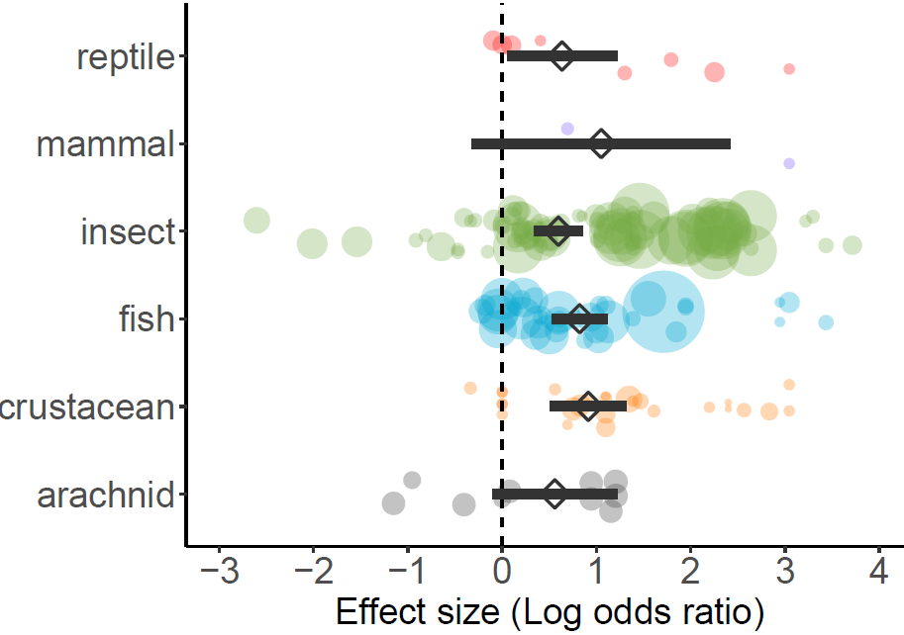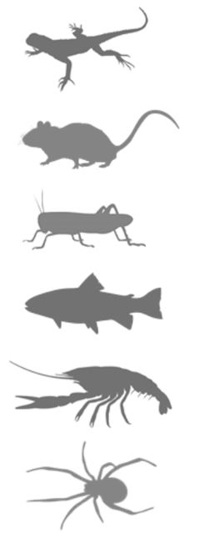

**Figure 3.** The log-odds of winning for winners or losing for losers against a naïve opponent in reptiles (red; N = 8 comparisons), mammals (purple; N = 2 comparisons), insects (green; N = 84 comparisons), fishes (blue, N = 37 comparisons), crustaceans (orange; N = 27 comparisons), and arachnids (grey; N = 10 comparisons). Circle sizes are proportional to the sample size of each comparison.

Lastly, we found a non-statistically significant trend of random assignment being used more frequently than self-selection over time (GLM: Wald Χ2 = 0.40; 95% CI = -0.05 – 0.09; p = 0.53). However, there were still some studies published in the last couple of years using self-selection protocols (Fig.4).   
**Figure 4.** The frequency of studies using either self-selection or random assignment as a function of study publication year (N = 37 studies).

**PUBLICATION BIAS**

We tested for publication bias by using the *regtest()* function from the *metafor* package to perform Egger’s regression test. This test looks at the relationship between observed effect sizes and their standard error which usually implies asymmetry in the funnel plot which in turn may be an indicator of publication bias (Egger et al., 1997; Stern & Egger, 2005)). Our test indicated that there was significant funnel plot asymmetry (z = 5.67; p < 0.0001).

We additionally tested for funnel plot asymmetry by performing a trim-and-fill analysis. This test assumes that there is a single symmetric distribution of effect sizes. Our trim-and-fill analysis revealed that there was significant funnel plot asymmetry and estimated that there are 21 missing effect sizes on the left side of the funnel plot. However, the new effect size calculated for overall winner and loser effects after imputing missing effect sizes remained statistically significant (estimate = 0.70; 95% CI = 0.55 – 0.85; p < 0.0001).

**Figure 5.** Funnel plot showing the relationship between standard error effect size (log odds ratio). The blue circles represent the 168 effect sizes from that were included in our meta-regression model. The blue dotted line represents the overall mean effect size estimate obtained from our meta-regression model. The white circles show “missing” effect sizes identified through a trim-and-fill analysis. The black dotted line indicates the new mean effect size after including the “missing” effect sizes.   
  
  
  
  
  
  
  
**PLOT WHERE X-AXIS VALUES ARE ODDS BUT EFFECT SIZES ARE IN LOG ODDS**