01/04/2022

-- create db --

use sample
switched to db sample

-- create and show collection --

db.myCollection1.insertOne({name: "abc", age: 18,status:"D",groups:["politics","news"]})
{
"acknowledged" : true,
"insertedId" : ObjectId("6246b72af182b34302b77ccc")
}
> show collections
myCollection1

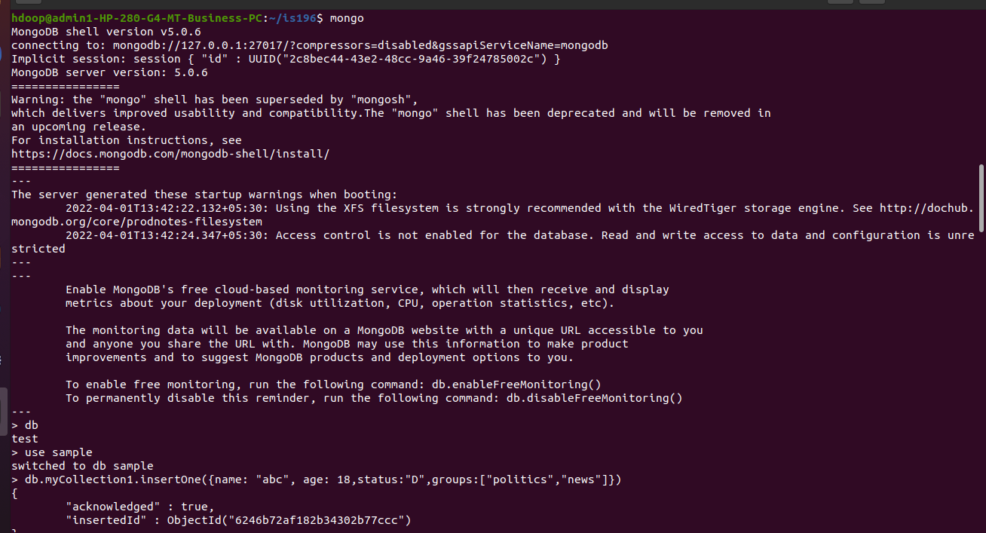

-- insert many ---

db.myCollection1.insertMany(
... {
... name:"xyz",
... age:19,
... status:"A",
... groups:["jouranlism","news"]
... },
... {
... name:"richa",
... age:20,
... status:"C",
... groups:["humanities","pyschology"]
... }
... )
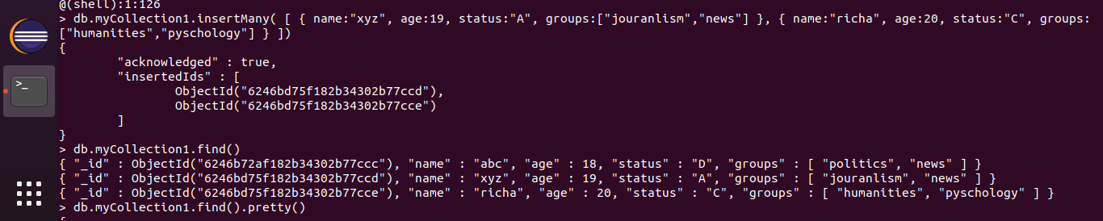

-- find --

db.myCollection1.find()
{ "_id" : ObjectId("6246b72af182b34302b77ccc"), "name" : "abc", "age" : 18, "status" : "D", "groups" : [ "politics", "news" ] }
{ "_id" : ObjectId("6246bd75f182b34302b77ccd"), "name" : "xyz", "age" : 19, "status" : "A", "groups" : [ "jouranlism", "news" ] }
{ "_id" : ObjectId("6246bd75f182b34302b77cce"), "name" : "richa", "age" : 20, "status" : "C", "groups" : [ "humanities", "pyschology" ] }
> db.myCollection1.find().pretty()
{
"_id" : ObjectId("6246b72af182b34302b77ccc"),
"name" : "abc",
"age" : 18,
"status" : "D",
"groups" : [
"politics",
"news"
]
}
{
"_id" : ObjectId("6246bd75f182b34302b77ccd"),
"name" : "xyz",
"age" : 19,
"status" : "A",
"groups" : [
"jouranlism",
"news"
]
}
{
"_id" : ObjectId("6246bd75f182b34302b77cce"),
"name" : "richa",
"age" : 20,
"status" : "C",
"groups" : [
"humanities",
"pyschology"
]
}
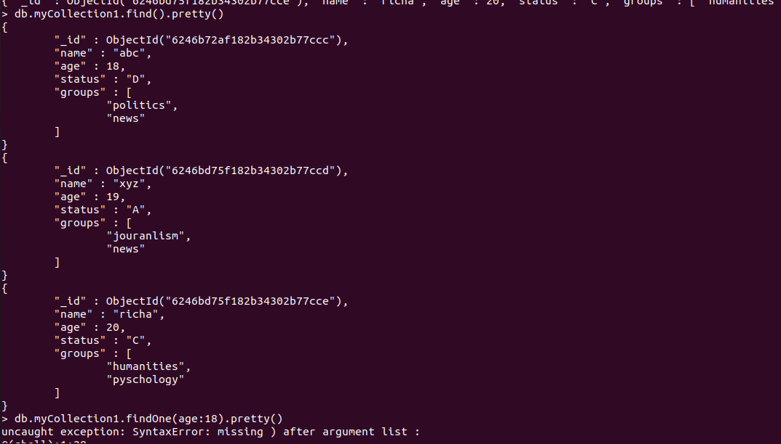

db.myCollection1.findOne({age:18})
{
"_id" : ObjectId("6246b72af182b34302b77ccc"),
"name" : "abc",
"age" : 18,
"status" : "D",
"groups" : [
"politics",
"news"
]
}

-- update --

db.myCollection1.update({name:"abc"},{$set :{name:"shriya"}})
WriteResult({ "nMatched" : 1, "nUpserted" : 0, "nModified" : 1 })
> db.myCollection1.findOne({age:18})
{
"_id" : ObjectId("6246b72af182b34302b77ccc"),
"name" : "shriya",
"age" : 18,
"status" : "D",
"groups" : [
"politics",
"news"
]
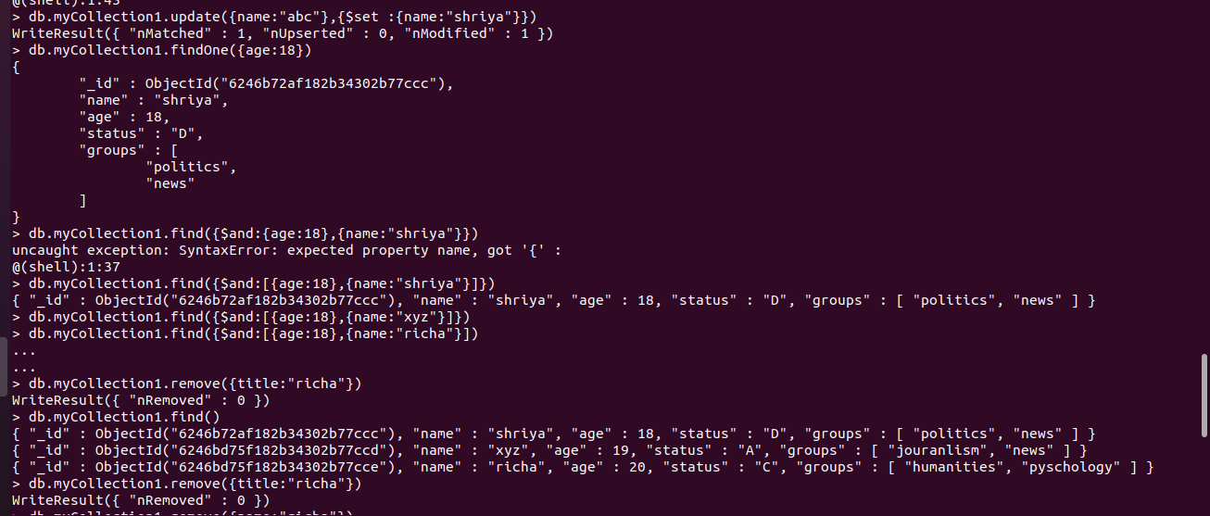
}

db.myCollection1.update({age:{lt:19}},{$set :{age:22}})
WriteResult({ "nMatched" : 0, "nUpserted" : 0, "nModified" : 0 })
> db.myCollection1.update({age:{$lt:19}},{$set :{age:22}})
WriteResult({ "nMatched" : 1, "nUpserted" : 0, "nModified" : 1 })
> db.myCollection1.find()
{ "_id" : ObjectId("6246b72af182b34302b77ccc"), "name" : "shriya", "age" : 22, "status" : "D", "groups" : [ "politics", "news" ] }
{ "_id" : ObjectId("6246bd75f182b34302b77ccd"), "name" : "xyz", "age" : 19, "status" : "A", "groups" : [ "jouranlism", "news" ] }
> db.myCollection1.updateMany({age:{$gt:19}},{$set :{age:17}})
{ "acknowledged" : true, "matchedCount" : 1, "modifiedCount" : 1 }
> db.myCollection1.find()
{ "_id" : ObjectId("6246b72af182b34302b77ccc"), "name" : "shriya", "age" : 17, "status" : "D", "groups" : [ "politics", "news" ] }
{ "_id" : ObjectId("6246bd75f182b34302b77ccd"), "name" : "xyz", "age" : 19, "status" : "A", "groups" : [ "jouranlism", "news" ] }
> db.myCollection1.updateMany({age:{$gt:18}},{$set :{age:17}})
{ "acknowledged" : true, "matchedCount" : 1, "modifiedCount" : 1 }
> db.myCollection1.find()
{ "_id" : ObjectId("6246b72af182b34302b77ccc"), "name" : "shriya", "age" : 17, "status" : "D", "groups" : [ "politics", "news" ] }
{ "_id" : ObjectId("6246bd75f182b34302b77ccd"), "name" : "xyz", "age" : 17, "status" : "A", "groups" : [ "jouranlism", "news" ] }

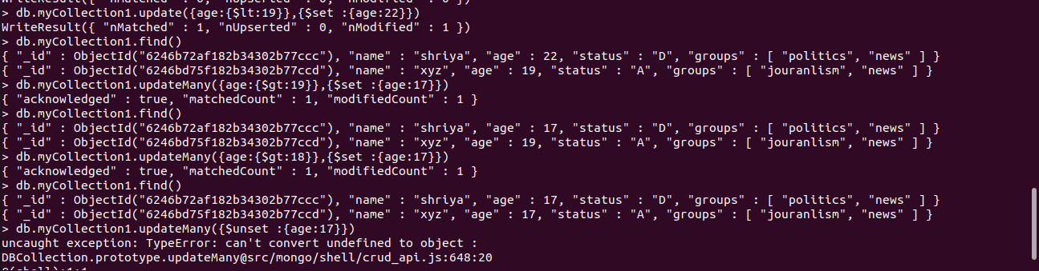
db.myCollection1.update({name:"xyz"},{$unset :{name:"xyz"}})
WriteResult({ "nMatched" : 1, "nUpserted" : 0, "nModified" : 1 })
> db.myCollection1.find()
{ "_id" : ObjectId("6246b72af182b34302b77ccc"), "name" : "shriya", "age" : 17, "status" : "D", "groups" : [ "politics", "news" ] }
{ "_id" : ObjectId("6246bd75f182b34302b77ccd"), "age" : 17, "status" : "A", "groups" : [ "jouranlism", "news" ] }
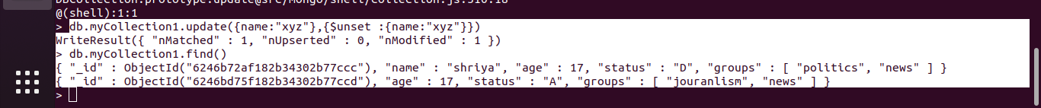

-- AND OR --

db.myCollection1.find({$and:[{age:18},{name:"shriya"}]})
{ "_id" : ObjectId("6246b72af182b34302b77ccc"), "name" : "shriya", "age" : 18, "status" : "D", "groups" : [ "politics", "news" ] }

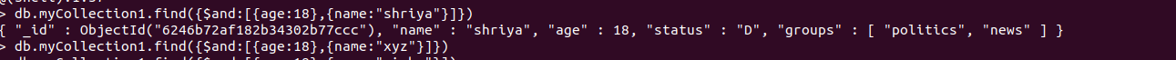
db.myCollection1.find({$or:[{age:18},{name:"xyz"}]})
{ "_id" : ObjectId("6246b72af182b34302b77ccc"), "name" : "shriya", "age" : 18, "status" : "D", "groups" : [ "politics", "news" ] }
{ "_id" : ObjectId("6246bd75f182b34302b77ccd"), "name" : "xyz", "age" : 19, "status" : "A", "groups" : [ "jouranlism", "news" ] }
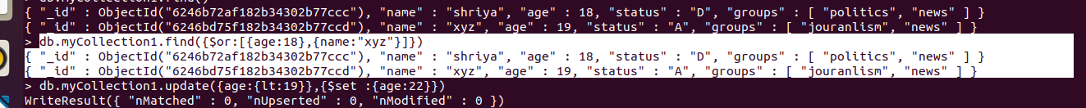
-- remove ---

db.myCollection1.find()
{ "_id" : ObjectId("6246b72af182b34302b77ccc"), "name" : "shriya", "age" : 18, "status" : "D", "groups" : [ "politics", "news" ] }
{ "_id" : ObjectId("6246bd75f182b34302b77ccd"), "name" : "xyz", "age" : 19, "status" : "A", "groups" : [ "jouranlism", "news" ] }
{ "_id" : ObjectId("6246bd75f182b34302b77cce"), "name" : "richa", "age" : 20, "status" : "C", "groups" : [ "humanities", "pyschology" ] }
> db.myCollection1.remove({title:"richa"})
WriteResult({ "nRemoved" : 0 })
> db.myCollection1.remove({name:"richa"})
WriteResult({ "nRemoved" : 1 })
> db.myCollection1.find()
{ "_id" : ObjectId("6246b72af182b34302b77ccc"), "name" : "shriya", "age" : 18, "status" : "D", "groups" : [ "politics", "news" ] }
{ "_id" : ObjectId("6246bd75f182b34302b77ccd"), "name" : "xyz", "age" : 19, "status" : "A", "groups" : [ "jouranlism", "news" ] }

