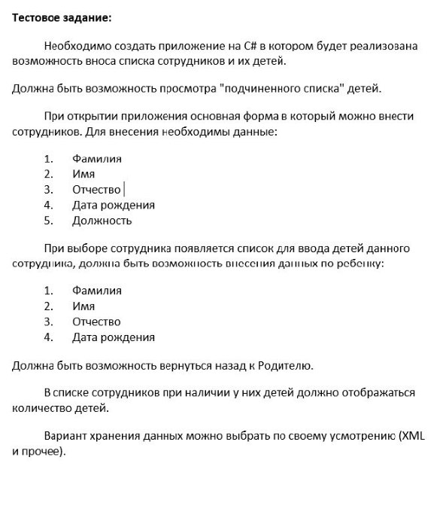

**The test was done using: create entity models(CodeFirst), pattern CQRS, Mediatr, Dependency Injection, to implement the logic the following services are used**