*Study Location*

This study focused on two New Hampshire locations: the area surrounding USGS gauge 01073500, Lamprey River, Newmarket, and the area surrounding USGS gauge 01074520, Pemigewasset River, Woodstock. The two locations were chosen for differences in winter severity. Woodstock is about 100 km north of Newmarket and is no less than 120 kilometers from the coastline with an elevation of 226 m, while Newmarket is located about 12 kilometers from the coast with an elevation of 12 m. These differences in coastal proximity, elevation and latitudinal difference result in more mild winter weather in Newmarket: Newmarket’s average annual minimum temperature range is -23.3 to -20.6 °C, while Woodstock’s is -28.9 to -26.1 °C.1 Additionally, areas within the Pemigewasset watershed received an average of 800 inches of snow per year from 1981 to 2010, while areas within the Lamprey River watershed received an average of 530 inches per year during this time.2 These differences in climate are meant to be representative of differences between the White Mountains and Southeastern New Hampshire, and the results of this study may be reflective of how the two regions experience climate change differently.

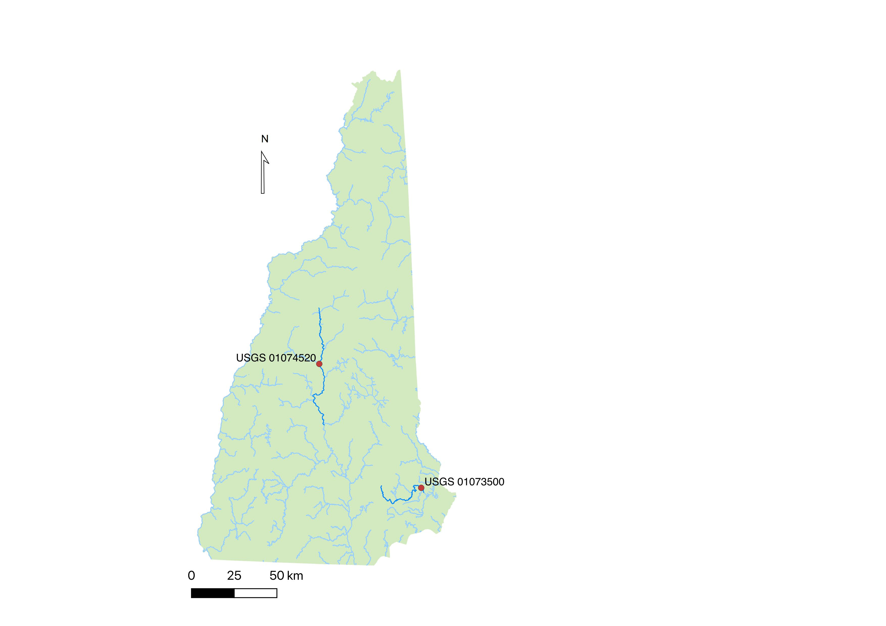

*Data*

This study used .csv files from LOCA-WBM (localized constructed analogs-water balance model) daily climate and drought data found using CMIP5 (Coupled Model Intercomparison Project Phase 5) simulations for both RCP 4.5 and 8.5 scenarios, for each site for the following: precipitation, snowfall, snowpack (SWE), and soil moisture. My advisor, Liz Burakowski, ran these simulations. There are 29 different models for each variable at each site; this study chose to focus analysis on data from one model that predicted comparatively high precipitation, one that predicted comparatively moderate precipitation, and one that predicted comparatively low precipitation. Historical data from this simulation runs from 1980-1-1 through 2005-12-31; future simulated data is available from 2006-1-1 to 2099-12-31.

This study also used USGS stream gauge daily discharge data for each location, USGS 01073500 (Newmarket, Lamprey River) and USGS 01075000 (Woodstock, Pemigewasset River).

Analysis will begin on 1980-1-1.

*Table: Data sources used for analysis in this study.*

|  |  |  |
| --- | --- | --- |
| Data Source | Data | Period |
| LOCA-WBM CMIP5 Simulation | Precipitation | Daily |
| Snowfall |
| Snowpack (SWE) |
| Soil moisture |
| USGS Gauges | Stream discharge | Daily |

*References*

1. USDA Plant Hardiness Zone Map, 2012. Agricultural Research Service, U.S. Department of Agriculture. Accessed from https://planthardiness.ars.usda.gov/

2. Anthony Arguez, Imke Durre, Scott Applequist, Mike Squires, Russell Vose, Xungang Yin, and Rocky Bilotta (2010). NOAA's U.S. Climate Normals (1981-2010).