Ali Jaouhari, Nadeen Alorainey, Kristina Wegener  CSC 440, Group Assignment 1, Due September 8th | 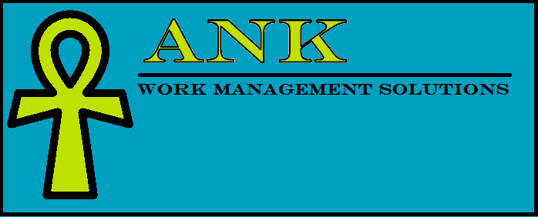

VISION

Revision History

Version | Date | Description | Author
Inception Draft | 9/6/14 | First Draft. Will be refined throughout elaboration. | Kristina Wegener

Introduction
We will be creating a web-based work request system which will allow any user to enter a request online and view statistics. The system will also allow employee users to delegate work responsibilities and mark requests as complete.

Positioning

Business Opportunity
There is a need for a lightweight work management system for small towns and cities to track requests such as graffiti and litter removal, pothole reporting, etc.

Problem Statement
Most work management systems like IBM’s Maximo or BMC’s Track-It are expensive, require user licenses with annual fees and have many features that go unused. For a small organization that has limited requests but still needs a management system, these systems are not a viable solution

Product Position Statement
This product will fill a niche need for small organizations who require a tracking system for work requests but at a minimal one-time cost.

Alternatives and Competition
IBM Maximo, BMC Track-It, Email/Spreadsheet

Stakeholder Descriptions

Market Demographics
…

Stakeholder (Non-User) Summary
…

User Summary
…

Key High-Level Goals and Problems of the Stakeholders

High-Level Goal | Priority | Problems and Concerns | Current Solutions

User Level Goals
Users and Employee Users need a system to fulfill these goals:
Users: Entry of Work Requests, Check on Status of a Request
Employee User: View Open Work Requests, Assign Work Requests, Complete Work Requests,
View Statistics on Completed Work Requests

User Environment
…

Product Overview

Product Perspective
The ANK Work Management System will be sold as a package and will reside on client’s system.

Summary of Benefits
Supporting Feature | Stakeholder Benefit

Assumptions and Dependencies
…

Cost and Pricing
…

Licensing and Installation
…

Summary of System Features
- Web-Based, Anywhere Access for all Employees and Users

Other Requirements and Constraints
…

