**getc():**  
It reads a single character from a given input stream and returns the corresponding integer value (typically ASCII value of read character) on success. It returns EOF on failure.

Syntax:

int getc(FILE *stream);

**Example**

#include <stdio.h>

int main()

{

   printf("%c", getc(stdin));

   return(0);

}

Input: g (press enter key)

Output: g

==========================================================

**getchar():**  
The difference between getc() and getchar() is getc() can read from any input stream, but getchar() reads from standard input. So getchar() is equivalent to getc(stdin).

Syntax:

int getchar(void);

Example:

|  |
| --- |
| int main()  {     printf("%c", getchar());     return 0;  } |

Input: g(press enter key)

Output: g

=======================================================

**Gets**

The gets method is used to read complete set of characters from the console. This [program](https://www.tutorialgateway.org/c-programming-examples/) will help you to practically understand this gets function.

// C gets function example

#include <stdio.h>

int main()

{

char name[50];

printf("\n Please Enter your Full Name: \n");

gets(name);

printf("=============\n");

printf("%s", name);

return 0;

}

**OUTPUT**

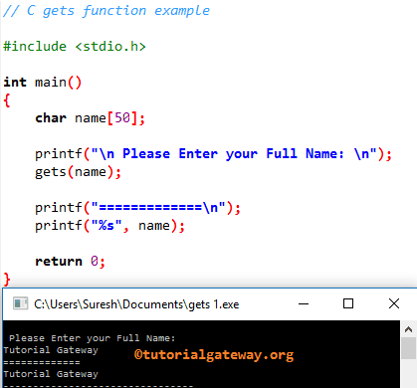

**putc()**

|  |  |
| --- | --- |
| putc() | Declaration: int putc(int char, FILE *fp)  putc function is used to display a character on standard output or is used to write into a file. In a C program, we can use putc as below.  putc(char, stdout); putc(char, fp); |

#include <stdio.h>

int main()

{

   char ch;

   FILE *fp;

   if (fp = fopen("test.c", "r"))

   {

     ch = getc(fp);

     while (ch != EOF)

     {

        putc(ch, stdout);

        ch = getc(fp);

     }

     fclose(fp);

     return 0;

   }

   return 1;

}

#### ****Output:****

|  |
| --- |
| Hi, How are you? |

**putchar()**

|  |  |
| --- | --- |
| putchar() | Declaration: int putchar(int char)  putchar() function is used to write a character on standard output/screen. In a C program, we can use putchar function as below.putchar(char);  where, char is a character variable/value. |

#include <stdio.h>

#include <ctype.h>

int main()

{

   char c;

   printf("Enter some character. Enter $ to exit...\n");

   while (c != '$');

   {

      c = getchar();

      printf("\n Entered character is: ");

      putchar(c);

      printf("\n")

   }

   return 0;

}

#### ****Output:****

|  |
| --- |
| Enter some character. Enter $ to exit… A Entered character is: A B Entered character is: B $  Entered character is: $ |

**Puts()**

|  |  |
| --- | --- |
| **puts()** | Declaration: int **puts**(const char *string)  puts() function is used to write a line to the output screen. In a C program, we use puts function as below. **puts**(string);  where, string – data that should be displayed on the output screen. |

#include <stdio.h>

#include <string.h>

int main()

{

   char string[40];

   strcpy(str, "This is a test string");

   puts(string);

   return 0;

}

#### ****Output:****

|  |
| --- |
| This is a test string |

**Ungetc()**

The **ungetc()** function takes a single character and shoves it back onto an input stream. It is the opposite of the [getc()](https://www.geeksforgeeks.org/eof-and-feof-in-c/) function, which reads a single character from an input stream. Also, ungetc() is an input function, not an output function.  
**Syntax:**

int ungetc(int char, FILE *stream)

// get 1 at the input

#include <stdio.h>

int main()

{

    int ch;

    // reads characters from the stdin and show

    // them on stdout until encounters '1'

    while ((ch = getchar()) != '1')

        putchar(ch);

    // ungetc() returns '1' previously

    // read back to stdin

    ungetc(ch, stdin);

    // getchar() attempts to read

    // next character from stdin

    // and reads character '1' returned

    // back to the stdin by ungetc()

    ch = getchar();

    // putchar() displays character

    putchar(ch);

    return 0;

}