Project Harmony: Low-Fi Prototyping & Pilot User Testing

|  |  |
| --- | --- |
| David Mailhot: Team Manager | Jennifer Apacible: Design & Documentation |
| Eric Oltean: Development | Eve Yi Zhao: User Testing |

URL: http://www.cs.washington.edu/education/courses/cse440/12au/projects/harmony/documents/User_Testing_report.pdf

**Introduction and Mission Statement**

[Introduction] Every time we interact with another person, there is a natural expectation that each person will be considerate of the other. Unfortunately, people can do or say things that are thoughtless or rude. We envision a future in which people can use Project Harmony to improve their social performance. Designed to be deployed on a wearable computing device, our application analyzes the social cues of nearby people in any social situation. It will display feedback about their current social performance by giving quick advice and pointing out mistakes. The wearer can also review this information with video playback of each social encounter. With this information, the wearer can learn to be more considerate to the people they interact with in everyday situations.

[Purpose] Our application is intended to be used in public and during social encounters. Therefore, it is very important that the interface design be minimalist as well as unobtrusive and discreet. Our use cases involve spontaneous social encounters, so wearers cannot be slowed down or distracted by an overwhelming interface. As a result, our usability testing had two focus areas: the comprehension of our minimalist interface and the simulation of using the app in the middle of a social encounter.

[Mission Statement] Project Harmony seeks to empower people with the improvement of their social performance.

**Prototype Description**

[Description] The prototype of the UI is designed to simulate both the view and the controls of a wearable computing device. For our prototype, we used transparencies attached to a cardboard (Figure 1). The transparencies acted as our interface views, and allowed us to simulate how the screen of a wearable computing device would overlay the field of vision of the wearer. We also let the user wear lens-free glasses to simulate controlling an actual wearable computing device.

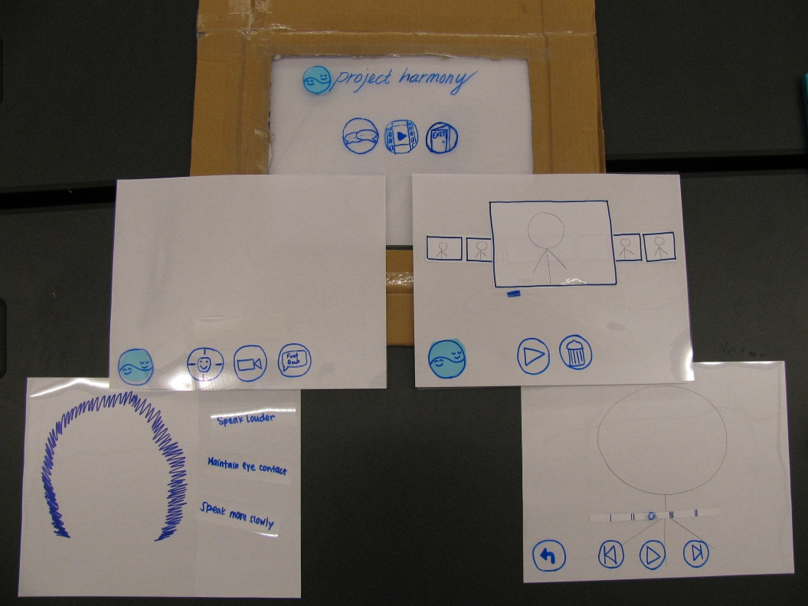

Figure 1

We used transparencies to show our views, including main screen (Figure 2), real time tasks, and video playback. Small post-it notes were attached to the transparencies (Figure 3) to signify selected icons. Cardboard is used as a frame of transparencies and creating virtual views through the glasses. [IMG3-1-2]

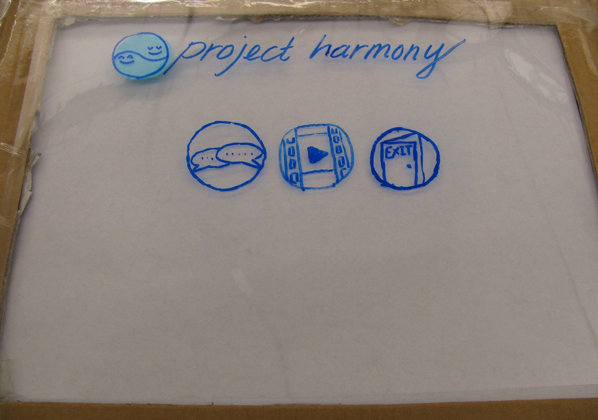

Figure 2

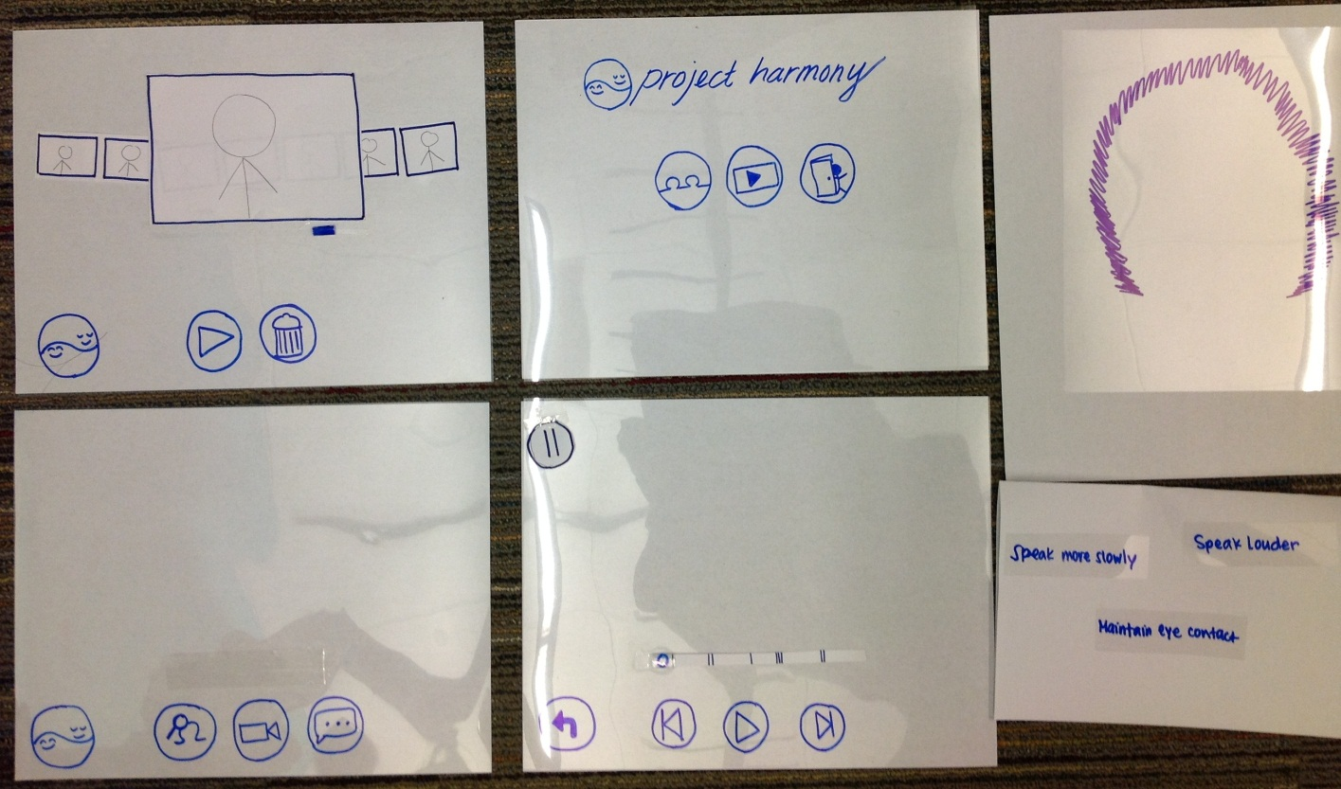

Figure 3

We also had a pair of glasses frames to simulate a user wearing the hardware. We needed to see how intuitive human gesture would be and how complicated memorizing commands were. Finally, we used an iPad to show a video that we pre-recorded for our video playback task.

[Functionality] The prototype application has two modes accessible from the home screen: conversation mode and video playback. In conversation mode, a test subject can toggle the friendly person indicator as well as real time social performance feedback. The friendly person indicator highlights friendly people with an on-screen visual cue. The social feedback comes up as short pieces of advice to the wearer to improve their behavior in the middle of a conversation. These two features are meant for use in real time social interactions.

In video playback mode, a test subject can review previous recordings of social interactions with annotated feedback about their performance. They have the ability to select the recording they want to view, and actually view it right on the device. This feature is meant for use as a reflection and self-improvement tool while alone.

[Main Interaction Ideas] As an augmented reality application, our views are designed to overlay the user’s field of vision. The overlay allows information to be displayed to the wearer in the middle of social interactions, but we also do not want to impair the wearer’s ability to continue with their social interaction.

Since we envisioned the application being used in public and in the middle of social encounters, we put a high priority on supporting discreet control gestures to navigate the application so that use of it won’t catch the attention of other people. Therefore, instead of voice controls, we designed a control scheme using a touchpad mounted on the wearable device. Swiping along the length of the touchpad (backward and forward) will cycle through the onscreen icons. Tapping the touchpad will select the currently highlighted icon. We also make use of swiping up and down on the touchpad to select different option groups on certain screens (Figure 4).

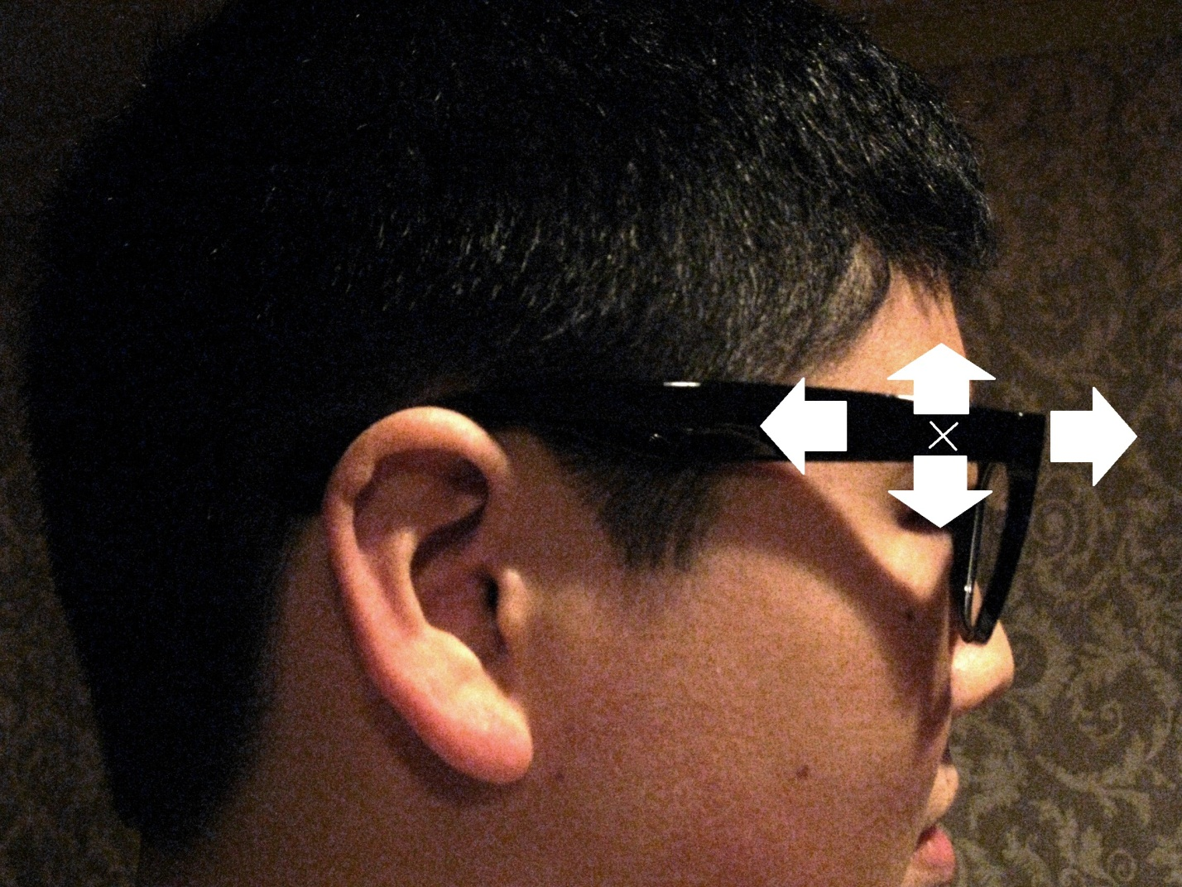

Figure 4

[Operation] The user operates our prototype by interacting with the glasses (Figure 4) that we provided. Our ‘computer’ holds the cardboard display in front of the user to emulate an augmented reality view. By interacting with the glasses, the user can signal our ‘computer’ to give appropriate visual feedback on the screen of our device. As the user scrolls from side to side, the different icons on the ‘screen’ are highlighted. By tapping on the glasses, the user can either toggle icons or move from screen to screen. By a pair of glasses as our low fidelity wearable device, we can get feedback on how to input information for our final product.

**Method**

[Participants] We wanted to select participants with different levels of comfort with social interaction. To be relatively sure of each participant’s background, we asked acquaintances whom we could make a reasoned judgment about. We found three participants that fit our target customers based on our contextual inquiries. Participant 001 (herein referred to as 001) finds socializing difficult and uncomfortable and has been diagnosed with a mild case of Asperger’s syndrome. Participant 002 (herein referred to as 002) is relatively socially competent with a close circle of friends, but sometimes has difficulty socializing with people who are not within his comfort zone. Participant 003 (herein referred to as 003) maintains healthy friendships, but does not make new acquaintances often; social situations with strangers make him nervous. For more information about each participant, refer to Appendix E, which displays more information about our participants that we gathered through our questionnaire.

[Environment] For our user testing sessions, we chose a room in the basement of the CSE building. This allowed us to make sure there were no interruptions; we wanted our scripted social interactions to be constant through all of our sessions. Our actors sat at a table, while our equipment was laid out on another. For each task, we had our subject start standing at some distance from the first table, allowing them to approach the actors sitting there as the first two tasks dictated. We purposefully oriented each subject-actor interaction such that our note taker could optimally observe the details of the interaction.

[Tasks]

*Task 1: “Find the friendliest person in the room and start a conversation with him/her.”*

Since this was the first time each of our subjects had used our interface, we wanted to see if our icons were intuitive enough for participants to navigate the application and activate its features. Additionally, we wanted to introduce them to the experience of having the screen overlay fill with information.

*Task 2:“Have a conversation with this person (main actor). Get real time feedback about your performance and record the interaction. Try to respond to the feedback.”*

We wanted to test if our display of real time feedback would be too distracting during an actual conversation. We also wanted to see if the user is able to employ that feedback in a conversation without having to consciously make an effort. We hypothesized that if we made our snippet of feedback short enough and direct enough that people would be able to quickly process it during a conversation and act on it.

*Task 3: “Review a previous social interaction and see what you can learn from it.”*

This was a test of whether our feedback with a video provided enough contexts for a subject to realistically learn from their previous socializing ‘mistakes.’ We also wanted to know how well our video playback system fit into the screen layout of the app.

[Procedure] Before user testing sessions, we created our props, wrote a script, and printed out the forms we would need. We also delegated roles; David was our facilitator and computer, Eve was our main actress, and Jennifer was the note taker.

Each participant was scheduled for a thirty minute testing session. Upon arrival, David introduced our application (Appendix B) and asked the participant to fill out a survey (Appendix D) and consent form (Appendix A). He then demonstrated how to use the application by moving his fingers across the glasses frames and reading from the script. Before the tasks began, David asked each of the participants to be verbal with their thoughts.

For each task, the participant said what was on their mind or how they chose to choose which icon to select. As they worked through tasks, Jennifer took note of the time it took for each of the tasks and the number of errors that was made. Upon completing each task, the participants were also given a chance to give immediate feedback about the specific task. After completing all three tasks, the participants were then asked a number of set questions (Appendix C). These questions were derived mostly from Nielsen’s heuristics. We also asked for suggestions and any general comments about our product and interface.

After the usability tests, our team looked back at the notes and determined critical events (Appendix J), as well as anything that didn’t go smoothly during the user test based on our preparation or scripts. We made appropriate changes between tests to make the experience run more smoothly for the next participants. After finishing all of the interviews, we gathered the information we gathered during the sessions to take the next steps in improving our application.

[Test Measures] During each of the user test sessions, we recorded several observations. Before having the participant go through each of the tasks, we asked the participants to fill out a questionnaire that includes some demographic information as well as some self-perceptions about their social interactions (Appendix D). For each of these tasks, we measured the time it took for each of the participants to finish each of the tasks as well as the number of errors they made. We also recorded every action the participants made and every verbal or nonverbal queue each participant gave (Appendix I). At the end of the entire process, we asked the participant a set of questions, some derived from Nielsen's heuristic evaluation concepts (Appendix C).

**Results**

[Summary of Results]

*User 001: Finds socializing difficult and uncomfortable*

The very first thing 001 did was exit out of the application [error]. Overall, she made many errors in the first two tasks. In the first task, she said that the aura around "friendliest" person was not very intuitive. Even though this participant went to the wrong screen in the first task, she also made the same errors in the second task by going to the playback screens [error] all the way to playing the video [error]. However, she did not make any errors with the third task. She later told us that the icons were not intuitive and remembering the buttons’ meanings was difficult. She was also worried about the social ramifications of using glasses to utilize this product.

*User 002: Finds socializing easy*

002 had the hardest time with the second task. He needed a lot of guidance and had a number of questions. He tried to ‘redo’ this task several times; each time he went back to the main menu and tried to navigate again. He didn't find it very easy to finish the second task. For example, he assumed that the real time feedback would automatically begin in the real time mode.

*User 003: Nervous when socializing with strangers*

This user had no trouble completing any of the tasks. 003 was able to navigate quickly and efficiently. He did not make any errors and never hesitated when deciding how to navigate through the application.

**Discussion**

[Lessons] We received a lot of constructive feedback about our interface, mostly about our icons. 001 and 002 noted that some of them, such as the logo (‘back’ icon), did not have intuitive functionality. One of our participants mentioned that standardized icons would be easier to use. Another participant suggested using text captions over the icons. We will be changing our icons to be more self-explanatory and are considering incorporating the text captions in our interface.

We were originally worried about information overload; we weren’t sure how to balance the amount of information to show (Appendix K). 001 felt that reading real time feedback, consciously changing her actions, and holding a conversation was extremely difficult. However, 002 and 003 felt that it was very easy to keep track of everything that was happening. We will need to conduct additional user testing sessions to learn more about our users multi-tasking.

Since our application employs augmented reality, one of our largest concerns was if the interface was obtrusive. 003 suggested that if the icons disappeared when inactive, they would not obstruct the view of the user. 002 mentioned that we should choose colors that can ‘blend in’ with the interactions. However, all three participants agreed that the interface was not obtrusive and liked the choice to group the icons together at the bottom of the screen. With this in mind, we are now considering auto-hiding icons as well as taking another look at the icons’ colors.

[Limitations] There are some aspects of using our application that our user testing sessions could not reveal. First, our user testing sessions were scripted. Because of this, we are not able to find out how the participants would use the application in the wild. We aren't able to find how fast a user will be able to use the application and how fluid it would be in a user's everyday life. We are also not able to find how fast a user is able to take the real time feedback and utilize it in real time.

Appendix A: Consent Form

Usability Test Consent Form

The Project Harmony application is being produced as part of the coursework for Computer Science course CSE 440 at the University of Washington.  Participants in experimental evaluation of the application provide data that is used to evaluate and modify the interface of Project Harmony.  Data will be collected by interview, observation and questionnaire.  
  
Participation in this experiment is voluntary.  Participants may withdraw themselves and their data at any time without fear of consequences.  Any concerns about the experiment may be discussed with the researchers (Jennifer Apacible, David Mailhot, Eric Oltean, and Eve Zhao) or with Professor James Landay, the instructor of CSE 440:

James A. Landay

CSE Department

University of Washington

206-685-9139

landay at cs.washington.edu

Participant anonymity will be provided by the separate storage of names from data.  Data will only be identified by participant number.  No identifying information about the participants will be available to anyone except the researchers and their supervisors.  
  
I hereby acknowledge that I have been given an opportunity to ask questions about the nature of the experiment and my participation in it.  I give my consent to have data collected on my behavior and opinions in relation to the Project Harmony experiment.  I understand I may withdraw my permission at any time  
  
  
Name ______________________________________________  
  
Date _______________________________________________  
  
Signature____________________________________________  
  
Witness name ________________________________________  
  
Witness signature_____________________________________

Appendix B: Script

Thank you for participating in this user testing session. Please remember that this is completely voluntary and you can quit at any time. Project Harmony, our application, is designed to be deployed on a wearable computing device, such as Google’s Project Glass. Its purpose is to help people improve their social performance.  
  
In this session, we are testing are user interface. All errors or mistakes are the fault of our UI, not you.  
  
Do you have any questions? [Wait for answer]  
  
Would you like to continue with your participation? [Wait for answer]  
  
Please sign this consent form indicating that you understand everything we have told you so far. [*Wait for participant to sign consent form*]  
  
Before we begin, we have a short survey for you to fill out. [*Wait for participant to finish survey*]  
  
During this process, please give us feedback. Talk out loud what you are thinking or what you think will happen. Please let us know if something unexpected happens or if you really like something.  
  
Please put on this pair of glasses. [*If participant already wears glasses, then omit*] To interact with our interface, you can swipe the front right temple area of your glasses forward [*demonstrate*], backwards [*demonstrate*], upwards [*demonstrate*], or downwards [*demonstrate*]. You can also tap the front right temple area of your glasses [*demonstrate*].  
  
I will now give you a brief demonstration of how to use Project Harmony. [*Swipe to highlight real time mode, tap to select it, swipe to highlight recording mode*]  
  
We will give you three tasks to perform. Don’t hesitate to ask us any questions or give us comments or suggestions during the process.  
  
[*Hands Card 1: “Find the friendliest person in the room and start a conversation with him/her.”*]  
  
[*Hands Card 2: “Have a conversation with this person (main actor). Get real time feedback about your performance and record the interaction. Try to respond to the feedback.”*]  
  
[*Hands Card 3: “Review a previous social interaction and see what you can learn from it.”*]  
  
Now that we have finished all of our tests, please answer the following questions. [Appendix C]

Appendix C: Post User-Testing Questionnaire

Post-User Testing Questionnaire

Heuristic Evaluation Questions (Nielsen):

* Did you ever feel lost as to what was going on? (Visibility of system status)
* Do you feel like this product will naturally flow in your daily life? (Match between system and real world)
* Did you feel it was easy to recover from your mistakes? (User control and freedom)
* Did any part of the UI stick out like a sore thumb? (Consistency and standards)

Experience:

* Was there something that happened that you were not expecting?
* Did anything feel intrusive to your view?

General:

* Favorite/Least favorite aspect:
* Suggestions? General comments?

Appendix D: Initial Participant Questionnaire

Project Harmony User Testing Questionnaire

**Participant ID:** [*Filled in by Project Harmony team*]  
  
**Gender:** Male _____ Female _____   
**Age:** _____  
**Occupation:** _________________________   
  
  
On a scale from 1 (least) to 10 (most), how happy are you with your current level of social skill? _______  
  
  
On a scale from 1 (not often) to 10 (often), how concerned are you about being courteous towards others and following social rules? _______  
  
  
On average, how often do you feel like you could have done something better during a social interaction?  
____ Daily  
____ Weekly  
____ Monthly  
____ Yearly  
____ Never  
  
  
On average, how often do you approach a stranger for any reason?  
____ Daily  
____ Weekly  
____ Monthly  
____ Yearly  
____ Never  
  
  
On a scale from 1 (not comfortable) to 10 (comfortable), how comfortable would you be receiving feedback and advice about your social performance? _______  
  
  
On a scale from 1 (not comfortable) to 10 (comfortable), how comfortable would you be receiving feedback and advice about your social performance from a computing device? _______

Appendix E: Initial Participant Questionnaire Results

|  |  |  |  |
| --- | --- | --- | --- |
| Participant ID | 001 | 002 | 003 |
| Gender | Female | Male | Male |
| Age | 22 | 19 | 20 |
| Occupation | Student | Student | Student |
| Happiness with social skill level (1-10) | 5 | 7 | 6 |
| Amount of concern about being courteous and following social rules (1-10) | 8 | 8 | 10 |
| Frequency - thought could have done better in social interaction | Weekly | Monthly | Weekly |
| Frequency - approach a stranger for any reason | Monthly | Weekly | Daily |
| Level of comfort receiving feedback on social performance from person (1-10) | 8 | 10 | 5 |
| Level of comfort receiving feedback on social performance from device (1-10) | 8 | 10 | 5 |

Appendix F: Performance Summary

|  |  |  |  |  |  |  |
| --- | --- | --- | --- | --- | --- | --- |
|  |  | Time |  |  | Errors |  |
| Participant ID | Task 1 | Task 2 | Task 3 | Task 1 | Task 2 | Task 3 |
| 001 | 4:40 | 4:46 | 1:40 | 3 | 3 | 0 |
| 002 | 2:45 | 12:04 | 1:58 | 1 | 4 | 0 |
| 003 | 1:57 | 2:40 | 1:00 | 0 | 0 | 0 |

Appendix G: Graph – Time per Task

Appendix H: Graph – Errors per Task

Appendix I: User Testing Sessions Observations

Appendix I.A: Participant 001

Participant 001 (herein referred to as 001)

November 8, 2012 @ 1955 PST

-------------------------------------------------  
*TASK 1: Find the friendliest person in the room and start a conversation with him/her*

*ACTIONS:*   
Start at main menu  
Scroll between buttons  
Exited app [ERROR]  
001: “I saw a person! I didn’t know [exit button] exits!!!”  
001 Facial expression: D:<, confusion  
Scroll between buttons  
Select Playback -> Goes to video playback [ERROR]  
Scroll between buttons  
Select logo -> Goes to home screen  
Scroll between buttons  
Select RT -> Go to real time screen  
Scroll between buttons  
Selects RT Feedback (toggle on) [ERROR]  
"Maintain eye contact" comes up  
001: “Hmm, I thought [RT button] would be something like ‘help’”  
David: "Is it unclear what to do?"  
001: "So I'm supposed to maintain eye contact..? Shit."  
001 Facial expression: looks uncertain  
Selects "Search for people"  
001 looks around the room  
001 looks at Jennifer  
001 looks at Eve  
Aura appears in front of Eve  
001 looks at Eric  
Aura disappears from view  
001 looks at Eve  
Aura appears in front of Eve  
001: "It looks like it’s singling her out … maybe she’s someone to talk to? I don’t know if I’m supposed to ask for help or directions though."  
001 Facial expression: confusion  
David: "Ask for help on homework"  
001: "Hi, I was wondering if you can help me on algorithms homework."  
*TEAM COMMENTS:*  
Very tentative in choosing how to navigate, questioning a lot of choices  
*TIME:* 4:40  
*THOUGHTS:*  
001: I wasn't sure what all the icons were  
001: Figuring out what to do is an issue the first time you use the app  
001: After the first time you use it it's easier to figure out what to do  
001: I selected the logo to 'go back' because it was the only thing left so obviously it would be the back button.  
001: The highlights look kinda like some sort of... halo. Looks like it's supposed to single someone out  
David: Was there enough context to know that this was the friendliest person?  
001: Yes only because it's the only thing to single someone out and I was supposed to find a friendly person so ... I figured that was what it was about.  
-------------------------------------------------  
*TASK 2: Have a conversation with this person (main actor). Get real time feedback about your performance and record the interaction. Try to respond to the feedback.*  
*ACTIONS:*  
Start at main menu  
Scroll between buttons  
Select playback -> Move to playback screen [ERROR]  
Scroll between buttons  
Select logo -> move back to main menu  
Select playback -> move to playback screen [ERROR]  
Scroll between buttons  
Select "Play video" [ERROR]  
001: “Oh no, this does not look like the situation I’m trying to figure out..”  
001 Facial expression: shock, confusion, frustration  
Select back arrow -> playback screen  
Select logo -> move back to main menu  
001: “I can’t remember what these buttons were... what are these icons again?"  
001 Facial expression: thinking really hard, trying to figure out which icon is right  
Scroll between buttons  
Select RT -> Real time screen  
Scroll between buttons  
Select "Video recording on" (toggle on)  
Select "Feedback" (toggle on)  
001 approaches Eve  
001: “Have you registered for classes?”  
Eve: "Uh.."  
001: “Did you take any computer science classes last quarter?”  
Feedback pops up: Speak more slowly  
"Oh ... what ... do you take?"  
Feedback disappears  
001: “Oh no, what just happened.. Did I do something?”  
More talking, 001 slowly trails off  
Feedback pops up: Speak more slowly  
Normal conversation ensues  
*TEAM COMMENTS:*  
Still pretty tentative, even with almost 5 minutes in the first task. Didn’t really know how to navigate directly to real time feedback right away.  
*TIME:* 4:46  
*THOUGHTS:*  
001: I thought too much about the specific topic (registration) so it was very unnatural.  
David: Text feedback or audio feedback?  
001: Audio would be very distracting because I’m trying to listen to the person and feedback at the same time. Text is not as distracting.  
-------------------------------------------------  
*TASK 3: Review a previous social interaction and see what you can learn from it.*

*ACTIONS:*Start at main menu  
Scroll between buttons  
Click on Playback -> move to Playback screen  
Scroll between buttons  
Click Play  
Go to video replay screen  
Click Play  
Watch video  
*TEAM COMMENTS:*  
Very fluid movements; 001 knew exactly what to do to get to the video and playback  
*TIME:* 1:40  
*THOUGHTS:*  
David: Did you learn anything from your previous interaction?  
001: I look like Atanas! Oh wait, that’s not me... I don’t know if that was me or if it was someone else. I thought it was a recording of myself!  
David: How does this recording work?  
001: I’m talking to Atanas, but then I’m looking down at the phone/my hands … ohh, I was doing that before.  
David: Do you have any thoughts about that?  
001: The video playback makes sense …. no other comment.  
David: How do you think you would choose another video?  
002: I think I have to move that bar but I have no idea how to do that.  
David: If I told you you could scroll up and down, would you try to scroll up?  
001: Ohh okay. It’s not obvious unless I knew I could scroll up and down.  
-------------------------------------------------  
*Post-User Testing Questionnaire*  
*Did you ever feel lost as to what was going on?*

* The entire process was kind of confusing.
* Figuring out what the buttons mean and remembering them
* 3rd task was very intuitive, so it took a lot less time
* Buttons related to the 3rd task [video playback] were very standardized

*Do you feel like this product will naturally flow in your daily life?*

* I would worry about social ramifications - fiddling with glasses while talking to someone
* Not sure how subtle it [fiddling with glasses] would be
* How would I focus on just one conversation if multiple are happening are happening at the same time?
* How do I multitask - reading text, following instructions, changing my own actions, and keeping track of what the other person(s) are saying?

*Did you feel it was easy to recover from your mistakes?*

* I spent a lot of time trying to remember which button to press because I knew I had pressed some “wrong” button before
* It requires me to think a lot because i need to remember what everything is

*Did any part of the UI stick out in a positive or negative way?*

* Speech bubble button in real time mode - vague meaning
* Seemed like it would have to do with having a conversation or playing something
* Exiting the application was unexpected when I pressed that one button
* Magnifying glass = help button/search?

*Was there something that happened that you were not expecting?*

* I wasn't expecting the video playback since I hadn't had any interactions yet

*Did anything feel intrusive to your view?*

* It felt hard to focus on both interactions and UI.

*Favorite things:*

* I loved the video playback

*Suggestions? General comments?*

* Exit button is so confusing
* What are standard exit buttons?
* Looks like someone is going into something instead of exiting
* Power button (circle with line) would have been more clear that it was “exit”
* Sniper thing with person
* Viewfinder?

Appendix I.B: Participant 002

Participant 002 (herein referred to as 002)

November 9, 2012 @ 1610 PST

-------------------------------------------------  
*TASK 1: Find the friendliest person in the room and start a conversation with him/her.*  
*ACTIONS:*  
Start at main menu  
Scroll between buttons  
Select RT -> Go to real time screen  
Scroll between buttons  
Select logo -> Go to main menu [ERROR]  
002: “Ohh, so that’s the back button … that’s such a terrible back button...”  
002: “Why can’t you just call this a ‘home’ button? Is that copyrighted?”  
Scroll between buttons  
Select RT -> Go to real time screen  
Scroll between buttons  
Selects "Search for people"  
002: “So if I swipe forward... does it start on the right side? Does the circle I’m selecting start on the left side if I originally swipe backwards?”  
David: “Yes”  
002 looks around the room (Low-Fi frame following view)  
002 looks at Eric, the friendly person  
Aura appears in front of Eric  
002 walks up to Eric (Low-Fi frame following)  
*TIME:* 2:45  
*THOUGHTS:*002: Redesign the back button  
002: If the person is off screen, is there a gradient on the side that will tell you to go in a certain direction? Think FPS indicators of friend locations or shooters.  
David: Would you want these indicators?  
002: You could rate people in terms of friendliness … red to green or something.  
David: Would you want to know who is annoyed, angry, or frustrated?  
002: You could put a thunder cloud on top of their head.  
David: And that cloud would be helpful?  
002: Well, if it gets in my way, no … but it would be useful for me to know whom to avoid! I want to avoid bad encounters, like angry drunks.  
-------------------------------------------------  
*TASK 2: Have a conversation with this person (main actor). Get real time feedback about your performance and record the interaction. Try to respond to the feedback.*  
*ACTIONS:*  
Start at menu screen  
Scroll between buttons  
Select playback -> Go to playback screen [ERROR]  
Scroll between buttons  
Click play -> Show video [ERROR]  
Scroll between buttons  
Click play -> Video begins to play [ERROR]  
002: “Okay … this is obviously what I’m not supposed to do.”  
Scroll between buttons  
Select logo -> Go to video selection screen  
002: “This stuff [videos] are in the way! I can’t see anyone I’m trying to talk to if I keep looking at this screen.”  
002: “Oh, this is the video playback? It’s not clear at all that those were videos...”  
002 Facial expression: Confused, eyebrows raised  
002: “On the playback screen, there should be a ‘create new video’ option”  
David: “This isn’t necessarily where you begin to record a new video”  
002: “You should add a ‘recording’ section”  
David: “These two screens are for video playback … let’s start over.”  
002: “You need to make it super clear that this middle button on the main menu is for the user to see previous videos.”  
*TIME:* 6:54  
Begin at main menu  
Scroll between buttons  
002: “You should use gray text to not interfere with my vision. The icons also need more context.”  
Scroll between buttons  
Select “recording”  
002 starts talking, holds conversation for a minute [ERROR]  
David: “You haven’t activated the feedback mode”  
002: “You said record the interaction... oh, they’re two separate things? Would you always have record interaction and feedback at the same time?  
002 Facial expression: Really, really, really confused  
002: “Instead of ‘feedback’ on the button, maybe something like ‘social feedback’ will be better. I didn’t know that button was for real time feedback.”  
*TIME:*3:50  
Start at main menu  
Scroll between buttons  
Select RT -> Go to real time screen  
Select ‘record’  
Select ‘RT feedback’  
002 starts talking to Eve  
Notification: “Speak more slowly”  
002 starts speaking more slowly  
Notification disappears.  
Notification: “Speak louder”  
002 starts speaking more loudly  
Notification disappears.  
*TIME:* 1:20  
*THOUGHTS:*  
002: “I followed the feedback given, but it doesn’t seem to do much.”  
David: “How do you feel about having words on the screen during a conversation?”  
002: “The text seems to fade in, or scroll in or something. It would be distracting if it scrolls up and down.”  
David: “Would you have time to read this type of feedback and follow it while interacting with someone?”  
002: “Yes”  
002: “You should have the feedback scroll side to side instead of down to up. Side to side is less distracting and scrolling up will make the text go on people’s faces.”  
002: “One big thing - the UI is good about being non-intrusive.”  
-------------------------------------------------  
*TASK 3: Review a previous social interaction and see what you can learn from it.  
ACTIONS:*  
Start at main menu  
Scroll between buttons  
Select playback button -> Go to playback button  
Scroll between buttons  
Select play button -> Go to play screen  
Scroll between buttons  
Select play button -> Video begins  
002: “How do I rewind this?”  
Scroll between buttons  
Scroll up to video seek  
Scroll to beginning of video  
002: “His lips are rather distracting...”  
*TIME:* 1:58  
*THOUGHTS:*  
002: “When the video appears, the circle that appears with the text feedback … is that where the video has to show feedback?”  
002: “With the glasses design, I’m only expecting to swipe side to side, not up and down.”  
-------------------------------------------------  
*Post-User Testing Questionnaire  
Did you ever feel lost as to what was going on?*

* I assumed the middle button in the main menu was video recording.
* I’m not sure how you’re distributing between the tasks into different buttons.
* The buttons are really confusing.
* The left most button on the main menu looks like it means ‘instant messaging.’
* The button for real time feedback is not clear.

*Do you feel like this product will naturally flow in your daily life?*

* This app could be completely abused for easily taking advantage of women.

*Did you feel it was easy to recover from your mistakes?*

* Yes

*Did any part of the UI stick out in a positive or negative way?*

* The logo in the bottom left corner should be a ‘home’ button.
* The icons in the main menu are not intuitive.
* Example: Not sure which one is for real time, which is for playback
* Text captions over buttons would be super helpful
* Animations when scroll over buttons would also be helpful

*Was there something that happened that you were not expecting?*

* I have no idea what the buttons did in the beginning.

*Did anything feel intrusive to your view?*

* Currently, everything is okay.
* Don’t add anything that obstructs where the person actually will appear in the line of sight.

*Least favorite things:*

* Icons aren’t labeled
* Exit button in main menu - get rid of the door and just leave ‘exit’ there

*Suggestions? General comments?*

* Nothing not already talked about

Appendix I.C: Task observations 003

Participant 003 (herein referred to as 003)

November 9, 2012 @ 1745 PST

-------------------------------------------------   
*TASK 1: Find the friendliest person in the room and start a conversation with him/her.  
ACTIONS:*  
Start at main menu  
003: "I want to look around to see who the people are... so I’m going to select the conversation circle"  
Scroll between buttons  
Select RT -> Go to RT screen  
003: “I’m going to choose this ‘person targeting’ button now”  
Scroll between buttons  
Select ‘toggle button to show friendly people  
003 looks around room  
003 looks at Jennifer  
003 looks at Eric  
Aura appears in front of Eric  
003: “Okay, I’m going to ask that guy [Eric] for help now”  
*TEAM COMMENTS:*  
Very fast at discovering how to find the friendliest person; did not make any errors at all  
*TIME:* 1:57  
*THOUGHTS:*  
003: You should have the buttons [options] show up only when I want them to show up. Like, have them go away after a while when I don’t have to use them. Kind of like the Windows OS taskbar - auto-hiding.  
-------------------------------------------------  
*TASK 2: Have a conversation with this person (main actor). Get real time feedback about your performance and record the interaction. Try to respond to the feedback.*  
*ACTIONS:*  
Start at main menu  
Scroll between buttons  
Select RT -> Go to RT screen  
003: “The cool thing about these glasses is that it’ll make everyone look smart!”  
Select Video Recording (Toggled on)  
Select Feedback (Toggled on)  
003 walks up to Eric  
003 and Eric begins a conversation  
Feedback appears: speak more loudly  
003 speaks more loudly  
Feedback disappears  
*TIME:* 2:40  
*THOUGHTS:*  
003: I like how the feedback came from under the person’s face  
David: Was the feedback distracting?  
003: I was able to read the feedback, take note of it, continue the conversation, and it was not distracting.  
003: Back on Task 1 … oh, on the ‘person target’ icon … am I finding out information about that person? Like, social network type information? I’m not completely sure what it does.  
-------------------------------------------------  
*TASK 3: Review a previous social interaction and see what you can learn from it.*

*ACTIONS:*Start at main menu  
Scroll between buttons  
Select playback -> Go to video selection screen  
Scroll between buttons  
Select play -> Video begins playing  
003 watches  
Select pause  
*TEAM COMMENTS:*  
Again, completely errorless  
003 navigated as if he had used the product before  
*TIME:* 1:00  
*THOUGHTS:*  
David: What did you learn about yourself in the video?  
003: I learned that I kept looking at my phone and looking away from the person I was talking to. The other person was so annoyed at me.  
003: I really enjoyed the feedback coming up when I was looking at my previous interaction  
003: Does this bar here note the locations where there is feedback?  
David: Yes  
003: I really like that. And those |< and >| buttons are to skip between the feedback locations? That is great.  
-------------------------------------------------  
*Post-User Testing Questionnaire*  
*Did you ever feel lost as to what was going on?*

* The ‘target person’ is confusing … wasn’t quite sure what it meant right away
* Feedback in real time was not intrusive

*Do you feel like this product will naturally flow in your daily life?*

* Definitely very useful

*Did you feel it was easy to recover from your mistakes?*

* Didn’t make mistakes, but felt it was intuitive on how to recover

*Did any part of the UI stick out like a sore thumb?*

* Loved the logo
* Consistency of the elements were great

*Was there something that happened that you were not expecting?*

* “Glowing thing” [aura] was not expected at first and was originally confusing

*Did anything feel intrusive to your view?*

* No

*Favorite thing:*

* Video player - jumping between feedback locations

*Suggestions? General comments?*

* Looks like there’s a very solid design
* Put logos in main menu at the bottom of the view. They’re slightly obtrusive in the middle there.
  + No comment on logo position
* On views, good that the icons were at bottom of screen, not at sides.
  + Easier to look at.

Appendix J: Critical Incidents

|  |  |
| --- | --- |
| **Incident** | **Severity Rating** |
| Exit Application | 3 |
| Unsure what color halo is | 4 |
| Cannot find 'back' button | 3 |
| Cannot figure out what any buttons do | 4 |

Appendix K: Views with potentially too much information

