**Practical No.1**

**Install NS3 in Ubuntu and execute hello-simulator script.**

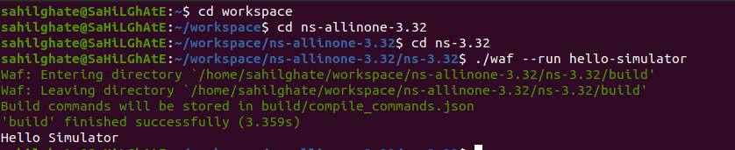

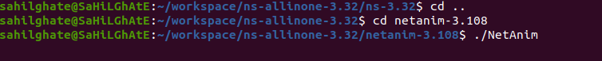

**Install Netanime tool on Ubuntu and check if its properly installed.**

