Homework 12

Daniel Vogel

11/6/2020

## R Markdown

Documents to include:

* Your Rmd file
* A Word file
* An html file, including any folders with images

summary(gapminder)

## country continent year lifeExp   
## Afghanistan: 12 Africa :624 Min. :1952 Min. :23.60   
## Albania : 12 Americas:300 1st Qu.:1966 1st Qu.:48.20   
## Algeria : 12 Asia :396 Median :1980 Median :60.71   
## Angola : 12 Europe :360 Mean :1980 Mean :59.47   
## Argentina : 12 Oceania : 24 3rd Qu.:1993 3rd Qu.:70.85   
## Australia : 12 Max. :2007 Max. :82.60   
## (Other) :1632   
## pop gdpPercap   
## Min. :6.001e+04 Min. : 241.2   
## 1st Qu.:2.794e+06 1st Qu.: 1202.1   
## Median :7.024e+06 Median : 3531.8   
## Mean :2.960e+07 Mean : 7215.3   
## 3rd Qu.:1.959e+07 3rd Qu.: 9325.5   
## Max. :1.319e+09 Max. :113523.1   
##

print('Median Life Expectancy By Continent')

## [1] "Median Life Expectancy By Continent"

gapminder %>%  
 filter(year == 2007) %>%  
 group_by(continent) %>%  
 summarise(lifeExp = median(lifeExp), .groups='drop')

## # A tibble: 5 x 2  
## continent lifeExp  
## <fct> <dbl>  
## 1 Africa 52.9  
## 2 Americas 72.9  
## 3 Asia 72.4  
## 4 Europe 78.6  
## 5 Oceania 80.7

## Plots of Gapminder Data

You can also embed plots, for example:

ggplot(gapminder, aes(x = continent, y = lifeExp)) +  
 geom_boxplot(outlier.colour = "hotpink") +  
 geom_jitter(position = position_jitter(width = 0.1, height = 0), alpha = 1/4)

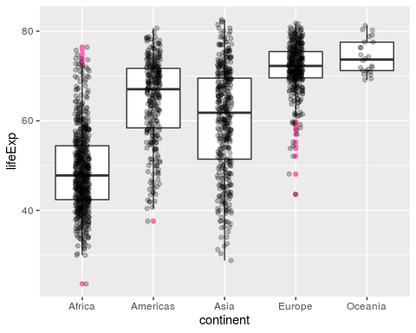

Figure 1

Same plot, different dimensions.

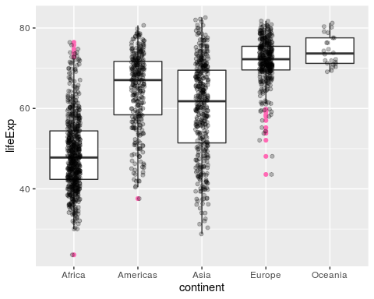

Figure 2