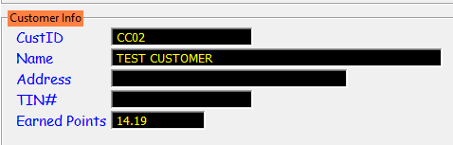

WEB LOYALTY POINTS SYSTEM



USER’S MANUAL

TABLE OF CONTENTS
WEB LOYALTY POINTSSYSTEM 3
I. INTRODUCTION TO WEB Loyalty Points System 4
1. Web Loyalty Points System 4
A. WEB MENU 6
A.1 Customer Maintenance 6
A.1.1. Manage Customers 7
A.1.1.1 Add Customers 8
A.1.2. Manage Group 8
A.2 Promo 9
A.2.1 Redeems 10
A.2.1.1 Add Points Redemption 11
A.2.2. Adjust 12
A.2.2.1 Add Points Adjustment 13
A.2.3. Customer Points Ledger 14
A.3 Sign Out 15
B. Promo Maintenance 16
B.1 Rules 17
B.2 Sponsor 18
B.3 Points Promo 20

C. Earning and Redemption of Points in POS 23
C.1 Earning of Points 24
C.2 Redemption of Points 25

This page is intentionally left blank.

WEB LOYALTY POINTS SYSTEM

I. INTRODUCTION to Web Loyalty Points System

Web Loyalty Points System is a setup where sales in POS system will earn an accumulated points for specific customers. This manual will guide the user on how to configure all things necessary for the Points system to work.

1. Web Loyalty Points System

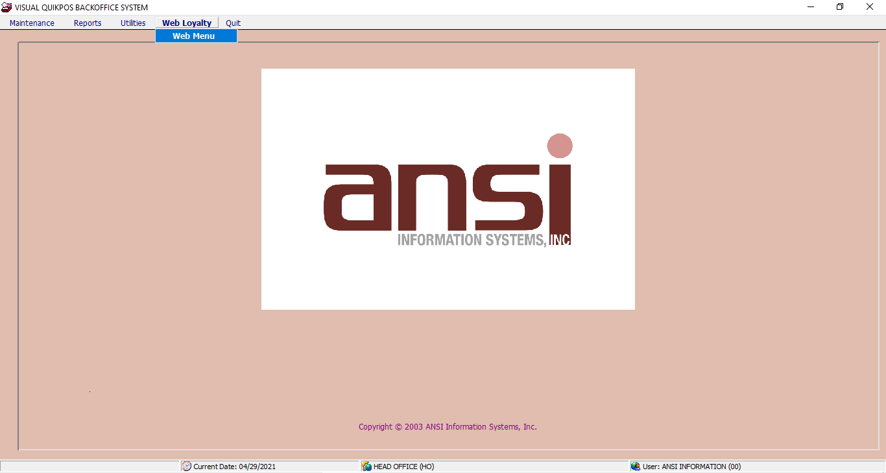Run Web Loyalty Points System from HO backend. Go to Web Loyalty > Web Menu.

Web browser will automatically be launched and will ask for user’s credentials as initial display.
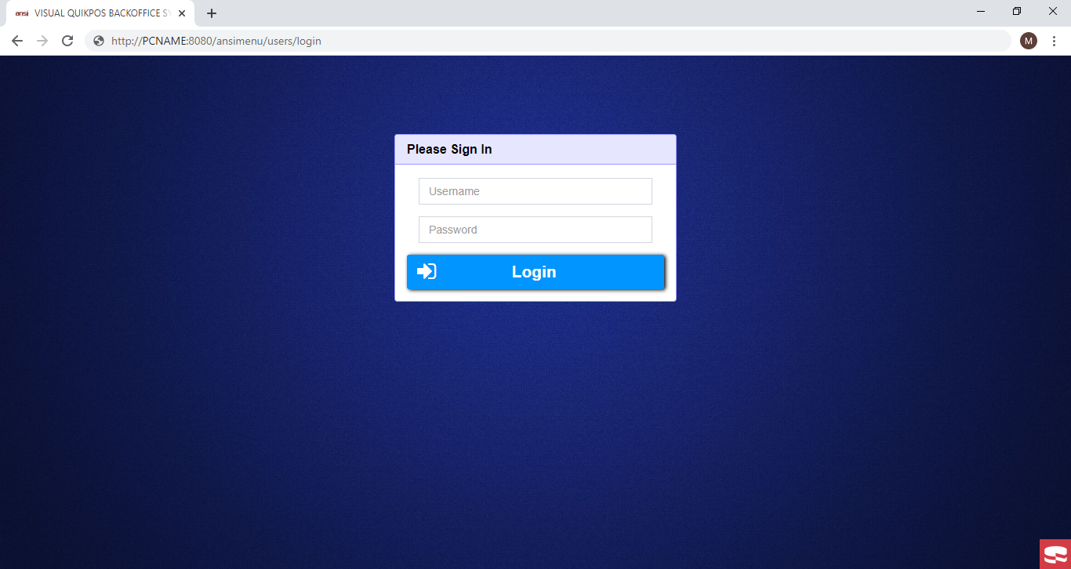

Log in using user and password of HO backend users. If the Username or Password is invalid, an error message pops up. Only the users with privilege 5 can access the modules in the Web Menu.

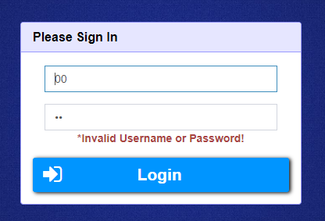

 The user can use the Delete/Backspace key to erase the entered User ID and Password if it is invalid.

A. WEB MENU

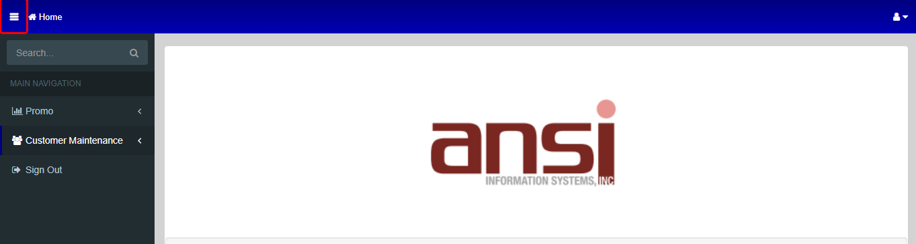There are two (2) main menu to select in the web menu. These menus are located at the upper left corner of the Menu Screen. Click the 3-bar icon in the upper left corner to view available menu, and under these menus, different modules can be opened. These modules show different operations to be performed.

A.1. Customer Maintenance

Under the Customer Maintenance menu are the Manage Customer and Manage Group.
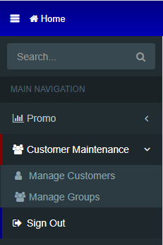

A.1.1 Manage Customers

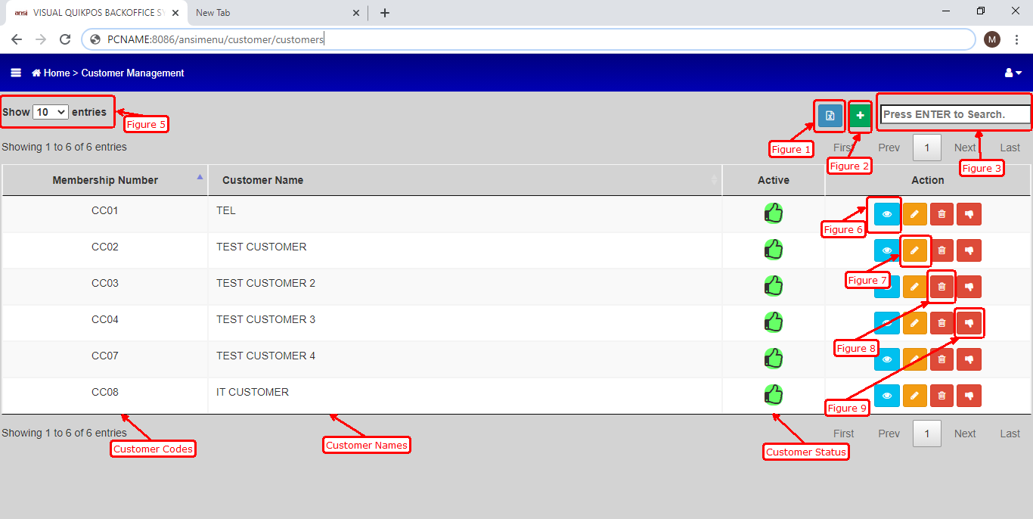 This module is used to show/add/update loyalty customers to be used in POS for earning and redemption of points. Customer Code in HO should be unique per customer and should not found in SAP Customers (Business Partner Master Data).

Figure 1. This icon is used as an option to add customers via excel file. Customer File template is imported for multiple customers to be added all at once.
Figure 2. Add icon is used to add specific customer only and set details manually. (See Add Customers for more details)
Figure 3. Search bar is used to locate specific customer for viewing or editing. User can key in either customer code or customer name.
Figure 5. Show entries drop down is for the number of customers to display in the default display.
Figure 6. View icon is used to show details of a specific customer
Figure 7. Edit icon is used to update details of a specific customer
Figure 8. Delete icon is used to delete or removed a specific customer details permanently in the customer master list.
Figure 9. Status icon is used to deactivate customer if the status is active and to activate customer if the status is inactive.

A.1.1.1 Add Customers

To add new customers, click the plus (+) icon in the upper right corner of the customer maintenance default display.

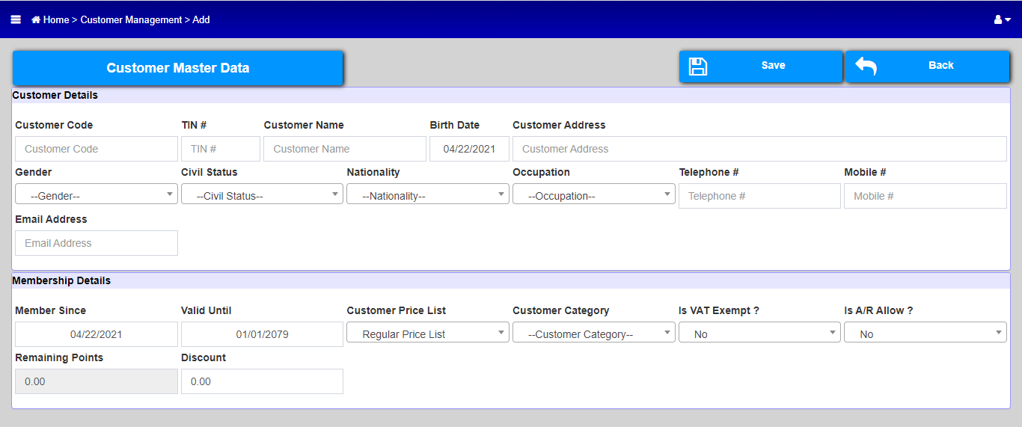

Key in customer details. See below fields that are mandatory when adding a customer.

- Customer Code
- Customer Name
- Customer Address
- Mobile #
- Email Address
- Customer Category (Customer Group)

A.1.2 Manage Group

This module is used to add customer groups for promo condition purposes and group customers to any purpose it may serve.
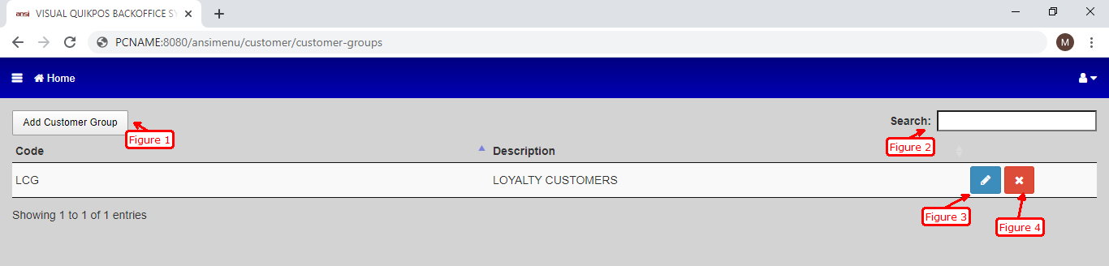

Figure 1. To add customer group.

Figure 2. To search specific Customer Group.

Figure 3. To update or edit the customer group.

Figure 4. To delete a specific customer Group.

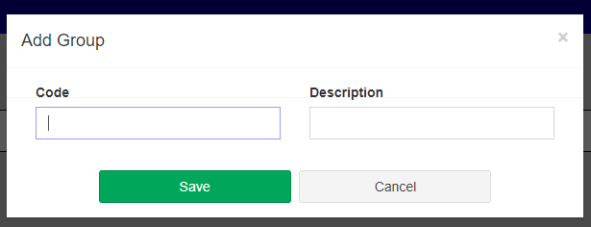After clicking the icon, user should provide customer group code and customer group description.

A.2 PROMO

Another Maintenance in Web Menu is the Promo. Under the menu are the Redeems, Adjust and Customer Points Ledger modules.

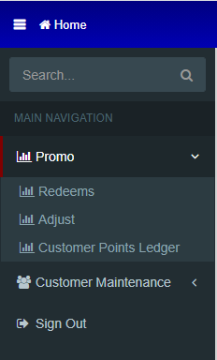

A.2.1 Redeems

This module allows the user to deduct points manually from a specific customer.

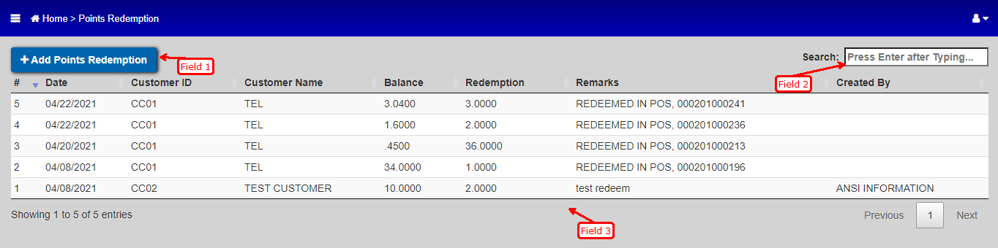

Field 1. This field is used to add redemption transaction.
Field 2. Used for searching of redemption transactions for specific customer. User can key in customer code or customer name.
Field 3. Shows the details of previous redemption transactions

A.2.1.1 Add Points Redemption

To add redemption transaction, click Add Points Redemption in the upper left corner of the Redeems default display.

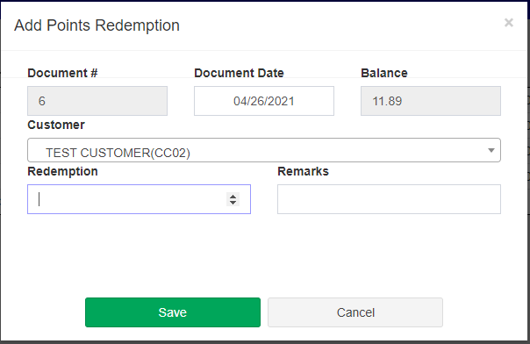

Document #: Indicates document number and field is not editable and is incremental

Document Date: Date where the redemption will be posted

Balance: Indicates the current points of the customer chosen

Customer: User will choose the customer where the redemption will take effect

Redemption: Where the user will key in the point/s to be redeemed. Negative value is not allowed

Remarks: User can input comments in this field with regards to the redemption

Save: To add the redemption transaction. The transaction will take effect promptly once the redemption is added successfully

Cancel: To cancel the redemption to be added. No changes in points of the customer

A.2.2 Adjust

This module allows the user to add/deduct points manually from a specific customer.

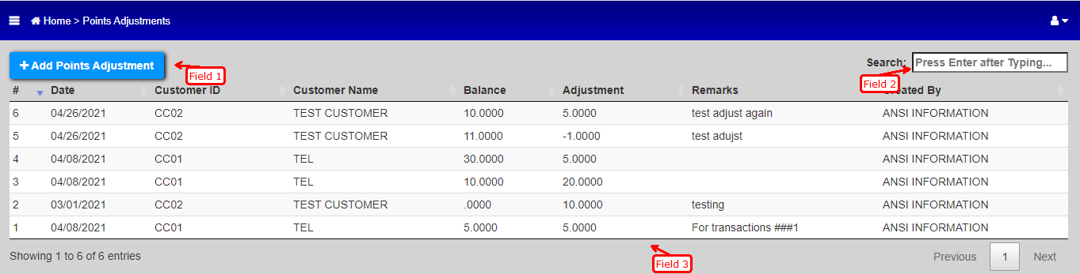

Field 1. This field is used to add adjustment of points transaction.
Field 2. Used for searching of adjust transactions for specific customer. User can key in customer code or customer name.
Field 3. Shows the details of previous adjust transactions

A.2.2.1 Add Points Adjustment

To add points adjustment transaction, click Add Points Adjustment in the upper left corner of the Adjust default display.

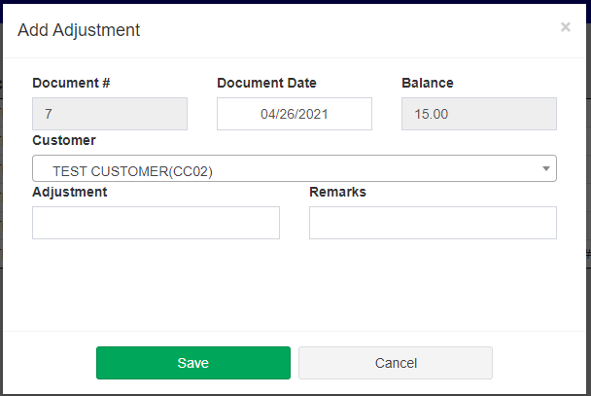

Document #: Indicates document number and field is not editable and is incremental

Document Date: Date where the adjustment will be posted

Balance: Indicates the current points of the customer chosen

Customer: User will choose the customer where the adjustment will take effect

Adjustment: Where the user will key in the point/s to be adjusted. Positive value will be added to the current points of the customer and negative value will be deducted

Remarks: User can input comments in this field with regards to the adjustment

Save: To add the adjustment transaction. The transaction will take effect promptly once the adjustment is added successfully

Cancel: To cancel the adjustment to be added. No changes in points of the customer

A.2.3 Customer Points Ledger

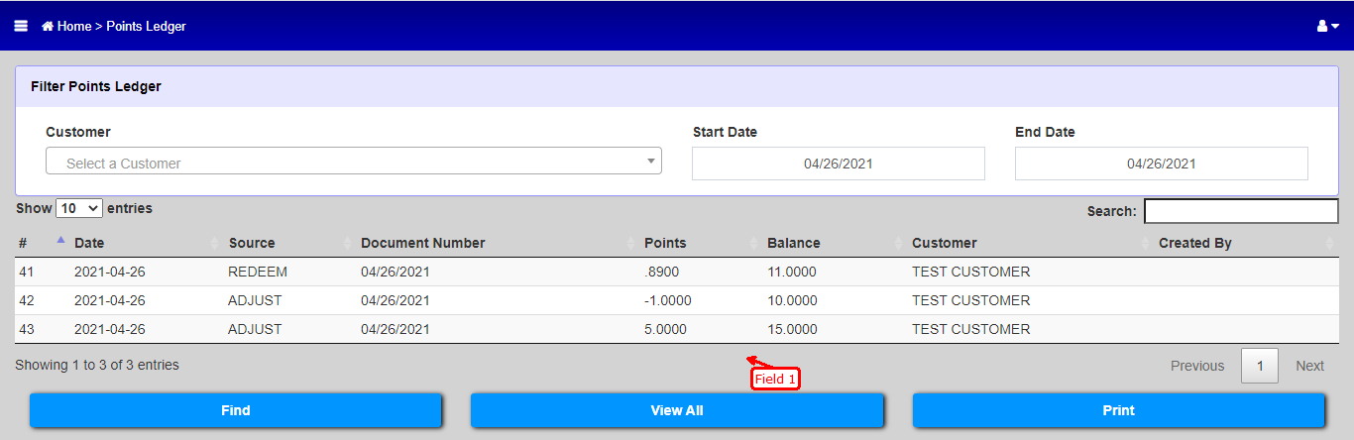This module shows all transactions that took place with regards to the points of a customer (earn, redeem, and adjust).

Initial display of Customer Points Ledger

Customer: Specify customer to display its point transaction history. Default is none.

Start Date: Will show all transactions from this starting date.

End Date: Will show all transactions until this end date.

Show entries: Show entries drop down is for the number of transactions to display in the default display.

Search: Additional condition on displaying transactions. Can be Source or Document Number.

Field 3: Shows the details of point transactions took place based on customer, start date and end date. Default is system date

Find: Displays transactions that will be based on the parameters set

View All: Displays all transactions took place for all customers on the range of date set in the parameter.

Print: Print transaction details in the default display

A.3 Sign Out

This is the exit function of the Web Menu. Once clicked, the Web Loyalty Points system will be logged out.
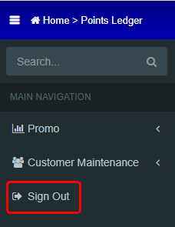

Another way of signing out is clicking the person icon located in the upper right corner of the Web Menu and click sign out. This icon also indicates the user that is currently logged on the Web system.

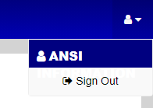

B. Promo Maintenance for Points

Creation of Points promo takes place in Promo Maintenance resides in HO Backend Module. Go to HO Backend module and log on and Run the promo maintenance.
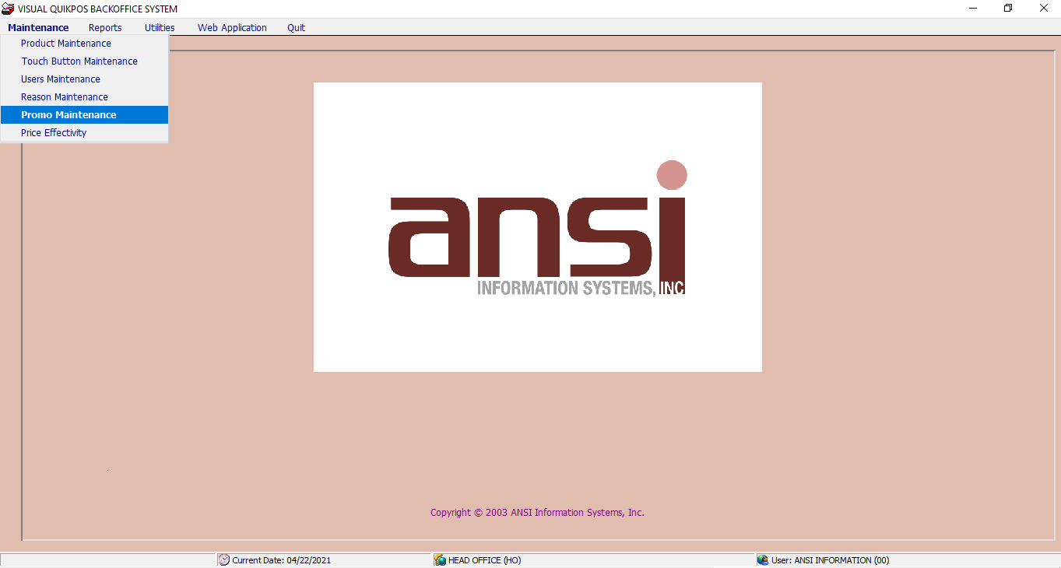

In adding new Points promo, the user needs to define first the rules then the sponsors.

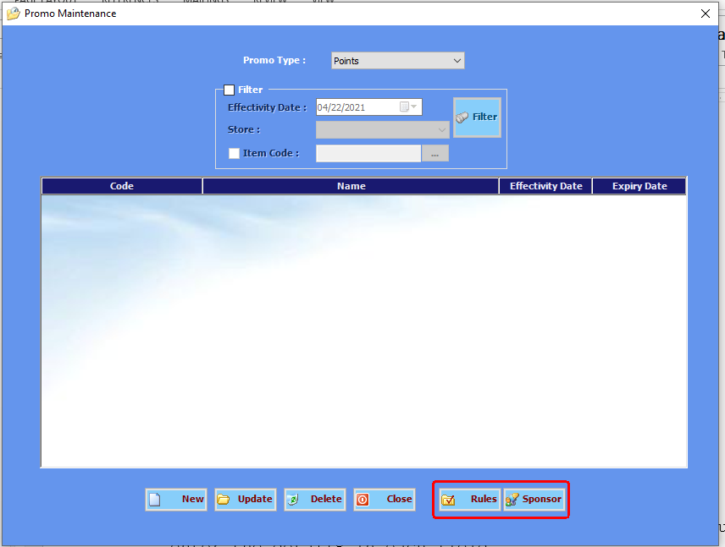

B.1 Rules

In the Rules Promo Maintenance window, click the New button and enter the Code of the rule. The user must also enter the details in each field.

- Minimum Required Quantity - requires the minimum quantity of items to be bought by the customer before earning points. If there’s a check mark on the Each Product field, it means that the customer needs to buy the number of quantity indicated in the Minimum Required Quantity field for each product before he/she earn points.

- Minimum Required Amount field - indicates the minimum amount the customer needs to buy to earn points.

- Minimum Required Sponsor - indicates the number of sponsors the customer must purchase to earn points.

- Mechanics field - the user needs to select which mechanics to be used. It can be a Fixed Number, Quantity, Amount or No Mechanics.

  - Fixed Number - the ruling must satisfy the amount defined in Minimum Required Quantity, Minimum Required Amount and Minimum Required Sponsor.

  - Quantity - the system will only check the amount entered in the Minimum Required Quantity.

  - Amount - the system will only check the amount entered in the Minimum Required Amount.

  - No Mechanics - the system will not apply any mechanics for the Points promo. It means whenever a customer buys an item, he/she will get points depending on the number of points defined in the rules.

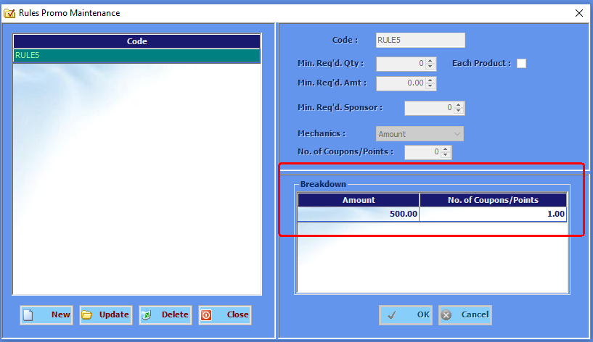

- Breakdown field - the user defines the Quantity or Amount the customer must avail to earn the points or coupons defined in the No. of Coupons/Points column.

The Rules defined are displayed in the left part of the Rules Promo Maintenance window under the Code column.

B.2 Sponsor

To create a sponsor, click the Sponsor button and this opens the Sponsors Promo Maintenance window.

The user needs to enter the Sponsor Code and define the Products or Product Categories to be included as the sponsor.
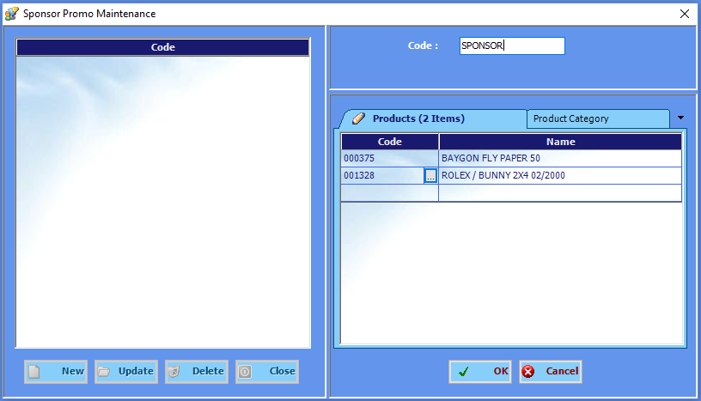

To search for products or product categories, click the browse button . Enter the product/product category code and click Find. The system displays the list of products/product categories. Put a check on each product/product categories to be set as sponsor and click OK.

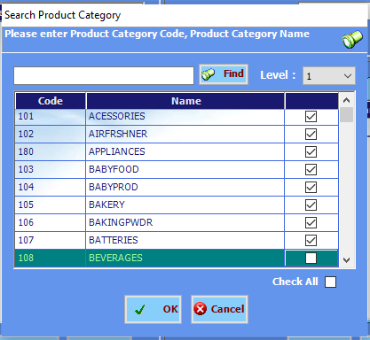

After defining the Rules and Sponsors, the user may create Points Promo. Select the Points under the Promo Type field and click the New button in the Promo Maintenance window.

B.3 Points Promo

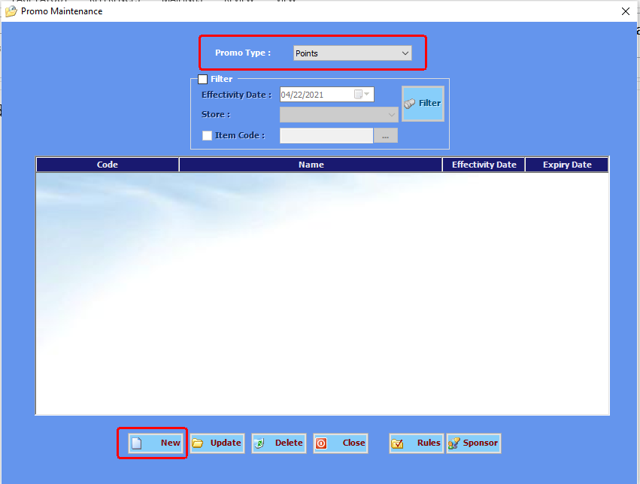

Enter the Code and Name of the Points Promo and supply the following fields.

- Customer/Category field - the user may define the customers who can avail the points promo. If there are customers defined, the user needs to put a check mark on the Inclusive column to include the selected customers in the promo. No check means the customers selected cannot avail the points promo. If no customers defined, it means that all customers can avail the promo.
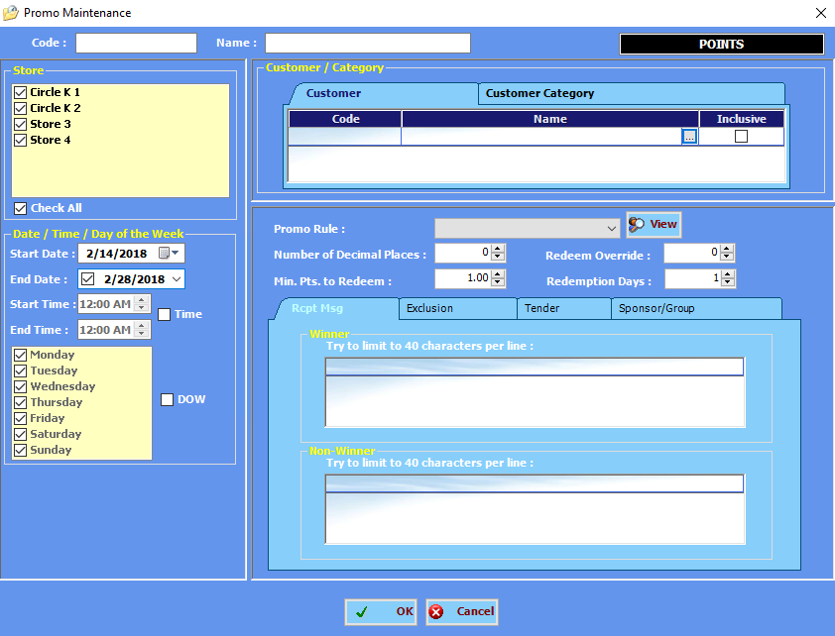

- Date/Time/Day of the Week field - the user may define the date and time the promo will be available as well as the date and time the promo will start or end. The Time checkbox and the DOW checkbox enables the time and days the promo will be available.
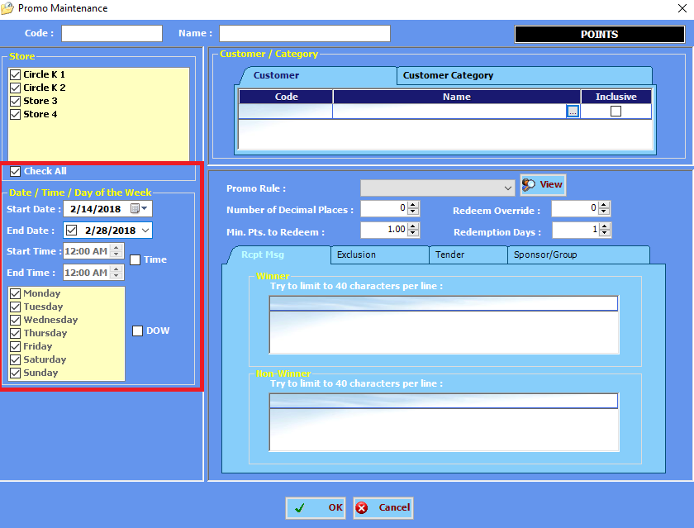

- Promo Rule field - the user may select the rule to be applied in this promo. The number of decimal places is dependent on the ruling applied in the promo. Click the View button to view the details on the selected Promo Rule.
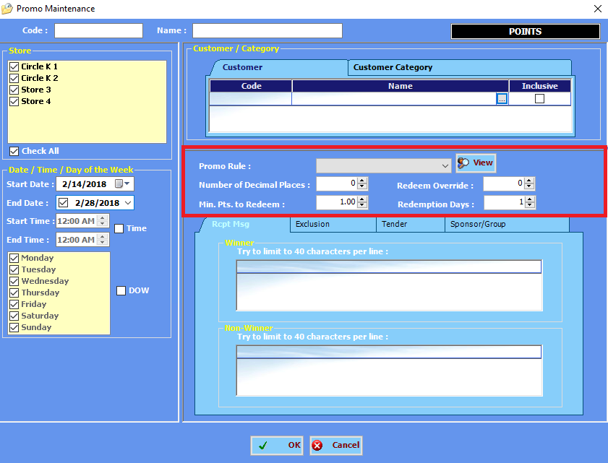

- Number of Decimal places - defines the number of decimal places of points to be applied in the promo

- Min. Pts. to Redeem - this defines the minimum number of points to redeem

- Redeem Override - this defines the manager privilege level that can override in POS for redemption

- Redemption Days – No. of extension days to redeem points after the promo expires

- Receipt Message tab - the user may enter the message for the Winner and for the Non-Winner. Each line is limited to 40 characters only.
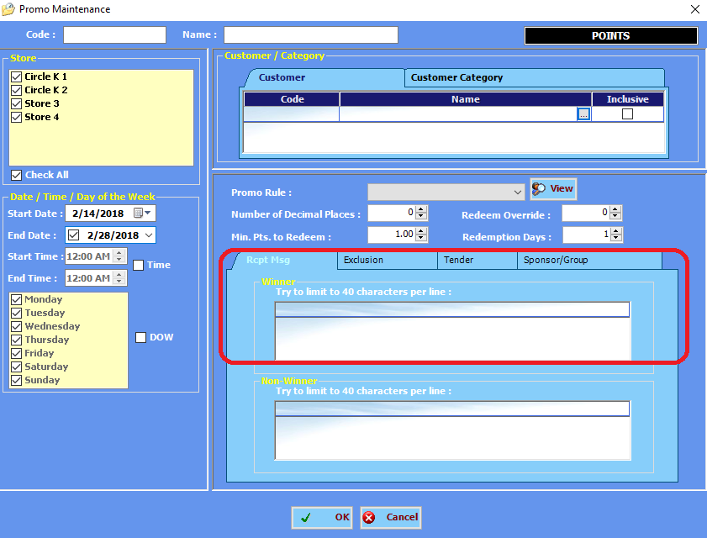

- Exclusion tab - the user may define the products/product categories/vendors to be excluded in the promo. Double-click the browse button to select the products/product categories/vendors to be excluded in the promo. The user may exclude the products on sale by putting a check mark on the On-Sale Products Excluded.

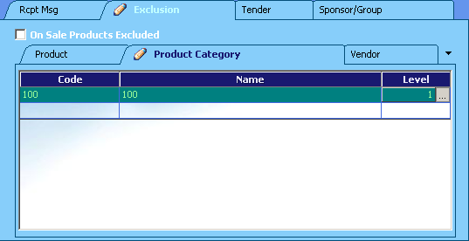

- Tender tab - the user may define the type of tender to be included in the promo by clicking the browse button and selecting the tender. It is necessary to put a check mark on the Inclusive column to include the selected tender in the promo.
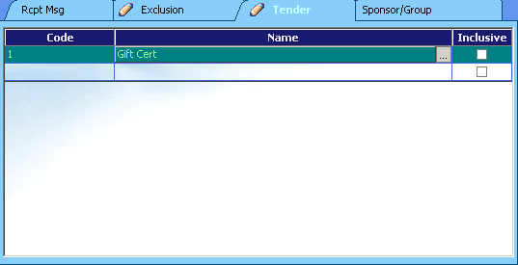

- Sponsor/Group - user may also define the Sponsor to be included in the promo. Once the Required Rule column is checked, the mechanics on the rule selected will be applied including the start and the end date of the promo. The number of points earned by the customer is reflected on the receipt.

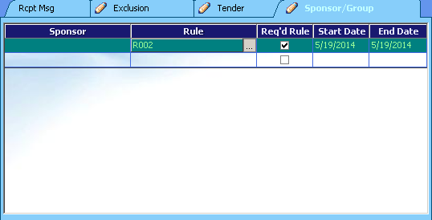

C. Earning and Redemption of POINTS in POS

After creating customer and promo for points, user should run online update POS in HO and store to download the updates from HO.

C.1 Earning of Points

Earning of Points will automatically take effect in POS if the criteria are met. See below factors on how to earn points

1. Promo is already downloaded to POS
2. Promo duration
3. Loyalty customer is used in the transaction
4. Rules of Points promo are met within the transaction

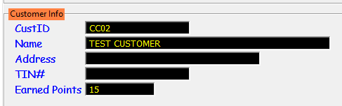To start off the transaction, choose the loyalty customer. System will automatically verify the current points from HO.

Note: If POS is offline or POS server is offline to HO, points will not be verified. Botasks Service should also be started, otherwise, points will not be verified.

Start scanning of items or items selection then after payment, sample receipt will look like the following:
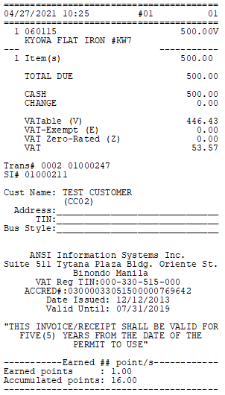

At the bottom of the receipt, earned points and accumulated points will be printed. The next time the customer is used in a transaction, updated points will be reflected.

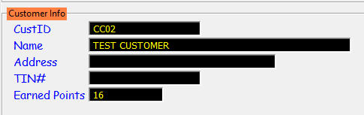

C.2 Redemption of Points

Redemption of Points will take effect in POS if the criteria are met. See below factors on how to redeem points

1. Promo is already downloaded to POS
2. Promo duration
3. Loyalty customer is used in the transaction
4. Points are available for customer used
5. Cashier used loyalty points tender
6. POS is online to POS server and POS Server is online to HO

To start off the transaction, choose the loyalty customer. System will automatically verify the current points from HO


Start scanning of items or items selection then upon payment, use Loyalty Tender.

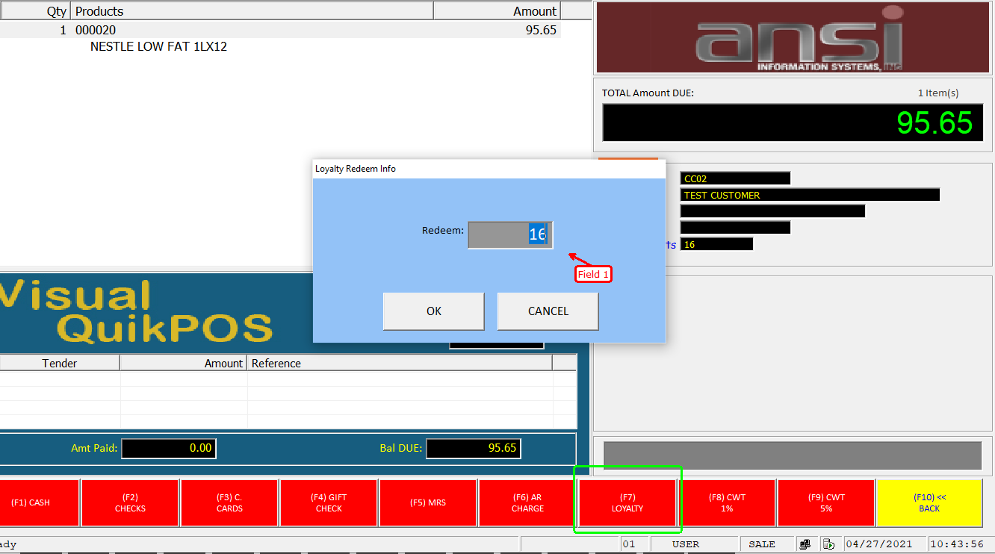

Upon clicking loyalty tender, system will verify current points of the customer in HO. Field 1 will show available points of the customer available to be redeemed. User can enter the number of points customer wants to redeem.

Points can be partially redeemed and loyalty tender is can be used in multiple tenders transaction. In redemption of points, decimal value is not allowed. User can only redeemed points using whole number.

Note: If POS is offline or POS server is offline to HO, points will not be verified. Botasks Service should also be started, otherwise, points will not be verified and redemption will not put through.

Sample receipt will look like the following:

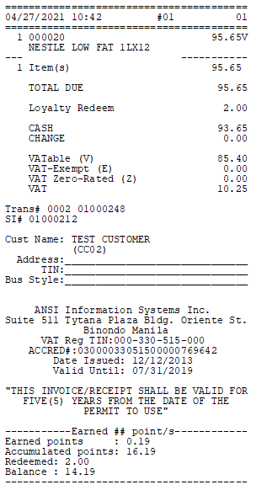

At the bottom of the receipt, earned points and accumulated points, Redeemed and Balance will be printed. The next time the customer is used in a transaction, updated points will be reflected.



