Sockets depuración
Item | PN
1 | 6-102618-8 | 2 filas de 12P – 0.25mm
2 | 5-102699-7 | 2 filas 8P – 0,25 mm
3 | 535542-8 | Receptáculo 2 filas 16P – 0,25 mm
4 | 535541-6 | Receptáculo 1 filas 8P – 0,25 mm
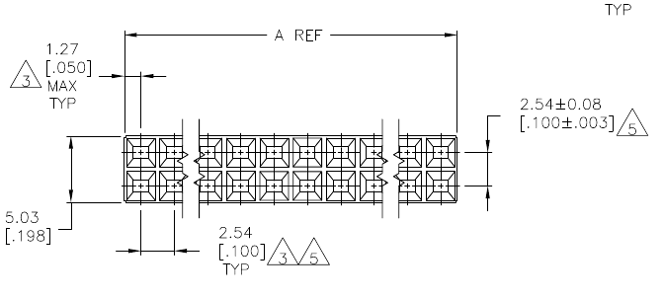
3: Item 3
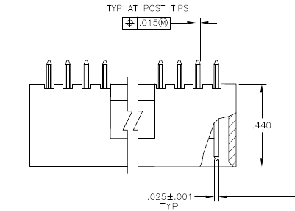
2: Item 1
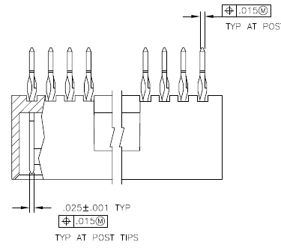
1: Item 2

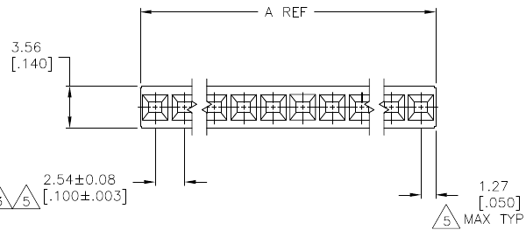
4: Item 4

Definición de buses

GPIB Port Expander [I2C] [PCA6408]
1 | 2 | 3 | 4 | 5 | 6 | 7
+5.0V | +3.3V | GND | SDA | SCL | /INT | /RESET

Viking Port Expander [SPI] [MC33996]
1 | 2 | 3 | 4 | 5 | 6 | 7 | 8 | 9
VPWR | VCC | GND_PWR | MOSI | MISO | SCLK | /CS | /RESET | PWM

Capacitive Keyboard [I2C] [PCF8885]
1 | 2 | 3 | 4 | 5 | 6 | 7 | 8
x | VCC | GND | SDA | SCL | A0 | /INT | SLEEP

Lan Connection [SPI] [ENC28J60]
1 | 2 | 3 | 4 | 5 | 6 | 7 | 8
x | VCC (+3.3) | GND_PWR | MOSI | MISO | SCLK | /CS | /RESET

Port Expander 8 bit [I2C] [PCA6408A]
1 | 2 | 3 | 4 | 5 | 6 | 7 | 8
VDD(PORT) | VCC (I2C) | GND | SDA | SCL | ADDR | /INT | /RESET

Keyboard Port Expander 16 bit [I2C] [PCA6416A]
1 | 2 | 3 | 4 | 5 | 6 | 7 | 8
VDD(PORT) | VCC (I2C) | GND | SDA | SCL | ADDR | /INT | /RESET

LED Driver 15 bit [I2C] [PCA9952]
1 | 2 | 3 | 4 | 5 | 6 | 7 | 8
VCC(LED) | VDD(I2C) | GND | SDA | SCL | X | X | /RESET

Pic18 Pin Definitions

In Circuit Debbugger / In Circuit Serial Programming
Clock | Data | Reset
RB6 | RB7 | /MCLR  (pull up needed)
ICPGC | ICPGD | ICRST

Master Serial Synchronous Port
PIN | RB0 | RB1 | RB3 | RC7
I2C | SDA | SCL
SPI | SDI | SCK | SDO | SDO  (conf alternativa)

Protección ESD + Transitorios
TVS

Part Number | Description | Quantity
SD05C-01FTG | TVS DIODE 5VWM 18VC SOD323 | 12
SD15C-01FTG | TVS DIODE 15VWM 31VC SOD323 | 12
SMAJ250CA | TVS DIODE 250VWM 405VC SMA | 12
SP1003-01ETG | TVS DIODE 5VWM 12VC SOD882 | 12 | 30PF 30KV UNIDIRECTIONAL DISCRETE TVS-
SD24-01FTG | TVS DIODE 24VWM 42VC SOD323 | 6
SPHV24-01ETG | TVS DIODE 24VWM 50VC SOD882 | 24

Estandares ESD
IEC 61000-4-2 ESD test voltage levels

Disposición espacial de tarjetas
Tarjeta madre
Tarjeta periferico
Conectores en angulo
Backplane
Tarjeta periferico
Tarjeta núcleo MCU
Diodos

Part Number | Description | Quantity Shipped
DST5100S | DIODE SCHOTTKY 100V 5A TO277B | 10
DURB1640CT | DIODE RECTIFIER 8A 400V TO263 | 6
DURD560A | DIODE RECTIFIER 5A 600V TO252 | 10
MBRD10200CT | DIODE SCHOTTKY 200V 5A TO252 | 10
SD05C-01FTG | TVS DIODE 5VWM 18VC SOD323 | 12
SD15C-01FTG | TVS DIODE 15VWM 31VC SOD323 | 12
V230LA20AP | VARISTOR 360V 4.5KA DISC 14MM | 12
V360CH8T | VARISTOR 360V 250A 2SMD | 12

