COMPUTER PROGRAMMING ASSIGNMENT
ICS2102 / HBC2204 / HCB2351

C PROGRAMMING ASSIGNMENT

NAME: Ekirapa Japheth
REGISTRATION NUMBER: HDB212-D1-0023/2021
COURSE: BBIT

SECTIONS COVERED:
- Section A – Arrays
- Section B – Structures and Functions
- Section C – Pointers and Dynamic Memory Allocation

SECTION A: ARRAYS
Problem Statement
Develop a C program that stores the marks of 10 students in an array. The program should read the marks using a loop, calculate the average mark, determine the highest and lowest marks, and display all marks that are greater than the average.

Algorithm
- Start the program.
- Declare an array to store marks of 10 students.
- Use a loop to input the marks of the 10 students.
- Add all the marks to calculate the total.
- Calculate the average by dividing the total by 10.
- Set the first mark as the initial highest and lowest mark.
- Compare the remaining marks to determine the highest and lowest marks.
- Display the average, highest mark, and lowest mark.
- Compare each mark with the average and display marks greater than the average.
- End the program.

Source Code:

#include <stdio.h>

int main()

{

int marks[10];

int i;

int highest, lowest;

float average, total = 0;

printf("====================================\n");

printf(" SECTION A - ARRAYS\n");

printf("====================================\n");

printf("Name: Ekirapa Japheth\n");

printf("Registration Number: HDB212-D1-0023/2021\n");

printf("Course: BBIT\n\n");

printf("Enter marks for 10 students:\n");

for(i = 0; i < 10; i++)

{

printf("Enter mark for student %d: ", i + 1);

scanf("%d", &marks[i]);

total = total + marks[i];

}

average = total / 10;

highest = marks[0];

lowest = marks[0];

for(i = 1; i < 10; i++)

{

if(marks[i] > highest)

{

highest = marks[i];

}

if(marks[i] < lowest)

{

lowest = marks[i];

}

}

printf("\n====================================\n");

printf(" RESULTS\n");

printf("====================================\n");

printf("Average mark: %.2f\n", average);

printf("Highest mark: %d\n", highest);

printf("Lowest mark: %d\n", lowest);

printf("\nMarks greater than the average:\n");

for(i = 0; i < 10; i++)

{

if(marks[i] > average)

{

printf("%d ", marks[i]);

}

}

printf("\n\nProgram completed successfully.\n");

return 0;

}

Screenshots

Section A: Source code – top part

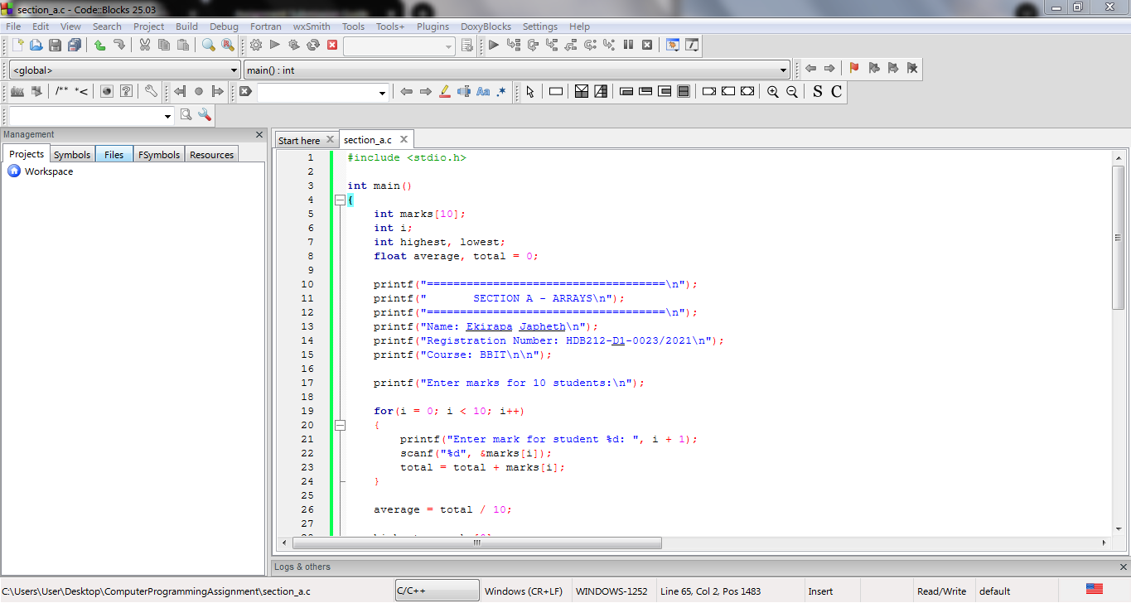

Section A: Source code – bottom part
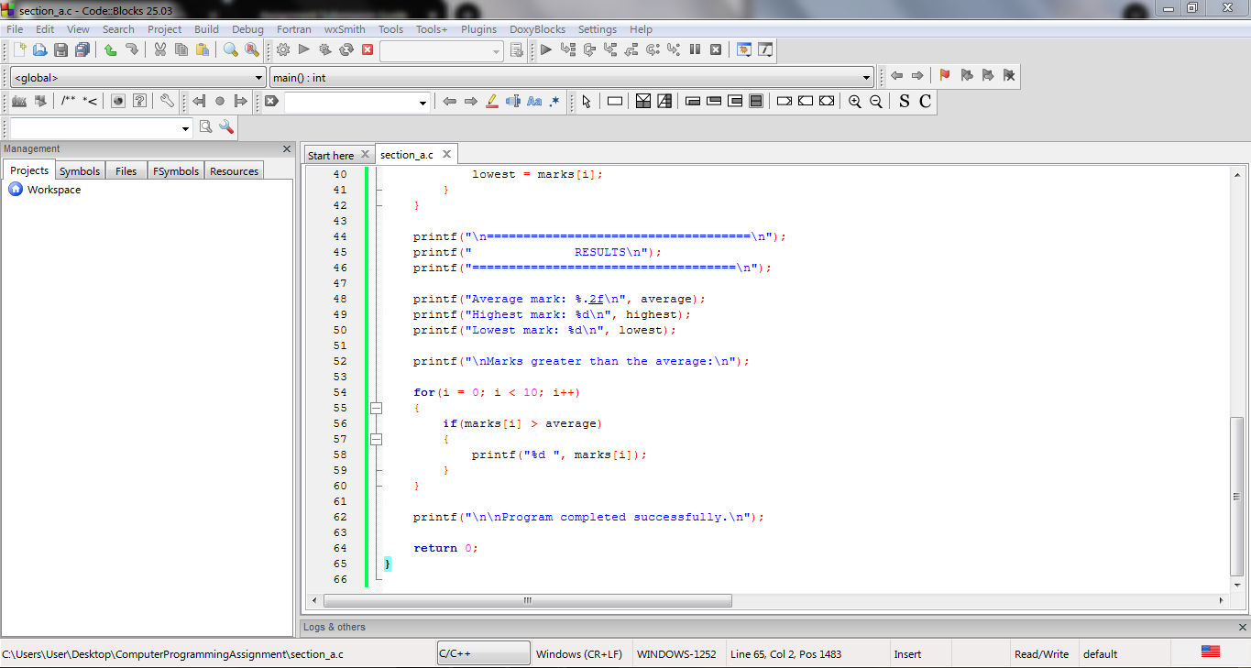

Section A: Program execution

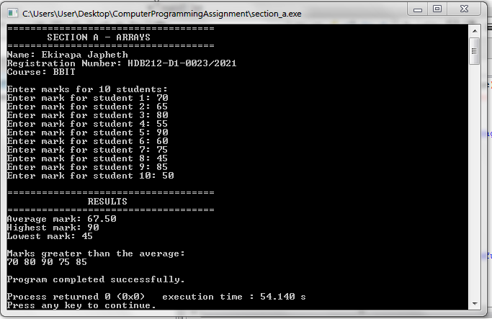

Section A: Successful compilation

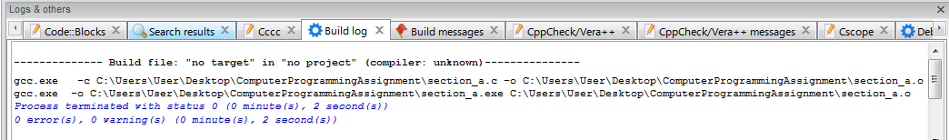

SECTION B: STRUCTURES AND FUNCTIONS
Problem Statement
Develop a Student Record Management Program using structures and functions. The program should store information for five students, including Admission Number, Student Name, Course, Age, and CAT Marks. The program should capture and display student information and calculate the average CAT marks.

Algorithm
- Start the program.
- Define a structure called Student.
- Create variables to store admission number, name, course, age, and CAT marks.
- Declare an array to store records for 5 students.
- Use a function to capture information for each student.
- Use a function to display the information of each student.
- Use a function to calculate the average CAT marks.
- Display the average CAT marks.
- End the program.

Source Code:
#include <stdio.h>

struct Student
{
char admissionNumber[30];
char name[50];
char course[50];
int age;
float catMarks;
};

void captureStudent(struct Student *student, int number)
{
printf("\nEnter information for Student %d\n", number);

printf("Admission Number: ");
scanf(" %[^\n]", student->admissionNumber);

printf("Student Name: ");
scanf(" %[^\n]", student->name);

printf("Course: ");
scanf(" %[^\n]", student->course);

printf("Age: ");
scanf("%d", &student->age);

printf("CAT Marks: ");
scanf("%f", &student->catMarks);
}

void displayStudent(struct Student student, int number)
{
printf("\n----------------------------------------\n");
printf("Student %d\n", number);
printf("----------------------------------------\n");
printf("Admission Number: %s\n", student.admissionNumber);
printf("Student Name: %s\n", student.name);
printf("Course: %s\n", student.course);
printf("Age: %d\n", student.age);
printf("CAT Marks: %.2f\n", student.catMarks);
}

float calculateAverage(struct Student students[], int size)
{
float total = 0;
int i;

for(i = 0; i < size; i++)
{
total = total + students[i].catMarks;
}

return total / size;
}

int main()
{
struct Student students[5];
float average;
int i;

printf("============================================\n");
printf(" SECTION B - STUDENT RECORD\n");
printf("============================================\n");
printf("Name: Ekirapa Japheth\n");
printf("Registration Number: HDB212-D1-0023/2021\n");
printf("Course: BBIT\n");

for(i = 0; i < 5; i++)
{
captureStudent(&students[i], i + 1);
}

printf("\n\n============================================\n");
printf(" STUDENT RECORDS\n");
printf("============================================\n");

for(i = 0; i < 5; i++)
{
displayStudent(students[i], i + 1);
}

average = calculateAverage(students, 5);

printf("\n============================================\n");
printf("Average CAT Marks: %.2f\n", average);
printf("============================================\n");

printf("\nProgram completed successfully.\n");

return 0;
}

Screenshots
Section B: Source code – top part

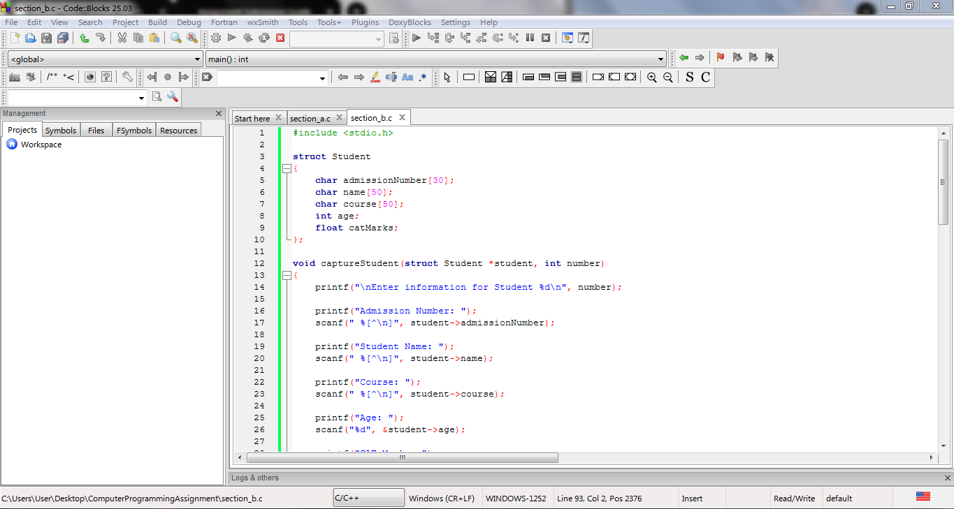

Section B: Source code – bottom part

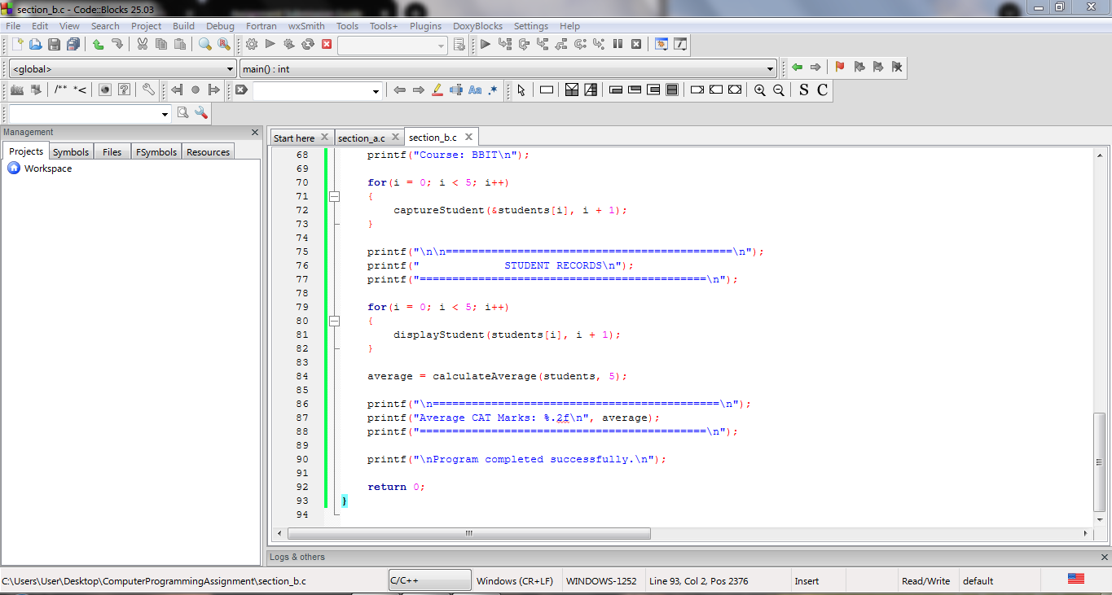

Section B program execution

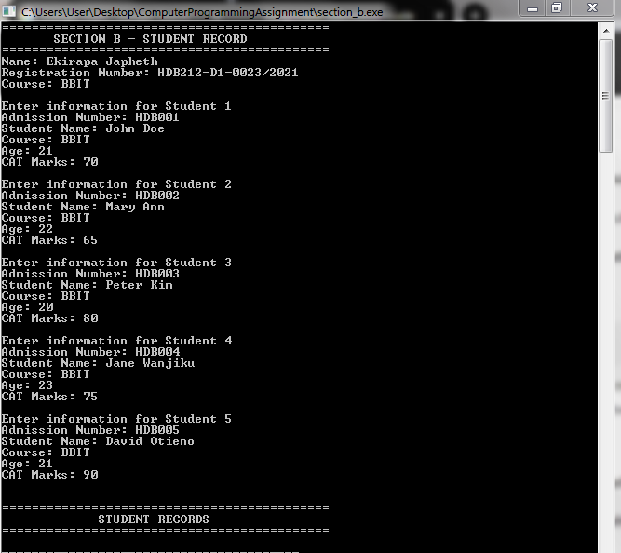
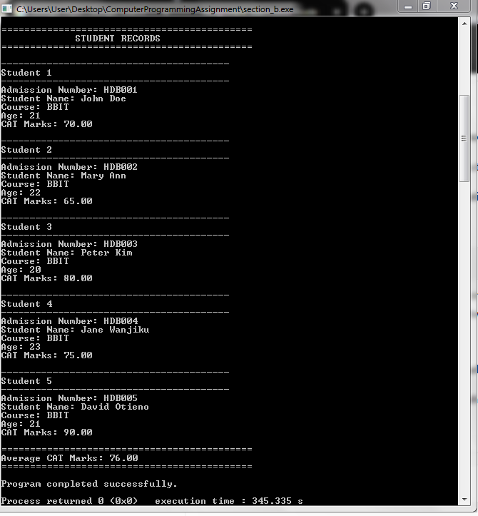

Section B: Successful compilation
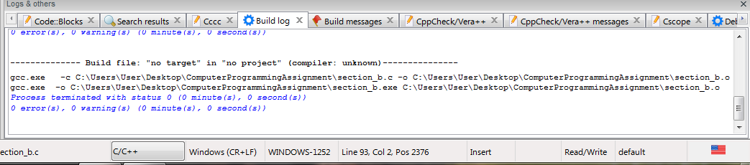

SECTION C: POINTERS AND DYNAMIC MEMORY ALLOCATION
Problem Statement
Develop a C program that dynamically allocates memory for 15 integers using malloc(). The program should allow the user to enter 15 integers, calculate their total and average, and free the allocated memory before the program terminates.

Algorithm
- Start the program.
- Declare a pointer to an integer.
- Dynamically allocate memory for 15 integers using malloc().
- Check whether memory allocation was successful.
- Use a loop to read 15 integers.
- Add the integers to calculate the total.
- Calculate the average of the 15 integers.
- Display the total and average.
- Free the allocated memory using free().
- Display a message confirming that the memory has been freed.
- End the program.

Source Code:

#include <stdio.h>

#include <stdlib.h>

int main()

{

int *numbers;

int i;

int total = 0;

float average;

printf("============================================\n");

printf(" SECTION C - POINTERS AND DYNAMIC MEMORY\n");

printf("============================================\n");

printf("Name: Ekirapa Japheth\n");

printf("Registration Number: HDB212-D1-0023/2021\n");

printf("Course: BBIT\n\n");

numbers = (int *)malloc(15 * sizeof(int));

if(numbers == NULL)

{

printf("Memory allocation failed.\n");

return 1;

}

printf("Enter 15 integers:\n");

for(i = 0; i < 15; i++)

{

printf("Enter number %d: ", i + 1);

scanf("%d", &numbers[i]);

total = total + numbers[i];

}

average = (float)total / 15;

printf("\n============================================\n");

printf(" RESULTS\n");

printf("============================================\n");

printf("Total: %d\n", total);

printf("Average: %.2f\n", average);

free(numbers);

printf("\nMemory has been freed successfully.\n");

printf("Program completed successfully.\n");

return 0;

}
Screenshots
Section C: Source code – top part
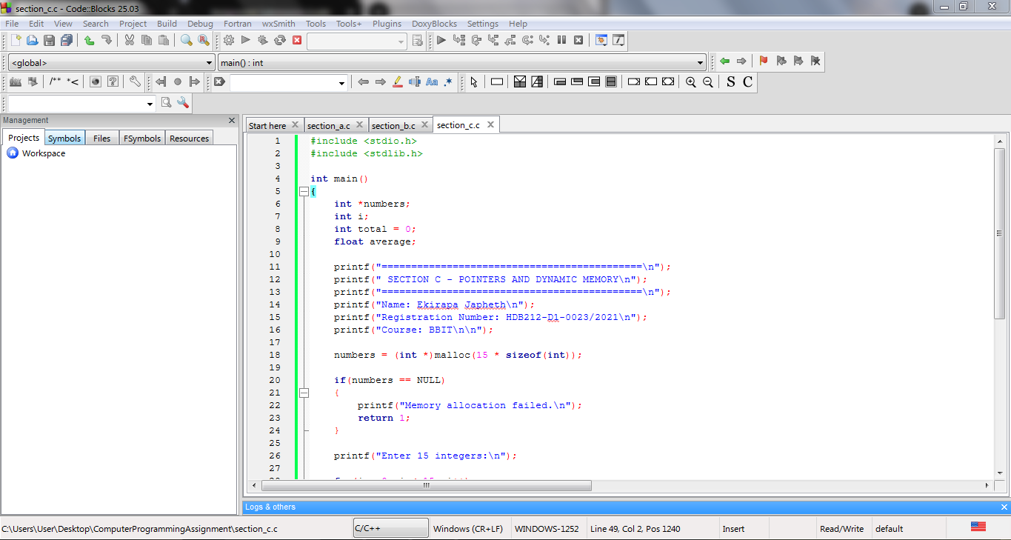

Section C: Source code – bottom part

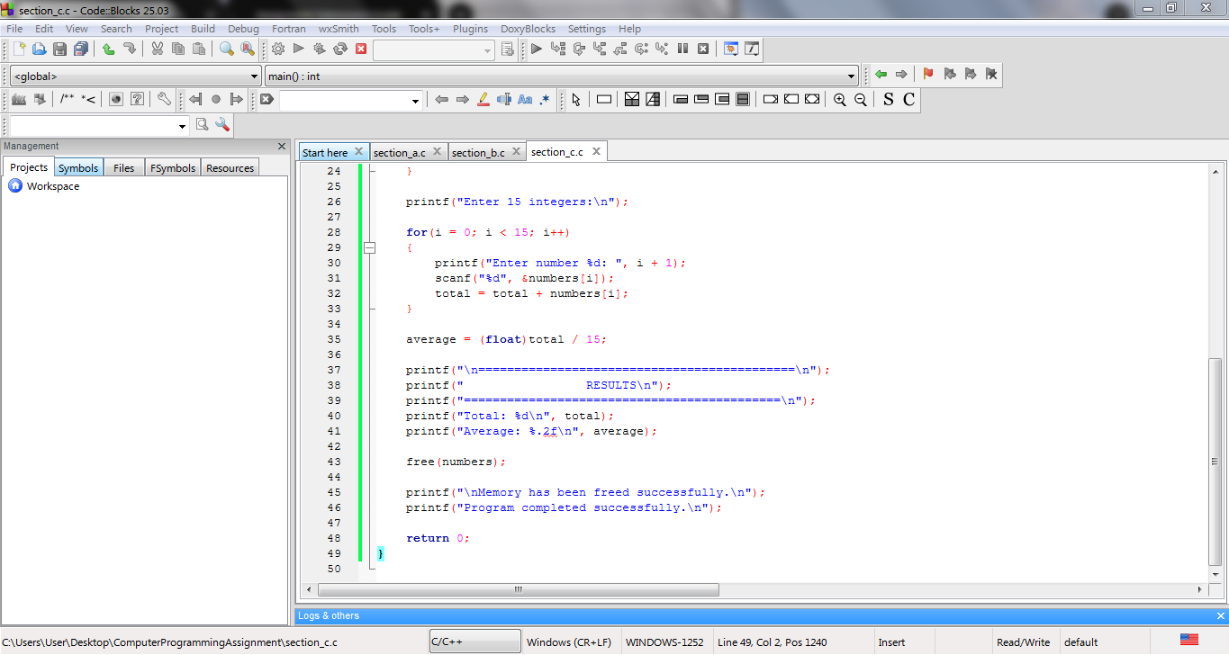

Section C program execution
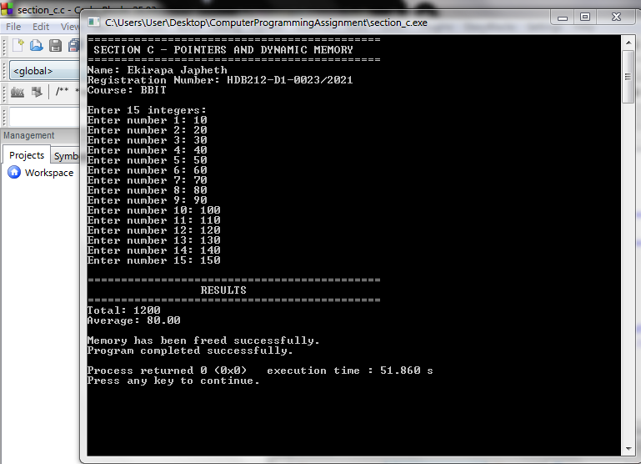
Section C: Successful compilation
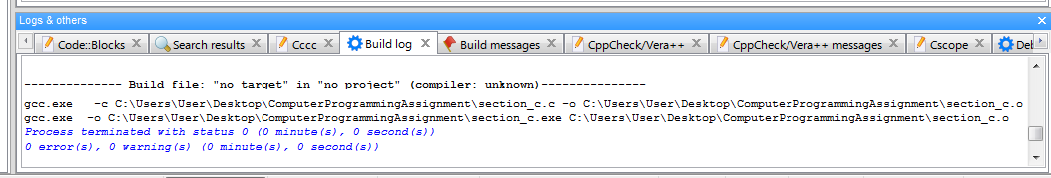

CONCLUSION
The assignment provided practical experience in C programming through the use of arrays, structures, functions, pointers, and dynamic memory allocation. Section A demonstrated how arrays and loops can be used to process student marks. Section B demonstrated the use of structures and functions to manage student records and calculate CAT marks. Section C demonstrated dynamic memory allocation using malloc() and the release of allocated memory using free(). The programs were compiled and executed successfully.

