OSASS Administration Portal — User Manual
System: Online Staff Appointment & Promotion System (OSASS)
Portal: Administration Portal
Audience: University Administrators (Admin and SuperAdmin roles) at the University of Mines and Technology (UMaT), Tarkwa
Version: 1.0 | May 2025

Table of Contents
- Overview
- Getting Started
  - Logging In
- Dashboard
- Organization Management
  - Schools
  - Faculties
  - Academic Departments
  - Units & Sections
- Academic Management
  - Academic Staff
  - Academic Positions
  - Service Positions
  - Publication Indicators
  - Academic Committees
- Non-Academic Management
  - Non-Academic Staff
  - Non-Academic Positions
  - Knowledge Material Types
  - Non-Academic Committees
- Administration
  - Staff Updates
  - Audit Logs
  - Administrators (SuperAdmin Only)
- Account Management
  - Change Password
- Navigation & Layout
- Role Permissions Reference

1. Overview
The OSASS Administration Portal is the backend management system for university administrators. It provides full control over the organisational structure, staff records, promotion criteria, and the promotion assessment committees that drive both the Academic and Non-Academic promotion portals.
Key capabilities: - Manage the university’s organisational hierarchy (Schools → Faculties → Departments / Units) - Register and manage academic and non-academic staff members - Define promotion position levels and their eligibility criteria - Configure publication indicators and scoring weights for academic promotions - Configure knowledge material types and scoring for non-academic promotions - Manage service position types used in all promotion applications - Create and manage promotion assessment committees (DAPC, FAPC, UAPC for academic; Institutional, University for non-academic) - Publish staff update announcements to both staff portals - Review system activity via the Audit Logs
User roles: - Admin — Full access to all sections except the Administrators management page - SuperAdmin — Full access including managing other administrator accounts

2. Getting Started

2.1 Logging In
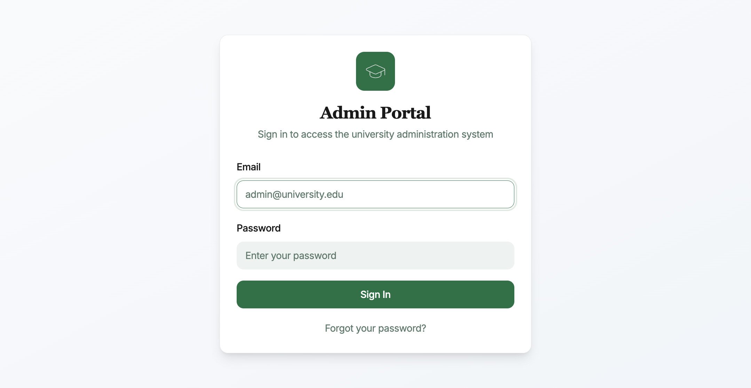
Login Page
Steps to log in:
- Navigate to the Administration Portal URL.
- Enter your Admin Email (e.g., y.asante@umat.edu.gh).
- Enter your Password.
- Click Sign In.
Successful login redirects you to the Dashboard.
Security note: The Administration Portal is restricted to authorised administrator accounts only. Do not share your credentials. Contact the IT department if you suspect unauthorised access.

3. Dashboard
The Dashboard provides a summary of the university’s current OSASS data at a glance.
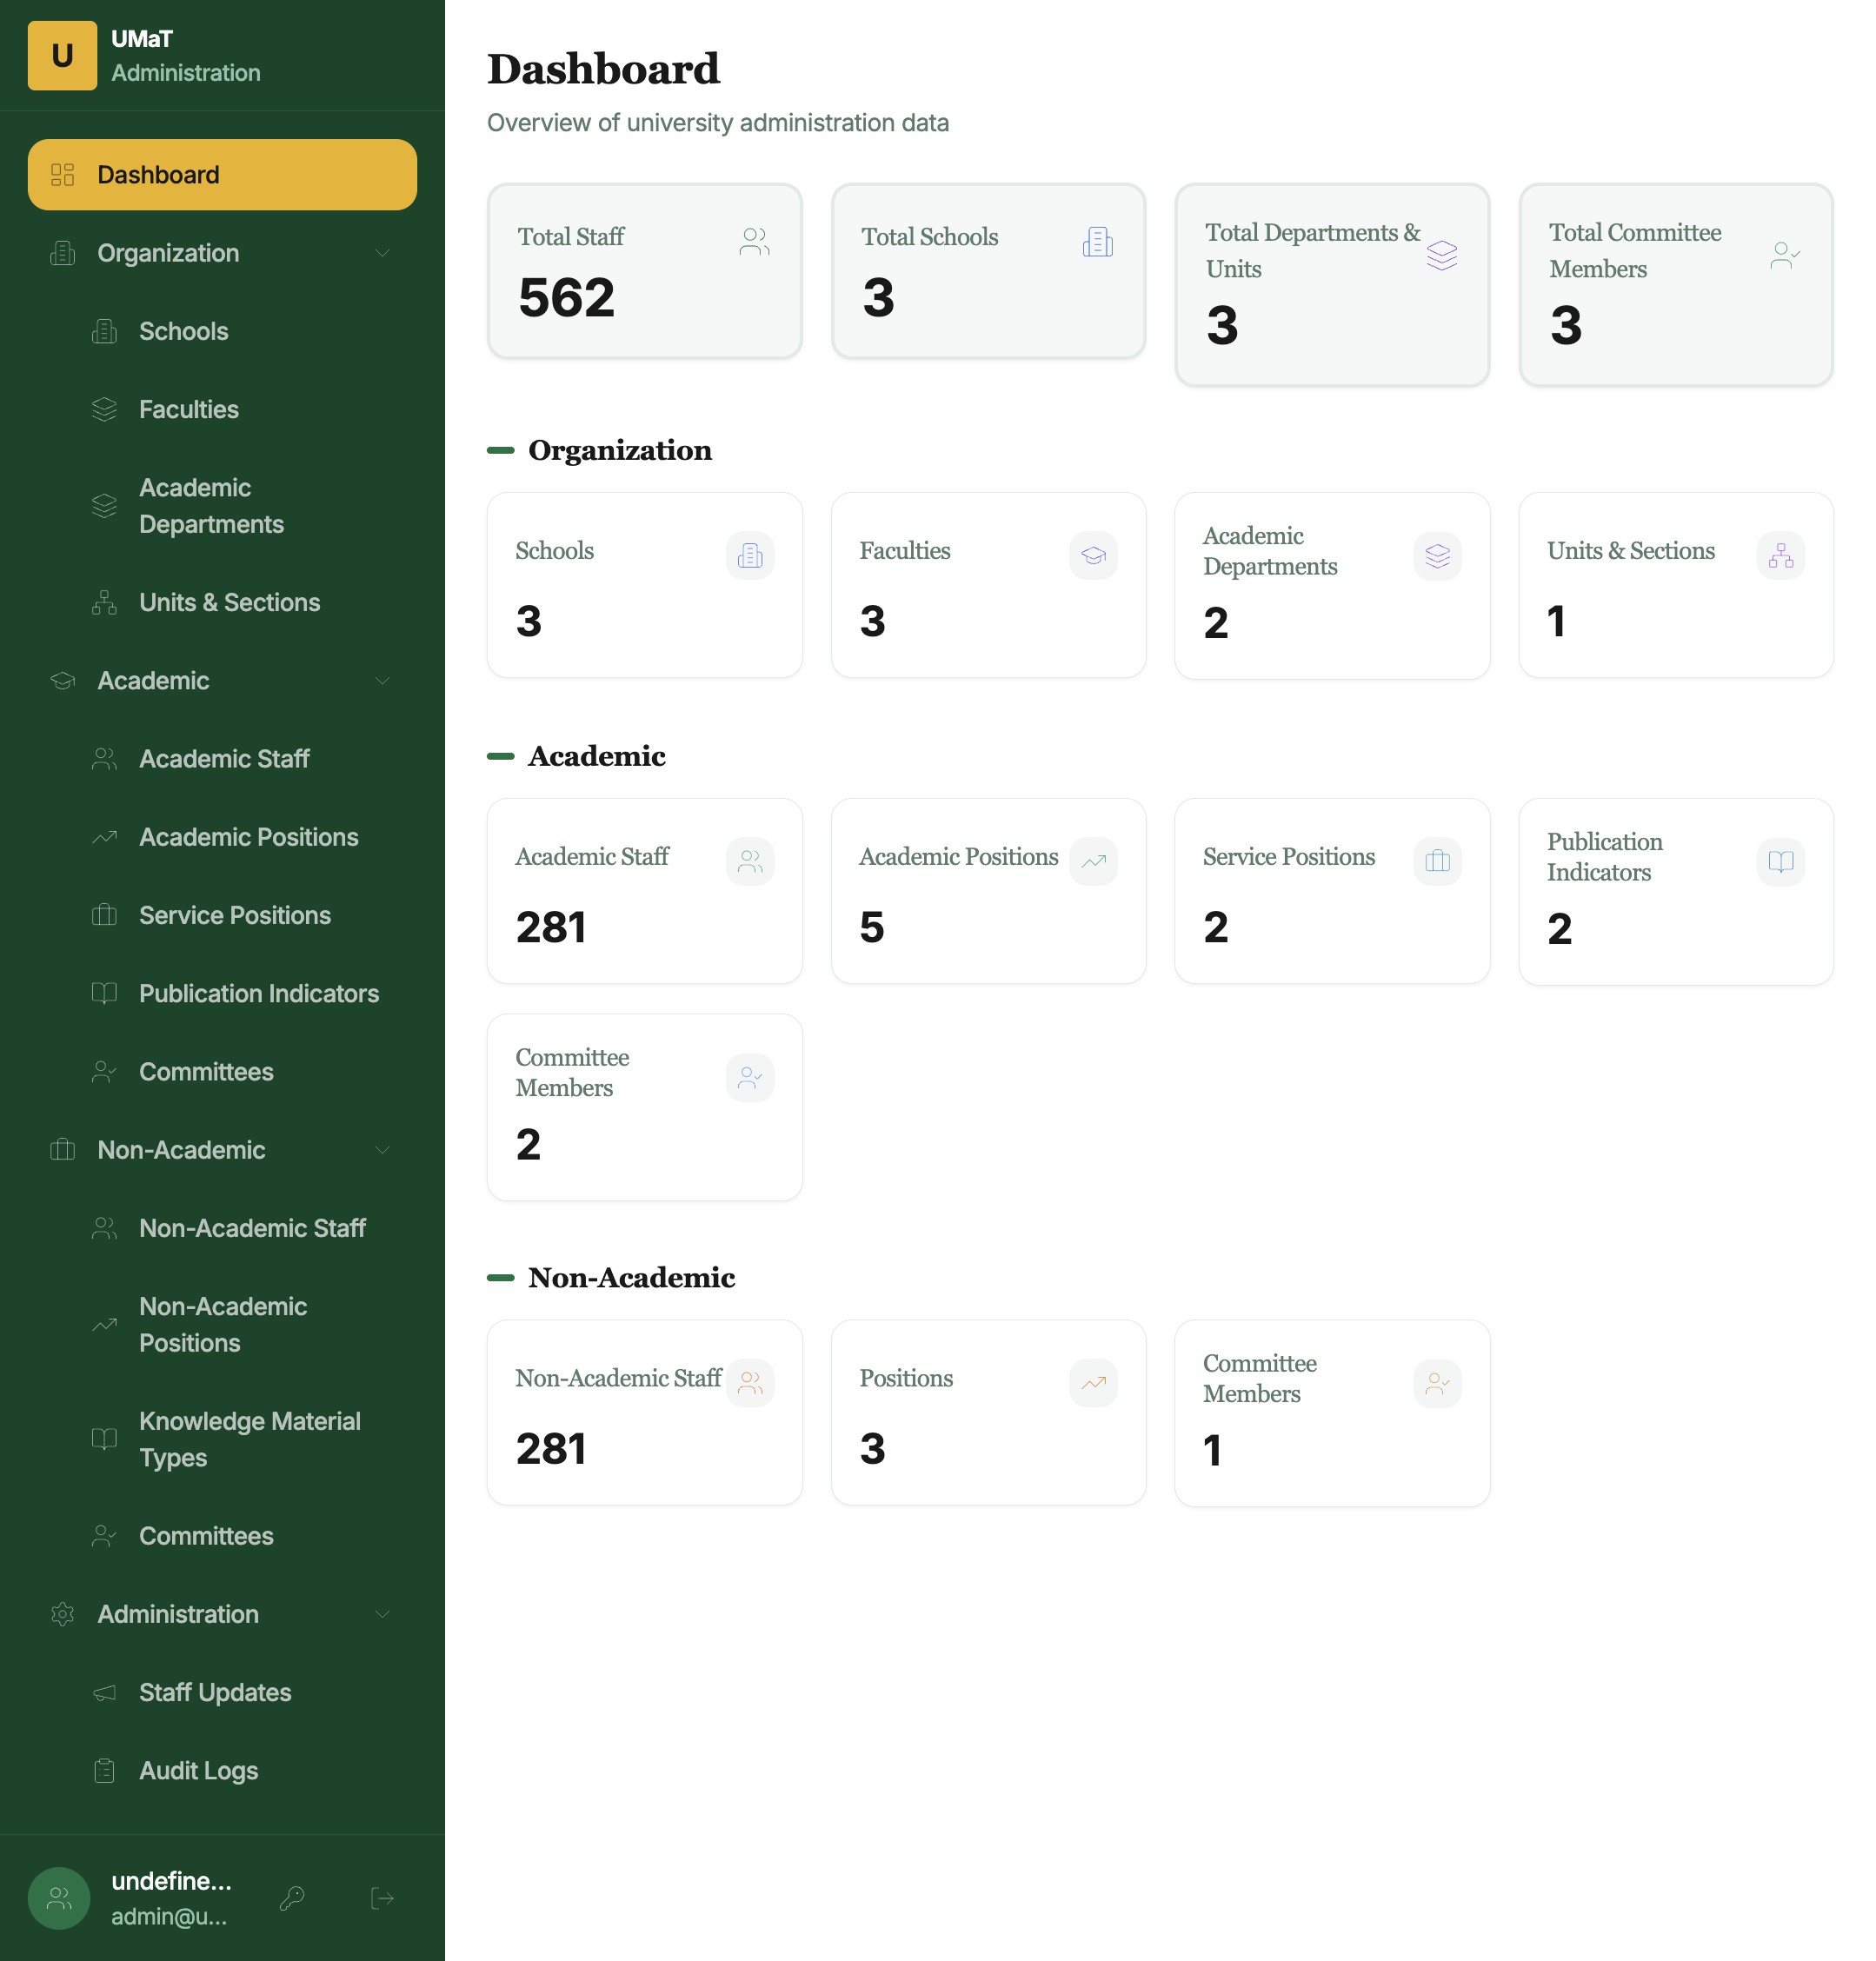
Dashboard
Dashboard stat cards:
Card | Description
Total Staff | Combined total of registered academic and non-academic staff
Schools | Number of schools configured in the system
Departments/Units | Total academic departments and non-academic units/sections
Committee Members | Total active committee members across all committees
The dashboard also shows a quick navigation panel to the most frequently used management sections.

4. Organization Management
The Organization section allows you to build and maintain the university’s hierarchical structure. All other records (staff, committees, etc.) are linked to this structure.

4.1 Schools
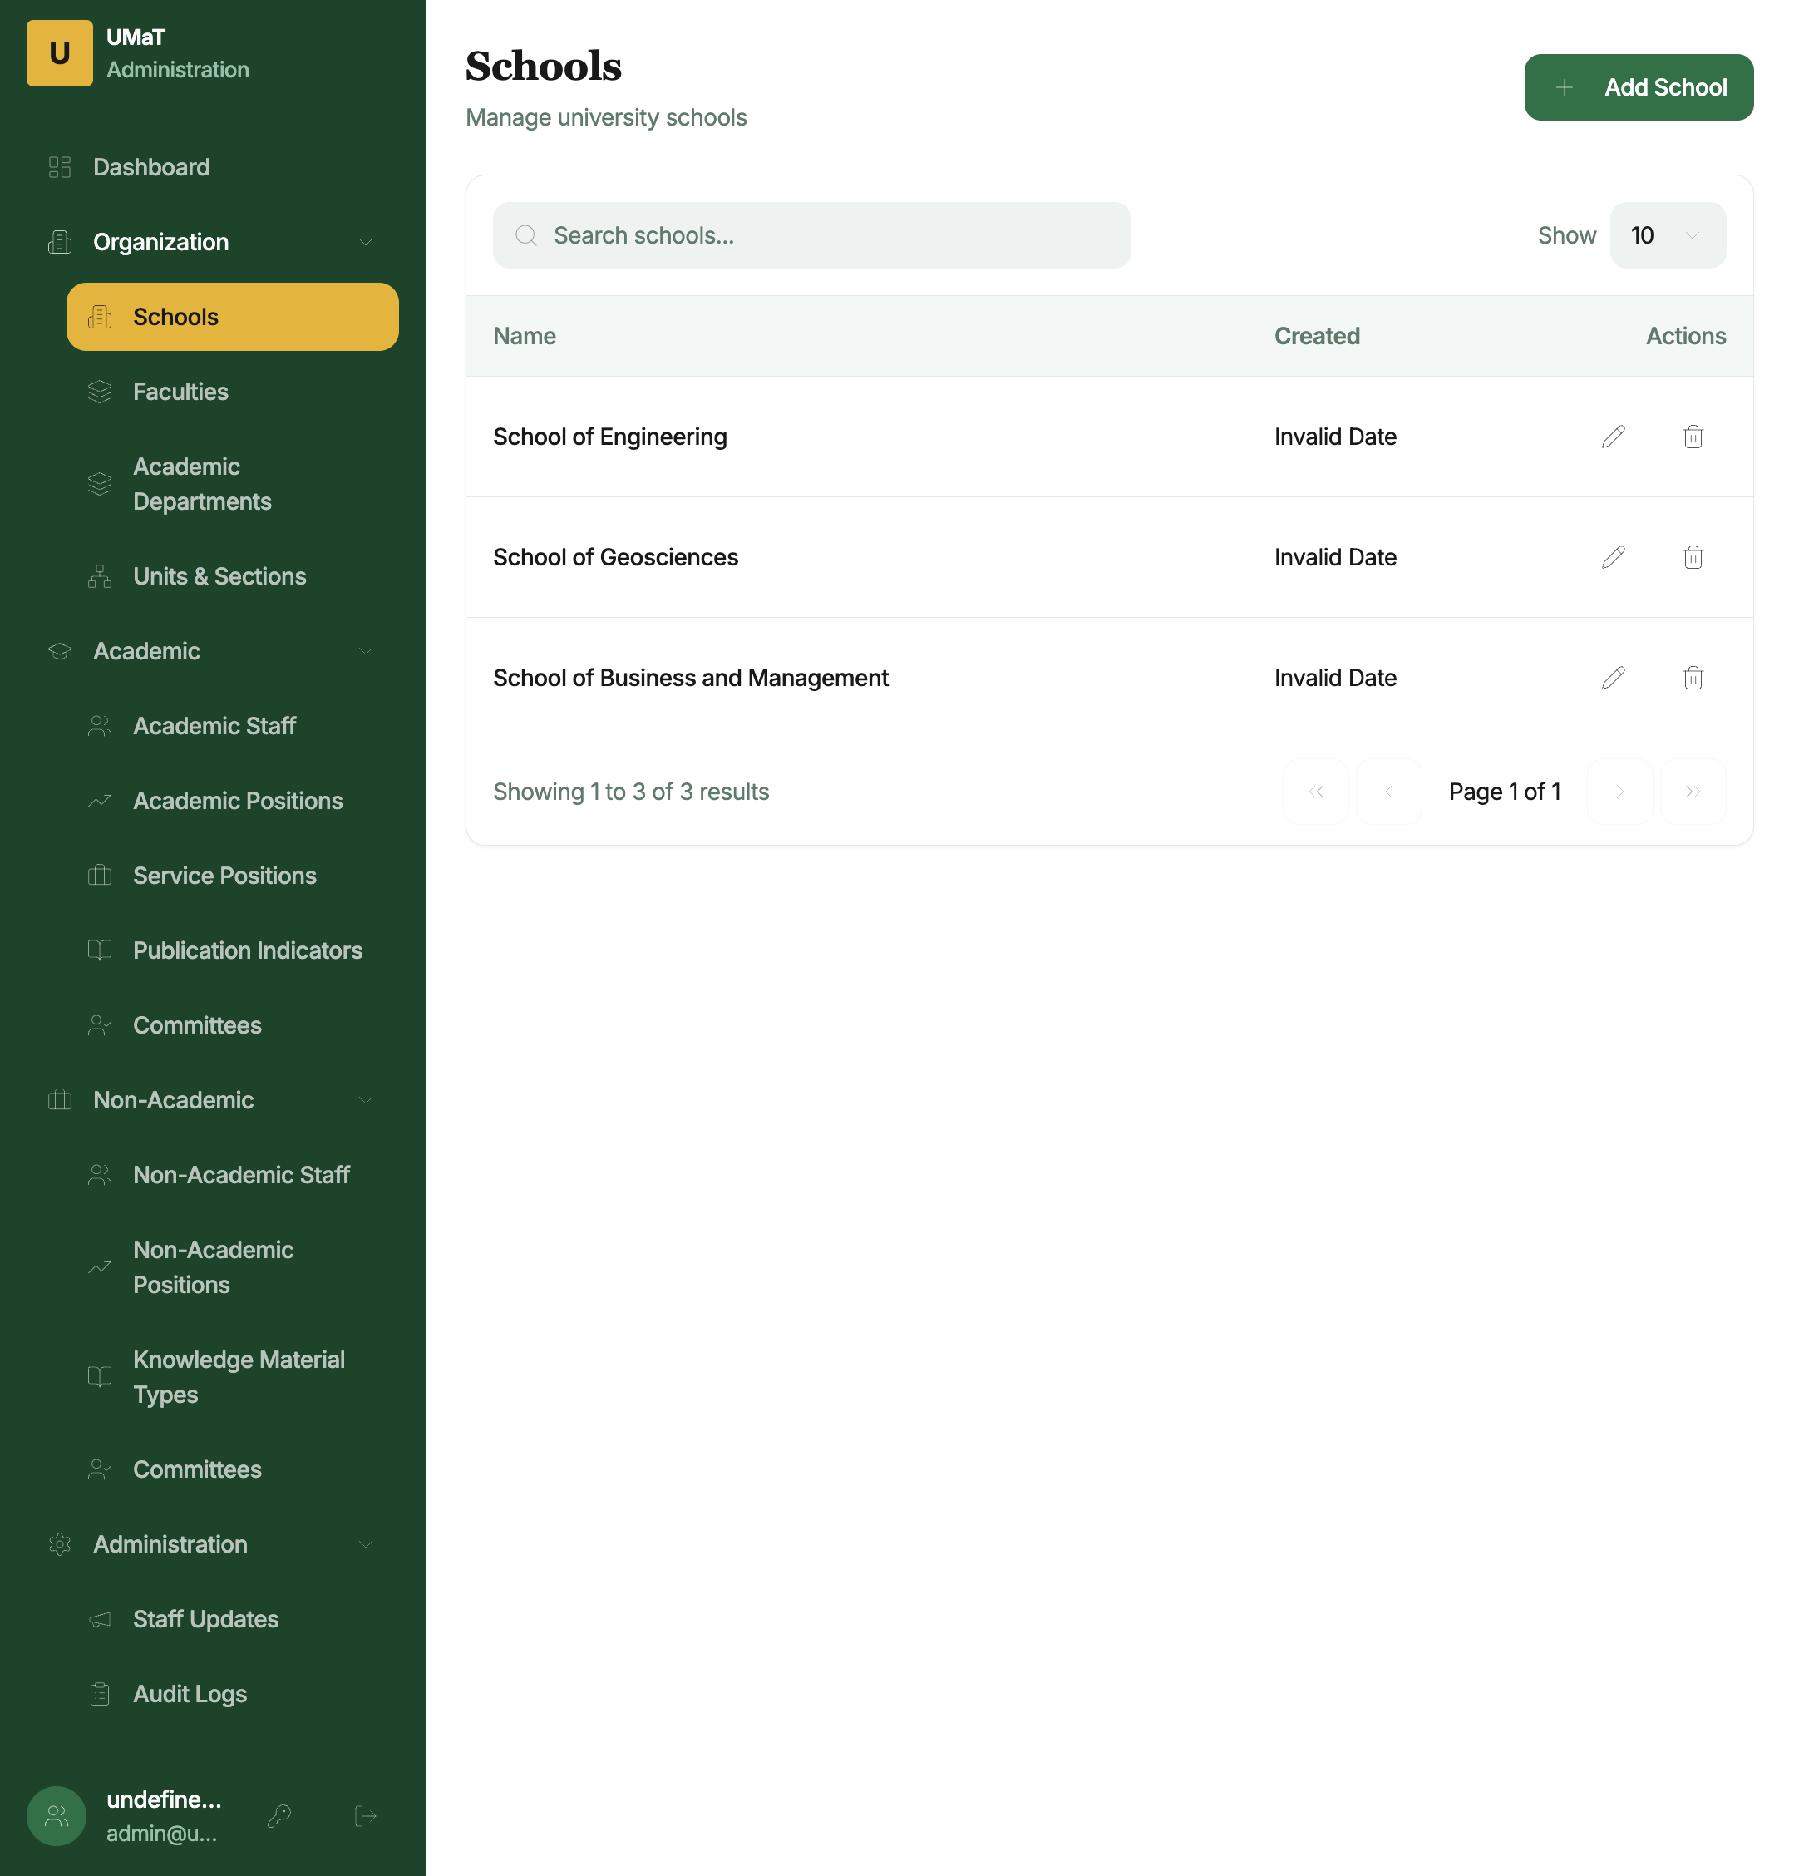
Schools
How to access: Click Organization → Schools in the sidebar.
The Schools page lists all registered schools at UMaT. Each row shows the school name and action buttons.
To add a school: 1. Click + Add School. 2. Enter the School Name (e.g., School of Mines and Technology). 3. Click Save.
To edit a school: Click the pencil (✏) icon in the Actions column, update the name, and click Save.
To delete a school: Click the trash (🗑) icon. A confirmation dialog appears. Note that a school can only be deleted if no faculties are linked to it.

4.2 Faculties
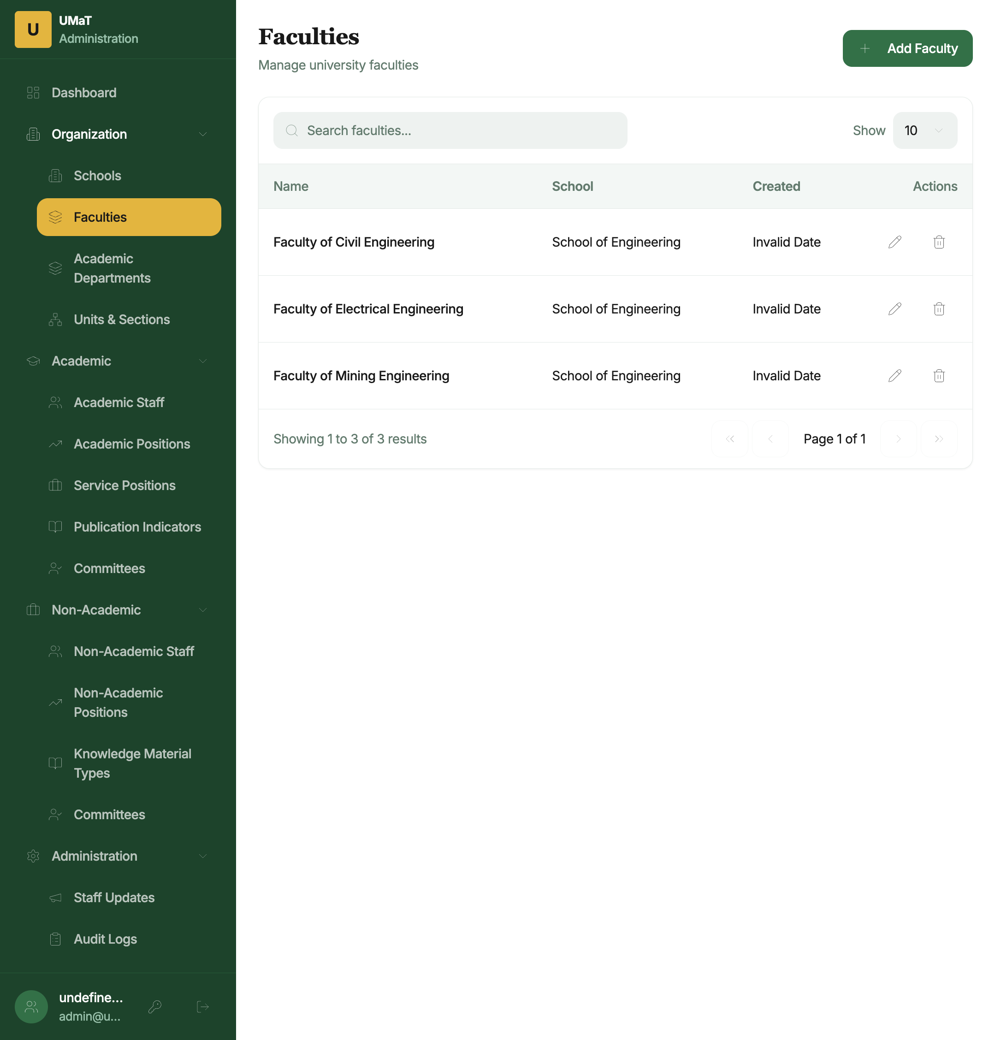
Faculties
How to access: Click Organization → Faculties.
Lists all faculties with their parent School name.
To add a faculty: 1. Click + Add Faculty. 2. Enter the Faculty Name and select the School it belongs to. 3. Click Save.

4.3 Academic Departments
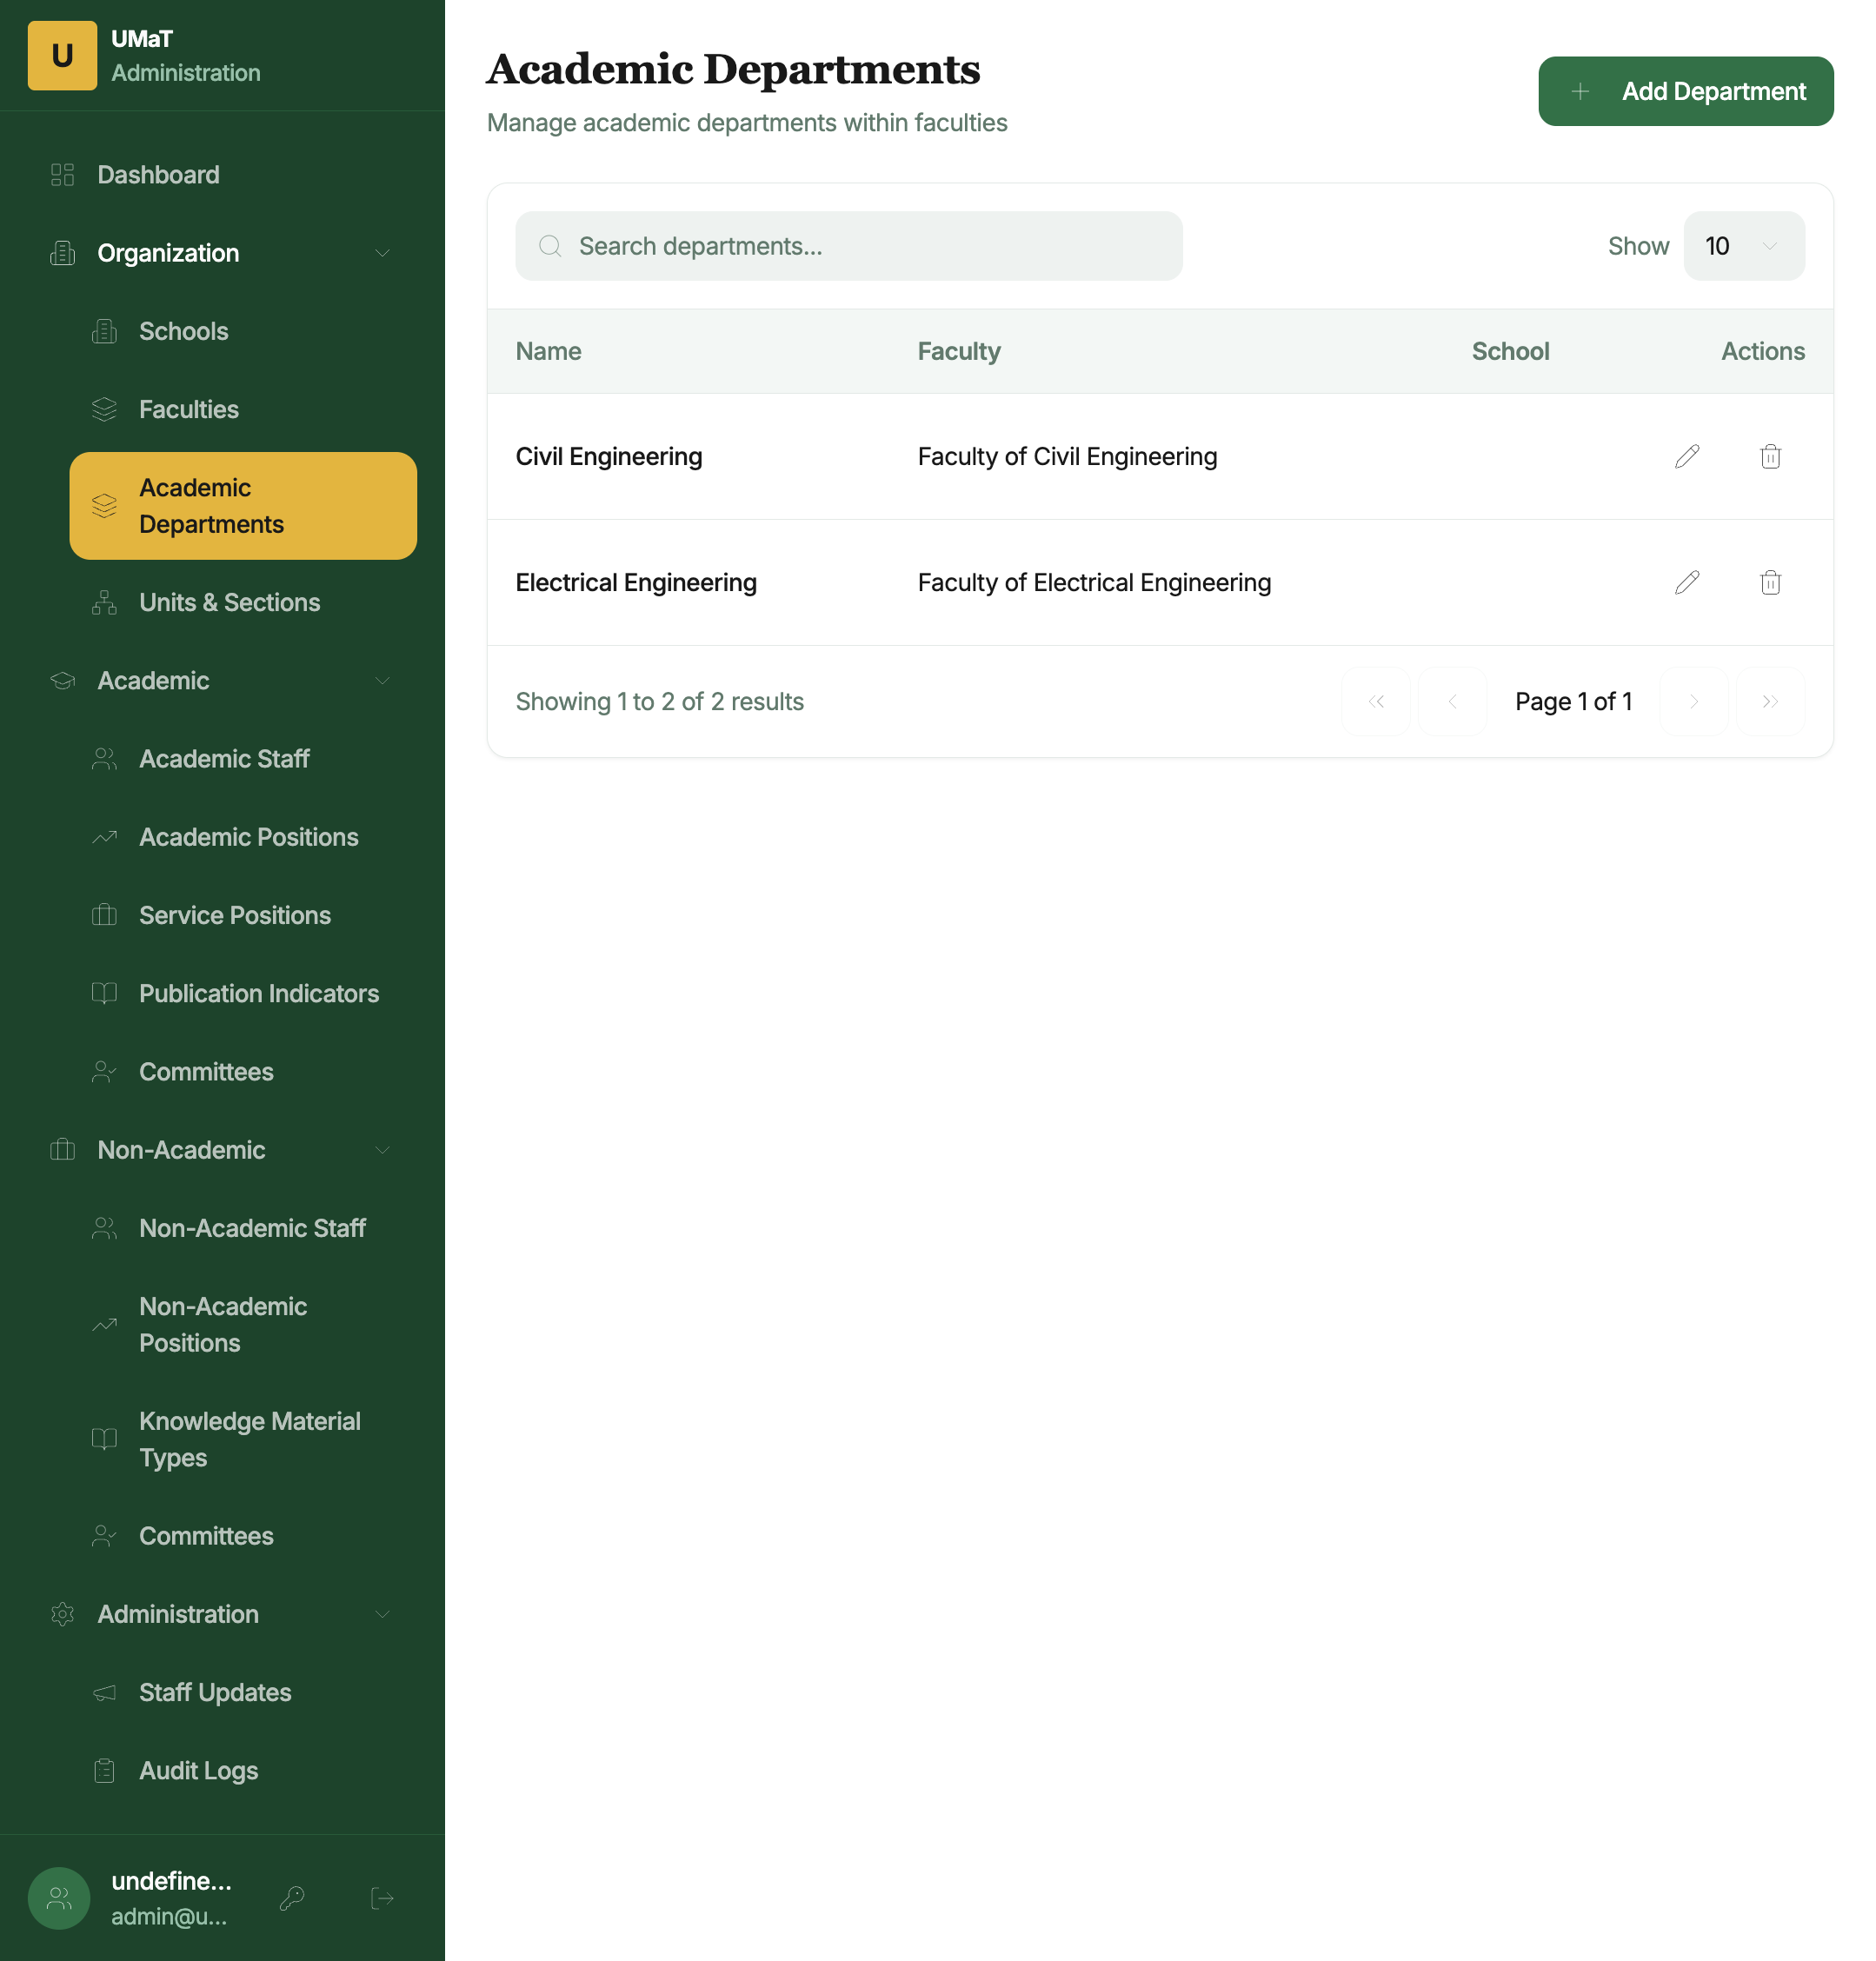
Academic Departments
How to access: Click Organization → Academic Departments.
Lists all academic departments with their parent Faculty.
To add a department: 1. Click + Add Department. 2. Enter the Department Name and select the Faculty. 3. Click Save.

4.4 Units & Sections
How to access: Click Organization → Units & Sections.
Manages non-academic units and sections (e.g., Registry, Finance Department, Security Unit). These are used for assigning non-academic staff to their organisational unit.
To add a unit/section: Click + Add Unit, enter the name and its parent group, and save.

5. Academic Management

5.1 Academic Staff
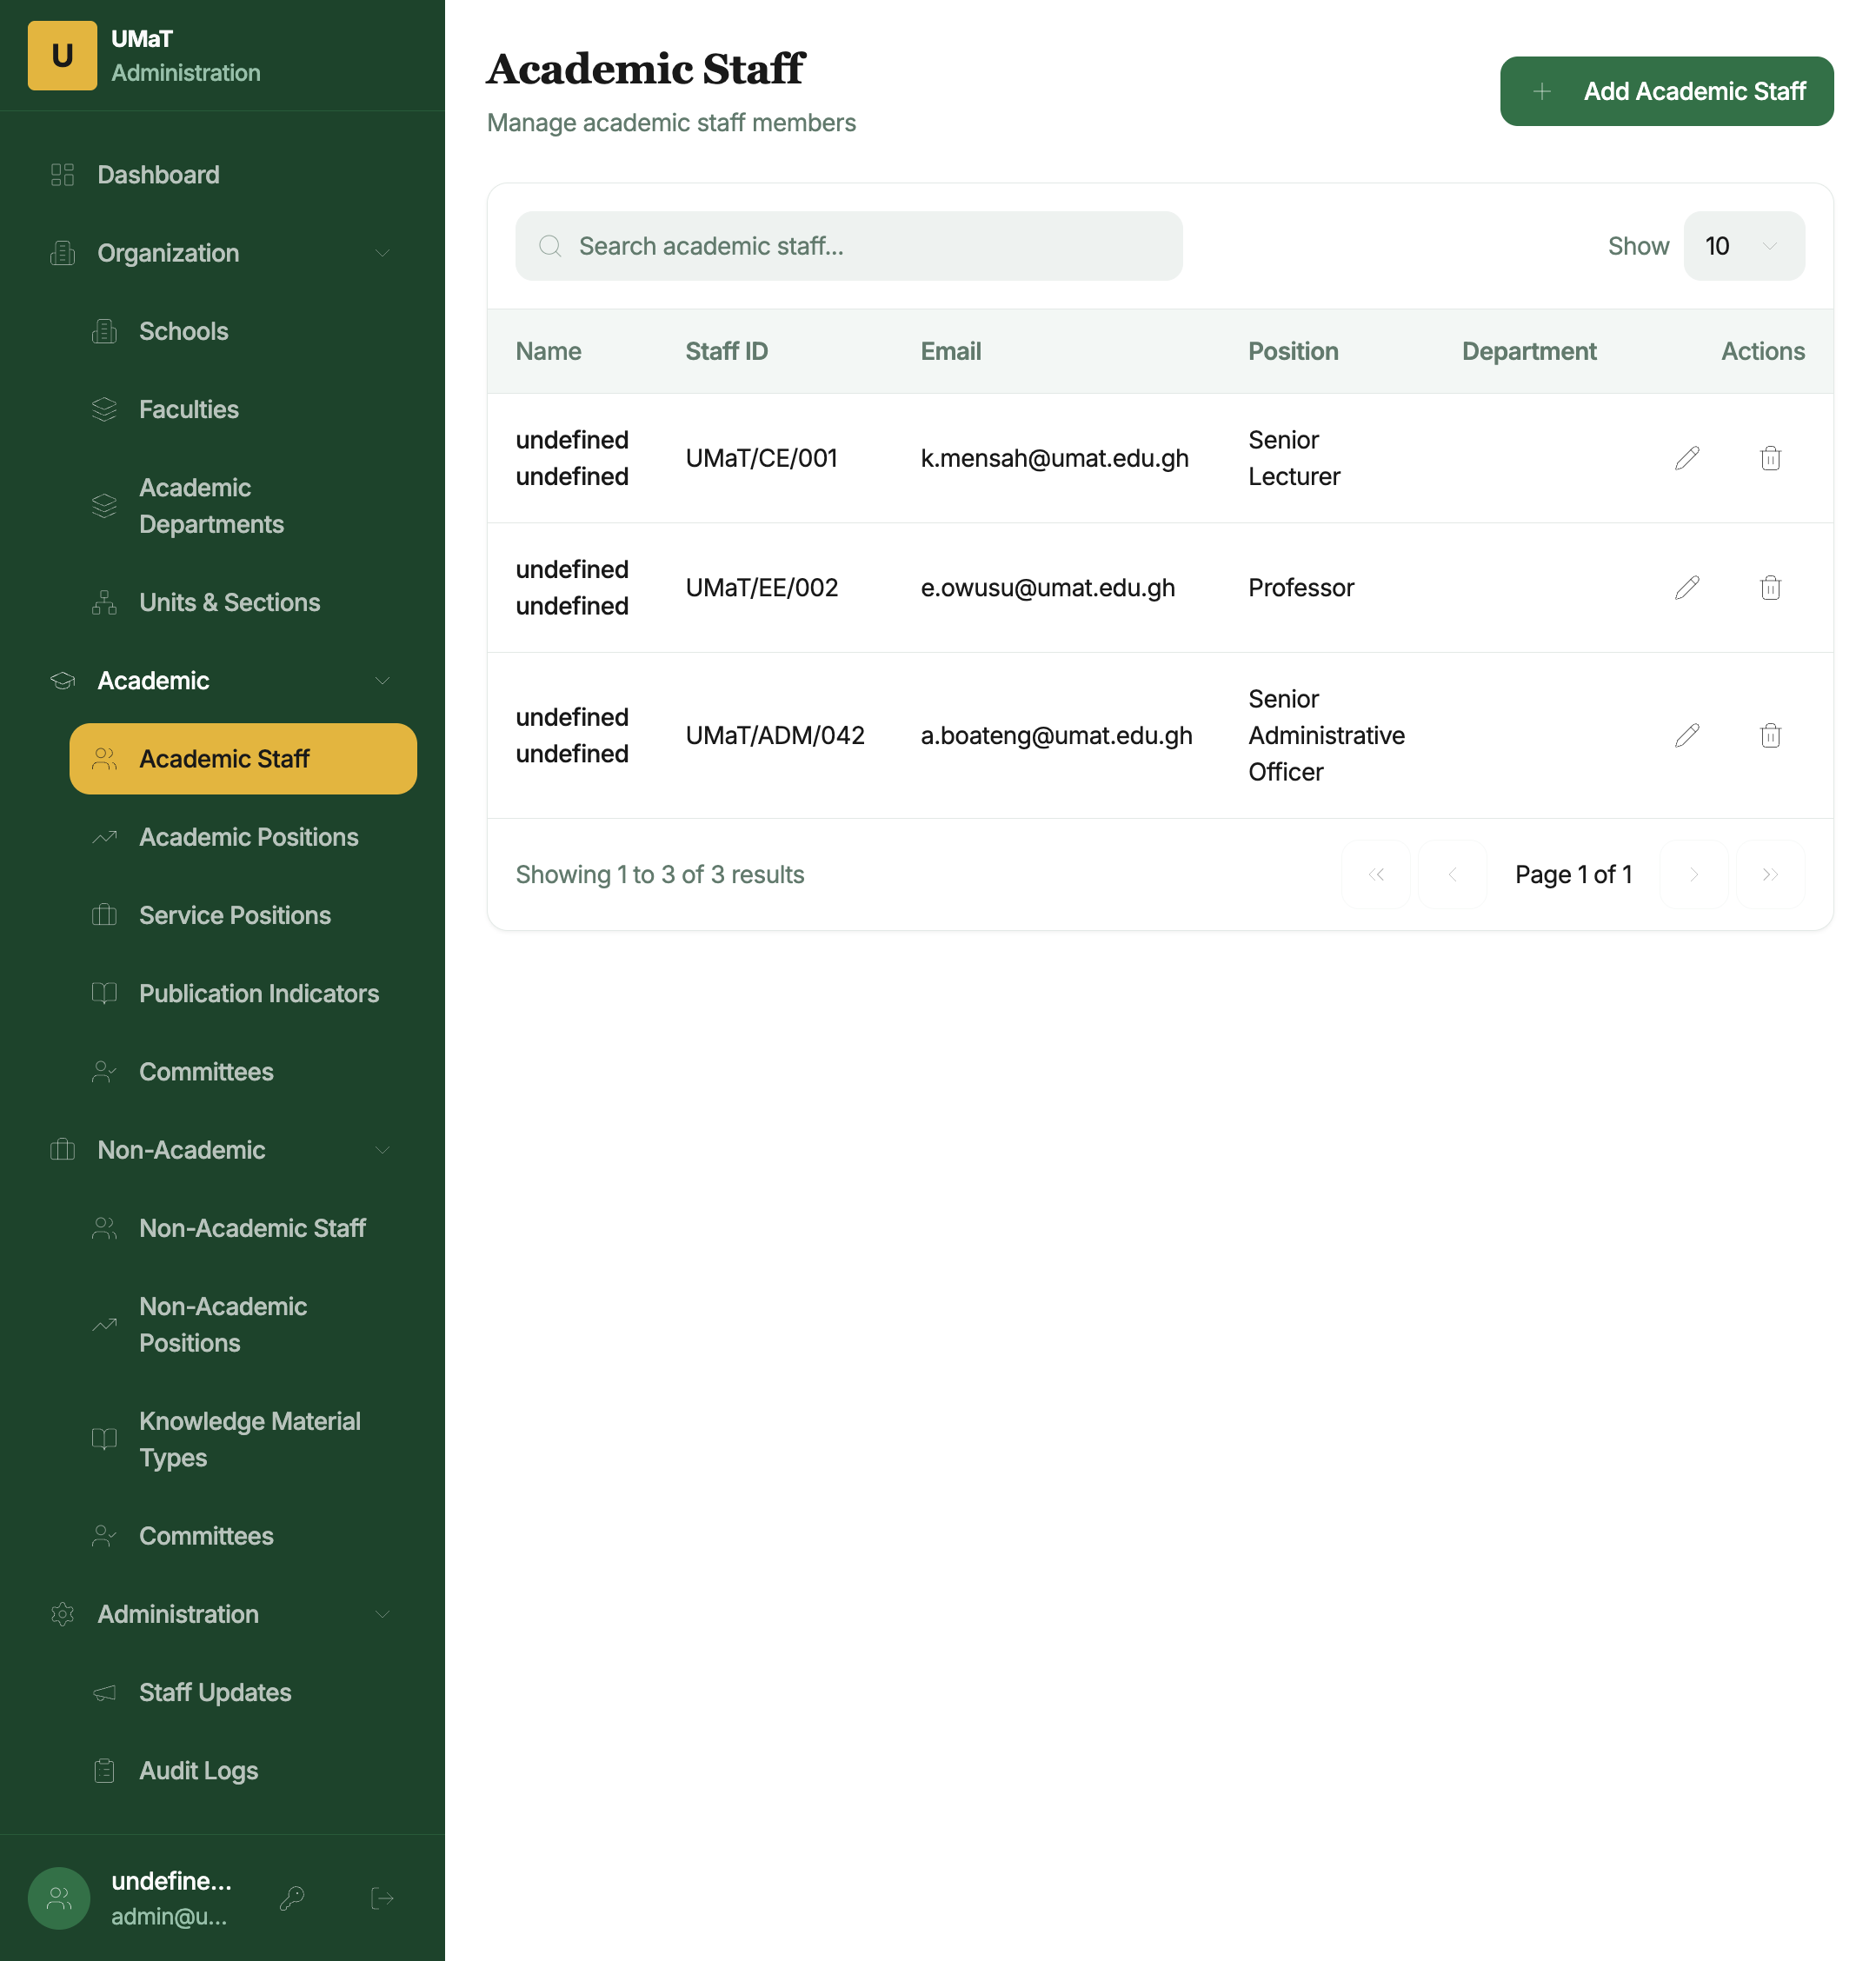
Academic Staff
How to access: Click Academic → Academic Staff.
The Academic Staff page lists all registered academic staff members in a searchable, paginated table.
Table columns: - Name — Full name of the staff member - Staff ID — University staff ID (e.g., UMaT/CE/001) - Email — Official university email - Position — Current academic position/rank - Department — Home department - Actions — Edit (✏) and Delete (🗑) buttons
To search: Use the search bar at the top of the table to filter by name or staff ID.
To adjust page size: Change the Show dropdown to view 10, 25, or 50 records per page.
To add a new academic staff member: 1. Click + Add Academic Staff. 2. Fill in the form with: Staff ID, First Name, Last Name, Email, Current Position, Department. 3. Click Save.
To edit a staff member: Click the pencil icon, make changes, and save.
To remove a staff member: Click the trash icon and confirm the deletion.
Note: Staff must be registered here before they can log in to the Academic Portal.

5.2 Academic Positions
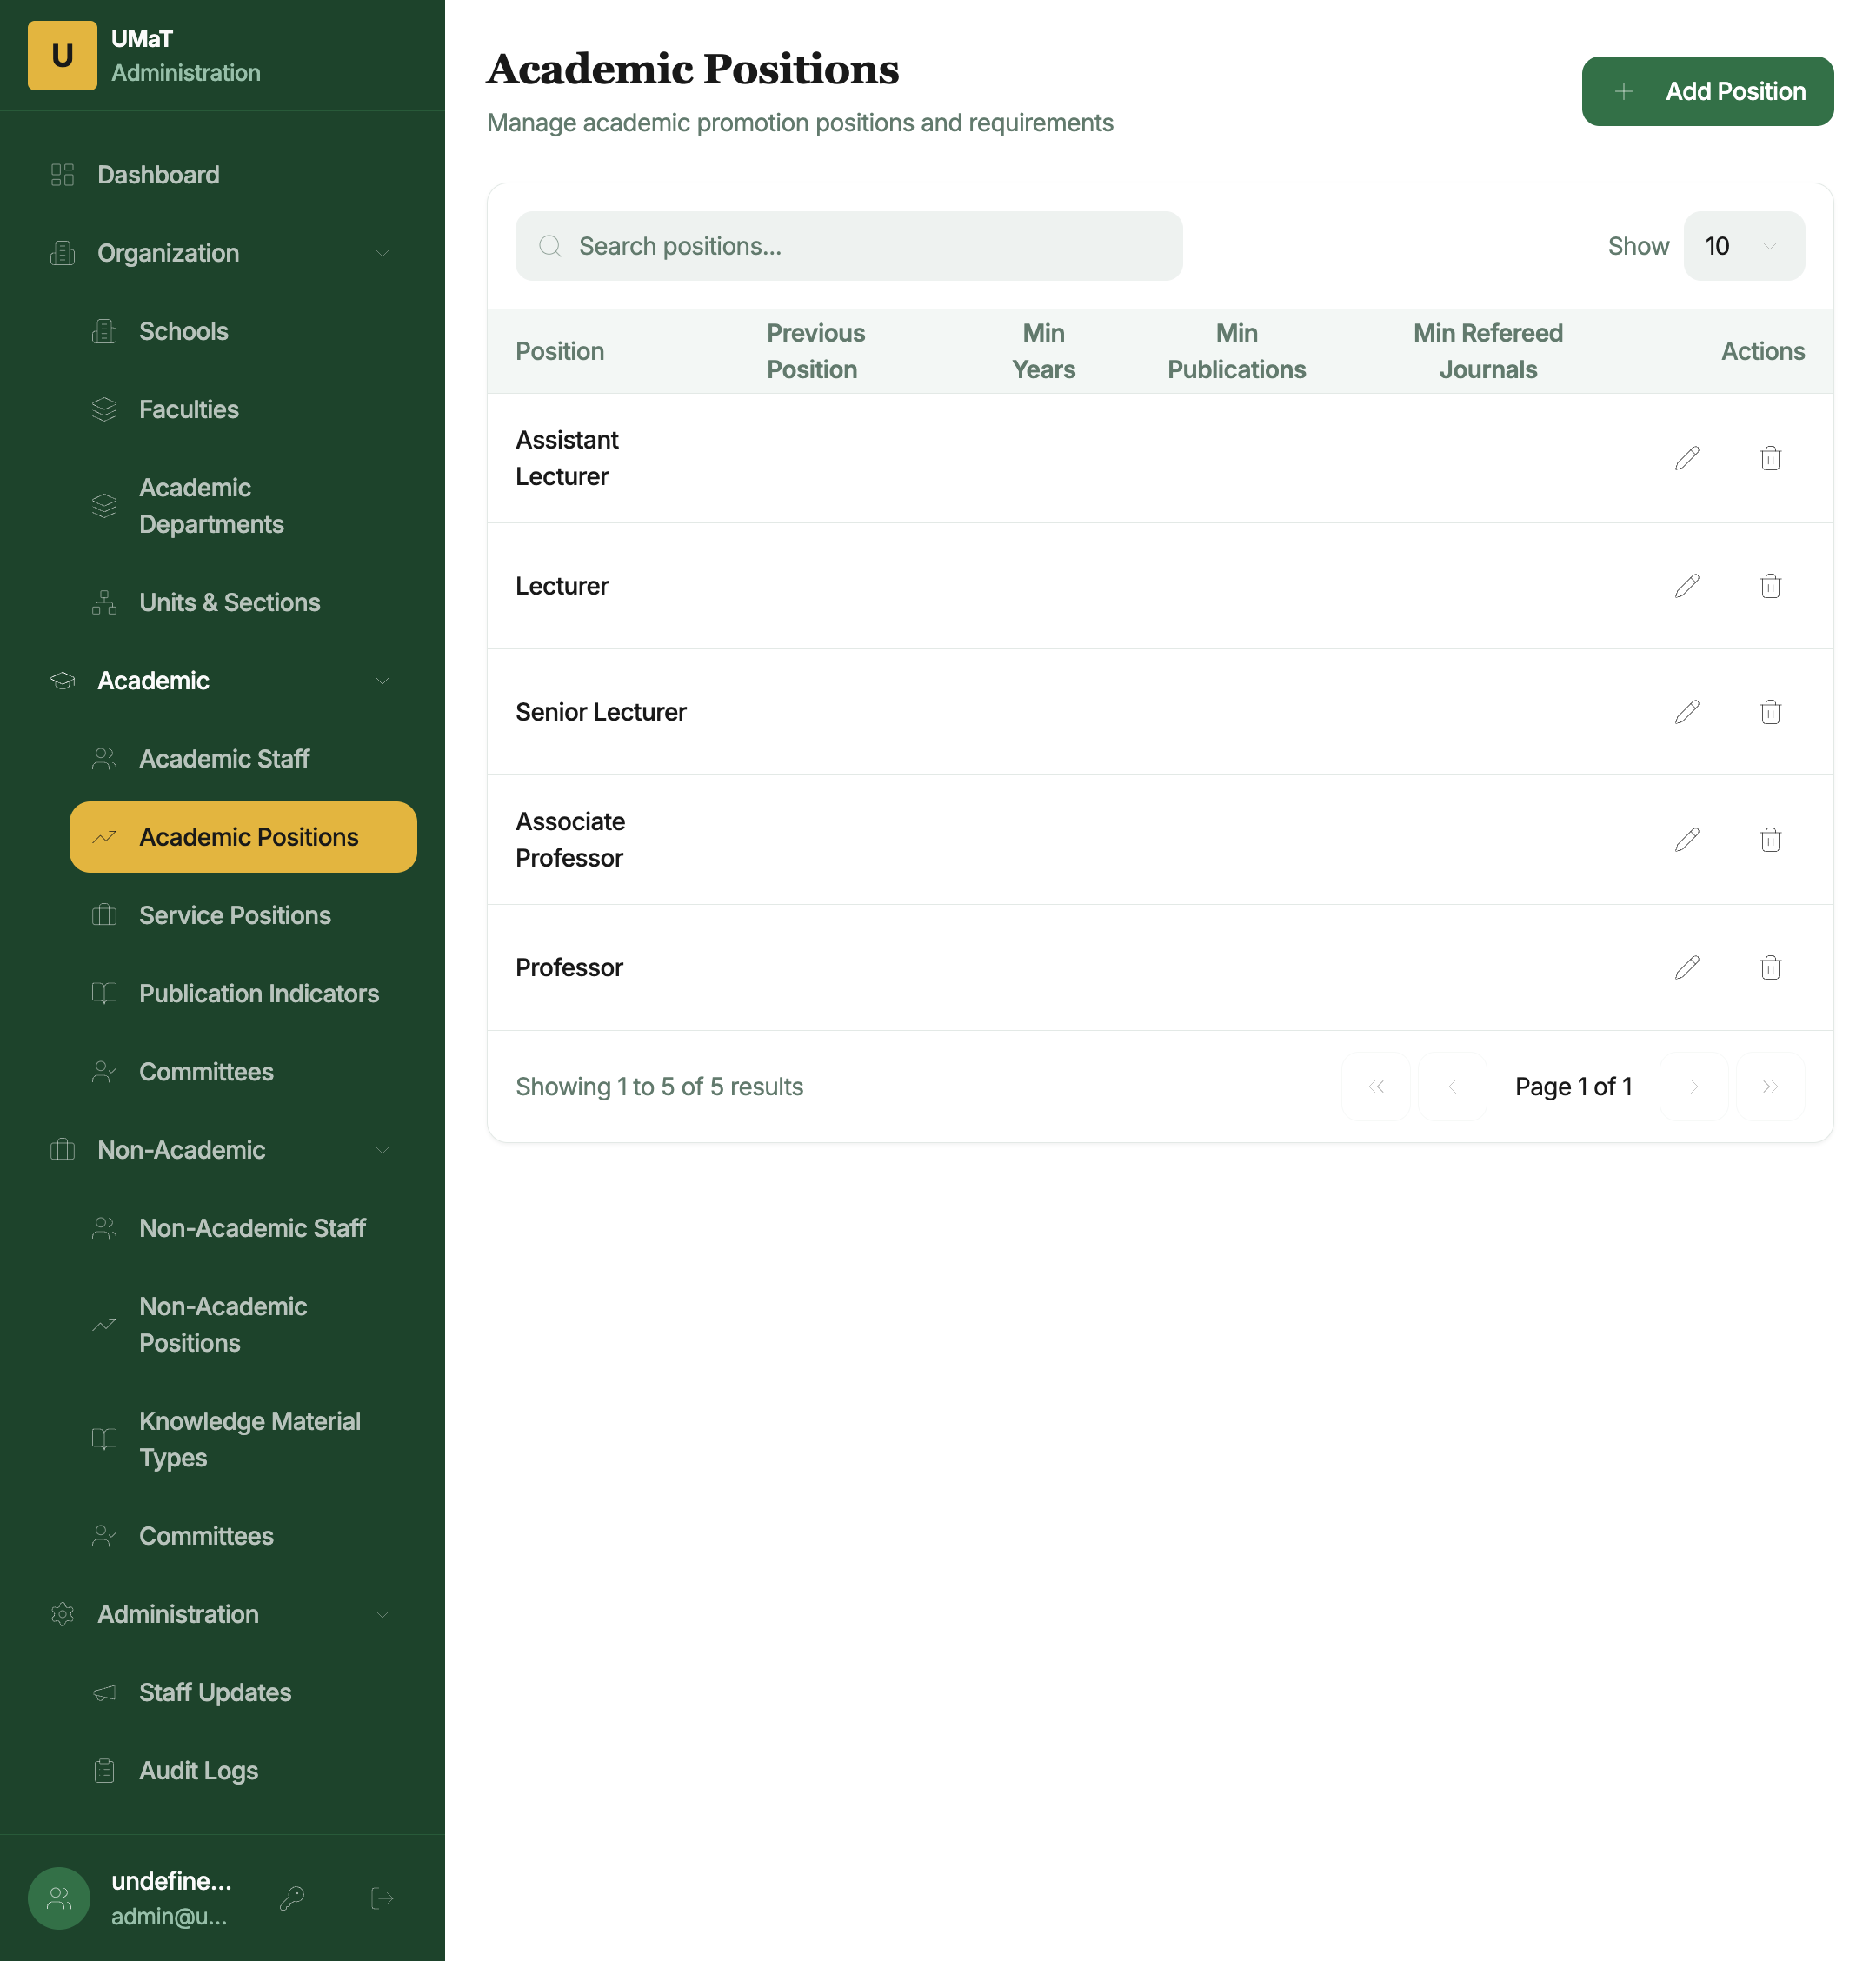
Academic Positions
How to access: Click Academic → Academic Positions.
Manages the hierarchy of academic promotion positions (e.g., Assistant Lecturer, Lecturer, Senior Lecturer, Associate Professor, Professor). Each position defines the eligibility criteria used by the promotion system.
Position details include: - Position name and rank order - Minimum years in current rank required - Required performance levels (Teaching, Publications, Service) - Minimum publication counts
To add a new position: Click + Add Position, fill in all required criteria fields, and save.

5.3 Service Positions
How to access: Click Academic → Service Positions.
Manages the service role types available for selection in the Service section of academic promotion applications (e.g., Head of Department, Senate Member, Faculty Board Member).
To add a service position type: Click + Add Service Position, enter the name, assign a score value, and save.

5.4 Publication Indicators
How to access: Click Academic → Publication Indicators.
Defines the publication types that academic staff can claim in their promotion application, and their respective score values.
Examples: - Scopus-Indexed Journal Article → 10 points - Web of Science Journal Article → 8 points - Conference Proceedings Paper → 4 points
To add a publication indicator: Click + Add Indicator, enter the indicator name and score, and save.

5.5 Academic Committees
How to access: Click Academic → Committees.
Manages membership of the three-tier academic promotion assessment committees:
Committee | Abbreviation | Scope
Department Academic Promotions Committee | DAPC | Department-level review
Faculty Academic Promotions Committee | FAPC | Faculty-level review
University Academic Promotions Committee | UAPC | University-level final review
Table columns: Staff Name, Staff ID, Email, Committee Type, Role (Chairperson / Member), Can Submit Reviewed Application, Department (for DAPC)
To add a committee member: 1. Click + Add Committee Member. 2. Select the Staff member, Committee Type, whether they are a Chairperson, and whether they can submit reviewed applications to the next level. 3. Click Save.

6. Non-Academic Management

6.1 Non-Academic Staff
How to access: Click Non-Academic → Non-Academic Staff.
Identical in layout to the Academic Staff page. Lists all non-academic staff with their staff ID, email, current position, and unit.
Register non-academic staff here before they can access the Non-Academic Promotion Portal.

6.2 Non-Academic Positions
How to access: Click Non-Academic → Non-Academic Positions.
Defines the non-academic position hierarchy and promotion eligibility criteria (e.g., Junior Administrative Officer → Senior Administrative Officer → Principal Administrative Officer).
Fields include: position name, grade level, minimum years, and required performance/knowledge/service levels.

6.3 Knowledge Material Types
How to access: Click Non-Academic → Knowledge Material Types.
Defines the types of academic qualifications and professional certifications that non-academic staff can claim in the Knowledge & Profession section of their application.
Examples: - Bachelor’s Degree → 5 points - Master’s Degree → 10 points - Professional Certificate → 5 points - Short Course Completion → 2 points
To add a knowledge material type: Click + Add Type, enter the name and point value, and save.

6.4 Non-Academic Committees
How to access: Click Non-Academic → Committees.
Manages membership for the two-tier non-academic promotion review committees:
Committee | Scope
Institutional Committee | Unit/section-level review
University Committee | University-level final review
Configuration follows the same steps as Academic Committees.

7. Administration

7.1 Staff Updates
How to access: Click Administration → Staff Updates.
Manage the announcements and notices displayed to staff in both the Academic and Non-Academic promotion portals.
Table columns: Title, Category (Announcement / Policy / Technical), Status (Visible / Hidden), Date Created
To publish a new update: 1. Click + Add Update. 2. Enter the Title, Content, and Category. 3. Toggle Visible to publish it immediately, or leave hidden to save as a draft. 4. Click Save.
To edit or hide an update: Use the edit icon to modify, or toggle the visibility switch to hide it from staff without deleting.

7.2 Audit Logs
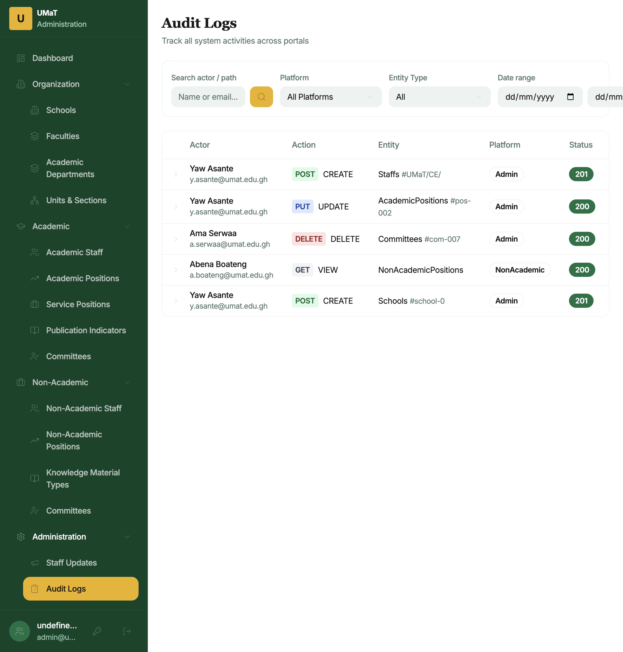
Audit Logs
How to access: Click Administration → Audit Logs.
The Audit Logs page provides a read-only record of all significant actions performed across the OSASS system. This is used for accountability, troubleshooting, and compliance.
Table columns:
Column | Description
Actor | Name and email of the user who performed the action
Action | HTTP method badge (POST, PUT, DELETE, GET) and action label (CREATE, UPDATE, DELETE, VIEW)
Entity | Entity type and ID affected by the action
Platform | Which portal/system the action originated from (Admin, Academic, NonAcademic)
Status | HTTP response status code badge (green for 2xx, red for 4xx/5xx)
Clicking a row expands it to show the full request path and IP address.
Filtering options: - Search — Filter by actor name or email - Platform — Filter by originating portal (All Platforms, Admin, Academic, NonAcademic) - Entity Type — Filter by the type of entity affected (Schools, Faculties, Staffs, Committees, Applications, etc.) - Date range — Filter logs by a specific date range (From / To)
Note: Audit logs are read-only and cannot be deleted or edited.

7.3 Administrators (SuperAdmin Only)
How to access: Click Administration → Administrators (visible to SuperAdmin role only).
Manages the list of administrator accounts that can log in to the Admin Portal.
To create a new administrator: 1. Click + Add Administrator. 2. Enter the Name, Email, and Role (Admin or SuperAdmin). 3. A temporary password will be sent to the email. 4. Click Save.
To deactivate an administrator: Use the edit action to update their status.
Security: Only SuperAdmins can create other SuperAdmins. Use SuperAdmin accounts sparingly.

8. Account Management

8.1 Change Password
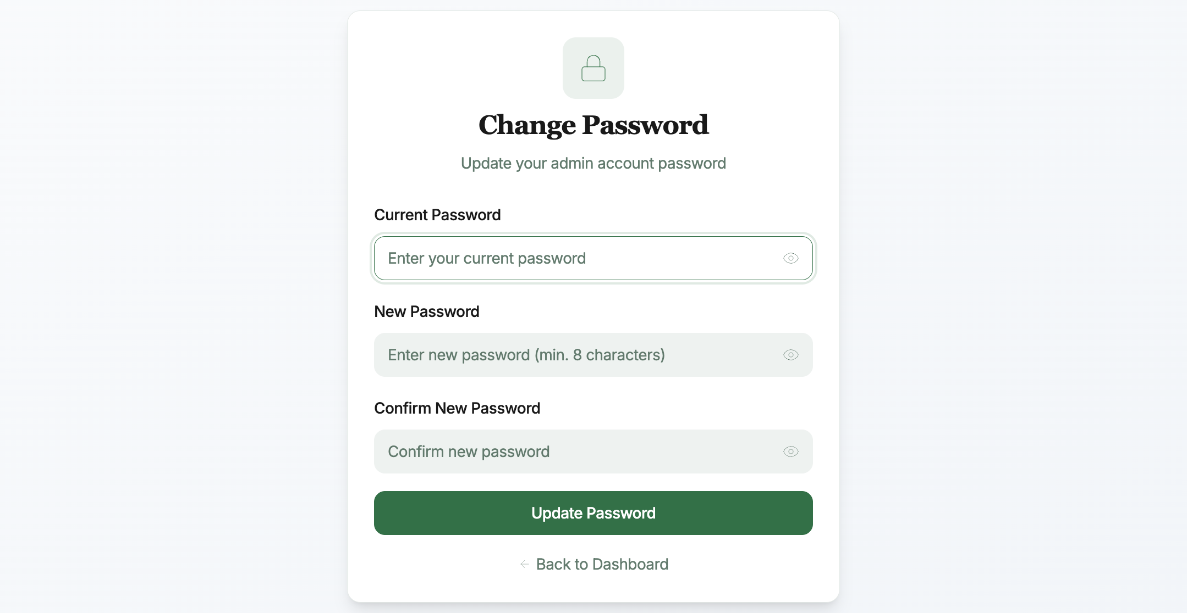
Change Password
How to access: Click the key icon (🔑) in the bottom-left user profile area, or navigate to Change Password.
Steps: 1. Enter your Current Password. 2. Enter and confirm your New Password (minimum 8 characters). 3. Click Update Password. 4. Click Back to Dashboard to return.

9. Navigation & Layout

Left Sidebar
The sidebar is organized into five collapsible groups:
Group | Items
Dashboard | System overview and stats
Organization | Schools, Faculties, Academic Departments, Units & Sections
Academic | Academic Staff, Academic Positions, Service Positions, Publication Indicators, Committees
Non-Academic | Non-Academic Staff, Non-Academic Positions, Knowledge Material Types, Committees
Administration | Staff Updates, Audit Logs, Administrators (SuperAdmin only)
The active page is highlighted in amber/gold in the sidebar. The UMaT logo (“U”) and “Administration” label appear at the top of the sidebar.
At the bottom of the sidebar, your admin name and email are displayed with two action buttons: - Key icon (🔑) — Change Password - Sign out icon (→) — Log out

All Management Pages — Common Layout
Every management list page (Schools, Faculties, Staff, etc.) follows the same layout pattern:
- Page header — Title and description
- Action button — + Add [Item] in the top right
- Search bar — Filter the table by name/keyword
- Data table — Columns vary by entity; always includes Name/ID and Actions
- Pagination — Page navigation at the bottom of the table with total count

Add/Edit Dialogs
Clicking + Add or the edit icon opens a modal dialog or a slide-over panel for entering the form data. All dialogs have: - Input fields with validation - Save / Update button - Cancel button to dismiss without changes

10. Role Permissions Reference
Feature | Admin | SuperAdmin
Dashboard | ✅ | ✅
Organization management | ✅ | ✅
Academic management | ✅ | ✅
Non-Academic management | ✅ | ✅
Staff Updates | ✅ | ✅
Audit Logs | ✅ | ✅
Administrators page | ❌ | ✅
Create SuperAdmin accounts | ❌ | ✅

For technical support: support@umat.edu.gh
For system access or role changes, contact your IT Administrator.

Document generated: May 2025 | OSASS v2

