OSASS Non-Academic Assessment Portal — User Manual
System: Online Staff Appointment & Promotion System (OSASS)
Portal: Non-Academic Promotion Assessment Portal
Audience: Non-academic staff serving on Non-Academic Promotion Assessment Committees (Institutional / University)
Version: 1.0 | May 2025

Table of Contents
- Overview
- Getting Started
  - Logging In
  - Forgot Password
- Dashboard
- Pending Applications
- Application Review
  - Applicant Information
  - Performance at Work Assessment Tab
  - Knowledge & Profession Assessment Tab
  - Service Assessment Tab
  - Performance Overview Panel
  - Activity Timeline
  - Assessment Actions
- Application History
- Account Management
  - Change Password
- Navigation & Layout
- Committee Roles & Permissions

1. Overview
The OSASS Non-Academic Assessment Portal is the dedicated review portal for non-academic staff who serve as members of Non-Academic Promotion Assessment Committees. These committees review and score promotion applications submitted by non-academic staff in the Non-Academic Promotion Portal.
The non-academic promotion review process involves two levels:
Level | Committee | Scope
1 | Institutional Committee (HOU / AAPSC) | Unit/section-level review
2 | University Committee (UAPC) | University-level final review
The Chairperson of each committee has the authority to advance applications to the next level, return them to the applicant for corrections, and — at the University Committee level — approve or reject applications.
Key difference from the Academic Assessment Portal: The three scored categories in this portal are Performance at Work, Knowledge & Profession, and Service (instead of Teaching, Publications, and Service).

2. Getting Started

2.1 Logging In
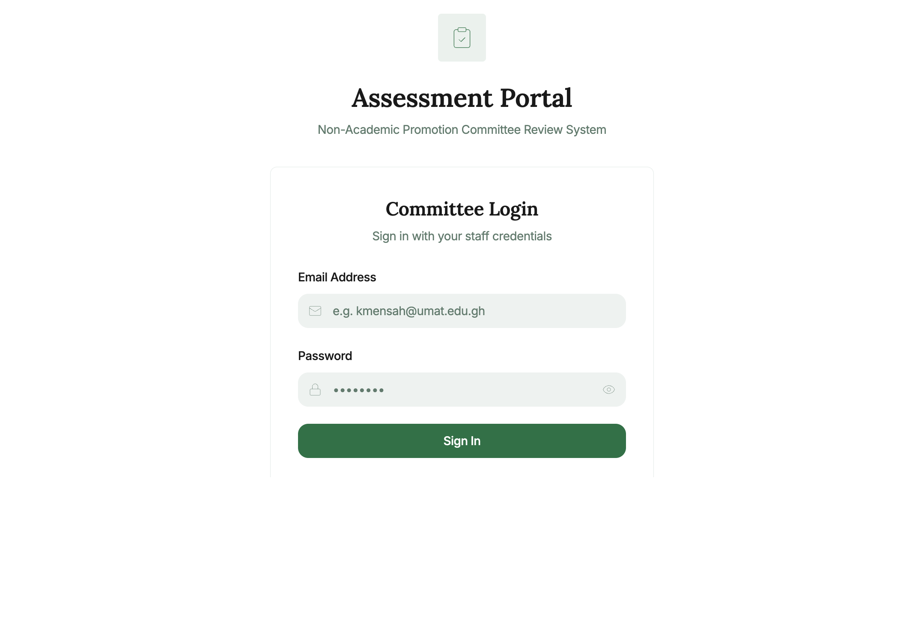
Login Page
Steps to log in:
- Navigate to the Non-Academic Assessment Portal URL.
- Enter your Staff Email (e.g., k.agyeman@umat.edu.gh).
- Enter your Password.
- Click Sign In.
Successful login redirects to your Dashboard.
Note: Access is restricted to staff registered as committee members in the Admin Portal. Contact the HR Office if you need access.

2.2 Forgot Password
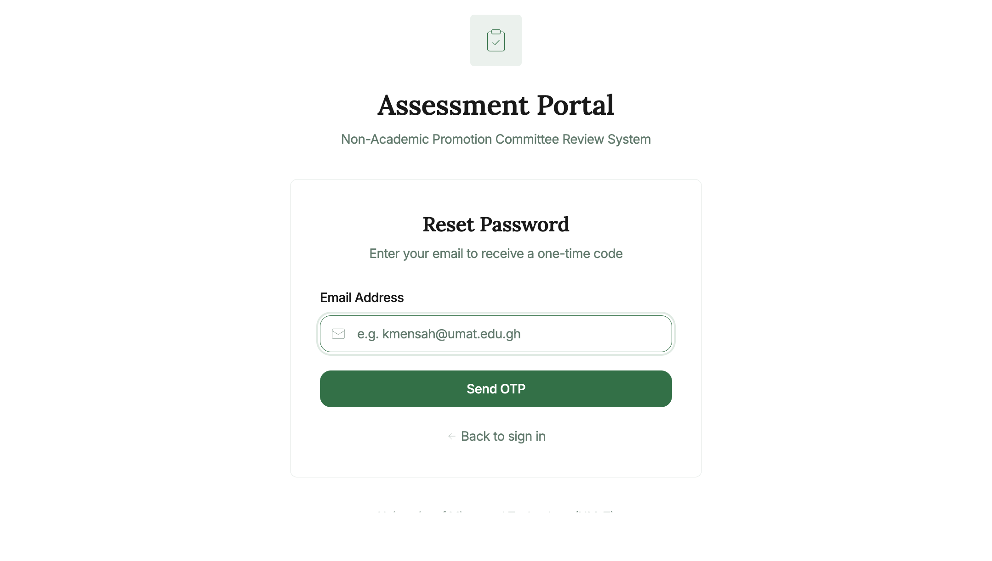
Forgot Password
- Click “Forgot password?” on the login page.
- Enter your registered email and click Send OTP.
- Retrieve the one-time code from your email.
- Enter the OTP, set a new password, and confirm.
- Click Back to sign in.

3. Dashboard

Dashboard
The Dashboard displays your committee assignments as cards. Each card shows:
Element | Description
Committee name | e.g., “Institutional” or “University”
Full committee title | e.g., “Head of Unit Committee” or “University Assessment Committee”
Chair badge | Shown if you are the Chairperson
Pending Applications | Link with count badge
View History | Link to reviewed applications
Example: Mr. Kofi Agyeman, serving as Chairperson of the Institutional Committee, sees an “Institutional” card with a “Chair” badge and a pending applications count.

4. Pending Applications
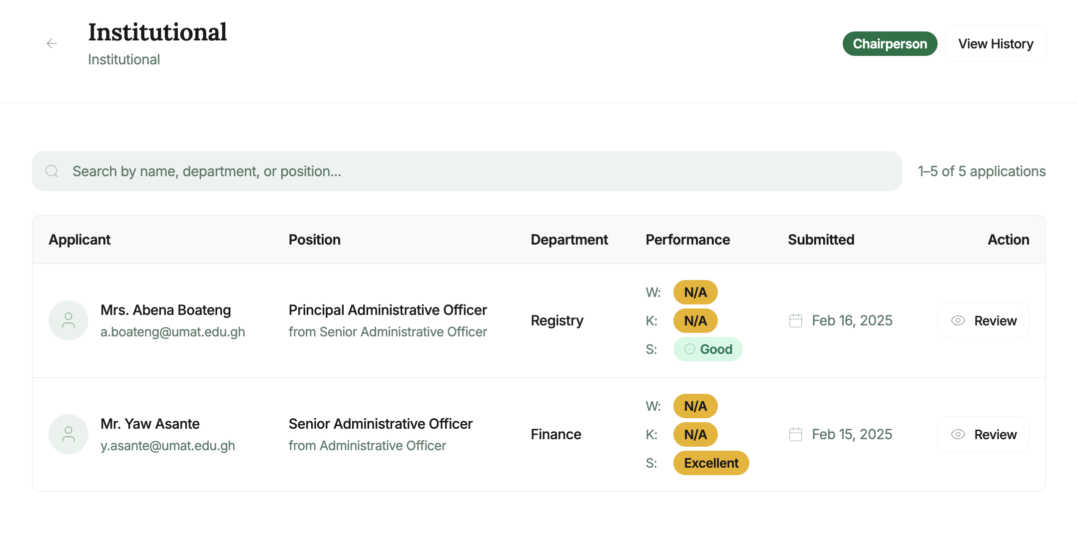
Pending Applications
How to access: Click Pending Applications on a committee card.
Lists all non-academic promotion applications forwarded to your committee for review.
Table columns:
Column | Description
Applicant Name | Full name of the non-academic staff member applying
Current Position | Applicant’s current non-academic rank/grade
Applying For | Target promotion position
Unit | The applicant’s home unit or section
Submission Date | Date the application was submitted
Status | Review status (Pending / In Progress)
Resubmission indicator | Badge if the application was previously returned
To search: Use the search bar to filter by name or staff ID.
To review an application: Click anywhere on the application row.

5. Application Review
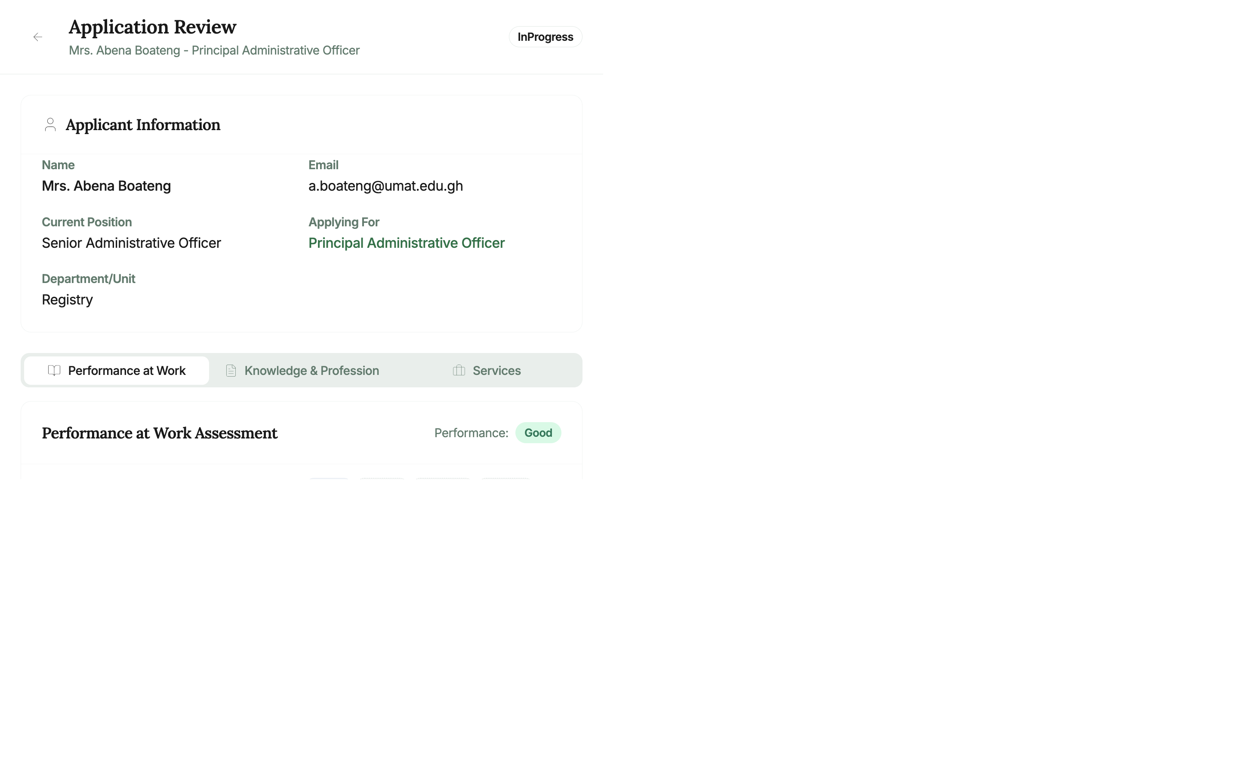
Application Review
The Application Review page shows the full details of the non-academic promotion application with three assessment tabs corresponding to the three scoring categories.

5.1 Applicant Information
A card at the top of the page shows: - Name and Email - Current Position and Applying For (promotion target) - Unit (the applicant’s institutional unit or section) - Submission date and current Review Status badge (e.g., InProgress)

5.2 Performance at Work Assessment Tab
The Performance at Work tab (active by default) shows the applicant’s self-assessment across work performance categories.
Assessment categories include (subset shown depending on configuration): - Quality of Work - Punctuality & Regularity - Knowledge of Procedures - Ability to Work Independently - Ability to Work Under Pressure - Human Relations - Initiative & Foresight - Ability to Inspire and Motivate
For each category: - Applicant’s self-score and remarks (expand the row to view) - Score input fields for each committee level (Institutional / University) - Score badge indicators showing the score each committee has entered
If you have assessment rights: 1. Expand the category accordion row (click the row or › chevron). 2. In the score input panel for your committee level, enter a numeric score. 3. Add optional remarks.

5.3 Knowledge & Profession Assessment Tab
Click the Knowledge tab to review the applicant’s qualifications and professional certifications.
For each qualification/certificate item: - Title (e.g., Master of Business Administration) - Year awarded and material type (e.g., Master’s Degree, Professional Certificate) - System-Generated Score (based on the knowledge material type’s configured point value) - Committee score badges (Institutional / University) - Expand to enter your committee’s assessment score

5.4 Service Assessment Tab
Click the Service tab to review the applicant’s institutional service records.
For each service record: - Service title, role, and duration - System-generated score - Committee score badges - Expand to enter your assessment

5.5 Performance Overview Panel
On the right side of the review page, the Performance Overview panel summarises all scores:
Category | Columns shown
Performance at Work | SELF, Institutional (HOU), University (AAPSC/UAPC) totals
Knowledge & Profession | Same format
Service | Same format
Each score box shows the numeric total and a performance level label: - 🟢 High — Top performance range - 🔵 Good — Second range - 🟡 Adequate — Meets minimum - 🔴 Inadequate — Below minimum

5.6 Activity Timeline
Scroll down the right panel to see the Activity Timeline — a chronological history of all events: - Application submitted - Received by Institutional Committee - Any returns and resubmissions - Committee score entries and advancements

5.7 Assessment Actions
For non-chairperson committee members: - Save Scores — Save your entered scores without finalising the review
For chairpersons (additional actions):
Action | Description
Save Scores | Save the committee’s full assessment
Return to Applicant | Return with written reason for correction
Advance to University Committee | Forward the reviewed application to the University-level committee
Approve (University Committee only) | Grant the promotion
Reject (University Committee only) | Reject with a written reason
How to advance an application: 1. Ensure all scoring is complete. 2. Click “Advance to University Committee”. 3. Enter your recommendation in the dialog. 4. Click Confirm.
How to return an application: 1. Click “Return to Applicant”. 2. Specify the return reason and what corrections are needed. 3. Click Confirm Return.

6. Application History
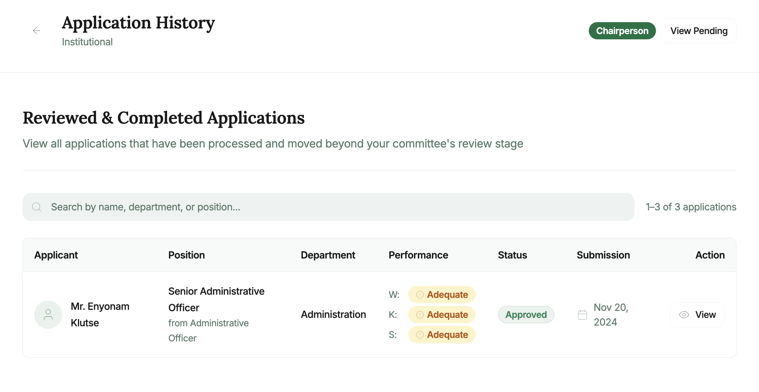
History
How to access: Click View History on a committee card.
Shows all applications previously reviewed at this committee level, including: - Applicant name and position - Review outcome (Advanced / Approved / Rejected / Returned) - Review date and performance scores

7. Account Management

7.1 Change Password
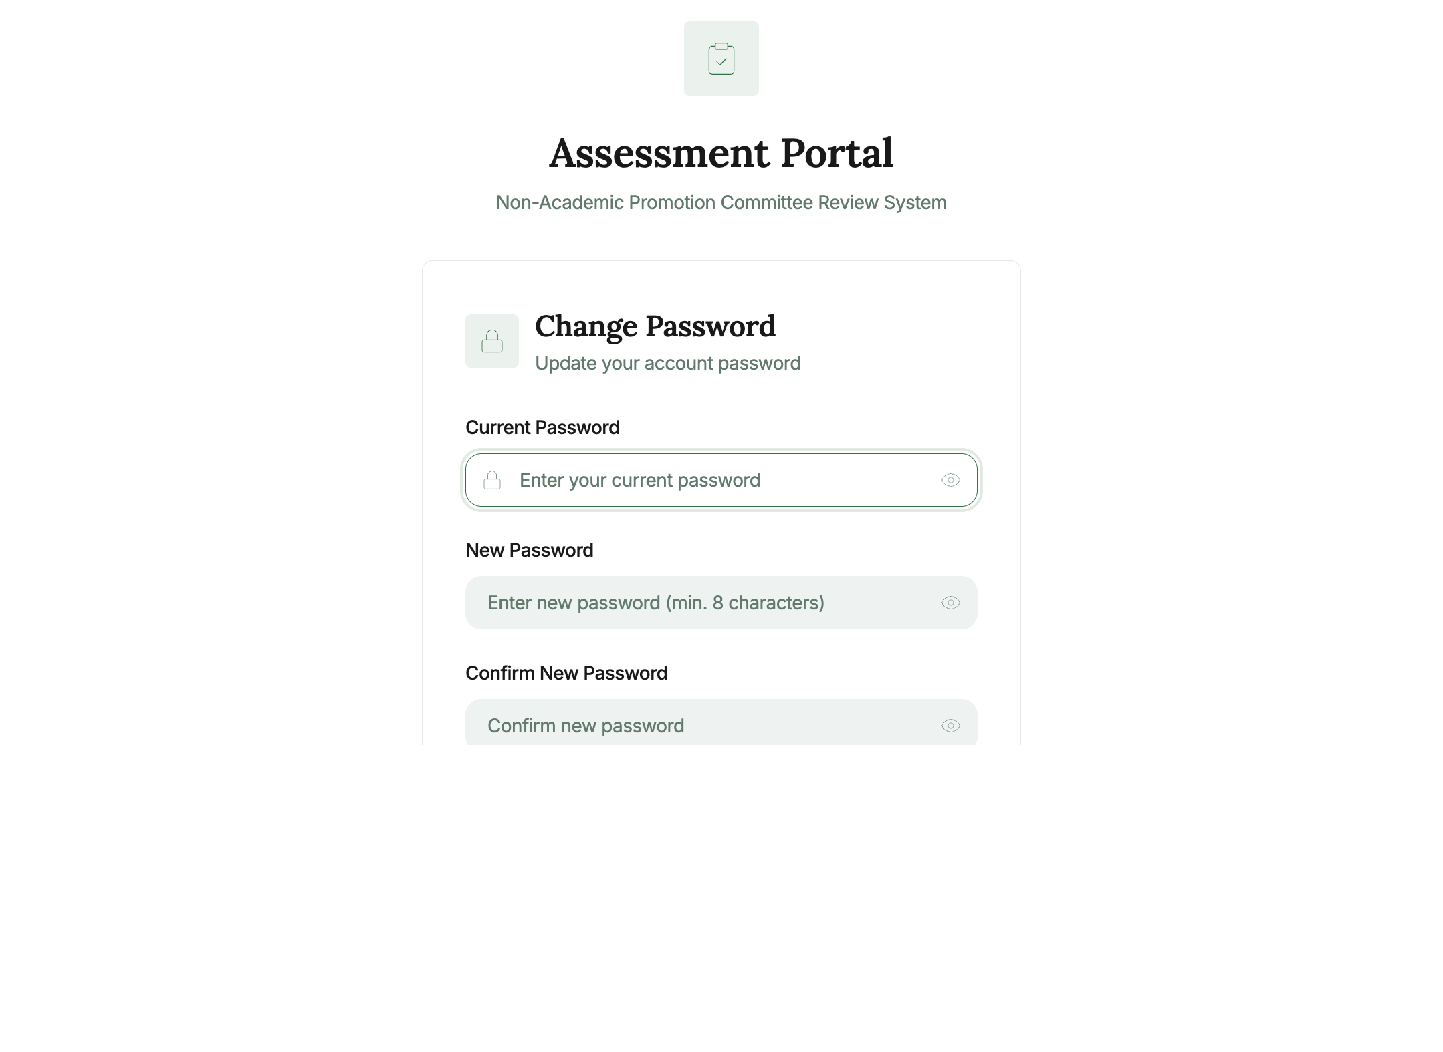
Change Password
How to access: Click the user icon in the top right and select Change Password.
- Enter your Current Password.
- Enter and confirm your New Password.
- Click Update Password.

8. Navigation & Layout

Top Header Bar
- Portal title (“Assessment Portal”) and subtitle (“Non-Academic Promotion Committee”) on the left
- Your name in the top right

Back Navigation
- A back arrow (←) on review and list pages returns you to the previous screen.

9. Committee Roles & Permissions
Permission | Committee Member | Chairperson
View pending applications | ✅ | ✅
View application review details | ✅ | ✅
Enter assessment scores | ✅ | ✅
Save score drafts | ✅ | ✅
Return application to applicant | ❌ | ✅
Advance to University Committee | ❌ | ✅
Approve application (University) | ❌ | ✅
Reject application (University) | ❌ | ✅
View application history | ✅ | ✅

For technical support: support@umat.edu.gh
For committee assignment queries, contact the Human Resources / Non-Academic Promotion Office.

Document generated: May 2025 | OSASS v2

