OSASS Non-Academic Promotion Portal — User Manual
System: Online Staff Appointment & Promotion System (OSASS)
Portal: Non-Academic Staff Promotion Portal
Audience: Non-Academic Staff of the University of Mines and Technology (UMaT), Tarkwa
Version: 1.0 | May 2025

Table of Contents
- Overview
- Getting Started
  - Logging In
  - Forgot Password
- Dashboard
- Eligibility Check
- Promotion Forecast
- Promotion Application
  - Application Overview
  - Performance at Work Section
  - Knowledge & Profession Section
  - Service Section
  - Review & Submit
- Application Progress Tracking
- Promotion History
- Promotion Letter
- Staff Updates
- Resources
- Account Management
  - Settings
  - Change Password
- Navigation & Layout

1. Overview
The OSASS Non-Academic Promotion Portal is the dedicated web application for UMaT non-academic staff to apply for career promotion. It mirrors the Academic Portal in structure but is tailored to the specific scoring criteria and career path of non-academic roles — including administrative, technical, and support staff categories.
Key capabilities: - Check promotion eligibility in real time - Plan your career progression with the Promotion Forecast tool - Build and submit a promotion application across three scored categories: Performance at Work, Knowledge & Profession, and Service - Track the review progress through institutional review committees - Download your official promotion letter upon approval

2. Getting Started

2.1 Logging In
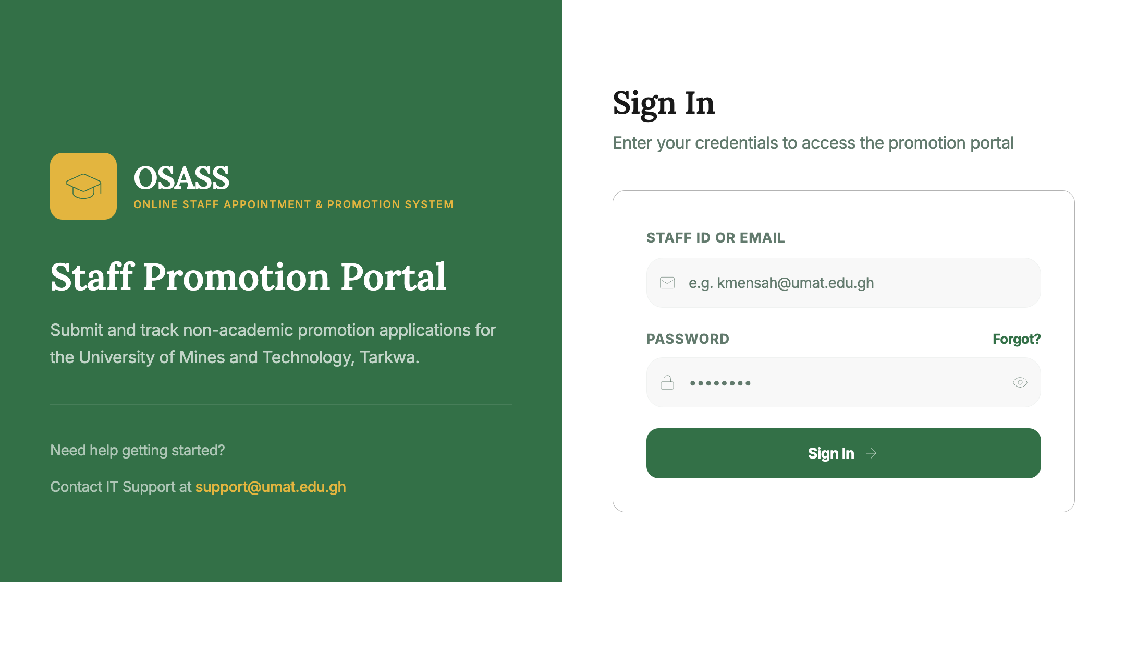
Login Page
Steps to log in:
- Navigate to the Non-Academic Portal URL. The Sign In page loads immediately.
- Enter your Staff ID or Email (e.g., a.boateng@umat.edu.gh).
- Enter your Password.
- Click the Sign In button.
On a successful login, you will be redirected to the Dashboard.
Note: If you have not received your credentials, contact the Human Resources Office or IT Support at support@umat.edu.gh.

2.2 Forgot Password
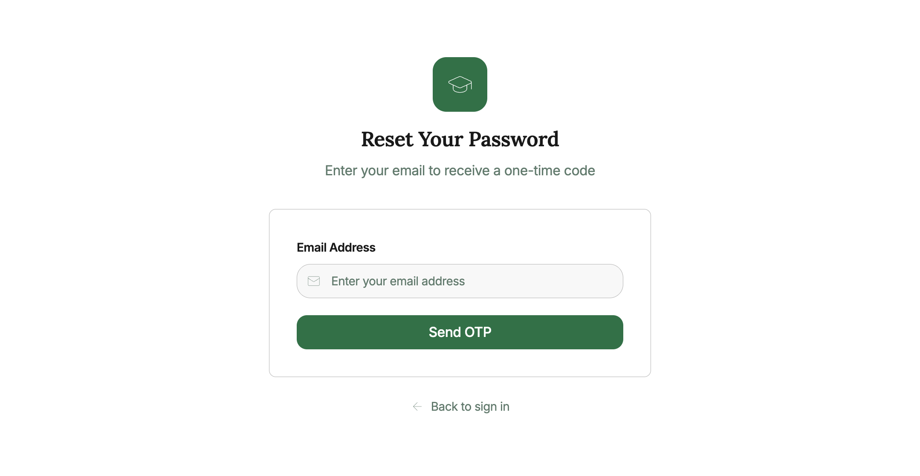
Forgot Password
- Click “Forgot password?” on the login page.
- Enter your registered Email Address and click Send OTP.
- Check your email for the one-time code.
- Use the OTP and set a new password when prompted.
- Click Back to sign in once complete.

3. Dashboard
The Dashboard is your central hub after signing in, providing an overview of your promotion status and quick access to all portal features.
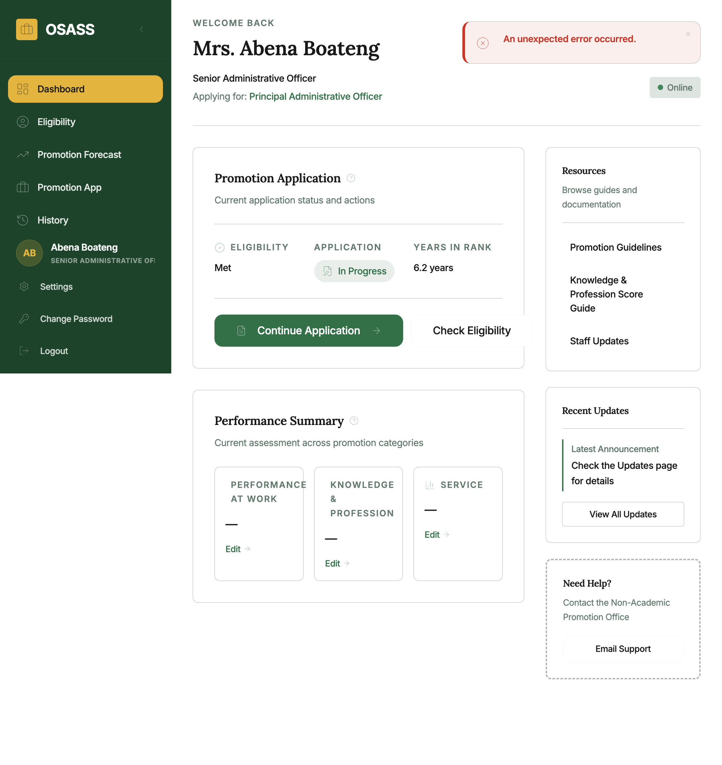
Dashboard
Dashboard sections:
Section | Description
Welcome Back | Your name, current position, and the target position you are applying for
Promotion Application card | Eligibility status, application status badge, and years in rank. Provides the primary action button (Start / Continue / View Status / View Letter)
Performance Summary card | Current scores across Performance at Work, Knowledge & Profession, and Service with quick “Edit” links
Resources panel | Quick links to Promotion Guidelines, Score Guide, and Staff Updates
Recent Updates | Preview of the latest staff announcement
Need Help? | Contact details for the Non-Academic Promotion Office
First-time onboarding: A Welcome to OSASS banner appears on first login explaining the portal’s three key actions. Click “Got it, let me explore” to dismiss it.

4. Eligibility Check
Before starting an application, verify that you meet all promotion criteria on the Promotion Eligibility Assessment page.
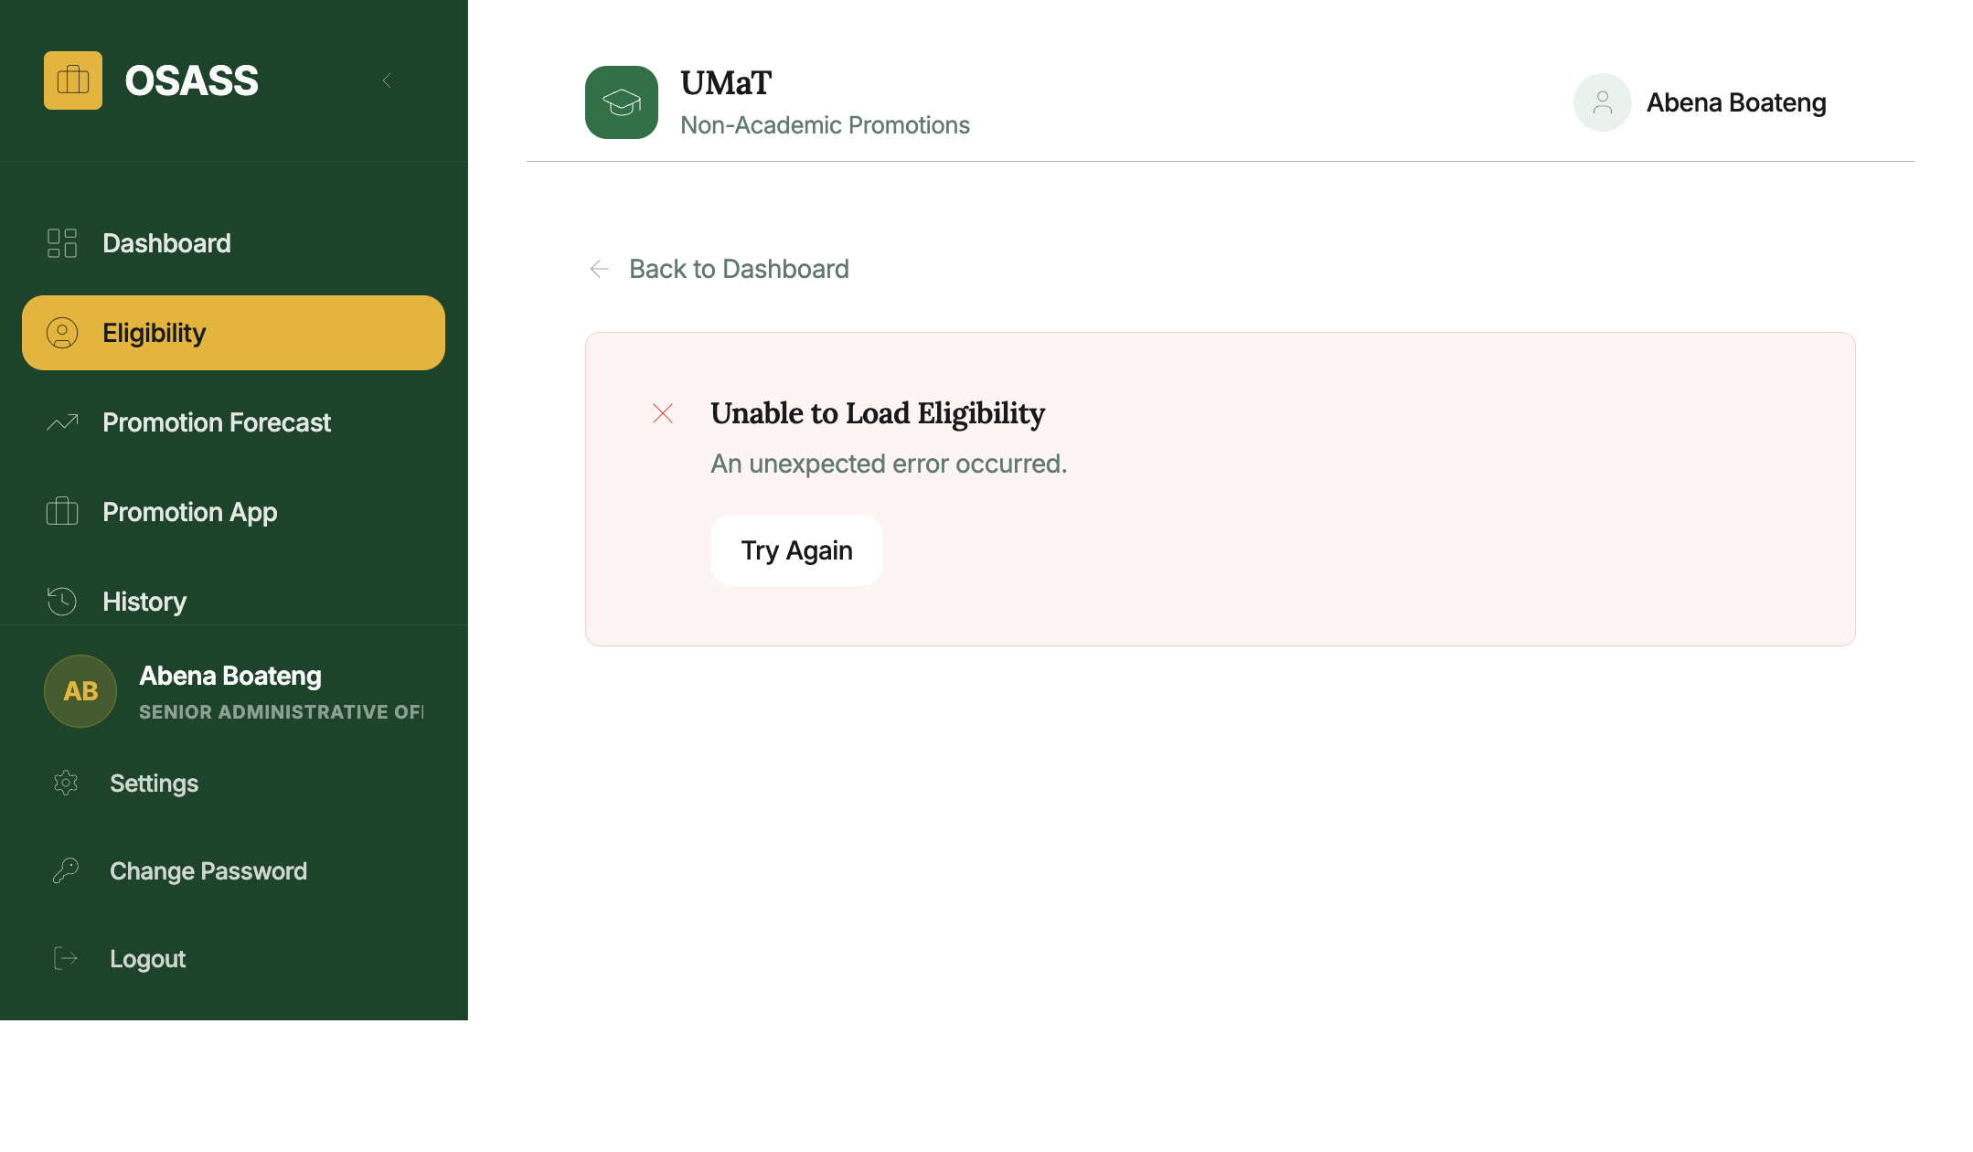
Eligibility
How to access: Click Eligibility in the left sidebar.
What the page shows:
Section | Description
Overall status banner | Green (Eligible) or Amber (Action Required) with a summary message
Years in Current Rank | Progress bar showing years served vs. minimum required (e.g., 6.2 / 5 means 6.2 years against a 5-year minimum — requirement met)
Performance Requirements | Submitted performance levels across Performance at Work, Knowledge, and Service; indicates whether the required performance combination has been achieved
Knowledge Requirements | Whether minimum qualifications or certificates have been submitted
What to do: - If Eligible: Proceed to start or continue your application. - If Not Eligible: Review which specific criteria are unmet and update the relevant sections of your application profile.

5. Promotion Forecast
The Promotion Forecast tool shows your complete non-academic career promotion path and helps you plan for future milestones.
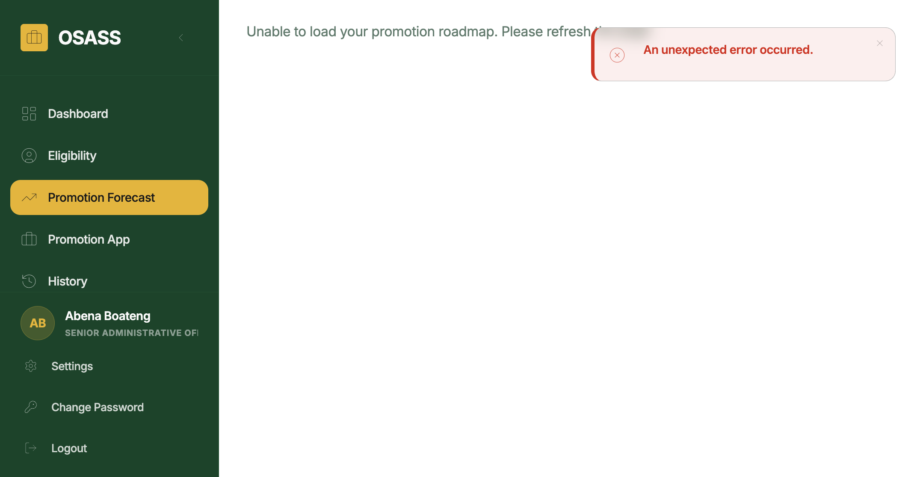
Forecast
How to access: Click Promotion Forecast in the sidebar.
What the page shows:
- Your current position and date of last promotion
- For each career milestone:
  - Target position and eligibility status
  - Years required vs. years served
  - Estimated eligibility date for future milestones
  - A prioritised list of required actions (e.g., “Document your service activities”, “Obtain a professional certificate”)
  - Any performance gap analysis (current vs. required scores)
- Future milestones are shown as locked until intermediate promotions are completed

6. Promotion Application
The non-academic promotion application consists of three scored sections. All sections must be completed before the application can be submitted.

6.1 Application Overview
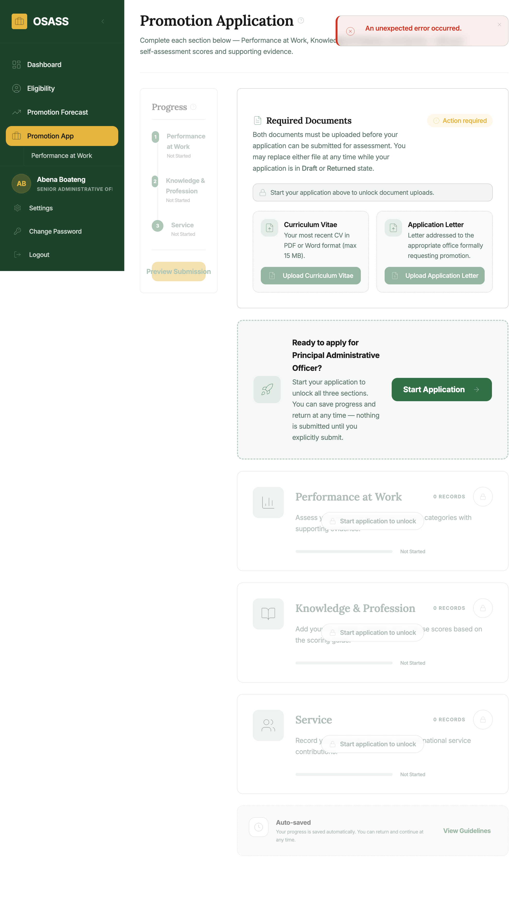
Application Overview
How to access: Click Promotion App in the sidebar or “Continue Application” on the dashboard.
The overview displays three category cards:
Category | Max Score | Description
Performance at Work | 60 | Ratings from supervisors on work quality, efficiency, attendance, and attitude
Knowledge & Profession | 30 | Academic qualifications, professional certifications, and training completions
Service | 20 | Institutional service roles performed within UMaT
Click any card to enter that section.

6.2 Performance at Work Section
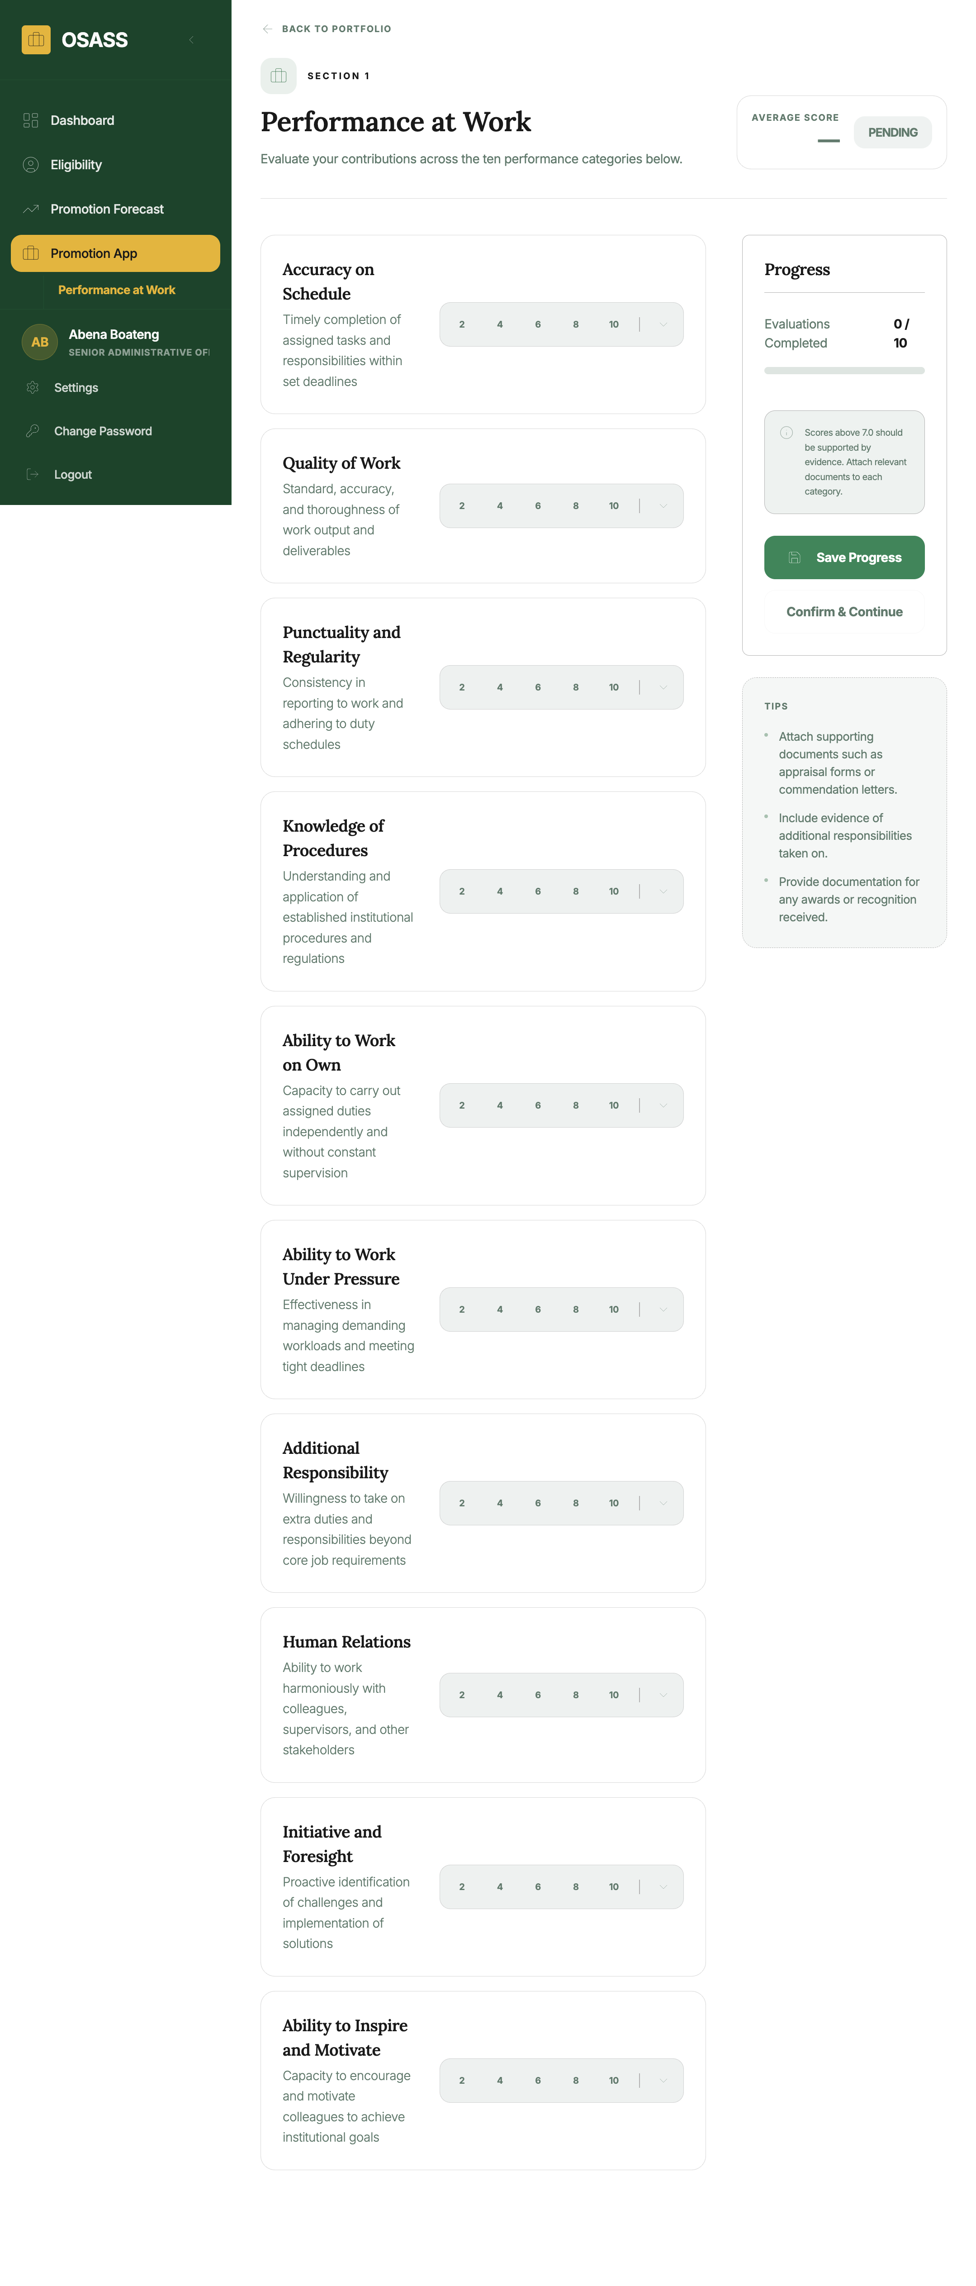
Performance Section
How to access: Click the Performance at Work card or navigate via Promotion App → Performance at Work.
What to do in this section: 1. Add performance ratings for each assessment year within the promotion period: - Select the category (e.g., Efficiency, Punctuality, Teamwork) - Select the rating (Excellent, Good, Satisfactory, Poor) - Enter the year and name of rater (supervisor/HOD) 2. Upload the performance appraisal document (official annual appraisal forms signed by your supervisor). 3. Click Save after each entry. 4. Click Mark as Complete when all ratings are entered.
The system aggregates performance ratings into a numeric score based on the institutional scoring matrix.

6.3 Knowledge & Profession Section
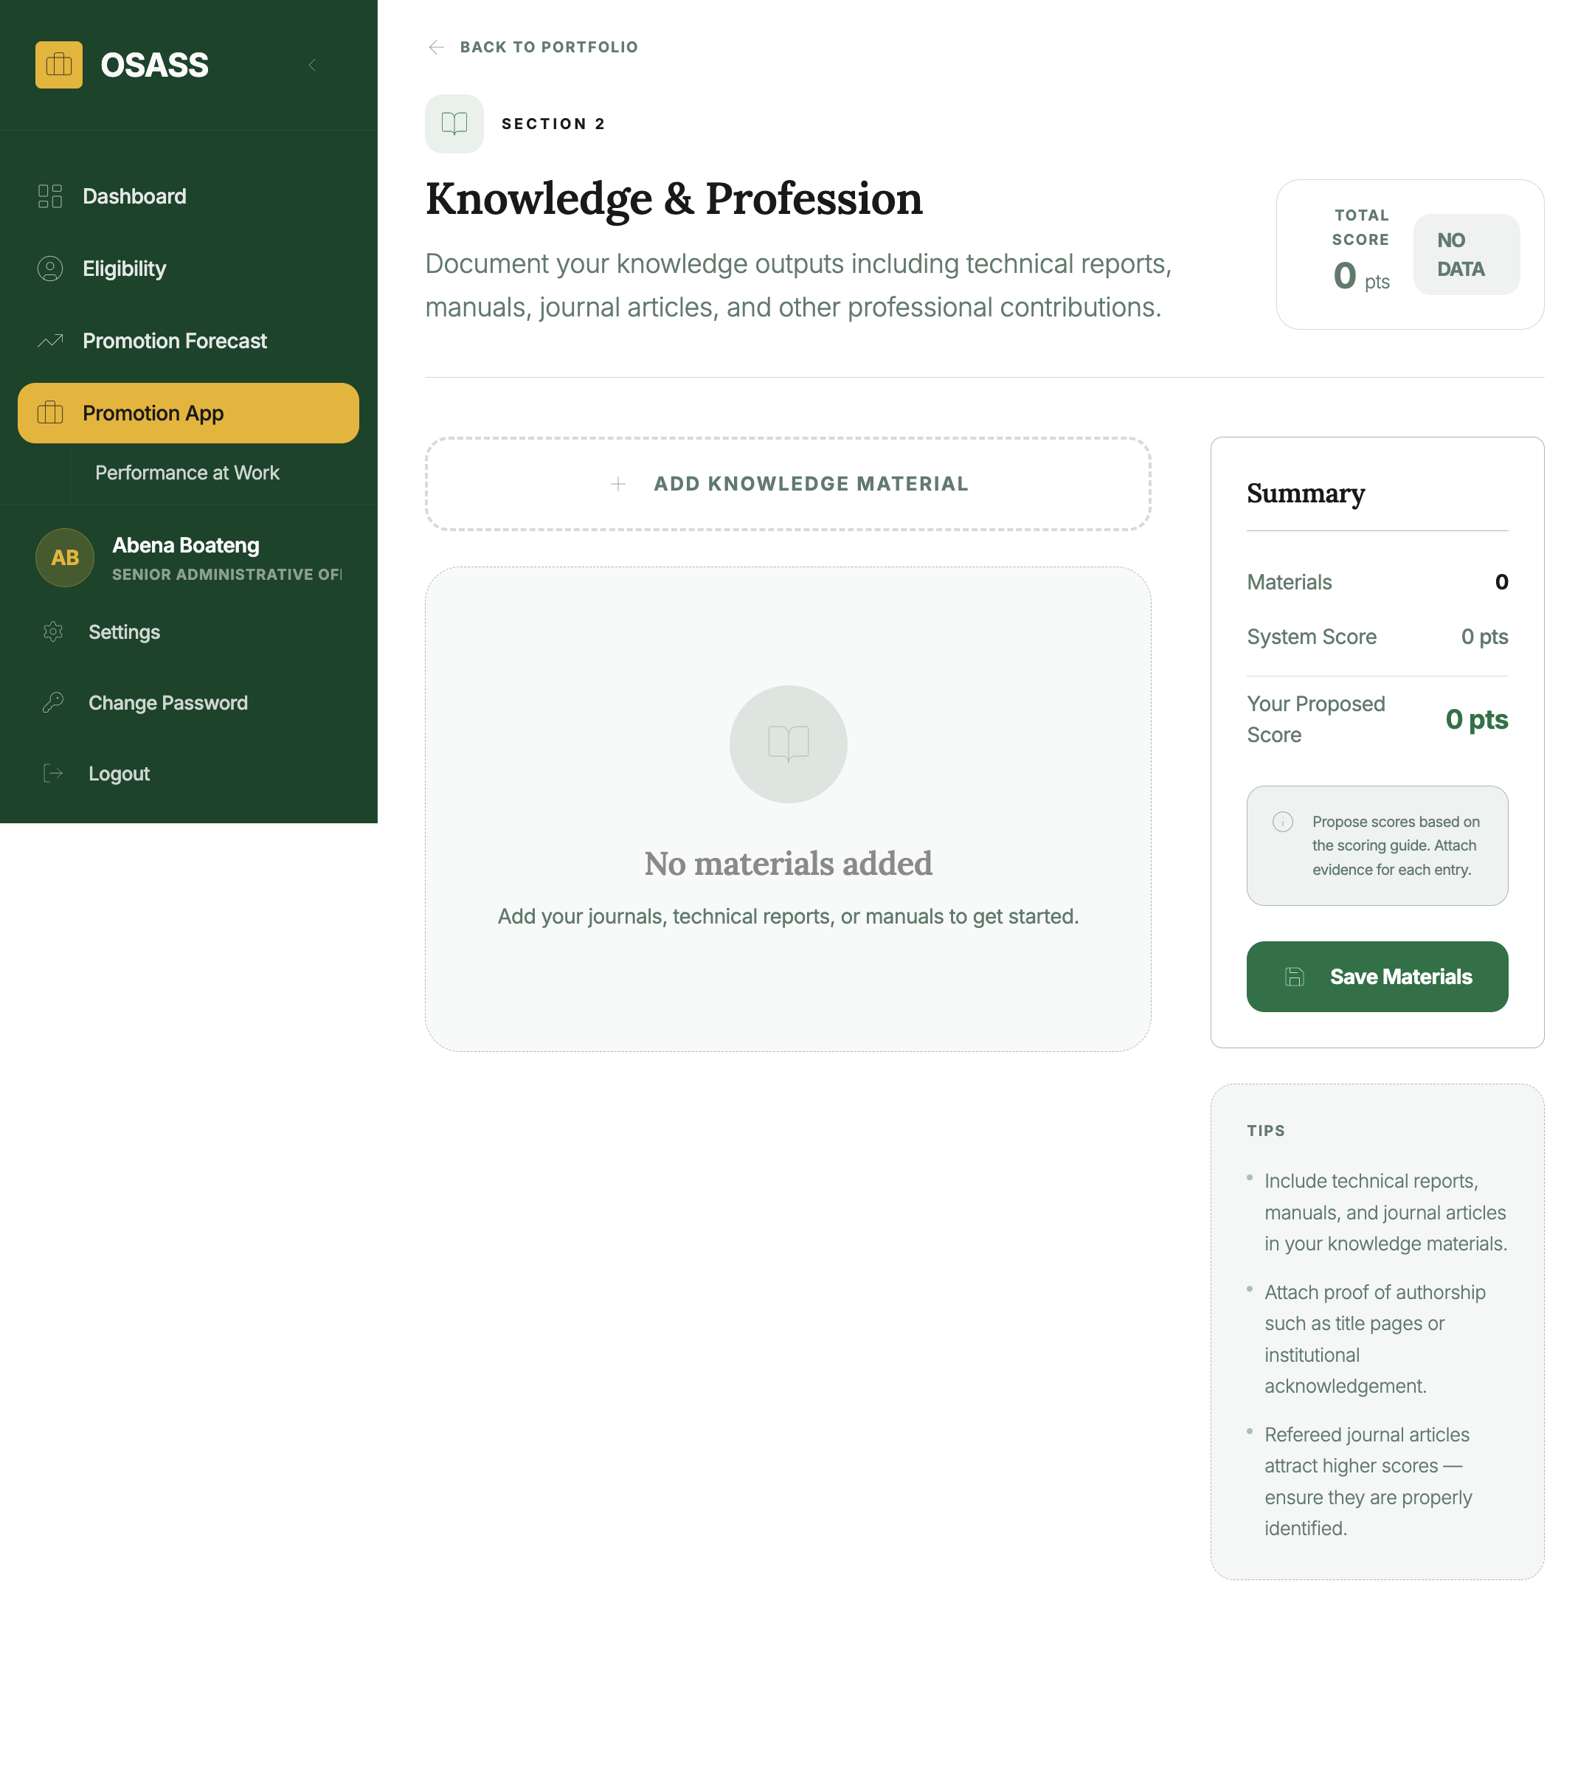
Knowledge Section
How to access: Click the Knowledge & Profession card or navigate via Promotion App → Knowledge & Profession.
What to do in this section: 1. Add qualifications and certifications obtained during the assessment period: - Select the type from the dropdown (e.g., Master’s Degree, Professional Certificate, Training Course) - Enter the name of the qualification/certificate - Enter the awarding institution and year awarded 2. Upload supporting documents (degree certificates, transcripts, course completion letters). 3. Click Save for each entry.
Each knowledge material type carries a score defined by the administration. For example, a Master’s Degree may carry 10 points while a professional certificate carries 5 points.

6.4 Service Section
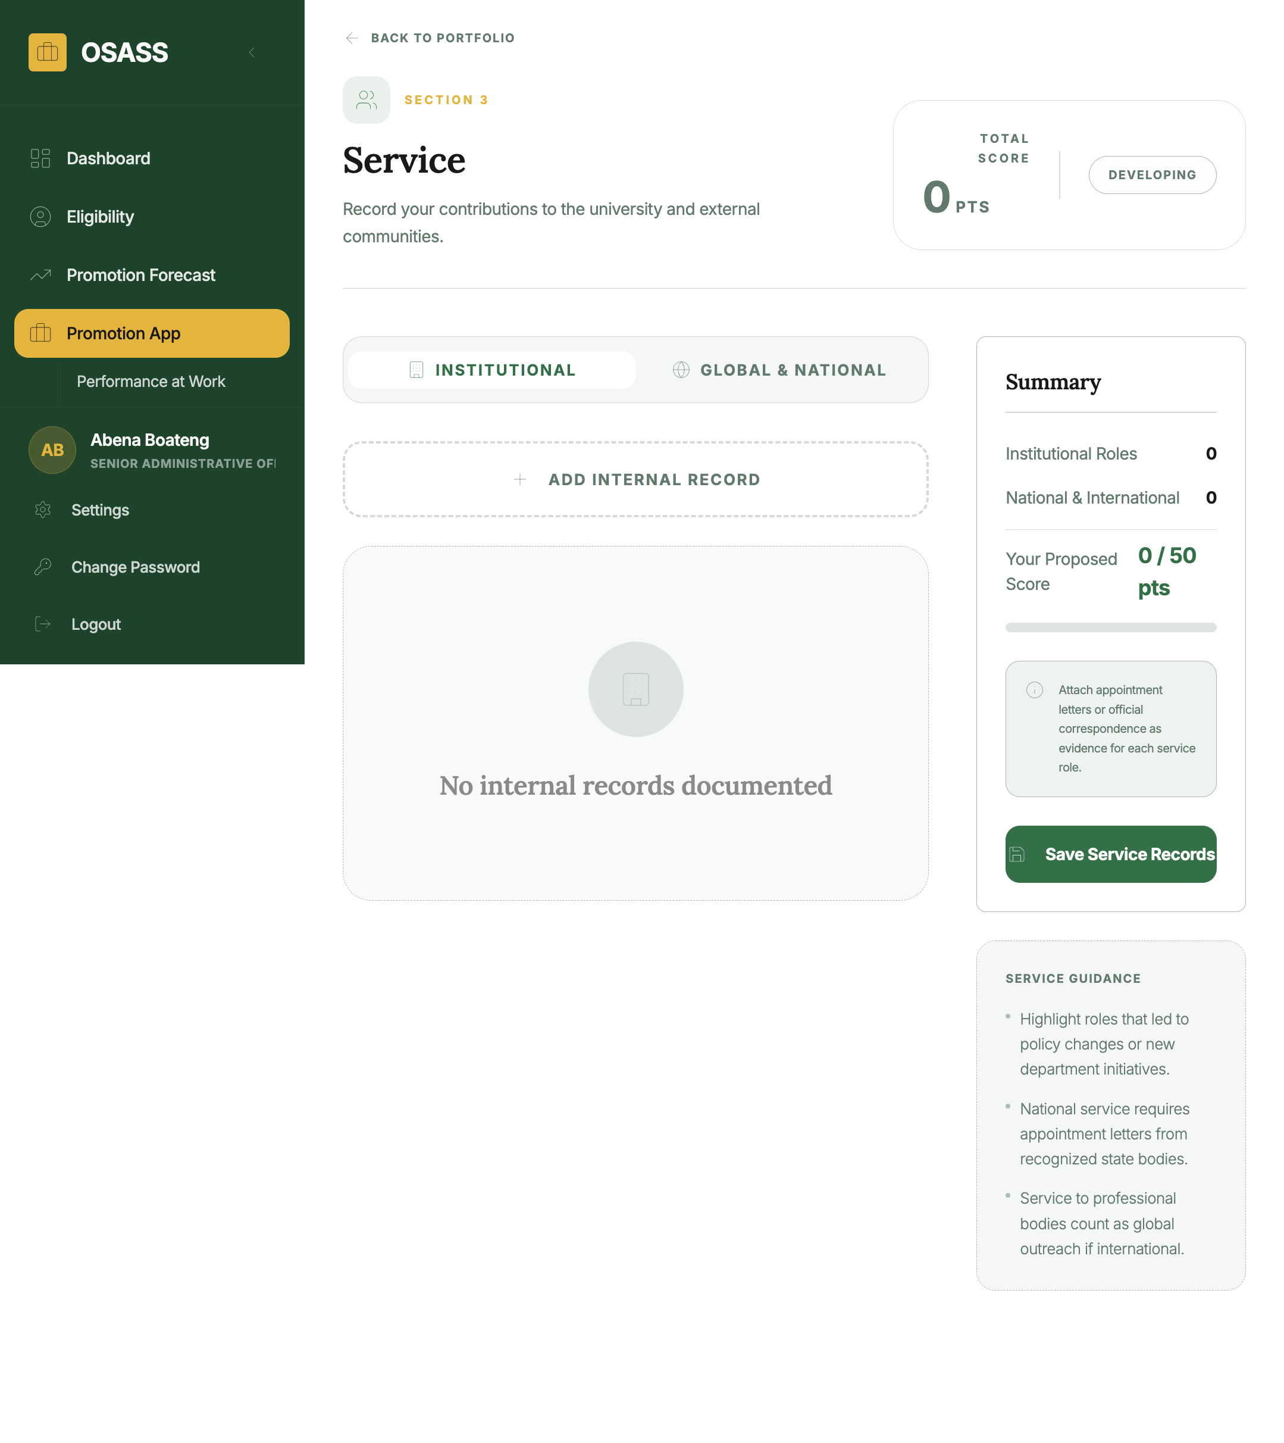
Service Section
How to access: Click the Service card or navigate via Promotion App → Service.
What to do in this section: 1. Add service roles performed at UMaT: - Select the position type (e.g., Head of Unit, Secretary to Committee, Sports Coordinator) - Enter the period of service (start and end dates) - Add any supporting remarks 2. Upload a service document if available. 3. Click Save and Mark as Complete when all roles are entered.

6.5 Review & Submit
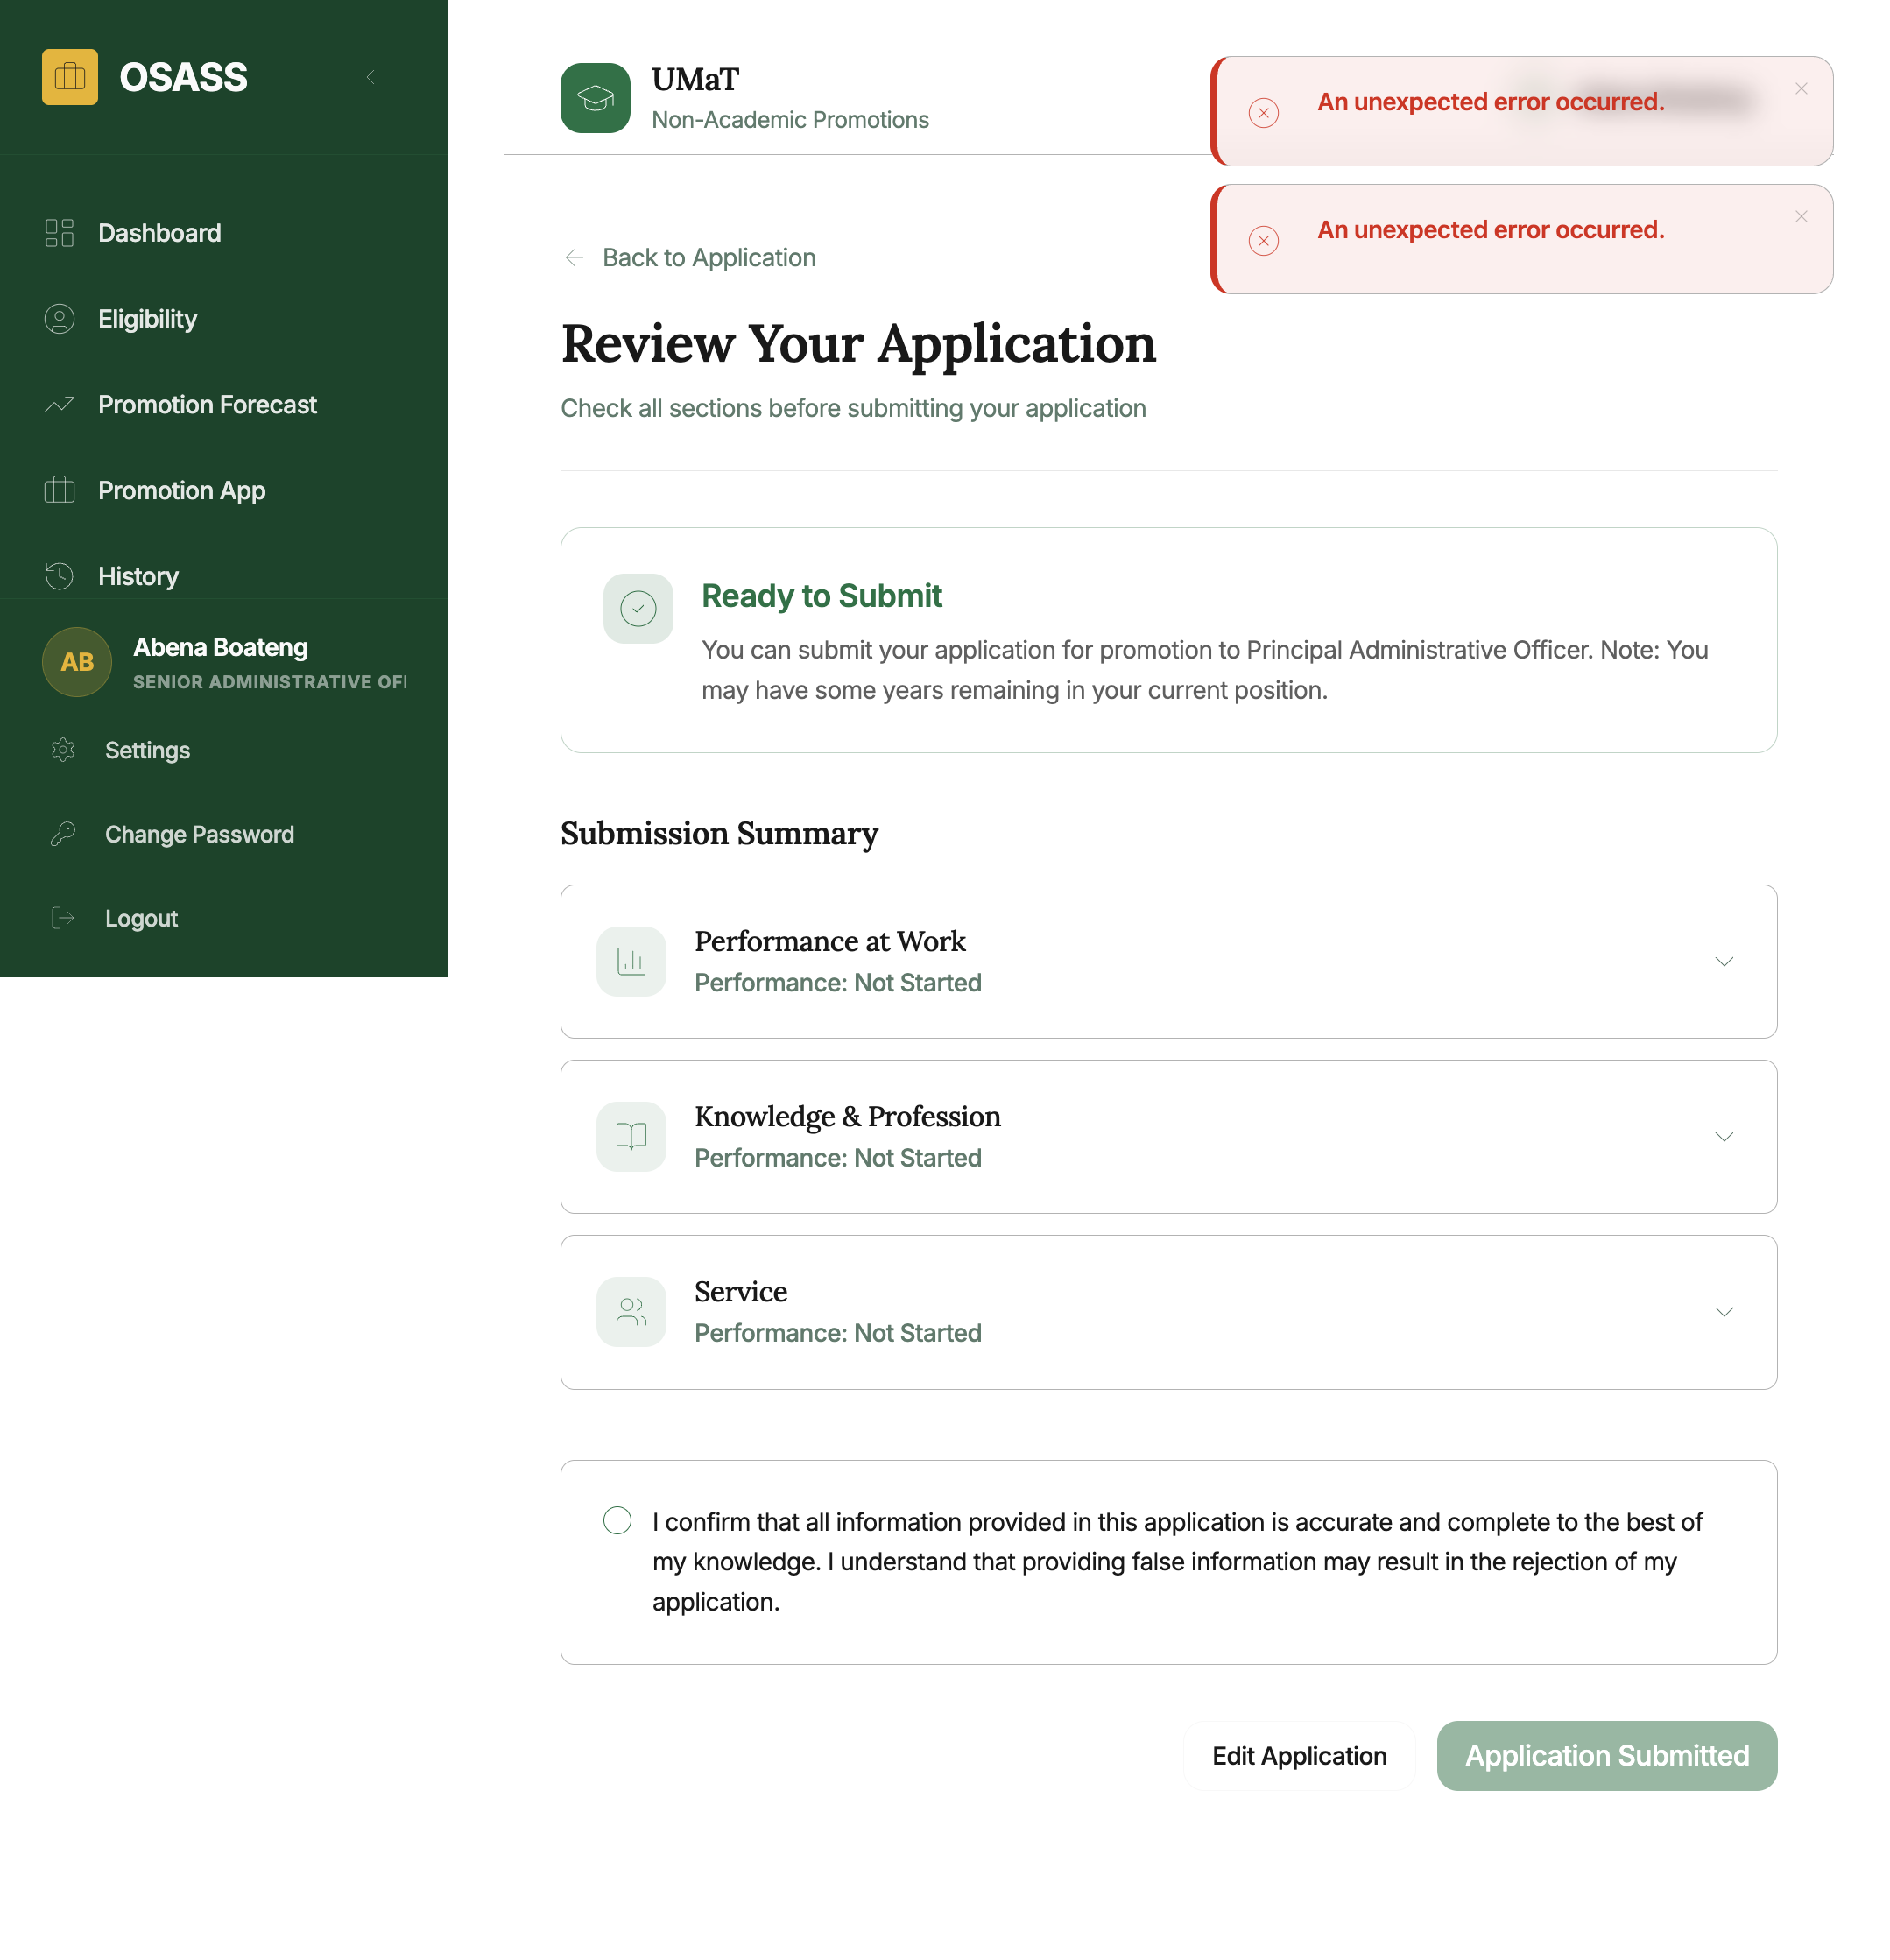
Review Page
How to access: Navigate to the Review page once all three sections show Completed status.
What the Review page shows: - A summary of all three sections with scores and completion status - The overall score vs. the passing threshold - A checklist verifying all required documents are uploaded
Submitting: 1. Review all information carefully — the application cannot be edited after submission. 2. Click Submit Application and confirm in the dialog. 3. You will receive a confirmation and be redirected to the Progress page.

7. Application Progress Tracking
After submission, track your application through the institutional review pipeline.
How to access: Click “View Application Status” on the dashboard or navigate to /progress.
The progress page shows each review stage:
Stage | Description
Submitted | Application received
Under Review (Institutional Committee) | Committee is reviewing
Under Review (University Committee) | University-level review in progress
Approved / Rejected / Returned | Final decision
If Returned, the committee’s notes for correction will be shown and you can resubmit after making the required changes.

8. Promotion History
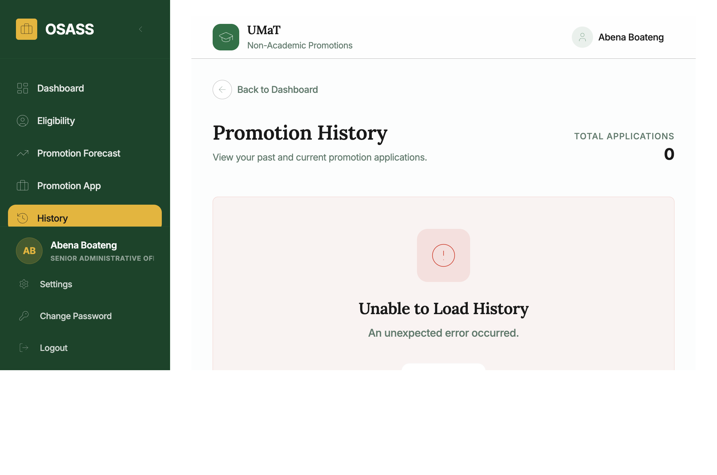
Promotion History
How to access: Click History in the left sidebar.
Shows a complete record of all past promotion applications including: - Year, from/to positions, outcome status - Date submitted and date of decision - Total score achieved per cycle

9. Promotion Letter
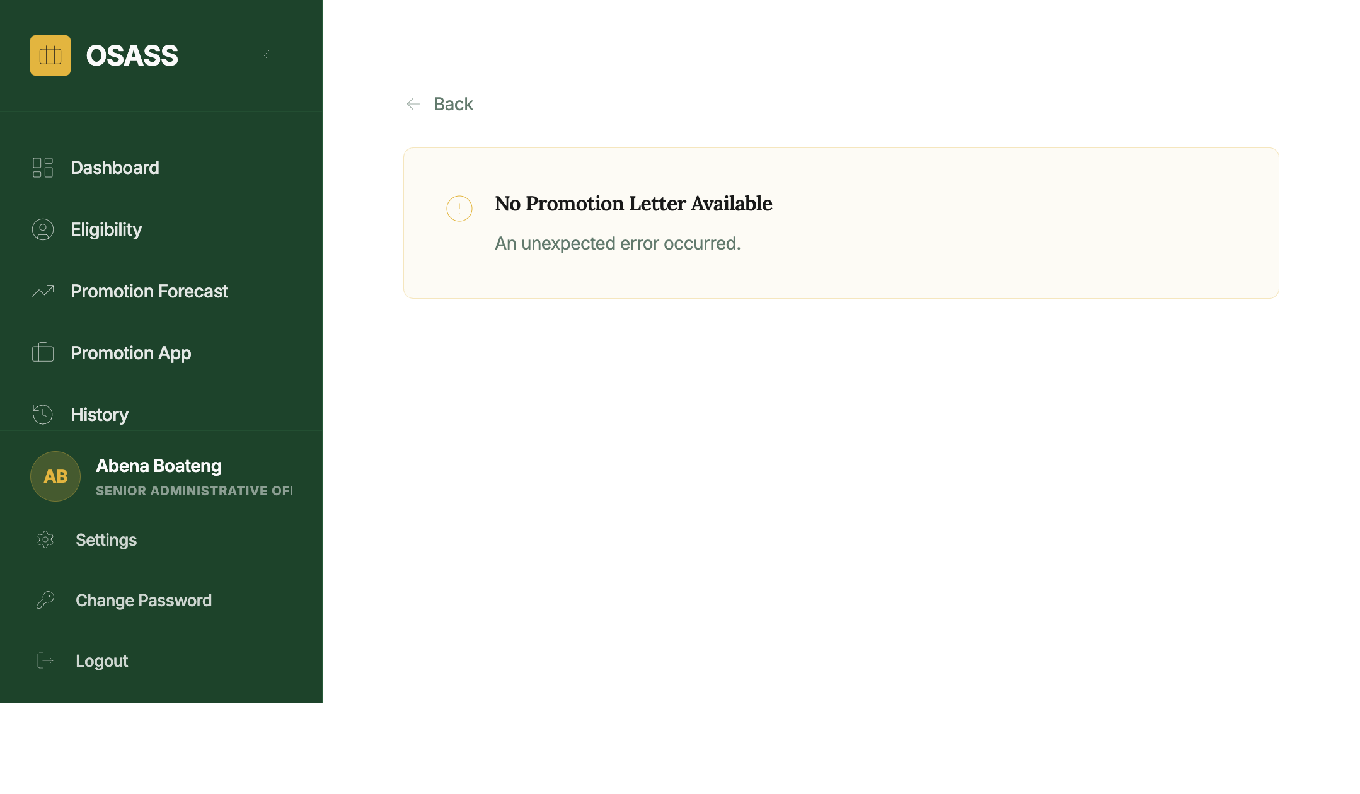
Promotion Letter
How to access: Click Promotion Letter in the sidebar (only active after an approved application).
Displays your official promotion letter showing: - Full name and staff ID - Promotion from/to position and effective date - Reference number and approving authority
Use the action buttons to print or download as PDF.

10. Staff Updates
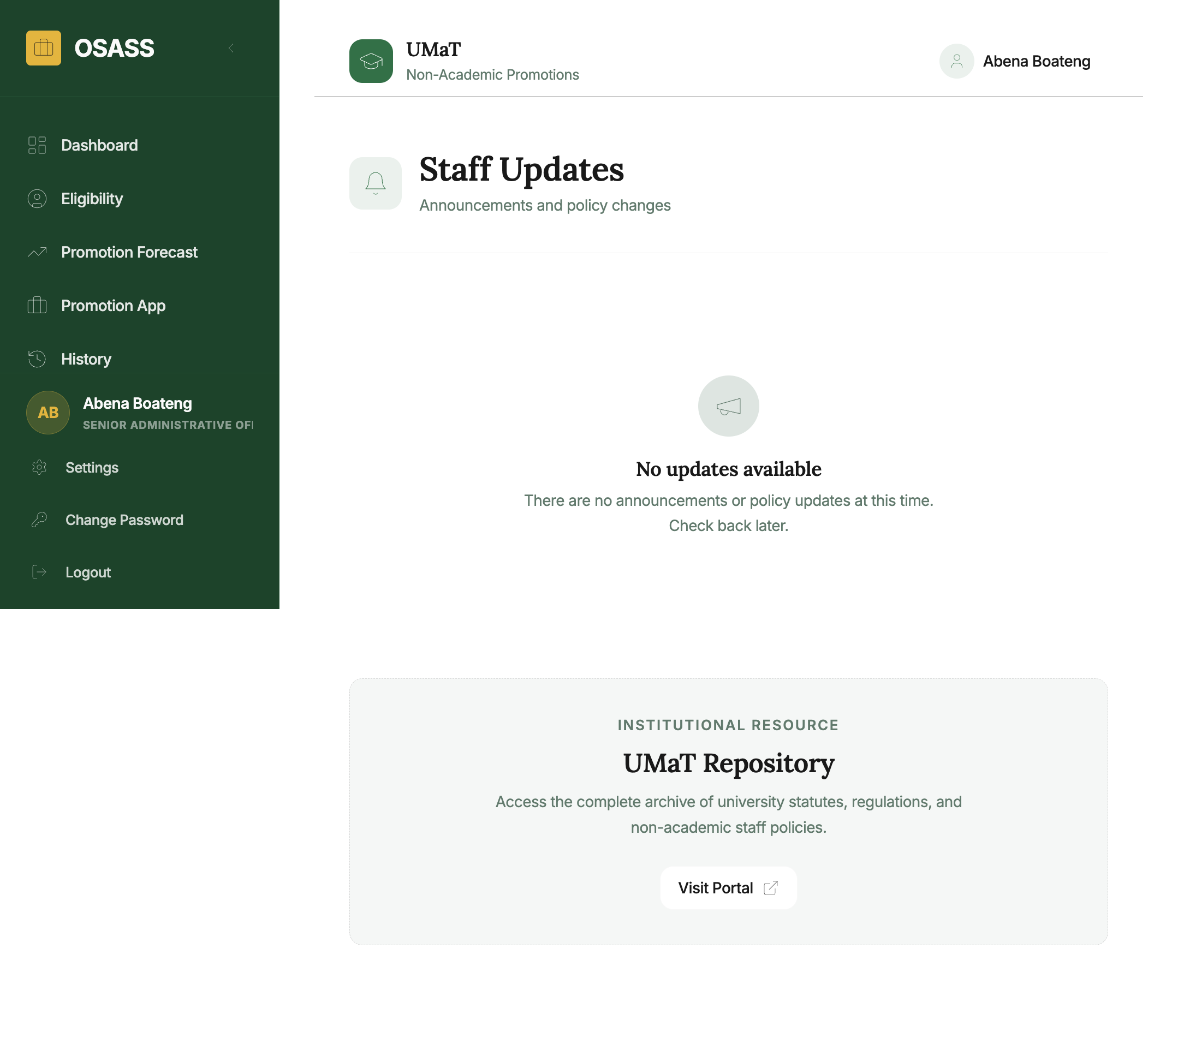
Staff Updates
How to access: Access via the sidebar or the Resources panel on the dashboard.
Shows institutional announcements and notices from the HR / Promotion Office. Use the search bar to find specific updates. Updates are paginated.

11. Resources
Navigate to the Guidelines page for the official UMaT non-academic promotion criteria, scoring methodology, and required documentation.
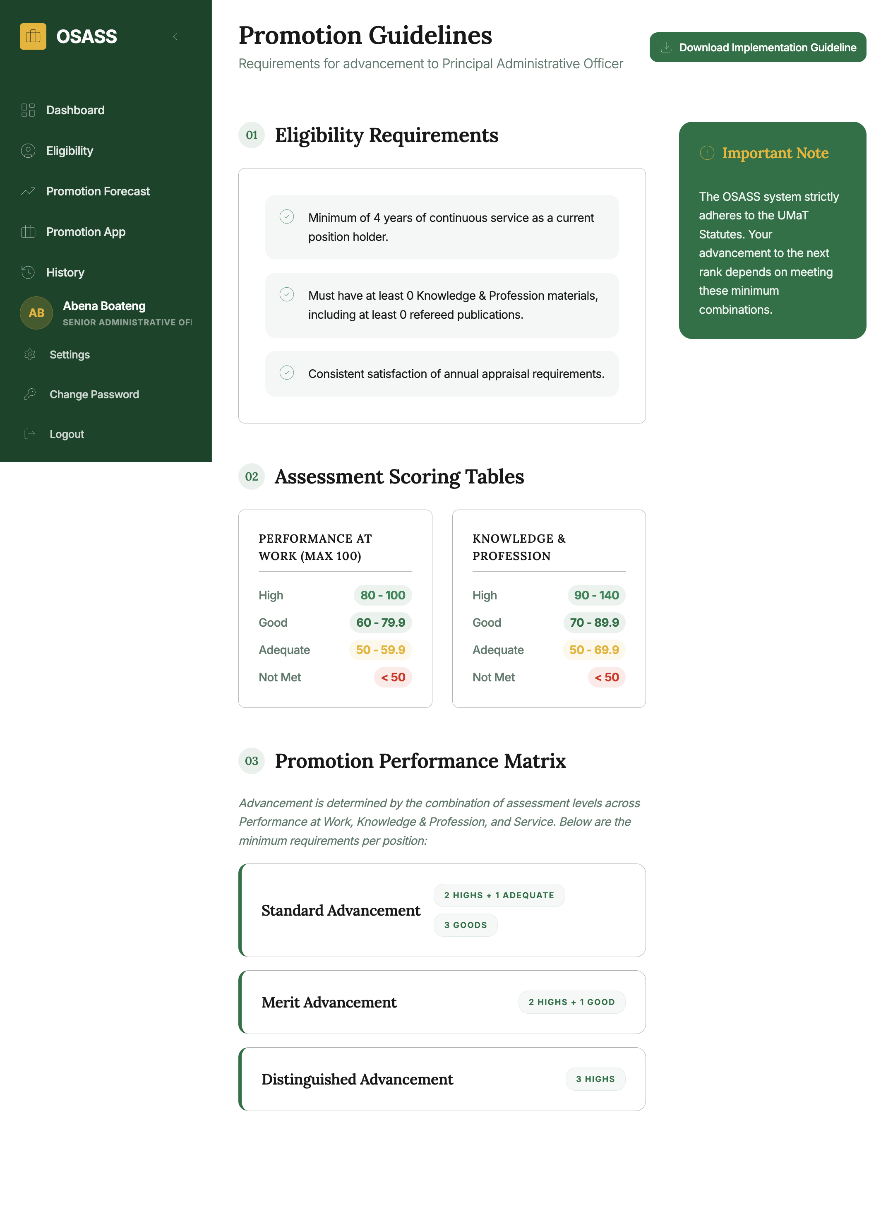
Guidelines
The guidelines explain: - Position levels and minimum years for each - Performance rating score mapping - Knowledge material indicator scores - Service role score values

12. Account Management

12.1 Settings
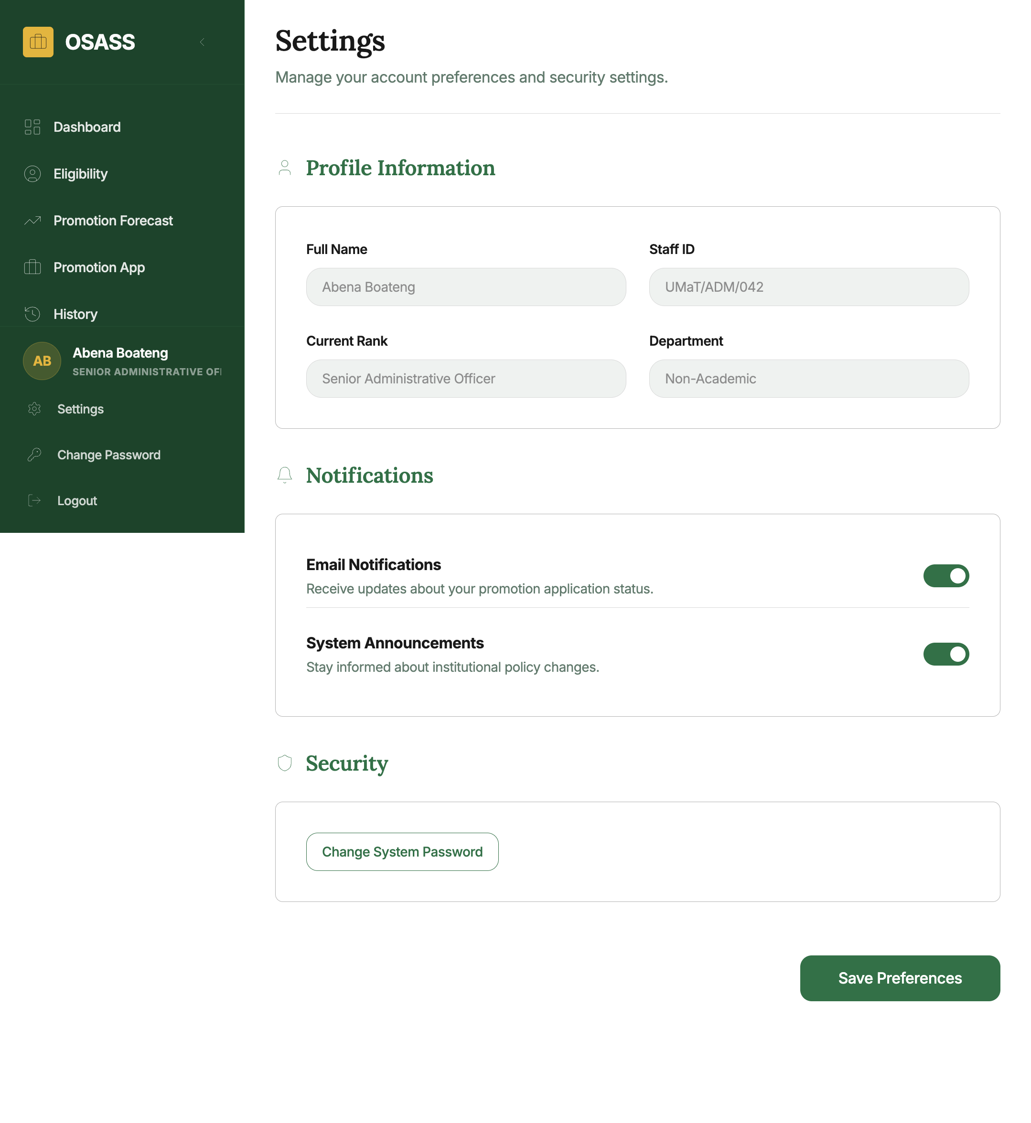
Settings
How to access: Click Settings in the sidebar footer.
Allows you to toggle between Light and Dark display themes.

12.2 Change Password
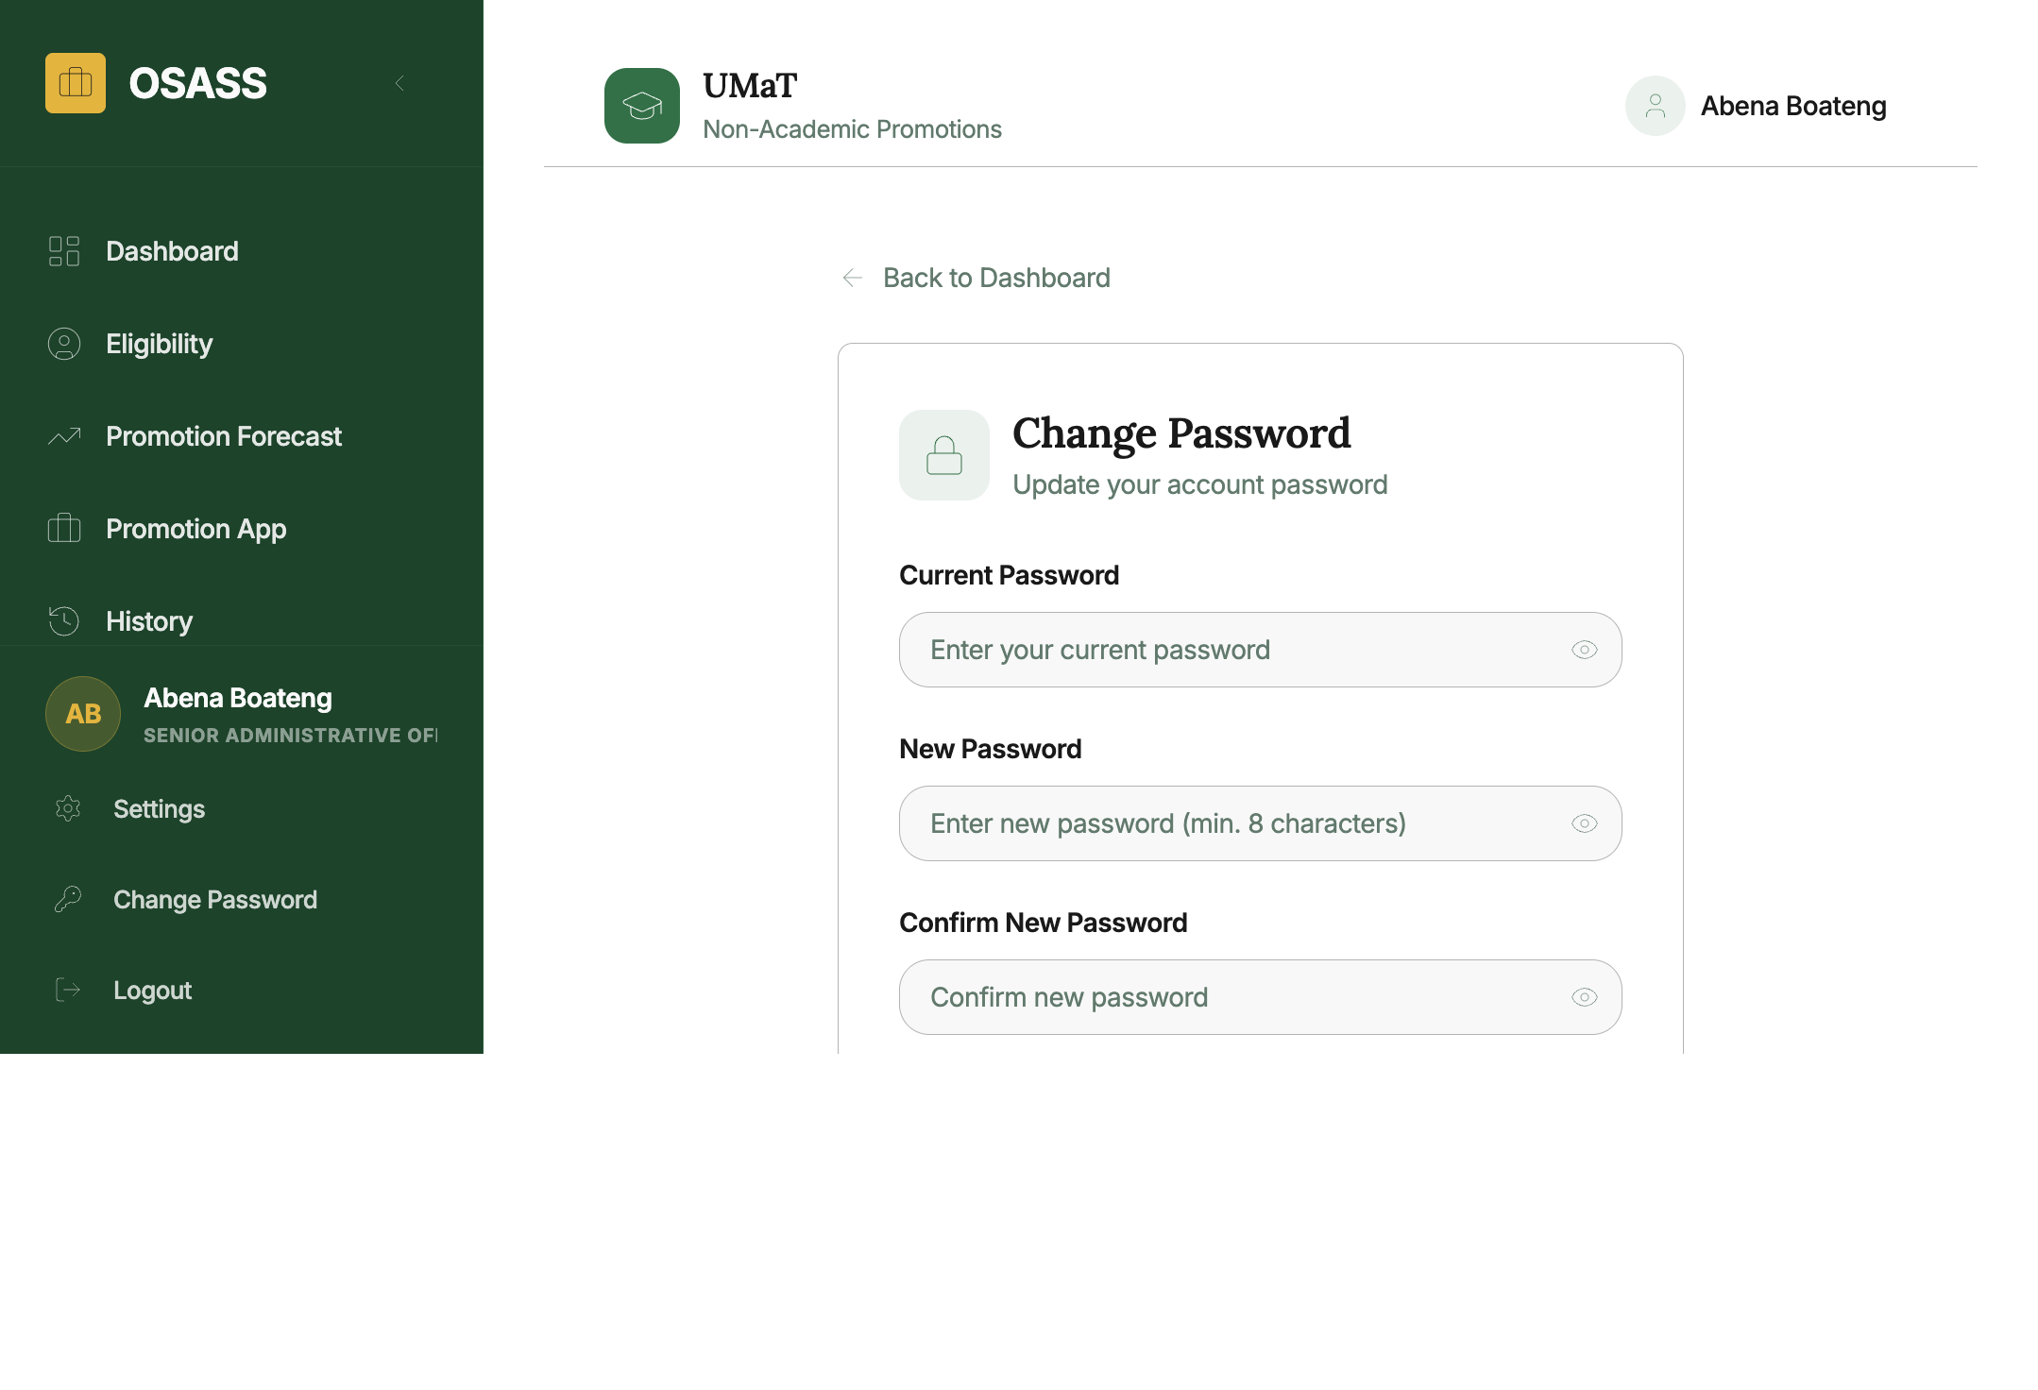
Change Password
How to access: Click Change Password in the sidebar footer.
- Enter your Current Password.
- Enter and confirm your New Password (min. 8 characters).
- Click Update Password.

13. Navigation & Layout

Left Sidebar
Item | Description
OSASS logo + collapse toggle | Collapse sidebar to icon-only view
Dashboard | Home page
Eligibility | Eligibility assessment
Promotion Forecast | Career path planner
Promotion App | Application sections (Performance at Work, Knowledge & Profession, Service)
History | Past promotion records
User profile card | Name and current position
Settings | Theme preferences
Change Password | Password management
Logout | Secure sign-out

Top Header Bar
- Portal identifier (UMaT logo + “Non-Academic Promotions”)
- Your name shown on the right

For technical support: support@umat.edu.gh
For promotion queries: contact the Human Resources / Non-Academic Promotion Office.

Document generated: May 2025 | OSASS v2

