

*Paleoceanography and Paleoclimatology*

Supporting Information for

Secular resonance transitions in the late Cretaceous and astronomical imprints during the Oceanic Anoxic Event II (Schill Grund Platform, North Sea, Offshore Netherlands)

M. Arts1*, A.C. Da Silva1, G.J. Vis3, D. Beelen4, F.J. Hilgen2

1Universite de Liège, Department of Geology, Sedimentary Petrology

Allée du Six Aout 12, 4000, liège, Belgium

2 Utrecht University, Department of Earth Sciences, Stratigraphy & paleontology

Vening Meineszgebouw A, Princetonlaan 8,3584 CB Utrecht, The Netherlands

3 TNO Geological Survey Netherlands

Princetonlaan 6, 3584 CB Utrecht, the Netherlands

4 Utrecht University, Department of Physical Geography

Vening Meineszgebouw A, Princetonlaan 8,3584 CB Utrecht, The Netherlands

**Contents of this file**

Text S1

Figures S1 to S12

Tables S1

**Introduction**

The supporting information consists of geographic information, text and visualizations of the intermediate steps taken in producing and interpreting results and extended. Figures S1 and S2 are geographic maps with locations of the seismic and well-log data used in the study. Table S1 is compilation of biostratigraphic data used to trace the location of the K/Pg boundary and calculate sedimentation rates for different stages. Text S1 gives a in extended explanation on how the K/Pg boundary was confined to a single reflector, which is also visualized in Figure S3. Figure S4 shows how the K/Pg can be anchored from a reflector to an exact location within a log using the phase relationship of the 405 kyr eccentricity cycle with the K/Pg boundary. Figure S5 shows an intermediate step in which the records are anchored to the K/Pg boundary and from which the 405 kyr eccentricity cycle is filtered but not let tuned to astronomical solution la2010d. Figures Figure S6 and S7 show the difference in sedimentation rate and time between the records solely anchored to the K/Pg boundary and the records which were tuned to la2010d. Figure S8 shows the spectral power and long orbital cycles extracted from the tuned Gr log of well G14-05. As the Gr record of well G14-05 has a composite environmental nature resulting in a suboptimal result when studying longer period astronomical cycles. For the sake of data completion, the figure in the supplementary information. Figures S10 and S11 are comparison figures between the modulation of obliquity and eccentricity extracted from astronomical solutions and the Gr log of well G14-05 and the Th log of well G17-S-01. As none of the eccentricity or obliquity amplitude modulation records extracted from astronomical solutions fits with the amplitude modulation extracted from the well-logs there is no need to include these figures in the main article. To enable other people to reach the same conclusion the figures are included in the supplementary information. Figures S11 and S12 show an expanded view of the 405 kyr eccentricity cycle extracted from the Gr log of well G14-05 and the Th log of well G17-S-01. Many of the main figures containing the 405 kyr eccentricity cycle are temporally compressed not allowing one to check the relationship between the well-log records and the extracted 405 kyr eccentricity cycle. Figures S11 and S12 do allow for one to check the fit between the extracted 405 kyr eccentricity cycles and the original data

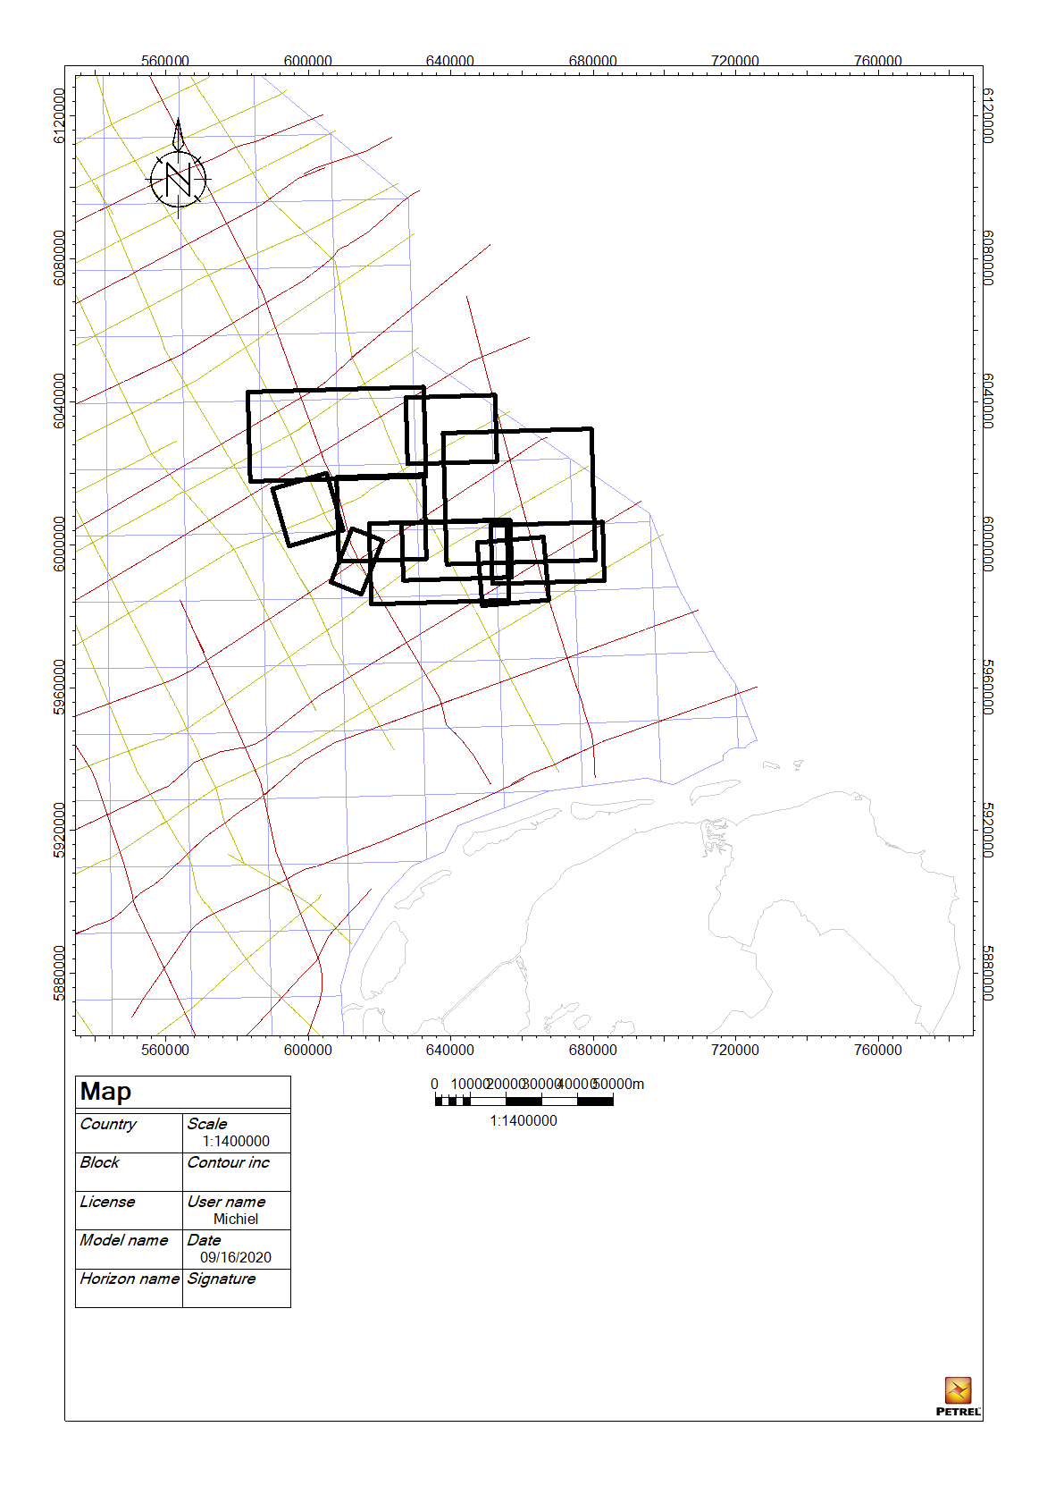

Figure S1. Used seismic data. The orange and red lines are 2D seismic surveys, while the black rectangles are 3D seismic data sets.

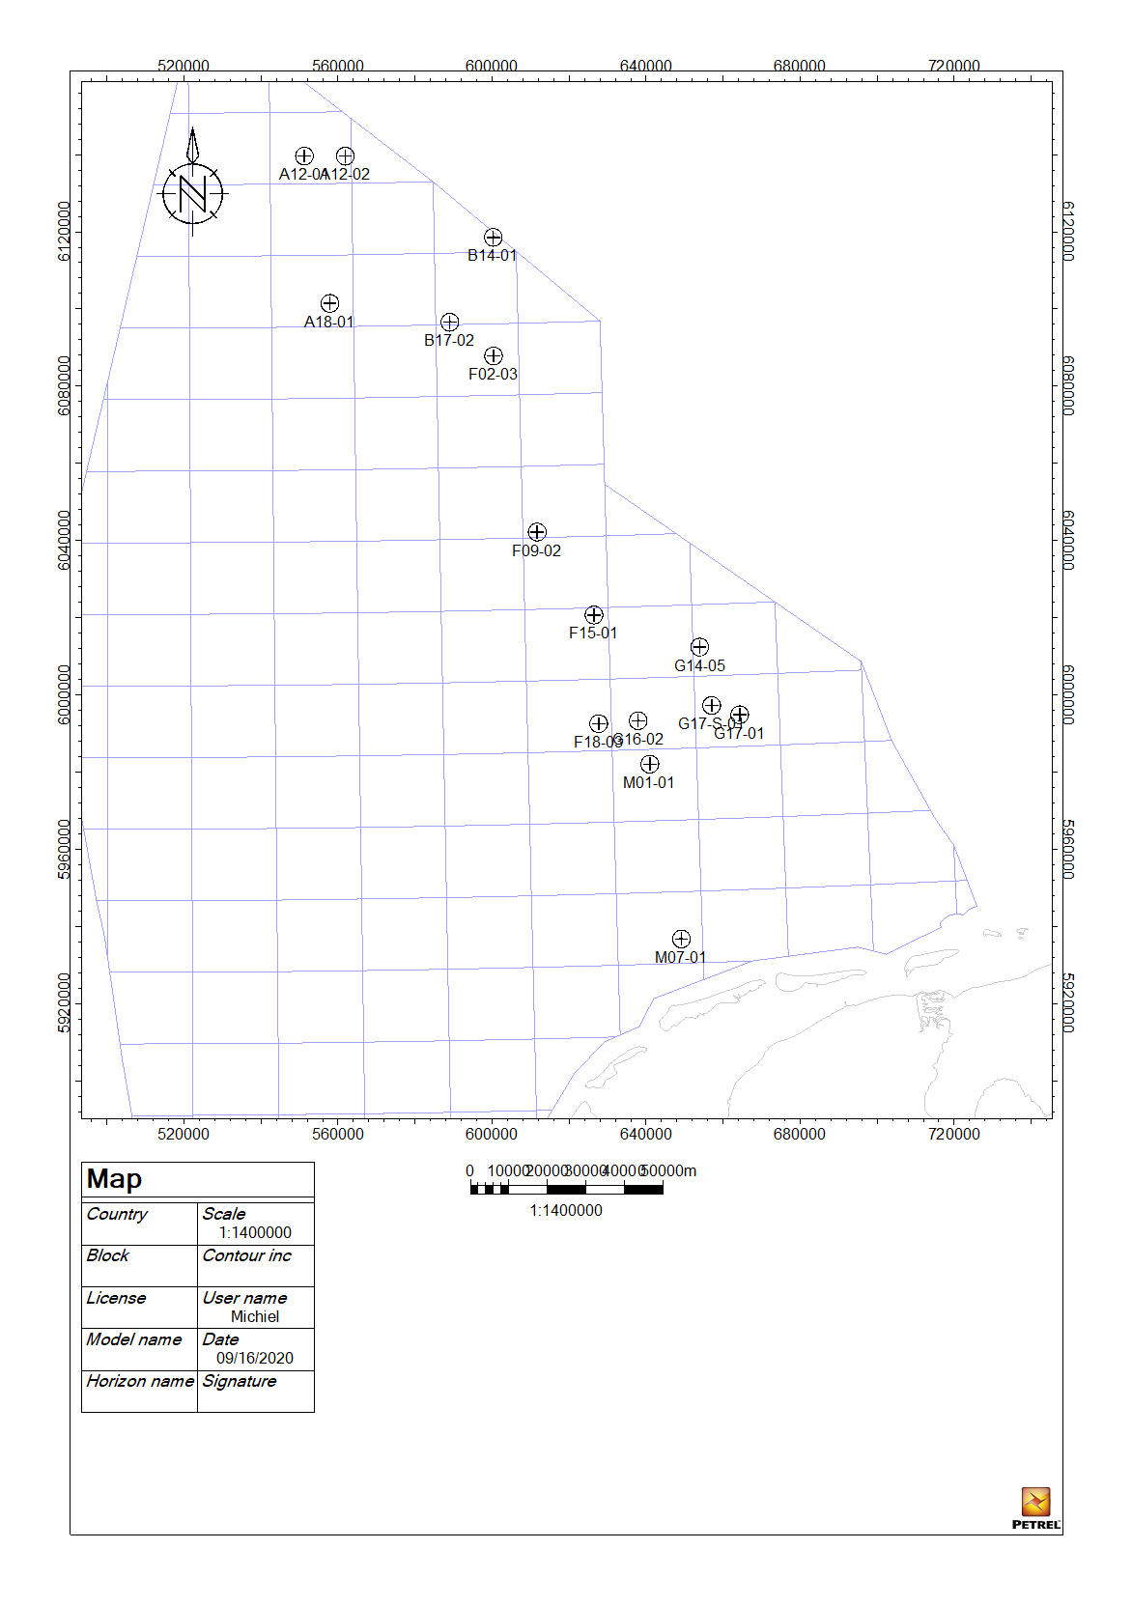

Figure S2. Used well in this study except for wells G17-S-01 and G14-05 all other wells were investigated for the biostratigraphic information present in set wells.

|  |  |  |  |  |  |  |  |  |  |  |  |  |  |  |  |  |
| --- | --- | --- | --- | --- | --- | --- | --- | --- | --- | --- | --- | --- | --- | --- | --- | --- |
|  |  |  | well | sedrate m/Ma | well | sedrate m/Ma | well | sedrate m/Ma | well | sedrate m/Ma | well | sedrate m/Ma | well | sedrate m/Ma | well | sedrate m/Ma |
|  |  |  | G17-01 | G17-01 | G16-02 | G16-02 | F15-01 | F15-01 | F18-03 | F18-03 | F02-03 | F02-03 | A18-01 | A18-01 | B14-01 | B14-01 |
| Boundary | Ages (Gale et al., 2020) | Definition | depth |  | depth |  | depth |  | depth |  | depth |  | depth |  | depth |  |
| Maastrichtian Palaeocene | 66 | Top NCF 19 | 1493-1500 |  | 1580 |  | 1655 |  | 1512 |  | 1522 |  | 2280 |  | 1990-2010 |  |
| Campanian Maastrichtian | 72.1 | Top NCF17 | 1756 | 41.96721311 | 1750 | 27.86885246 | 1925 | 44.26229508 | 1660 | 24.26229508 | 1574 | 8.524590164 |  |  | 2104 | 18.68852459 |
| Santonian Campanian | 83.6 | Top NCF 15 | 2237 | 41.82608696 | 2056 | 26.60869565 | 2385/2400 | 41.30434783 | 1884 | 19.47826087 |  |  |  |  |  |  |
| Coniacian Santonian | 86.3 | Top NCF 13 |  |  |  |  |  |  |  |  |  |  |  |  |  |  |
| Turonian Coniacian | 89.9 | middle NCF 13 |  |  |  |  |  |  |  |  |  |  |  |  |  |  |
| Cenomanian Turonian | 93.9 | bottom NCF 12 OAEII | 2480 | 31.97368421 | 2170 | 11.06796117 | 2748 | 33.78640777 | 2092 | 523 | not present |  | 2446 | 5.949820789 | no present |  |
| Albian Cenomanian | 100.5 | Top NCF 8 | 2560 | 12.12121212 |  |  |  |  | 2172 | 12.12121212 |  |  |  |  |  |  |
| Aptian Albian | 113 | Top NCF 5 |  |  |  |  |  |  |  |  |  |  |  |  |  |  |
| Barremian Aptian | 125 | Middle NCF 4 LO Gavellinella barremiana & LO Conorodtalites intercedens | 2609 | 2 |  |  | 2840 | 2.958199357 |  |  |  |  |  |  |  |  |
| Hauterivian Barremian | 129.4 | Top NCF 2 | 2646 | 8.409090909 |  |  |  |  |  |  |  |  |  |  |  |  |
| Valanginian Hauterivian | 132.9 | Bottom NCF 1 | 2719 | 20.85714286 |  |  | 2935 | 12.02531646 |  |  |  |  |  |  |  |  |
| Berriasian/Ryazanian Valanginian | 139.8 | No definition |  |  |  |  |  |  |  |  |  |  |  |  |  |  |
|  |  |  |  |  |  |  |  |  |  |  |  |  |  |  |  |  |
|  |  |  | well | sedrate m/Ma | well | sedrate m/Ma | well | sedrate m/Ma | well | sedrate m/Ma | well | sedrate m/Ma | well | sedrate m/Ma |  |  |
|  |  |  | A12-01 | A12-01 | B17-02 | B17-02 | F12-01 | F12-01 | M01-01 | M01-01 | M07-01 | M07-01 | F09-02 | F09-02 |  |  |
| Boundary | Ages (Gale et al., 2020) | Definition | depth |  | depth |  | depth |  | depth |  | depth |  | depth |  |  |  |
| Maastrichtian Palaeocene | 66 | Top NCF 19 | 2120 |  | 1950/2013 |  | 1460 |  | 1400 |  | 1435 |  | 1570 |  |  |  |
| Campanian Maastrichtian | 72.1 | Top NCF17 |  |  | 2205 | 41.80327869 | 1640 | 29.50819672 |  |  | 1635 | 32.78688525 |  |  |  |  |
| Santonian Campanian | 83.6 | Top NCF 15 |  |  |  |  |  |  |  |  | 1795/1835 | 29.56521739 | 1620 | 2.840909091 |  |  |
| Coniacian Santonian | 86.3 | Top NCF 13 |  |  |  |  |  |  |  |  |  |  |  |  |  |  |
| Turonian Coniacian | 89.9 | middle NCF 13 |  |  |  |  |  |  |  |  |  |  |  |  |  |  |
| Cenomanian Turonian | 93.9 | botom NCF 12 OAEII | 2705? | 20.96774194 | 2653 | 20.55045872 | 1960 | 14.67889908 | 1694 | 10.53763441 | 2052 | 24.95145631 | not present |  |  |  |
| Albian Cenomanian | 100.5 | Top NCF 8 |  |  |  |  |  |  | 1720 | 3.939393939 | 2130 | 11.81818182 |  |  |  |  |
| Aptian Albian | 113 | Top NCF 5 |  |  |  |  | 1970 | 0.523560209 |  |  | 2145 | 1.2 |  |  |  |  |
| Barremian Aptian | 125 | Middle NCF 4 LO Gavellinella barremiana & LO Conorodtalites intercedens |  |  | 2781 | 4.115755627 | 1985 | 1.25 | 1800 | 3.265306122 | 2160/2185 | 3.333333333 |  |  |  |  |
| Hauterivian Barremian | 129.4 | Top NCF 2 |  |  |  |  |  |  | 1950 | 34.09090909 |  |  |  |  |  |  |
| Valanginian Hauterivian | 132.9 | Bottom NCF 1 |  |  |  |  |  |  |  |  |  |  |  |  |  |  |

Table S1. Results of re-evaluation of biostratigraphic data. The Biostratigraphy of the Chalk Group in the Dutch offshore based on Gradstein et al. (2016), Hardenbol et al. (1998b, 1998a), Sikora et al. (1999) and htttps://www.dinoloket.nl/sites/www.dinoloket.nl/files/file/DRW-0289.pdf. The NCF zonation is based on Gradstein and Waters (2016). Ages are based on (Gale et al., 2020).

Text S1.

The Top chalk group reflector is based on the strong impedance/lithological contrast between the carbonates of the Chalk Group to clays and sands of the Lower North Sea group (ref). The K/Pg boundary is not distinct enough to be picked up by logging tools, which makes it impossible for the K/Pg to generate a distinct seismic reflector. Twelve wells with cutting based biostratigraphy were evaluated to see if there is a seismic reflector which roughly corresponds to the location of the K/Pg boundary (see table S1). In seismic data with a north zero phase polarity based on the available biostratigraphy-based the K/Pg boundary corresponds to an S-wave crossing above the third peak below the top of the Chalk Group. In the Petrel standard color scheme, the location of the K/Pg boundary is observed as a white line above the third red reflector of the Chalk Group (Figure S3). The location of the K/Pg boundary is consistent enough that it can be traced throughout the Schill Grund Platform. Only when a section gets more condensed near structural highs the location of the K/Pg gets harder to predict. The seismic reflector can only be used as rough indicator for the K/Pg boundary. The known phase relationship between the 405kyr eccentricity cycle and the K/Pg boundary (Batenburg, 2013; Batenburg et al., 2014, 2012; Husson et al., 2011; Westerhold et al., 2008) can be used to narrow down/calibrate the record fit the known 405kyr eccentricity cycle to K/Pg boundary phase relationship.

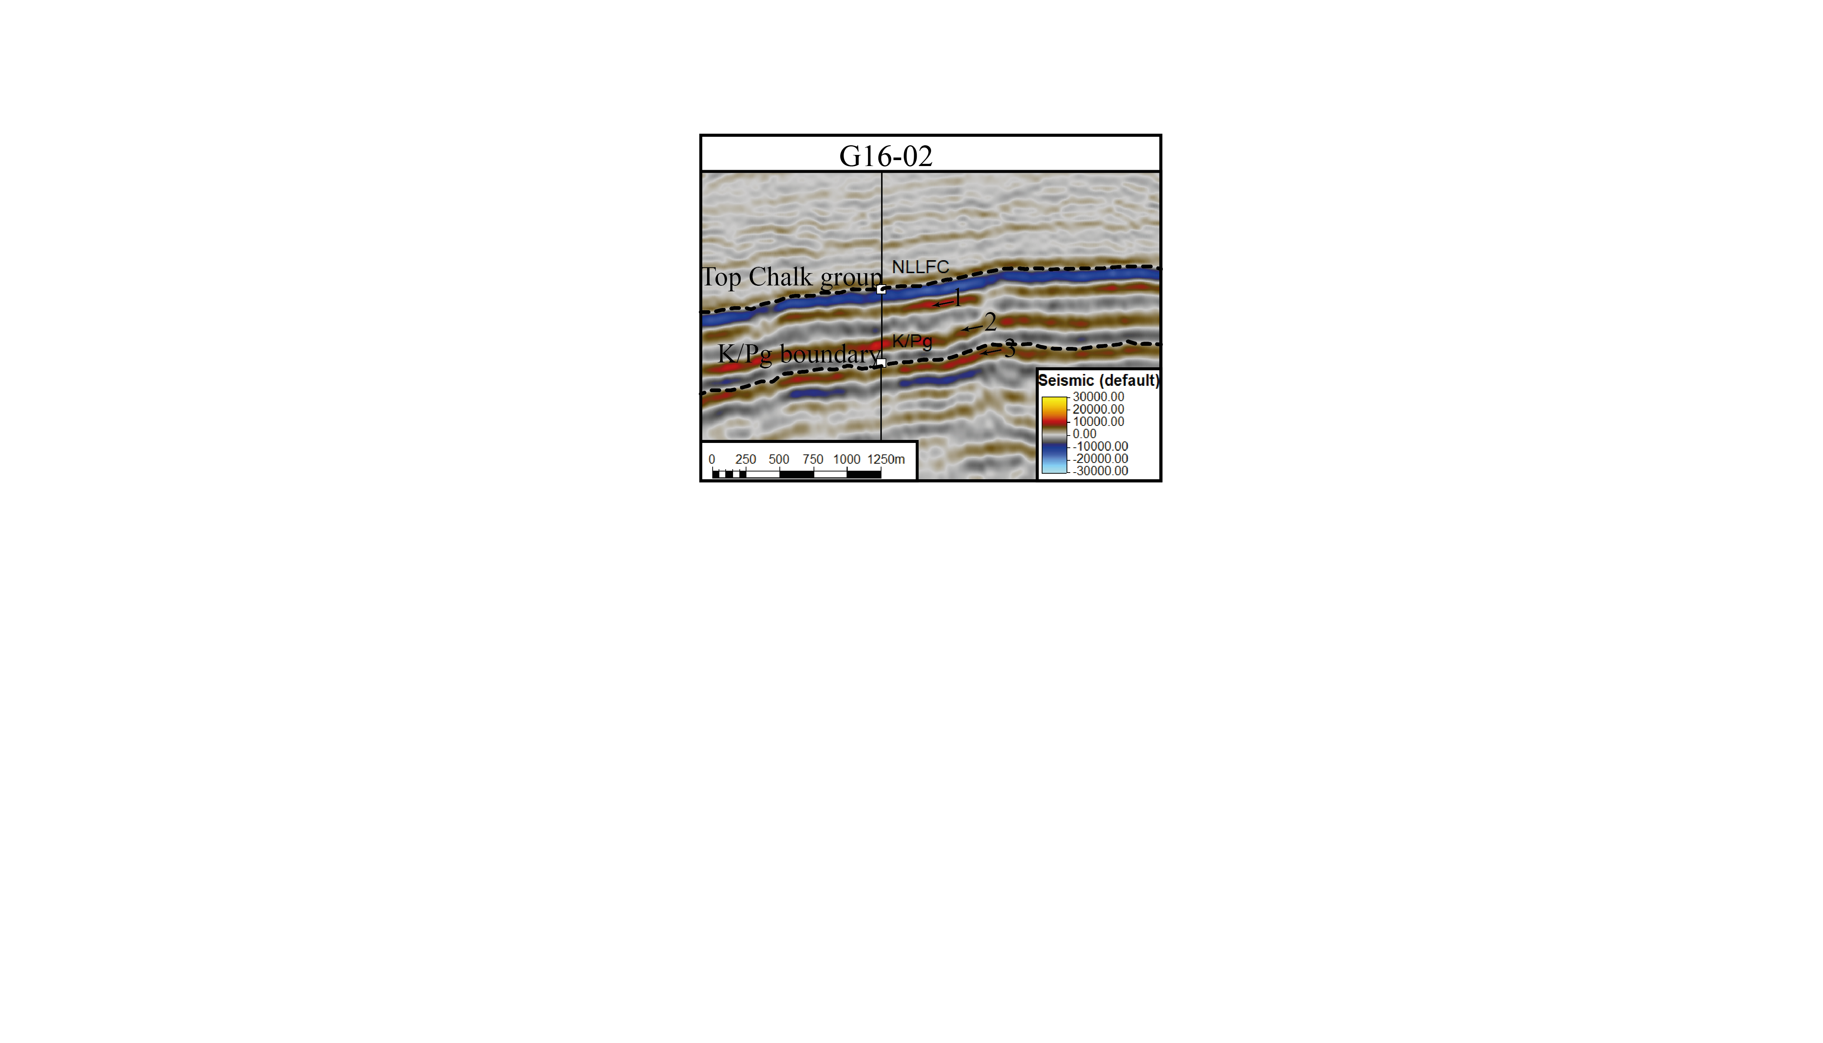

Figure S3. Seismic reflector K/Pg boundary. Well G16-02 displayed on an intersection of seismic cube G16_Z3GDF2005A-1. Indicated are the Top of the Chalk group, the location of the K/Pg boundary based on biostratigraphy and the seismic reflector corresponding to the K/Pg boundary

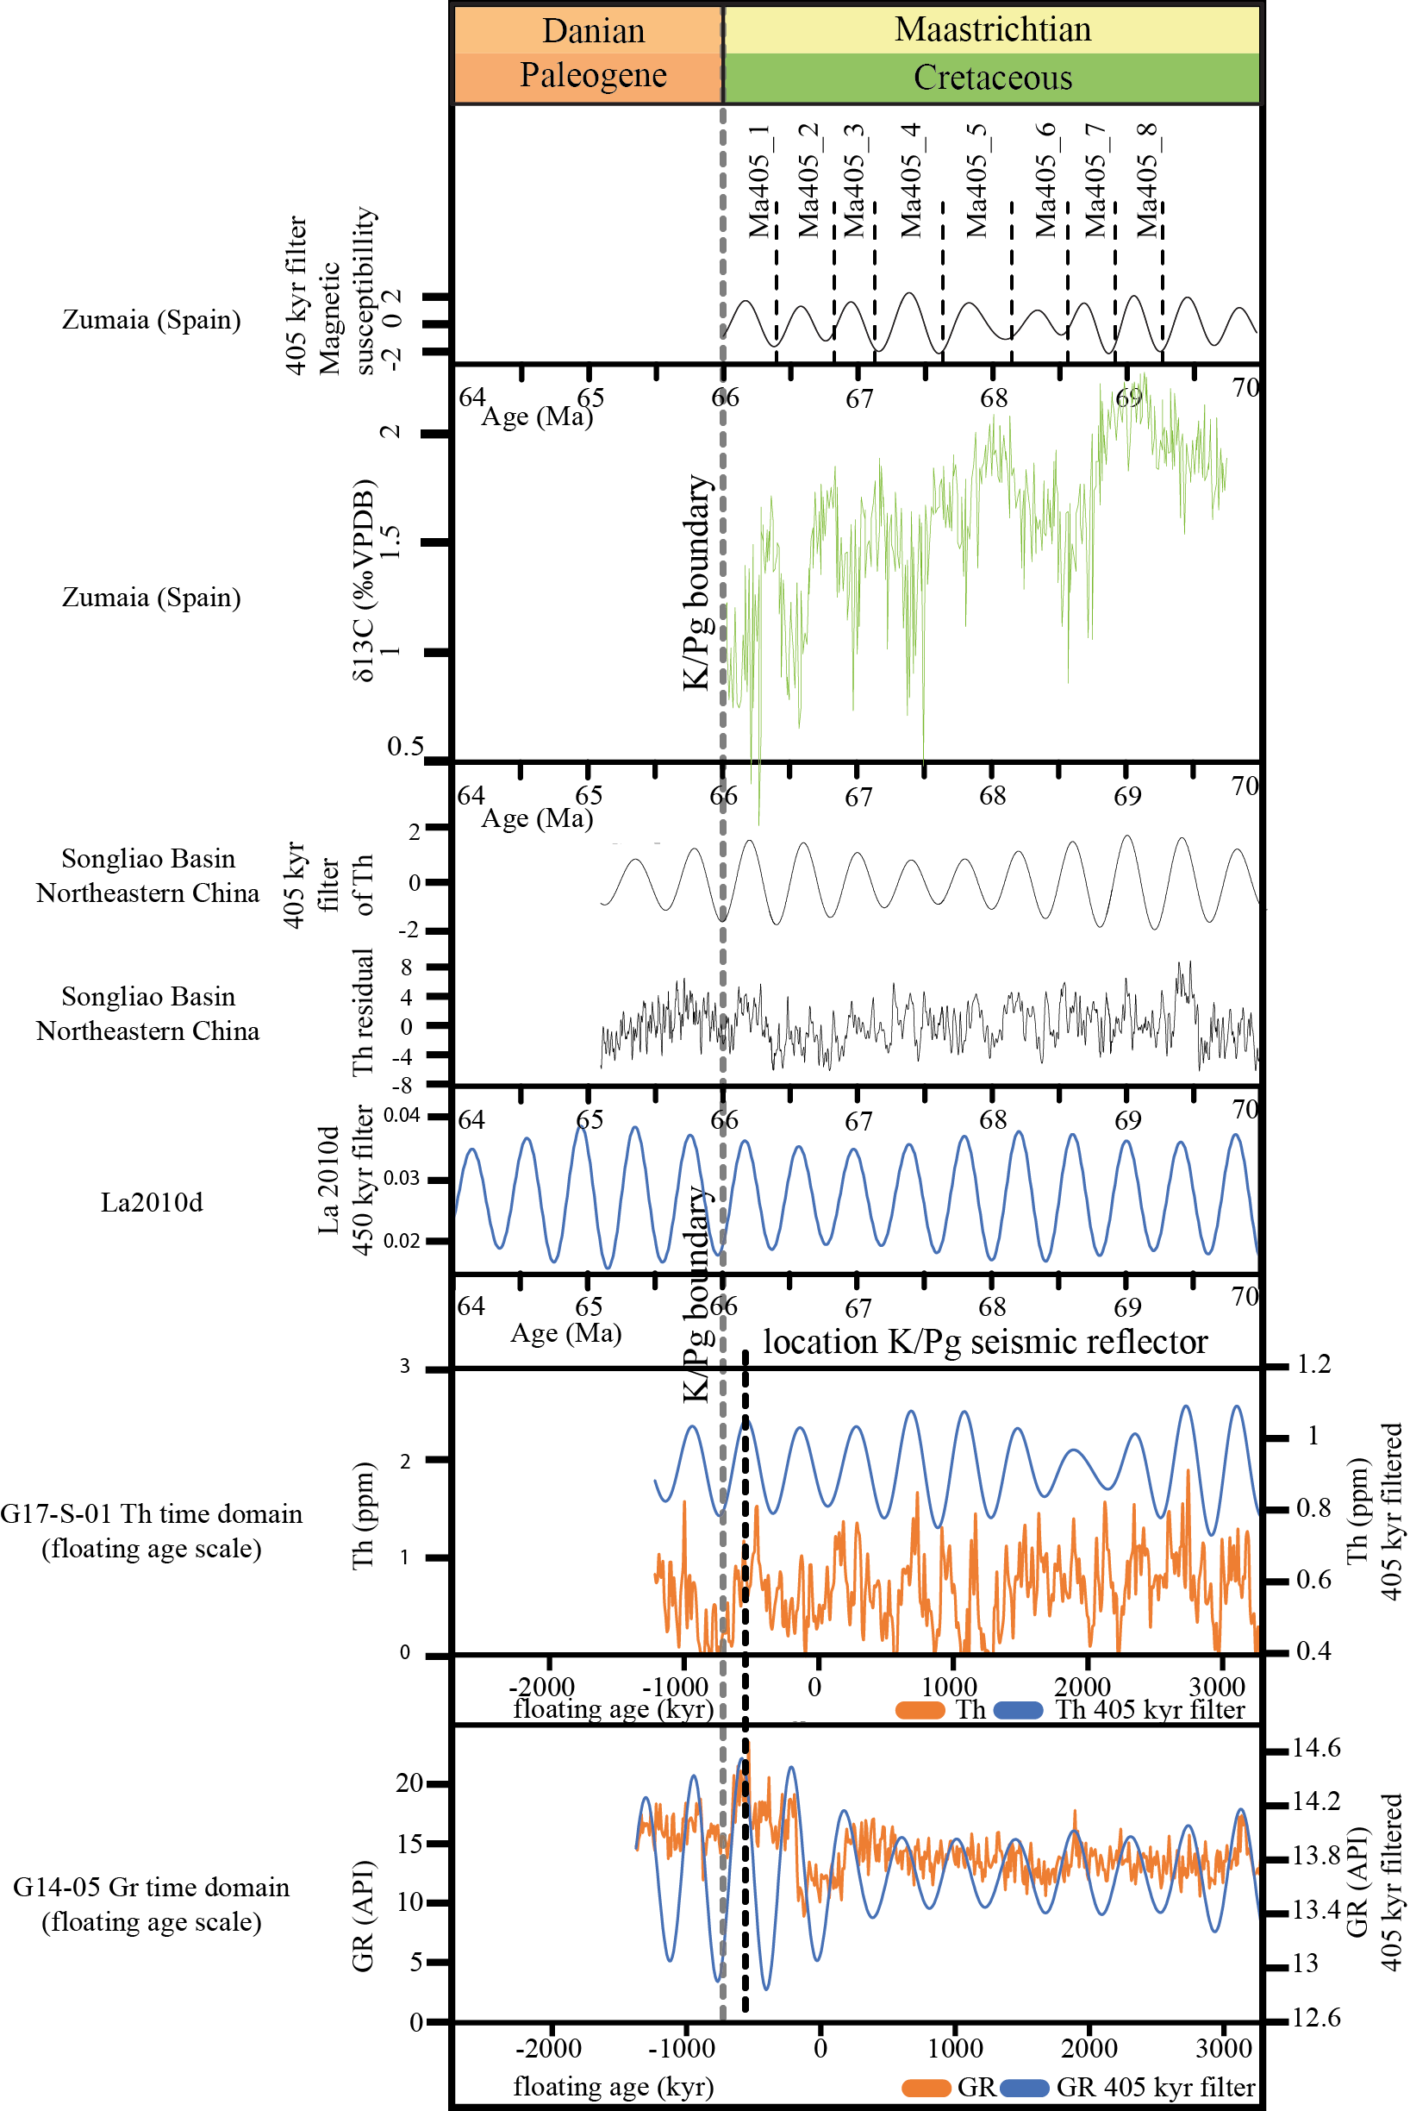

Figure S4. The Zumaia record is modified after Batenburg et al. (2012) and Friedrich et al. 2016) Batenburg et al. (2012) and Friedrich et al. (2016). Note that the filtering of the 405 kyr eccentricity cycle is in antiphase to the δ13C record. The Songliao record is modified after Wu et al. (2014). The Songliao record was tuned to the 405kyr eccentricity cycle from 2010d. The K/Pg boundary is indicated in both the Zumaia and Songliao records. The records of wells G14-05 and G17-S-01 are in the floating time domain and the location of the K/Pg boundary seismic reflector is indicated by the black dotted line. Using the K/Pg boundary seismic reflector, the K/Pg boundary reference records and the 405 kyr eccentricity cycle to K/Pg boundary phase relationship the K/Pg boundary is placed in wells G14-05 and G17-S-01 at the first eccentricity minima above the K/Pg boundary seismic reflector.

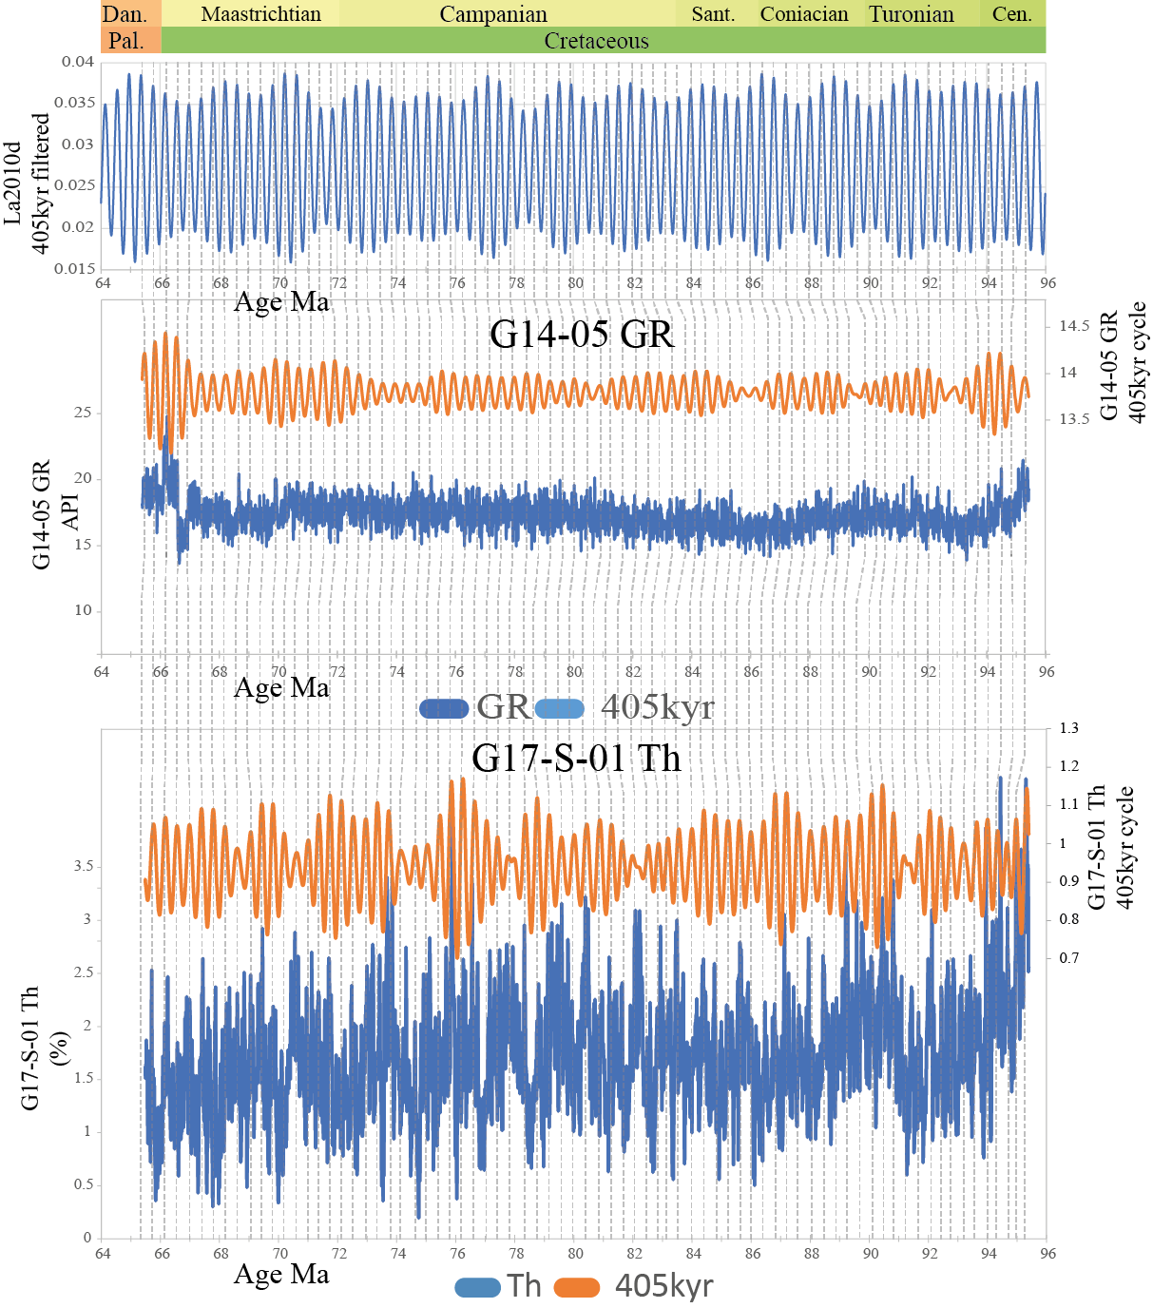

Figure S5. Well-logs G14-05 GR and G17-S-01 Th in the time domain and anchored to K/Pg seismic reflector and the known 405kyr phase relationship of the K/Pg boundary (Batenburg, 2013; Batenburg et al., 2012, 2014; Husson et al., 2011; Westerhold et al., 2008). Above the records of G14-05 GR and G17-S-01 Th is the 405kyr eccentricity cycle filtered from set records. The grey lines indicate the 450kyr eccentricity maxima filtered from la2010d connected to the 405kyr eccentricity cycle maxima filtered from G14-05 GR and G17-S-01 Th.

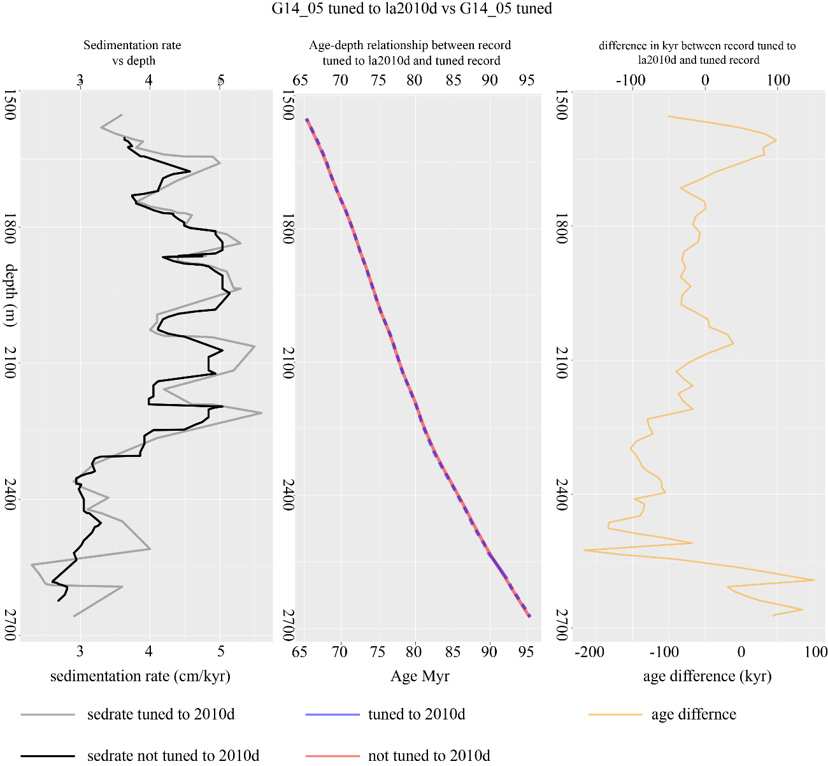

Figure S6. Well G14-05 tuned vs. tuned to la2010d comparison. Left: comparison sedimentation rate, middle: depth vs. age, right: time difference between tuned and tuned to la2010d.

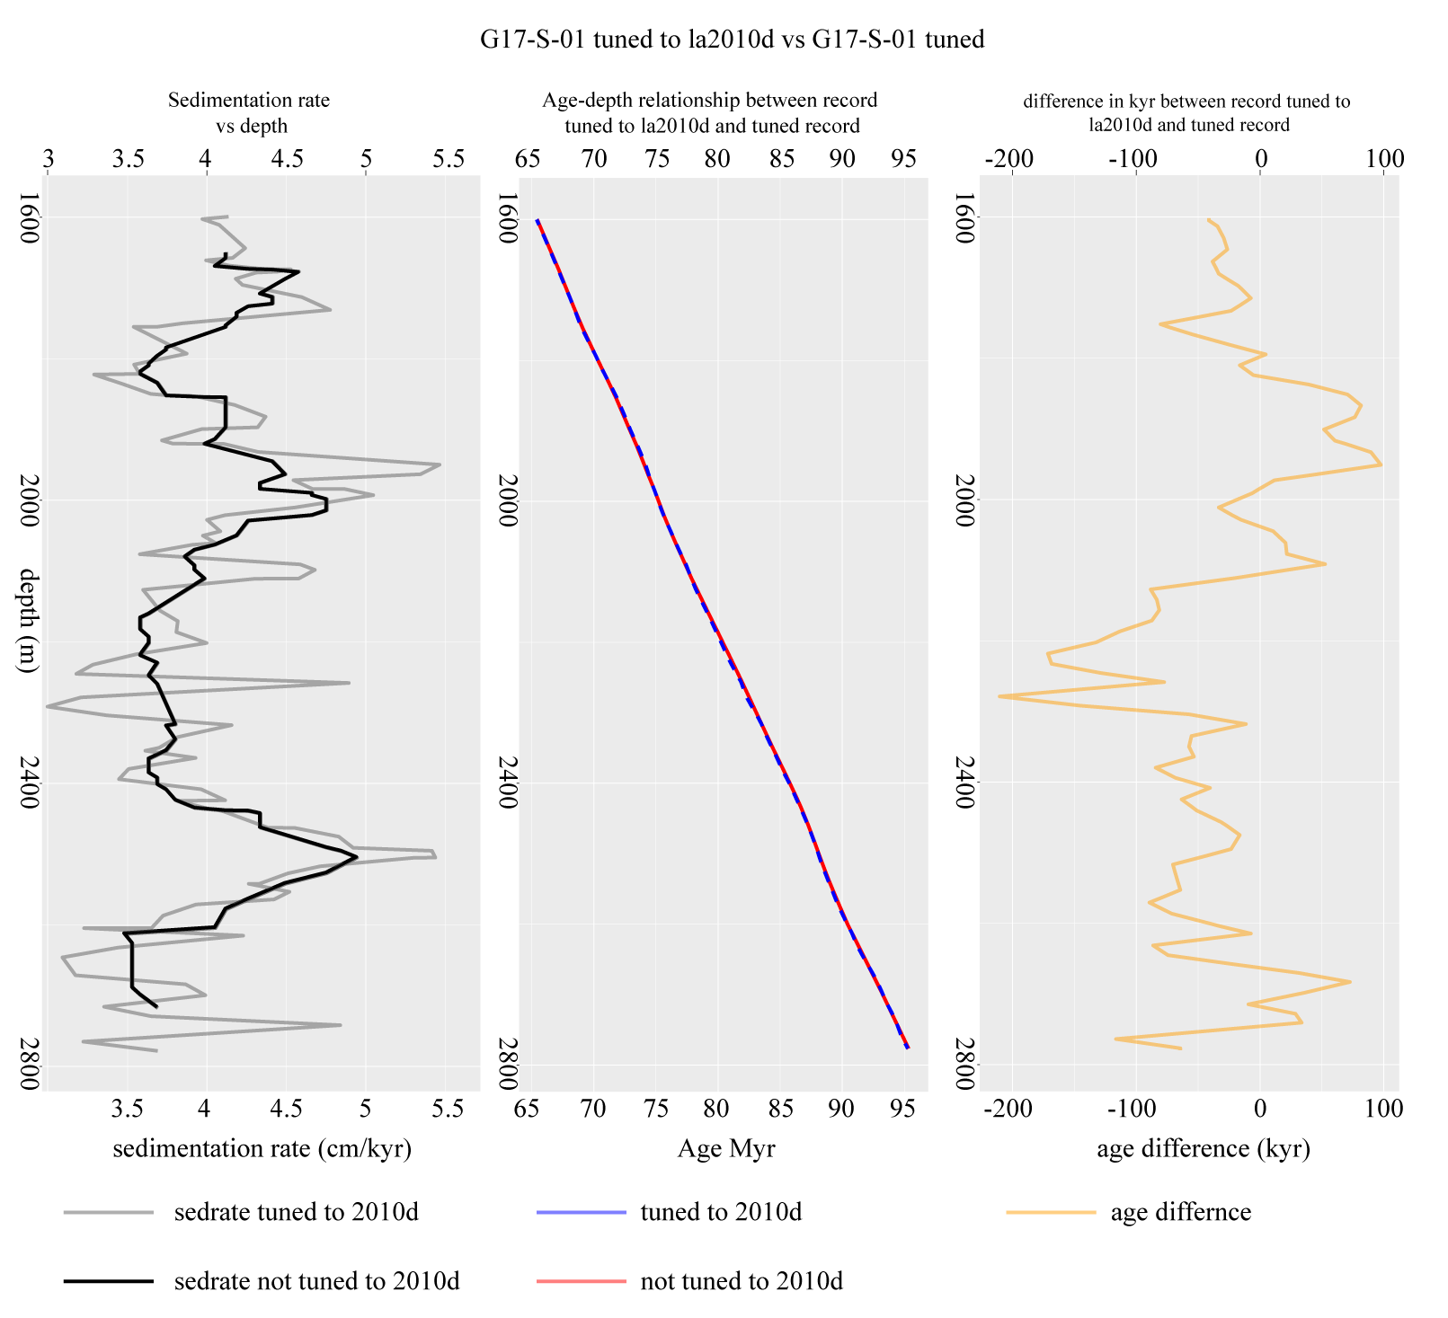

Figure S7. Well G17-S-01 tuned vs. tuned to la2010d comparison. Left: comparison sedimentation rate, middle: depth vs. age, right: time difference between tuned and tuned to la2010d.

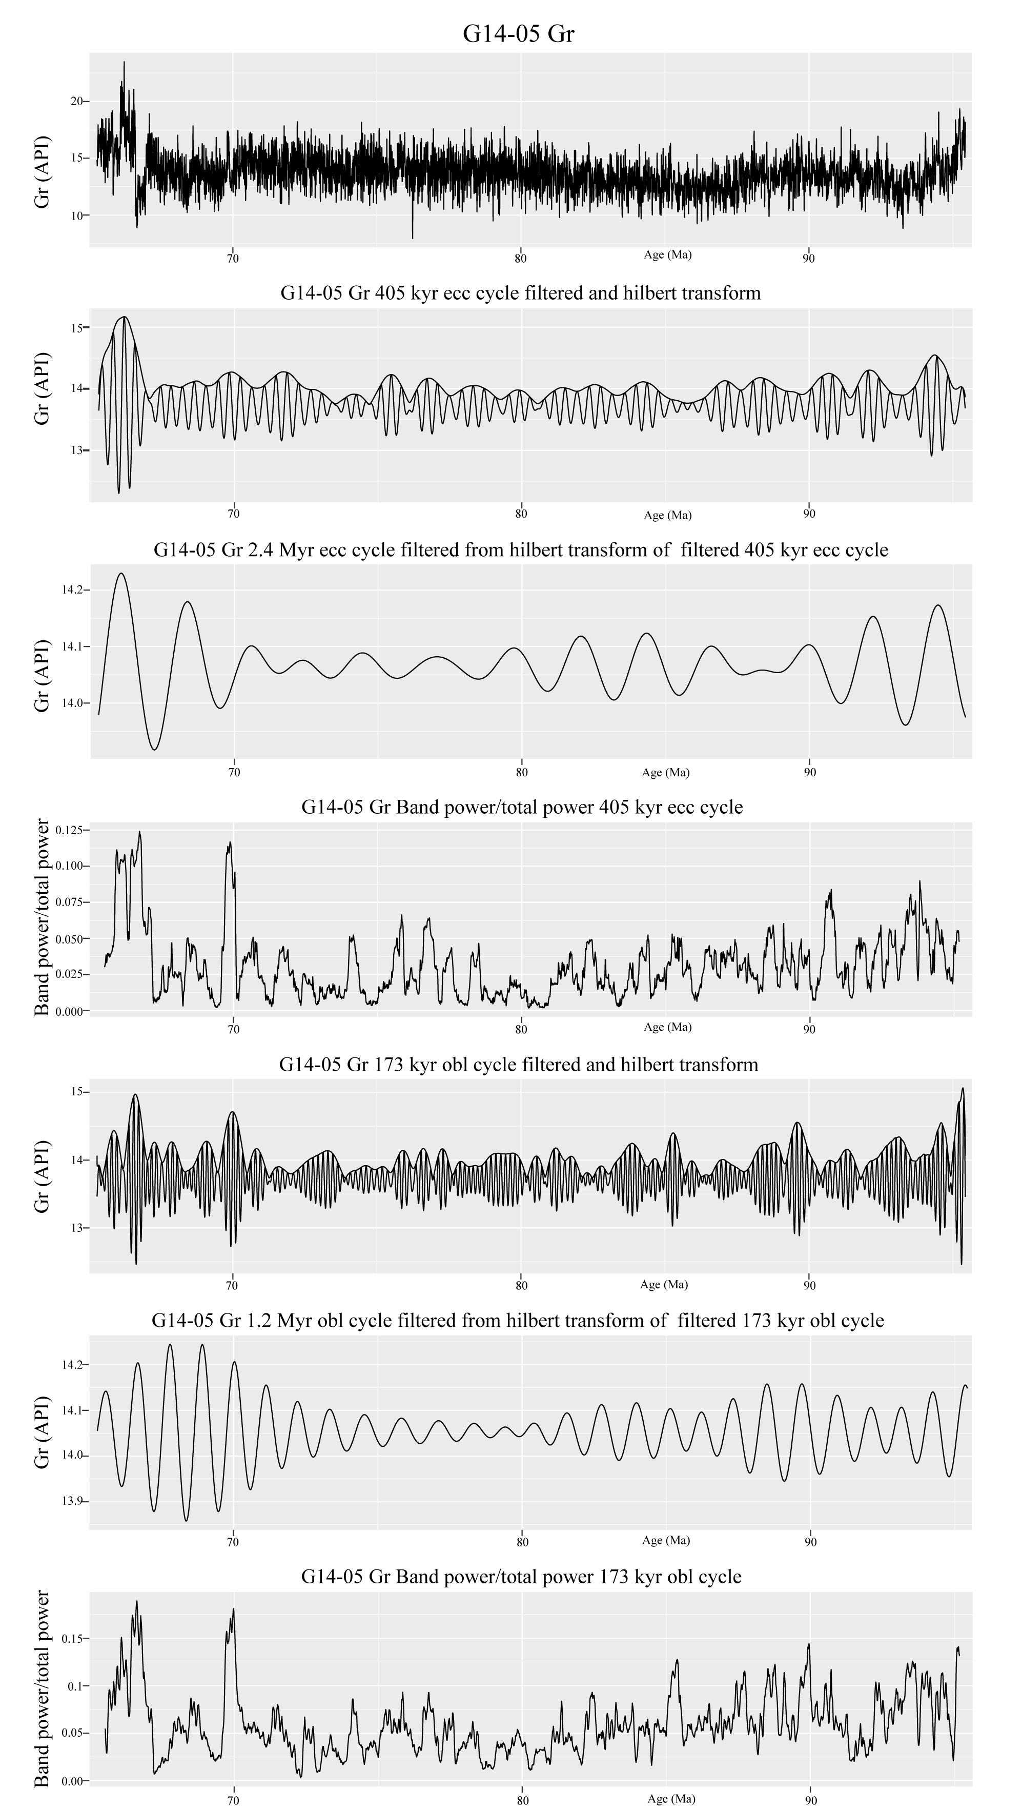

Figure S8. Filtering and amplitude modulation extracting from G14-05.

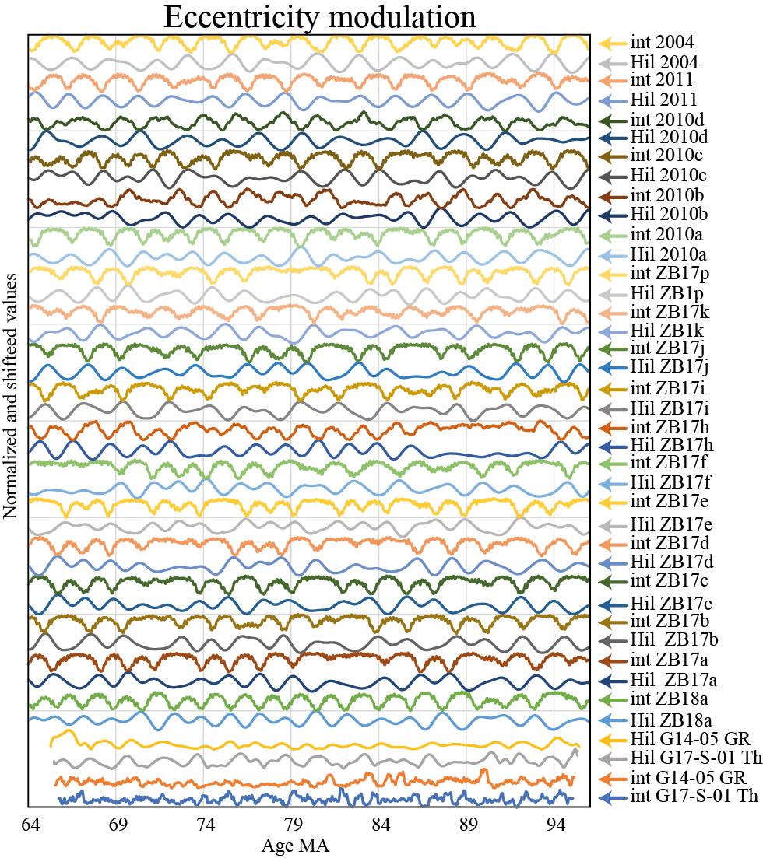

Figure S9. Eccentricity modulation extracted from G14-05 Gr, G17-S-01 Th, la2004, La2010a-d, 2011, ZB17a-p and ZB18 using the technique described in Ma et al. (2017). Hil stands for Hilbert transform in which first the long 405kyr eccentricity cycle was filtered from the data using a Taner filter and then a Hilbert transform was conducted on the data to extract the modulation of the eccentricity cycle. Int stands for integrate power in which the spectral power of the short eccentricity cycle was extracted from an EHA spectra, which should show a modulation of this cycle by longer period eccentricity cycles. Values were normalized (0-1) and shifted as to not overlap with each other and make comparison between the results easier.

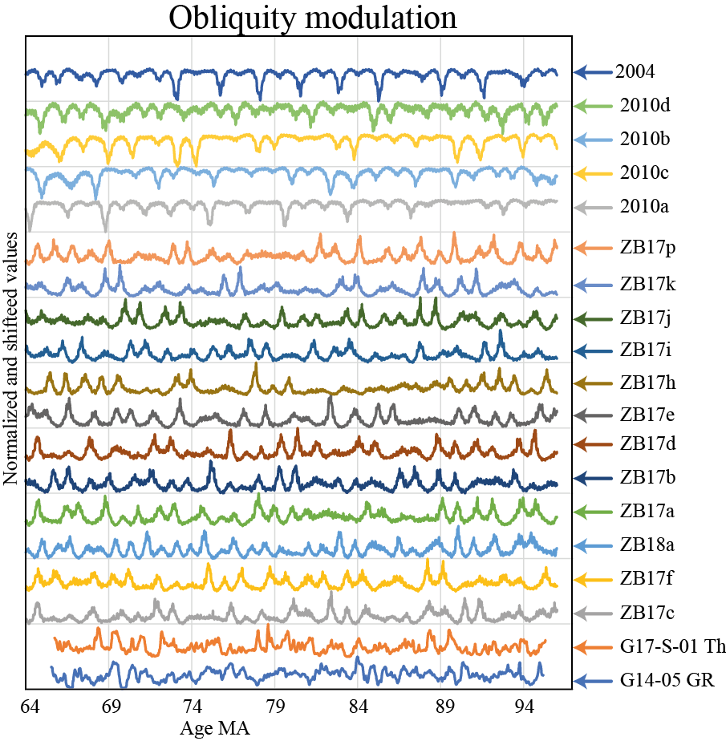

Figure S10. Obliquity modulation extracted from G14-05 Gr, G17-S-01 Th, la2004, La2010a-d, ZB17a-p and ZB18 using the technique described in Ma et al. (2017). Int stands for integrate power in which the spectral power of the obliquity cycle was extracted from an EHA spectra, which should show a modulation of this cycle by longer period obliquity cycles. Values were normalized (0-1) and shifted as to not overlap with each other and make comparison between the results easier.

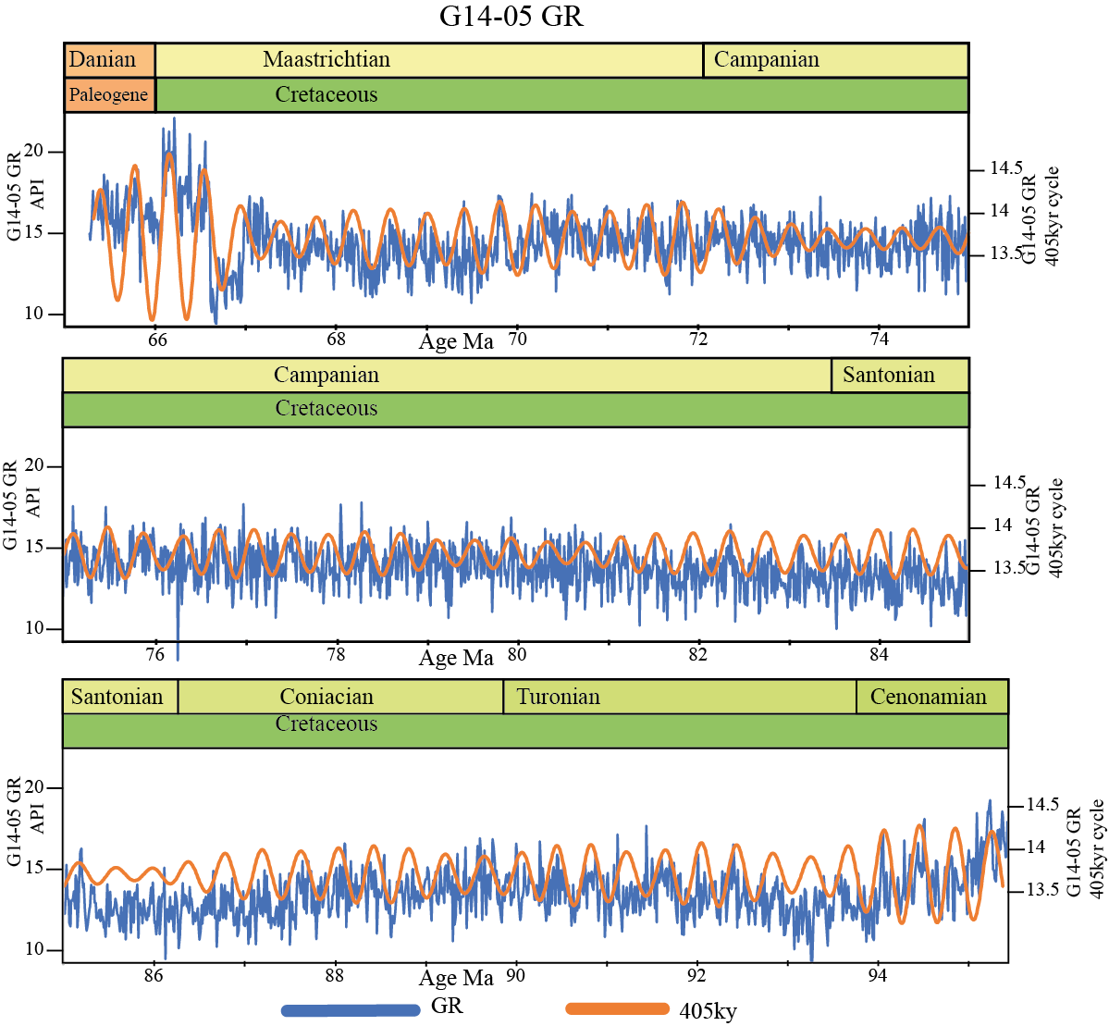

Figure S11. Well G14-05 Gr in the time tuned to la 2010d domain with the filtered 405 kyr eccentricity cycle.

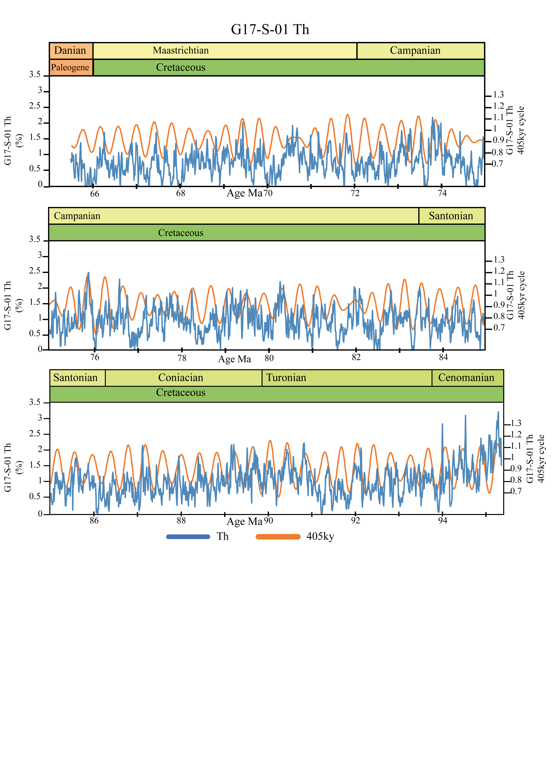

Figure S12. Well G17-S-01 Th in the time tuned to la 2010d domain with the filtered 405 kyr eccentricity cycle.