Supplementary information

Biostratigraphy

All studied samples from the Zumaia, Sopelana and Bidart sections are rich in well preserved planktonic foraminifera. The planktonic species represent more than 90% of all foraminifera, as expected for material deposited in deep facies. About 60 species of planktonic foraminifera can be recognised in the studied assemblages. The lowermost 52m of the logged Maastrichtian succession, before the appearance of Abathomphalus mayaroensis, are included in the Gansserina gansseri biozone. The upper 92m belong to the A. mayaroensis biozone. Some specialists differentiate another biozone in between, which extends from the first occurrence of Contusotruncana contusa until the first occurrence of A. mayaroensis. Additionally, some differentiate a biozone of Plummerita hantkeninoides from its first occurrence up to the K/Pg boundary.

Characteristics of the planktonic foraminifera Contusotruncana contusa, Abathomphalus mayaroensis, Racemiguembelina fructicosa and Plummerita hantkeninoides:
- Within the four selected species, P. hantkeninoides is the only Maastrichtian species with tubulospines and a surface covered with ridges and costellae.
- The name A. mayaroensis refers to those specimens of Abathomphalus that have two muricocarinas in all chambers of the last whorl.
- R. fructicosa is considered a species distinct from Racemiguembelina powelli, for having a shorter biseriate development and a larger number of chambers in the final part of the test.
- The species C. contusa stands apart from other large species within the genus Contusotruncana, for example C. patelliformis, because it has a higher side spiral and a larger size.

Characteristics of identified 405-kyr minima and maxima

The levels that have been identified as 405-kyr minima share the characteristics of having rather thin, very poorly developed cycles, with minimal difference between the marly and carbonaceous part of the cycles. In between the 405-kyr minima, the cycles are generally more pronounced and bundled in groups of five corresponding to the ~100-kyr periodicity. There are either two or three bundles with darker marls midway between two 405-kyr minima.
The 405-kyr minima as identified in the field have been used as starting point for the development of the age model.
Supplementary figures

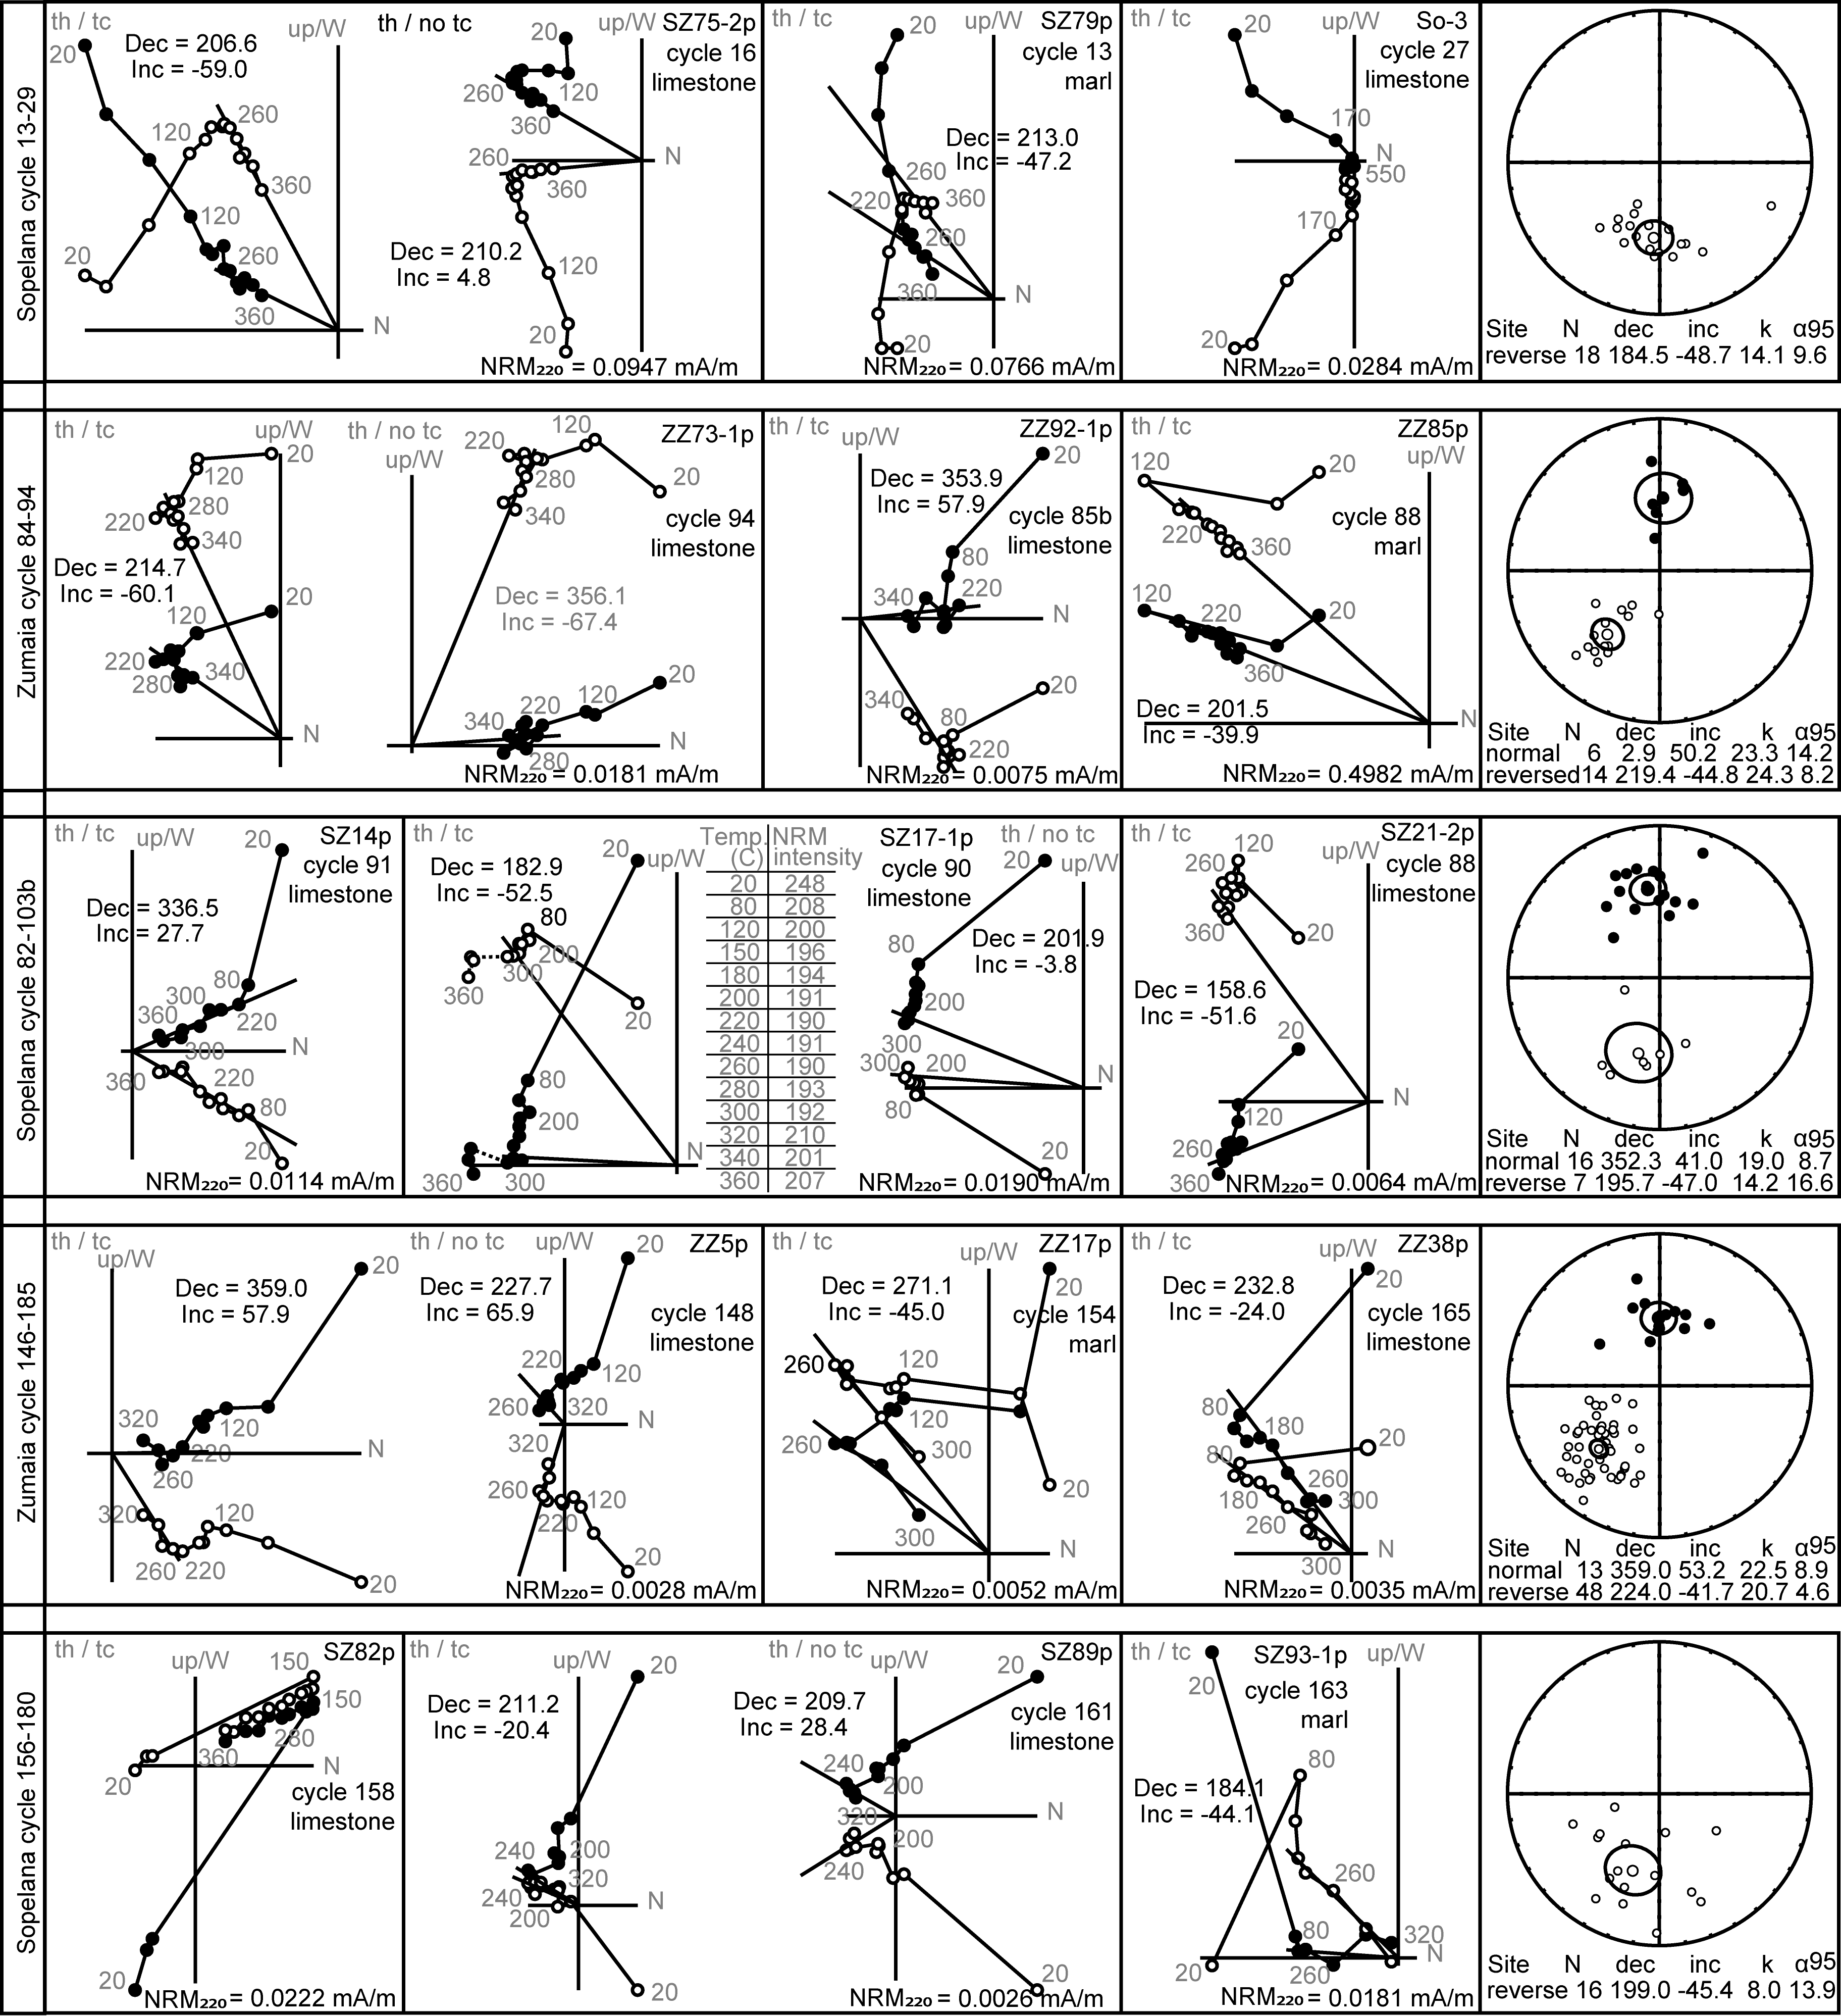
Supplementary Figure 1: Paleomagnetic results: examples of NRM behaviour and equal area projections
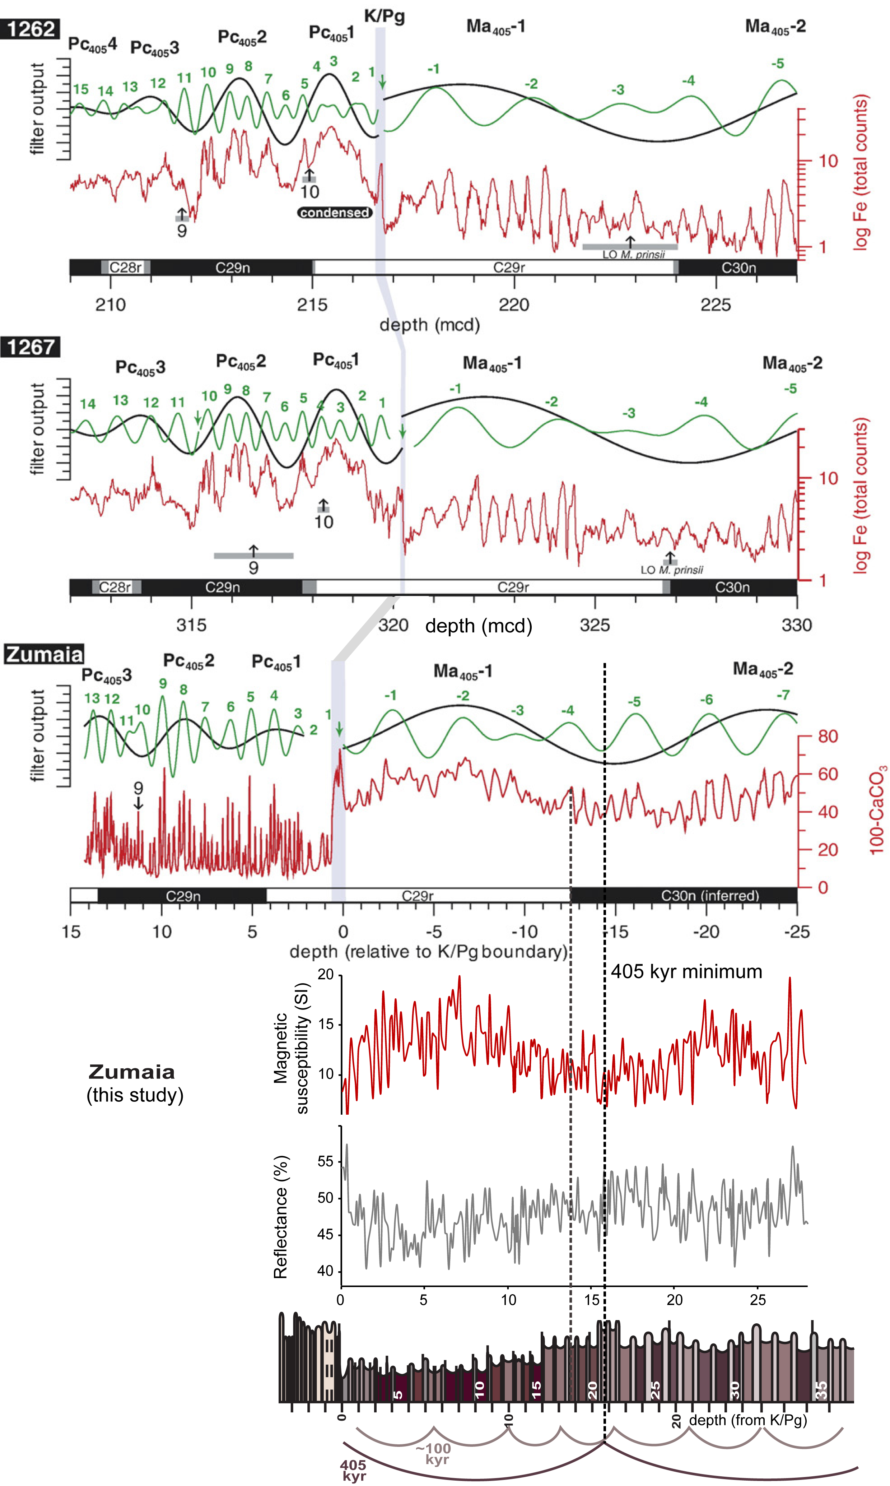
Supplementary Figure 2: Correlation of the base of C29r with the magnetic susceptibility and reflectance records from Zumaia (this study) to the carbonate content at Zumaia (ten Kate and Sprenger, 1993) and XRF data from Site 1262 and 1267 from the Walvis Ridge, as compiled by Westerhold et al. (2008).
Supplementary table 1

Stratigraphic level | 405 kyr cycle | Description
0 m | minimum | Cycles 1-3 are lighter and thinner than the underlying cycles. This is consistent with the identification of a 405-kyr minimum at the K/Pg-boundary by Kuiper et al. (*).
2-12 m | maximum | The marls, grouped in bundles of five, are darkest and thickest in the middle of these three bundles, and these bundles are most clearly expressed.
16 m | minimum | The marl of cycle 21, and to a lesser extent the marl of cycle 22, is lighter and thinner than the surrounding marls and form a protruding point of the cliff.
17-28 m | maximum | The marls, grouped in bundles of five, are darkest and thickest in the middle of these three bundles, and these bundles are most clearly expressed.
32 m | minimum | The marl of cycle 41 is poorly developed and the limestone of cycle 42 is very prominent, forming a slightly protruding point.
38-44 m | maximum | The marls, grouped in bundles of five, are darkest and thickest in the middle of these two bundles, and these bundles are most clearly expressed. Just below 41m, the beds are hard to distinguish, coinciding with a probable ~100-kyr minimum.
47 m | minimum | The individual cycles are very thin and the more resistant part of the cycle is very poorly expressed.
49-59 m | maximum | The marls, grouped in bundles of five, are darkest and thickest in the middle of these three bundles, and these bundles are most clearly expressed.
61 m | minimum | The individual beds are thinner and poorly expressed, especially the marlyer beds.
65-72 m | maximum | The marls, grouped in bundles of five, are darkest and thickest in the middle of these two bundles, and these bundles are most clearly expressed. At 68m there is a double limestone bed with no marl in between, coinciding with a probable ~100-kyr-minimum.
76 m | minimum | The marl of cycle 94, and to a lesser extent the marl of cycles 93 and 95, is very thin and light compared to the surrounding marls and this level forms the furthest protruding point.
80-89 m | maximum | The marls, grouped in bundles of five, are darkest and thickest in the middle of these three bundles, and these bundles are most clearly expressed compared to bundles above. At 82m, there is a very thin limestone and a very thin marl, probably coinciding with a probable ~100-kyr minimum.
91 m | minimum | The marly and less marly layers are hard to distinguish at this level, the marls are not so dark and the less marly layers are very thin and not very resistant.
96-108 m | maximum | The marls, grouped in bundles of five, are darkest and thickest in the middle of these two bundles, and these bundles are most clearly expressed.
111 m | minimum | The cycles are thin and difficult to identify, because the marls are very poorly expressed, and all beds are very carbonaceous
114-119 | maximum | The individual cycles are easier to identify and the marls around 116 are very prominent.
122 m | minimum | The cycles are thin and difficult to identify here, because the marls are very poorly expressed, and all beds are very carbonaceous.
126-132 m | maximum | The cycles are very regular and easy to distinguish, with a very prominent marl at 128m.
135 m | minimum | The marl of cycle 173 is very thin, and the limestones of cycle 173 and 174 very prominent, forming a protruding point into sea.
137-143 m | maximum | The cycles are very clear and grouped in groups of five, with the darkest marls in these two bundles.

Table 1: characteristics of the 405-kyr maxima and minima. Minima are used as tie-points for the age model. Underlined levels are particularly well-defined minima.

