测试说明：
- TCP分为flange和TCP_4hole，其中flange为默认法兰中心，TCP_4hole为沿着flange法兰Z轴正向偏移200mm
测试现场环境（测试位置一直保持不变）：
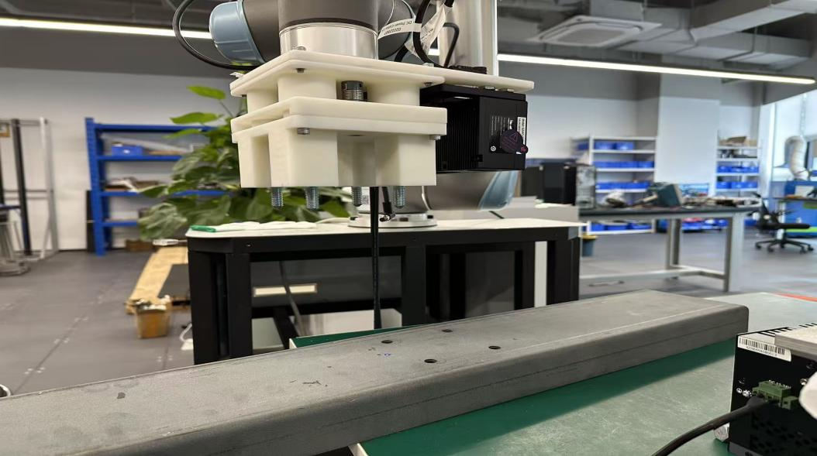
测试次数 | TCP设置 | 姿态调整沿着Z轴偏移/mm | 标定文件 | 获取的4孔姿态中心（相机侧） | 经过换算后需要调整的角度 | 结果（预期旋转角度接近0°）
 | Flange | 150 | 0608 | PoseList:  Size:1  [  [  -0.356639351259396,  -0.24630224607048049,  0.13141032210606474,  0.9650829577157418,  -0.004837673605753398,  -0.008442443629904145,  -0.26176364680046016  ]  ] | 旋转 (deg): RX=-0.561°, RY=-0.979°, RZ=-30.350° | Z轴旋转过多，错误
 | Flange | -150 | 0608 | PoseList:  Size:1  [  [  -0.35251983422214284,  -0.2503914685691543,  -0.16851237304153324,  0.9650589526733153,  -0.004832076148301642,  -0.008412245505813803,  -0.26185320893724195  ]  ] | 旋转 (deg): RX=-0.560°, RY=-0.975°, RZ=-30.361° | Z轴旋转过多，错误
 | Flange | -150 | 0527 | PoseList:  Size:1  [  [  -0.35164238662843217,  -0.250830952167879,  -0.16720322004416888,  0.9654016347605823,  -0.004710191051711246,  -0.009708648567857029,  -0.2605441226449705  ]  ] | 旋转 (deg): RX=-0.546°, RY=-1.126°, RZ=-30.205° | Z轴旋转过多，错误
 | TCP_4hole | 150 | 0608 | PoseList:  Size:1  [  [  -0.35663051501727444,  -0.24627286865958128,  0.131432255608164,  0.9650076732317294,  -0.0048372428663858375,  -0.008418249296616786,  -0.2620418378124298  ]  ] | 旋转 (deg): RX=-0.561°, RY=-0.976°, RZ=-30.383° | Z轴旋转过多，错误
 | TCP_4hole | -150 | 0608 | PoseList:  Size:1  [  [  -0.3525323765678929,  -0.2503733306516544,  -0.1685253837778306,  0.9650590527194846,  -0.00483507029388706,  -0.008429356656502964,  -0.2618522346778459  ]  ] | 旋转 (deg): RX=-0.561°, RY=-0.977°, RZ=-30.360° | Z轴旋转过多，错误

