相机坐标系下 | 转换到法兰坐标系 | 标定参数 | 标定外参解释
[  -0.043069044402604686,  0.0004974435875224267,  0.26443036458687724,  0.7188857599997753,  -0.026695731739901717,  -0.03239846694738541,  -0.6938594535753453  ]  ] | [  -0.729100361295575,  -0.7400450016975244,  -0.009338351475603312,  0.7082930102840156,  -0.7034901164587654,  0.027960840431615546,  -0.051389289059082646  ]  ]————错误的数值 | [  0.11871790210044586, 0.040763527298959844, 0.0855245417531863, 0.7078827186207565, -0.01037719344113772, -0.009907388286083977, 0.7061842636250972  ] | 参考坐标系： 相机坐标系到法兰坐标系（单位为m和rad）  位姿值： 0.118718, 0.040764, 0.085525, 0.707883, -0.010377, -0.009907, 0.706184  位姿解析： 旋转轴：(-0.0146917, -0.0140266, 0.999794) 。旋转角：89.8742。  平移：(0.118718, 0.0407635, 0.0855245) 。
[  -0.04312546206921042,  0.0004983511874704829,  0.26442409952226875,  0.718848550143168,  -0.026693182640654792,  -0.032436717649132085,  -0.6938963145209295  ] | [  0.12620604750220124,  -0.0009587099641354933,  0.21073823371889372,  0.9982807603777686,  0.0034257266296848967,  -0.05613430538853563,  0.016514466845451103  ] | [  0.11871790210044586,  0.040763527298959844,  0.0855245417531863,  0.7078827186207565,  -0.01037719344113772,  -0.009907388286083977,  0.7061842636250972  ]

通信方式 | 测试条件 | 相机坐标系下 | 转换到法兰坐标系 | 转换到TCP移动的位置  (自研算法转换) | 备注
Adapter | 手动触发  相机设置中从参数中获取法兰位姿开启  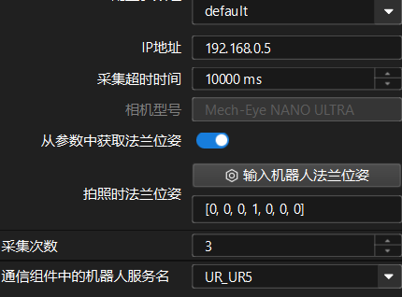 | [  -0.04309412693267978,  3.706442412969822e-05,  0.26431273482804385,  0.7189156161137387,  -0.026107245753204944,  -0.03184566006355257,  -0.6938765038262233  ] | [  0.13305698808348815,  -0.00041241664818166706,  0.150982579102137,  0.9983261814359153,  0.003422213431885982,  -0.05530258539779968,  0.016575523012273885  ] | 旋转 (deg): RX=0.392°, RY=-6.341°, RZ=1.900°
Adapter | 手动触发  相机设置中从参数中获取法兰位姿关闭  提示：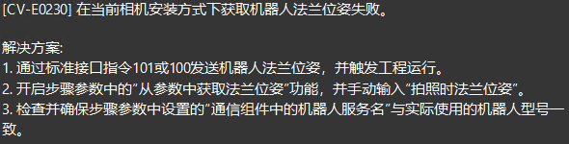 | 获取失败
Adapter | 网络助手触发：  格式（p,1,0,关节,法兰\r）  p,1,0,10.5, -90.49, 94.9, -94.34, -88.92, 131.2,-453.546,-198.151,400.65,173.30,47.23,0.34\r | [  -0.0431268578979834,  3.791738778227173e-05,  0.2643222848996641,  0.7190107993231186,  -0.02611302027999927,  -0.03184486593930092,  -0.6937776914414985  ] | [  -0.3738647880375357,  -0.24393768984397557,  -0.14739606096668584,  0.9589014196388415,  0.014579763806654029,  0.050510578138234306,  -0.27882643238778165  ] | 旋转 (deg): RX=1.694°, RY=5.869°, RZ=-32.396°
Adapter | 手动触发  机设置中从参数中获取法兰位姿开启  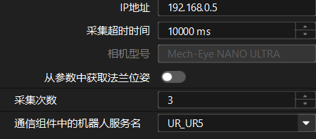 | [  -0.043107944898975396,  3.2779289879643e-05,  0.2643558425511068,  0.7188003250333818,  -0.02608379664407637,  -0.03186002206574372,  -0.6939961579709979  ] | [  -0.37386378705217777,  -0.24395173018745217,  -0.14742996814816367,  0.958986402889086,  0.01461109356471344,  0.050492783778398914,  -0.27853558804038436  ] | 旋转角 (deg): [rx=1.698°, ry=5.866°, rz=-32.361°] | 2026-06-22T16:38:08.013[0m[D] [ getFL ] UR_UR5 getFL: QJsonObject()[0m  2026-06-22T16:38:08.013[0m[D] [ getFL ] getFL failed and call getJ instead. 将位姿设为QJsonArray() 时，字符串数量不正确。[0m  2026-06-22T16:38:08.014[0m[D] [ getJ ] UR_UR5 getJ: QJsonObject()[0m  2026-06-22T16:38:08.014[33m[W] getJ失败。
Adapter | 手动触发  机设置中从参数中获取法兰位姿开启   | [  -0.04312962896567738,  2.185936620876898e-05,  0.2643331254392496,  0.7189002596426282,  -0.026099229681849828,  -0.03186196824936068,  -0.6938919670057099  ] | [  -0.3738476121375534,  -0.24393749459820338,  -0.14740715311253363,  0.9589455599810048,  0.01460337086024336,  0.050507125937610385,  -0.27867397578847913  ] | 旋转角 (deg): [rx=1.697°, ry=5.868°, rz=-32.378°] | 2026-06-22T16:38:08.013[0m[D] [ getFL ] UR_UR5 getFL: QJsonObject()[0m  2026-06-22T16:38:08.013[0m[D] [ getFL ] getFL failed and call getJ instead. 将位姿设为QJsonArray() 时，字符串数量不正确。[0m  2026-06-22T16:38:08.014[0m[D] [ getJ ] UR_UR5 getJ: QJsonObject()[0m  2026-06-22T16:38:08.014[33m[W] getJ失败。

