**System Requirement Specification**

1. **Purpose**

The purpose of this document is to describe the eLibrary System. This document contains the functional, behavioral and non-functional requirements of the project and it also contains the guidelines for system engineers and designers to start working the project.

1. **Scope**

Library Management System is basically updating the manual library system into an internet application so that the user scan knows the details of their accounts, availability of books and remaining time for borrowing. The project is specifically designed for the use of librarians and library users. The product will work as a complete user interface for library management process and library usage from ordinary users. eLibrary System can be used by any existing or new library to manage its books and book borrowing, insertion and monitoring.

1. **Product Functions**
2. Administrators

* admin should be able to insert, modify and delete books.
* can accept or reject a new user according to the library policy or payment methods.
* Increase the period for borrowing a book for specific type or group of users.
* Can get the information (status report) of any member who has borrowed a book.
* add and edit book categories and arrange books by categories.
* Add and edit authors and publisher’s information.
* Can send lateness warnings to people who have exceeded deadline date.
* Can record books returned by users.

1. **Library members**

* The member should be provided with the updated information about the books catalog.
* Members are given an access to check their account’s information and change it.
* Members could search through books by subject, title, authors or any information related to the book.
* can extends the period of borrowing books according to the library policy.
* the customer may suggest a book to be brought to the library book collection.

1. **Operating environment**

The eLibrary System is a website and shall operate in all famous browsers, for a model we are taking Microsoft internet explorer, google chrome, Mozilla Firefox with Flash player and JavaScript.

1. **User Characteristics**

Users of this eLibrary System are members, librarians and the administrators who maintain the website. Members and librarians are assumed to have basic knowledge of computers and internet browsing. Administrators of the system should have more knowledge of internal modules of the system and are able to rectify small problems they may arise due to disk crashes, power failures and other catastrophes.

1. **Design and implementation constraints**

* The information of all users, books and libraries must be stored in a database that is accessible by the website.
* MS SQL server will be used as SQL engine and database.
* The online library System is running 24 hours a day.
* Users may access from any computer that has internet browsing capabilities and an internet connection.
* Users must have their correct usernames and passwords to enter into their online accounts and do actions.

1. **Functional requirements**

**Insert book:**

This action is done to add new book to library book collection.

**Delete/ modify book:**

This event is to delete an existing book or modify its information.

**Delete member:**

Admin can delete a member due to some specific rules.

**Return Book:**

Admin should confirm the return of books borrowed by users.

**Register:**

When new user enters for the first time then he must register extending borrowing time to some limit decided by Admin

**Common functions:**

**Login:**

Both Admin and members must be logged in before they modify any information.

**Search for book:**

When user or admin wants to search on some book by name, author or subject etc.

1. **Non-Functional Requirements**

**Error handling:**

eLibrary System shall handle expected and non-expected errors in ways that prevent loss in information and long downtime period.

1. **Performance Requirements**

The system shall accommodate high number of books and users without any fault.

1. **Security Requirements**

* System will use secured database
* Normal users can just read information, but they cannot edit or modify anything except their personal and some other information.
* System will have different types of users and some other information.
* System will have different types of users and every user has access constraints

1. **User Requirements**

**12.1- Use cases**

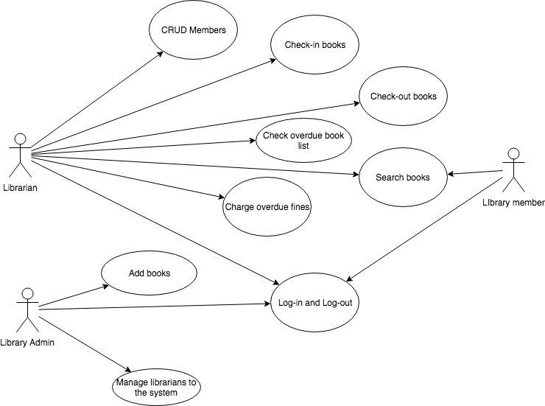

**Glossary**

* **MS SQL:** Microsoft SQL Server is an SQL database management system incorporating among others a DBMS developed and marketed by Microsoft.
* **SQL :** (Structured Query Language) is a standardized computer language used to exploit relational databases.
* **eLibrary Architecture:** This is the architecture of the eLibrary system.
* **Actors:** Users who manipulate the system.
* **Librarian:** A librarian generally refers to a person who is entrusted with the management of document collections and user assistance in a library, as well as general administration functions.
* **User Actions:** A *user action* is an interaction with the web browser that involves a call to a web server, which can potentially have multiple nested calls.
* **System Action:** An action system is a collection of actions
* **BOOKID:**  The identity of the book, which makes the distinction of the book.
* **MUM:** Maharishi University of Management.
* **Stakeholder:** A stakeholder is an actor, individual or collective, actively or passively concerned by a decision or a project.
* **Stakeholder Summary:** This project team must balance the interest of many different project stakeholders. Some of these stakeholders may have competing goals and interests, and many may have limited resources. This stakeholder analysis can help the team schedule appropriate attention to each and decide how best to mitigate conflicting stakeholder interests when they do happen.
* **Librarians:** A librarian is a person who works professionally in a [library](https://en.wikipedia.org/wiki/Library), providing access to information and sometimes social or technical programming to users.
* **Admin:** The system administrator title is the person responsible for the eLibrary System servers.
* **Developers and Testers:** The aim of testers and developers is the same i.e. to provide a quality product to the stakeholders. It means that the testers by their out-of-box thinking and by placing themselves, apply all possible scenarios on the application.
* **Processing:** In a library setting, the act of preparing a book or other item for library circulation, involving putting labels, jackets and other identifying information on the item
* **TEACH:** Technology for Educational Achievement in Wisconsin is a state telecommunications access program and mechanism to provide discounted BadgerNet services to schools and libraries.
* **Circulation:** The library name for checking out a book or other item of library material
* Cataloging: The act of creating a record which provides a standardized bibliographic description of a book or other item in a library’s collection, the process may result in a catalog card for the file or in a machine-readable record for a computerized database