Cause of Deaths 2020

# Research Question

* Is the Coronavirus a real global pandemic?

# How was the data collected?

* Weekly counts of death by jurisdiction and cause of death
  + Provided by the CDC. Downloaded and accessed as a CSV. Can be accessed [here](https://data.cdc.gov/NCHS/Weekly-counts-of-death-by-jurisdiction-and-cause-o/u6jv-9ijr?fbclid=IwAR3oPM9rkxOVoZ4PRdfaGAvzLJy7kSPU3ymb1metm1R2vvAl6dAPE53OaKU).
  + 329988 rows × 15 columns. Variables include jurisdiction, cause group, and number of deaths.
  + Used to calculate the number of deaths per U.S. state per year, from 2015-2020.

# Data Cleaning

* The dataset used contained unneeded variables that were not needed to answer the research question, so these variables were dropped.
* Missing values for number of deaths variable were handled by replacing the missing values with the mean(average) of that jurisdiction for all years.

# Data Analysis

Lets look at the first few rows of the dataset we are working with. We only need the columns “Jurisdiction”, “Year”, “Cause.Group”, and “Number.of.Deaths”.

## Jurisdiction Year Cause.Group Number.of.Deaths  
## 1 Alabama 2015 Alzheimer disease and dementia 120  
## 2 Alabama 2015 Alzheimer disease and dementia 120  
## 3 Alabama 2016 Alzheimer disease and dementia 76  
## 4 Alabama 2016 Alzheimer disease and dementia 76  
## 5 Alabama 2017 Alzheimer disease and dementia 96  
## 6 Alabama 2017 Alzheimer disease and dementia 96

Lets check for null values.

sum(is.na(data$Number.of.Deaths))

## [1] 34

There are 34 null values. Lets look at some of these null values.

head(filter(data, is.na((data$Number.of.Deaths))))

## Jurisdiction Year Cause.Group Number.of.Deaths  
## 1 Indiana 2020 Alzheimer disease and dementia NA  
## 2 North Carolina 2020 Alzheimer disease and dementia NA  
## 3 North Carolina 2020 Alzheimer disease and dementia NA  
## 4 North Carolina 2020 Alzheimer disease and dementia NA  
## 5 Indiana 2020 Circulatory diseases NA  
## 6 North Carolina 2020 Circulatory diseases NA

Lets fill these values with the mean per state per cause of all years and check for null values again.

sum(is.na(data$Number.of.Deaths))

## [1] 0

Since there are no more null values in our data, we can continue with our analysis. There are rows in our data where Jurisdiction is “United States”. Lets look at some of these values.

head(filter(data, data$Jurisdiction == "United States"))

## Jurisdiction Year Cause.Group Number.of.Deaths  
## 1 United States 2015 Alzheimer disease and dementia 6187  
## 2 United States 2015 Alzheimer disease and dementia 6187  
## 3 United States 2016 Alzheimer disease and dementia 5155  
## 4 United States 2016 Alzheimer disease and dementia 5155  
## 5 United States 2017 Alzheimer disease and dementia 5844  
## 6 United States 2017 Alzheimer disease and dementia 5844

nrow(filter(data, data$Jurisdiction == "United States"))

## [1] 8138

We need specific Jurisdiction locations so we will drop these rows.

## Number of rows before drop: 329988   
## Number of rows after drop: 321850

Lets sum the total deaths and total deaths per year.

## Total Deaths: 25864451

Lets look at the new dataframe

## Year Deaths Death Rate  
## 1 2015 4173810 0.1613725  
## 2 2016 4189572 0.1619819  
## 3 2017 4298704 0.1662012  
## 4 2018 4338856 0.1677536  
## 5 2019 4334354 0.1675796  
## 6 2020 4529155 0.1751112

Lets plot the distance from the mean for number of deaths per year and the total deaths per year.

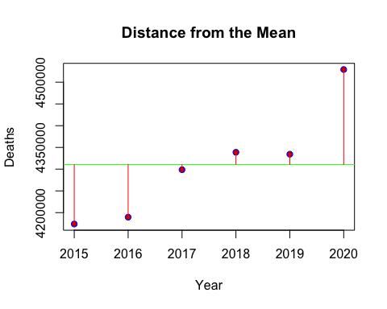

## Year Mean Deaths Above or Below the Mean  
## 1 2015 4310742 -136931.83  
## 2 2016 4310742 -121169.83  
## 3 2017 4310742 -12037.83  
## 4 2018 4310742 28114.17  
## 5 2019 4310742 23612.17  
## 6 2020 4310742 218413.17

The plot below shows that the number of deaths increase every year. I am just guessing but I believe that this is because the population also increase every year. We will prove that in a different analysis.

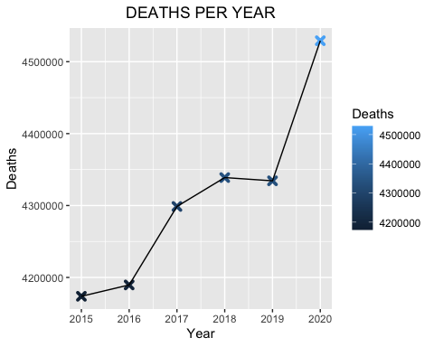

Lets look at the total deaths per cause, with the death rate, and the rank.

## Deaths Death Rate Rank  
## Circulatory 10286544 0.3977097 1  
## Malignant 7232838 0.2796440 2  
## Respiratory 3162371 0.1222671 3  
## Alzheimer 3204864 0.1239100 4  
## Other 1977834 0.0764692 5

Lets plot the total deaths by cause.

The bar plot above shows that Circulatory is the top cause of deaths, followed by Malignant. Alzheimer and Respiratory are really close but not even close to Circulatory and Malignant.

Lets look at the deaths by cause and year.

## Year Alzheimer Circulatory Malignant Respiratory Other  
## 1 2015 491824 1650874 1195622 520900 314590  
## 2 2016 499756 1661462 1199804 512750 315800  
## 3 2017 525260 1702034 1206588 538272 326550  
## 4 2018 534502 1721088 1206428 546294 330544  
## 5 2019 544070 1730348 1206824 522650 330462  
## 6 2020 609452 1820738 1217572 521505 359888

## Alzheimer Circulatory Malignant Other Respiratory  
## 2015 4 1 2 5 3  
## 2016 4 1 2 5 3  
## 2017 4 1 2 5 3  
## 2018 4 1 2 5 3  
## 2019 3 1 2 5 4  
## 2020 3 1 2 5 4

Lets plot every cause of death by year.

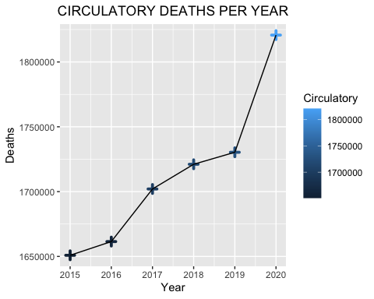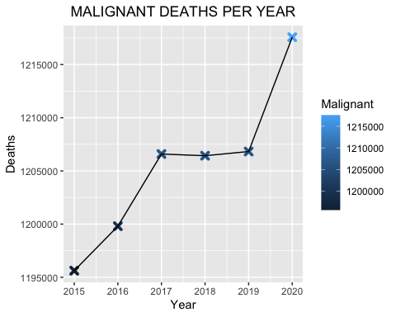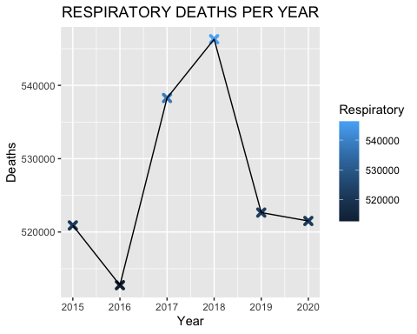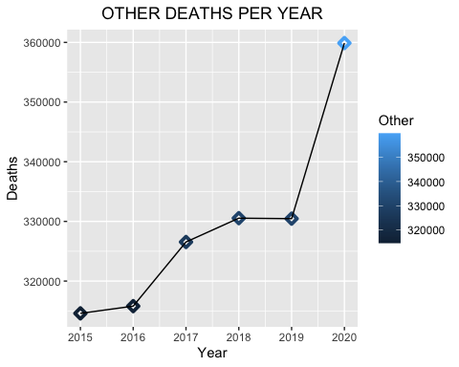

Four of the five plots above have something in common. Every year, the number of deaths for each cause increase except for the respiratory deaths plot. The respiratory deaths plot is the only plot that decrease from the year 2018 to 2019 and then decrease a little more from 2019 to 2020. How is this possible? Wasn’t there a global pandemic for a respiratory virus? Most of the country was on lockdown restrictions because of what was called “The Coronavirus Pandemic”. Covid-19 was said to be a deadly virus and that a lot of people were dying from the virus. If this claim is true, then why does the data from this analysis show otherwise? The things that make you go hmmm…..