Total_Deaths

Total Deaths 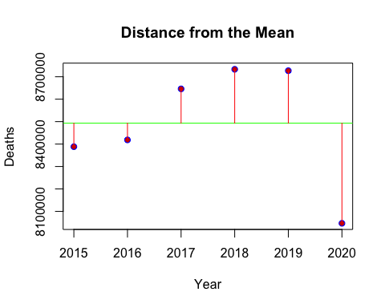

## Year Mean Deaths Above or Below the Mean  
## 1 2015 8493325 -105016.83  
## 2 2016 8493325 -74776.83  
## 3 2017 8493325 152661.17  
## 4 2018 8493325 239861.17  
## 5 2019 8493325 233671.17  
## 6 2020 8493325 -446399.83

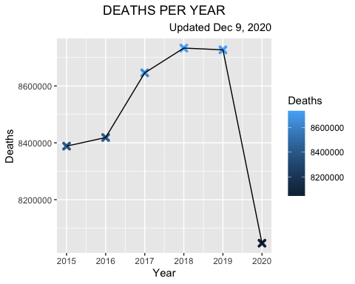

Deaths by Cause and Year

## Alzheimer Circulatory Malignant Other Respiratory  
## 2015 978278 3314300 2381810 650998 1062922  
## 2016 994914 3333214 2390754 653556 1046110  
## 2017 1047324 3419926 2403926 674468 1100342  
## 2018 1067976 3460902 2404396 682624 1117288  
## 2019 1086700 3481924 2406082 683998 1068292  
## 2020 1066751 3223636 2151603 654320 950615

## Alzheimer Circulatory Malignant Other Respiratory  
## 2015 4 1 2 5 3  
## 2016 4 1 2 5 3  
## 2017 4 1 2 5 3  
## 2018 4 1 2 5 3  
## 2019 3 1 2 5 4  
## 2020 3 1 2 5 4

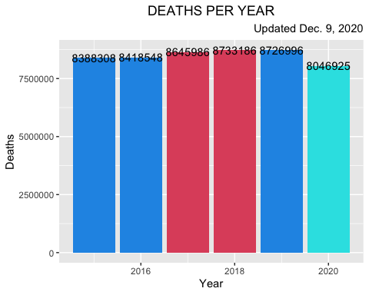

## Year Deaths Death Rate  
## 1 2015 8388308 0.1646059  
## 2 2016 8418548 0.1651993  
## 3 2017 8645986 0.1696624  
## 4 2018 8733186 0.1713735  
## 5 2019 8726996 0.1712521  
## 6 2020 8046925 0.1579068

## Alzheimer Circulatory Malignant Other Respiratory  
## 2015 978278 3314300 2381810 650998 1062922  
## 2016 994914 3333214 2390754 653556 1046110  
## 2017 1047324 3419926 2403926 674468 1100342  
## 2018 1067976 3460902 2404396 682624 1117288  
## 2019 1086700 3481924 2406082 683998 1068292  
## 2020 1066751 3223636 2151603 654320 950615

## Cause Deaths Death.Rate Rank  
## 1 Circulatory diseases 20233902 0.39705499 1  
## 2 Malignant neoplasms 14138571 0.27744476 2  
## 3 Respiratory diseases 6345569 0.12452071 3  
## 4 Alzheimer disease and dementia 6241943 0.12248723 4  
## 5 Other select causes 3999964 0.07849231 5

## Deaths Death Rate Rank  
## Circulatory 20233902 0.39705499 1  
## Malignant 14138571 0.27744476 2  
## Respiratory 6345569 0.12452071 3  
## Alzheimer 6241943 0.12248723 4  
## Other 3999964 0.07849231 5

## Alzheimer Circulatory Malignant Other Respiratory  
## 2015 0.1166240 0.3951095 0.2839440 0.07760778 0.1267147  
## 2016 0.1181812 0.3959369 0.2839865 0.07763286 0.1242625  
## 2017 0.1211341 0.3955507 0.2780395 0.07800938 0.1272662  
## 2018 0.1222894 0.3962932 0.2753172 0.07816437 0.1279359  
## 2019 0.1245217 0.3989831 0.2757056 0.07837726 0.1224123  
## 2020 0.1325663 0.4006047 0.2673820 0.08131305 0.1181339

## Alzheimer Circulatory Malignant Other Respiratory  
## 2015 4 1 2 5 3  
## 2016 4 1 2 5 3  
## 2017 4 1 2 5 3  
## 2018 4 1 2 5 3  
## 2019 3 1 2 5 4  
## 2020 3 1 2 5 4