

School of Future Tech

React JS
Case Study Report

On

Title: Programmable Interactive Visual Alarm Routine Matrix

By
Japji Kaur
150096725078

Project Overview
This project is a ReactJS-based routine management application that transforms traditional alarms into a complete daily routine orchestration system. Users can create tasks, assign durations, track progress, receive audio alerts, and monitor their schedule through an interactive dashboard.

Objectives
- Manage daily routines efficiently
- Provide visual progress tracking
- Automate task transitions
- Improve productivity and time management

Key Features
- Task creation and management
- Countdown timer system
- Pause, Resume, Skip and Reset controls
- Circular progress clock using SVG
- LocalStorage persistence
- Analytics dashboard
- Audio alerts using Web Audio API
- Export routine data as JSON

Technologies Used
ReactJS, JavaScript, HTML5, CSS3, LocalStorage API, Web Audio API, SVG Graphics, React Hooks (useState, useEffect, useRef), and optional @dnd-kit for drag-and-drop.

System Workflow
The Routine Matrix application follows a structured workflow that guides users through creating, managing, and executing time-based routines.
- Routine Creation
  - The user creates routine tasks using the TaskForm component.
  - For each task, the user specifies a title, duration, alarm sound, color theme, and optional subtasks.
  - Tasks can also be loaded instantly using predefined templates such as Morning Ritual, Evening Wind-down, and Focus Session.

- Task Storage and Persistence
  - All routine data is maintained in React state during execution.
  - The routine matrix is automatically serialized into JSON format and stored in LocalStorage.
  - This ensures that routines remain available even after browser refreshes or application restarts.
  - Users can additionally export routines as JSON files and import them later for portability.
- Routine Organization
  - Tasks are displayed in the Routine Matrix timeline.
  - Using the drag-and-drop functionality provided by @dnd-kit, users can reorder tasks dynamically.
  - Each task is represented as a configurable behavioral block containing duration, alarm settings, and progress indicators.
- Routine Execution
  - When the user clicks Start, the custom timer engine begins execution.
  - The first task becomes the active task and is highlighted in the interface.
  - A Web Worker-based timer continuously tracks elapsed time with high precision.
  - The countdown updates in real time within the Circular Timer component.
- Task Progress Monitoring
  - The Circular Timer visualizes the percentage completion of the current task.
  - Subtask milestones can be checked off during execution.
  - The Circular Clock displays the current time and the overall routine progression within a radial timeline.
- Alarm and Transition System
  - When a task reaches its scheduled completion time, a synthesized alarm sound is generated using the Web Audio API.
  - Depending on the task configuration, different sounds such as Glass Chime, Zen Bowl, Synth Pluck, or Pulse Alarm are played.
  - The completed task is marked as finished and automatically logged into the session history.
- Automatic Task Advancement
  - After completion, the system automatically transitions to the next task in the routine.
  - The active task highlight moves to the next behavioral block.
  - The timer resets according to the next task's duration and continues execution seamlessly.
- Analytics and Monitoring
  - Throughout execution, the Analytics Dashboard continuously updates:
    - Completed tasks count
    - Time utilization statistics
    - Routine completion percentage
    - Category-wise time allocation
    - Session history logs
  - Users receive real-time feedback regarding their routine performance.

- Routine Completion
  - Once the final task is completed, the timer stops automatically.
  - A final completion sound is played to notify the user that the routine has ended.
  - Analytics display the final execution statistics for the completed session.

Workflow Diagram
User Creates Routine
↓
Task Stored in State & LocalStorage
↓
Tasks Displayed in Routine Matrix
↓
User Clicks Start
↓
Timer Engine Starts
↓
Active Task Highlighted
↓
Countdown Updates in Real Time
↓
Task Completes
↓
Alarm Sound Generated
↓
Task Marked Completed
↓
Session Log Updated
↓
Next Task Activated
↓
Analytics Updated
↓
Repeat Until Last Task
↓
Final Completion Sound
↓
Routine Finished

Learning Outcomes
This project demonstrates React component architecture, state management, browser APIs, audio synthesis, SVG rendering, data persistence, and interactive UI design.

Component Structure
Header.jsx
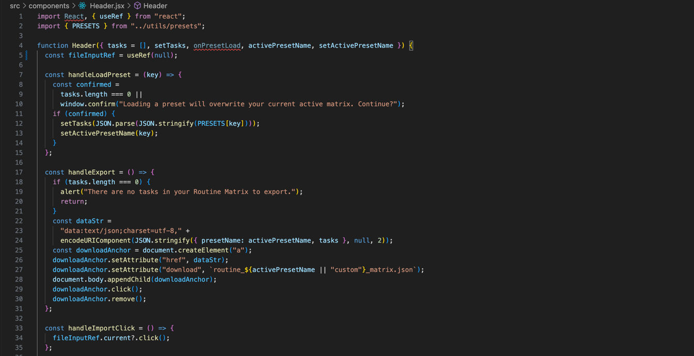
TaskForm.jsx
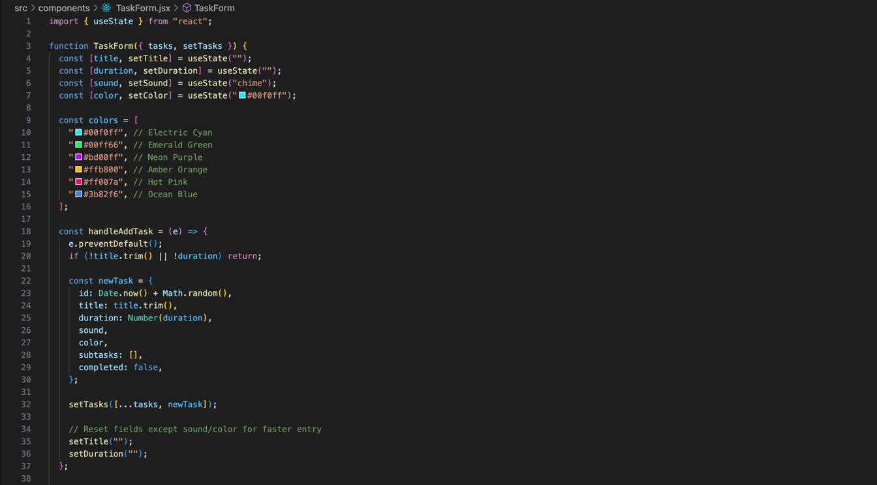

TaskList.jsx
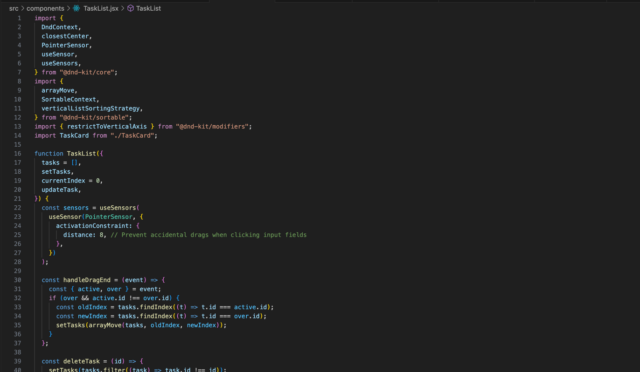
TaskCard.jsx
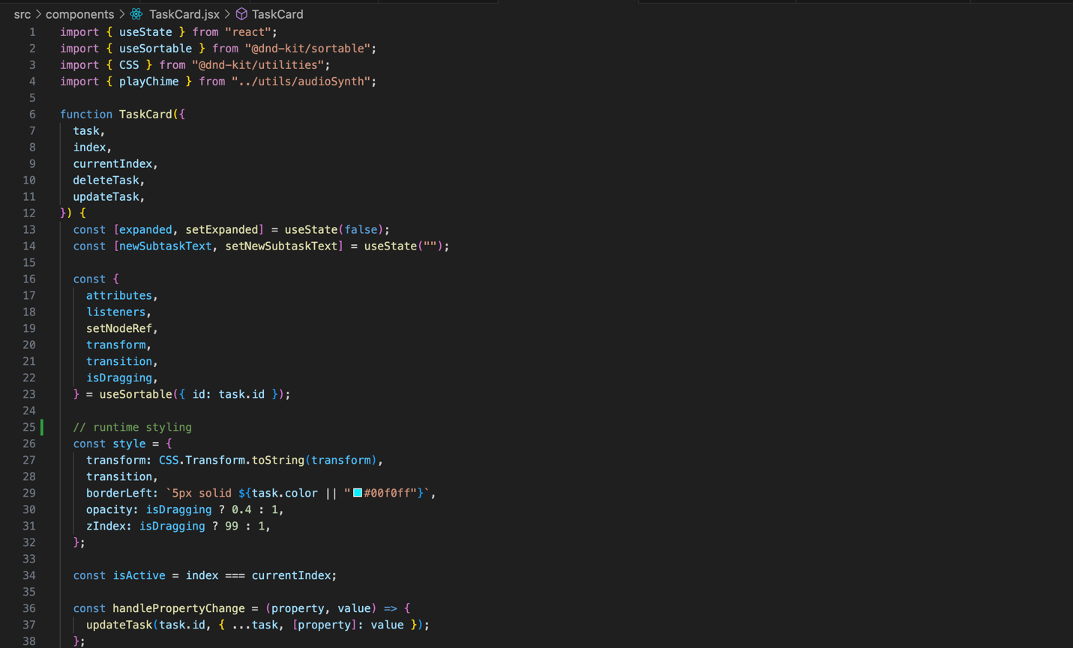

CircularTimer.jsx
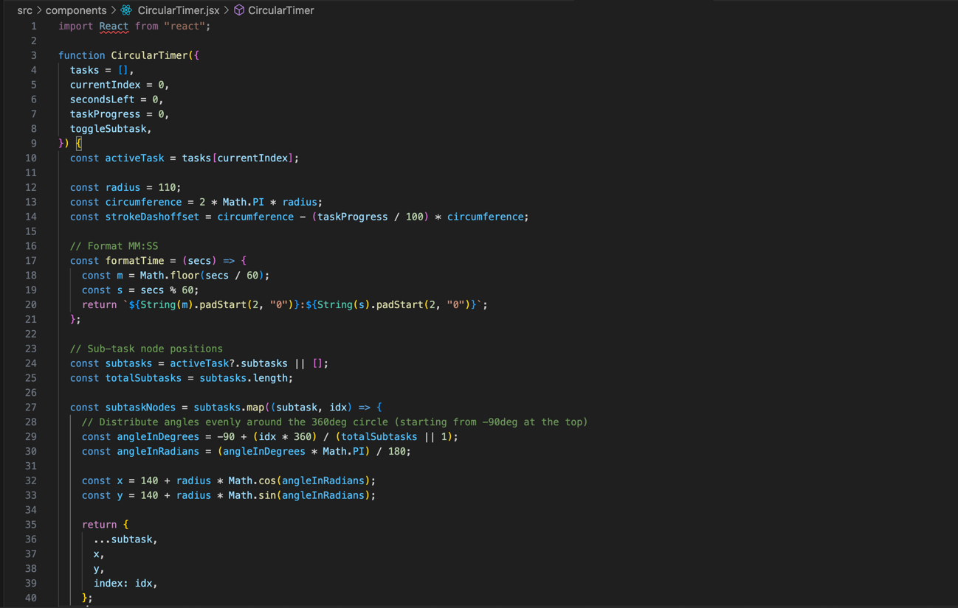
CircularClock.jsx
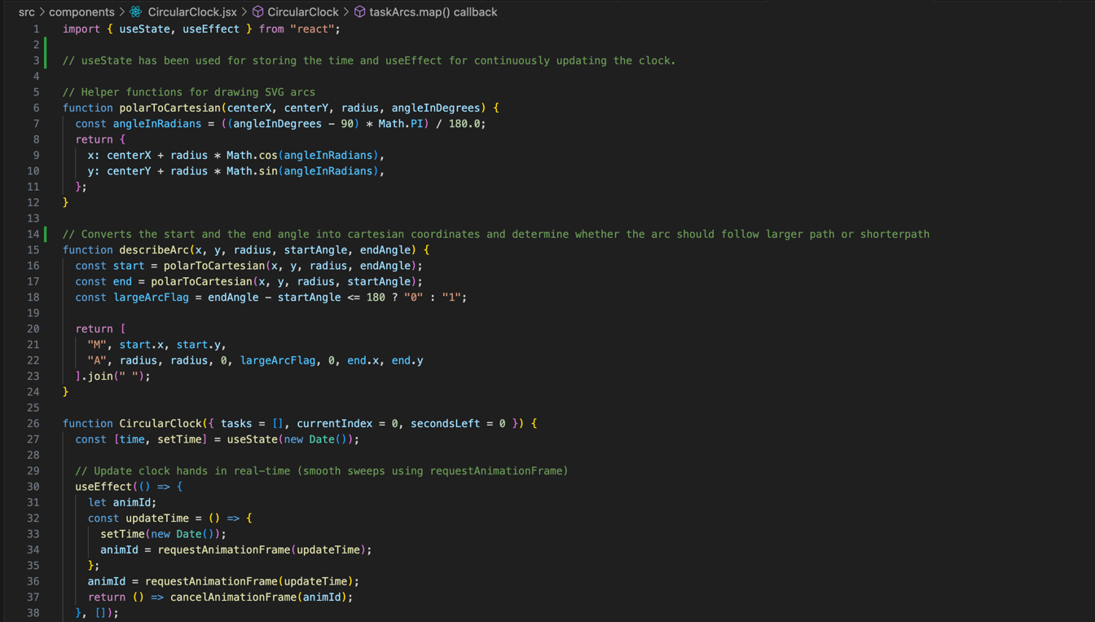

ControlPanel.jsx
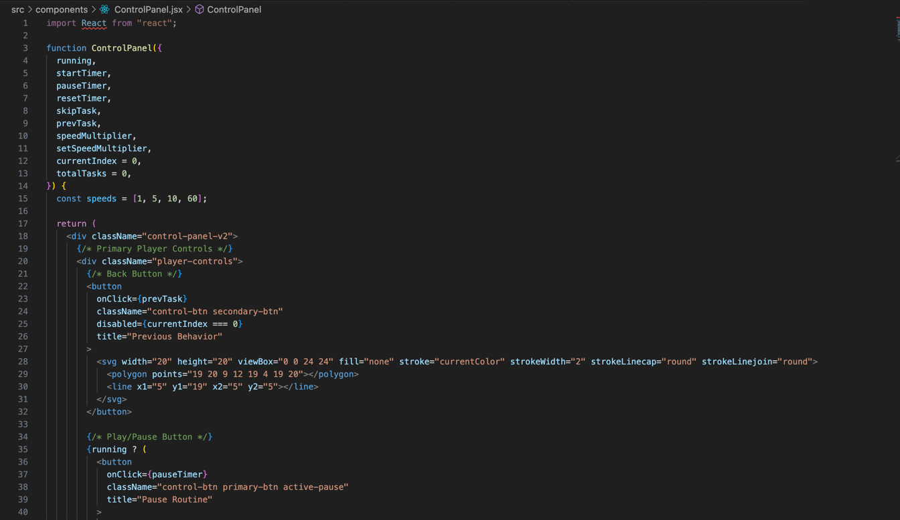
Analytics.jsx
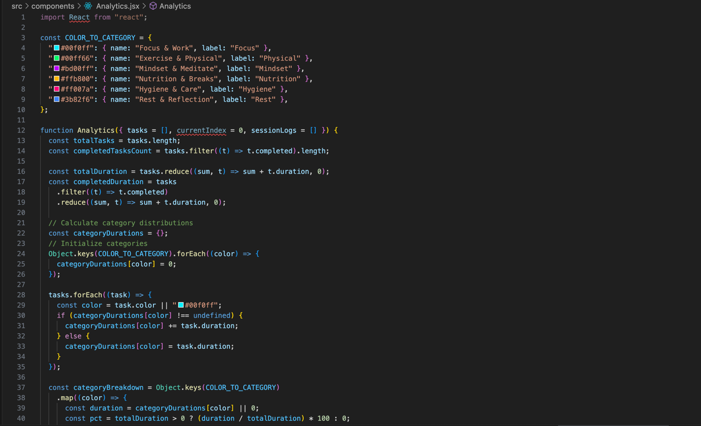

App.jsx
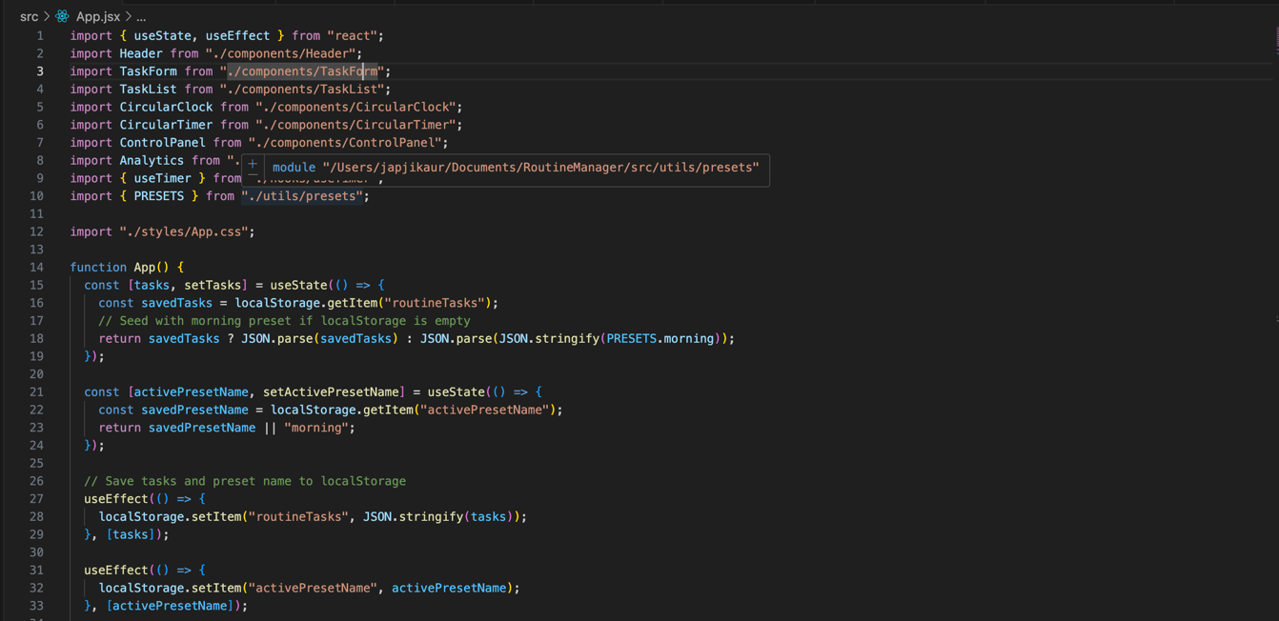

Ouput:

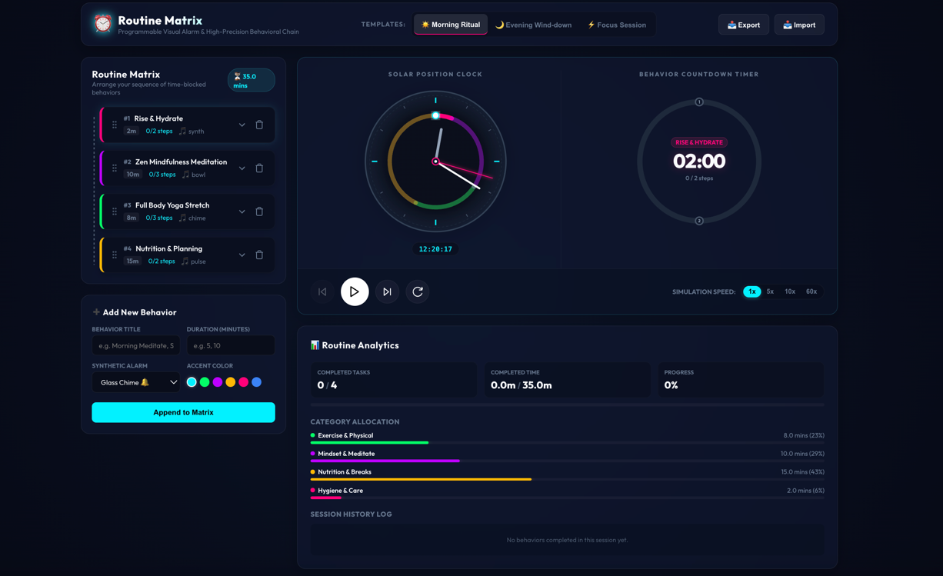

Conclusion:
The Routine Matrix is a frontend-only ReactJS application that helps users organize and execute structured daily routines through an interactive visual scheduling system. By combining React state management, LocalStorage persistence, drag-and-drop task organization, Web Audio API-based alarms, and real-time analytics, the application provides an efficient way to manage time-blocked activities. The project demonstrates modern React development concepts while delivering a practical productivity tool that improves routine planning, task execution, and personal time management without requiring a backend database.

