

School of Future Tech
Case Study Report

on

Title: Student Scholarship Management System

By

Japji Kaur
150096725078

Student Scholarship Management System (C++)

1. Introduction
The Student Scholarship Management System is a C++ application designed to determine whether a student is eligible for a scholarship based on predefined criteria such as academic performance and family income.
The system collects student information, verifies eligibility using conditional logic, and allocates the appropriate scholarship amount. It also stores the student details and scholarship information in a text file using file handling, allowing records to be maintained permanently.
This project demonstrates the use of Object-Oriented Programming concepts, conditional statements, menu-driven programs, and file handling in C++.

2. Objectives
• To design a system that verifies student scholarship eligibility
• To implement decision-making logic using conditional statements
• To apply Object-Oriented Programming (OOP) concepts
• To implement file handling to store student records
• To create a menu-driven application for easy user interaction

3. System Requirements
Hardware Requirements:
• Computer or Laptop
• Minimum 4GB RAM
• Any standard processor

Software Requirements:
• C++ Compiler (GCC / g++)
• Code Editor (VS Code / CodeBlocks / Dev C++)
• Operating System: Windows / Mac / Linux

4. Methodology / Program Flow
1. The user runs the program.
2. A menu-driven interface appears.
3. The user enters student details such as name, marks, and family income.
4. The program checks eligibility based on predefined criteria.
5. The scholarship amount is calculated.
6. Student details and scholarship status are stored in a file.
7. The user can view the scholarship status from the menu.

5. Scholarship Eligibility Criteria
Marks ≥ 90 → Scholarship ₹50,000
Marks ≥ 85 → Scholarship ₹30,000
Marks ≥ 80 → Scholarship ₹20,000
Marks < 80 → Not Eligible
Additional condition:
Family income must be ≤ ₹200000

6. Features of the System
• Menu-driven program
• Object-Oriented design using classes
• Scholarship eligibility verification
• Automatic scholarship calculation
• File storage for student records
• Multiple student entries supported

7. Concepts Used
Object-Oriented Programming:
• Class and Object
• Encapsulation
Control Structures:
• if-else statements
• switch statements
• do-while loop
File Handling:
• ofstream
• ios::app
Input Handling:
• cin
• getline()
• cin.ignore()

8. Code Implementation
The program uses a Student class that contains:
Data Members:
• Name
• Marks
• Income
• Scholarship Amount
Member Functions:
• getDetails() – Accept student details
• checkEligibility() – Determine scholarship eligibility
• displayScholarship() – Display scholarship status
• saveToFile() – Store student details in a file

9. Sample Output:
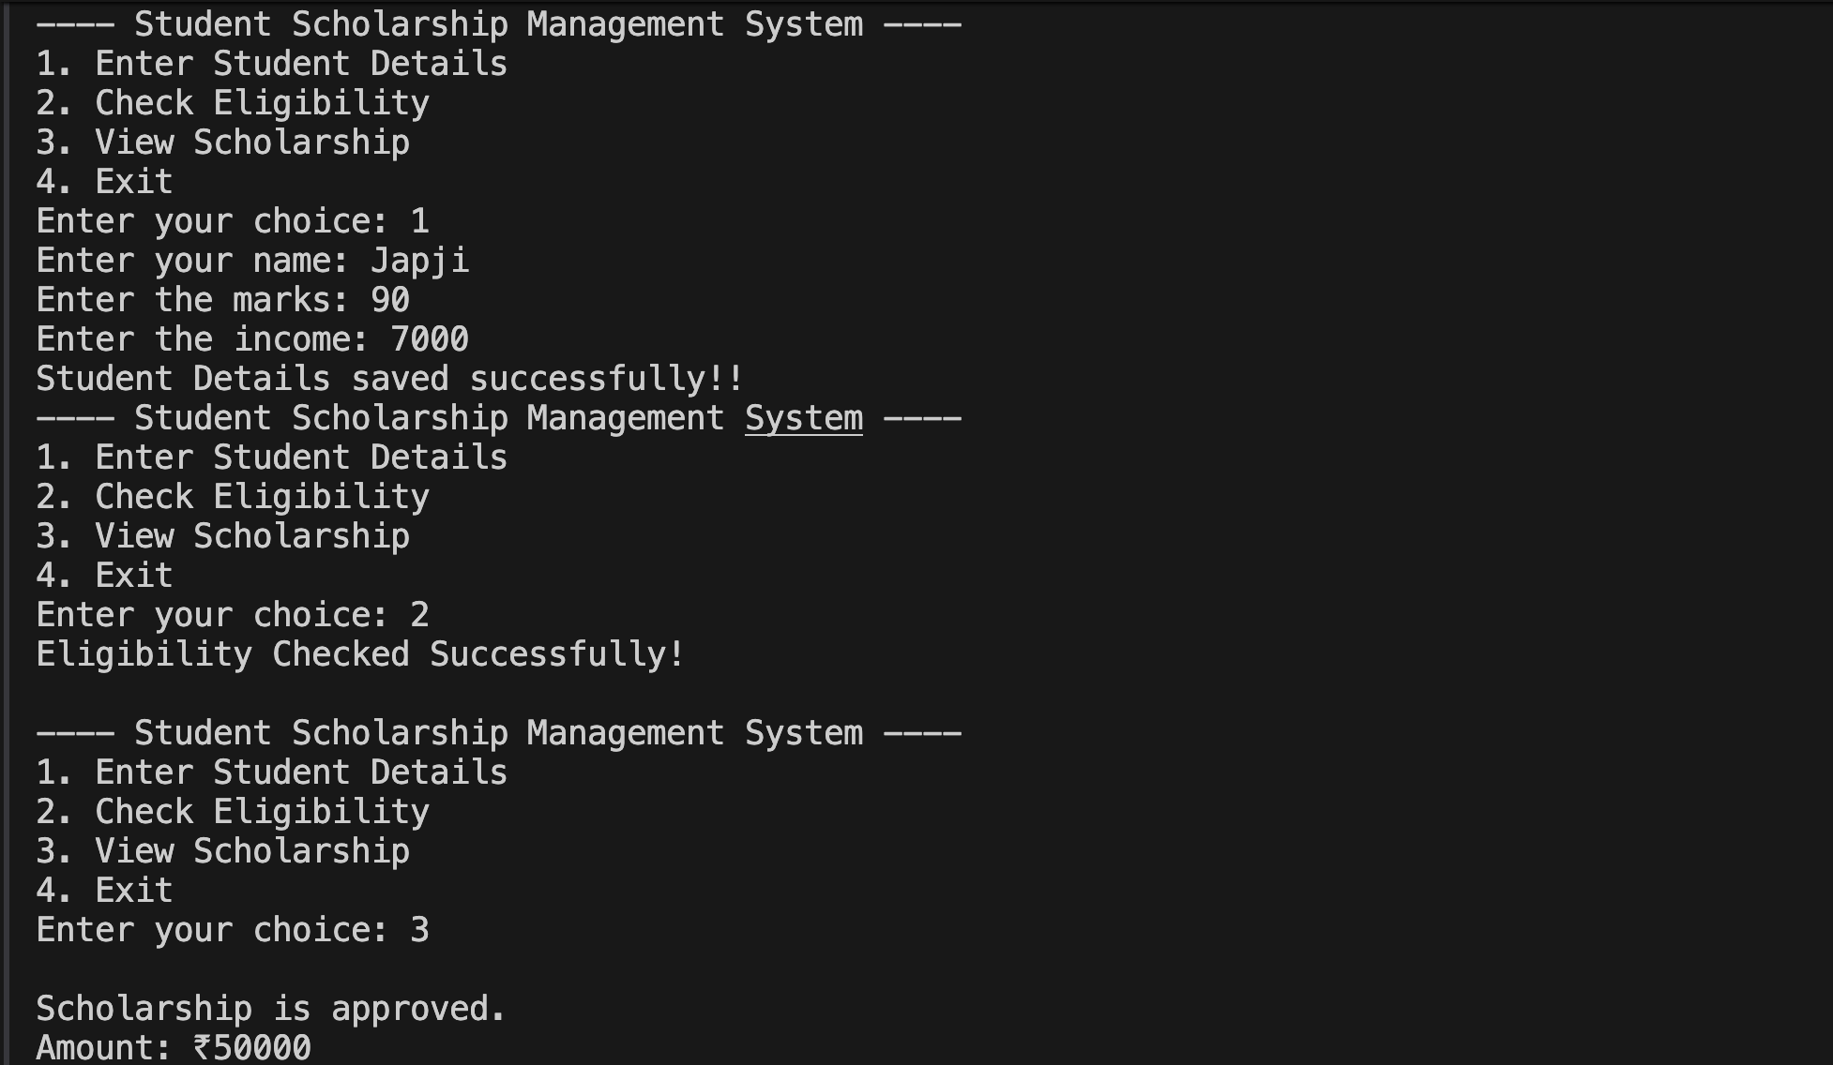

10. Advantages
• Simple and easy to use
• Demonstrates key C++ programming concepts
• Maintains student records using file storage
• Can be extended into a full management system

11. Limitations
• Data is stored in a text file instead of a database
• Limited validation of user input
• No graphical user interface

12. Future Improvements
• Using a database instead of text files
• Adding a graphical user interface (GUI)
• Implementing student ID and multiple record management
• Storing scholarship rules in configuration files instead of hardcoding

13. Conclusion
The Student Scholarship Management System successfully demonstrates the implementation of C++ programming concepts such as classes, conditional logic, loops, and file handling.
The program provides a simple method to determine scholarship eligibility and maintain student records. This project helps in understanding how programming can be used to automate real-world administrative tasks.

