Python Basic

Lab Assignment 1



**Name: Japman Singh**

**Roll number: 04913202717, CSE1**

**GitHub Repository: https://github.com/japmansingh/ML_College/**

**Q1.** Create a program that asks the user to enter their name and their age. Print out a message addressed to them that tells them the year that they will turn 100 years old. Extras:

1. Add on to the previous program by asking the user for another number and printing out that many copies of the previous message.
2. Print out that many copies of the previous message on separate lines. (Hint: the string "\n is the same as pressing the ENTER button)

**Pseudocode:**

input: name, age, repeat

output: year for age 100 years

initialise name, age

initialise year to now.year + 100 – age

initialise result to name + 100 years old year

print result

initialise repeat

print result repeat number of times

# Program Screenshot and Output:

# 

**Q2.** Take a list, say for example this one: a = [1, 1, 2, 3, 5, 8, 13, 21, 34, 55, 89] and write a program that prints out all the elements of the list that are less than 5.

Extras:

1. Instead of printing the elements one by one, make a new list that has all the elements less than 5 from this list in it and print out this new list.
2. Write this in one line of Python.
3. Ask the user for a number and return a list that contains only elements from the original list a that are smaller than that number given by the user.

**Pseudocode:**

input: list

output: elements greater than 5

initialise a as [1, 1, 2, 3, 5, 8, 13, 21, 34, 55, 89]

for each item in a ,

if item is smaller than 5:

print element

initialise new_list to item

for item in a

if item is smaller than 5

print new_list

initialise num

print item

for each item in a

if item is smaller than num

# Program screenshot and Output:

# 

Q3. Write a program that asks the user how many Fibonacci numbers to generate and then generates them. Take this opportunity to think about how you can use functions. Make sure to ask the user to enter the number of numbers in the sequence to generate.(Hint: The Fibonacci seqence is a sequence of numbers where the next number in the sequence is the sum of the previous two numbers in the sequence. The sequence looks like this: 1, 1, 2, 3, 5, 8, 13, ...).

**Pseudocode:**

input: limit

for fibonacci series,

output: fibonacci sequence upto n terms

function fibonacci(n_terms)

initialise n1 to 0

initialise n2 to 1

initialise count to 0

if n

n_terms is greater than or equal to 0

print enter an integer

elif n_terms is equal 1

print Fibonacci sequence upto n_terms print n1

else: print Fibonacci sequence while count is smaller than n_terms

print n1

initialise nth to n1 + n2

set n1 to n2

set n2 to nth

set count += 1

initialise length

print fibonacci(n_terms)

# Program screenshot and Output:

Q4. Write a program (function!) that takes a list and returns a new list that contains all the elements of the first list minus all the duplicates.

Extras:

* Write two different functions to do this - one using a loop and constructing a list, and another using sets.

**Pseudocode:**

function duplicate_f1(list)

initialise new_list

for each i in list

if i not is in new_list

new_list.append(i)

return new_list

function duplicate_f2(list)

return list(set(x))

initialise user_list

initialise limit

for each i in range limit

initialise elem

append elem in user_list

print user_list

print Function using loop

duplicate_f1(user_list)

print Function

set duplicate_f2(user_list)

# Program screenshot and Output:

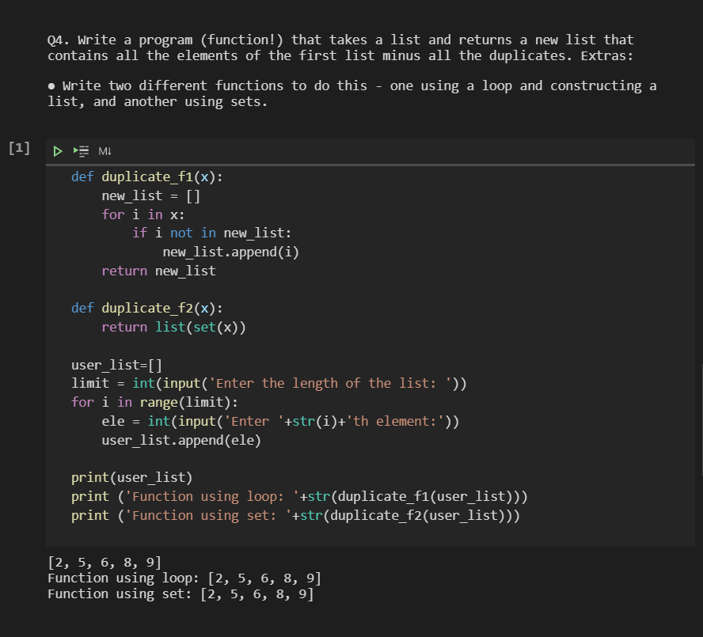

Q5. Ask the user for a number and determine whether the number is prime or not. (For those who have forgotten, a prime number is a number that has no divisors.). Use functions.

**Pseudocode:**

input: number

output: number is prime or not

function prime(number)

initialise flag to false

if number is greater than 1

for each i from 2 to number

if i modulus number is 0

set flag to true

break

if flag is true

print number is a prime number

else print number is not a prime number

# Program screenshot and Output:

