1.mail servers :-

ibm.com :- mx0b-001b2d01.pphosted.com

wipro.com : wipro-com.mail.protection.outlook.com

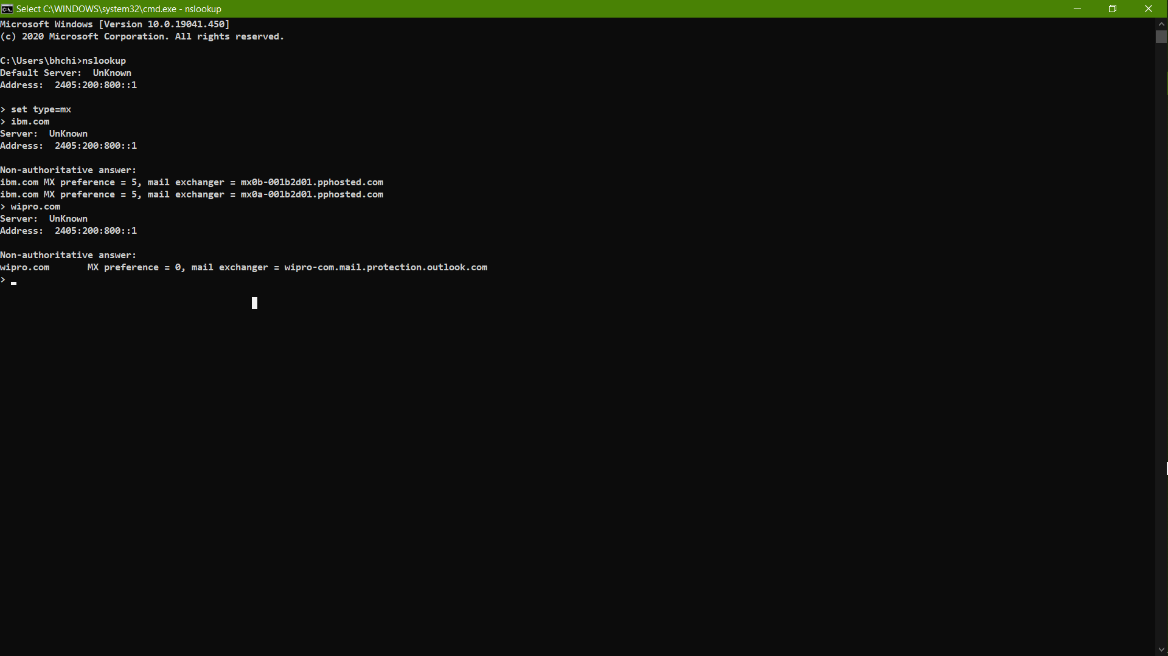

2:=

Mail servers addresss :-

ibm:-

>> 148.163.156.1

wipro:-

>> 104.47.126.36

>> 104.47.124.36

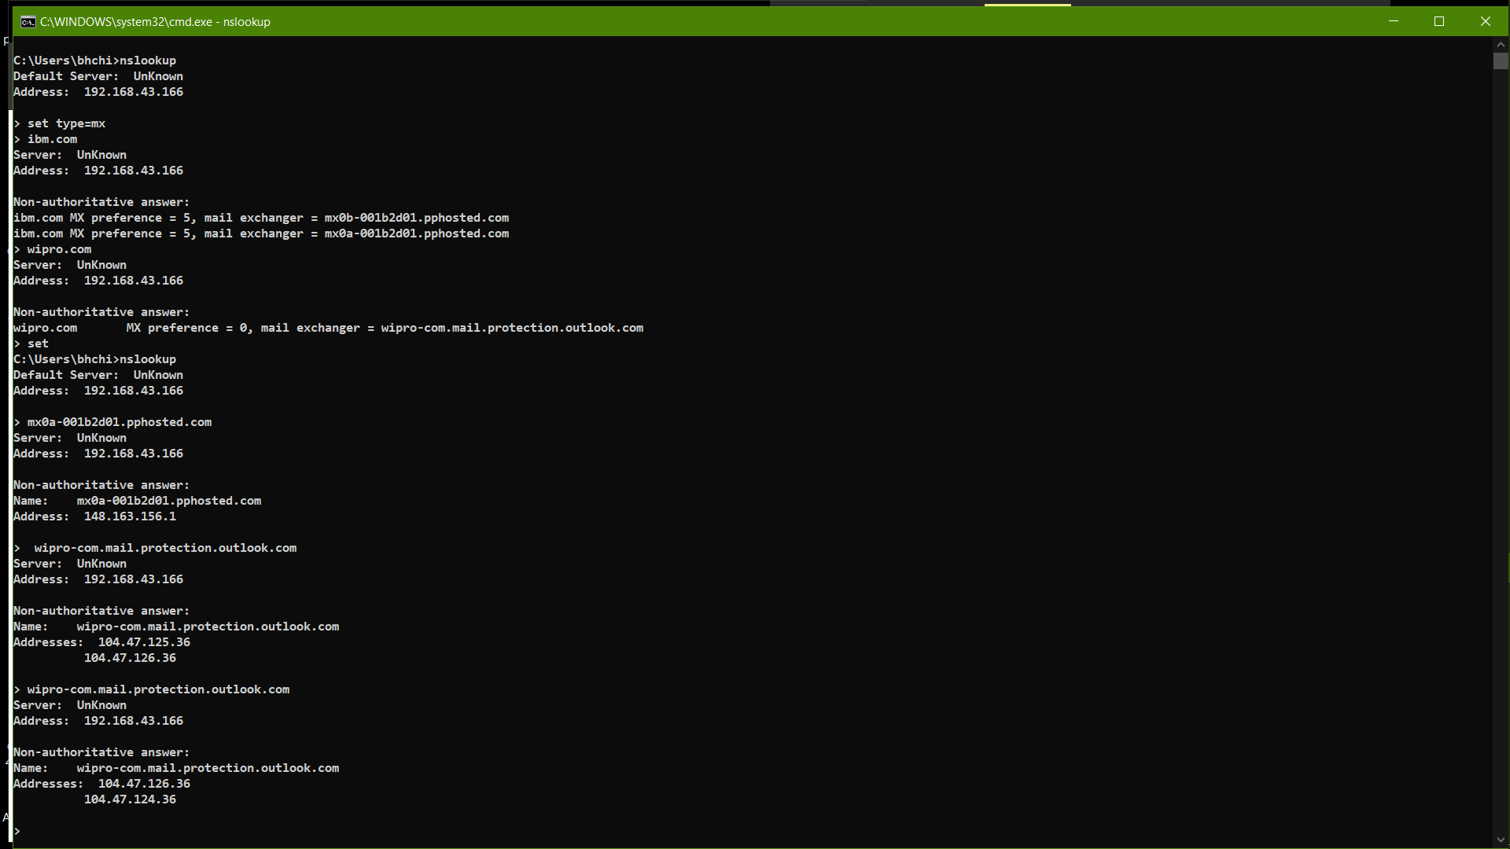

3.

open ports are:===

80,443,8086

