Tasks in build.xml, makedir, delete dir, Copy and movnent

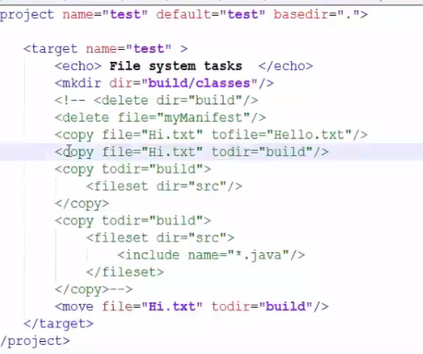

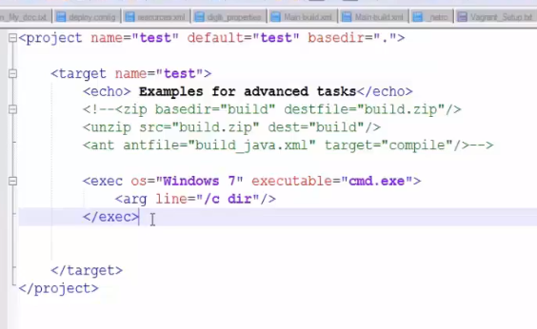

Doing external tasks from ant:

