What is Kubernetes cluster: A Kubernetes cluster is a combination of one master and one or more nodes.

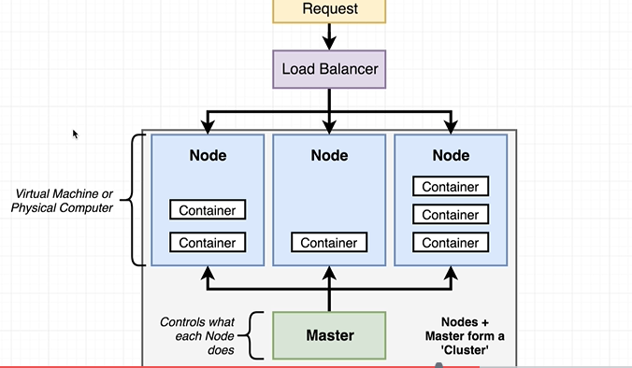

Nodes are basically are virtual machine or a physical computer used to run some same or different number of containers.

Master controls the node.

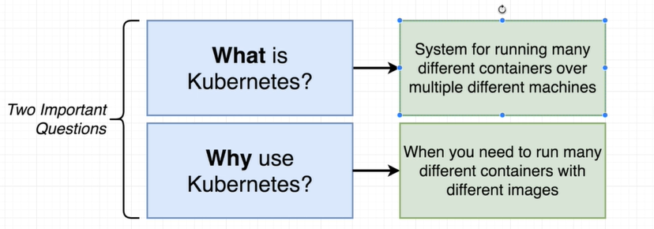

Kubernetes is best to use in an environment where we have multiple types of containers. It is not suitable for a single type of container.

